**Bresenham Line Drawing Algorithm-**

### ****Procedure-****

Given-

* Starting coordinates = (X0, Y0)
* Ending coordinates = (Xn, Yn)

The points generation using Bresenham Line Drawing Algorithm involves the following steps-

### ****Step-01:****

Calculate ΔX and ΔY from the given input.

These parameters are calculated as-

* ΔX = Xn – X0
* ΔY =Yn – Y0

### ****Step-02:****

Calculate the decision parameter Pk.

It is calculated as-

**Pk = 2ΔY – ΔX**

### ****Step-03:****

Suppose the current point is (Xk, Yk) and the next point is (Xk+1, Yk+1).

Find the next point depending on the value of decision parameter Pk.

Follow the below two cases-

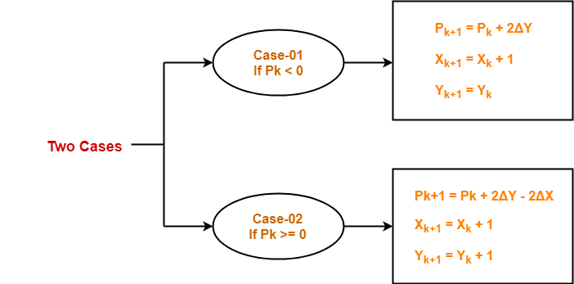

### ****Step-04:****

Keep repeating Step-03 until the end point is reached or number of iterations equals to (ΔX-1) times.

## ****Problem-01:****

Calculate the points between the starting coordinates (9, 18) and ending coordinates (14, 22).

## ****Solution-****

Given-

* Starting coordinates = (X0, Y0) = (9, 18)
* Ending coordinates = (Xn, Yn) = (14, 22)

### ****Step-01:****

Calculate ΔX and ΔY from the given input.

* ΔX = Xn – X0 = 14 – 9 = 5
* ΔY =Yn – Y0 = 22 – 18 = 4

### ****Step-02:****

Calculate the decision parameter.

Pk

= 2ΔY – ΔX

= 2 x 4 – 5

= 3

So, decision parameter Pk = 3

### ****Step-03:****

As Pk >= 0, so case-02 is satisfied.

Thus,

* Pk+1 = Pk + 2ΔY – 2ΔX = 3 + (2 x 4) – (2 x 5) = 1
* Xk+1 = Xk + 1 = 9 + 1 = 10
* Yk+1 = Yk + 1 = 18 + 1 = 19

Similarly, Step-03 is executed until the end point is reached or number of iterations equals to 4 times.

(Number of iterations = ΔX – 1 = 5 – 1 = 4)

|  |  |  |  |
| --- | --- | --- | --- |
| **Pk** | **Pk+1** | **Xk+1** | **Yk+1** |
|  |  | 9 | 18 |
| 3 | 1 | 10 | 19 |
| 1 | -1 | 11 | 20 |
| -1 | 7 | 12 | 20 |
| 7 | 5 | 13 | 21 |
| 5 | 3 | 14 | 22 |

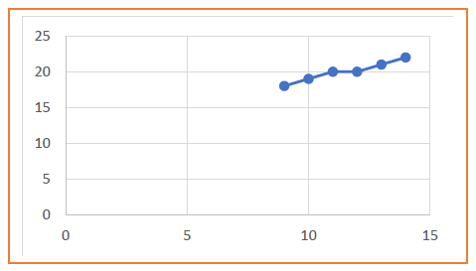

## ****Problem-02:****

Calculate the points between the starting coordinates (20, 10) and ending coordinates (30, 18).

## ****Solution-****

Given-

* Starting coordinates = (X0, Y0) = (20, 10)
* Ending coordinates = (Xn, Yn) = (30, 18)

### ****Step-01:****

Calculate ΔX and ΔY from the given input.

* ΔX = Xn – X0 = 30 – 20 = 10
* ΔY =Yn – Y0 = 18 – 10 = 8

### ****Step-02:****

Calculate the decision parameter.

Pk= 2ΔY – ΔX

= 2 x 8 – 10

= 6

So, decision parameter Pk = 6

### ****Step-03:****

As Pk >= 0, so case-02 is satisfied.

Thus,

* Pk+1 = Pk + 2ΔY – 2ΔX = 6 + (2 x 8) – (2 x 10) = 2
* Xk+1 = Xk + 1 = 20 + 1 = 21
* Yk+1 = Yk + 1 = 10 + 1 = 11

Similarly, Step-03 is executed until the end point is reached or number of iterations equals to 9 times.

(Number of iterations = ΔX – 1 = 10 – 1 = 9)

|  |  |  |  |
| --- | --- | --- | --- |
| **Pk** | **Pk+1** | **Xk+1** | **Yk+1** |
|  |  | 20 | 10 |
| 6 | 2 | 21 | 11 |
| 2 | -2 | 22 | 12 |
| -2 | 14 | 23 | 12 |
| 14 | 10 | 24 | 13 |
| 10 | 6 | 25 | 14 |
| 6 | 2 | 26 | 15 |
| 2 | -2 | 27 | 16 |
| -2 | 14 | 28 | 16 |
| 14 | 10 | 29 | 17 |
| 10 | 6 | 30 | 18 |

