C++ ASSIGNMENT 2
Functions and Object-Oriented Programming Concepts

Q1 – Call by Value, by Reference and by Pointer (6 Marks)

What the question asks
The hostel office reduces a student's fee using a concession. You must show three parameter-passing methods and explain whether the original fee in main() changes.

Three implementations

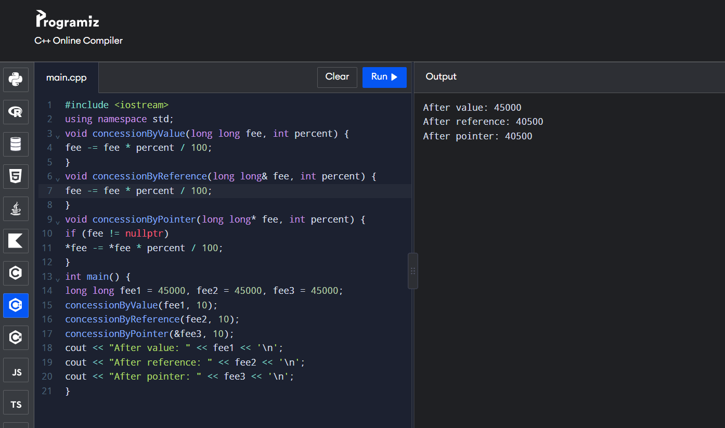

Explanation
- Call by value: a separate copy is passed. The function changes only its local copy, so the original remains 45000.
- Call by reference: the parameter is an alias for the caller's variable. Changing it changes the original fee.
- Call by pointer: the function receives the variable's address. Dereferencing with *fee changes the original. Check for nullptr before dereferencing.
- const reference: use const T& when a large object must be read without copying and must not be modified. For a small long long, passing by value is usually simple and inexpensive.

Predict the output program in the assignment

void change(int a, int& b, int* c) {

a += 10;

b += 10;

*c += 10;

}

int& bigger(int& p, int& q) { return p > q ? p : q; }

void show(int x, int y = 5, int z = 10) {

std::cout << x + y + z << ' ';

}

int main() {

int a = 1, b = 2, c = 3;

change(a, b, &c);

std::cout << a << ' ' << b << ' ' << c << '\n';

bigger(a, c) = 100;

std::cout << a << ' ' << c << '\n';

show(1); show(1, 2); show(1, 2, 3);

std::cout << '\n';

}

After change(): a=1, b=12, c=13. bigger(a,c) returns a reference to c because c is larger, so c becomes 100. show(1), show(1,2), show(1,2,3) print 16, 13 and 6.

Expected output (spacing depends on the exact print characters):
1 12 13
1 100
16 13 6
Default arguments: show(1) uses y=5 and z=10; show(1,2) uses z=10; show(1,2,3) supplies all values.

Complete the Code
The value-call leaves hostelFee at 45000. The reference-call changes it to 40500.
Design decision: use a reference when the purpose is to update the stored fee. Return a new fee when the function should calculate without mutating the input. If several concessions apply, the order and combination rule must be specified; the assignment does not give that policy.

Alternative concept and complexity
Return-value alternative: long long applyConcession(long long fee, int percent) { return fee - fee * percent / 100; }, called as hostelFee = applyConcession(hostelFee, 10);. All methods take O(1) time for a fixed-size fee. Passing a large Student object by value copies its members; reference/const reference avoids that full copy. A scalar parameter uses O(1) space; copying an object requires space proportional to its size.

Q2 – Return by Reference and Its Dangers (4 Marks)

Return a reference to the highest mark
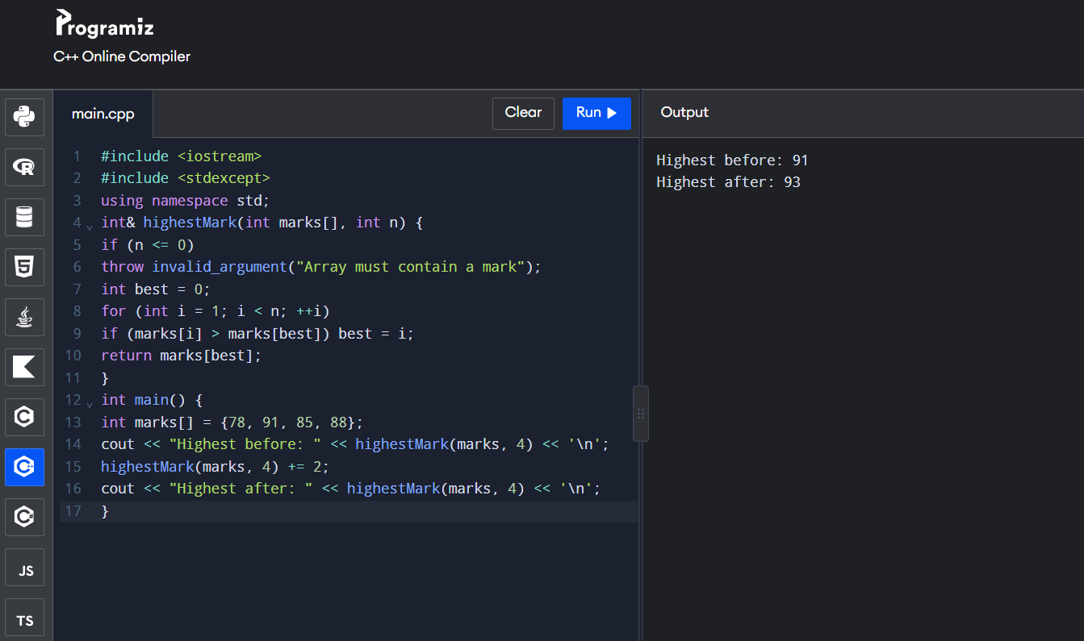
The function returns an alias to the array element. Therefore, the returned expression can be used on the left side of += and changes the original array.

Dangling reference – unsafe example
int& wrongReference() { int local = 50;
return local;
}

A compiler commonly warns about returning a reference to a local variable. When the function ends, local no longer exists. The returned reference dangles; using it is undefined behaviour. Do not expect a particular output.

Reference, const reference and copy
- int&: refers to the original object and allows modification
- const int&: refers to the original but prevents modification through that reference.
- int: returns a copy; changing the copy does not change the array.

Changed condition – std::vector
#include <vector> #include <algorithm> #include <stdexcept>

int& highestMark(std::vector<int>& marks) {
if (marks.empty()) throw std::invalid_argument("No marks"); return *std::max_element(marks.begin(), marks.end());
}
If a vector grows and reallocates, references, pointers and iterators to its old elements become invalid. Do not use a reference obtained before an operation that may reallocate. reserve() can reduce reallocations but does not guarantee that future growth cannot reallocate.

Alternative: return an index or pointer
int highestIndex(const int a[], int n) { if (n <= 0) return -1;
int best = 0;
for (int i = 1; i < n; ++i)
if (a[i] > a[best]) best = i; return best;
}
// Use: int i = highestIndex(marks, n); marks[i] += 2;

int* highestPointer(int a[], int n) { if (n <= 0) return nullptr;
int best = 0;
for (int i = 1; i < n; ++i)
if (a[i] > a[best]) best = i; return &a[best];
}
Finding the maximum is O(n) time and O(1) extra space for reference, index or pointer. An index can be used again after vector reallocation if the logical element ordering is unchanged. A pointer/reference to a vector element may be invalidated by reallocation.

Q3 – Default Arguments and Function Overloading (6 Marks)

Why the original design is ambiguous
double charge(double weight);
double charge(double weight, bool express);
double charge(double weight, bool express = false, bool insured = false);
charge(2) can match the first overload and the third overload using its default arguments. Both require the same int-to-double conversion, so the compiler cannot choose uniquely. A two-argument call can similarly match the second and third overloads.

Redesigned overloads

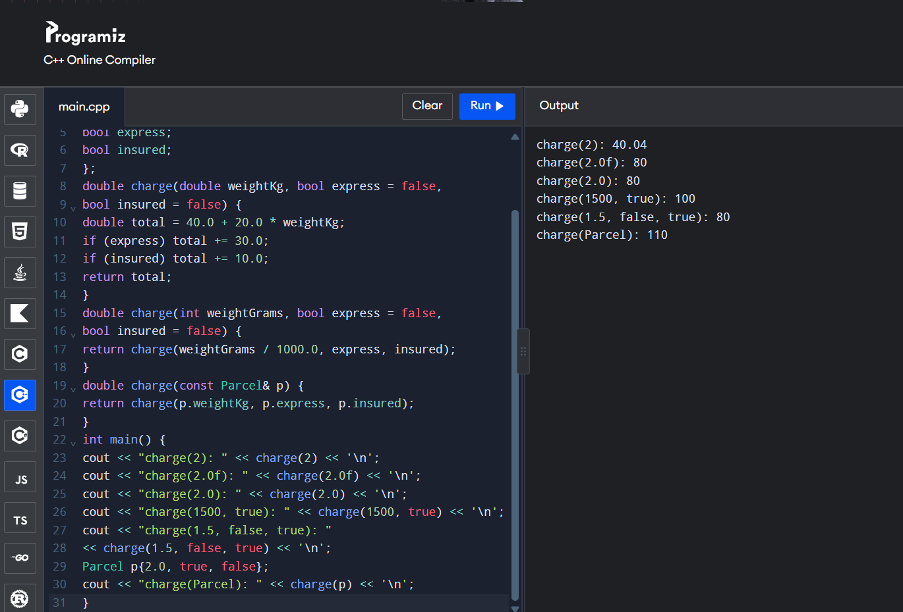

Rate assumption: the PDF does not specify courier prices. This executable example assumes base 40 + 20 per kg, express
+30 and insurance +10. Replace these rates with the faculty's rates if provided.

Call | Selected overload | Reason
charge(2) | int overload | Exact int match; interpreted as 2 grams.
charge(2.0f) | double overload | float-to-double promotion beats conversion to int.
charge(2.0) | double overload | Exact double match.
charge(1500,true) | int overload | First argument is exact int.
charge(1.5,false,true) | double overload | First argument is exact double.
charge(p) | Parcel overload | Argument is a Parcel object.

Expected output using the sample rates:
Overload resolution prefers exact match, then promotion, then standard conversion. If two viable overloads have equally good conversion sequences, the call is ambiguous. Default arguments must be trailing because omitted arguments are taken from the right.

Alternative concept and complexity
One Parcel structure with optional fields gives one function and makes adding options straightforward, but callers must construct or fill the structure. A function template can support different types but may need constraints and can make overload behaviour harder to understand. Overload resolution happens at compile time, so it adds no run-time cost. Passing a large Parcel by const reference avoids copying; passing by value copies it. The fare calculation is O(1).

Q4 – Specifying a Class with an Array Inside It (6 Marks)

Complete SavingsAccount class

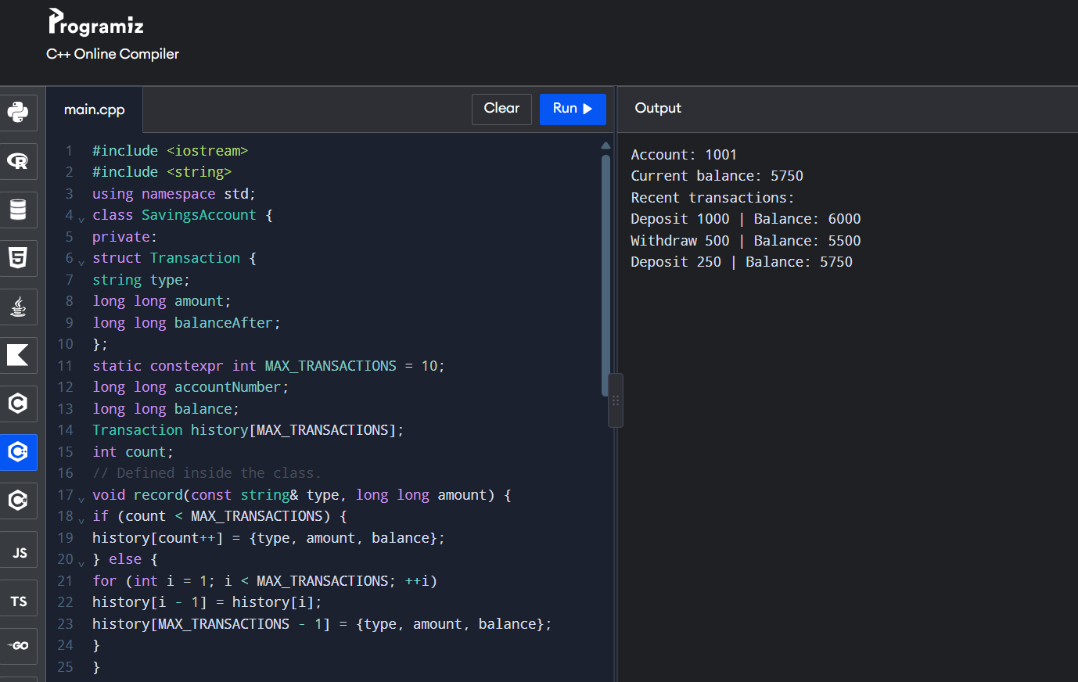
The transaction array is private so outside code cannot directly change records or break the count/order. The class maintains the account rules through deposit() and withdraw().

Handling the 11th transaction
- Shifting array: move records 1–9 to positions 0–8 and put the new record at position 9. This preserves chronological order but copies k1 records, so insertion is O(k).
- Circular buffer: maintain a start index for the oldest record. When full, overwrite that slot and advance start modulo capacity. Insertion is O(1); printing must start at the oldest index.
For a capacity of ten, shifting is easy and likely sufficient. If the capacity becomes fifty or may grow further, a circular buffer is more efficient. Both fixed arrays use O(k) storage.

Alternative using std::deque
std::deque<Transaction> history;

void addTransaction(const Transaction& t) { if (history.size() == 10)
history.pop_front(); history.push_back(t);
}
A deque supports push_back and pop_front at the ends in constant time. A custom circular buffer also gives O(1) insertion with fixed capacity but requires correct index handling.

Q5 – Static Members and Arrays of Objects (7 Marks)

Static member concepts
- A static data member is shared by every object and is defined once outside the class (unless declared inline static in modern C++).
- A static member function has no this pointer. It cannot directly access a particular object's non-static members.
- An array of objects calls the constructor once for each element. All objects share the same static counter.

Predict the Token program

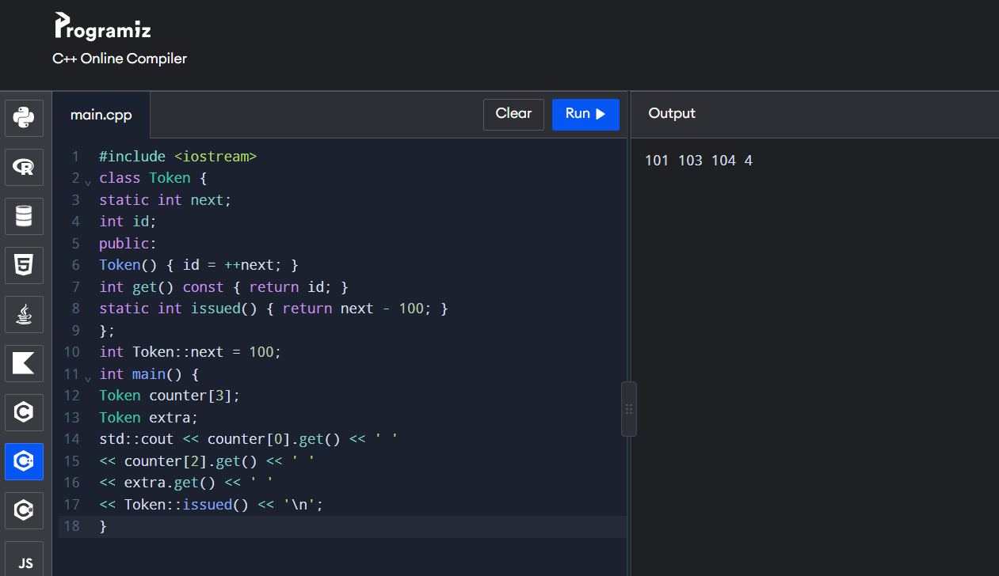

next starts at 100. Each constructor increments it and saves the new value in id. Three array objects plus one extra object means four constructor calls. issued() returns 104100=4.

Complete the BusTicket code
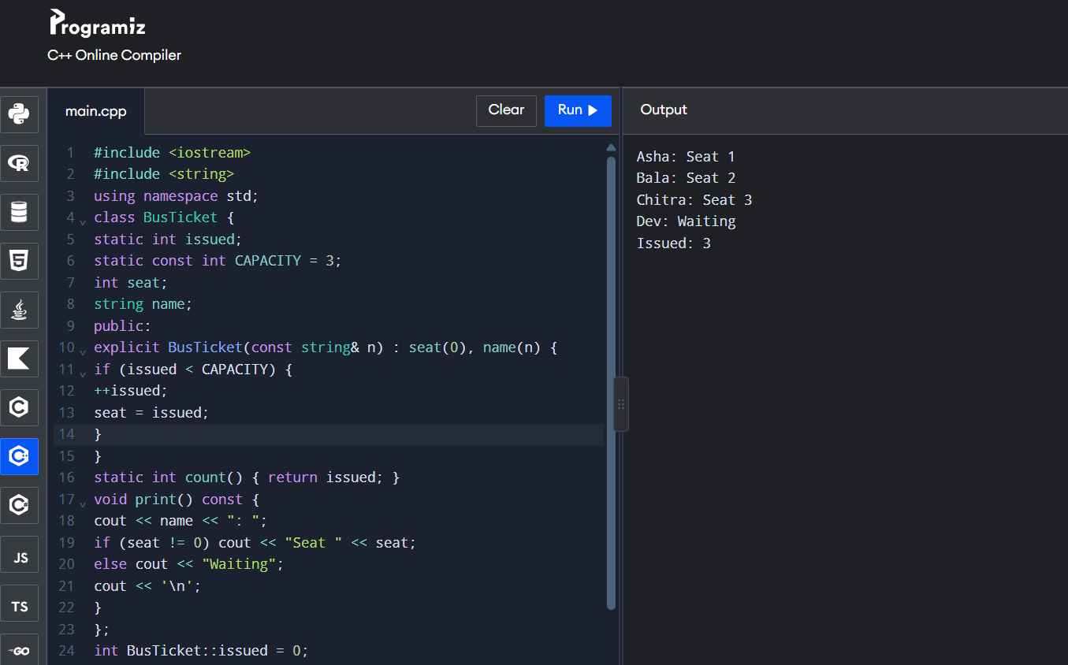

Creating tickets in a function called twice
The static issued count remains even after local ticket objects are destroyed. After the first trip creates three seats, the second call sees issued==3, so later tickets are waiting. If separate buses need independent seat counts, a single class-wide static counter is unsuitable; use a Bus or TicketOffice object with its own counter.
A global counter has O(1) update time and O(1) storage but is less encapsulated. A TicketOffice object can support two buses independently. Static is suitable when all tickets belong to one shared pool.

Q6 – Friend Functions and Inline Functions (8 Marks)

Completed friend-function program
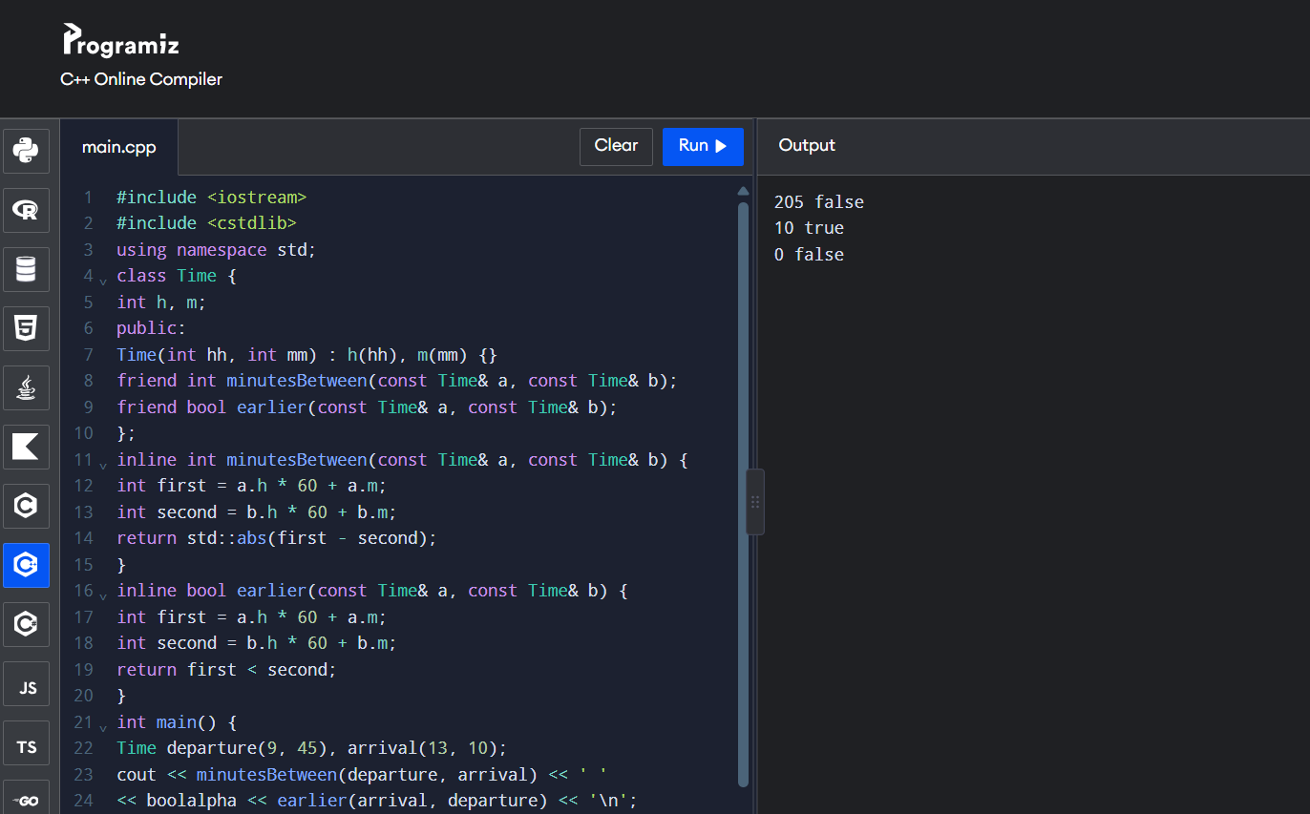

09:45 = 585 minutes after midnight; 13:10 = 790 minutes. Difference = 205. Arrival is not earlier than departure. 11:55 is earlier than 12:05 by ten minutes. A time compared with itself has difference zero and is not earlier.

Why use friend functions?
- A friend function is not a class member, but the class grants it access to private/protected members.
- It is called as minutesBetween(a,b), not a.minutesBetween(b).
- It is useful when an operation treats two objects equally, such as comparing two Time objects.
- Making h and m public would allow unrelated code to create invalid times, such as 25:90.

Meaning of inline
inline asks the compiler to consider inline substitution, but the compiler may ignore the request or inline functions without the keyword. Functions defined inside a class are implicitly inline. At -O2 the compiler may optimise ordinary functions automatically. Do not claim inline is always faster.

Required timing experiment
g++ -std=c++17 -O0 -Wall -Wextra time_benchmark.cpp -o bench_O0 g++ -std=c++17 -O2 -Wall -Wextra time_benchmark.cpp -o bench_O2
./bench_O0
./bench_O2
Use the same 10,000,000-call workload for the inline and non-inline versions. Record your own measurements; results depend on the CPU, compiler, operating system and optimisation settings.

Member-function alternatives are a.minutesTo(b) and a.isEarlier(b), or use public getters while keeping data private. All approaches do O(1) work per comparison. Keep the data private; choose friend functions for symmetric operations or member functions/getters when those interfaces are clearer.

Q7 – Diagnose, Redesign and Validate (13 Marks)

Chosen program: Q4 transaction history – diagnose
When the fixed transaction array is full, the original program shifts k1 records for every new transaction. This is simple for ten records, but the work grows with the history capacity k. The repeated copying is the limitation.

Define the objective
Retain the latest 50 transactions in chronological order and reduce insertion after the buffer becomes full from O(k) shifting to O(1) overwrite/index updates. Both versions must retain exactly the same 50 latest values for the same input.

Revised solution: circular buffer

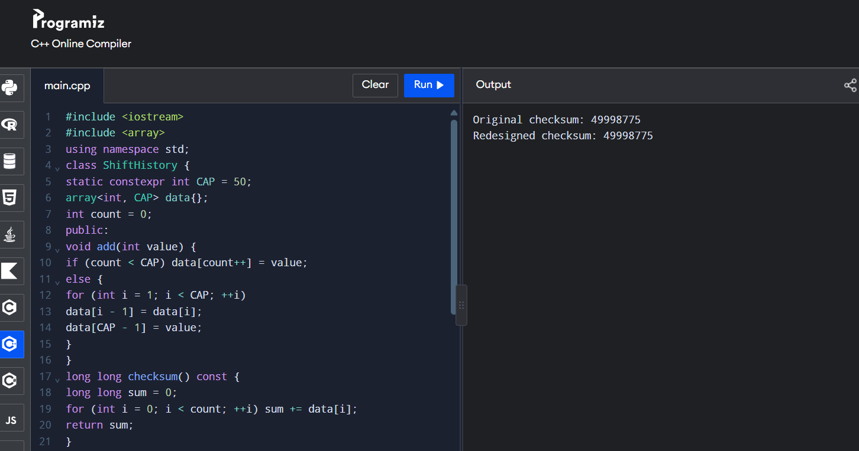

Both versions retain values 999,951 through 1,000,000. Their sum is 49,998,775. Equal checksums are a quick validation; for stronger evidence, compare every retained element in chronological order.

Pseudocode / class design
CircularHistory
private: data[50], start, count
public: add(value), checksum()

add(value):
if count < 50:
data[(start + count) % 50] = value count++
else:
data[start] = value start = (start + 1) % 50
The circular buffer uses the same O(k) storage as the fixed array. It adds a start index and modular arithmetic. The trade-off is slightly more complicated code and the need to print records in circular chronological order.

Predict before implementing
Prediction: after the buffer is full, the shifting version performs up to 49 record assignments for each new item at capacity 50. The circular version performs one array write and one index update. The retained data should be identical.

Implement and validate
Run both versions with the same sequence, such as one million inserted IDs. First compare the retained records/checksum. Then time only the insertion loops using std::chrono::steady_clock. Run multiple trials and report a median. Do not include compilation time.
Measurement | Shift array | Circular buffer
Capacity | 50 | 50
Input | 1 to 1,000,000 | 1 to 1,000,000
Final checksum | 49,998,775 | 49,998,775
Space | O(k) | O(k)
Full-buffer insert | O(k) | O(1)

Defend the final design
The circular buffer is preferable when capacity is larger or insertion speed matters because it avoids shifting records. The shifting array may be preferable for a very small history because it is simpler and already stores entries in chronological order. The redesign meets the objective if both retain the same data and measurements show reduced insertion work. If timing differences are small for a tiny workload, explain that practical results depend on capacity and compiler optimisation.

