**MEASURING THE PULSE OF PROSPERITY: AN INDEX OF ECONOMIC FREEDOM ANALYSIS**

**1. INTRODUCTION:**

**1.1 OVER VIEW:**

Economic freedom is the fundamental right of every human to control his or her own

Labor and property. In an economically free society, individuals are free to work,

produce, consume, and invest in any way they please. In economically free

Societies, governments allow labor, capital, and goods to move freely, and refrain

from coercion or constraint of liberty beyond the extent necessary to protect and

maintain liberty itself.

For much of human history, most individuals have lacked economic freedom and

opportunity, condemning them to poverty and deprivation.

Today, we live in the most prosperous time in human history. Poverty, sicknesses,

and ignorance are receding throughout the world, due in large part to the advance of

economic freedom. In 2022, the principles of economic freedom that have fueled this

monumental progress are once again measured in the Index of Economic Freedom,

an annual guide published by The Heritage Foundation, Washington's No. 1 think

tank.

**1.2. PURPOSE:**

We measure economic freedom based on 12 quantitative and qualitative factors,

grouped into four broad categories, or pillars, of economic freedom:

1) Rule of law property rights, government integrity, judicial effectiveness)

2) Government size (government spending, tax burden, fiscal health)

3) Regulatory efficiency (business freedom, labor freedom, monetary freedom)

4) Open markets (trade freedom, investment freedom, financial freedom)

**2. PROBLEM DEFINITION & DESIGN THINKING:**

**2.1 EMPATHY MAP:**

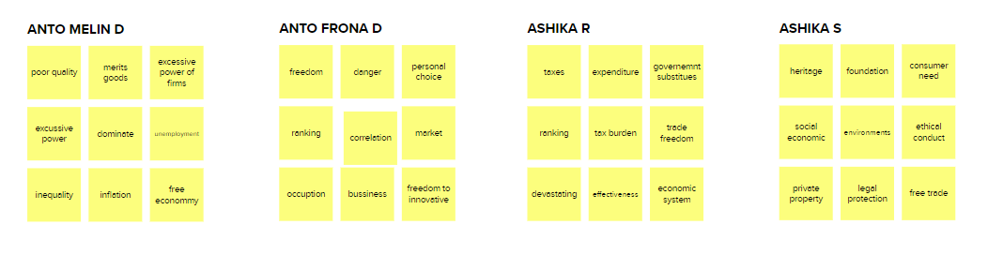

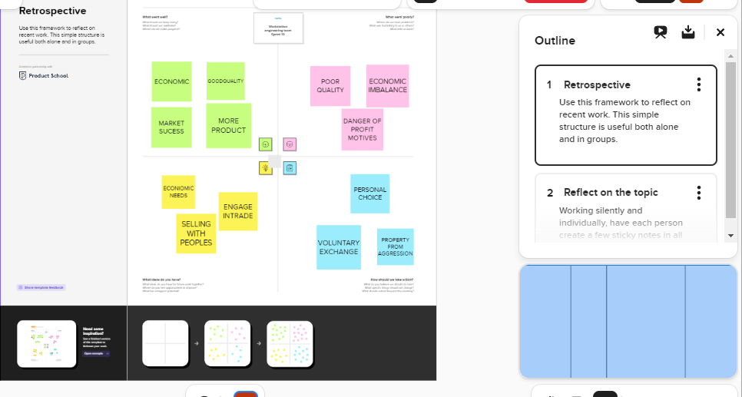

**Team Leader: Anto melin D:**<https://trailblazer.me/id/melin12345>

**Team member:Anto Frona D:** <https://trailblazer.me/id/frona45>

**Team member: Ashika R**: <https://trailblazer.me/id/ashir202>

**Team member: Ashika S:** <https://trailblazer.me/id/ashis1333>

**3. Result**

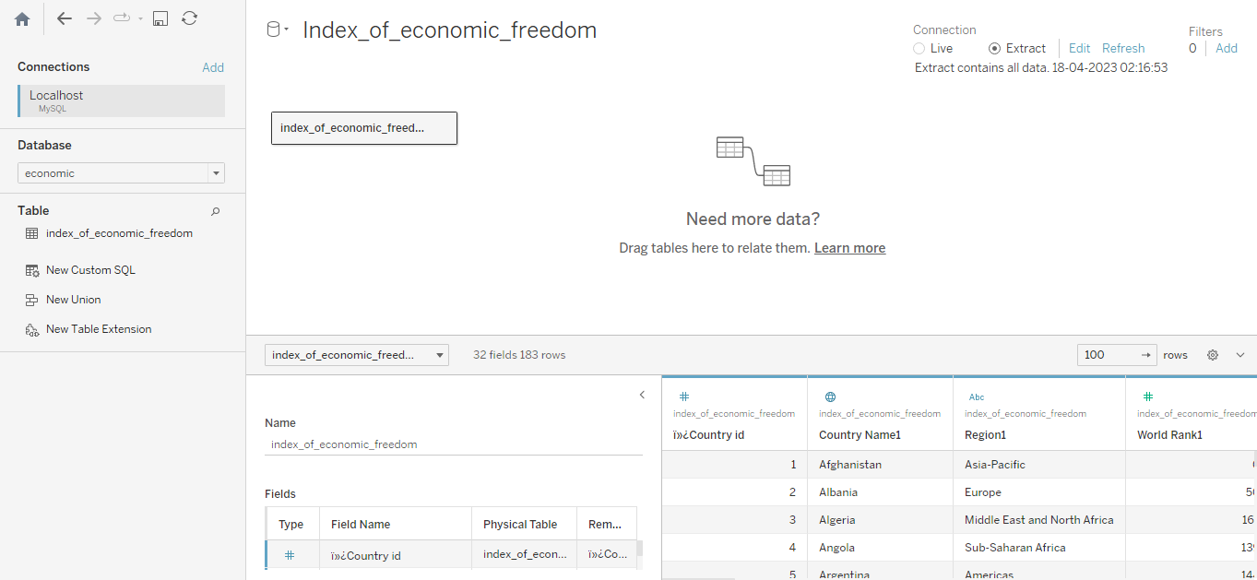

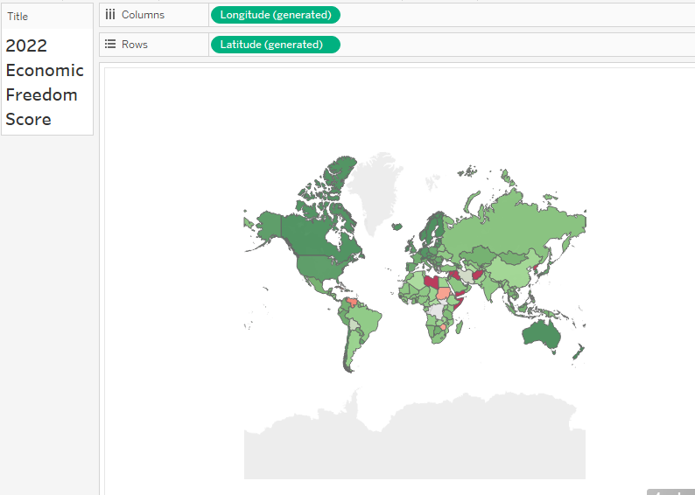

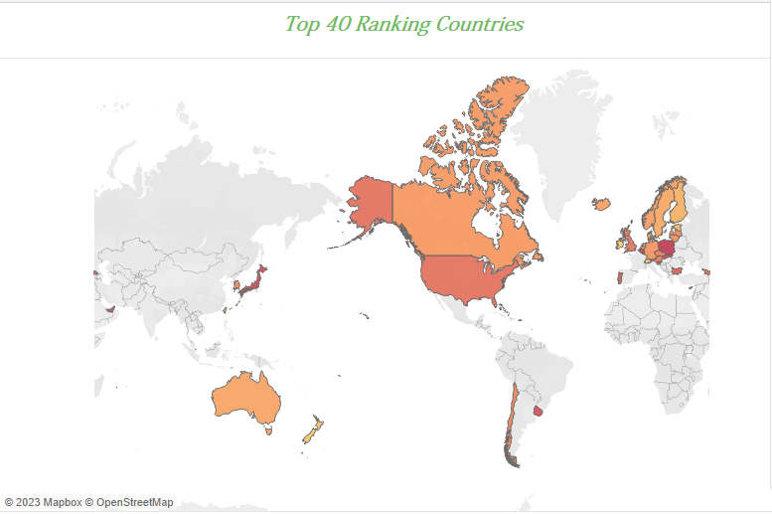

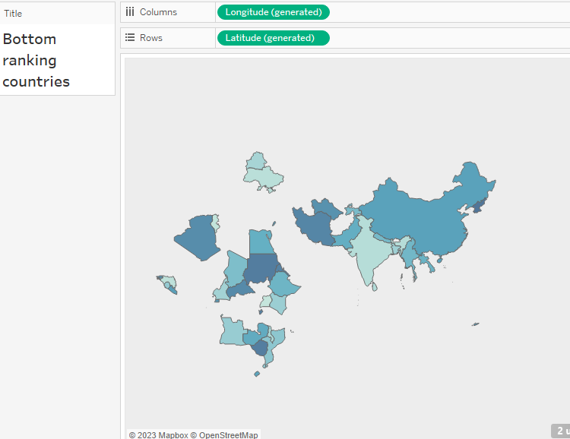

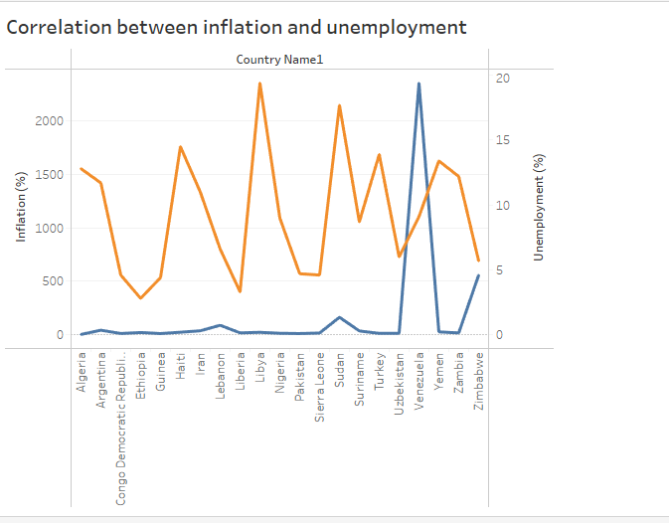

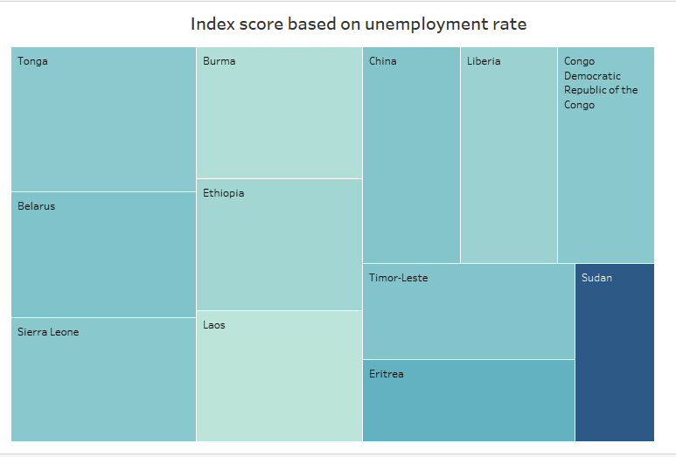

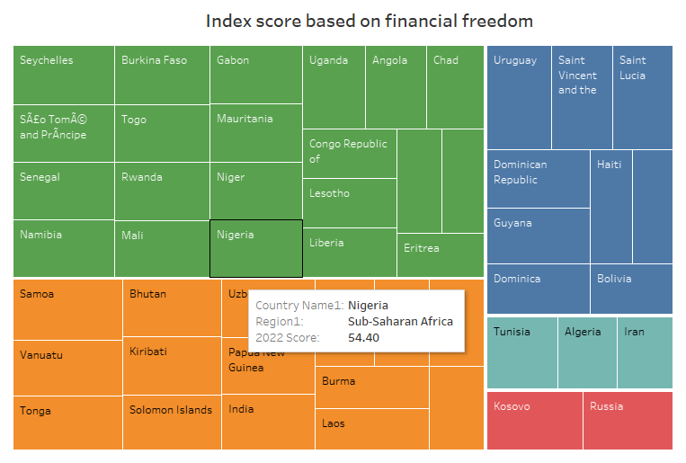

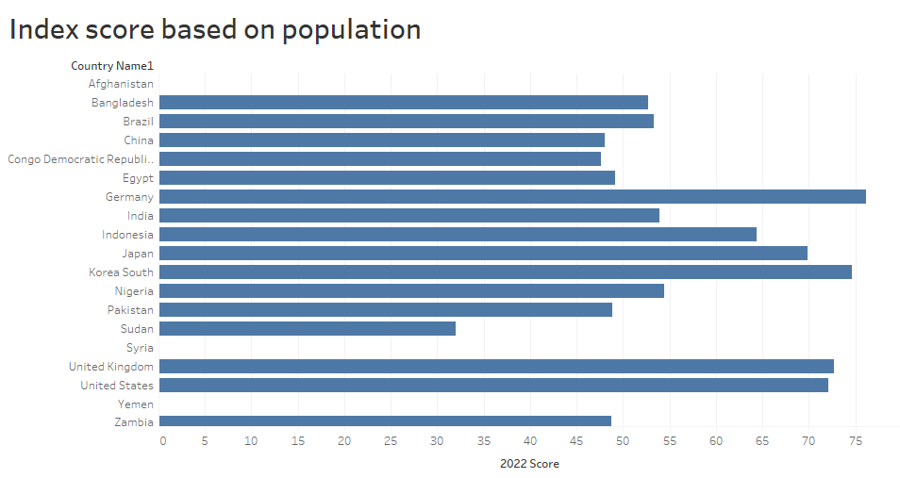

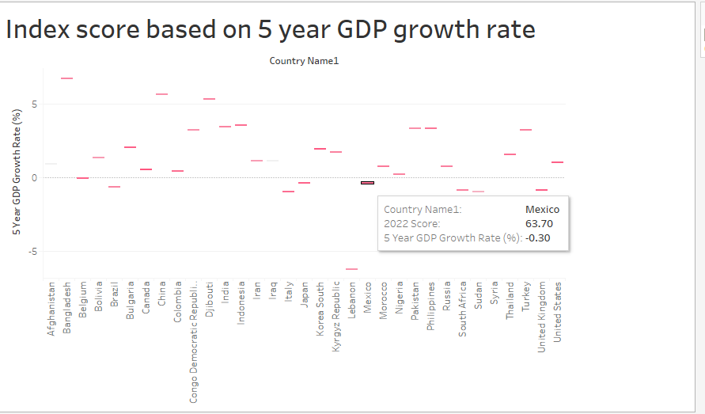

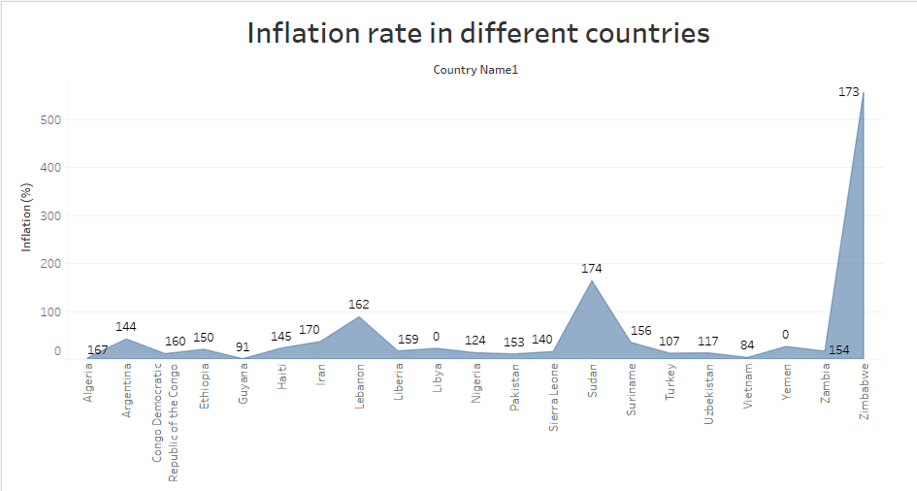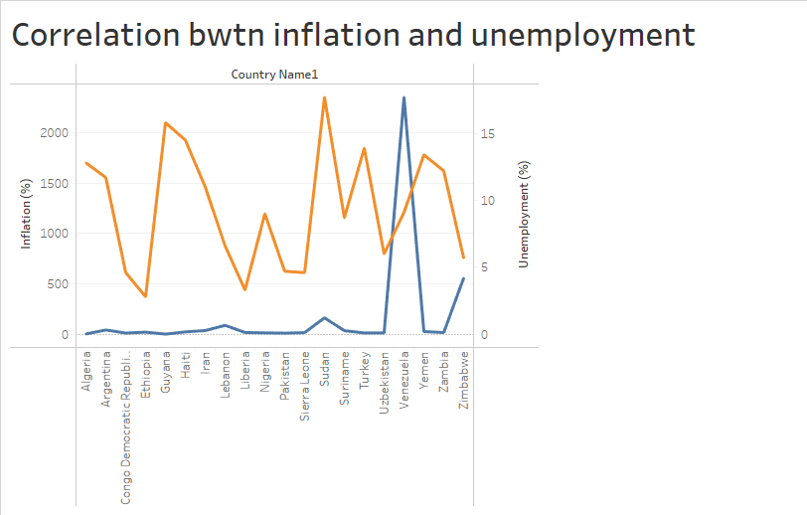

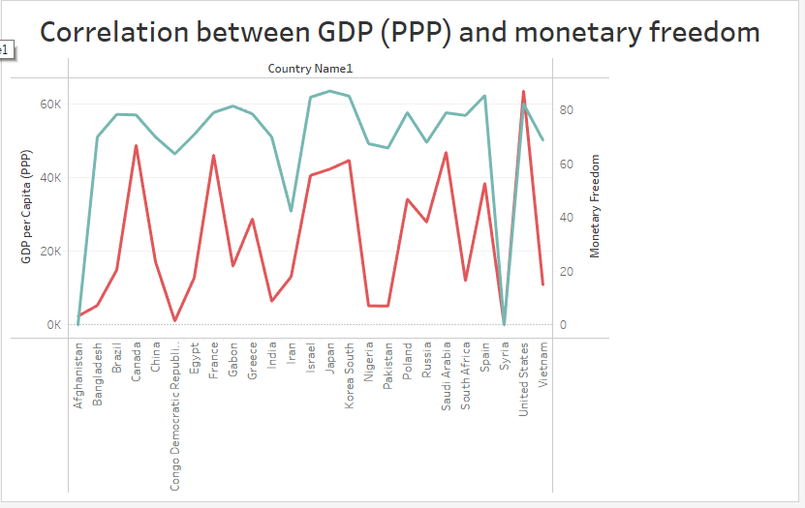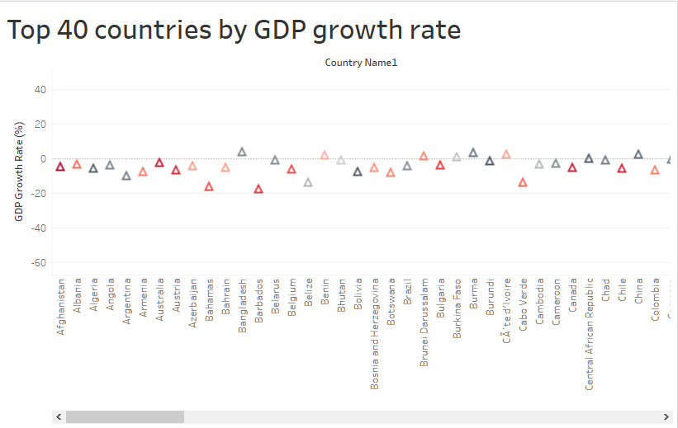

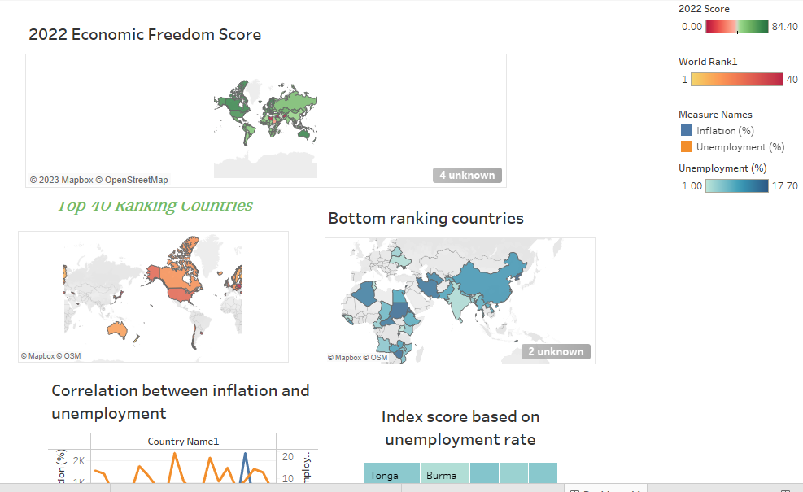

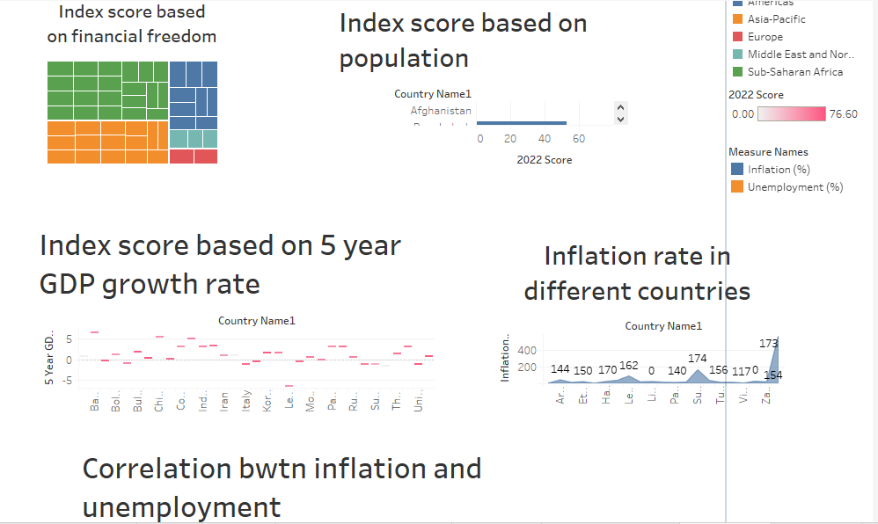

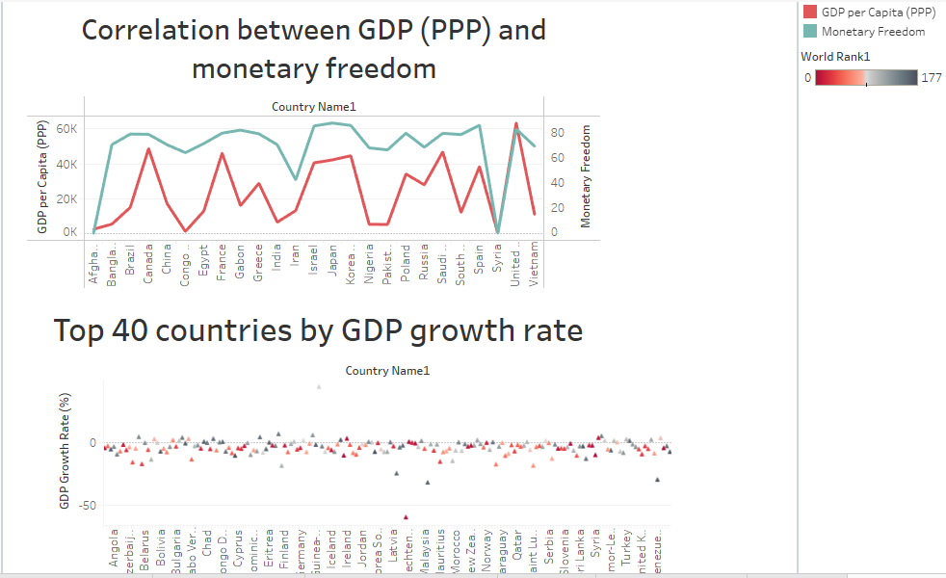

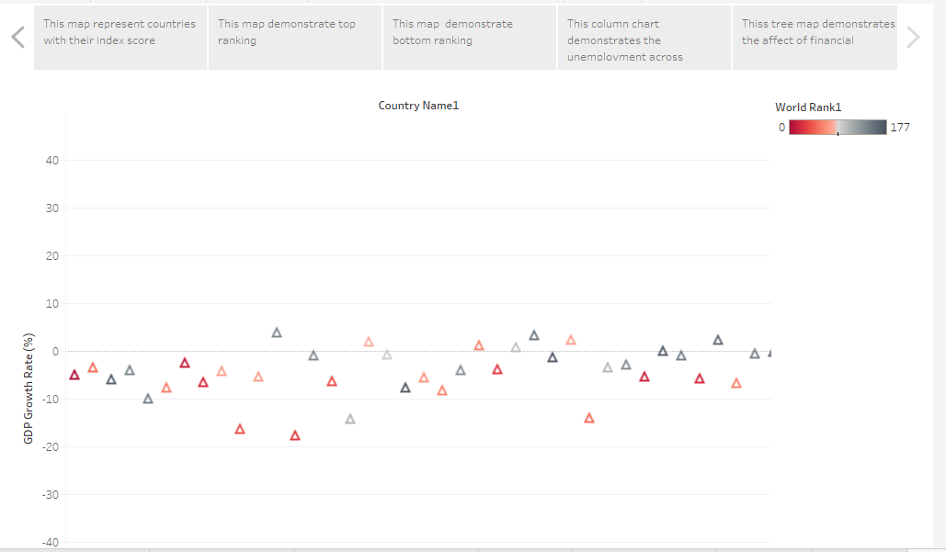

**4.ADVANTAGES AND DISADVANTAGES:**

**ADVANTAGES:**

A useful and intuitive definition of ( economic freedom ) is the freedom to buy from, or sell to, a willing counterparty. A society based on economic freedom is a free-market society.

The most obvious benefit of economic freedom is that, as a system, it is the most conducive to wide spread prosperity , that is , to high or rising income and consumption for the bulk of the population.

There is a positive correlation between economic freedom and a country’s overall prosperity and growth rate due to economic development. Free countries with market

economics tend to have a greater wealth per capita, cleaner environments, higher life expectancy, and less poverty.

The ideals of economic freedom are strongly associated with healthier societies, cleaner environments, grater per capita wealth, human development, democracy, and poverty elimination.

**DISADVANTAGES:**

* Poor quality. Since profit maximization is the biggest motivation for firms , they may try to reduce their costs unethically.
* Merit goods. Goods and services that are not profitable will not be produced or run.
* Excessive power of firms.
* Unemployment and inequality.
* Promote the idea of monopolization.
* Poor working conditions.
* Limited product choices.
* Reduced social safety net.
* Exploitation of consumers.

**5.CONCLUSION**

Scholars from the Fraser institutive and elsewhere, on the other hand, have marshalled enormous amounts of data to study the impacts from economic liberty. They behind by looking at freedom levels in different nations, and researches found associations between countries freedom scores and measures of wellbeing

More recently, and including this study, scholars have begun to find similar positive outcomes between where local government rank in indices of economic liberty and important metrics such as income, employment population growth.

In conclusion, all the economic systems are designed to manage the production, consumption, and distribution of goods and services; they simply have varying degrees of control along the economic spectrum. If the rate of the employment rate and can employment, increased, it positively affects the sector of economic stability of the country. It can also help to make the people of India more self-sufficient and increase economic inequality.

**6. Future scope:**

A develop economy means an economy(country) with high level of economic activity characterized by high per capita income or per capita gross domestic product(GDP), high level of industrialization, developed infrastructure, technological advancement, and a relatively high rank in human development, health.