



Sample Questions
Part 1

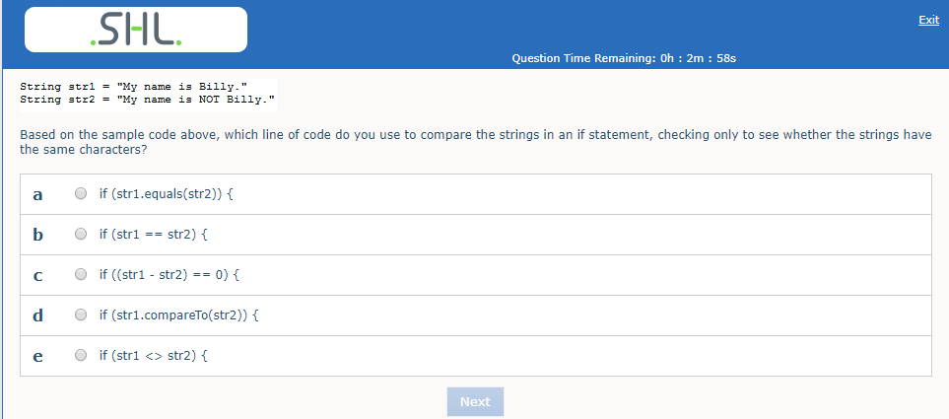

ANSWER : (d)
https://www.tutorialspoint.com/Java-Program-to-Compare-Strings

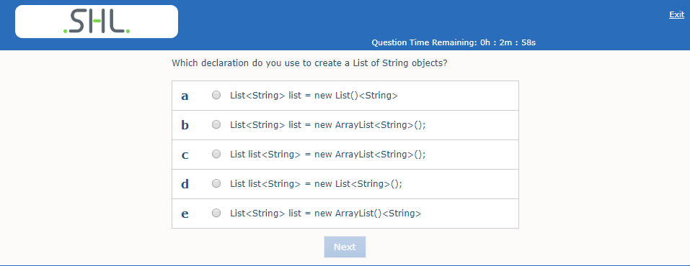

ANSWER: Ans is (b)

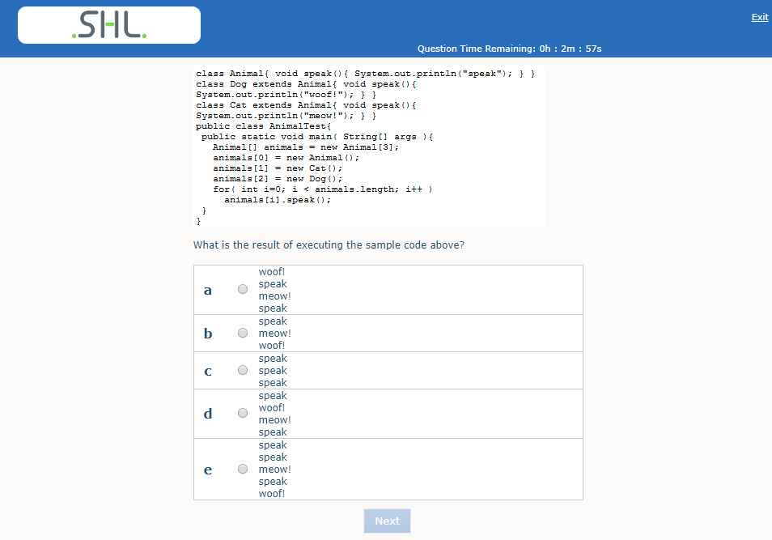

ANSWER : (b)
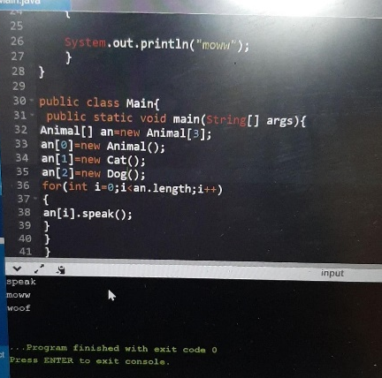
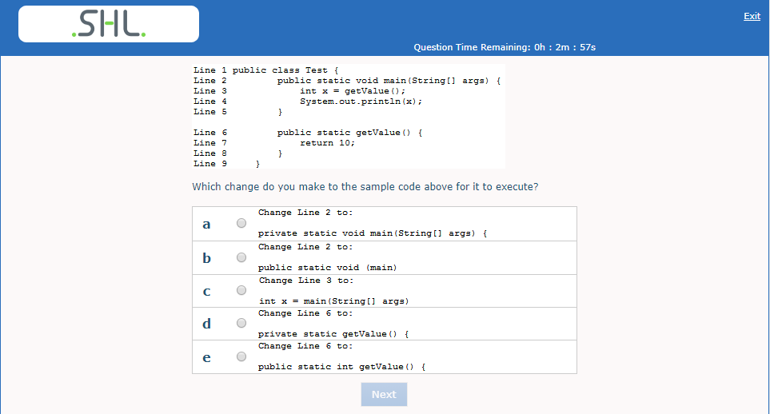

ANSWER: (e)

- 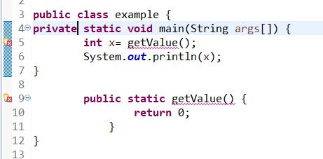= ERROR

- Syntax error

- Syntax

- 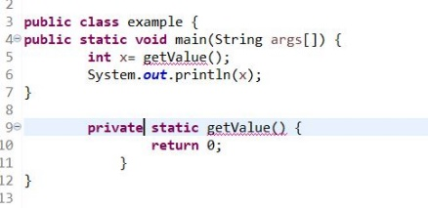

- 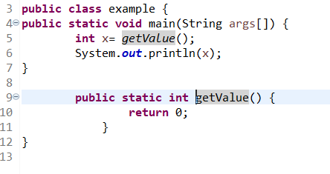

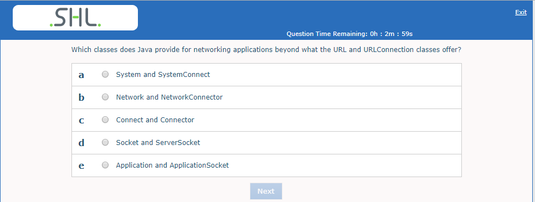

ANSWER: (d)
https://www.tutorialspoint.com/java/java_networking.htm

The java.net.Socket class represents a socket, and the java.net.ServerSocket class provides a mechanism for the server program to listen for clients and establish connections with them.

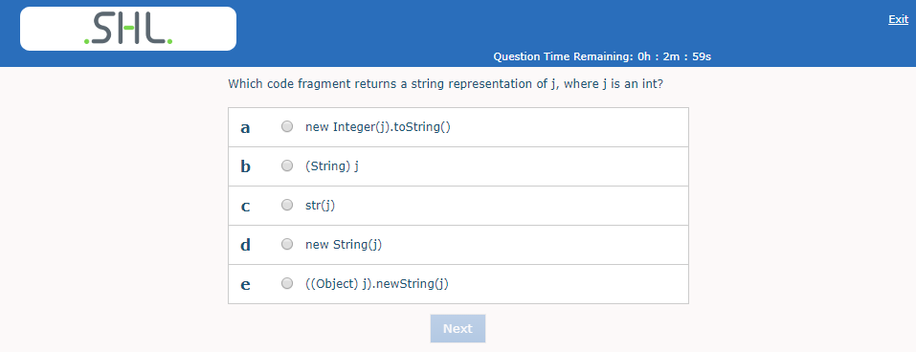

ANSWER: (a)

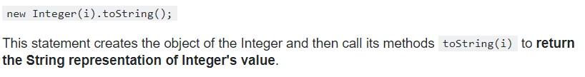

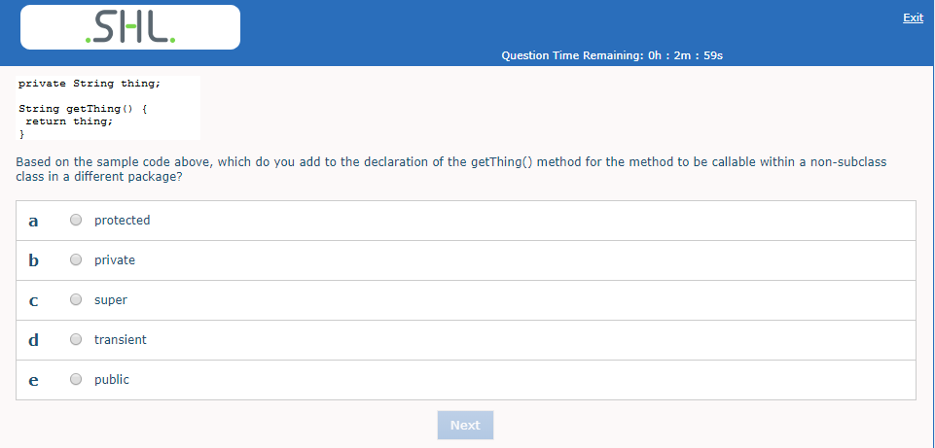

ANSWER: (e )
https://www.geeksforgeeks.org/access-modifiers-java/
As only public is accesible any where .

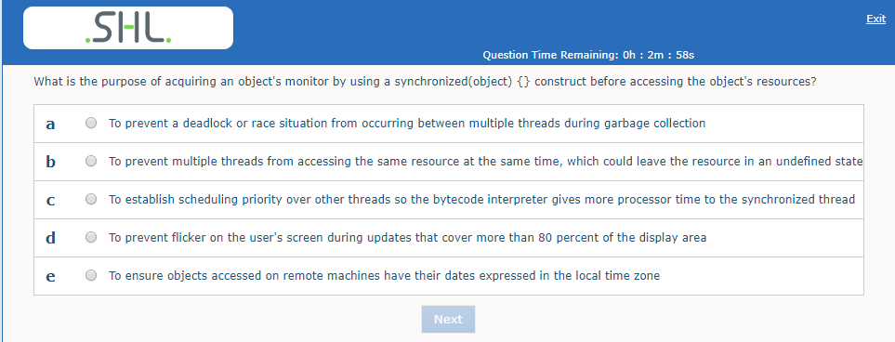
ANSWER : (b)

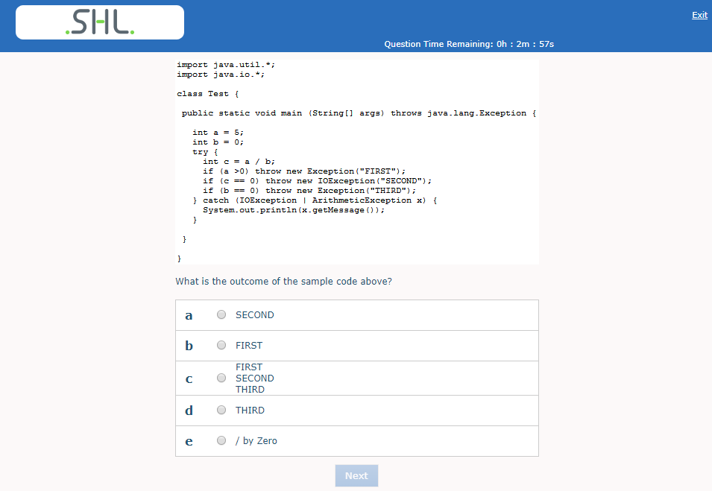
ANSWER : ( e )

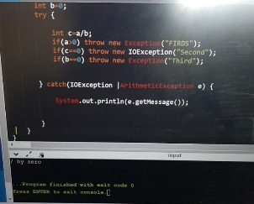

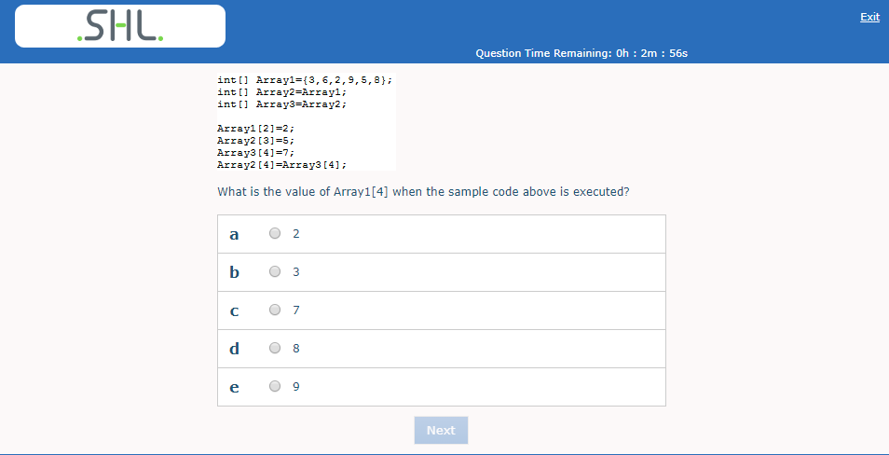

ANSWER : (c )
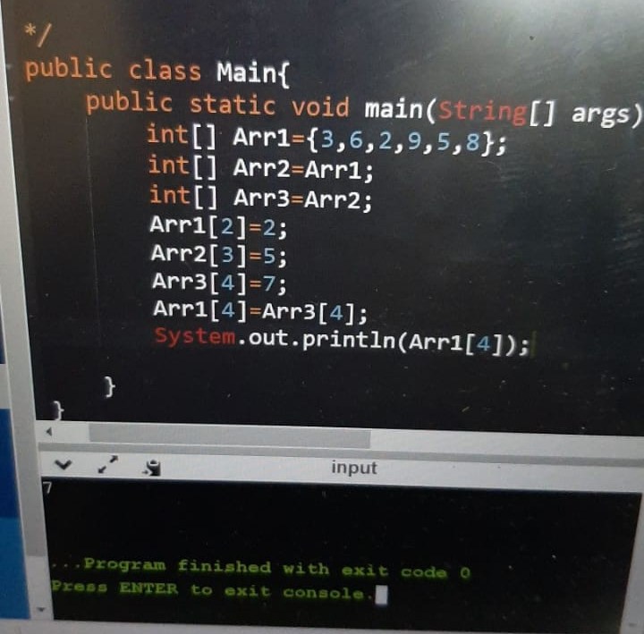

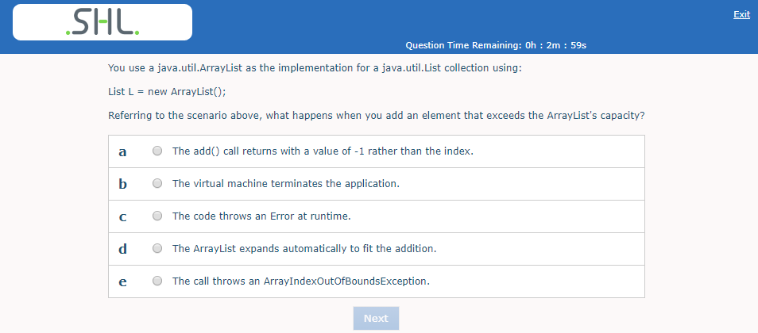

ANSWER: (d)

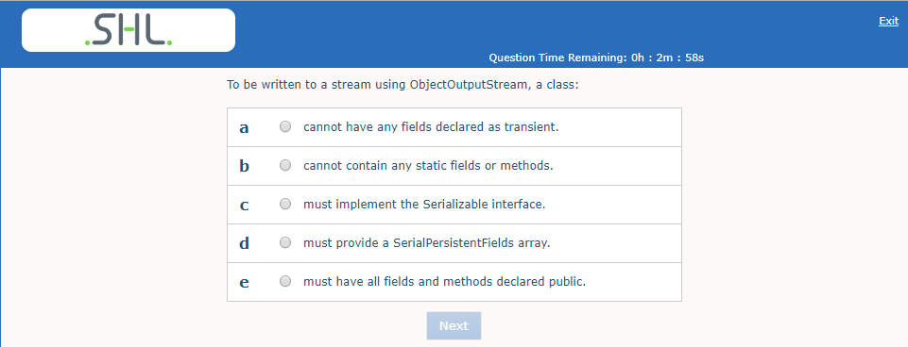

ANSWER: (c )

All fields and methods in the class must be declared public

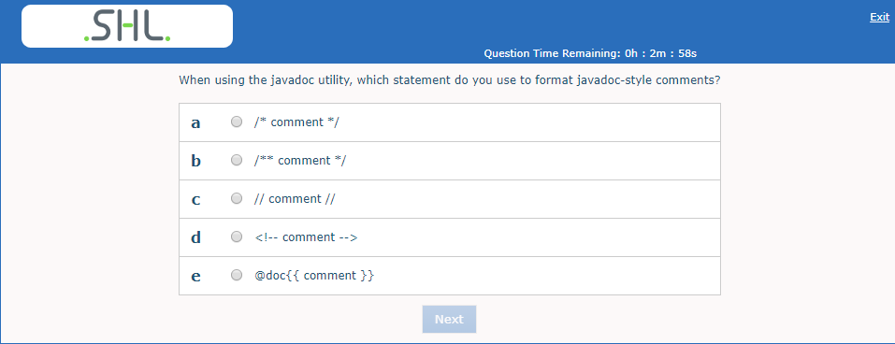

ANSWER: (b)

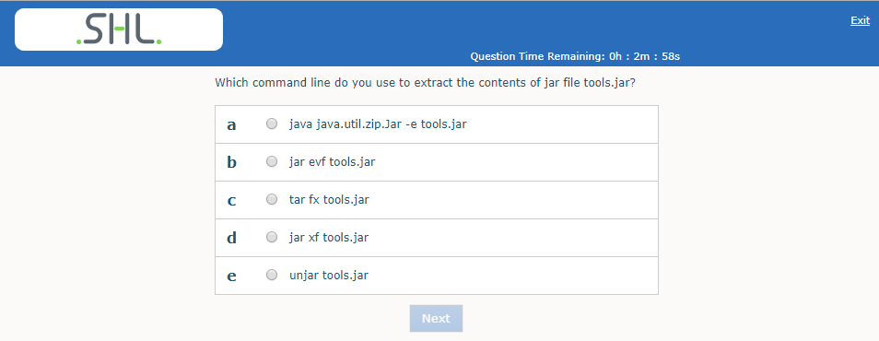

ANSWER: (d)
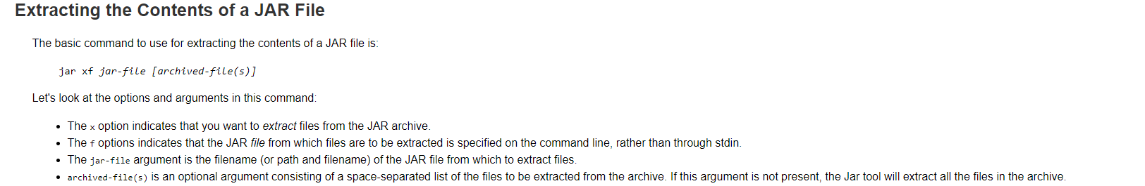

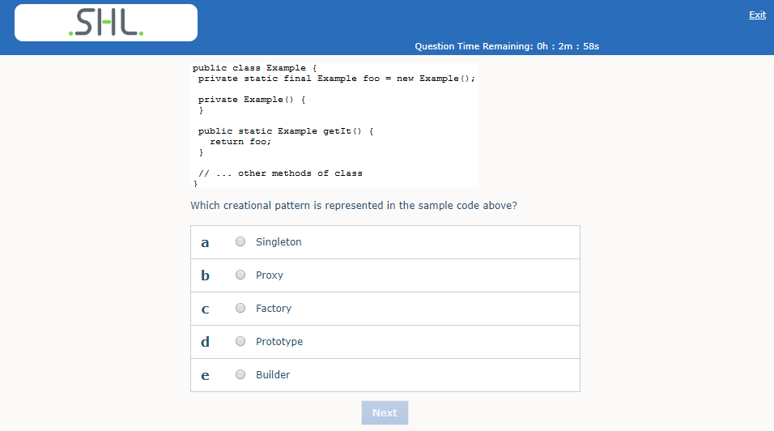
ANSWER : (a )
https://www.vogella.com/tutorials/DesignPatternSingleton/article.html

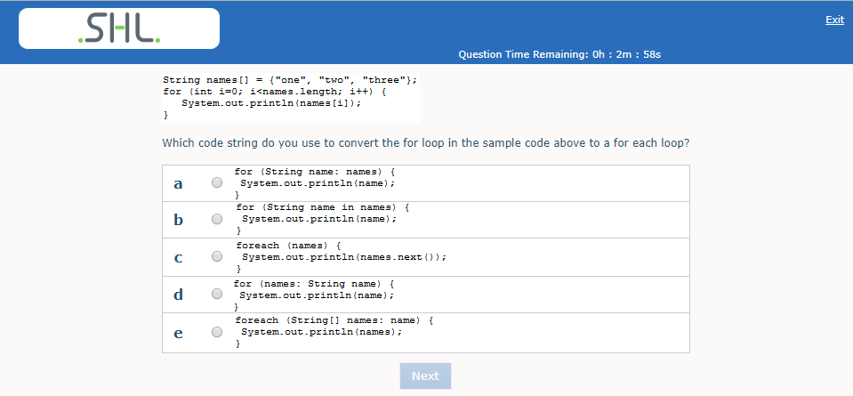
ANSWER: (a)
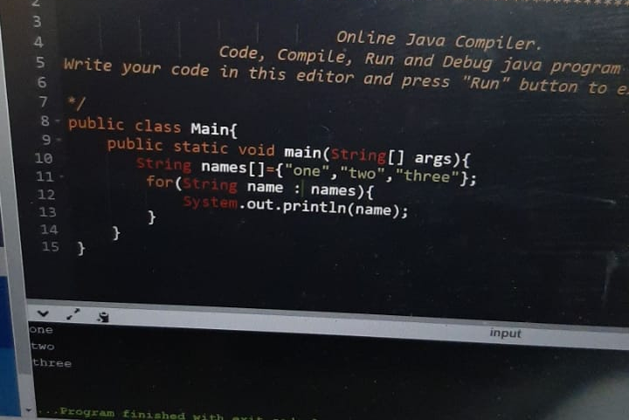

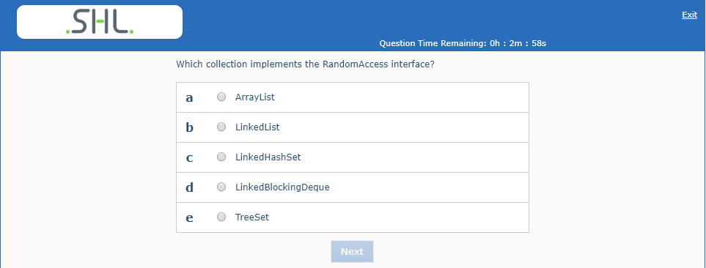
ANSWER: (a)
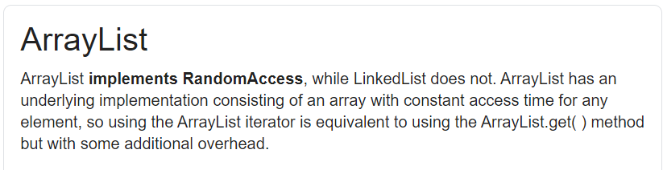

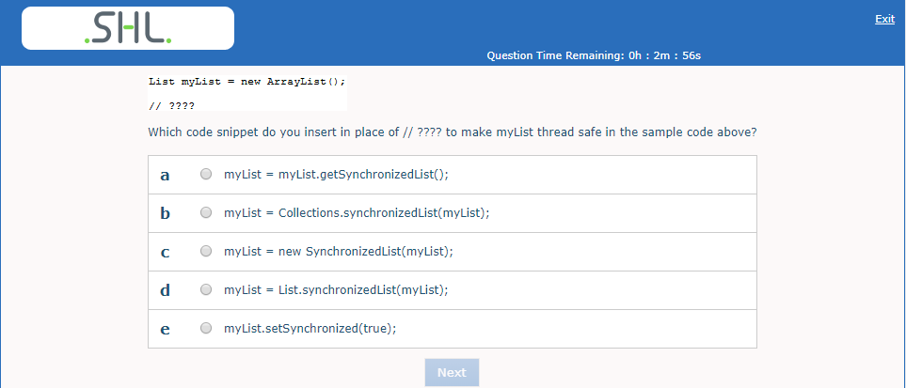
ANSWER: (b)
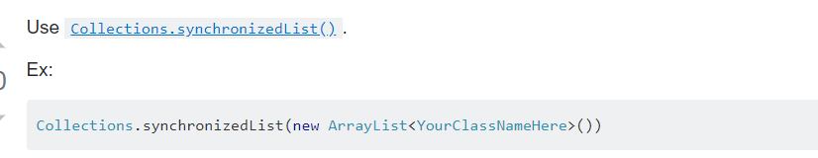

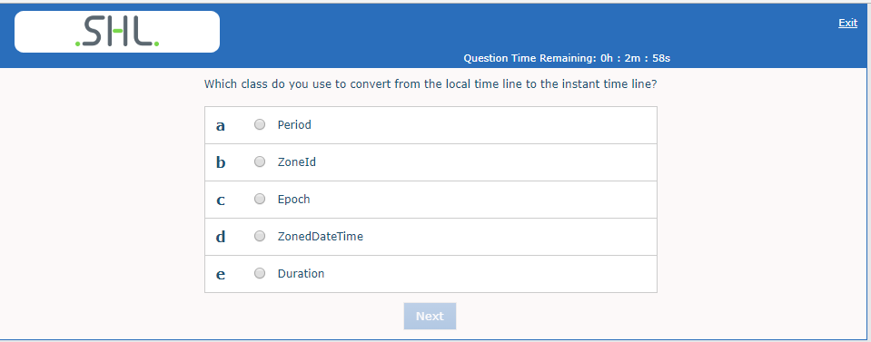
ANSWER: (d)
https://www.threeten.org/articles/zoned-date-time.html

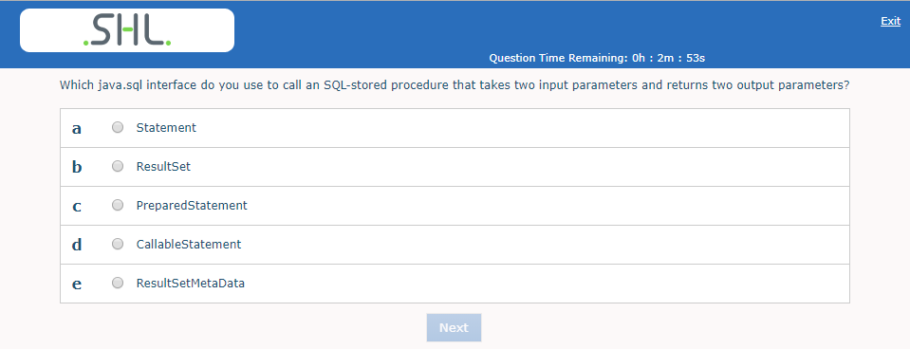

ANSWER: (d)

https://javaconceptoftheday.com/java-callablestatement-stored-procedures-in-out-parameters-examples/

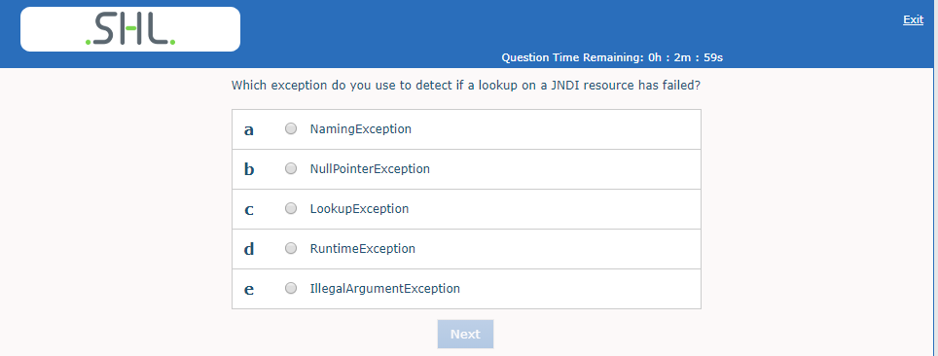

ANSWER: (a)
https://www.ibm.com/support/pages/javaxnamingnamingexception-name-compenvjdbc-not-found-context-java

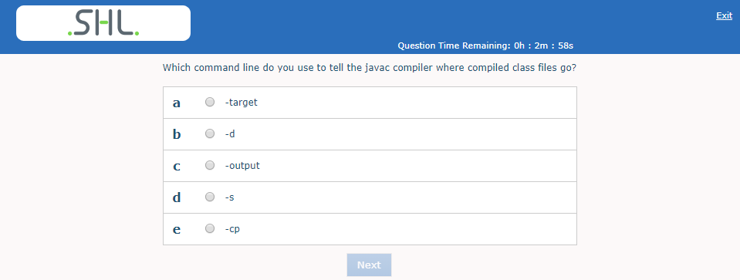

ANSWER: (b)
https://docs.oracle.com/javase/7/docs/technotes/tools/windows/javac.html

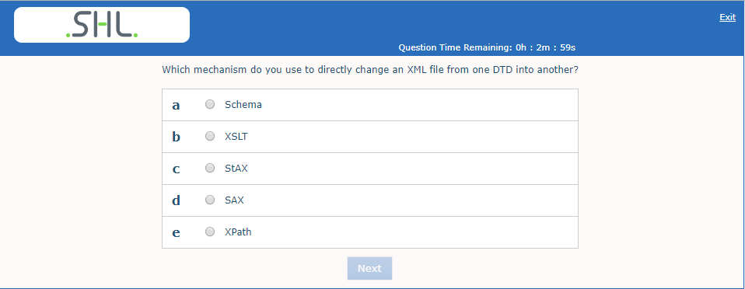

ANSWER: (b)
https://www.geeksforgeeks.org/displaying-xml-using-xslt/

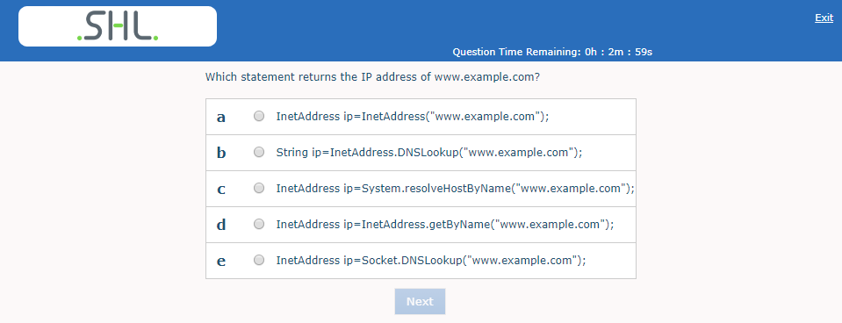

ANSWER:
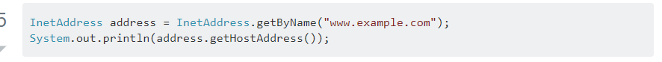

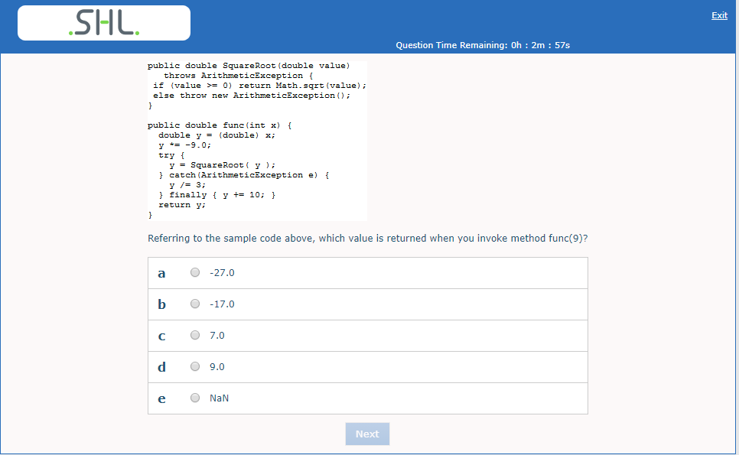

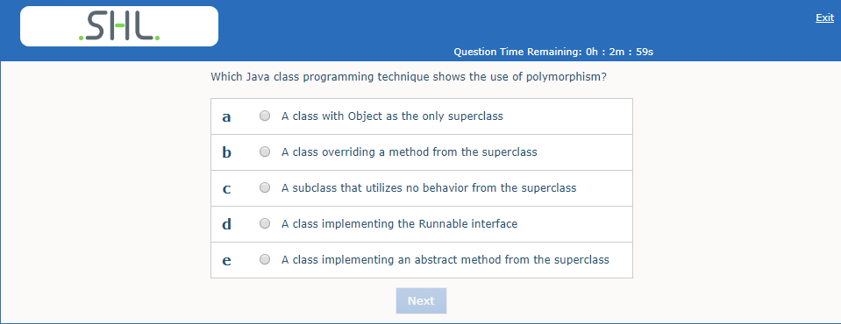

ANSWER: (b)

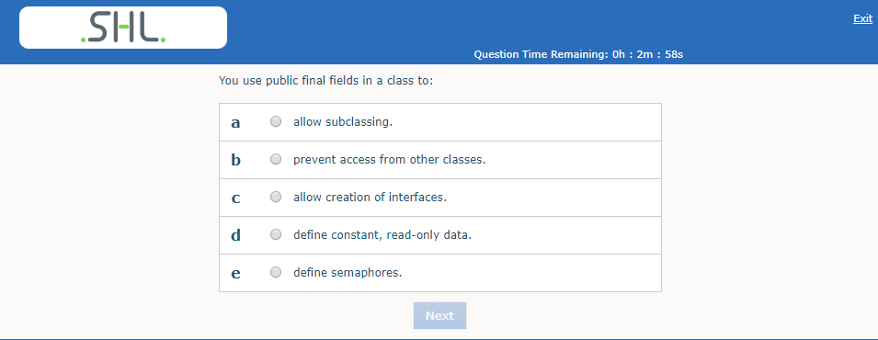
ANSWER: (b)

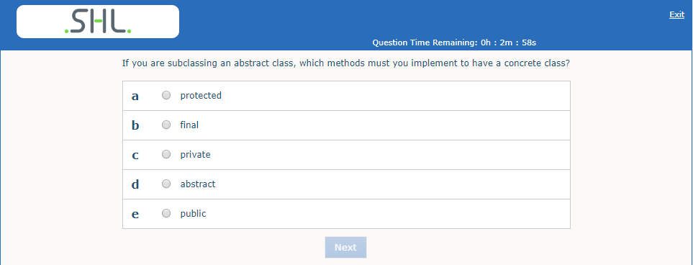
ANSWER: (d)
https://www.geeksforgeeks.org/difference-between-abstract-class-and-concrete-class-in-java/

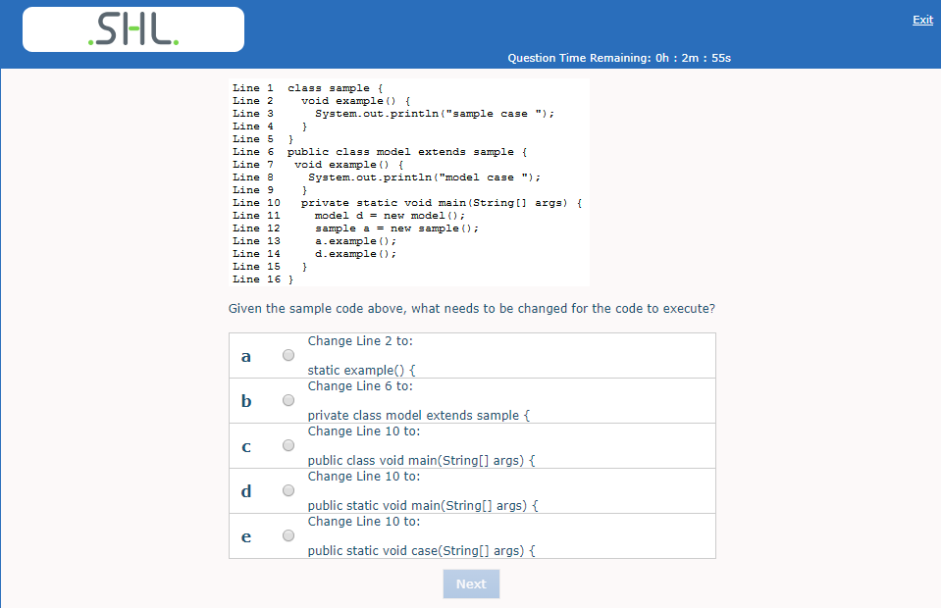
ANSWER:
- 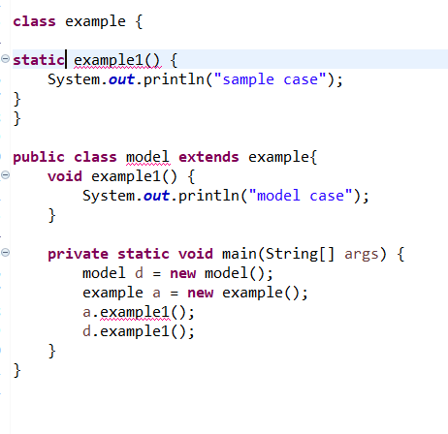
- 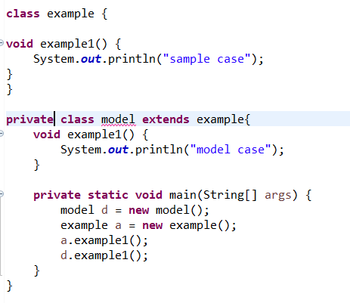
- A
- 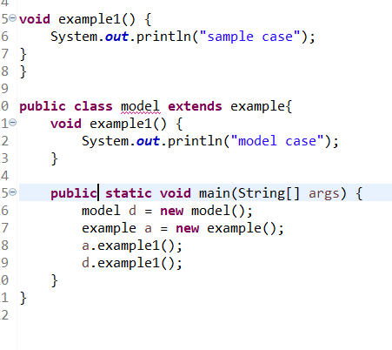

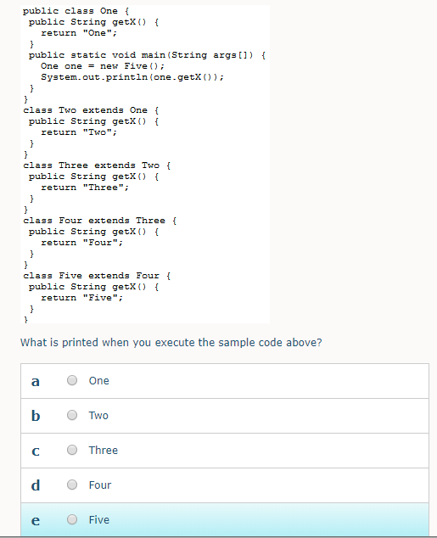

ANSWER: (a)

