PROJECT REPORT
on
Student Attendance Management
Mobile Application
React Native and Kotlin for Mobile Application Development
Master of Computer Applications
Submitted by
Ashika
NN25MCA018
Jescil Jimmy
NN25MCA053
Submitted To
Ms. Ashwini K.M.

(An off-Campus Institution of Nitte (Deemed to be University), MANGALORE)
Nitte Mahalinga Adyanthaya Memorial Institute of Technology
Nitte – 574110, Karkala, Udupi District
2026-27

1. Introduction
The Student Attendance Management Mobile Application is a cross-platform application built with React Native and Expo to digitize attendance management in colleges. Traditional paper registers are time-consuming, hard to maintain and prone to calculation errors, and finding students who fall short of the minimum attendance requires extra effort.
The proposed application lets professors register students, organize them by class or batch, record daily attendance as Present, Absent or Late with a single tap, and view automatically calculated attendance percentages. It identifies defaulters, ranks students, produces date-wise reports and shares summaries through the device’s native sharing options. Its offline-first design stores all data locally using AsyncStorage, so the core features work without internet and need no cloud server.
2. Requirements Specification
2.1 Functional Requirements
- Student management: add, view, edit, delete, search (name or roll number) and filter by class or batch.
- Daily attendance: select a date (with previous/next navigation) and mark each student P, A or L; bulk actions Mark All Present, Mark All Absent and Clear; live session counters.
- Percentage calculation: Attendance % = ((Present + 0.5 × Late) / Total Sessions) × 100, recalculated whenever records change.
- Defaulter identification: Safe (75% and above), Warning (65% to below 75%) and Critical (below 65%), with the number of consecutive lectures needed to reach 75%.
- Reports and analytics: date-wise reports, filtering by status, student rankings and shareable formatted summaries.
- Data storage: local persistence with schema versioning and a demo-data generator for testing.
2.2 Non-Functional Requirements
- Usability: a simple interface that lets attendance for a class be marked within a minute.
- Availability: core features must work fully offline.
- Performance: instant percentage updates and smooth list scrolling for typical class sizes.
- Portability: a single codebase for Android, iOS and supported web environments.
- Reliability: records must persist across app restarts and be migrated safely when the data structure changes.
2.3 Hardware and Software Requirements
Component | Specification
Development machine | Windows / macOS / Linux, minimum 8 GB RAM, Node.js (LTS)
Target device | Android or iOS smartphone, or a modern web browser
Framework and language | React Native, Expo, JavaScript (ES6+)
Libraries | React Navigation (tabs and stack), AsyncStorage
Tools | VS Code, Expo Go, Git
3. Design
3.1 System Architecture
The application follows a layered, offline-first architecture. The Presentation layer contains the React Native screens and components. The Navigation layer uses React Navigation to organize screens through bottom tabs (Students, Attendance, Reports) and stack navigation for detail and edit views. The Business Logic layer holds utility functions for percentage calculation, status classification and report formatting. The Storage layer wraps AsyncStorage and handles saving, loading and schema migration.
3.2 Module Design
Module | Responsibility
Student Directory | Add, edit, delete, search and filter student records
Daily Attendance | Date selection, P/A/L marking, bulk actions, live counters
Percentage Engine | Weighted attendance calculation for every student
Defaulter Module | Safe/Warning/Critical classification and lectures-needed estimate
Analytics and Reports | Date-wise reports, rankings, status filters, shareable summaries
Storage and Sharing | AsyncStorage persistence, migration, demo data, native share sheet
3.3 Data Design
Data is stored as JSON under a single versioned key. Students are kept as an array and attendance as sessions keyed by date, each mapping a student ID to a status code.
Entity | Fields
Student | id, rollNo, name, batch, gender, email, phone
Session (by date) | date → { studentId: "P" | "A" | "L" }
Stats (derived) | present, absent, late, total, percentage, status
3.4 Workflow
The professor registers students once, opens the Attendance tab, picks a date, marks statuses (or uses a bulk action) and saves. The percentage engine recomputes cumulative statistics from the stored sessions, which update the defaulter list, rankings and reports. Summaries can then be shared through WhatsApp, Gmail or Notes.
4. Code
4.1 storage.js – local persistence (AsyncStorage)
import AsyncStorage from '@react-native-async-storage/async-storage';

const KEY = 'attendance_app_v1';
const EMPTY = { version: 1, students: [], sessions: {} };

export async function loadData() {
try {
const raw = await AsyncStorage.getItem(KEY);
return raw ? JSON.parse(raw) : { ...EMPTY };
} catch (e) {
return { ...EMPTY };
}
}

export async function saveData(data) {
await AsyncStorage.setItem(KEY, JSON.stringify(data));
}

export async function addStudent(student) {
const data = await loadData();
data.students.push({ id: Date.now().toString(), ...student });
await saveData(data);
}
4.2 utils/attendance.js – percentage, status and report logic
// Present = 1 unit, Late = 0.5 unit, Absent = 0
export const calcPercentage = (present, late, total) =>
total === 0 ? 0 : ((present + 0.5 * late) / total) * 100;

export const getStatus = (pct) =>
pct >= 75 ? 'Safe' : pct >= 65 ? 'Warning' : 'Critical';

export function studentStats(studentId, sessions) {
let p = 0, a = 0, l = 0;
Object.values(sessions).forEach((day) => {
const s = day[studentId];
if (s === 'P') p++;
else if (s === 'A') a++;
else if (s === 'L') l++;
});
const total = p + a + l;
const pct = calcPercentage(p, l, total);
return { p, a, l, total, pct, status: getStatus(pct) };
}

// Consecutive lectures to attend to reach the target percentage
export function lecturesNeeded(p, l, total, target = 75) {
const weighted = p + 0.5 * l;
let n = 0;
while (((weighted + n) / (total + n)) * 100 < target) n++;
return n;
}

export function buildSummary(students, sessions) {
const rows = students
.map((s) => ({ ...s, ...studentStats(s.id, sessions) }))
.sort((x, y) => y.pct - x.pct);
return rows
.map((r, i) => `${i + 1}. ${r.rollNo} ${r.name} - ${r.pct.toFixed(1)}% (${r.status})`)
.join('\n');
}
4.3 screens/AttendanceScreen.js – daily attendance register
import React, { useState, useEffect } from 'react';
import { View, Text, FlatList, TouchableOpacity, Share } from 'react-native';
import { loadData, saveData } from '../storage';
import { buildSummary } from '../utils/attendance';

const today = () => new Date().toISOString().slice(0, 10);
const shiftDay = (d, n) => {
const x = new Date(d); x.setDate(x.getDate() + n);
return x.toISOString().slice(0, 10);
};

export default function AttendanceScreen() {
const [date, setDate] = useState(today());
const [students, setStudents] = useState([]);
const [marks, setMarks] = useState({});

useEffect(() => {
loadData().then((d) => {
setStudents(d.students);
setMarks(d.sessions[date] || {});
});
}, [date]);

const mark = (id, status) => setMarks((m) => ({ ...m, [id]: status }));
const markAll = (status) =>
setMarks(Object.fromEntries(students.map((s) => [s.id, status])));

const save = async () => {
const d = await loadData();
d.sessions[date] = marks;
await saveData(d);
};

const share = async () => {
const d = await loadData();
await Share.share({ message: buildSummary(d.students, d.sessions) });
};

const count = (c) => Object.values(marks).filter((v) => v === c).length;

const Btn = ({ label, onPress }) => (
<TouchableOpacity onPress={onPress}><Text>{label}</Text></TouchableOpacity>
);

return (
<View>
<Text>{date} P:{count('P')} A:{count('A')} L:{count('L')}</Text>
<Btn label="Prev" onPress={() => setDate(shiftDay(date, -1))} />
<Btn label="Next" onPress={() => setDate(shiftDay(date, 1))} />
<Btn label="Mark All Present" onPress={() => markAll('P')} />
<Btn label="Mark All Absent" onPress={() => markAll('A')} />
<FlatList
data={students}
keyExtractor={(s) => s.id}
renderItem={({ item }) => (
<View>
<Text>{item.rollNo} {item.name}</Text>
{['P', 'A', 'L'].map((c) => (
<Btn key={c} label={marks[item.id] === c ? '[' + c + ']' : c}
onPress={() => mark(item.id, c)} />
))}
</View>
)}
/>
<Btn label="Save Attendance" onPress={save} />
<Btn label="Share Report" onPress={share} />
</View>
);
}

5. Snapshots
The following snapshots present the responsive mobile application running natively in portrait orientation (viewport 420 × 890 dp) on an Android smartphone. The user interface prioritizes clarity, thumb-accessible controls, real-time visual feedback, and zero-latency performance during classroom roll call marking.
Figure 5.1: Mobile Dashboard  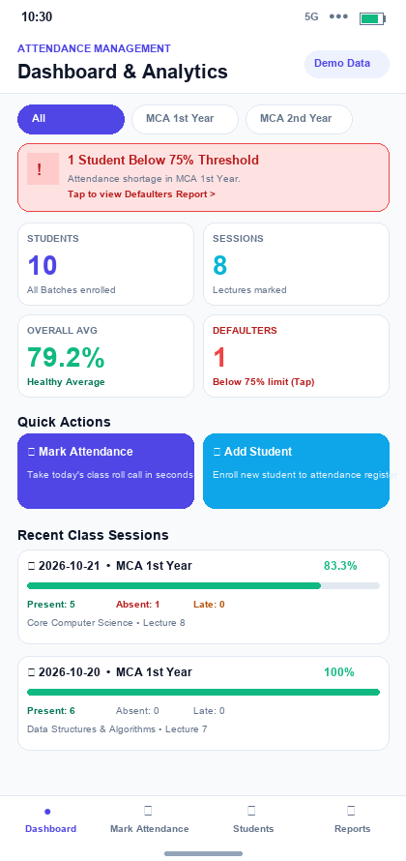  Figure 5.1: Executive Dashboard with Attendance Rate %, Today's Roll Call Status, and Defaulter Alert | Figure 5.2: Student Directory  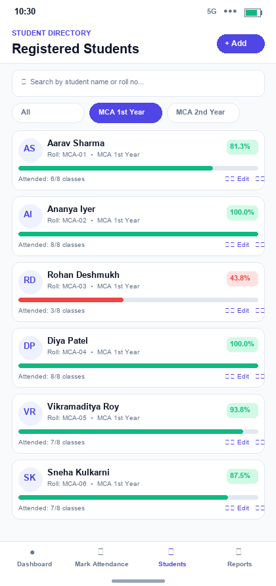  Figure 5.2: Searchable Student Roster with Batch Filter (MCA 2026-27) and Individual Attendance Progress

Figure 5.3: Student Enrollment Form  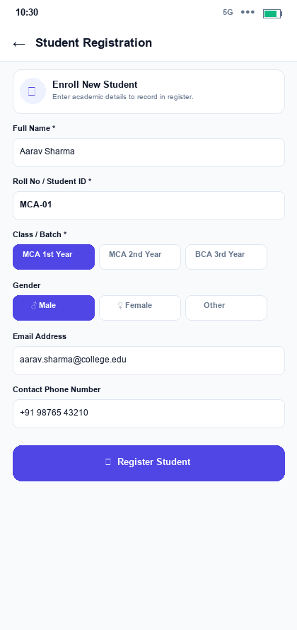  Figure 5.3: Student Registration Form with USN, Roll Number, Section, Gender, and Contact Validation | Figure 5.4: Daily Roll Call Register  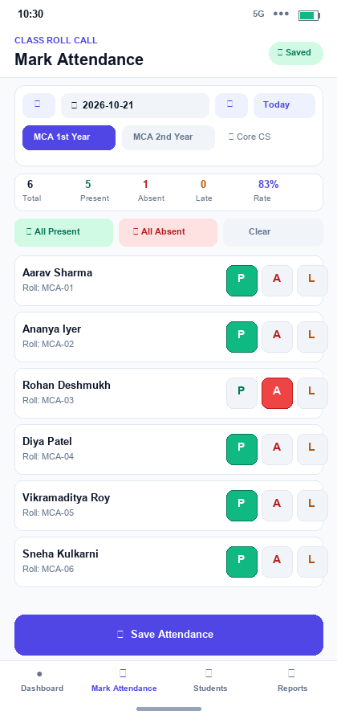  Figure 5.4: Daily Attendance Register with Date Picker, Bulk Actions ('Mark All Present'), and P/A/L Chips

Figure 5.5: Defaulters & Shortage Analysis  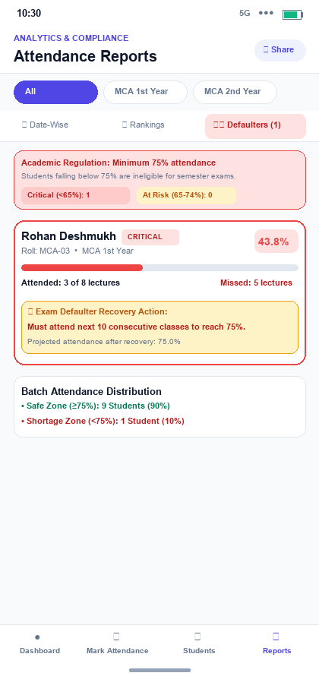  Figure 5.5: Automated Defaulter Tracking with Shortage Severity and 75% Recovery Threshold Calculations | Figure 5.6: Student Profile & History Timeline  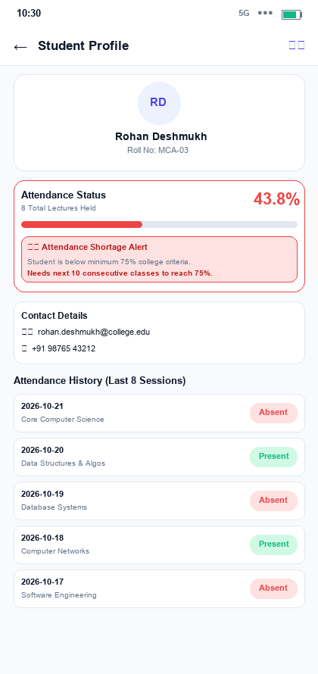  Figure 5.6: Individual Student Dossier with Circular Attendance Gauge, Shortage Banner, and Session Timeline

6. Future Enhancements
- Secure cloud backup and synchronization across multiple devices.
- User authentication with separate roles for professors and administrators.
- Export of attendance reports as PDF and CSV files.
- Timetable integration for automatic session preparation.
- Notifications to inform students about low attendance.
- Configurable attendance thresholds and Late weighting.
- Attendance correction history and audit logs.
- A structured local database (such as SQLite) for larger datasets.
- Secure student and faculty portals.

