Application Feature Planning and Release Governance System (OUTPUT IMAGES)

**MILESTONE 1**
Day 1: Project Setup &amp; Skeleton
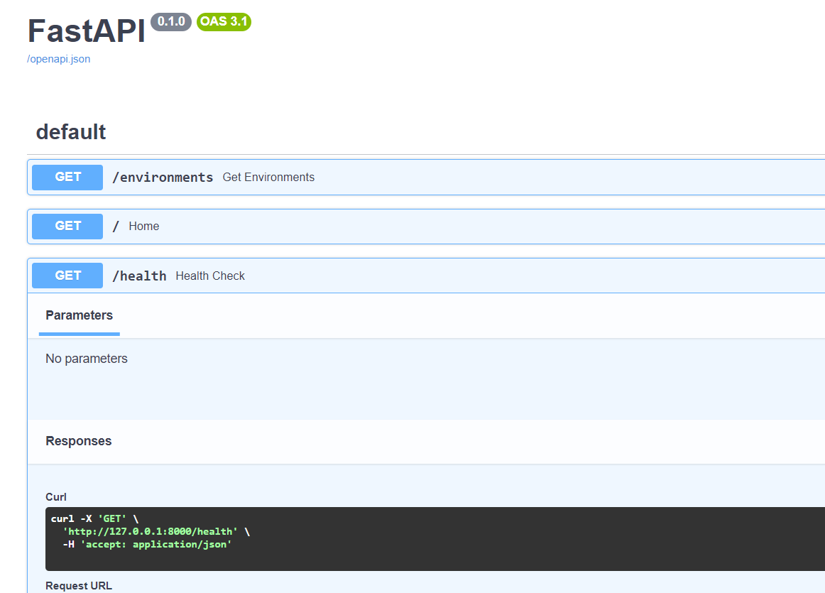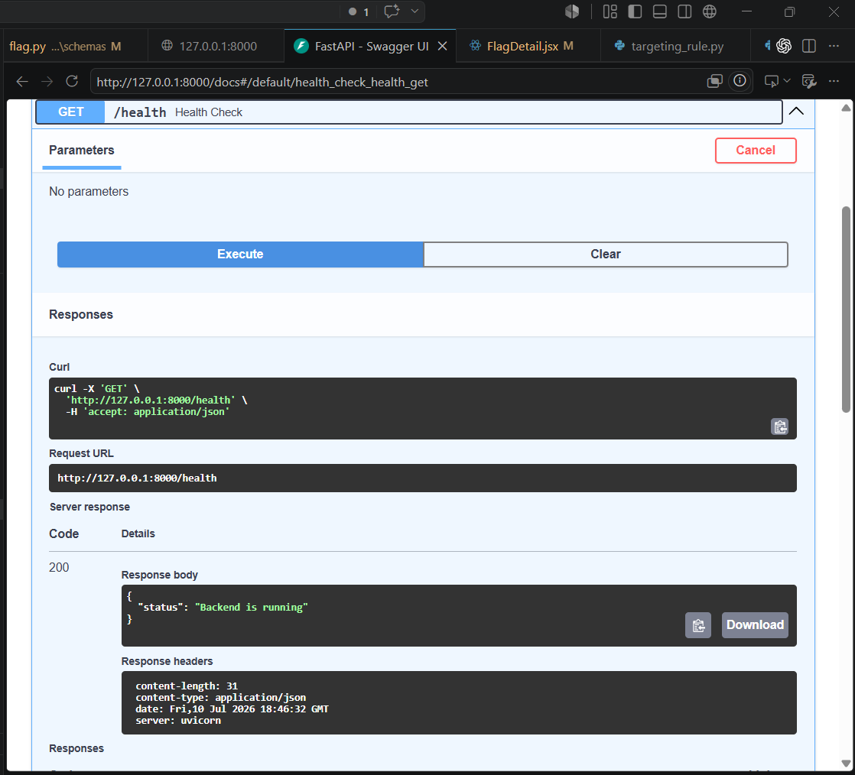

fig:1 Backend health_check

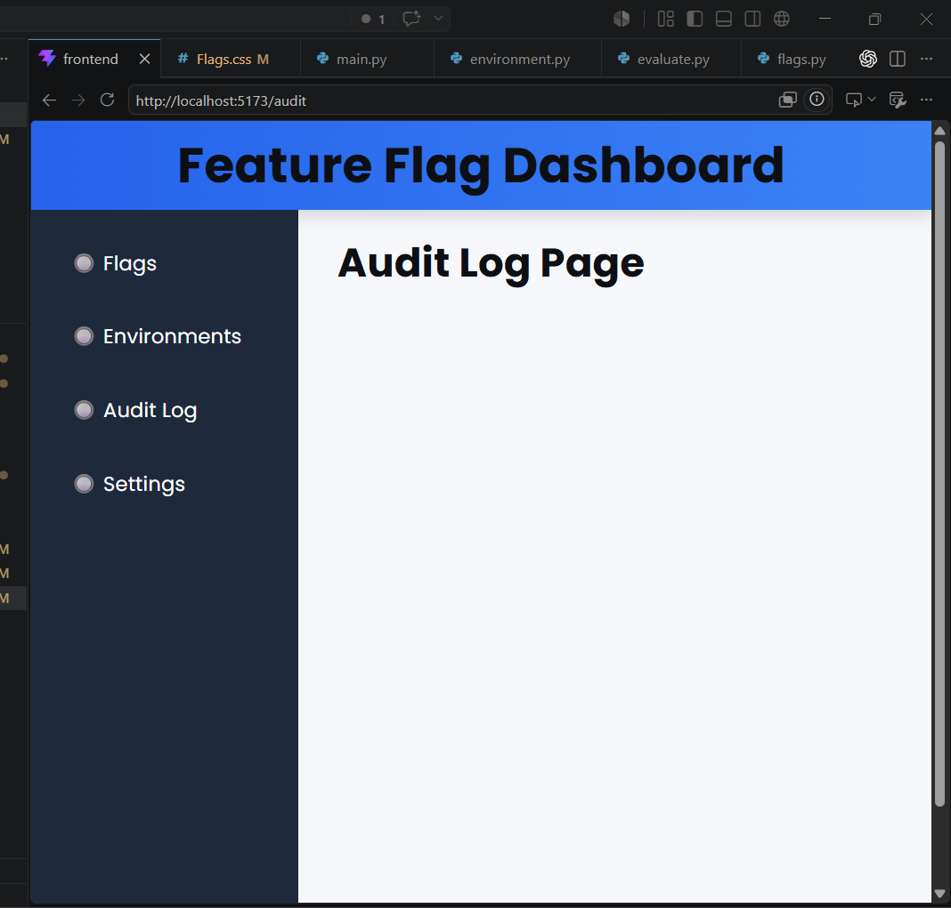
Fig:2 Frontend sidebar layout

Day 2: Database Schema &amp; Environment Switcher

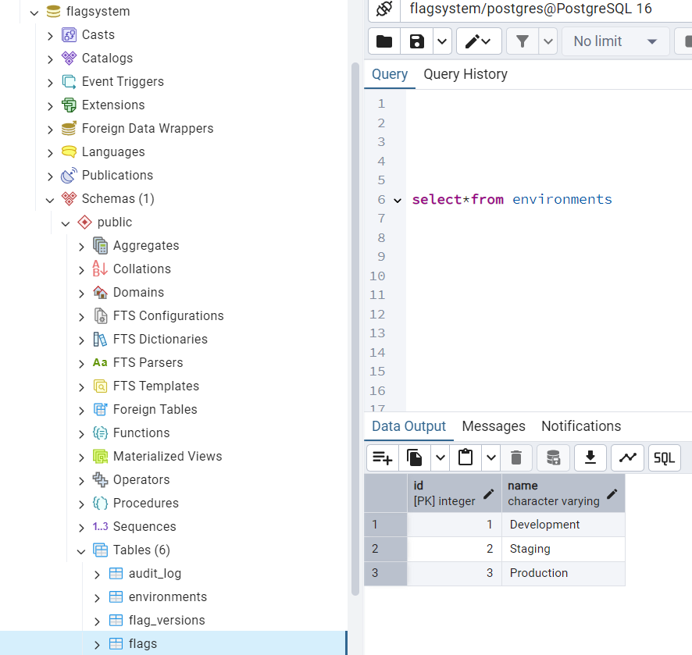
fig:3 Backend Design and create the PostgreSQL tables

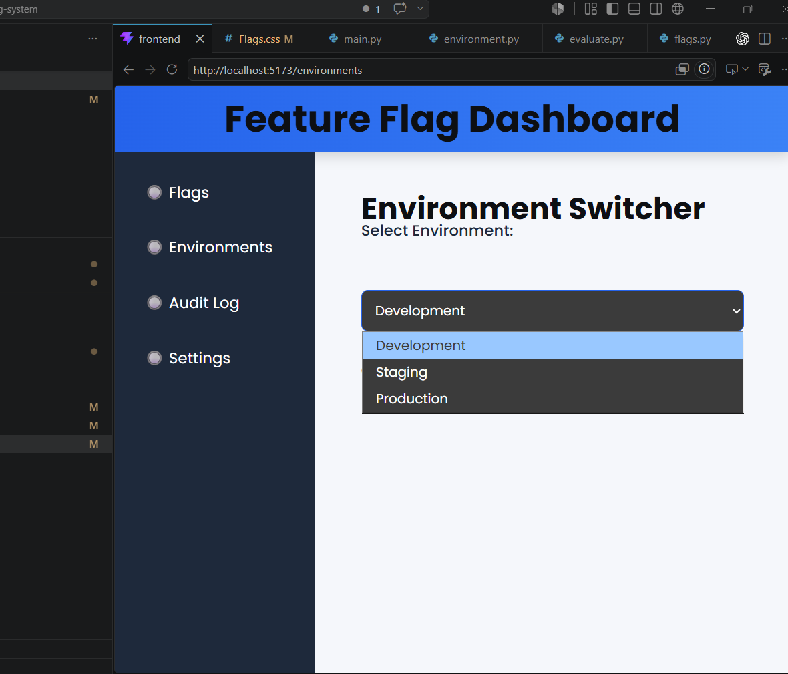

fig:4 Frontend Environment Switcher

Day 3: Flag CRUD API &amp; Flag Table UI

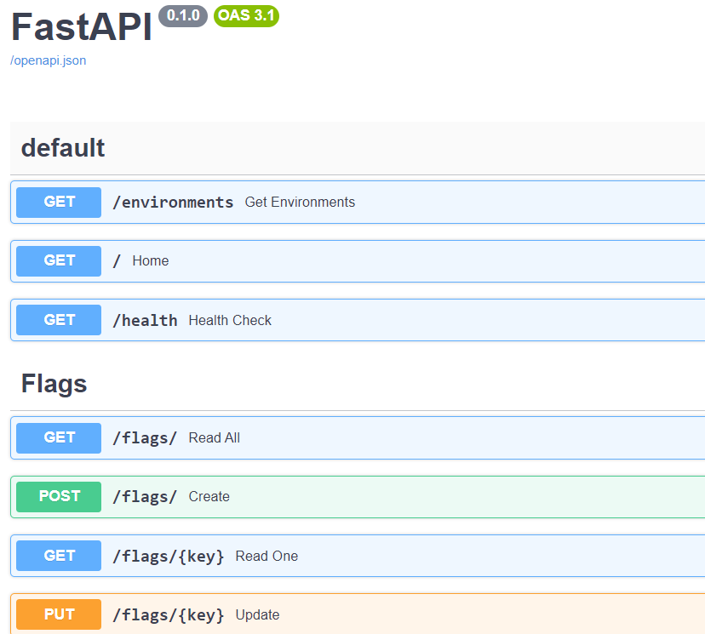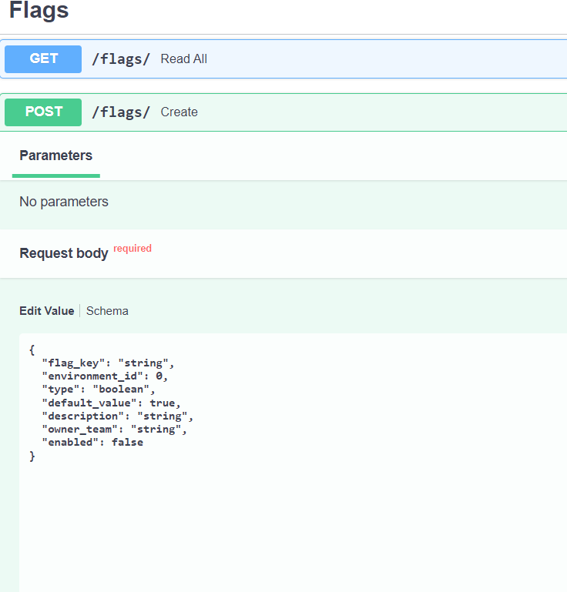

fig:5 Backend Build REST endpoints to create, read, update

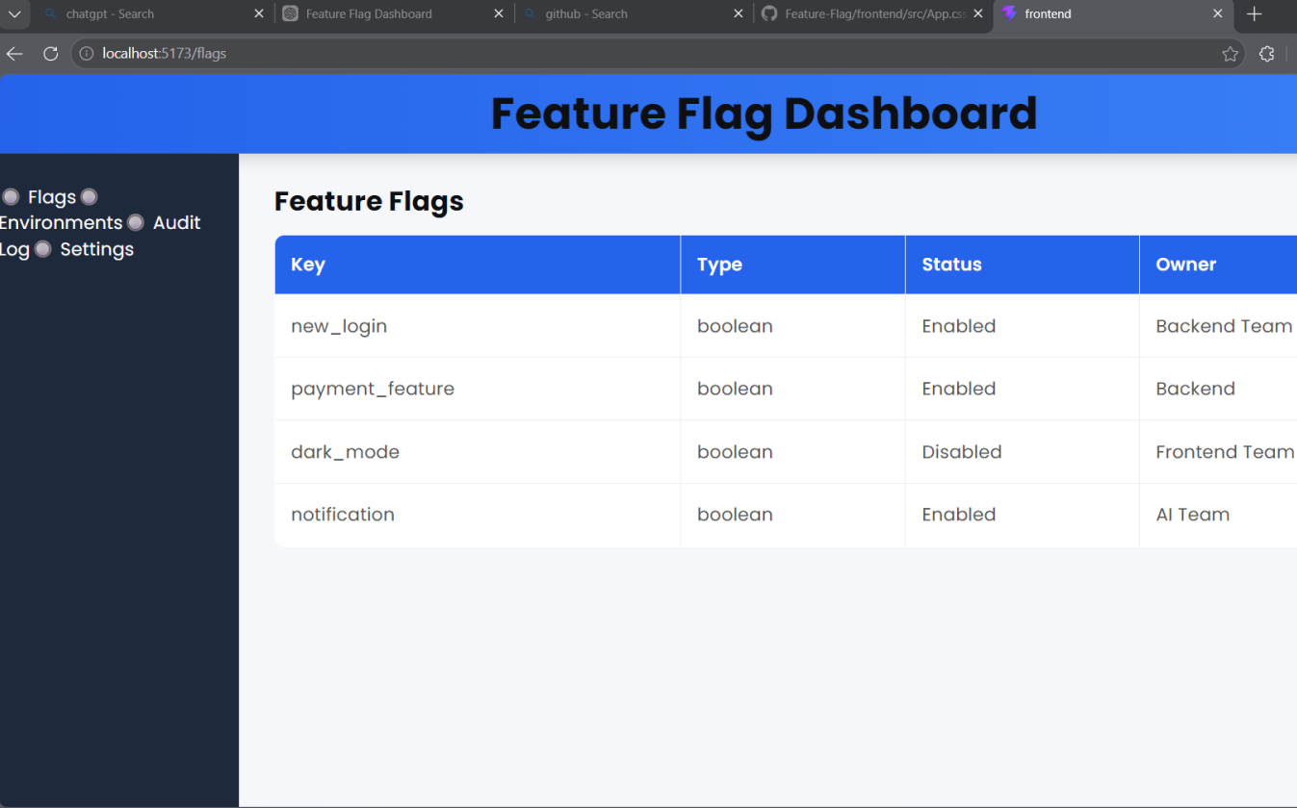

fig:6 Frontend Build the flag management table

Day 4: Core Evaluation Engine &amp; Flag Creation Form

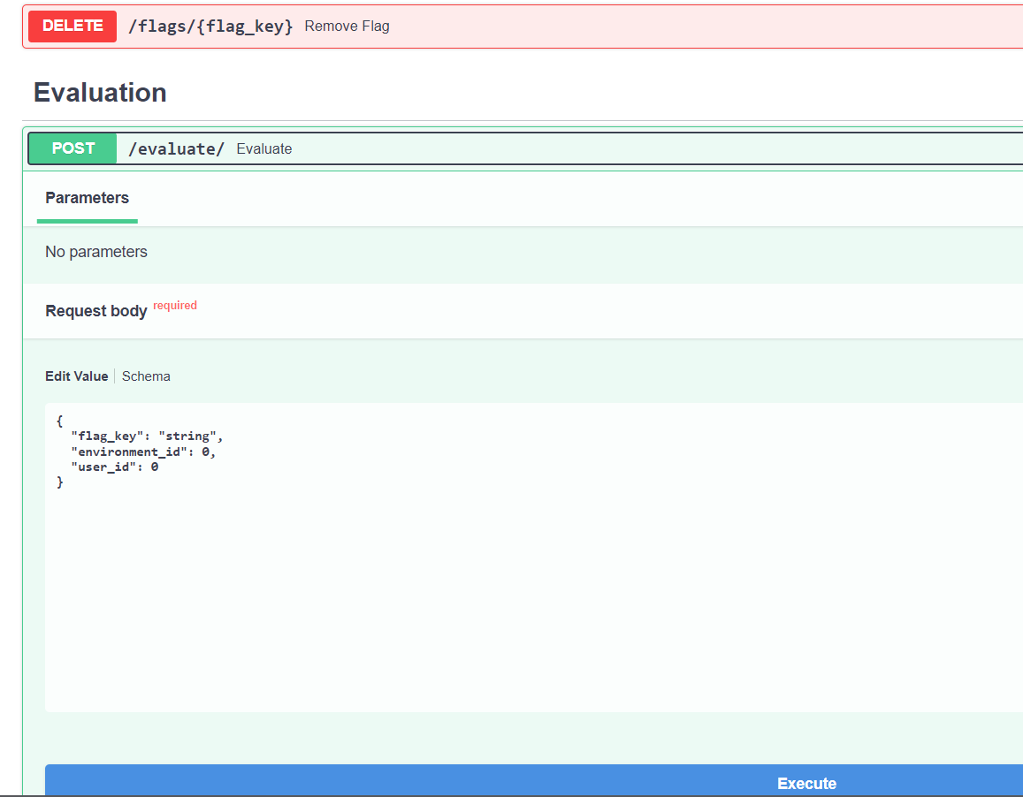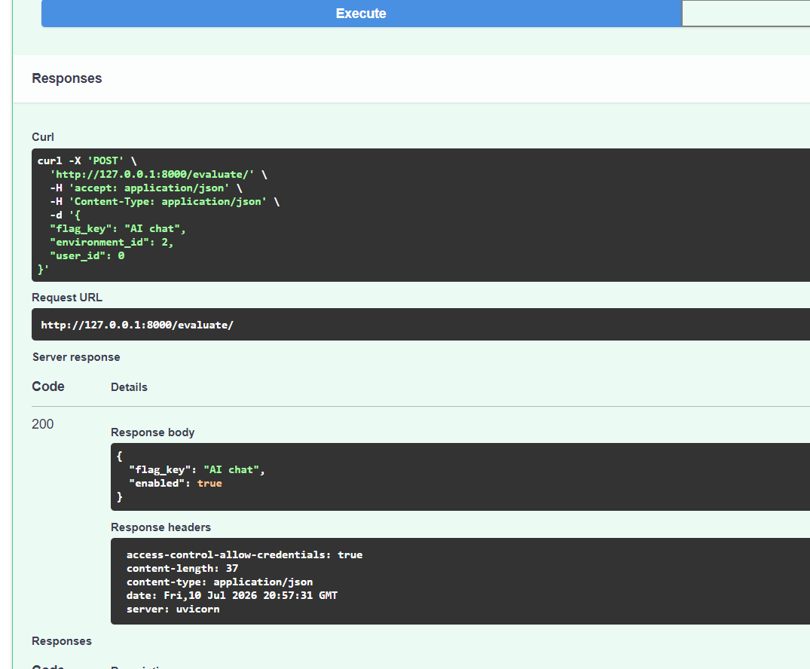

fig:7 Backend Build the core flag evaluation engine

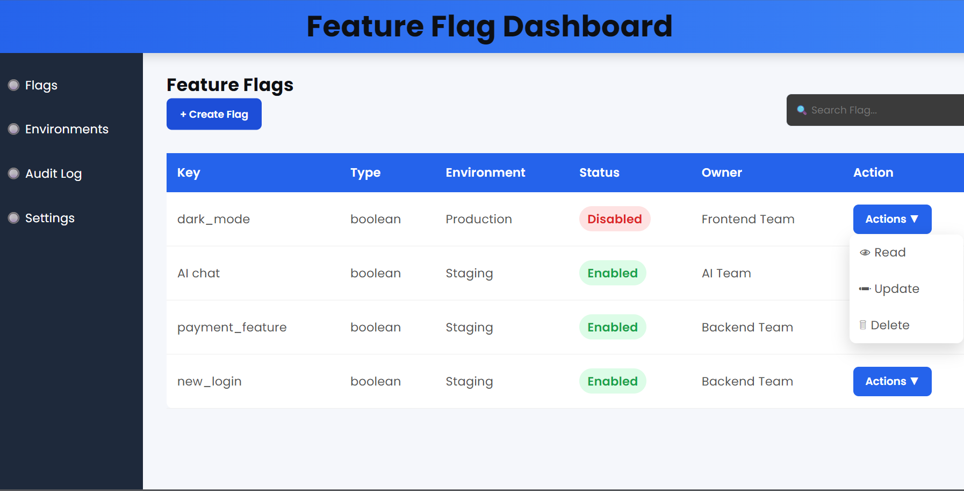
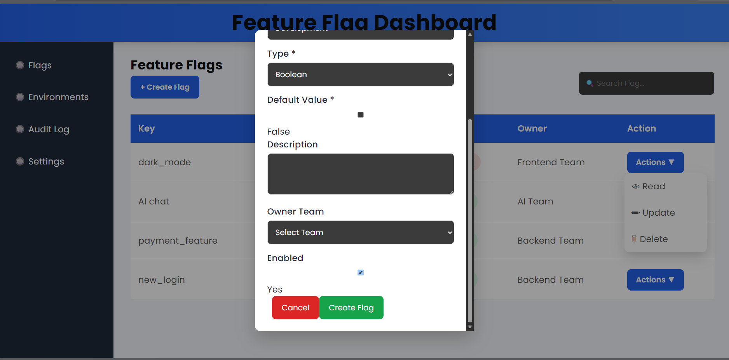
Fig:8 Frontend Build the &quot;Create/Edit

Day 5: Unit Tests for Evaluation Engine &amp; Flag Detail Page

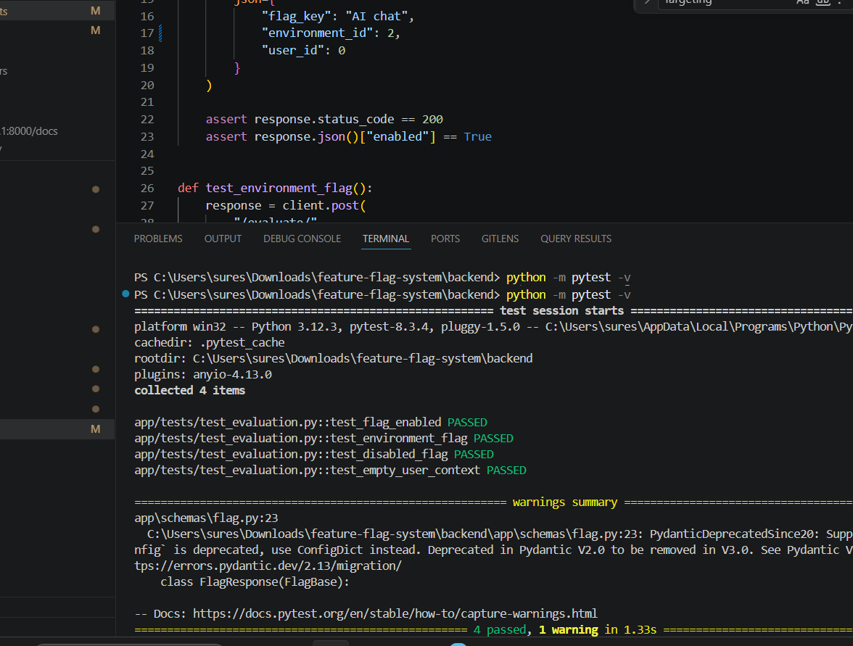

fig:9 Backend Write unit tests for the evaluation engine covering four cases

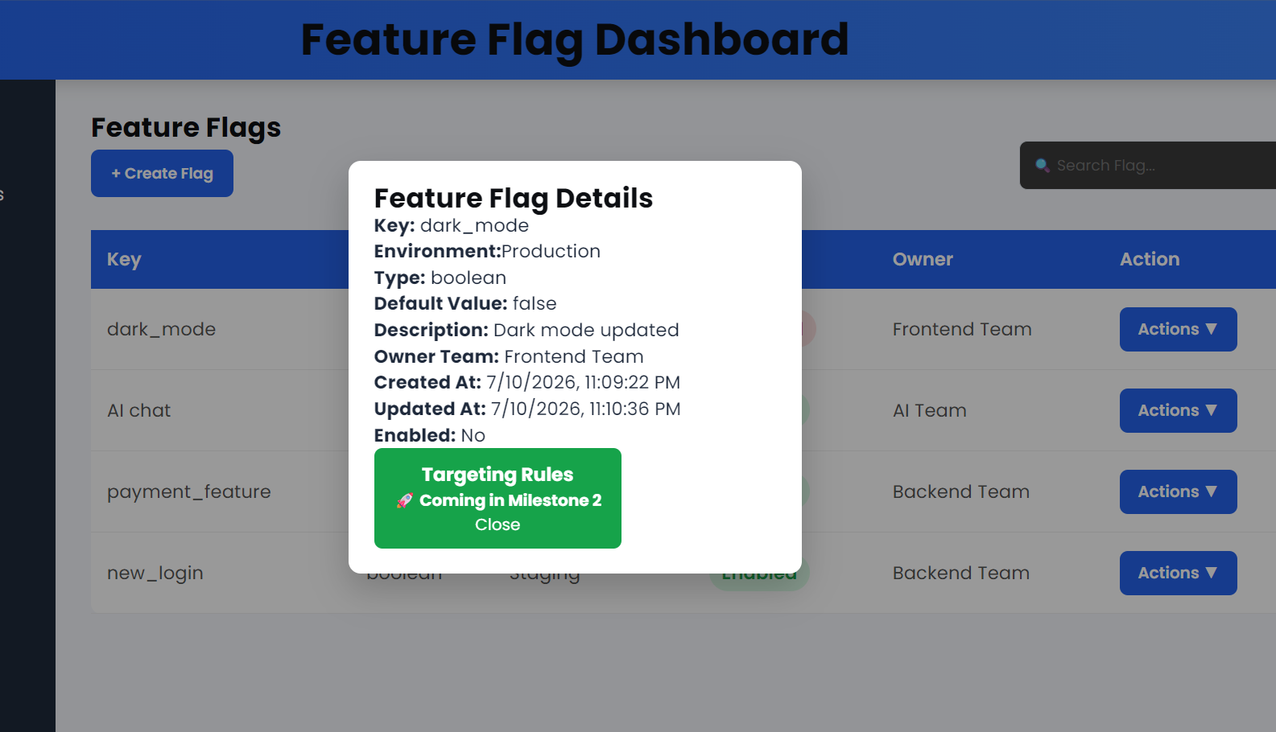
Fig:10 Frontend Build the Flag Detail page

Day 6: Milestone 1 Integration &amp; Demo

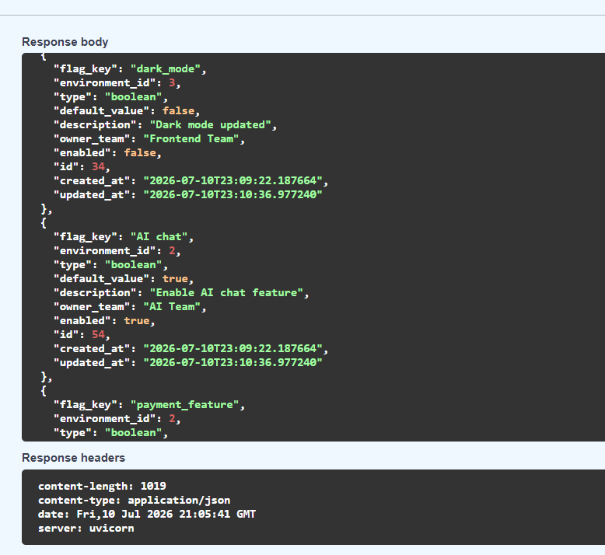

fig:11 Backend Review and clean up the CRUD + evaluation engine code

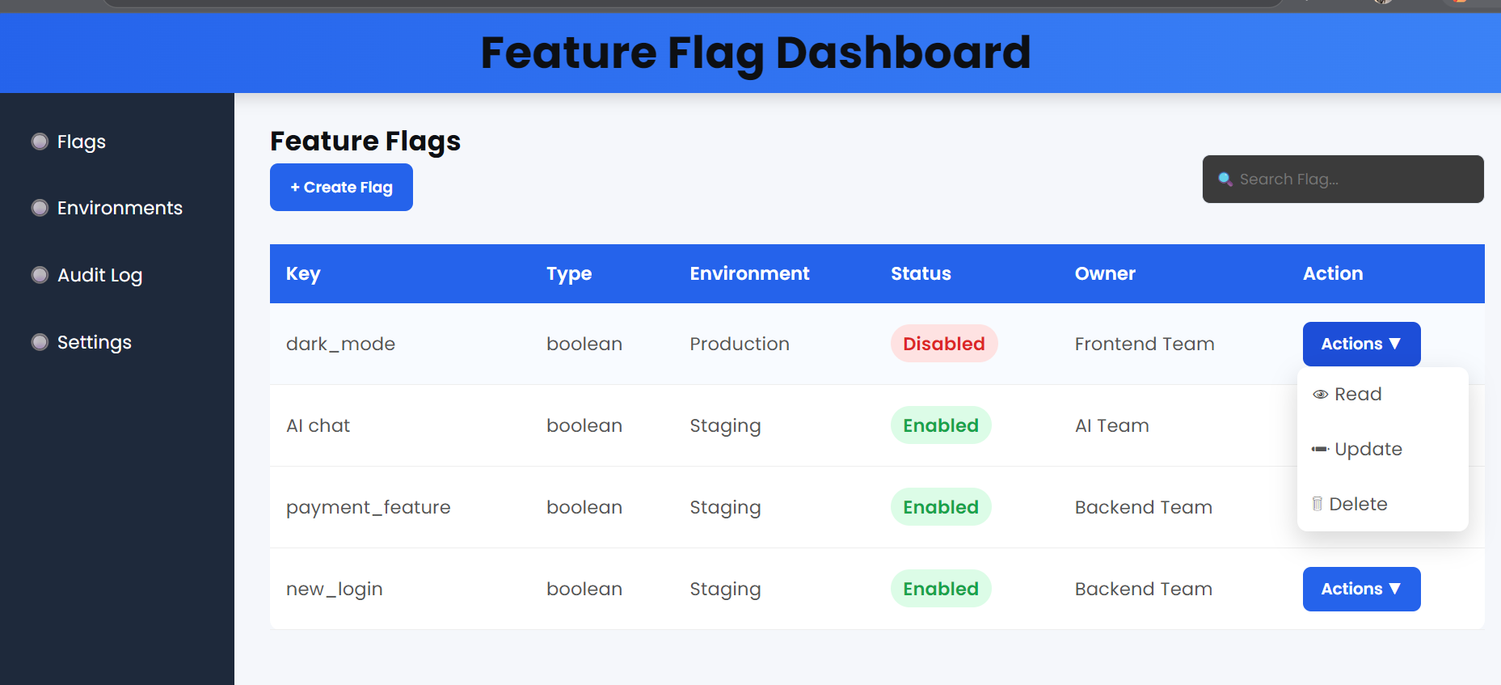

Fig:12 Frontend Fully connect the flag table, create form, and detail page to the live backend API (remove all mock data).

