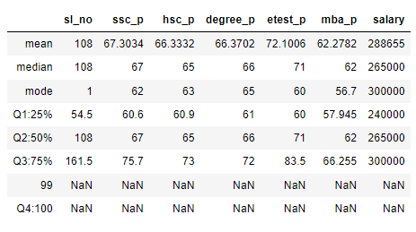

Percentile:

SSLC:

1.Between Q1-25% & Q2-50%, there’s are increase of 7 Points

2.Between Q2-50% & Q3-75%, there’s are increase of 8 Points

HSC:

1.Between Q1-25% & Q2-50%, there’s are increase of 5 Points

2.Between Q2-50% & Q3-75%, there’s are increase of 8 Points

Degree:

1.Between Q1-25% & Q2-50%, there’s are increase of 5 Points

2.Between Q2-50% & Q3-75%, there’s are increase of 6 Points

E-Test:

1.Between Q1-25% & Q2-50%, there’s are increase of 11 Points

2.Between Q2-50% & Q3-75%, there’s are increase of 12 Points

MBA:

1.Between Q1-25% & Q2-50%, there’s are increase of 5 Points

2.Between Q2-50% & Q3-75%, there’s are increase of 4 Points

SALARY:

1.Between Q1-25% & Q2-50%, there’s are increase of 25000 Rs

2.Between Q2-50% & Q3-75%, there’s are increase of 35000 Rs