**CSS**

🡪CSS Rules:

selector { property: value;}

🡪Types of CSS (inline ,internal / embedded, external)

**Id vs Class Difference:**

**- ID (`#`):**

- Unique; used for a single element.

- Higher specificity.

- Example: `#header {color: blue;}`

**- Class (`.`):**

- Reusable; used for multiple elements.

- Lower specificity.

- Example: `.button {background: red;}`

* Margin ,max-height, min-height, box shadow, border radius

**Box Model:**

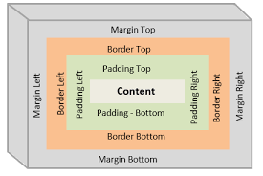

**### Box Model Diagram:**

**```**

**+-------------------------------+**

**| Margin |**

**+-------------------------------+**

**| Border |**

**+-------------------------------+**

**| Padding |**

**+-------------------------------+**

**| Content |**

**+-------------------------------+**

**```**

**Explanation:**

**1. Content:** The actual content of the element (text, images).

**2. Padding:** Space between content and the border.

**3. Border:** The edge of the element, surrounding the padding.

**4. Margin:** Space outside the border, separating the element from others.

Each layer affects the size and positioning of elements.

**🡪Display: inline, block, online-block**

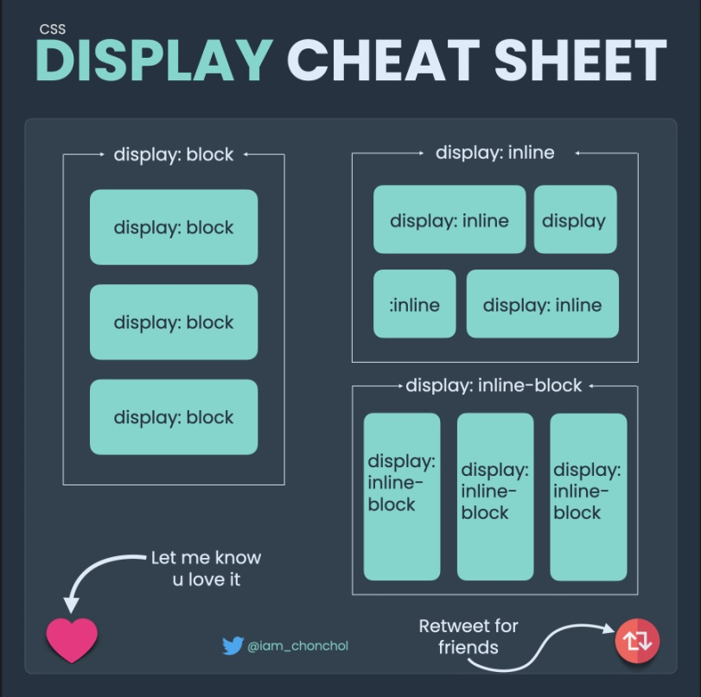

- **Block**: Full width, new line. Example: `<div>`.

- **Inline**: Fits content, same line. Example: `<span>`.

- **Inline-block:** Like `inline`, but allows width/height. Example: `<img>`.

*Terminal Open: Ctrl+J*