***Independent University, Bangladesh***

**Final Project Proposal**

**Coffee order Apps**



**Mobile Application (CSE 464) -** 1

**Submitted by:**

Md Ashikur Rahman 1831110

MD.Akram Hossain 1830707

**Submitted to:**

Sanzar Adnan Alam

**Date: 20-12-2021**

Table of Content

**Introduction 3**

**Initial Development 5**

**Goal 5**

**Structure 6**

# Introduction:

**Project Objective :**There is arguably no better way to start your day than with a hot cup of coffee in the morning. The dark brew gives you a much-needed energy boost to make it through the day. It is no wonder why 64% of the American adult population drink coffee daily, averaging 3.1 cups a day.

A recent study by the National Coffee Association shows that specialty coffee sales are increasing at 20% per annum, now accounting for 8% of the $18 billion market industry. The rise is fuelled partly by the avid drinkers ordering their ground coffee online. While roasters would love to see your smile as you take your first sip at the coffee shop, it would be lovely if everyone would become their own barista at home. Here are five exciting benefits of purchasing locally ground coffee online.

**1. Freshness**

All coffee enthusiasts agree that the fresher the beans, the sweeter the brew. There may be differing opinions on how quickly coffee starts to lose its flavor. However, there is a consensus that coffee tastes best four to fourteen days after roasting. Every coffee roaster has its ideal window for which they prefer their customers to consume the ground coffee. You may need to order ground coffee online from a vendor that will deliver the same level of freshness as you would have visited the shop.

**2. Convenience**

The freshly ground coffee will be delivered straight to your doorstep when you order coffee online. You may not have to stand in line at the coffee shops in Knoxville, TN, waiting for your turn. With the modern-day busy lifestyle, ordering ground coffee online helps you tick an errand off your weekend to-do list. From the comfort of your couch, you can scroll through the different flavors available, place it on your cart, and checkout.

**3. Never Run Out of Coffee**

Is there anything sadder than going to make your special morning cup of coffee only to realize that you’ve run out? Some roasters in Knoxville provide a range of subscription options when you order ground coffee online. With a frequent delivery of a bag every fortnight, you may never have to worry about running out of coffee ever again.

**4. Variety of Flavors**

Some coffee drinkers prefer to indulge in the same type of coffee every day. However, it does not hurt to try new blends of coffee from your favorite coffee house. Most shops provide a wide range of ground coffee online, allowing you to try beans from different countries and roast levels. Some subscription options provide “surprise” packages for their favorite clients, with bespoke blends from different origins.

**5. Value for Your Money**

Specialty coffees from local artisan roasters may be slightly more expensive than commercial grade ground coffee. However, the high-quality beans, freshness, deep flavor, and convenience of buying ground coffee online makes the entire experience worthwhile. Not to mention that you will also be supporting a local business with your purchase.

There are many upsides to ordering ground coffee online, including its convenience, having a continuous supply of fresh coffee and a variety of blends, and obtaining value for your money. You can reach out to The Great Roast online shop to place an order for your favorite blend

This proposed website solution would help the project to:

* Create an online portal to help promote and support the concept of a virtual company.
* Make an easy-to-understand online communication system available.
* Make it easier for customers.
* Provide product details.

# Initial Development:

We began by creating a marketing-focused Mobile Application, as well as a virtual trading platform. The storyboard depicts the right colors, fonts, graphics, and text content buttons, as well as their placement. A well-thought-out and well-executed website will entice and encourage repeat visitors. Making it user-friendly is also important.

**Goals:** The goals of the users are given below:

**User: Client**

**Goal2:** Clients can view Coffee details such as types and price.

**Goal3:** Clients can order coffee and tea.

**Goal4:** Clients can pay from here.

**User: Admin**

**Goal1:** Will upload and update item information.

**Goal2:** Will see cost and quantity.

**Goal3**: After Payment firebase automatically remove data

# Structure:

Our mobile application will have the following pages:

* Design
* Front-end
* Back-end

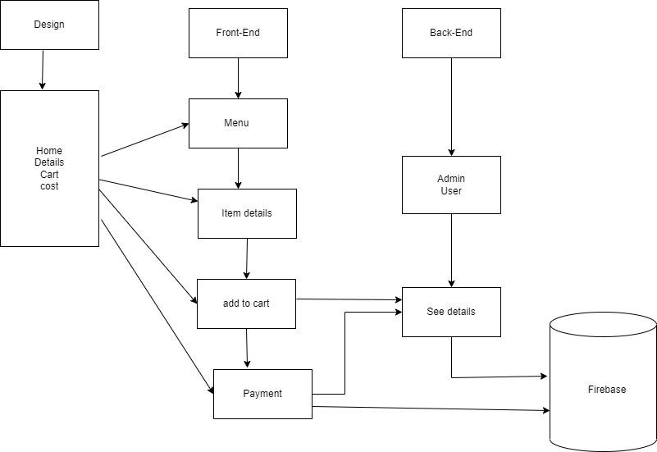

Figure: Structure

Finally,

With Infinite Geofencing, coffee apps can geofence all of their locations, allowing them to send users notifications when they are passing one of their coffee shops. with these location-specific notifications, the app can surface relevant offers and notify the users of new seasonal menu items