

**Microprocessor & Assembly language**

**Course ID: CSE216**

**Section: 02**

**Submitted To:**

**Prof DR. Farruk Ahmed**

**Submitted by:**

|  |  |
| --- | --- |
| **Name** | **ID** |
| Mohammad masum hossain | 1810691 |
| Md. Ashikhur Rahman | 1831110 |
| Fatematuz Jahura | 1830481 |

**LINE FOLLOWING ROBOT USING PID**

**Introduction:**

The Line follower robot is a mobile machine that can detect and follow the line drawn on the floor. Generally, the path is predefined and can be either visible like a black line on a white surface with a high contrasted color this kind of Robot should sense the line with IR sensor. The data is transmitted to the processor and the processor decide the commands and sends them to the motor driver and the path will be followed by the line follower robot.

In this project we used Arduino Uno for microprocessor and also motor shield to drive the motor.

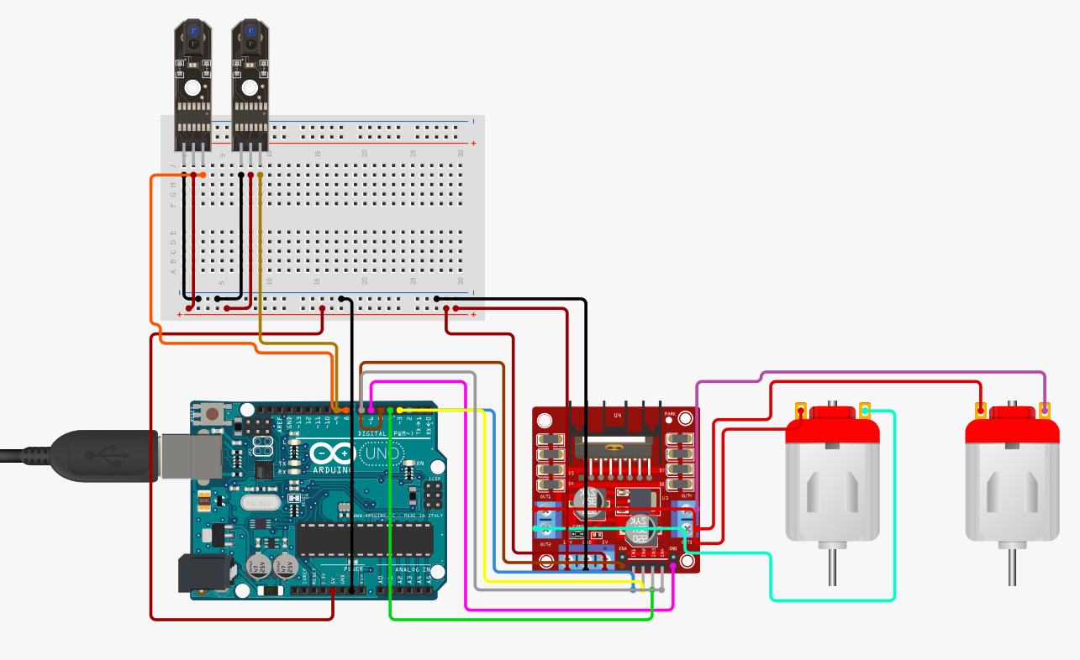

**Components:**

1. chassis board (including Motors and wheels)

2. Arduino Uno r3

3. L293D Motor shield.

4. IR Sensor

5. Jumper wires

6. Switch

&. Power supply

**Arduino Uno**: The Arduino Uno R3 is a microcontroller board. In Line following robot Arduino take data from the IR sensor and send it to the motor driver. And the Arduino will direct the motors to move with the help of motor shield.

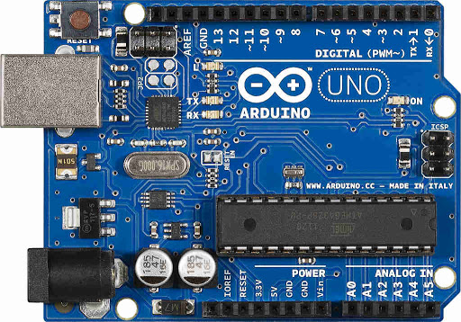

Pic: Arduino Uno r3

**L293D Motor shield**: The motor shield is a dual channel H- bridge motor driver which is capable of driving a pair of dc motor. It is ideal for four wheel robot.

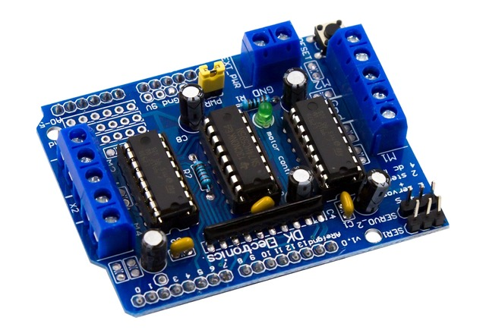

Pic : L293D Motor Shield

**Dc motor**: DC motor is any of a class of rotary electrical motors that converts direct current electrical energy into mechanical energy .The DC motors of the robot are connected to the controller using a l293d motor driver in this project

**Power supply**: TO drive the robot we need power supply , for this project we will use 5v power supply.

**IR sensor:** IR sensor is a radiation sensitive optoelectronic component which have spectral sensitivity within 780 nm . In this project we used two infrared proximity sensors to detect the line .Active infrared sensors can emit and detect infrared radiation. When object come close to the sensor the infrared light form the LED reflects off of the objects and is detected by the receiver.

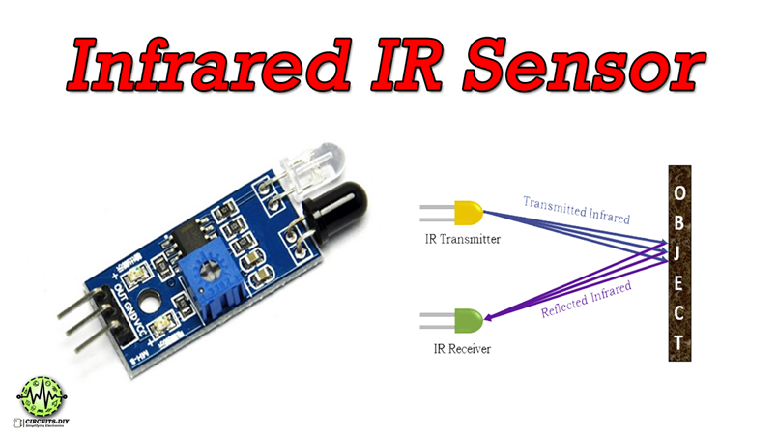

**Procedure:** There are four possible sensor outcomes:-

Case 1:

In this case, both the sensors don't detect the line. Both the motors rotate forward. As a result, the car moves forward

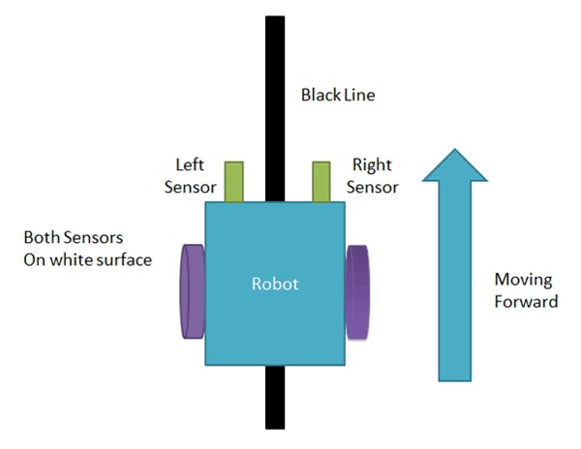

Case 2:

In this case, only the left sensor detects the line which means that the car requires to turn in the left direction. The left motor rotates backward and the right motor rotates forward. As a result, the car turns left.

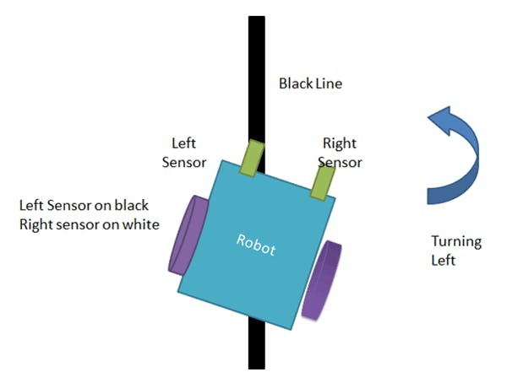

Case 3:

In this case, only the right sensor detects the line which means that the car requires to turn in the right direction. The left motor rotates forward and the right motor rotates backward. As a result, the car turns right.

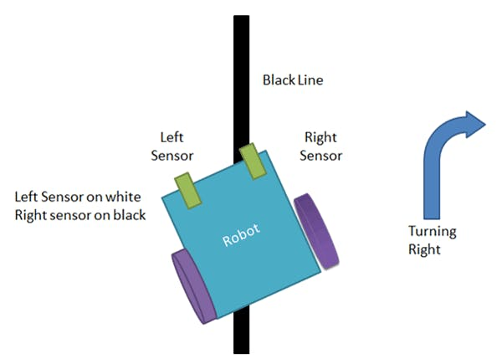

Case 4:

In this case, both the sensors detect the line. This means that the end has come. Both the motors stop rotating. As a result, the car stops.

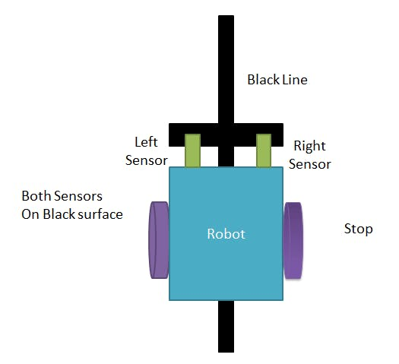

Program code:

#include<AFMotor.h>

int IR1=8; //Right sensor

int IR2=9; //left Sensor

// motor one

int enA = 5; //Right motor

int MotorAip1=2;

int MotorAip2=3;

// motor two

int enB = 6; //Left motor

int MotorBip1=4;

int MotorBip2=7;

void setup()

{

// put your setup code here, to run once:

pinMode(enA, OUTPUT);

pinMode(enB, OUTPUT);

pinMode(IR1,INPUT);

pinMode(IR2,INPUT);

pinMode(MotorAip1,OUTPUT);

pinMode(MotorAip2,OUTPUT);

pinMode(MotorBip1,OUTPUT);

pinMode(MotorBip2,OUTPUT);

}

void loop()

{

if(digitalRead(IR1)==HIGH && digitalRead(IR2)==HIGH)

//IR will not glow on black line

{

//Stop both Motors

digitalWrite(MotorAip1,LOW);

digitalWrite(MotorAip2,LOW);

digitalWrite(MotorBip1,LOW);

digitalWrite(MotorBip2,LOW);

analogWrite (enA, 0);

analogWrite (enB, 0);

}

else if(digitalRead(IR1)==LOW && digitalRead(IR2)==LOW)

//IR not on black line

{

//Move both the Motors

digitalWrite(MotorAip1,HIGH);

digitalWrite(MotorAip2,LOW);

digitalWrite(MotorBip1,HIGH);

digitalWrite(MotorBip2,LOW);

analogWrite (enA, 200);

analogWrite (enB, 200);

}

else if(digitalRead(IR1)==LOW && digitalRead(IR2)==HIGH)

{

//Tilt robot towards left by stopping the left wheel and moving the right one

digitalWrite(MotorAip1,HIGH);

digitalWrite(MotorAip2,LOW);

digitalWrite(MotorBip1,LOW);

digitalWrite(MotorBip2,HIGH);

analogWrite (enA, 200);

analogWrite (enB, 150);

delay(100);

}

else if(digitalRead(IR1)==HIGH && digitalRead(IR2)==LOW)

{

//Tilt robot towards right by stopping the right wheel and moving the left one

digitalWrite(MotorAip1,LOW);

// If I want to turn right then the speed of the right wheel should be less than that of the left wheel, here, let a be the right wheel

digitalWrite(MotorAip2,HIGH);

digitalWrite(MotorBip1,HIGH);

digitalWrite(MotorBip2,LOW);

analogWrite (enA, 150);

analogWrite (enB, 200);

delay(100);

}

else

{

//Stop both the motors

digitalWrite(MotorAip1,LOW);

digitalWrite(MotorAip2,LOW);

digitalWrite(MotorBip1,LOW);

digitalWrite(MotorBip2,LOW);

analogWrite (enA, 0);

analogWrite (enB, 0);

}

}

**Applications:**

1. Industrial Applications: These robots can be utilized as robotized hardware transporters in businesses supplanting customary transport lines.

2. Automobile applications: These robots can be used as programmed vehicles running on streets with implanted magnets.

3. Domestic applications: These can also be used at homes for domestic purposes.

4. Guidance applications: These can be used in public places like shopping malls, exhibition halls, and so on to give way direction.

**Advantages:**

• Robot development is programmed that means automatic robot movement.

• It is used for significant distance applications.

• Simplicity of building & cost effective.

• Fit and fail to remember framework.

• Used in home, health care, mechanical robotization, and so on.

**Limitation:**

• Line follower robot follows a black line about 1 or 2 inches in width on a white surface.

• Line tracing robots are simple robots with an additional sensor placed on them.

• It always needs a path to run either white or black since the IR rays should reflect from the particular path.

• The IR sensors may sometimes absorb IR rays from surroundings also. As a result, robots may move in improper way.

• It may not move properly if the black line drawn is of low intensity.

• Slow speed and instability on different line thickness or hard angles.

**Challenges may face during the project:**

1. Damaged components: We face two different problems with our components. The first one was with the motor driver, which stopped functioning while we were fixing it on the chassis. And the second one was with the sensor that we bought, so we had to purchase another one.

2. Code: Our challenge is to find a way to make a simple and effective code. Which will make our bot able to detect the black area and keep following it. When we achieved that, our second challenge was to upgrade our code to make our bot speedy and fast.

3. Connecting the circuit correctly: The challenge that we may face here that we had to connect the circuit, without damaging or burning the components.

**How we overcome it:**

1.We have to change both motor driver and the sensor, to complete the circuit.

2.The third challenge is very difficult to overcome with, as our motor driver got damaged while we were fixing it on the chassis, but from here we understood that we must be very sensitive and very concentrating while connecting the circuit.

**FUTURE SCOPE**

Line following robot with obstacle detection system can play a vital role in various field such as hospital and logistics industries etc. Robotics is fast grooming technology. By using robot in the industries the cost and work can be reduced, making it an efficient industry. In our country, there is a high demand of various material or services which can be efficiently met by the use of robots. Live monitoring of environment is difficult so a camera can be placed. . An accelerometer can placed on

The line following robot to check and control the speed of robot. A WI-FI module can be integrated with it so we can also monitor it through our computers.