ASHIM GHIMIRE

CPE301 – SPRING 2015

Design Assignment 0

**DO NOT REMOVE THIS PAGE DURING SUBMISSION:**

The student understands that all required components should be submitted in complete for grading of this assignment.

|  |  |  |  |
| --- | --- | --- | --- |
| **NO** | **SUBMISSION ITEM** | **COMPLETED (Y/N)** | **MARKS**  **(/MAX)** |
| 0. | COMPONENTS LIST AND CONNECTION BLOCK DIAGRAM w/ PINS |  |  |
| 1. | INITIAL CODE OF TASK 1/A |  |  |
| 2. | INCREMENTAL / DIFFERENTIAL CODE OF TASK 2/B |  |  |
| 3. | INCREMENTAL / DIFFERENTIAL CODE OF TASK 3/C |  |  |
| 4. | INCREMENTAL / DIFFERENTIAL CODE OF TASK 4/D |  |  |
| 5. | INCREMENTAL / DIFFERENTIAL CODE OF TASK 5/E |  |  |
| 6. | SCHEMATICS |  |  |
| 7. | SCREENSHOTS OF EACH TASK OUTPUT |  |  |
| 8. | SCREENSHOT OF EACH DEMO |  |  |
| 9. | VIDEO LINKS OF EACH DEMO |  |  |
| 10. | GOOGLECODE LINK OF THE DA |  |  |
|  |  |  |  |
|  |  |  |  |

|  |  |  |  |
| --- | --- | --- | --- |
| 0. | COMPONENTS LIST AND CONNECTION BLOCK DIAGRAM w/ PINS |  |  |

No components were used for this assignment.

|  |  |  |  |
| --- | --- | --- | --- |
| 1. | INITIAL CODE OF TASK 1/A |  |  |

/*

* DA0.asm

*

* Created: 4/2/2015 4:35:17 PM

* Author: Aseem

*/

.include "m328pdef.inc" ;includes definition file

.org 0 ;

ldi r16, 31 ;loads 31 to r16

ldi r17, 36 ;loads 36 to r17

adc r16, r17 ;adds r16 and r17 with carry and stores to r16

ldi r17, 44 ;loads 44 to r17

adc r16, r17 ;adds r16 and r17 with carry and stores to r16

ldi r17, 54 ;loads 54 to r17

adc r16, r17 ;adds r16 and r17 with carry and stores to r16

ldi r17, 59 ;loads 59 to r17

adc r16, r17 ;adds r16 and r17 with carry and stores to r16

brvs HIGH_PORTB2 ;branch if overflow flag is set

LDI R18, 0X04 ;loads 4 to r18

OUT DDRB, R18 ; sets direction output to PORTB.2 pin

LDI R18, 0X00 ; loads 0 to r18

OUT PORTB, R18 ; outputs LOW to PORTB.2 pin

JMP DONE ; jump to DONE

HIGH_PORTB2:

ldi R18, 0X04 ;loads 4 to r18

OUT DDRB, R18 ;sets direction OUTPUT to PORTB.2 pin

OUT PORTB, R18 ; outputs HIGH to PORTB.2 pin

DONE: JMP DONE ;infinite loop to DONE

|  |  |  |  |
| --- | --- | --- | --- |
| 7. | SCREENSHOTS OF EACH TASK OUTPUT |  |  |

TASK 1/A:

Five random numbers >30 and <60 were added and put into R16:

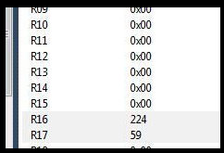

In my case, the sum did not produce overflow and hence PORTB.2 pin became LOW.

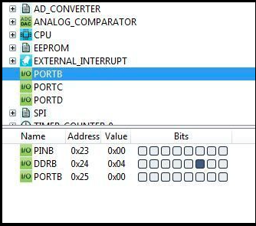

The program uses **19 clock cycles** and takes **2.38** **microseconds** for the completion.

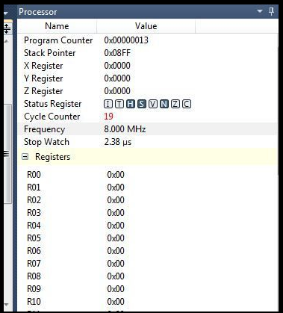

|  |  |  |  |
| --- | --- | --- | --- |
| 8. | SCREENSHOT OF EACH DEMO |  |  |

No demo was required for this lab.

No video was required for this lab.

**Student Academic Misconduct Policy**

<http://studentconduct.unlv.edu/misconduct/policy.html>

“This assignment submission is my own, original work”.

ASHIM GHIMIRE