ASHIM GHIMIRE

CPE301 – SPRING 2015

Design Assignment 1

**DO NOT REMOVE THIS PAGE DURING SUBMISSION:**

The student understands that all required components should be submitted in complete for grading of this assignment.

|  |  |  |  |
| --- | --- | --- | --- |
| **NO** | **SUBMISSION ITEM** | **COMPLETED (Y/N)** | **MARKS**  **(/MAX)** |
| 0. | COMPONENTS LIST AND CONNECTION BLOCK DIAGRAM w/ PINS |  |  |
| 1. | INITIAL CODE OF TASK 1/A |  |  |
| 2. | INCREMENTAL / DIFFERENTIAL CODE OF TASK 2/B |  |  |
| 3. | INCREMENTAL / DIFFERENTIAL CODE OF TASK 3/C |  |  |
| 4. | INCREMENTAL / DIFFERENTIAL CODE OF TASK 4/D |  |  |
| 5. | INCREMENTAL / DIFFERENTIAL CODE OF TASK 5/E |  |  |
| 6. | SCHEMATICS |  |  |
| 7. | SCREENSHOTS OF EACH TASK OUTPUT |  |  |
| 8. | SCREENSHOT OF EACH DEMO |  |  |
| 9. | VIDEO LINKS OF EACH DEMO |  |  |
| 10. | GOOGLECODE LINK OF THE DA |  |  |
|  |  |  |  |
|  |  |  |  |

|  |  |  |  |
| --- | --- | --- | --- |
| 0. | COMPONENTS LIST AND CONNECTION BLOCK DIAGRAM w/ PINS |  |  |

No components were used in this design assignment.

Atmel Studio was used to verify the output.

|  |  |  |  |
| --- | --- | --- | --- |
| 1. | INITIAL CODE OF TASK 1/A |  |  |

/*

* DA1.asm

*

* Created: 4/3/2015 6:41:26 PM

* Author: Ashim

*/

.INCLUDE "m328pdef.inc" ;definition file

; RAMEND = 0x08FF

; RAMBEGIN = 0x0100

; RAM MIDDLE = (08FF + 0100)/2 = 0x04FF

.MACRO init_space

LDI ZL, LOW(0X04FF) ;stores FF as address to the Z-Low register

LDI ZH, HIGH(0X04FF) ;stores 04 as address to the Z-high register

.ENDMACRO

init_space ;sets z-pointer to address 0x04ff

LDI R16, 11 ; stores 11 to R16

LDI R18, 5 ; stores 5 to R18

LDI R19, 25 ; counter to count 25 numbers

NUMBERS_TO_PARSE:

ADD R16, R18 ;R16= R16 + R18 ; our 25 numbers to be pushed to stack

ST Z+ , R16 ;store numbers to Z stack

DEC R19 ;counter = counter -1

CPI R19, 0 ; compare if the counter has reached 0

BRNE NUMBERS_TO_PARSE ;if not zero, keep putting numbers to the stack until the stack has 25 numbers

init_space ;resets the Z-pointer to 0x04ff

LDI R19, 25 ;re-initialize the counter to 25

NEW_NUMBER:

LD R16, Z+ ;load the value Z-register is pointing to in R16

MOV R17, R16 ;move it to a temporary register R17

SUBI R17, -3 ;add 3 to the number

;loop to see if the number is div by 3

DIV_THREE:

SUBI R17, 3 ;subtract 3 to the number

BRLO DIV_SEVEN ;if R17<0 => not divisible by3 => check if divisible by 7

CPI R17, 0 ;check if R17 = 0

BRNE DIV_THREE ;if not zero, keep looping

;loop to sum the numbers divisible by 3

SUM_THREE:

ADC R24, R16 ;add with carry the LSB to R24

BRCC DIV_SEVEN ;branch if no carrry to check if the num is also div by 7

INC R23 ;if carry is set, increment the MSB by 1

;loop to see if the number is div by 7

DIV_SEVEN:

MOV R17, R16 ;move the popped number to a temp register R17

SUBI R17, -7 ;add 7 to the number

DIV_SEVEN_LOOP:

SUBI R17, 7 ;subtract 7 to the number

BRLO NEXT_NUMBER ;if R17<0 => not divisible by => get new number

CPI R17, 0 ;check if R17 = 0

BRNE DIV_SEVEN_LOOP ; if not zero, keep looping

;loop to sum the numbers divisible by 7

SUM_SEVEN:

ADC R21, R16 ;add with carry the LSB to R21

BRCC NEXT_NUMBER ;branch if no carry to get next number

INC R20 ;if carry is set, increment the MSB by 1

NEXT_NUMBER:

SUBI R19, 1 ;decrement counter

CPI R19, 0 ;check if the 25 numbers have been parsed

BRNE NEW_NUMBER ;if not, get the next number

DONE: JMP DONE ;Infinite loop after

;those 25 numbers are calculated

|  |  |  |  |
| --- | --- | --- | --- |
| 7. | SCREENSHOTS OF EACH TASK OUTPUT |  |  |

TASK A:

Initialize Z register to the RAMMIDDLE to fill up the stack:

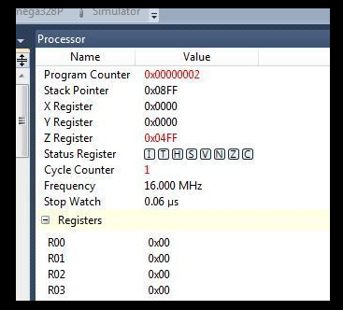

Value of Z register stack after filling up 25 numbers:

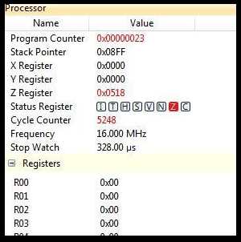

TASK B, C:

Value in R20:R21 after adding all the numbers divisible by 7 and value in R23:R24 after adding all the numbers divisible by 3:

In HEX: In DEC:

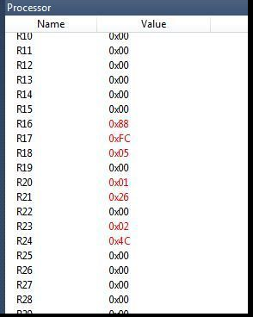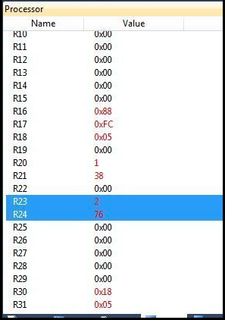

TASK D: The program takes 5248 cycles and 328 microseconds.



FLOWCHART:



**Student Academic Misconduct Policy**

<http://studentconduct.unlv.edu/misconduct/policy.html>

“This assignment submission is my own, original work”.

ASHIM GHIMIRE