ASHIM GHIMIRE

CPE301 – SPRING 2014

Design Assignment 2

**DO NOT REMOVE THIS PAGE DURING SUBMISSION:**

The student understands that all required components should be submitted in complete for grading of this assignment.

|  |  |  |  |
| --- | --- | --- | --- |
| **NO** | **SUBMISSION ITEM** | **COMPLETED (Y/N)** | **MARKS**  **(/MAX)** |
| 0. | COMPONENTS LIST AND CONNECTION BLOCK DIAGRAM w/ PINS |  |  |
| 1. | INITIAL CODE OF TASK 1/A |  |  |
| 2. | INCREMENTAL / DIFFERENTIAL CODE OF TASK 2/B |  |  |
| 3. | INCREMENTAL / DIFFERENTIAL CODE OF TASK 3/C |  |  |
| 4. | INCREMENTAL / DIFFERENTIAL CODE OF TASK 4/D |  |  |
| 5. | INCREMENTAL / DIFFERENTIAL CODE OF TASK 5/E |  |  |
| 6. | SCHEMATICS |  |  |
| 7. | SCREENSHOTS OF EACH TASK OUTPUT |  |  |
| 8. | SCREENSHOT OF EACH DEMO |  |  |
| 9. | VIDEO LINKS OF EACH DEMO |  |  |
| 10. | GOOGLECODE LINK OF THE DA |  |  |
|  |  |  |  |
|  |  |  |  |

|  |  |  |  |
| --- | --- | --- | --- |
| 0. | COMPONENTS LIST AND CONNECTION BLOCK DIAGRAM w/ PINS |  |  |

-Atmega 328p

-Atmega Target Board

-10-bit LED bar

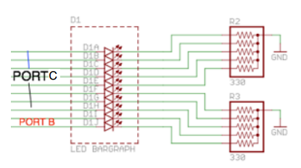

|  |  |  |  |
| --- | --- | --- | --- |
| 1. | INITIAL CODE OF TASK 1/A |  |  |

/*

* DA2.c

*

* Created: 4/5/2015 5:34:03 PM

* Author: Aseem

*/

#include <avr/io.h>

#include <avr/interrupt.h>

void delay_subroutine(void); //delay subroutine

int main(void)

{

DDRB = 0XFF; //set PORTB as output

DDRC = 0xFF; //set PORTC as output

PORTB = 0X20; //sets PORTB.5 to display the waveform with 0.5 period and 50% DC

EIMSK = (1<<INT0); //enable external interrupt 0

EICRA |= (1<<ISC11); // rising edge generates an interrupt request

TCNT0 = 0X00; // 8-bit counter

sei(); //enable external interrupts

while(1)

{

delay_subroutine();

PORTB = 0X20; //display the delay on PORTB.5

TCNT0++; //8 bit counter counting every rising edge

PORTC = TCNT0; //displaying the state of counter on PORTC

if((TCNT0 % 5)==0) //checks if the 5th rising pulse is encountered

{

PORTB ^= 0X10; //toggle PORTB.4

//10th bit of the LED bar

}

}

return 0;

}

void delay_subroutine(void) {

/*

TCNT= 2^16 - (0.25 sec at 8MHz)/ Prescalar

Prescalar = 2^(-2)*2^3*10^6/2^16 = 30.57

Use Prescalar greater than 30

*/

TCCR1A = 0; //9-bit PWM

TCCR1B = 0X03; // setting to 011

//divides the clock by 64

TCNT1 = 0x85EE; // TCNT = 34286, tick of system clock

while ((TIFR1&0X01)==0x00) //loops when Bit0 of TIFR1 is 0

{

//loop

}

TIFR1 = 0X01; // clears the interrupt flag

//by writing 1 to it

}

ISR (INT0_vect)

{

TCNT2++ ; //Timer counter 2

if (TCNT2 == 0X0002) //checks if INT0 occurs

{

PORTB ^= (1<<4); //toggle PC4

TCNT2 = 0; //clears counter

}

}

|  |  |  |  |
| --- | --- | --- | --- |
| 6. | SCHEMATICS |  |  |

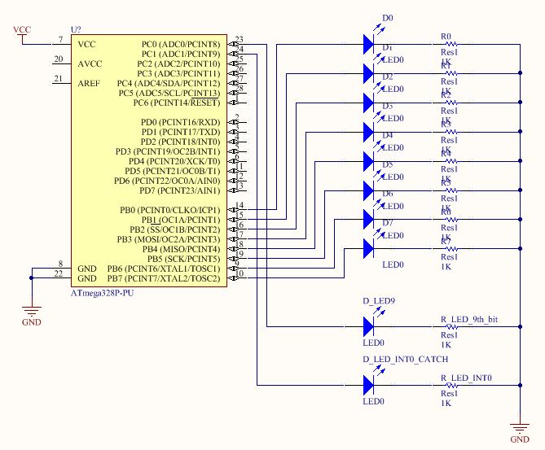

FLOWCHART:

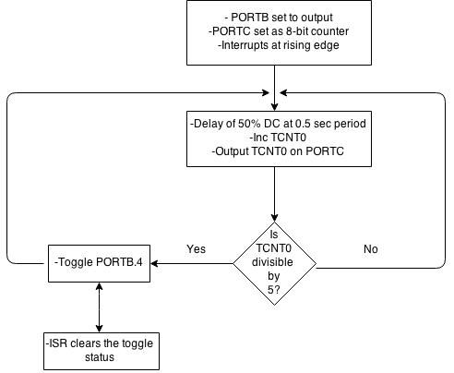

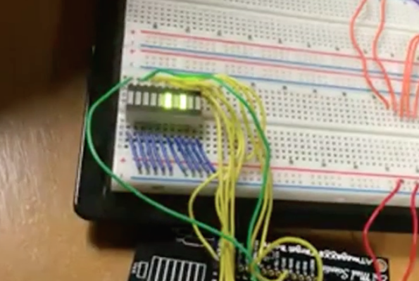

|  |  |  |  |
| --- | --- | --- | --- |
| 7. | SCREENSHOTS OF EACH TASK OUTPUT |  |  |

TASKA:

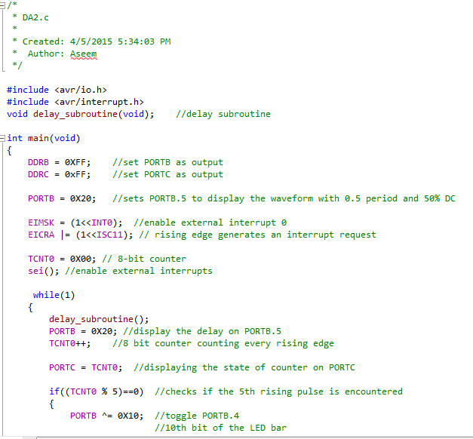

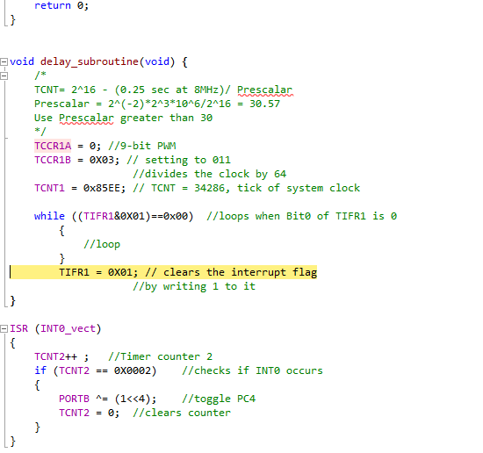

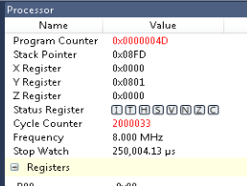

|  |  |  |  |
| --- | --- | --- | --- |
| 9. | VIDEO LINKS OF EACH DEMO |  |  |
| <https://www.dropbox.com/s/l2z3n2xer6qjyvw/DA2.mp4?dl=0> | | | |
| 10. | Github LINK OF THE DA |  |  |
| https://github.com/Ashim-Ghimire/301_GHIMIRE.git | | | |

**Student Academic Misconduct Policy**

<http://studentconduct.unlv.edu/misconduct/policy.html>

“This assignment submission is my own, original work”.

ASHIM GHIMIRE