ASHIM GHIMIRE

CPE301 – SPRING 2014

Design Assignment 3

**DO NOT REMOVE THIS PAGE DURING SUBMISSION:**

The student understands that all required components should be submitted in complete for grading of this assignment.

|  |  |  |  |
| --- | --- | --- | --- |
| **NO** | **SUBMISSION ITEM** | **COMPLETED (Y/N)** | **MARKS**  **(/MAX)** |
| 0. | COMPONENTS LIST AND CONNECTION BLOCK DIAGRAM w/ PINS |  |  |
| 1. | INITIAL CODE OF TASK 1/A |  |  |
| 2. | INCREMENTAL / DIFFERENTIAL CODE OF TASK 2/B |  |  |
| 3. | INCREMENTAL / DIFFERENTIAL CODE OF TASK 3/C |  |  |
| 4. | INCREMENTAL / DIFFERENTIAL CODE OF TASK 4/D |  |  |
| 5. | INCREMENTAL / DIFFERENTIAL CODE OF TASK 5/E |  |  |
| 6. | SCHEMATICS |  |  |
| 7. | SCREENSHOTS OF EACH TASK OUTPUT |  |  |
| 8. | SCREENSHOT OF EACH DEMO |  |  |
| 9. | VIDEO LINKS OF EACH DEMO |  |  |
| 10. | GOOGLECODE LINK OF THE DA |  |  |
|  |  |  |  |
|  |  |  |  |

|  |  |  |  |
| --- | --- | --- | --- |
| 0. | COMPONENTS LIST AND CONNECTION BLOCK DIAGRAM w/ PINS |  |  |

* Atmega 328p
* ATmega Target board
* Pololu AVR programmer
* Terminal.exe (software)
* LM 34
* 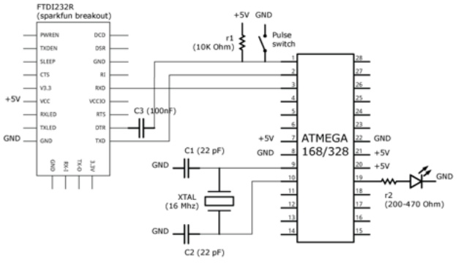

|  |  |  |  |
| --- | --- | --- | --- |
| 1. | INITIAL CODE OF TASK 1/A |  |  |

/*

* DA3.c

*

* Created: 4/8/2015 12:13:40 PM

* Author: Aseem

*/

#define F_CPU 8000000UL //Clock speed

#define BAUD 9600

#define MYUBRR (F_CPU/(16*BAUD))-1

#include <avr/io.h>

#include <util/delay.h>

#include <stdio.h>

#include <inttypes.h>

#include <avr/interrupt.h>

void convert_to_digital(){

//start analog to digital conversion

ADCSRA |= (1<<ADSC);

while ((ADCSRA&(1<<ADIF))==0){

//wait for conversion to finish

}

}

void usart_init() {

//enable receiver and transmitter

UCSR0B = (1<<RXEN0) | (1<<TXEN0);

//set frame format: 8bit,

UCSR0C = (1<<UCSZ00) | (3<<UCSZ01);

//set baud rate

UBRR0 = 0x0033;

}

void usart_send(uint8_t ch){

//wait for buffer to be ready to write to

while(!(UCSR0A &(1<<UDRE0)));

UDR0 = ch;

}

int main(void)

{

DDRC = 0x00; //input porb

DDRD = 0xFF; //output port

//variable for temperatures

//enable ADC, divide clock by 64 for 125kHz sampling

ADCSRA = (1<<ADEN) | (1<<ADPS1);

//REF0 and REF1 for "AVcc with external capacitor on AREF pin" mode

ADMUX= 0X00;

usart_init();

TCCR1A = 0X00;//gives system clock

TCCR1B = 0X0D;//enable CTC mode, prescalar set to 1024

OCR1A = 0X1E84; //8MHz/1024 = 0x1E84

TIMSK1 |= (1<<OCIE1A);//calls interrupt function

sei();

while(1){

}

return 0;

}

ISR(TIMER1_COMPA_vect){

uint8_t temp; //temperature

convert_to_digital(); //converts to digital

temp = ADC; //save to temp variable

usart_send(temp); //sends to terminal

}

|  |  |  |  |
| --- | --- | --- | --- |
| 7. | SCREENSHOTS OF EACH TASK OUTPUT |  |  |

TASK-A:

Temperature displayed on the right column:

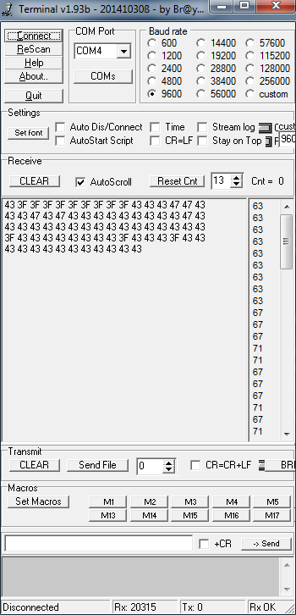

|  |  |  |  |
| --- | --- | --- | --- |
| 8. | SCREENSHOT OF EACH DEMO |  |  |

TASK 1/A:

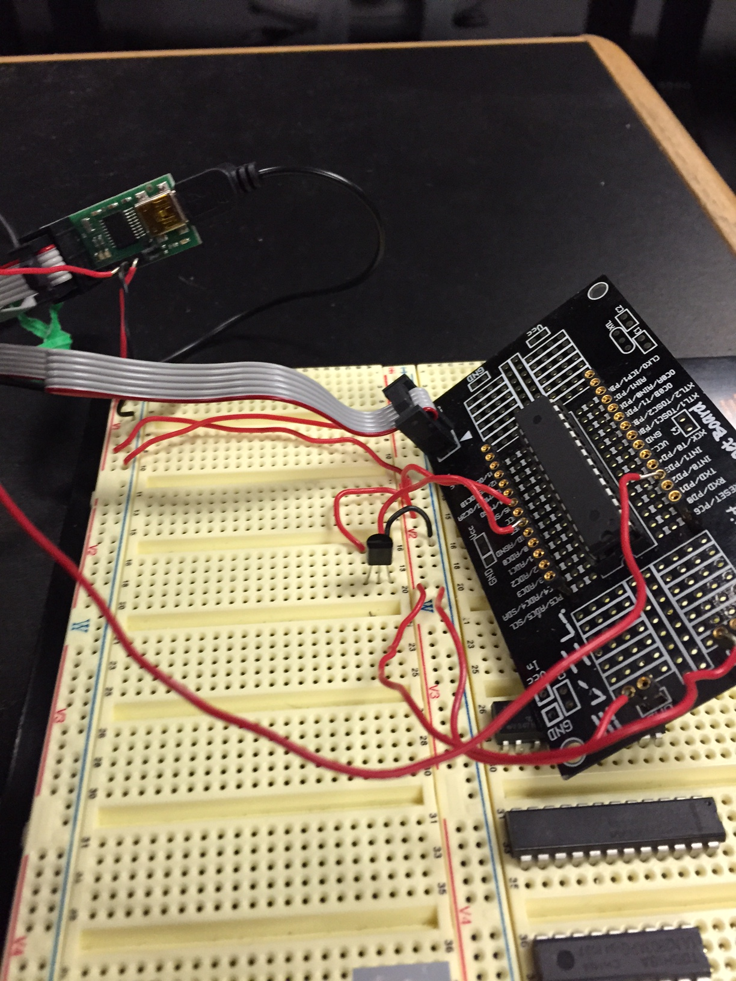

|  |  |  |  |
| --- | --- | --- | --- |
| 9. | VIDEO LINKS OF EACH DEMO |  |  |
| <https://www.dropbox.com/s/nzohqs67nuuv6p3/Video%20Apr%2009%2C%2011%2030%2039%20AM.mov?dl=0> | | | |
| 10. | GITHUB LINK OF THE DA |  |  |
| https://github.com/Ashim-Ghimire/301_GHIMIRE.git | | | |

**Student Academic Misconduct Policy**

<http://studentconduct.unlv.edu/misconduct/policy.html>

“This assignment submission is my own, original work”.

ASHIM GHIMIRE