ASHIM GHIMIRE

CPE301 – SPRING 2014

Design Assignment 4

**DO NOT REMOVE THIS PAGE DURING SUBMISSION:**

The student understands that all required components should be submitted in complete for grading of this assignment.

|  |  |  |  |
| --- | --- | --- | --- |
| **NO** | **SUBMISSION ITEM** | **COMPLETED (Y/N)** | **MARKS**  **(/MAX)** |
| 0. | COMPONENTS LIST AND CONNECTION BLOCK DIAGRAM w/ PINS |  |  |
| 1. | INITIAL CODE OF TASK 1/A |  |  |
| 2. | INCREMENTAL / DIFFERENTIAL CODE OF TASK 2/B |  |  |
| 3. | INCREMENTAL / DIFFERENTIAL CODE OF TASK 3/C |  |  |
| 4. | INCREMENTAL / DIFFERENTIAL CODE OF TASK 4/D |  |  |
| 5. | INCREMENTAL / DIFFERENTIAL CODE OF TASK 5/E |  |  |
| 6. | SCHEMATICS |  |  |
| 7. | SCREENSHOTS OF EACH TASK OUTPUT |  |  |
| 8. | SCREENSHOT OF EACH DEMO |  |  |
| 9. | VIDEO LINKS OF EACH DEMO |  |  |
| 10. | GOOGLECODE LINK OF THE DA |  |  |
|  |  |  |  |
|  |  |  |  |

|  |  |  |  |
| --- | --- | --- | --- |
| 0. | COMPONENTS LIST AND CONNECTION BLOCK DIAGRAM w/ PINS |  |  |

-Atmega 328p

-Atmega Development Board

- RGB LED

- Three Resistors

-Pololu USB AVR programmer (to power the Board)

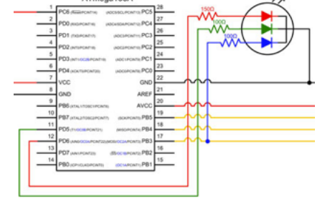

|  |  |  |  |
| --- | --- | --- | --- |
| 1. | INITIAL CODE OF TASK 1/A |  |  |

/*

* DA4.c

*

* Created: 4/9/2015 3:37:55 PM

* Author: ghimirea

*/

#define F_CPU 8000000L

#include <inttypes.h>

#include <avr/io.h>

#include <util/delay.h>

void delay(void){

//holds the colors for this time

TCNT1 = 0;

while(TCNT1 < 0x4e20){ //count until 20000 in decimal

TCNT1++;

}

}

void PWM_init(void)

{

TCCR0A = (1<<WGM00) | (1<<WGM01) | (1<<COM0B1) | (1<<COM0A1); // Non-inverting Fast PWM

TCCR0B = (1<<WGM02) | (1<<CS01); // no prescalar

TCCR2A = (1<<WGM20) | (1<<WGM21) | (1<<COM2B1); // Non inverting Fast PWM

TCCR2B = (1<<WGM22) | (1<<CS21); // no prescalar

}

int main(void)

{

DDRD = (1<<PORTD3) | (1<<PORTD5) | (1<<PORTD6); //set PORTB to display RGB LED

int duty = 0;

PWM_init(); //generates PWM

while(1){

for (duty=20; duty < 230; duty++){ //alter duty cycle for RED

OCR0A = duty; //output compare register

delay(); //delay subroutine

}

OCR0A = 0; //clears the PWM

for (duty=20; duty < 230; duty++){ //alter duty cycle for GREEN

OCR0B = duty;

delay(); //delay subroutine

}

OCR0B = 0; //clears the PWM

for (duty=20; duty < 230; duty++){ //alter duty cycle for BLUE

OCR2B = duty;

delay(); //delay subroutine

}

OCR2B = 0; //clears PWM

}

return 0;

}

FLOWCHART:

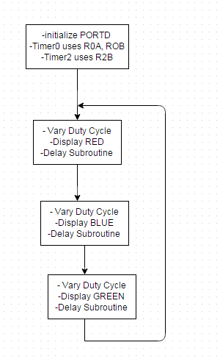

|  |  |  |  |
| --- | --- | --- | --- |
| 8. | SCREENSHOT OF EACH DEMO |  |  |

TASK A:

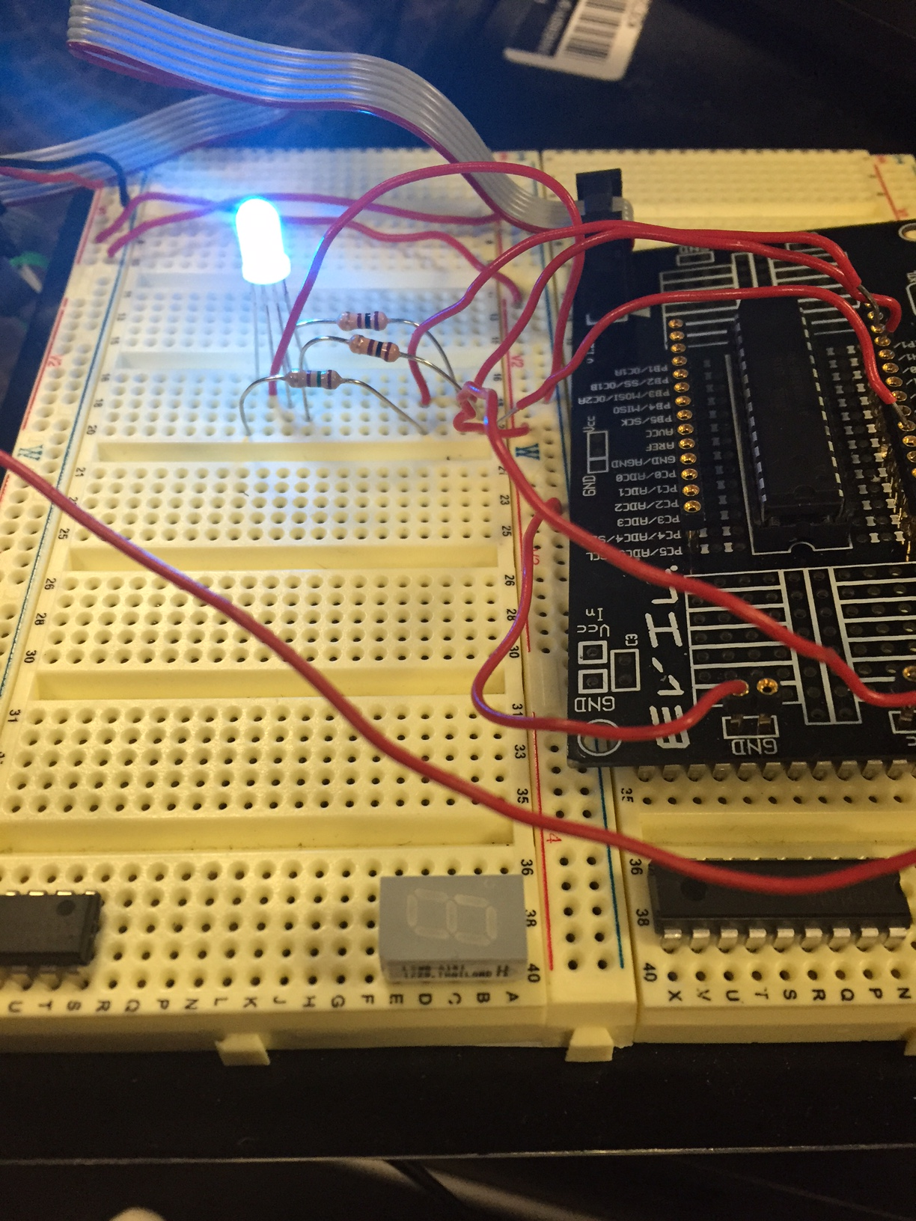

|  |  |  |  |
| --- | --- | --- | --- |
| 9. | VIDEO LINKS OF EACH DEMO |  |  |
| https://www.dropbox.com/s/i2zoirlrneiuw5h/Video%20Apr%2009%2C%206%2048%2029%20PM.mov?dl=0 | | | |
| 10. | GITHUB LINK OF THE DA |  |  |
| https://github.com/Ashim-Ghimire/301_GHIMIRE.git | | | |

**Student Academic Misconduct Policy**

<http://studentconduct.unlv.edu/misconduct/policy.html>

“This assignment submission is my own, original work”.

ASHIM GHIMIRE