Airbases​ Flow Model
Final Report

George Mason University
OR 635 – Discrete System Simulation
December 2023



Instructor:
Prof. Jie Xu

Members (Alphabetically Sorted Last Names):
Hadi Ghayoomi
Graham Hulsey
Ashim Kumar Thapa​
Kaleb Vierra

Contents
1. Simulated Problem Description 4
Introduction to Airbase Operations: 4
2. Input Data Analysis & Model Assumptions 4
Input Data for Airbase Operations: 4
Aircraft Composition: 5
Mission types and Flight Times: 5
Landing and takeoff Durations: 5
Refueling Times: 5
Maintenance Intervals and Maintenance Times: 5
Aircraft Breakdown Parameters: 6
3. Simulation Model 6
Overview of Airbase Simulation Model: 6
Model Assumptions: 6
Immediate Refueling upon Landing: 7
One-at-a-Time Refueling Processes: 7
Absence of Pilot Considerations: 7
Core Components and Functionality: 7
Mission Execution Dynamics: 7
Sequential Flow of Airbase Operations: 8
Mission Initiation: 8
Aircraft Deployment: 8
Takeoff Durations: 8
Landing Durations: 9
Refueling and Maintenance Integration: 9
Maintenance Dynamics: 9
4. Output Analysis and Design of Experiments 10
Statistical Analysis of Airbase Operations: 10
Deterrence mission results 11
Escort mission results 11
Reconnaissance mission results 12
Crew Utilization Results 12
5. Recommendations and Conclusions: 13
Recommendations: 13
Conclusion 14

1. Simulated Problem Description

Introduction to Airbase Operations:
Military aviation, a cornerstone of national defense, operates within a realm of strategic complexities. Our simulation ventures into the heart of this intricate domain, focusing on the dynamics of airbase operations—a linchpin in the success of military missions. Airbases serve as base, overseeing the coordinated efforts of diverse aircraft engaged in escort, deterrence, and reconnaissance missions, all while navigating the intricacies of refueling and maintenance processes.
In today's military, if airbase operations aren't at their best, there can be significant repercussions to a nation’s national defense. Further, poor use of resources can detract from other defense areas, and a lack of resources can lead to high risk in airbase operations. Knowing this, our simulation is designed to determine the optimal resourcing level for a single military airbase.
The realm of airbase operations is inherently uncertain, characterized by variables such as refueling duration, aircraft availability, and maintenance requirements. Stochastic simulation is the method of choice for modeling this intricate complexity. Unlike deterministic models, which oversimplify by ignoring variability, stochastic simulation embraces the inherent randomness and unpredictability of real-world scenarios. This adaptability positions stochastic simulation as an invaluable tool for decision-makers navigating the intricate landscape of airbase operations.
Our simulation of military airbase operations would be used in a resource determination process. National security involves many different domains and missions, each with unique resourcing requirements, such as aircraft, ground vehicles, or cyber infrastructure. By quantifying the benefits to adding additional resources on airbase performance, and highlighting the risk of reducing resources, the simulation model’s output can assist decision-makers who must trade scare resources between many competing domains. The subsequent sections will delve into the granular details of our simulation model, the implementation of code, and the statistical analyses that illuminate the nuanced performance of airbase operations in the face of uncertainty.

2. Input Data Analysis & Model Assumptions

Input Data for Airbase Operations:
Our simulation tries to simulate and capture the detailed features of various aircraft, refueling stations, runway management, and maintenance crews. We now detail the input data used to simulate the baseline operating conditions at the airbase.

Aircraft Composition:
The airbase initially is equipped with 6 bombers, 8 fighters, and 10 unmanned aerial vehicles (UAVs).

Mission types and Flight Times:
There are three types of missions named deterrence mission, escort mission, and control recon missions. They are different in their priority, the number of resources needed for each mission and duration of the missions. Priority order of missions (highest priority to lowest): Deterrence, Escort Strike, Reconnaissance. Queued requests for resources should be filled in this order. A Deterrence mission requires 2 fighters and 4 bombers and 12 hours in duration; an Escort mission requires 2 fighters, 1 bomber, and 1 UAV, and is 8 hours in duration; a Reconnaissance mission requires only 3 UAVs and is 12 hours in duration. The airbase’s objective is to fly each mission type continuously, so that there are no gaps in the deterrence posture of the airbase, it’s intelligence gathering operations, or it’s support to other elements operating in the area.
A critical facet of airbase operations lies in the durations associated with maintenance and refueling. Different aircraft types necessitate varying periods for these processes. Understanding and modeling these durations are pivotal for gauging the overall efficiency and responsiveness of the airbase in meeting operational demands.

Landing and takeoff Durations:
After finishing the mission, aircraft come back to the airbase and use runways to land in the airport which takes a certain time. They wait until the runway is idle for them to land. Runways are used for the aircraft to take off with a takeoff time and are shared between takeoff and landing. Initially there is 1 runway, and we use a buffer period of 15 minutes between each takeoff and/or landing to account for wake vortex and avoid crowding the runway.

Refueling Times:
We modeled random refueling times as exponentially distributed, with the following means: 1 hour for fighters, 1.5 hours for bombers, and 1 hour for UAVs.

Maintenance Intervals and Maintenance Times:
We modeled each aircraft as requiring two types of maintenance: regular (shorter) and irregular (longer). A fighter needs regular maintenance every 40 flight hours and irregular maintenance every 300 flight hours; a bomber needs regular maintenance every 30 flight hours and irregular maintenance every 250 flight hours; and a UAV needs regular maintenance every 50 flight hours and irregular maintenance every 500 flight hours.
Regular maintenance time is exponentially distributed, with the following means: 5 hours for fighters, 8 hours for bombers, and 3 hours for UAVs. Irregular maintenance times are also exponentially distributed, with the following means: 15 hours for fighters, 24 hours for bombers, and 10 hours for UAVs.

Aircraft Breakdown Parameters:
We also model aircraft breaking outside of maintenance windows. While reliability models can include lifetime wear, constant failure rates, and early failure rates, we chose to early failure rates due to faulty maintenance. To do so, we used the cumulative distribution function (CDF) of an exponential distribution, with the following mean time between failures: 150 flight hours since last irregular maintenance for fighters, 125 flight hours since last irregular maintenance for bombers, and 100 flight hours since last irregular maintenance for UAVs. In essence, each maintenance event “resets” an individual aircraft’s breakdown probabilities.
When an aircraft begins a mission, we calculate the probability that it breaks during that mission as the CDF of its distribution evaluated at the scheduled mission completion time, minus the CDF of its distribution evaluated at the time the mission begins. For example, consider a UAV that has gone 90 hours since it’s last irregular maintenance and is about to fly a 12-hour mission. It’s failure probability will be CDF(x=102, rate=1/100) minus CDF(x=90, rate=1/100), which yields approximately 4.6% chance of aircraft failure. If the same UAV had only 40 hours since its last irregular maintenance, it would have an approximately 7.6% chance of breaking on that mission. With this breakdown probability, we then simulate one random Bernoulli random variable that determines whether the aircraft breaks or not.

3. Simulation Model

Overview of Airbase Simulation Model:

Model Assumptions:
In crafting our simulation model, we embrace certain assumptions to manage the inherent complexity of real-world scenarios. These assumptions act as a lens, allowing us to focus on core operational processes while acknowledging the need for a manageable and comprehensible simulation framework.

Immediate Refueling upon Landing:
Our simulation assumes immediate refueling upon aircraft landing, and although aircraft must wait in queue, they are filled in a first-in-first-out (FIFO) arrangement. Different queueing management strategies could be used that prioritize certain resources over others.

One-at-a-Time Refueling Processes:
To streamline the simulation and maintain clarity, we assume a one-at-a-time refueling process per each refueling station. This simplification facilitates a more straightforward representation of refueling dynamics, allowing for focused analysis without compromising the overall integrity of the model.

Absence of Pilot Considerations:
For the scope of the current study, we omit pilot considerations from our simulation. This deliberate exclusion enables us to concentrate on the core elements of airbase operations, namely the interplay between mission execution, refueling, and maintenance, within the designated timeframe.
We next turn to describe the system components of the model.

Core Components and Functionality:

Mission Execution Dynamics:
At the core of our simulation lies the perpetual execution of diverse mission types. The airbase actively engages in escort, deterrence, and reconnaissance missions, necessitating strategic deployments of fighters, bombers, and UAVs. Gaps in missions equate to gaps in capability provided by the airbase, but downtime is required for maintenance, refueling, or lack of other resources previously mentioned.

Sequential Flow of Airbase Operations:
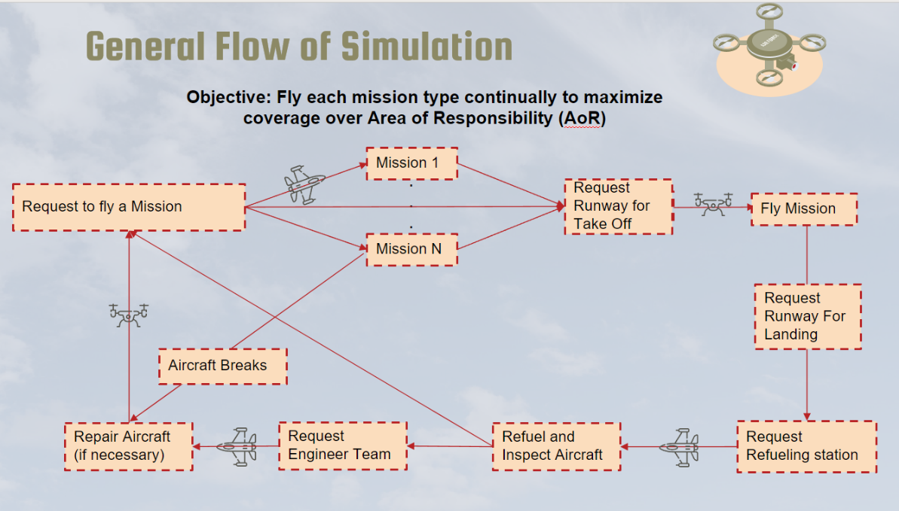

Mission Initiation:
- The simulation commences with the perpetual execution of escort, deterrence, and reconnaissance missions.
- Mission parameters dynamically define the number and type of aircraft involved based on mission requirements.

Aircraft Deployment:
- The model controls the strategic deployment of fighters, bombers, and UAVs in response to mission types.
- Resources are allocated based on mission priorities, contributing to the strategic efficiency of airbase operations.
- At the start of a mission, aircraft failure rates are calculated as described above. If at least one aircraft is deemed to have failed, the mission does not occur; all broken aircraft are sent directly to maintenance, and the non-broken aircraft return to their respective pools of available aircraft.

Takeoff Durations:
- Aircraft use the same runways for takeoff, with a 15-minute buffer between each.
- If a runway is not immediately available, the planes form a queue and are served in a FIFO arrangement:

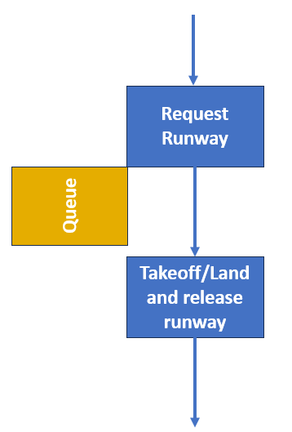
Figure 1: landing and takeoff diagram

Landing Durations:
- After completing a mission, the aircraft returns to the airbase and uses a runway for landing.
- The process is identical to the takeoff process described above.

Refueling and Maintenance Integration:
- After landing, aircraft enter a queue for refueling according to their respective aircraft type.
- Aircraft queue until a refueling station is available and are served in FIFO order.
- At the refueling station, each aircraft’s number of hours flown is checked. If the time since last maintenance exceeds the thresholds detailed above, the plane is sent to maintenance. Otherwise, the plane returns to the pool of available aircraft.
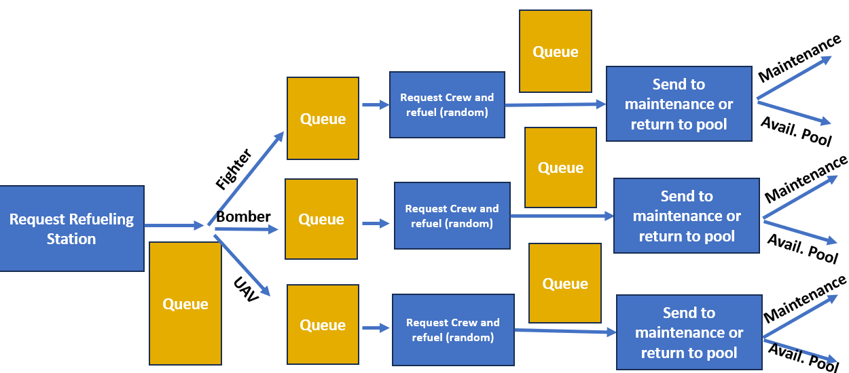
Figure 2: Refueling flowchart

Maintenance Dynamics:
- Aircraft undergo maintenance based on flight history and operational needs, ensuring sustained operational readiness.
- Engineer crews are assigned to each aircraft type to facilitate timely repairs, while accounting for the unique skills each crew must have to work on a specific aircraft type.
- After irregular maintenance is completed, each aircraft’s internal “clock” is reset so that proper breakdown rates (as described above) are calculated.
- Each plane is then returned to the pool of available aircraft.
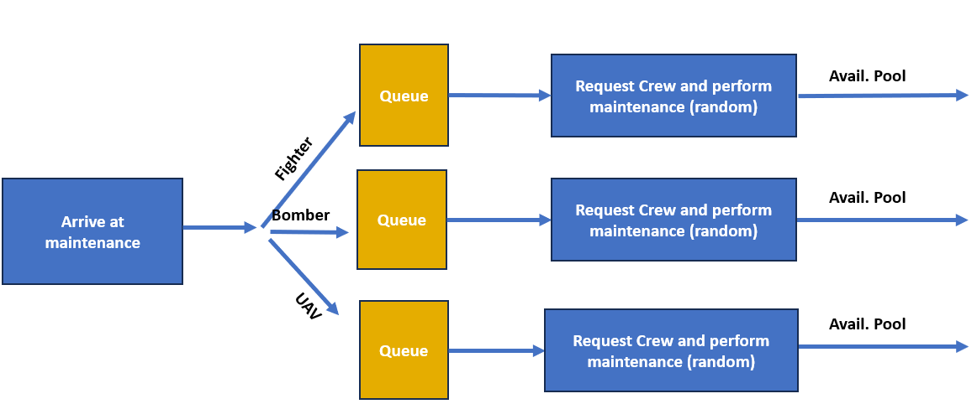
Figure 3: Maintenance flowchart

4. Output Analysis and Design of Experiments

Statistical Analysis of Airbase Operations:
We chose to simulate one year of airbase operations, as resourcing decisions are typically made once per year. To provide high-fidelity in the operations, our base time unit was 1 hour.
Each design (discussed below) runs 100 replications. With 100 replications of each design, and 12 months of simulation time, for any given design the simulation can typically achieve half-widths for mean mission delays of 0.65 hours for the deterrence mission (about 5% relative error), 2.5 hours for the escort mission (about 20% relative error), and 0.45 hours for the reconnaissance mission (about 10% relative error). More accurate simulations could be achieved by running each replication for longer, or by simulating more replications for each design.
Throughout the simulations, we track several key metrics:
- Average delay for each mission type.
- Maximum delay for each mission type.
- Average delay in queue for refueling station, maintenance crew, and runway. This is calculated as the total time each resource type were busy, divided by the simulation time multiplied by the number of each resource type.
Additionally, we ran a total of 432 experiment designs, each with a unique resource package, to identify the relationships between each resource type and the airbase’s objectives. For a decision-maker who must choose whether or how many resources to add, this is the most crucial part of the simulation output.
Our design was full factorial, meaning we simulated every combination of the following resource amounts:
- 1 Runway (typically it is not feasible to add runways due to space and engineering requirements)
- 6, 8, or 10 fighters; 4, 6 or 8 bombers; 8, 10, or 12 UAVs
- 1 or 2 maintenance engineer teams for each of fighters, bombers, and UAVs
Below, we present visualizations of the design of experiment outputs.

Deterrence mission results
In our exploration of the airbase simulation model, we specifically examined the deterrence mission type and its associated delays. The results show that introducing additional bombers reduces average mission delay. Specifically, a 2 unit increase in the number of bombers above baseline resulted in a substantial 25% reduction in the deterrence mission. Similarly, adding two fighters reduced the delay by 7%. Adding UAVs increased deterrence mission delay because the UAVs consume other resources and do not contribute to the deterrence mission. Below, we present visualizations of the outputs.
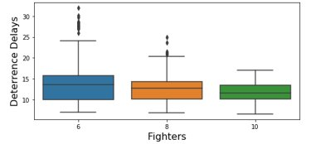 | 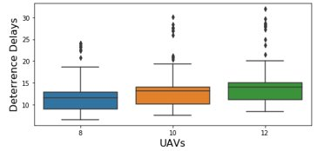 | 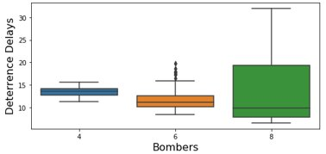

Escort mission results
For escort mission delays, increasing the number of fighters by 2 from baseline results in a 20% decrease in mean wait time. Increasing the number of bombers from baseline by 2 does not impact the average escort mission delay but decreasing the number of bombers from baseline by causing a roughly 100% increase in escort mission delays. As with the deterrence mission, increasing the number of UAVs causes an increase in the average escort mission delay time as these consume other resources, but UAV supply is not a bottleneck for the escort mission.
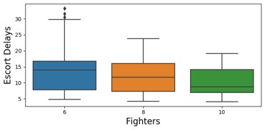 | 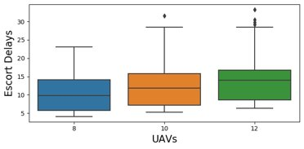 | 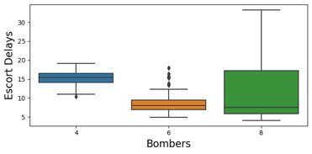

Reconnaissance mission results
For reconnaissance mission delays, increasing the number of UAVs by 2 from baseline results in a 5% decrease in mean wait time. Importantly, decreasing the number of UAVs from baseline by 2 does not impact the average reconnaissance mission delay. Adding or decreasing the number of fighters or bombers has not affect on average reconnaissance mission delay.
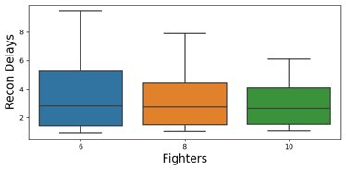 | 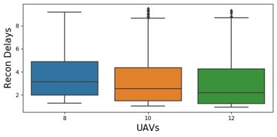 | 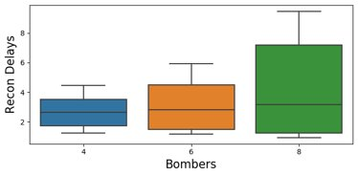

Below, we plot average wait times for each mission type across all different aircraft resource designs, with one standard deviation around the mean.

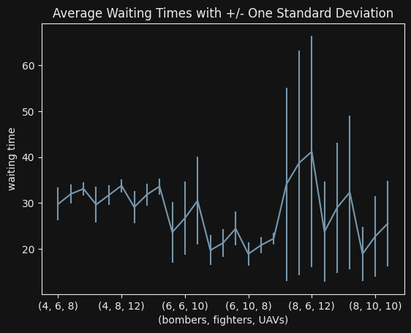
The combination of aircraft resource levels that resulted in the lowest cumulative average wait times across all missions was 8 bombers, 10 fighters, and 8 UAVs. This design is the third-from-right in the above notebook.

Crew Utilization Results
The examination of crew utilization in our airbase operations model reveals that surprisingly, higher refueling crew utilization is linked to longer mission delay time, suggesting a potential chokepoint in refueling. On the contrary, increased engineer crew utilization correlates with shorter mission delay time, emphasizing the positive impact of more frequent maintenance.
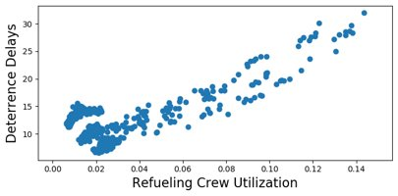 | 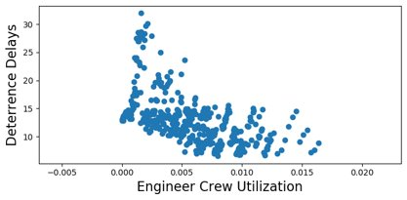

5. Recommendations and Conclusions:

Recommendations:
Based on the results of our simulation experiment, we make the following recommendations for adjusting the resource levels of the airbase.
- To decrease delay times for deterrence missions (the most important mission type), we recommend increasing the size of the bomber fleet from 6 to 8, which can reduce average deterrence delay times by approximately 25%.
- To decrease delay times for escort missions (the second-most important mission type), we recommend increasing the size of the fighter fleet from 8 to 10, which can reduce average escort delay times by approximately 20% and deterrence mission delay times by approximately 7%, in addition to the reduction achieved by increasing the number of bombers.
- To further decrease deterrence and escort mission delay times, we recommend decreasing the number of UAVs from 10 to 8. The simulation experiment showed that reducing the number of UAVs from baseline by 2 will have no effect on average reconnaissance delay times but will further decrease delay times of the other two missions.
- To loosen the bottlenecks associated with the refueling stations, we recommend increasing the number of refueling crews by 1, as increased refueling station utilization is associated with increased mission delays.
- Because maintenance engineering team utilization is associated with decreased mission delays, we recommend exploring opportunities for more preventive maintenance, such as shorter and more frequent regular maintenance. Additionally, new platforms with longer mean times between failures could help to reduce mission delays as well.
These recommendations may be considered in the annual resource adjustment process. Because the benefits and risks are clearly quantified, it is possible for a decision-maker to trade-off scarce resources between this airbase and other domains of national security.

Conclusion
As the curtains draw on this simulated odyssey, the optimization strategies charted here stand as blueprints for ongoing refinement. More expansive design of experiments could unearth better recommendations, at the cost of increased computational time. Then, designs better than full factorial, such as Latin hypercube sampling, could yield more efficient experiments. Further, ranking and selection procedures such as Optimal Computing Budget Allocation (OCBA) can combine efficient design of experiments with simulation-based optimization to yield optimal designs quickly. To improve the accuracy of the simulation, more replications could be completed for each design, or each replication could be simulated for a longer duration. The current simulation model specifications took approximately 2-hours to run the full design of experiments, so increasing number of replications or replication length will only add to the computational burden without optimizing the code or getting a faster computer. Lastly, as with all real-world decisions, the financial cost of implementing our recommendations, which was not considered here, should be considered.

