Assignment 5
Ques1)
Topology-
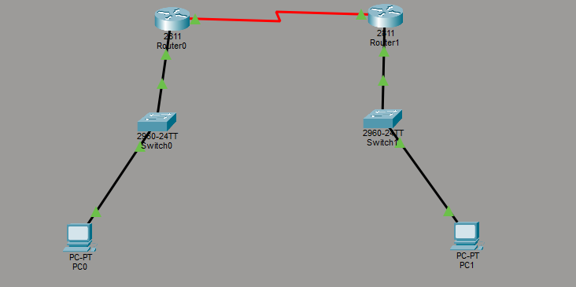
Configuration Commands on Router 1-
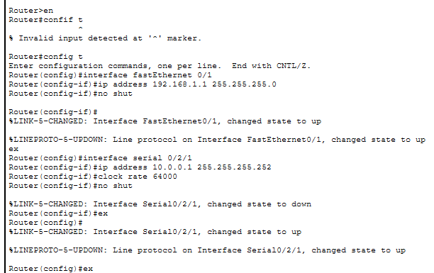

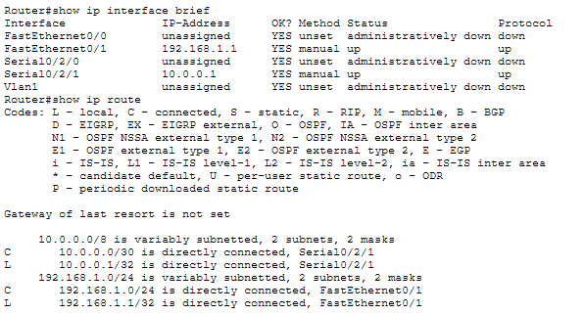

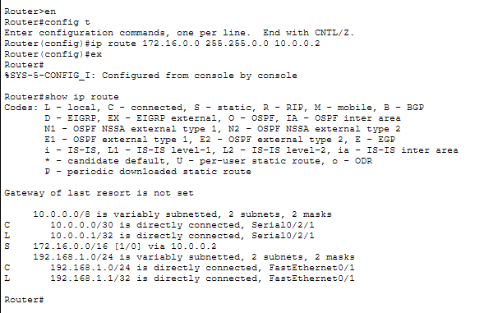

Configuration Commands on PC1-
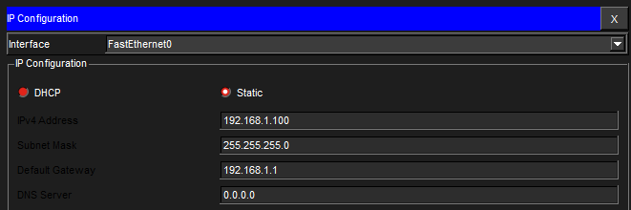

Configuration Commands on Router 2-
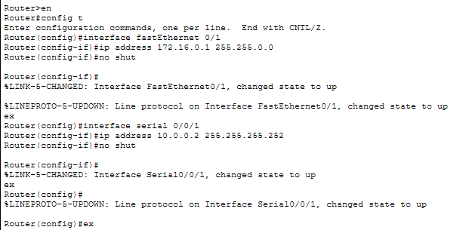

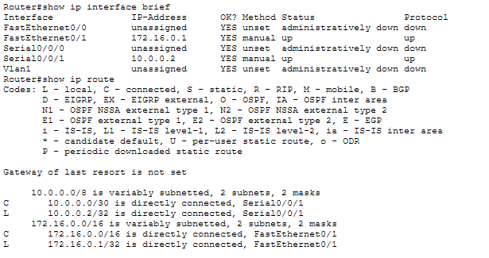

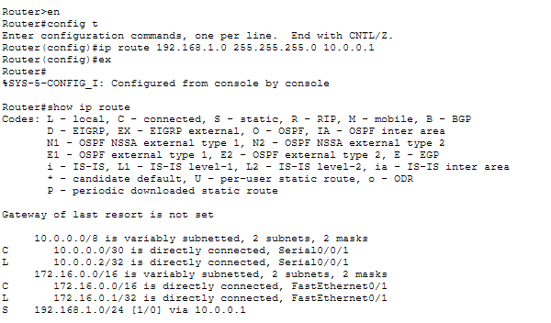

Configuration Commands on PC2-
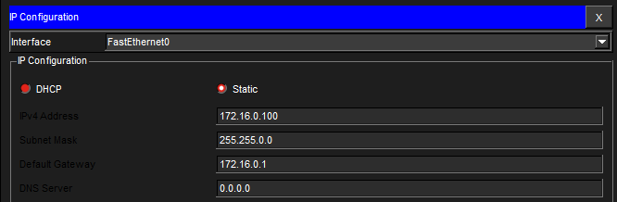
Ping from PC1-
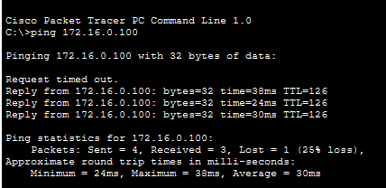
Ping from PC2-
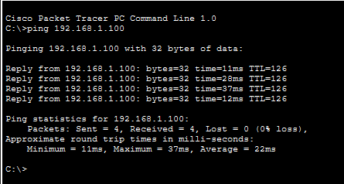

Ques2)
Topplogy-
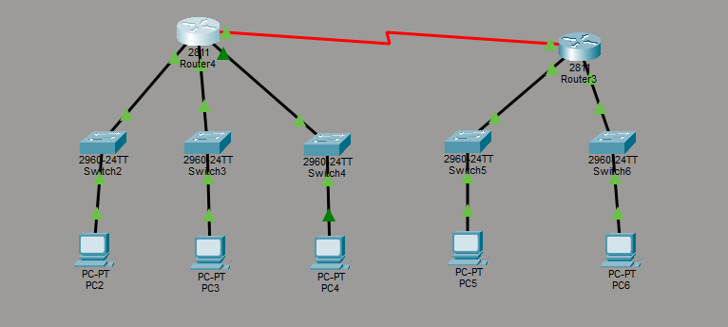
Configuration on Router 4-
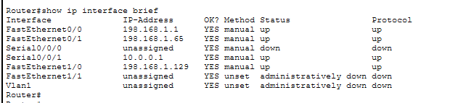
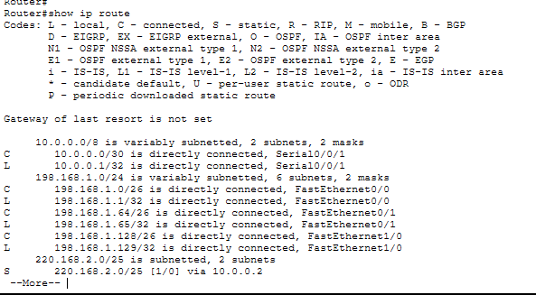
PC2 configuration –
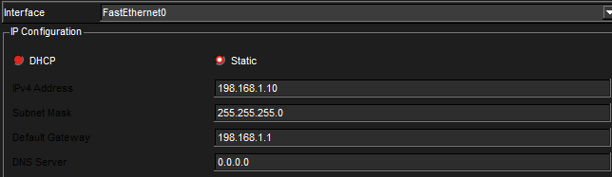
PC3 configuration –
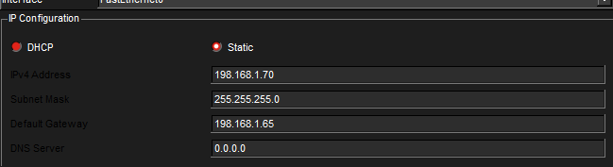
PC4 configuration –
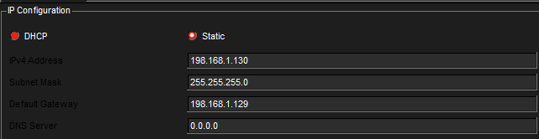

Ping from PC2 (subnet 1)-
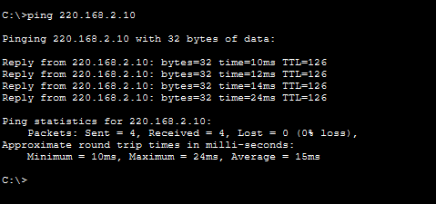

Configuration on Router 3-
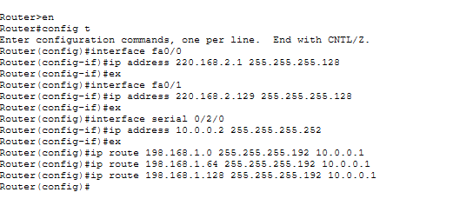
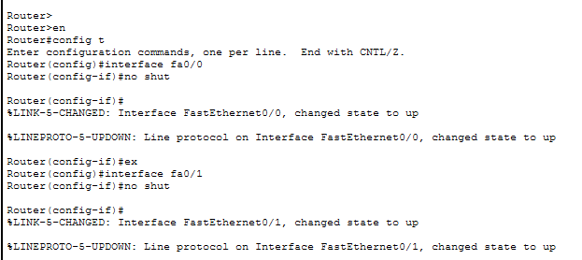

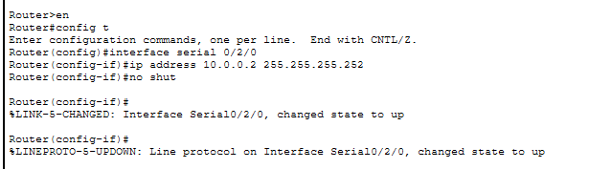

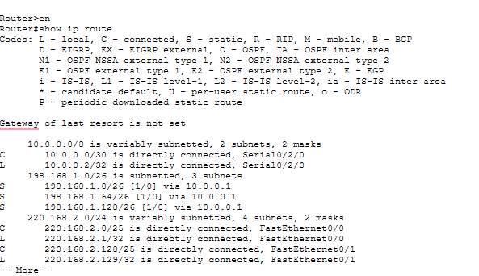
PC5 configuration –
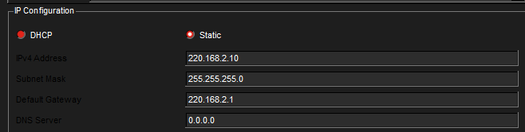

PC6 configuration –
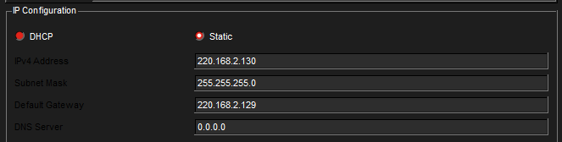
Pinging from PC5-
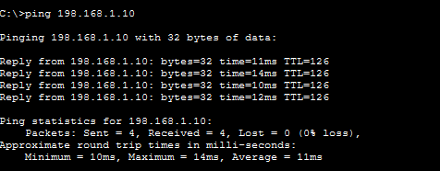

Ques3)
Topology-
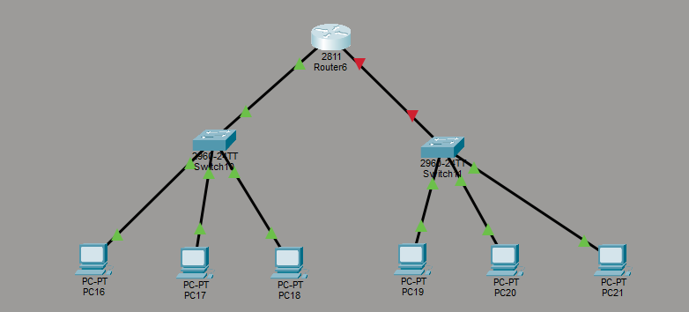

Configuration on Router6-
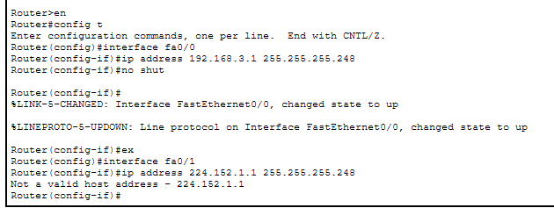
“224.x.x.x belongs to multicast address range, so it cannot be used for host addressing.
“The given network 224.152.1.0 belongs to Class D (multicast), which is not valid for host communication.

