

UNIT NAME-
SOFTWARE APPLICATION DEVELOPMENT

UNIT ID-
H7E1 04
ASSIGNMENT ID-
H7E1 04/AS/01

NAME-Ashini Sudusingha
SCN NO-2022/2023/MA/SP/136/002
NIC-200450311681
BATCH - Narwhal
BRANCH-Colombo
Calculator
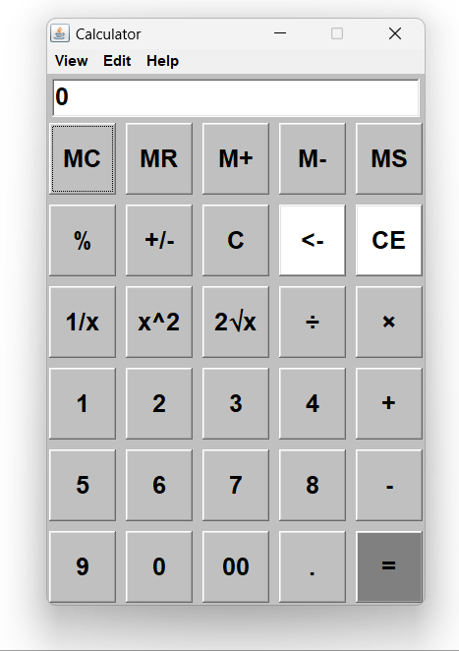

A calculator is an instrument or software used to carry out mathematical operations. These operations can be as simple as addition, subtraction, multiplication, and division. Calculators allow users to complete calculations fast and precisely, making them vital tools in a variety of industries, including science, engineering, and finance. This calculator created with AWT (Abstract Window Toolkit) in java. AWT is a set of APIs used to develop window-based applications in Java, providing a rich collection of GUI components such as buttons, text fields, labels, and panel etc.…Setup of this calculator’s graphical user interface with frame, panel, text filed, button, event handling and layout management. The Frame class is used to build the primary window, or frame. The container for each additional component will be this frame. The calculator's input and output are shown in a text box. Users can view the numbers they enter and the outcomes of their computations with this component.
Several essential elements are included in a calculator application developed using Java and AWT to provide a useful and intuitive user experience. The purpose of the number buttons—labeled for digits 0 through 9—is to facilitate user input. For convenience, these buttons are arranged in a grid pattern. Operation buttons are available for addition, subtraction, multiplication, and division in addition to the number buttons. There are several other functions like equals (=), clear (C), and delete (Del).
To organize these buttons, a panel is used, arranging them in a grid layout. This panel is then added to the main frame of the application, ensuring a neat and organized interface. Each button is equipped with an ActionListener to handle click events. When a button is clicked, the corresponding number or operation is processed. The logic for handling operations is implemented in the event handling methods. When an operator button is pressed, the current value is stored, and the operator is recorded. Upon pressing the equals button, the stored value and the current input are used to perform the operation, and the result is displayed.
The layout of the components, including the text field and buttons, is managed using layout managers provided by AWT. A grid layout is typically used for the buttons, ensuring a clean and user-friendly interface. This organization and event handling system makes the calculator both functional and easy to use.
Calculator Operations
- Addition (+) - Combines two numbers to produce their sum.
- Subtraction (-) - Subtracts the second number from the first to produce their difference.
- Multiplication (*) - Multiplies two numbers to produce their product.
- Division (/) - Divides the first number by the second to produce their quotient.
- Percentage (%) - A percentage is a number or ratio in mathematics that denotes a portion of 100. It is one technique for representing a dimensionless connection between two numbers; decimals, ratios, and fractions are other techniques. The symbol "%" is commonly used to indicate percentages, following the number.
- square root (√) - The square root of a number is defined as the value, which gives the number when it is multiplied by itself. The radical symbol √ is used to indicate the square root. For example, √16 = 4.
- Clear – The text field clear After click this button

