**Group 03**

**STAT 31631 – Statistical Modelling**

**Group project**

**Activity 01**

INTRODUCTION

This study employs a quantitative research design to analyze how various concrete mix components affect construction quality and sustainability, with a focus on the impact of material proportions and the age of the concrete on its compressive strength. Compressive strength is a critical measure of concrete's load-bearing capacity. The study examines the following independent variables: Cement, Fly Ash, Blast Furnace Slag, Water, Superplasticizer, Coarse Aggregate, Fine Aggregate, and Age (measured in days).

Cement binds the mix, while Fly Ash and Blast Furnace Slag improve durability and sustainability. Water is necessary for hydration but must be controlled to maintain strength. Superplasticizers enhance workability without extra water, and aggregates provide structural bulk. The curing age is crucial, as strength increases over time due to ongoing hydration.

The research aims to determine optimal mix proportions and curing periods to maximize compressive strength while promoting sustainability with supplementary materials like Fly Ash and Blast Furnace Slag. The study's findings will contribute to more effective and ecofriendly concrete mix designs, enhancing construction quality and reducing the environmental impact of concrete production

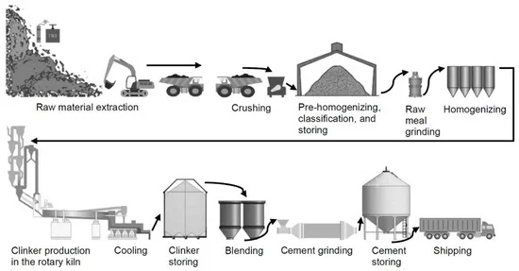

PROBLEM STATEMENT

In our project, we are focused on evaluating the strength of cement used in construction. for this, we will use some datasets taken from previous researches. These tests are designed to assess how well the cement can withstand different types of stress and strain, providing crucial information about its performance.

The primary goal of our evaluation is to ensure that the cement meets established industry standards and specifications. By conducting these tests, we aim to identify any potential weaknesses or inconsistencies in the cement's strength, which is essential for making informed decisions about its suitability for different construction applications.

Our findings will play a vital role in improving the overall quality and durability of construction projects.

OBJECTIVES

To analyze the influence of Cement, Fly Ash, Blast Furnace Slag, Water, Superplasticizer, Coarse Aggregate, and Fine Aggregate on the compressive strength of concrete.

To examine how the age of concrete (measured in days) affects its compressive strength.

To identify optimal mix proportions that maximize compressive strength while ensuring sustainability.

To provide recommendations for concrete mix designs that can be applied in the construction industry to improve quality and sustainability.

SIGNIFICANCE OF THE STUDY

This study is significant as it provides in its potential to enhance concrete production and construction practices. By developing a refined multiple linear regression model that incorporates various concrete components and age, the study aims to improve the accuracy of predicting concrete compressive strength. This advancement will lead to optimized concrete mix designs, resulting in higher quality and more durable concrete structures. The benefits extend to concrete producers, engineers, contractors, and the general public, contributing to cost savings, improved construction efficiency, and sustainable development.

Essentially, the study addresses a knowledge gap in concrete research and offers practical solutions to industry challenges, ultimately improving the construction sector and benefiting society as a whole.

GANTT CHART

GROUP MEMBERS:

**PS/2020/018 - W.D.Sandamali**

**PS/2020/110 - D.D.A.K.Indeewari**

**PS/2020/130-H.P.I.Sewwandi**

**PS/2020/132 - H.A.H.Dimalsha**

**PS/2020/135-W.T.N.Perera**

**PS/2020/238-D.W.P.S Gunathilaka**

**PS/2020/302-E.H.A.Thathsarani**

**PS/2020/318-M.R.Surandi**