Descriptive Analysis

GROUP_03

2024-07-28

#Import the dataset(Copy of Concrete_Data)  
  
Data<-read.csv("C:\\Users\\User\\OneDrive\\Desktop\\Copy of Concrete_Data.csv")  
  
colnames(Data)<-c("Cement","Blast_Furnace_Slag","Fly_Ash","Water","Superplasticizer","Coarse_Aggregate","Fine_Aggregate","Age_day","Concrete_compressive_strength")  
  
names(Data)

## [1] "Cement" "Blast_Furnace_Slag"   
## [3] "Fly_Ash" "Water"   
## [5] "Superplasticizer" "Coarse_Aggregate"   
## [7] "Fine_Aggregate" "Age_day"   
## [9] "Concrete_compressive_strength"

head(Data)

## Cement Blast_Furnace_Slag Fly_Ash Water Superplasticizer Coarse_Aggregate  
## 1 540.0 0.0 0 162 2.5 1040.0  
## 2 540.0 0.0 0 162 2.5 1055.0  
## 3 332.5 142.5 0 228 0.0 932.0  
## 4 332.5 142.5 0 228 0.0 932.0  
## 5 198.6 132.4 0 192 0.0 978.4  
## 6 266.0 114.0 0 228 0.0 932.0  
## Fine_Aggregate Age_day Concrete_compressive_strength  
## 1 676.0 28 79.99  
## 2 676.0 28 61.89  
## 3 594.0 270 40.27  
## 4 594.0 365 41.05  
## 5 825.5 360 44.30  
## 6 670.0 90 47.03

###Missing values  
  
print("Total of Missing values")

## [1] "Total of Missing values"

sum(is.na(Data))

## [1] 0

colSums(is.na(Data))

## Cement Blast_Furnace_Slag   
## 0 0   
## Fly_Ash Water   
## 0 0   
## Superplasticizer Coarse_Aggregate   
## 0 0   
## Fine_Aggregate Age_day   
## 0 0   
## Concrete_compressive_strength   
## 0

This data set has no missing values.

##########Descriptive Analysis##########  
  
#################Cement############  
  
##Summary  
  
summary(Data$Cement)

## Min. 1st Qu. Median Mean 3rd Qu. Max.   
## 102.0 192.4 272.9 281.2 350.0 540.0

##Histogram  
hist(Data$Cement,xlab = "Cement",main="Histogram of Cement")

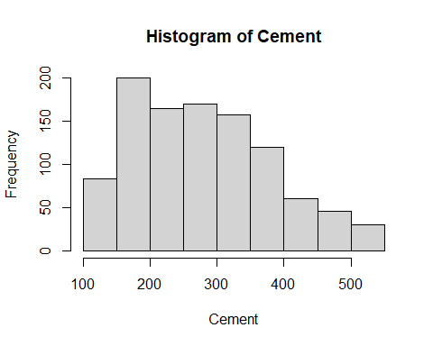

#################Blast_Furnace_Slag############  
  
##Summary  
  
summary(Data$Blast_Furnace_Slag)

## Min. 1st Qu. Median Mean 3rd Qu. Max.   
## 0.0 0.0 22.0 73.9 142.9 359.4

##Histogram  
hist(Data$Blast_Furnace_Slag,xlab = "Blast_Furnace_Slag",main="Histogram of Blast_Furnace_Slag")

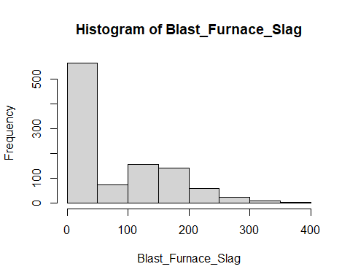

#################Fly_Ash############  
  
##Summary  
  
summary(Data$Fly_Ash)

## Min. 1st Qu. Median Mean 3rd Qu. Max.   
## 0.00 0.00 0.00 54.19 118.30 200.10

##Histogram  
hist(Data$Fly_Ash,xlab = "Fly_Ash",main="Histogram of Fly_Ash")

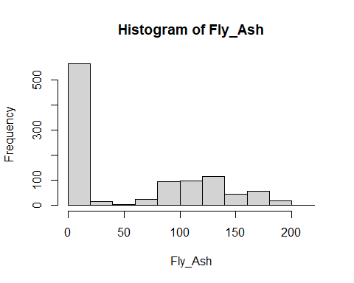

#################Water############  
  
##Summary  
  
summary(Data$Water)

## Min. 1st Qu. Median Mean 3rd Qu. Max.   
## 121.8 164.9 185.0 181.6 192.0 247.0

##Histogram  
hist(Data$Water,xlab = "Water",main="Histogram of Water")

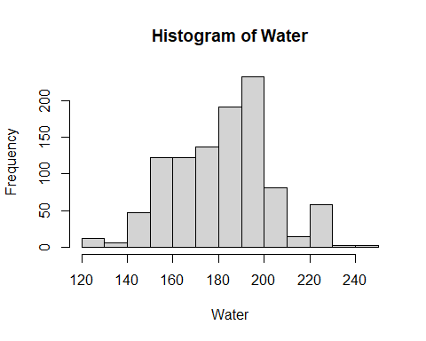

###############Superplasticizer############  
  
##Summary  
  
summary(Data$Superplasticizer)

## Min. 1st Qu. Median Mean 3rd Qu. Max.   
## 0.000 0.000 6.400 6.205 10.200 32.200

##Histogram  
hist(Data$Superplasticizer,xlab = "Superplasticizer",main="Histogram of Superplasticizer")

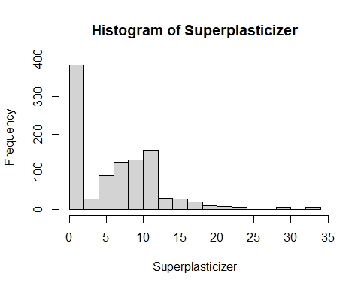

###############Coarse_Aggregate############  
  
##Summary  
  
summary(Data$Coarse_Aggregate)

## Min. 1st Qu. Median Mean 3rd Qu. Max.   
## 801.0 932.0 968.0 972.9 1029.4 1145.0

##Histogram  
hist(Data$Coarse_Aggregate,xlab = "Coarse_Aggregate",main="Histogram of Coarse_Aggregate")

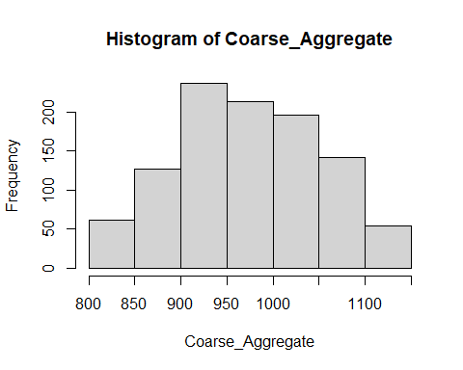

###############Fine_Aggregate############  
  
##Summary  
  
summary(Data$Fine_Aggregate)

## Min. 1st Qu. Median Mean 3rd Qu. Max.   
## 594.0 731.0 779.5 773.6 824.0 992.6

##Histogram  
hist(Data$Fine_Aggregate,xlab = "Fine_Aggregate",main="Histogram of Fine_Aggregate")

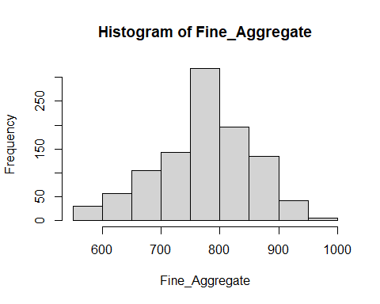

###############`Age_day`############  
  
##Summary  
  
summary(Data$Age_day)

## Min. 1st Qu. Median Mean 3rd Qu. Max.   
## 1.00 7.00 28.00 45.66 56.00 365.00

##Histogram  
hist(Data$Age_day,xlab = "Age_(day)",main="Histogram of Age_(day)")

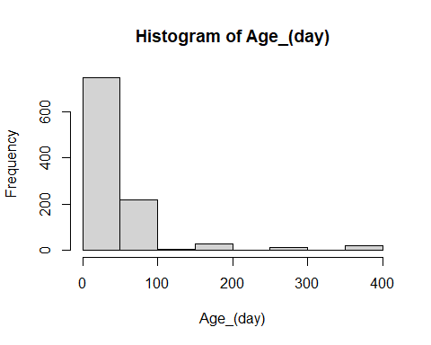

###############Concrete_compressive_strength############  
  
##Summary  
  
summary(Data$Concrete_compressive_strength)

## Min. 1st Qu. Median Mean 3rd Qu. Max.   
## 2.33 23.71 34.45 35.82 46.13 82.60

##Histogram  
hist(Data$Concrete_compressive_strength,xlab = "Concrete_compressive_strength",main="Histogram of Concrete_compressive_strength")

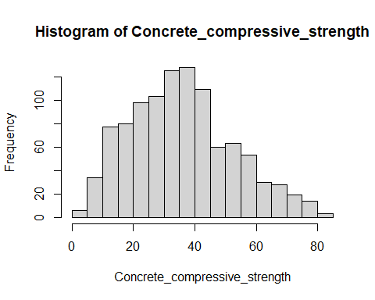

####Cement  
##Boxplot  
boxplot(Data$Cement,ylab="Cement",main="Boxplot of Cement",sub=paste("Outliers: ",boxplot.stats(Data$Cement)$out))

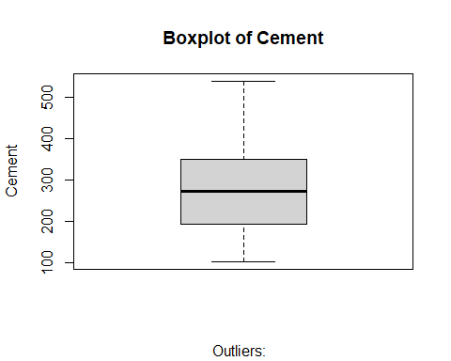

#This boxplot seems that no outliers

#Blast_Furnace_Slag  
##Boxplot  
boxplot(Data$Blast_Furnace_Slag,ylab="Blast_Furnace_Slag",main="Boxplot of Blast_Furnace_Slag",sub=paste("Outliers: ",boxplot.stats(Data$Blast_Furnace_Slag)$out))

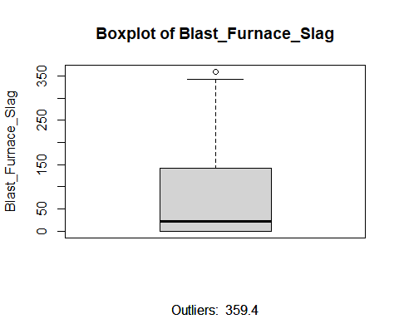

#This box plot seems that one outlier point.  
#Remove the outlier row.  
outlier_rows_Blast_Furnace_Slag<-boxplot.stats(Data$Blast_Furnace_Slag)$out  
  
#Clean Outliers  
Data_cleaned_1<-subset(Data,!(Blast_Furnace_Slag%in%outlier_rows_Blast_Furnace_Slag))

##Fly_Ash  
##Boxplot  
boxplot(Data_cleaned_1$Fly_Ash,ylab="Fly_Ash",main="Boxplot of Fly_Ash",sub=paste("Outliers: ",boxplot.stats(Data_cleaned_1$Fly_Ash)$out))

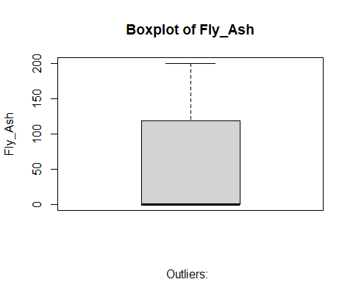

#This box plot seems that no outlier.

#Water  
##Boxplot  
boxplot(Data_cleaned_1$Water,ylab="Water",main="Boxplot of Water",sub=paste("Outliers: ",boxplot.stats(Data_cleaned_1$Water)$out))

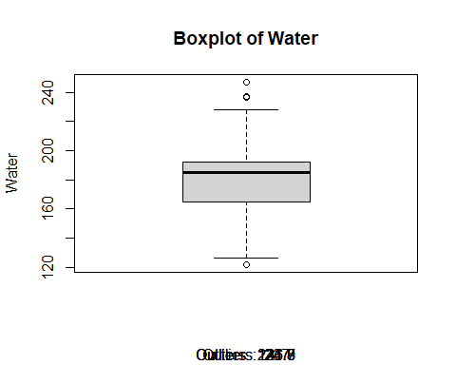

#This box plot seems that three outlier points.  
#Remove the outlier row.  
outlier_rows_Water<-boxplot.stats(Data_cleaned_1$Water)$out  
  
Data_cleaned_2<-subset(Data_cleaned_1,!(Water%in%outlier_rows_Water))

#Superplasticizer  
##Boxplot  
boxplot(Data_cleaned_2$Superplasticizer,ylab="Superplasticizer",main="Boxplot of Superplasticizer",sub=paste("Outliers: ",boxplot.stats(Data_cleaned_2$Superplasticizer)$out))

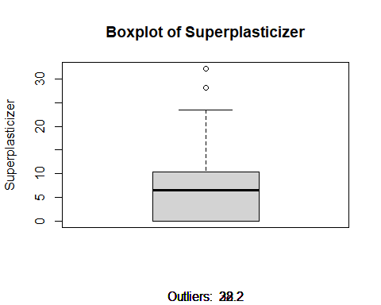

#This box plot seems that two outlier points.  
#Remove the outlier row.  
outlier_rows_Superplasticizer<-boxplot.stats(Data_cleaned_2$Superplasticizer)$out  
  
  
Data_cleaned_3<-subset(Data_cleaned_2,!(Superplasticizer%in%outlier_rows_Superplasticizer))

##Coarse_Aggregate  
##Boxplot  
boxplot(Data_cleaned_3$Coarse_Aggregate,ylab="Coarse_Aggregate",main="Boxplot of Coarse_Aggregate",sub=paste("Outliers: ",boxplot.stats(Data_cleaned_3$Coarse_Aggregate)$out))

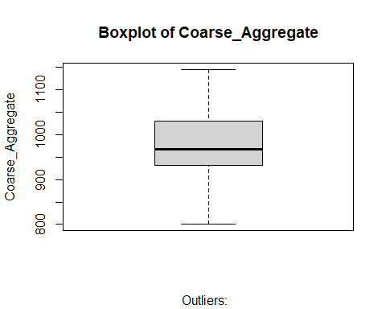

#This box plot seems that no outlier points.

##Fine_Aggregate  
##Boxplot  
boxplot(Data_cleaned_3$Fine_Aggregate,ylab="Fine_Aggregate",main="Boxplot of Fine_Aggregate",sub=paste("Outliers: ",boxplot.stats(Data_cleaned_3$Fine_Aggregate)$out))

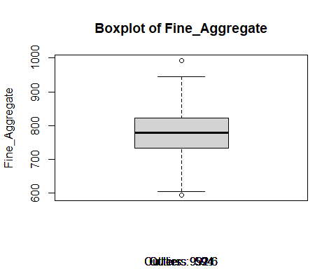

#This box plot seems that one outlier point.  
#Remove the outlier row.  
outlier_rows_Fine_Aggregate<-boxplot.stats(Data_cleaned_3$Fine_Aggregate)$out  
  
  
Data_cleaned_4<-subset(Data_cleaned_3,!(Fine_Aggregate%in%outlier_rows_Fine_Aggregate))

#Age_(day)  
##Boxplot  
boxplot(Data_cleaned_4$Age_day,ylab="`Age_(day)`",main="Boxplot of `Age_(day)`",sub=paste("Outliers: ",boxplot.stats(Data_cleaned_4$Age_day)$out))

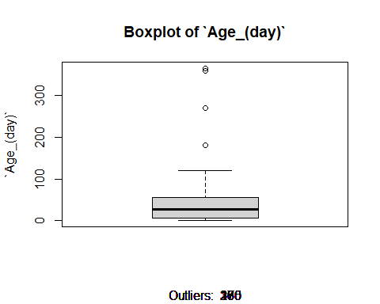

#This box plot seems that four outlier points.  
#Remove the outlier row.  
outlier_rows_Age<-boxplot.stats(Data_cleaned_4$Age_day)$out  
  
Data_cleaned_5<-subset(Data_cleaned_4,!(Age_day%in%outlier_rows_Age))

#Concrete_compressive_strength  
##Boxplot  
boxplot(Data_cleaned_5$Concrete_compressive_strength,ylab="Concrete_compressive_strength",main="Boxplot of Concrete_compressive_strength",sub=paste("Outliers: ",boxplot.stats(Data_cleaned_5$Concrete_compressive_strength)$out))

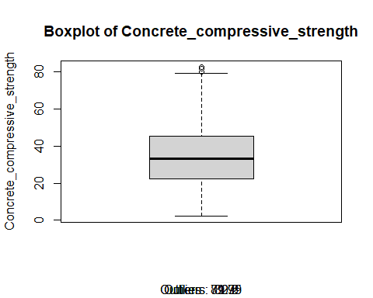

#This box plot seems that four outlier points.  
#Remove the outlier row.  
outlier_rows_Concrete_compressive_strength<-boxplot.stats(Data_cleaned_5$Concrete_compressive_strength)$out  
  
  
  
Data_cleaned_6<-subset(Data_cleaned_5,!(Concrete_compressive_strength%in%outlier_rows_Concrete_compressive_strength))

###This is our cleaned dataset  
  
cleaned_data<-Data_cleaned_6  
head(cleaned_data)

## Cement Blast_Furnace_Slag Fly_Ash Water Superplasticizer Coarse_Aggregate  
## 2 540.0 0.0 0 162 2.5 1055.0  
## 6 266.0 114.0 0 228 0.0 932.0  
## 9 266.0 114.0 0 228 0.0 932.0  
## 11 198.6 132.4 0 192 0.0 978.4  
## 12 198.6 132.4 0 192 0.0 978.4  
## 14 190.0 190.0 0 228 0.0 932.0  
## Fine_Aggregate Age_day Concrete_compressive_strength  
## 2 676.0 28 61.89  
## 6 670.0 90 47.03  
## 9 670.0 28 45.85  
## 11 825.5 90 38.07  
## 12 825.5 28 28.02  
## 14 670.0 90 42.33

nrow(cleaned_data)

## [1] 926