Sri Lanka Institute of Information

Technology
Programming Applications and Frameworks (IT3030)

Final Assignment Report

GROUP ID: 18

Smart Campus

Student ID | Student Name
IT23141988 | M.D.C. SAMARAWEERA
IT23222168 | K.M.R.H.A. BANDARA
IT23350496 | K.G.U. SILVA
IT23443556 | I.S. GALAHITIYAWA

Date: 27.04.2026
Contents
1.Introduction 4
3.Functional Requirements & Non-Functional Requirements 6
4.Overall Architecture Diagram 10
4.1 Overall Architecture 11
4.2 Frontend (React) 11
4.3 Backend (Spring Boot) 11
4.4 Authentication & Security 12
4.5 Database (PostgreSQL - Neon) 12
4.6 File Storage 12
4.7 CI/CD Integration 12
4.8 Data Flow 13
5.Database Design 14
6.REST API Architecture diagram 18
7.Frontend Architecture Diagram 19
8.System Functions 20
8.1 Facilities & Assets Catalogue (M.D.C. SAMARAWEERA - IT23141988) 20
8.2 Booking Management (GALAHITIYAWA I.S. - IT23443556) 22
8.3Maintenance & Incident Ticketing (BANDARA K.M.R.H.A. - IT23222168) 23
8.4 Notifications, Authentication & Role Management (SILVA K.G.U. -IT23350496) 25
9. API endpoints 28
9.1 TicketController Endpoints 28
9.2 BookingController Endpoints 29
9.3 ResourceController Endpoints 30
9.4 AuthController Endpoints 31
9.5 NotificationController Endpoints 32
10.Innovative Features 33
10.1 Activity Log – Incident Ticketing 33
10.2 Chatbot Assistant – Facilities & Assets Catalogue 34
10.3 Best Match Filter– Facilities & Assets Catalogue 35
10.4 Notification Preferences– Notifications 36
10.5 Admin dashboard with usage analytics (top resources, peak booking hours) – Booking Management 37
10.6 Venue & Capacity-Aware Equipment Conflict Checking - Booking Management 38
11. GitHub 40
12. Team Collaboration 42
13. References 43

Introduction

The rapid advancement of digital technologies has significantly transformed how organizations manage their operations, particularly within educational institutions. Universities today require efficient, centralized systems to handle complex processes such as resource allocation, booking management, and maintenance handling. In response to these needs, this project presents the design and implementation of a Smart Campus Operations Hub, a comprehensive web-based system developed to streamline facility and asset management alongside incident ticketing processes.

This system is built using a modern full-stack architecture, consisting of a Spring Boot REST API and a React-based client application, ensuring scalability, maintainability, and a user-friendly experience. The platform enables users to seamlessly browse available resources such as lecture halls, laboratories, and equipment, while also allowing them to submit and manage booking requests efficiently. Furthermore, it incorporates a structured workflow for maintenance and incident reporting, enabling users to raise tickets, attach supporting evidence, and track progress until resolution.
A key strength of the system lies in its role-based access control, supporting different user roles such as administrators, technicians, and general users, ensuring secure and organized operations. Additionally, features such as notifications, audit tracking, and workflow management enhance transparency and accountability across the platform.

This system addresses real-world challenges faced by universities by integrating booking and maintenance functionalities into a single unified solution. Overall, this project demonstrates the practical application of modern web development frameworks to deliver a robust, efficient, and scalable solution for smart campus management.

- System Overview
The Smart Campus Operations Hub is a comprehensive web-based platform designed to streamline and digitalize key operational processes within a university environment. The system integrates facility and asset management with maintenance and incident handling into a single unified solution, improving efficiency, transparency, and user experience.

The platform enables users to browse and book campus resources such as lecture halls, laboratories, and equipment, while also providing functionality to report and track maintenance issues through an incident ticketing system. Each process follows a well-defined workflow, ensuring proper validation, approval, and resolution stages.
The system is built using a modern full-stack architecture, consisting of a React-based frontend for an interactive user interface and a Spring Boot backend that exposes RESTful APIs to handle business logic and data processing. All data is securely stored in a cloud-based PostgreSQL (Neon) database, ensuring scalability, reliability, and efficient data management.

To enhance security and usability, the system incorporates Google OAuth 2.0 authentication, allowing users to log in securely while enabling role-based access control for Admins, Users, and Technicians. Additional features such as notifications, file attachments, and audit logging further improve system functionality and user engagement.

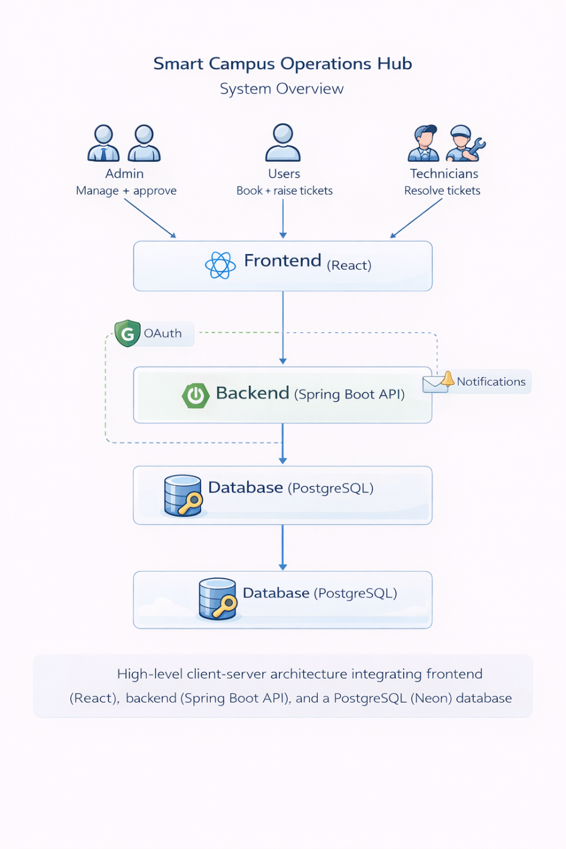
Overall, the Smart Campus Operations Hub provides a centralized, scalable, and secure solution that supports modern campus management needs by integrating multiple services into a single platform.

Functional Requirements & Non-Functional Requirements

Functional requirements describe what the system should do.

1. User Management & Authentication
- Users must be able to register and log in using secure authentication (e.g., OAuth 2.0).
- The system must support role-based access (USER, ADMIN, TECHNICIAN).
- Users must be able to log out securely.
- Admin must be able to manage user roles.

2. Facilities & Assets Management
- Admin can add, update, and delete resources (rooms, labs, equipment).
- Each resource must include:
- Name, type, capacity, location
- Availability time windows
- Status (ACTIVE / OUT_OF_SERVICE)
- Users can view available resources.
- Users can search and filter resources by type, location, and capacity.

3. Booking Management
- Users can create booking requests with:
- Date, time range, purpose, attendees
- System must:
- Prevent overlapping bookings for the same resource
- Validate input data
- Booking workflow:
- PENDING → APPROVED / REJECTED → CANCELLED
- Admin can:
- Approve/reject bookings with reason
- Users can:
- View their bookings
- Cancel approved bookings

4. Incident & Maintenance Ticketing
- Users can create incident tickets including:
- Resource/location
- Category, description, priority
- Contact details

- Users can upload up to 3 attachments (images).
- Ticket workflow:
- OPEN → IN_PROGRESS → RESOLVED → CLOSED / REJECTED
- Admin can:
- Assign technician to tickets
- See all Tickets created by users
- Eject tickets with reasons
- Close the ticket
- See the ticket analysis dashboard
- Technicians can:
- Only see assigned tickets by Admin
- Update status
- Add resolution notes
- See assigned tickets analysis dashboard
- Users and staff can:
- Add comments
- Edit/delete their own comments

5. Notifications System
- Users receive notifications for:
- Booking approval/rejection
- Ticket status updates
- New comments
- Notifications must be viewable in the UI panel.

6. Dashboard & Monitoring
- Admin dashboard should display:
- Total bookings
- Active tickets
- Resource usage statistics

- Users’ dashboard:
- Personal bookings
- Ticket status overview

7. Attachment Management
- Users can upload and view attachments in tickets.
- Attachments must be accessible to:
- Admin
- Assigned technician

8. Search & Filtering
- Users can search:
- Resources
- Bookings
- Tickets
- Filters should include:
- Date, status, category, priority

9. Audit & Logging
- System must track:
- Booking actions
- Ticket updates
- Admin can view activity logs.

Non-Functional Requirements

Non-functional requirements describe how the system performs.

1. Performance
- System should respond within 2–3 seconds for most operations.
- Must support multiple concurrent users.
2. Security
- Use secure authentication (OAuth 2.0).
- Implement role-based authorization.
- Protect APIs from unauthorized access.
- Validate all inputs to prevent attacks (SQL injection, XSS).
- Secure file uploads.
3. Scalability
- System should handle increasing users and data.
- Backend should support horizontal scaling.
4. Usability
- UI must be user-friendly and intuitive.
- Navigation should be simple and consistent.
- System should be responsive (mobile-friendly).
5. Reliability
- System should be available 99% uptime.
- Must handle errors gracefully without crashing.

6. Maintainability
- Code should follow clean architecture (layered structure).
- Easy to update and extend features.
7. Compatibility
- Web app must work on:
Chrome, Edge, Firefox
- Support different screen sizes.
8. Data Integrity
- Ensure no duplicate or conflicting bookings.
- Maintain accurate and consistent data.
9. Backup & Recovery
- System should support data backup.
- Ability to recover from failures.
10. Logging & Monitoring
- Log system errors and activities.
- Enable debugging and monitoring.
11. File Handling
- Limit file size and type for attachments.
- Ensure safe storage and retrieval.
12. Compliance & Standards
- Follow REST API best practices.
- Use proper HTTP status codes.

Overall Architecture Diagram

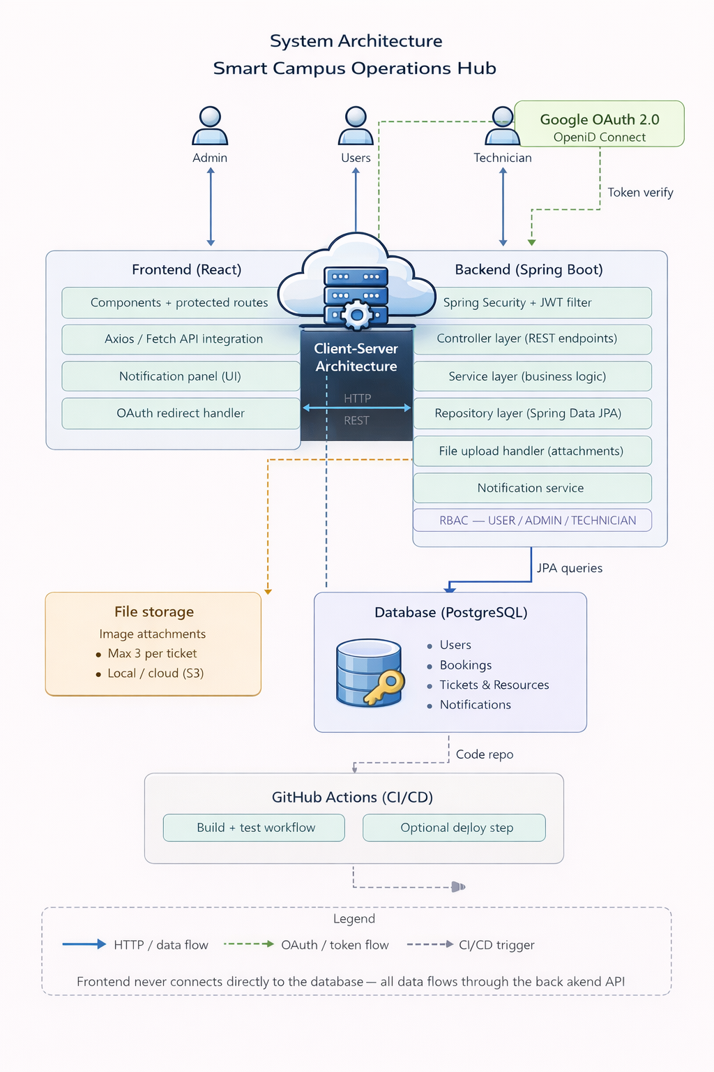
The Smart Campus Operations Hub is designed using a modern client–server architecture, ensuring a clear separation between presentation, business logic, and data management layers. The system integrates multiple components including a React-based frontend, a Spring Boot backend, a PostgreSQL (Neon) database, file storage services, and CI/CD pipelines, working together to provide a scalable and efficient solution.

4.1 Overall Architecture

The system follows a three-tier architecture consisting of:

- Presentation Layer (Frontend – React)
- Application Layer (Backend – Spring Boot)
- Data Layer (PostgreSQL Database)
All communication between the frontend and backend occurs via RESTful APIs over HTTP, ensuring that the frontend never directly interacts with the database. This improves security and maintainability.
Additionally, the system incorporates OAuth 2.0 authentication (Google OpenID Connect) for secure user login and identity management.

4.2 Frontend (React)
The frontend is implemented using React, following a component-based architecture to enhance reusability and maintainability. It includes:
- UI components with protected routes based on user roles
- Integration with backend APIs using Axios/Fetch
- A notification panel for real-time updates
- OAuth redirect handling for authentication
The frontend acts as the user interface for Admins, Users, and Technicians, enabling them to interact with system functionalities efficiently.

4.3 Backend (Spring Boot)
The backend of the system is developed using the Spring Boot framework, which provides a robust environment for building scalable and secure RESTful web services. The system follows RESTful API design principles, enabling efficient communication between the client and server using standard HTTP methods such as GET, POST, PUT, and DELETE.
A layered architecture is implemented to maintain clean code structure and separation of responsibilities:
- Controller Layer - Handles REST API endpoints and incoming requests
- Service Layer - Contains business logic such as booking validation and ticket workflows
- Repository Layer - Manages database interactions using Spring Data JPA
Additional backend features include:
- Spring Security with JWT filters for secure authentication and authorization
- Role-Based Access Control (RBAC) supporting USER, ADMIN, and TECHNICIAN roles
- File upload handling for ticket attachments
- Notification service for managing system alerts and updates
This structured approach improves maintainability, testability, and scalability of the backend system.

4.4 Authentication & Security

The system integrates Google OAuth 2.0 (OpenID Connect) for user authentication. Token-based verification ensures secure communication between the frontend and backend. Access to system features is controlled through role-based authorization.

4.5 Database (PostgreSQL - Neon)

The system utilizes a cloud-based relational database powered by PostgreSQL (Neon) to store and manage structured data efficiently. PostgreSQL provides a robust and reliable environment for handling complex queries and maintaining relationships between key entities such as users, resources, bookings, and incident tickets. The use of Neon as a serverless cloud platform further enhances scalability, performance, and ease of deployment.

Key features of the database design include:

- Structured schema with normalized tables to reduce redundancy
- Enforcement of relationships using foreign key constraints
- Efficient querying for booking management, ticket tracking, and resource allocation
The database ensures high levels of data integrity, consistency, and reliability, while the cloud-based nature of Neon enables seamless scaling and availability, supporting the overall functionality and performance of the system.

4.6 File Storage

The system supports file storage for ticket attachments, allowing users to upload images (maximum of 3 per ticket). Files can be stored either locally or using cloud storage services such as AWS S3.

4.7 CI/CD Integration

The project utilizes GitHub Actions for continuous integration and deployment:
- Automated build and test workflows
- Optional deployment pipeline
This ensures code quality, consistency, and faster delivery.

4.8 Data Flow

- User requests are sent from the frontend to the backend via HTTP/REST
- Backend processes the request and interacts with the database
- Responses are returned to the frontend for display
- Authentication flows use OAuth tokens for secure access

5.Database Design
The Smart Campus Operations Hub utilizes a relational database design implemented using PostgreSQL (Neon) to efficiently manage structured data and maintain relationships between system entities. The database schema is designed following normalization principles to reduce redundancy, ensure data integrity, and support scalable operations.

5.1 Core Entities
The system consists of the following main entities:
- User
Stores user information including name, email, role, and profile details. The system supports three roles: USER, ADMIN, and TECHNICIAN.
- Resource
Represents campus facilities and assets such as lecture halls, laboratories, and equipment.
- Booking
Handles resource reservation details including user, resource, and time period.
- Ticket
Manages maintenance and incident reports created by users, including status, priority, and resolution details.
- Ticket Attachment
Stores files (e.g., images) related to tickets as supporting evidence.
- Comment
Allows users, admins, and technicians to communicate within a ticket.
- Notification
Stores system-generated alerts related to bookings, tickets, and updates.
5.2 Relationships Between Entities
The database defines several relationships to support system functionality:
- A User can create multiple Tickets (1 → Many) as a reporter.
- A User (Technician) can be assigned to multiple Tickets (1 → Many, optional).
- A Ticket can have multiple Attachments (1 → Many).
- A Ticket can have multiple Comments (1 → Many).
- Each Comment is associated with one User (Many → 1) as the author.
- A Resource can have multiple Bookings (1 → Many).
- A User can make multiple Bookings (1 → Many).
- A User can receive multiple Notifications (1 → Many).
- A Ticket can generate multiple Notifications (1 → Many).
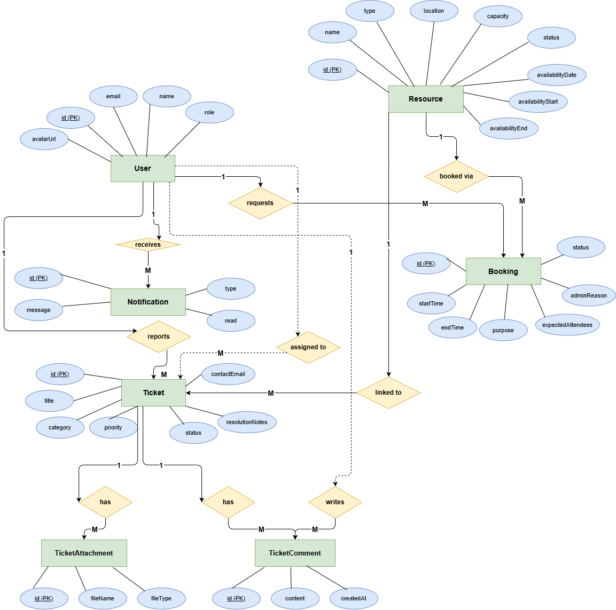
These relationships are enforced using foreign key constraints, ensuring referential integrity across the database.

Assumptions

The following assumptions were made during the design of the Entity-Relationship (ER) Diagram for the Smart Campus Operations Hub:
User & Roles
- The system maintains a single User entity with a role attribute to differentiate between USER, ADMIN, and TECHNICIAN.
- A user can have only one role at a time.
- All system actors (Admin, User, Technician) are represented within the same table.
Ticket Management
- Each Ticket must have one reporter (user who created it).
- A ticket may be assigned to zero or one technician (optional assignment).
- A ticket is associated with at most one resource (optional relationship).
- A ticket must have a status and priority, defined using enumerated values.
- A ticket can have multiple attachments, comments, and notifications.
Ticket Attachments
- Each attachment belongs to exactly one ticket.
- A ticket can have multiple attachments, but typically limited (e.g., maximum 3 files per ticket).
- Attachments store file data and metadata (e.g., file name, type).
Comments
- Each comment is associated with exactly one ticket.
- Each comment has one author (user).
- Users (User, Admin, Technician) can create comments.
- Only the comment owner is allowed to edit or delete their comment.
Booking & Resources
- Each booking is associated with one user and one resource.
- A resource can have multiple bookings, but time conflicts are prevented at the application level.
- A user can create multiple bookings.
Notifications
- Each notification is associated with one user.
- A notification may optionally be linked to a specific ticket or booking event.
- A user can receive multiple notifications.
- Notifications are generated automatically based on system events (e.g., ticket updates, booking approvals).
General Assumptions
- All entities use a unique primary key (ID).
- Relationships are enforced using foreign key constraints.
- Time-related attributes (e.g., created_at, updated_at) are stored for tracking purposes.
- The system ensures data integrity and consistency through validation and constraints at both database and application levels.

REST API Architecture diagram
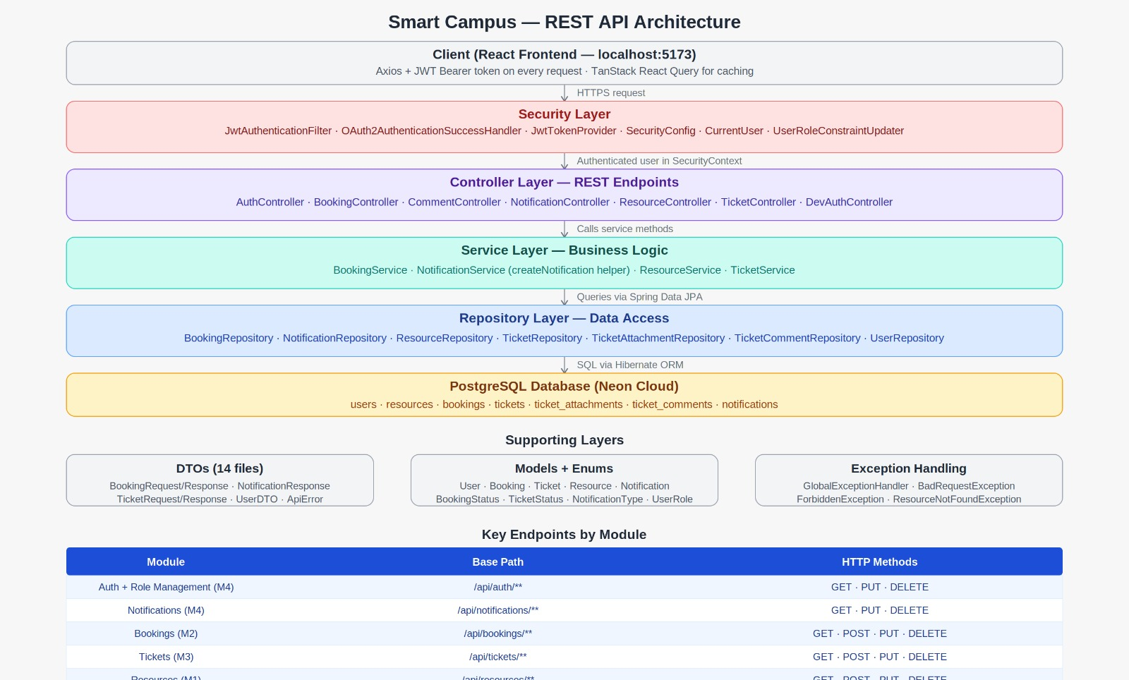

The Smart Campus REST API follows a strict layered architecture built on Spring Boot 3.5. At the top sits the React client on localhost:5173, communicating with the backend via Axios with a JWT Bearer token attached to every request. The first layer the request hits is the Security layer, which contains JwtAuthenticationFilter which runs before every controller, extracts the JWT from the Authorization header, validates it using JwtTokenProvider, and places the authenticated user into Spring Security's SecurityContext. OAuth2AuthenticationSuccessHandler handles the Google login flow, creating users on first sign-in and generating the JWT. SecurityConfig configures CORS (allowing only the frontend origin), disables server-side sessions (stateless), and registers all security rules including @EnableMethodSecurity for @PreAuthorize annotations.

Below security sits the Controller layer, which maps HTTP endpoints to service methods. Each controller handles request validation and response formatting only, no business logic lives here. The Service layer holds all business logic: NotificationService includes the shared createNotification() helper called by BookingService and TicketService to trigger event driven notifications. The Repository layer uses Spring Data JPA, method names like findByUserIdOrderByCreatedAtDesc auto-generate SQL queries, so no manual SQL is written. Finally, all data is persisted in a cloud hosted PostgreSQL database on Neon, with seven tables covering all entities. Supporting layers include 14 DTOs for request/response mapping, JPA entity models with enums, and a GlobalExceptionHandler that returns consistent JSON error responses.

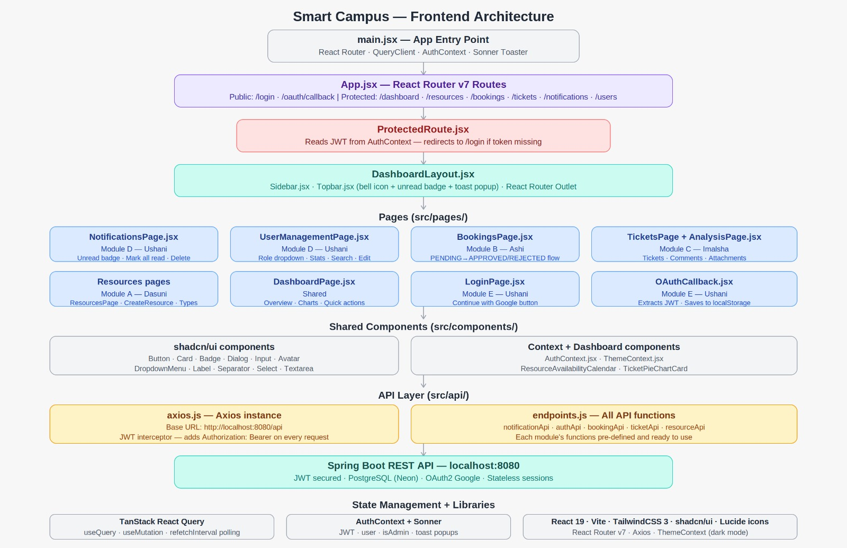
Frontend Architecture Diagram

The React frontend is built with Vite and uses a clean, layered component architecture. The entry point main.jsx wraps the entire app in four providers: React Router for navigation, TanStack QueryClient for API state management, AuthContext for JWT and user state, and Sonner's Toaster for toast pop ups. App.jsx defines all routes, public routes (/login, /oauth/callback) are open, while all other routes are wrapped in ProtectedRoute.jsx, which checks the JWT from AuthContext and redirects to /login if missing.

All authenticated pages render inside DashboardLayout.jsx, which provides the persistent Sidebar.jsx for navigation and Topbar.jsx for the notification bell badge that polls the unread count every 10 seconds and shows toast pop-ups when new notifications arrive.
All pages consume API functions from endpoints.js through the shared Axios instance in axios.js, which automatically injects the JWT Bearer token on every outgoing request. shadcn/ui components provide the consistent UI building blocks across all pages. TanStack React Query manages all server state with built-in caching, refetching, and mutation handling, while AuthContext handles the OAuth callback token storage and logout logic.

8.System Functions

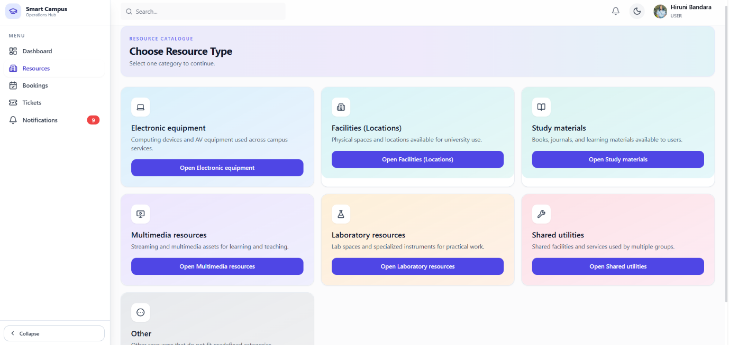
8.1 Facilities & Assets Catalogue (M.D.C. SAMARAWEERA - IT23141988)

Member 1 was responsible for the complete facilities and assets catalogue, which forms the foundation of the Smart Campus system. This module allows the university to maintain a centralised catalogue of all bookable resources including lecture halls, labs, meeting rooms, and equipment such as projectors and cameras.

Backend (Spring Boot REST API)

The following REST API endpoints were implemented:

- GET /api/resources - retrieves all resources with optional query filters for type, status, location, minimum capacity, and keyword search

- GET /api/resources/{id} - retrieves a specific resource by ID, returning 404 if not found

- POST /api/resources - creates a new resource (admin only), accepting all metadata fields

- PUT /api/resources/{id} - updates an existing resource's details and status (admin only)

- DELETE /api/resources/{id} - removes a resource from the catalogue (admin only), returning 204 No Content

The ResourceService handles all business logic including in-stream filtering for multi-field search. The Resource entity stores name, type, capacity, location, description, availability window (start and end times), availability date, and status (ACTIVE or OUT_OF_SERVICE). The OUT_OF_SERVICE status is enforced at the booking layer to prevent new bookings on unavailable resources. ResourceRequest and ResourceResponse DTOs decouple the API contract from the JPA entity.

Frontend (React)

The frontend includes ResourcesPage.jsx for browsing all resources with search and filter controls, ResourceCategoryPage.jsx for viewing resources grouped by category, CreateResourcePage.jsx and ResourceFormDialog.jsx for admin resource creation and editing, and resourceCategoryConfig.js for mapping resource types to labels and icons.

Innovative addition

Two features were added beyond the minimum requirements. The first is a Category Assistant (FacilitiesAssistant.jsx), a conversational interface that helps users describe what they need and suggests the most relevant resource category. The second is a Best Match Filter that scores and ranks resources based on multiple criteria including capacity, availability, and location to surface the most suitable option rather than returning a flat filtered list.

8.2 Booking Management (GALAHITIYAWA I.S. - IT23443556)

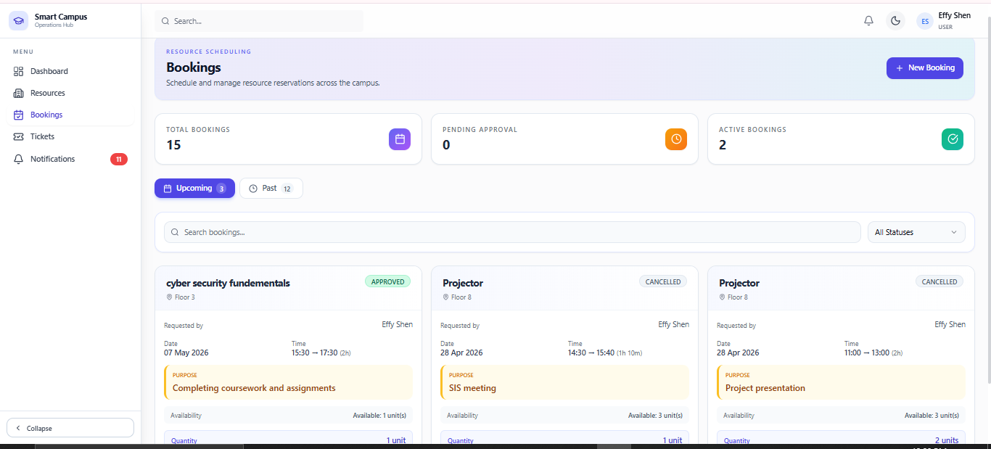

Member 2 owned the complete booking workflow from submission to resolution, including conflict detection, role-based visibility, and admin approval controls.

Backend (Spring Boot REST API)

The following REST API endpoints were implemented:
- GET /api/bookings - lists bookings; users see only their own while admins can filter by resource, status, and user ID

- GET /api/bookings/{id} - retrieves a specific booking (owner or admin only), returning 403 for unauthorised access

- POST /api/bookings - creates a new booking request after validating the resource availability window and checking for scheduling conflicts

- PUT /api/bookings/{id}/status - allows admins to approve or reject a booking; rejection requires a reason; triggers a notification to the booking owner

- DELETE /api/bookings/{id} - cancels a booking; owners can cancel PENDING or APPROVED bookings; admins can cancel any; REJECTED bookings cannot be cancelled

A custom JPQL query in BookingRepository detects overlapping time ranges for the same resource with APPROVED status and throws a 400 Bad Request if a conflict is found. The service layer also validates that requested start and end times fall within the resource's defined availability window. The booking status follows a strict workflow: PENDING on creation, then APPROVED or REJECTED by an admin, with CANCELLED as a terminal state for approved bookings. The BookingResponse DTO includes nested ResourceResponse and UserDTO objects to provide complete booking context without exposing JPA entities directly.

Frontend (React)

BookingsPage.jsx provides the full booking management interface. Users see their own bookings with status badges and cancellation controls. Admins see all bookings with filter dropdowns and approve/reject/cancel action buttons with confirmation dialogs.

Innovative Addition

Two features were added beyond the minimum requirements. The first is a Dual-Strategy Conflict Detection Engine that prevents double-booking through two purpose-built algorithms, an interval overlap check for exclusive venues and a capacity-aware unit sum check for shared equipment, ensuring maximum resource utilization without sacrificing scheduling integrity. The second is an Admin Analytics Dashboard embedded within the Booking Management module that derives real-time insights from loaded booking data, surfacing the top five most booked resources and the six peak booking hours of the day through proportional bar visualizations, enabling administrators to make informed decisions about resource availability and scheduling.

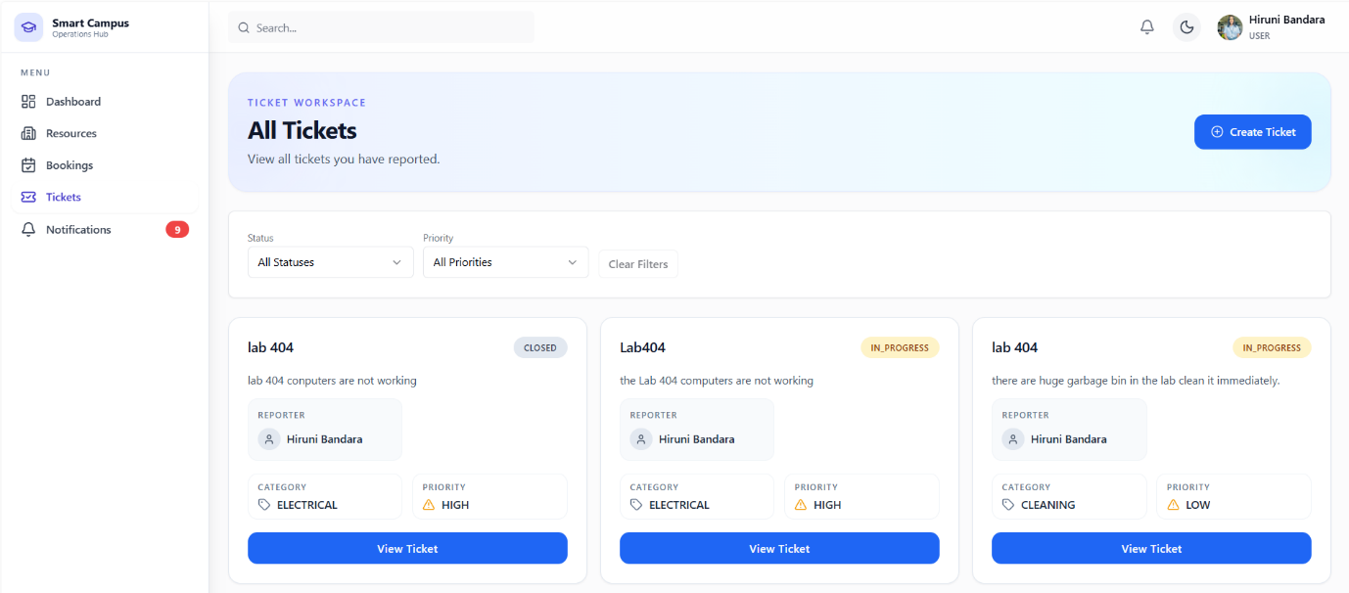
8.3Maintenance & Incident Ticketing (BANDARA K.M.R.H.A. - IT23222168)

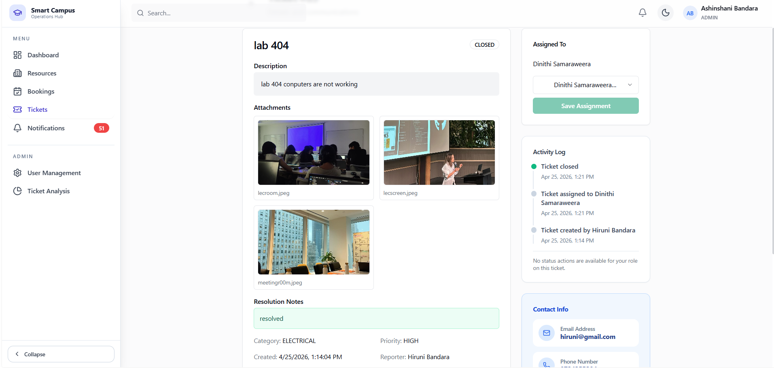
Member 3 was responsible for the full incident ticketing system covering ticket creation, image attachments, technician assignment, status transitions, and comment threads.

Backend (Spring Boot REST API)

The following REST API endpoints were implemented:

- GET /api/tickets - lists tickets; users see their own; admins and technicians see all with filters for status, priority, and assigned technician

- GET /api/tickets/{id} - retrieves full ticket detail including attachments and comments

- POST /api/tickets - creates a new incident ticket with title, description, category, priority, contact details, and up to 3 image attachments uploaded as multipart files

- PUT /api/tickets/{id}/status - updates ticket status following the workflow OPEN → IN_PROGRESS → RESOLVED → CLOSED, with REJECTED available for admins with a mandatory reason

- PUT /api/tickets/{id}/assign - assigns a technician to a ticket (admin only); triggers notifications to both the ticket reporter and the assigned technician

- DELETE /api/tickets/{id} - deletes a ticket (admin only)

- POST /api/tickets/{id}/comments - adds a comment to a ticket (any authenticated user)

- PUT /api/tickets/{id}/comments/{cid} - allows a user to edit their own comment
- DELETE /api/tickets/{id}/comments/{cid} - allows a user to delete their own comment; admins can delete any comment

- GET /api/tickets/{id}/attachments - retrieves the attachment list for a ticket

The Ticket entity stores title, description, category, priority, contact email and phone, status, reporter, assigned resource, assigned technician, admin reason, and timestamps. TicketStatus covers OPEN, IN_PROGRESS, RESOLVED, CLOSED, and REJECTED. TicketPriority covers LOW, MEDIUM, HIGH, and CRITICAL. Comment ownership rules are enforced at the service layer before any edit or delete operation.

Frontend (React)

TicketsPage.jsx provides the main ticket list with status and priority filters. TechnicianTicketAnalysisPage.jsx gives technicians a focused view of their assigned tickets with status update controls and resolution note input.

Innovative addition
Member 3 implemented an Activity Log for the ticketing system that records a timestamped audit trail of significant ticket actions including status changes, technician assignments, and comments. This is displayed as a chronological timeline in the ticket detail view, providing transparency and auditability beyond the minimum requirements.

8.4 Notifications, Authentication & Role Management (SILVA K.G.U. -IT23350496)
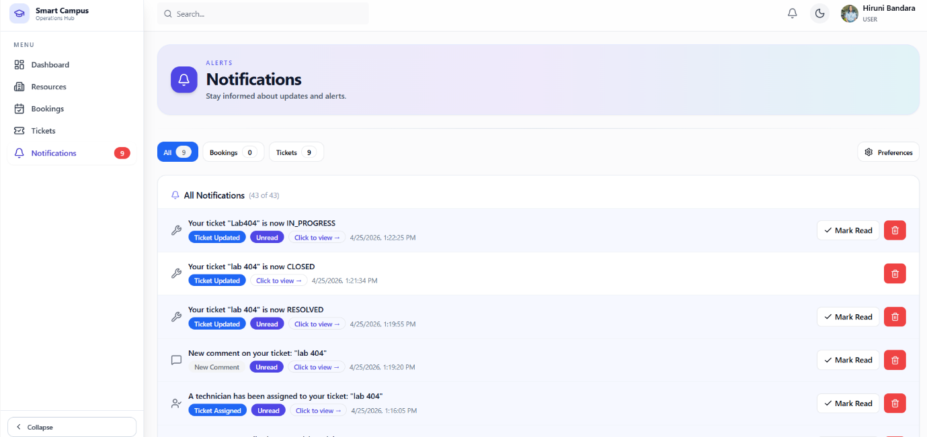

Member 4 was responsible for three interconnected areas: the complete notification system, OAuth 2.0 authentication with JWT session management, and admin user role management.

Notification System

Four REST API endpoints were implemented in NotificationController.java:

- GET /api/notifications - returns all notifications for the logged-in user ordered by newest first, returning 200 OK

- GET /api/notifications/unread/count - returns { count: N } used by the topbar bell badge, returning 200 OK

- PUT /api/notifications/{id}/read - marks a specific notification as read in the database, returning 200 OK with the updated notification

- DELETE /api/notifications/{id} - permanently removes a notification, returning 204 No Content

Notifications are event-driven and created automatically by BookingService and TicketService when system events occur. There is no public POST endpoint because a direct POST would bypass the system's intended logic and allow injection of arbitrary notifications. The system supports seven notification types: BOOKING_CREATED (admin notified when a user submits a new booking), BOOKING_APPROVED, BOOKING_REJECTED, BOOKING_CANCELLED (booking owner notified), TICKET_STATUS_CHANGED, TICKET_ASSIGNED, and TICKET_COMMENT_ADDED. The NotificationResponse DTO prevents infinite JSON serialisation caused by the circular @ManyToOne relationship between the Notification and User entities.

OAuth 2.0 Authentication and JWT

Six REST API endpoints were implemented in AuthController.java:

- GET /api/auth/me - returns the current logged-in user's profile (any authenticated user)

- GET /api/auth/users - lists all registered users (admin only)

- GET /api/auth/users/{id} - retrieves a specific user by ID (admin only)

- PUT /api/auth/users/{id} - updates a user's name, email, or role (admin only)

- PUT /api/auth/users/{id}/role - changes a user's role only, used by the role dropdown in the UI (admin only)

- DELETE /api/auth/users/{id} - deletes a user with a backend guard preventing self-deletion (admin only), returning 204 No Content

The authentication flow works as follows: the user clicks Continue with Google, which redirects to Google's OAuth 2.0 login page. After Google authenticates the user, OAuth2AuthenticationSuccessHandler runs and finds or creates the user in the database. If userRepository.count() equals zero the first user is automatically assigned the ADMIN role; all subsequent users receive the USER role. JwtTokenProvider generates a signed JWT containing the user's email and role with a 24-hour expiry. The token is sent to the frontend via a redirect to /oauth/callback?token=... and stored in localStorage. JwtAuthenticationFilter validates this token on every API request and sets the user in Spring Security's SecurityContext. Sessions are fully stateless as enforced by SessionCreationPolicy.STATELESS in SecurityConfig. The @EnableMethodSecurity annotation enables @PreAuthorize guards on all admin-only endpoints, returning 403 Forbidden automatically for unauthorised access.

The system supports four roles: USER (default for all new sign-ins), ADMIN (first user automatically or promoted by an existing admin), TECHNICIAN (assigned by admins for maintenance staff), and LECTURER (academic staff with USER-level permissions)

Frontend

NotificationsPage.jsx provides the full notification management UI with real-time polling every 3 seconds. It includes filter tabs for ALL, BOOKINGS, and TICKETS each showing live count badges, blue card highlighting for unread notifications, click-to-navigate to related resources, and skeleton loading states. UserManagementPage.jsx is the admin user management page showing five stat cards, search by name or email, role filter tabs, an instant role change dropdown, an edit dialog, and a self-guard that prevents admins from changing or deleting their own account. LoginPage.jsx and OAuthCallback.jsx handle the Google login flow, and AuthContext.jsx provides the currentUser and isAdmin context to all components.
Innovative addition

Notification preferences allow users to enable or disable individual notification types via toggle switches in a dialog, with group toggles for all booking or all ticket types at once, persisted to localStorage. Real time toast popups in the topbar automatically detect when the unread count increases using useEffect and useRef, and display the newest notification message without the user needing to check. Filter tabs with live count badges make it easy to view only booking or ticket notifications.

9.API endpoints

9.1 TicketController Endpoints
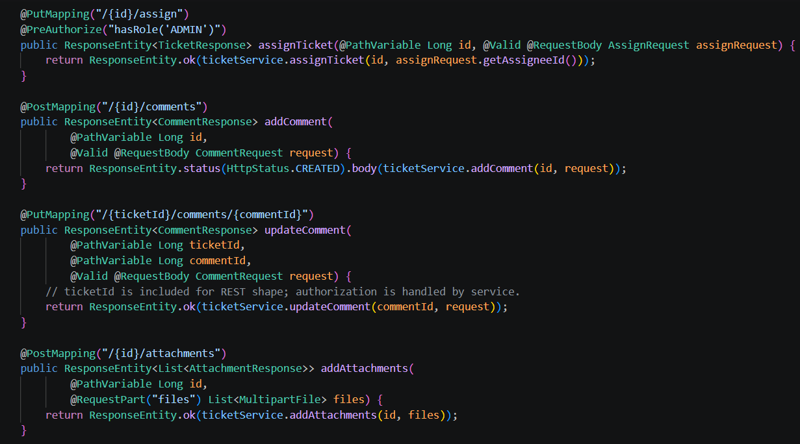
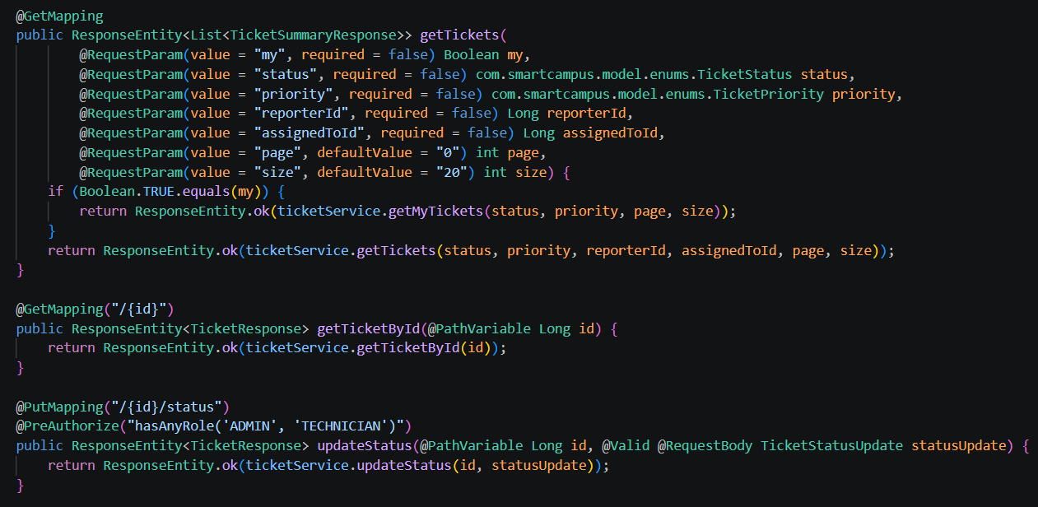
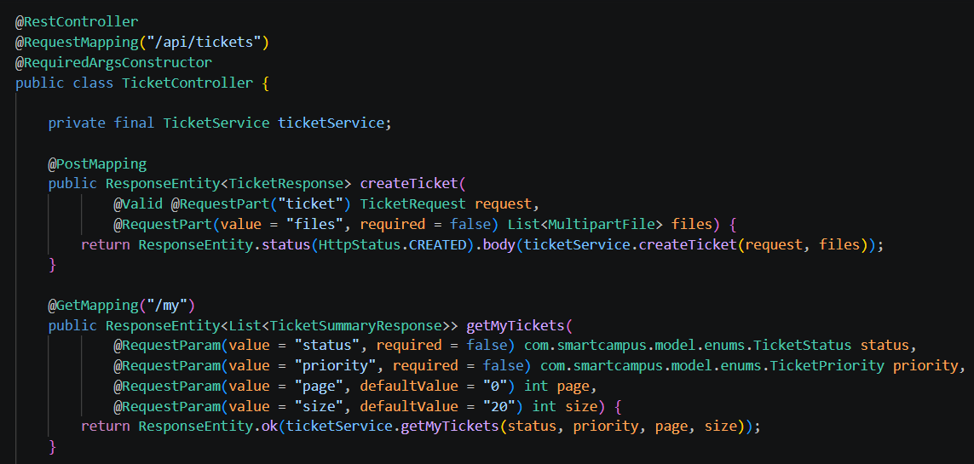
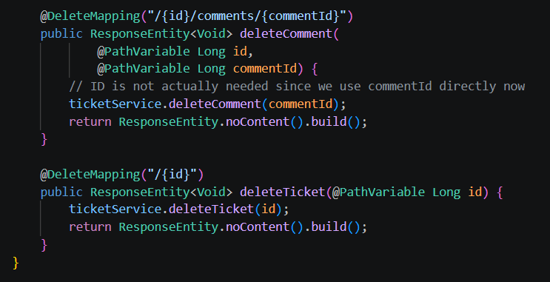
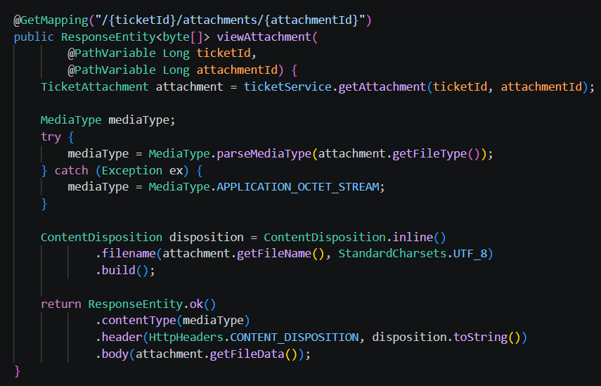

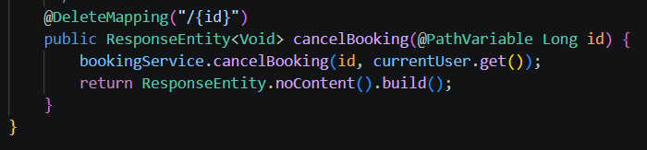
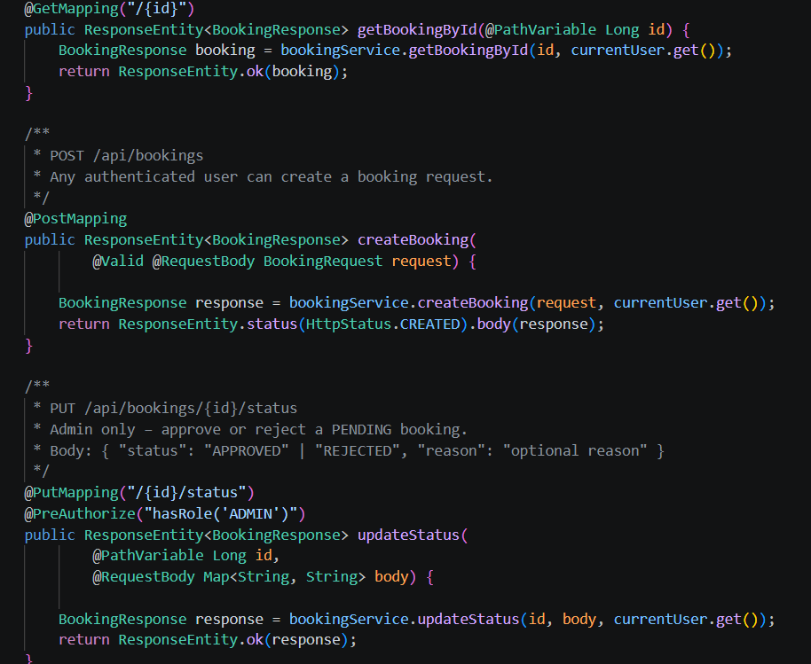
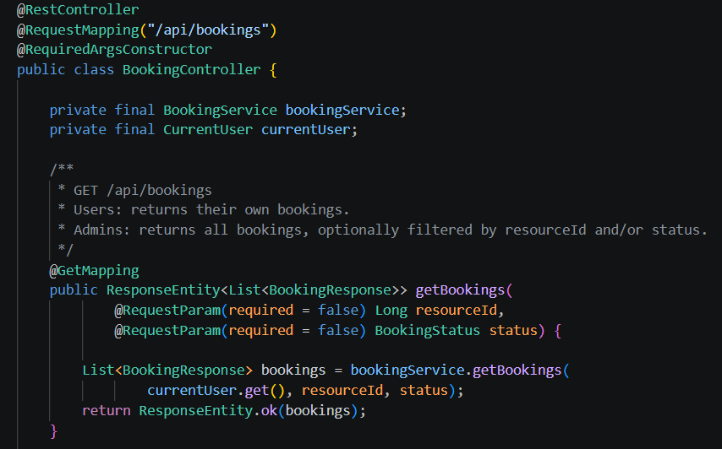
BookingController Endpoints

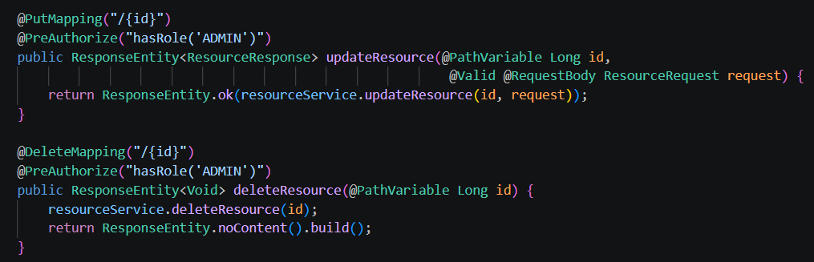
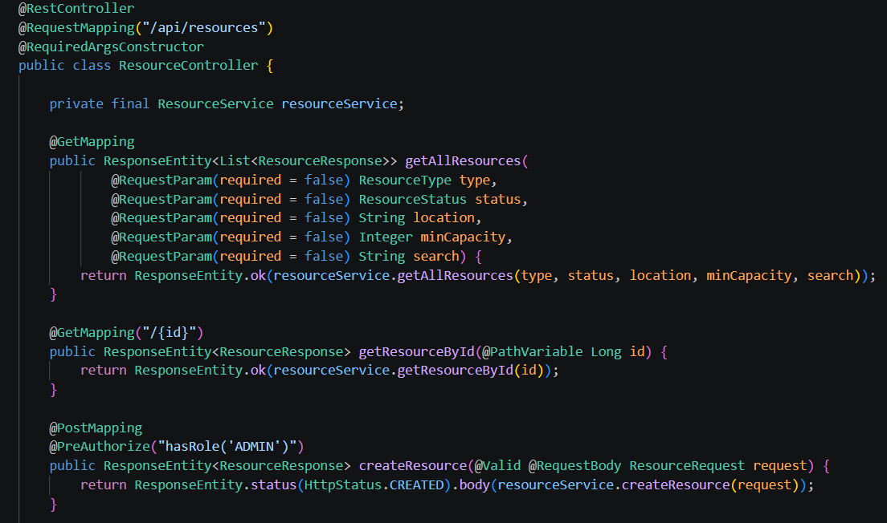
9.3 ResourceController Endpoints

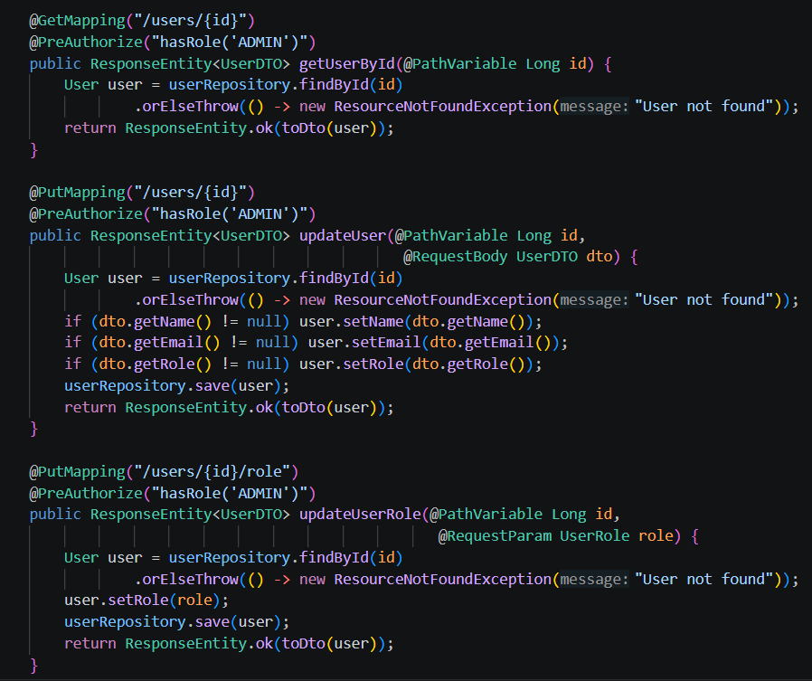
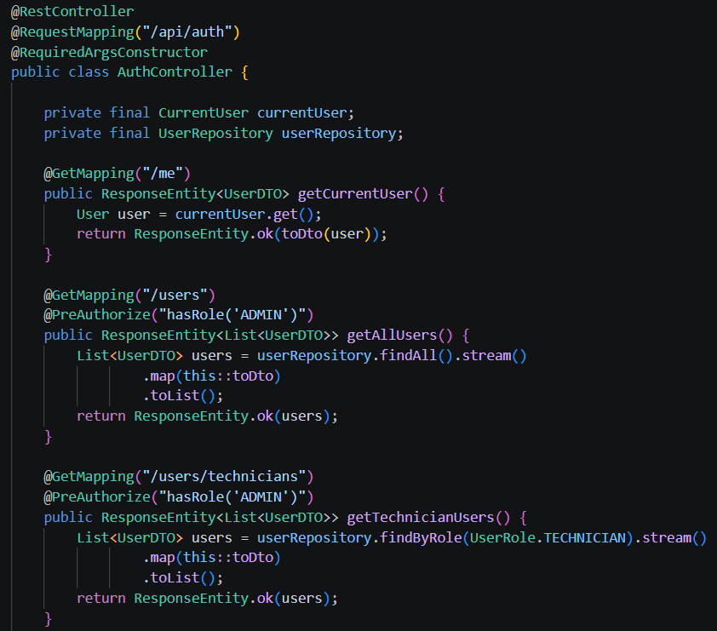
AuthController Endpoints

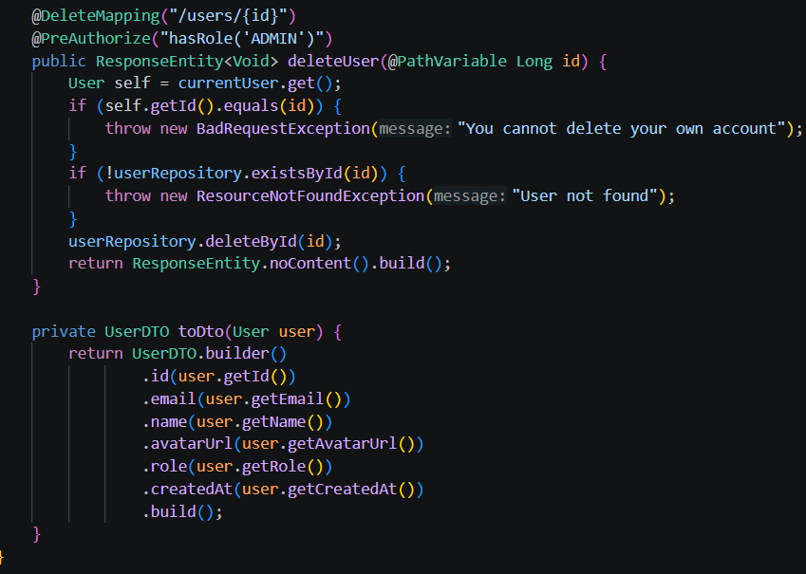

9.5 NotificationController Endpoints
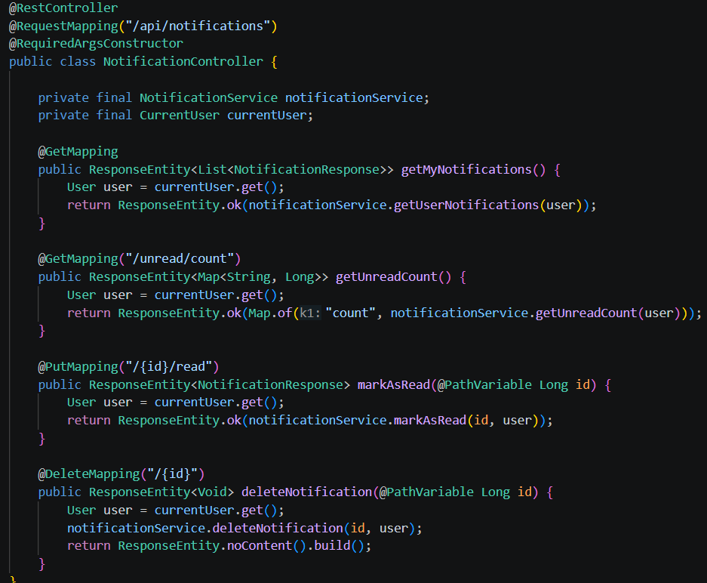

Innovative Features

10.1 Activity Log – Incident Ticketing

The Activity Log provides a complete, time-ordered audit trail of actions taken on a ticket from creation
to closure. It improves transparency for end users, supports technician handovers, and enables
administrators to verify accountability and compliance.

The log records significant ticket events, including (but not limited to): ticket creation, status changes,
assignments, and priority updates. System-generated events are captured
alongside user actions where applicable.

Information Captured Per Entry
Each activity entry should store and display the following core fields:

- Timestamp (date/time in a consistent time zone)
- Actor (user/technician/admin/system) and identifier (e.g., user ID or username)
- Action Type (e.g., STATUS_CHANGED, ASSIGNED)
- Description (human-readable summary of what changed)
Typical Activity Types
Recommended standardized event taxonomy:
- Ticket Created
- Status Updated (e.g., Open -> In Progress -> Resolved)
- Assigned / Reassigned (assignee changes)
- Priority Updated
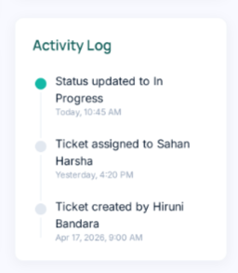

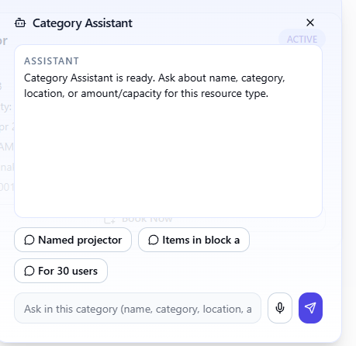
10.2 Chatbot Assistant – Facilities & Assets Catalogue

The Category Assistant is a conversational interface embedded within the Resources module that enables users to discover and filter bookable resources using natural language queries, without needing to manually navigate filters or search fields.
When a user opens the resource catalogue page, the Category Assistant appears as an interactive panel in the bottom corner of the screen. It is pre-loaded with context about the current resource category and accepts free-text queries about resource attributes such as name, location, capacity, and availability. Quick-suggestion chips (e.g., "Named projector", "Items in block A", "For 30 users") are displayed to guide first-time users and reduce typing effort.

Key Capabilities

The assistant understands intent-based queries such as:
- "Show me a projector in block A" - filters by name and location
- "Find a room for 30 users" - filters by capacity
- "What equipment is available in lab 2?" - filters by category and location
Information the Assistant Can Answer

The assistant is scoped to resource-relevant attributes to keep responses focused and accurate:
- Resource name and type
- Location or block
- Capacity or quantity available
- Category (e.g., equipment, lecture hall, lab)

10.3 Best Match Filter– Facilities & Assets Catalogue

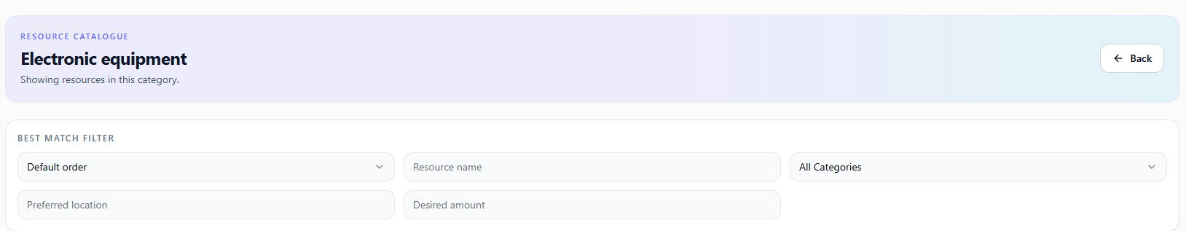
The Best Match Filter is a smart filtering system embedded within the Resource Catalogue that allows users to find the most suitable resource based on multiple criteria simultaneously, rather than applying simple one-dimensional filters.
When a user navigates to a resource catalogue (e.g., Electronic Equipment), the Best Match Filter panel appears at the top of the listing. Users can input multiple preferences at once including sort order, resource name, category, preferred location, and desired amount or capacity. The system then ranks and displays resources that best match the combination of criteria provided.

Filter Fields Available

- Default Order / Sort - controls how results are ranked (e.g., by name, availability, or best match score)
- Resource Name - free-text search to find a specific item by name
- All Categories - dropdown to filter within a subcategory of the current resource type
- Preferred Location - narrows results to resources in a specific block, room, or building
- Desired Amount - filters resources by quantity or capacity needed
How It Differs from a Simple Search
Unlike a basic search that filters on a single field, the Best Match Filter combines all provided inputs together and scores each resource against the full set of criteria. Resources that match more criteria rank higher in the results, giving users the most relevant options first even when their requirements are partially met.

10.4 Notification Preferences– Notifications

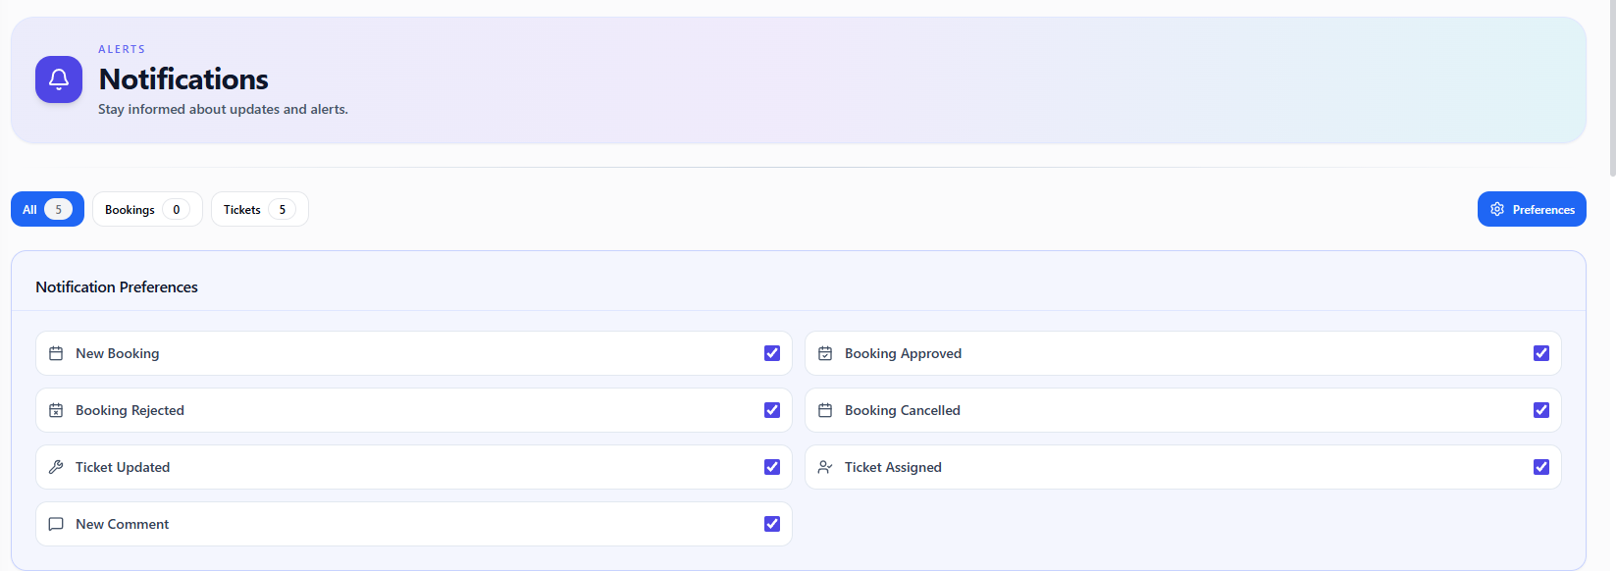

The Notification Preferences feature allows users to personalize which types of notifications they receive, giving them full control over their alert experience within the Smart Campus platform.
Accessible via the Preferences button on the Notifications page, users can individually enable or disable each notification type using simple checkboxes. The preferences panel is organized clearly, showing all available notification categories in a two-column layout for easy scanning.

Configurable Notification Types

Users can toggle the following notification types on or off independently:
- New Booking - notified when a new booking request is submitted
- Booking Approved - notified when their booking is approved by an admin
- Booking Rejected - notified when their booking is rejected
- Booking Cancelled - notified when a booking is cancelled
- Ticket Updated - notified when the status of their ticket changes
- Ticket Assigned - notified when a technician is assigned to their ticket
- New Comment - notified when a comment is added to their ticket
Integration with Filter Tabs

The Notifications page also features filter tabs - All, Bookings, and Tickets - with live count badges showing how many notifications exist in each category, making it easy to focus on the most relevant alerts.

10.5 Admin dashboard with usage analytics (top resources, peak booking hours) – Booking Management

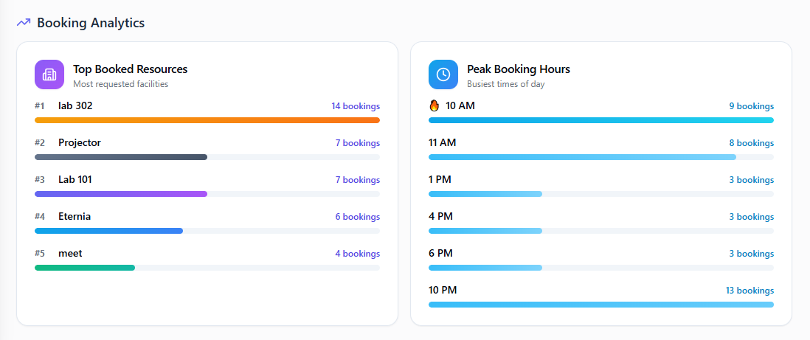

Admin Analytics Dashboard – Booking Management
The Admin Analytics Dashboard is an intelligent data visualization panel embedded within the Booking Management module, accessible exclusively to administrators. It provides real-time insights into booking activity across the campus without requiring any additional API calls - the analytics are derived entirely from the booking data already loaded on the page.

Dashboard Components
- Top Booked Resources - displays the five most frequently booked resources across the campus, ranked by total booking count. Each resource is shown with a proportional horizontal bar, color-coded by rank, allowing administrators to instantly identify which facilities and assets are in highest demand.
- Peak Booking Hours - identifies the six busiest hours of the day based on booking start times. Results are first ranked by frequency to select the top hours, then re-sorted chronologically so the chart reads naturally across the day. The busiest hour is highlighted with a visual indicator to draw immediate attention.

How It Works
The dashboard uses JavaScript's Array.reduce() method to aggregate the bookings array into structured count maps - one grouping bookings by resource name and another extracting the hour from each booking's start time using getHours(). These counts are then sorted and sliced to produce the top results. Bar widths are rendered as percentages relative to the highest count, giving a clear visual sense of proportion between entries.
Why It Adds Value
Rather than requiring administrators to manually review individual bookings, the dashboard surfaces actionable patterns at a glance - which resources need more availability windows, and which time slots experience the heaviest load. This directly supports better resource planning and scheduling decisions for campus operations.

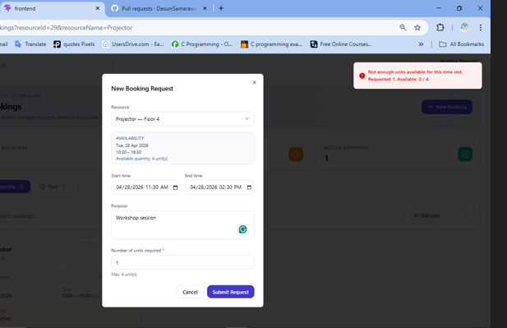
10.6 Venue & Capacity-Aware Equipment Conflict Checking - Booking Management

Dual-Strategy Conflict Detection Engine - Booking Management
The Dual-Strategy Conflict Detection Engine is an intelligent scheduling safeguard built into the Booking Management module that prevents resource double-booking through two distinct algorithms, each tailored to the nature of the resource being booked.
How It Works
When a booking request is submitted, the system first identifies the type of the requested resource and then applies the appropriate conflict detection strategy.
- Venue Conflict Check for exclusive-use resources such as lecture halls, meeting rooms, and labs, the system uses a custom JPQL query called findConflictingBookings() in BookingRepository.java. This query applies a standard interval overlap algorithm: two bookings conflict if the existing booking's start time is before the new request's end time and the existing booking's end time is after the new request's start time. If any approved booking satisfies this condition for the same resource, the request is immediately rejected with a descriptive error message.
- Capacity-Aware Equipment Check -for shared resources such as projectors, cameras, and computers where multiple users can borrow units simultaneously, a simple overlap check would incorrectly block valid bookings. Instead, the system uses a second custom JPQL query called sumBookedQuantity() which aggregates the total units already committed, including both approved and pending bookings, within the requested time slot using COALESCE(SUM(...), 0). If adding the newly requested quantity would exceed the resource's total available capacity, the request is rejected with a message indicating exactly how many units remain available.
Why It Adds Value
A single conflict detection approach cannot fairly serve both exclusive facilities and shared equipment. By branching on resource type and applying purpose-built queries for each case, the system maximizes resource utilization, multiple users can simultaneously borrow different units of the same equipment, while still guaranteeing that no venue is ever double-booked. The inclusion of pending bookings in the equipment capacity sum further prevents race conditions where multiple users could simultaneously claim the last available unit before any request is approved.
10.7 Incident Ticket Analysis Dashboard for Admin and technician
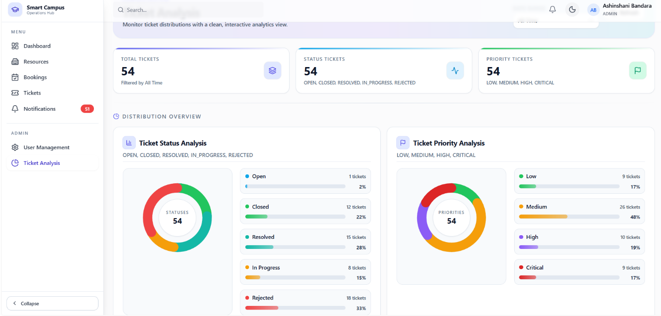
The Smart Campus Analytics Dashboard provides a unified platform for both administrators and technicians to monitor and manage ticket-related activities efficiently. The system presents real-time insights into total tickets, status distribution, and priority levels using interactive visualizations such as charts and summary cards.

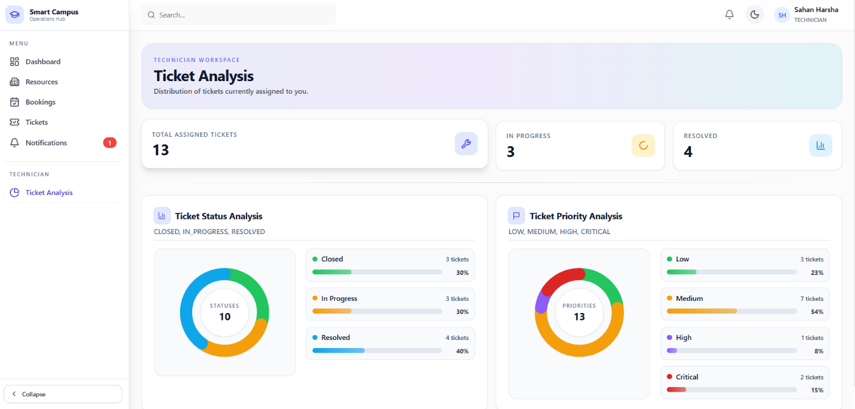
For administrators, the dashboard offers a comprehensive overview of all system tickets, enabling effective decision-making, workload monitoring, and identification of critical issues. It helps in analyzing ticket statuses (open, closed, resolved, in progress, rejected) and priorities (low, medium, high, critical), ensuring better resource allocation and operational control.

For technicians, the dashboard delivers a personalized view of assigned tickets, allowing them to track their progress, manage workload, and prioritize tasks based on urgency. It highlights key metrics such as assigned tickets, in-progress tasks, and resolved issues, supporting improved productivity and timely task completion.
Overall, this analytics dashboard enhances transparency, efficiency, and performance by providing role-based insights, enabling a streamlined and data-driven ticket management process.

GitHub
  - GitHub Repo link: https://github.com/DasuniSamaraweera/smart-cm

  - OneDrive Link:

  - Image of the GitHub Commit Tree:

The Smart Campus Operations Hub project is managed using Git-based version control, with the source code hosted on a GitHub repository. Version control plays a critical role in maintaining code consistency, enabling collaboration among team members, and tracking changes throughout the development lifecycle.
Each team member contributes to the project through structured workflows, including branching, committing, and merging code. Meaningful commit messages are used to clearly describe changes, ensuring traceability and accountability.

Key practices followed include:

- Use of feature branches for individual development tasks
- Regular commits to maintain an active commit history
- Use of pull requests (PRs) for code review and integration
- Avoidance of large, single day commits to ensure continuous progress tracking
This approach ensures that the project maintains a clean and organized development history while supporting collaborative development.

11.1 Repository Structure
The project repository is organized to separate frontend and backend components:
- Frontend (React) - Contains UI components, routing, and API integration
- Backend (Spring Boot) - Contains REST API, business logic, and database interaction
- Configuration files and documentation (e.g., README, .gitignore) are also included
This structured organization improves maintainability and clarity of the project.

11.2 Continuous Integration (CI/CD)
The project integrates GitHub Actions to implement Continuous Integration and Continuous Deployment (CI/CD) practices. CI/CD automates the process of building, testing, and optionally deploying the application whenever changes are pushed to the repository.
CI/CD Workflow Includes:
- Automated build process for backend and frontend
- Execution of test cases to ensure code quality
- Validation of code before merging into the main branch
- Optional deployment steps (if configured)

The workflow is triggered on events such as:
- Code push
- Pull request creation
This ensures that any issues are detected early, improving reliability and reducing integration problems.

11.3 Benefits of CI/CD Integration
- Ensures early detection of errors
- Improves code quality and stability
- Enables faster development and deployment cycles
- Supports team collaboration and integration

12. Team Collaboration
IT Number | Student Name | Contribution
IT23141988 | SAMARAWEERA M D C | - Resources catalog  - Facility assistant chatbot as Innovative Part  - Resource display Calander  - Best match filter for the resource catalog as Innovative Part  - Database Design in report
IT23222168 | BANDARA K.M.R.H.A. | - Incident Ticketing Module  - Activity Log Implementation as Innovative Part  - System Architecture in report  - Functional & Non-Functional Requirements  - Incident Ticketing Use Case Scenario
IT23350496 | SILVA K.G.U. | - Notifications + role management + OAuth integration improvements Module  - Notification preferences (enable/disable categories) as innovative part  - Front end architecture diagram in report  - Rest API architecture diagram
IT23443556 | GALAHITIYAWA I.S. | - Booking Management Module  - Conflict Detection Engine (Venue & Capacity-Aware Equipment Conflict Checking) as Innovative Part  - Admin Analytics Dashboard (Top Resources & Peak Booking Hours) as Innovative Part  - ER diagram in report

Conclusion

The Smart Campus Operations Hub successfully demonstrates the design and implementation of a modern, full-stack web application that addresses real-world challenges in university operations. By integrating facility and asset booking with incident ticketing and maintenance management into a single platform, the system provides a centralized and efficient solution for both users and administrative staff.

The use of a React-based frontend and a Spring Boot RESTful backend, combined with a cloud-based PostgreSQL (Neon) database, ensures that the system is scalable, maintainable, and capable of handling complex workflows. Features such as role-based access control, structured ticket lifecycle management, file attachment handling, and real-time notifications enhance both functionality and user experience. Additionally, the implementation of secure authentication using OAuth 2.0 further strengthens system security.

Throughout the development process, best practices in software engineering were followed, including layered architecture, version control using GitHub, and continuous integration through GitHub Actions. These practices contributed to improved code quality, collaboration, and reliability of the system.

Overall, the project highlights the effective application of modern technologies and architectural principles to build a robust and scalable solution. The Smart Campus Operations Hub not only meets the specified requirements but also provides a strong foundation for future enhancements such as analytics dashboards, mobile integration, and advanced automation features

  - References

