MACHINE LEARNING ENGINEER ASSESSMENT
Freight Rate Prediction
Technical Assessment Report

Spotter

Development Dataset | 48,000 labeled loads

Final Validation Dataset | 12,000 loads

Primary Validation MAE | $103.75

Primary Validation RMSE | $648.45

Primary Validation R² | 0.8200

Prepared as part of the Machine Learning Engineer assessment

1. Executive Summary
This project develops a machine learning regression pipeline for predicting freight load rates from historical shipment information. The development dataset contains 48,000 labeled loads covering January through October 2025, while the final validation dataset contains 12,000 future loads from November and December 2025.
The analysis began with exploratory data analysis and data-quality checks, followed by feature evaluation, model comparison, hyperparameter tuning, and time-aware validation. Because the final validation period occurs after the labeled development period, chronological validation was preferred over a random train/test split.
GradientBoostingRegressor with Huber loss produced the strongest overall validation performance among the evaluated models. The final model achieved a mean absolute error of $103.75, RMSE of $648.45, and R² of 0.8200 on the October 2025 holdout.
The provided scoring script successfully validated all 12,000 final predictions and all 31 required December predictions.

2. Problem Definition
The objective is to estimate the posted freight rate for an unseen load using historical shipment, route, equipment, geographic, and operational information.

Target
posted_rate

Final Prediction Format
load_id,predicted_rate
The final validation output contains exactly 12,000 rows and follows the required load ID and prediction format.

3. Dataset Overview
Dataset | Rows | Time Period | Purpose
Development | 48,000 | Jan–Oct 2025 | Model training and validation
Validation | 12,000 | Nov–Dec 2025 | Final prediction
December inputs | 31 | Dec 2025 | Required fixed scenario

The development data contains route, geographic, equipment, shipment, date, market, quote, and target information.

Main Features
- pickup and delivery locations
- pickup and delivery latitude/longitude
- distance
- equipment
- weight
- date
- market_index
- quote_signal

4. Exploratory Data Analysis
The target distribution is strongly right-skewed. The median posted rate is approximately $2,031 while the mean is approximately $2,374, indicating that a relatively small number of high-rate observations increase the mean.
Target Statistic | Value
Minimum | $57.22
Median | $2,030.76
Mean | $2,373.98
Maximum | $25,533.00

Distance was the strongest individual numerical predictor of posted rate, with a correlation of approximately 0.91. This is consistent with the expected relationship between shipment distance and total freight cost.

Equipment Distribution
Equipment | Training Loads
Dry Van | 27,202
Reefer | 12,045
Flatbed | 8,753

5. Data Quality and Preprocessing
The primary data-quality issues identified were missing numerical values and a small number of negative weight observations.
Feature | Missing Values
weight | 300
market_index | 374

Missing numerical values were handled using median imputation. Categorical variables were handled using most-frequent imputation followed by one-hot encoding.
A total of 292 negative-weight observations were identified. Removing these observations was tested as a sensitivity experiment, but it did not improve the validation results. They were therefore retained rather than imposing an unsupported assumption about the underlying data-generation process.

6. Validation Strategy
A chronological validation strategy was used because the final validation period occurs after the labeled development period. A random split could allow information from later observations to influence the model-selection process and would not accurately represent the forecasting setting.

Primary Holdout
Training Period | Validation Period
January–September 2025 | October 2025

Rolling Validation
Validation Month | MAE | RMSE | R²
July | $122.01 | $633.14 | 0.8230
August | $95.37 | $614.15 | 0.8266
September | $99.89 | $614.06 | 0.8375
October | $103.75 | $648.45 | 0.8200
Average | $105.25 | $627.45 | 0.8268

The rolling validation results were reasonably stable across months, supporting the use of the selected model for the later validation period.

7. Feature Engineering
Multiple feature configurations were evaluated. Experiments included raw shipment and geographic features, date-derived features, log-transformed distance, market index, quote signal, and equipment information.
An important finding was that additional date and market-signal features did not consistently improve out-of-time performance. The final model therefore emphasizes the feature set that provided the strongest and most stable validation performance.

Final Feature Groups
- distance
- weight
- pickup latitude / longitude
- delivery latitude / longitude
- pickup location
- delivery location
- equipment

8. Model Comparison
Model | MAE | RMSE | R²
HistGradientBoosting | $127.34 | $650.67 | 0.8188
ExtraTrees | $158.43 | $705.20 | 0.7872
RandomForest | $150.09 | $674.67 | 0.8052
GradientBoosting | $106.38 | $649.09 | 0.8197

Gradient Boosting provided the strongest overall validation performance and was selected for hyperparameter tuning.

9. Hyperparameter Tuning
Gradient Boosting was tuned across the number of estimators, learning rate, tree depth, minimum leaf size, and subsampling fraction.
Configuration | MAE | RMSE | R²
300 estimators, depth 3 | $106.38 | $649.09 | 0.8197
500 estimators, depth 3, leaf 3 | $104.95 | $648.67 | 0.8199
500 estimators, depth 4, leaf 3 | $103.90 | $648.71 | 0.8199
700 estimators, depth 4, subsample 0.8 | $103.75 | $648.45 | 0.8200

Selected Configuration
GradientBoostingRegressor(
n_estimators=700,
learning_rate=0.03,
max_depth=4,
min_samples_leaf=3,
subsample=0.8,
loss="huber",
random_state=42
)

10. Loss Function Analysis
Loss Function | MAE | RMSE | R²
Huber | $103.75 | $648.45 | 0.8200
Squared Error | $122.65 | $654.57 | 0.8166
Absolute Error | $104.56 | $648.45 | 0.8200

Huber loss was selected because it produced the best MAE while maintaining strong RMSE and R² performance. Its robustness is particularly useful for a dataset containing a small number of extreme target values.

11. Error and High-Rate Analysis
The majority of predictions were relatively accurate, but a small number of extreme observations generated disproportionately large errors.
Absolute Error Threshold | Number of October Loads
> $100 | 955
> $250 | 195
> $500 | 96
> $1,000 | 67
> $2,000 | 47
> $5,000 | 21

Loads above $7,500 represented only approximately 0.32% of the development data, while loads above $10,000 represented approximately 0.21%.
Historical route behavior was investigated to determine whether these extreme events could be predicted from previous observations. The analysis showed that many October high-rate loads occurred on routes whose previous loads had normal rates. This indicates that the rare extreme regime is only weakly identifiable from the supplied features.
A separate high-rate classifier achieved a ROC-AUC of approximately 0.72, but predicted probabilities remained too low to support reliable hard classification. The final pipeline therefore avoids an additional hard classification stage.

12. Final Model and Training
After model selection and validation, the selected Gradient Boosting configuration was retrained using all 48,000 labeled development rows.
The resulting model was applied to every row in the 12,000-row validation dataset.

Final Prediction Distribution
Statistic | Prediction
Number of predictions | 12,000
Minimum | $190.30
Median | $2,034.24
Mean | $2,356.03
Maximum | $6,820.59

13. December Prediction Scenario
The assessment requires predictions for a fixed shipment scenario across all 31 days of December 2025.
Input | Value
Pickup | Lexington
Delivery | Fort Wayne
Distance | 360
Equipment | Dry Van
Weight | 32,000

The final model produced a prediction of approximately $812.30 for the fixed scenario across the month.
The flat prediction is expected because the final model does not rely on date-derived features and the other shipment inputs remain unchanged for each December row.

Required December Chart
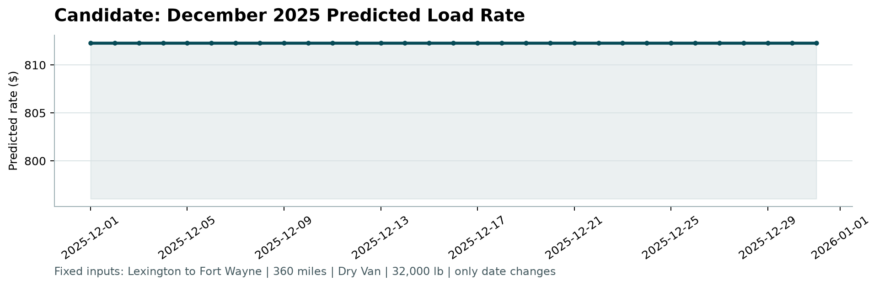

14. Official Output Validation
The provided scoring script was executed against the final prediction files.
python score.py --predictions outputs/validation_predictions.csv --december-predictions outputs/december_predictions.csv --output-dir scorer_results
Check | Result
Validation prediction rows | 12,000 — Passed
Validation prediction columns | Passed
Validation load IDs | Passed
December prediction rows | 31 — Passed
December date coverage | Passed
December chart | Generated

The scoring script does not calculate the hidden evaluation metrics. Those metrics are calculated by Spotter after submission.

15. Reproducibility
The complete solution can be reproduced from the repository using the following steps.
python -m venv .venv
.venv\Scripts\Activate.ps1
pip install -r requirements.txt
python src\final_model.py
python src\december_predictions.py
python score.py --predictions outputs\validation_predictions.csv --december-predictions outputs\december_predictions.csv --output-dir scorer_results

16. Limitations
- The supplied feature set does not fully explain the rare extreme-rate regime.
- A small number of extreme observations disproportionately affect RMSE.
- Historical route behavior was not sufficient to reliably predict all high-rate shocks.
- The final model intentionally prioritizes stable performance across the dominant pricing regime.
- Hidden evaluation performance may differ from the development validation results.

17. Conclusion
The final solution uses a time-aware machine learning workflow designed to reflect the chronological nature of the assessment. Exploratory analysis identified distance as the strongest individual predictor and revealed a small but important extreme-rate regime.
After comparing multiple ensemble models and tuning Gradient Boosting, the selected Huber-loss GradientBoostingRegressor achieved an October validation MAE of $103.75 and R² of 0.8200, with an average rolling validation MAE of $105.25.
The final model was retrained on all labeled development data and produced valid predictions for all 12,000 validation loads. The required 31-day December scenario was also generated and successfully validated by the provided scoring script.

