**Table of Contents**

**List of Figures3**

**List of Tables5**

**List of Abbreviations6**

**Chapter 1: Introduction7**

1.1 Background8

1.2 Motivation and Challenges10

1.3 Goals and Objectives10

1.4 Solution Overview11

1.5 Report Outline12

**Chapter 2 Literature / Market Survey13**

2.1 Introduction14

2.2 Literature / Technologies Overview15

2.2.1 Technologies Overview24

2.3 Summary25

**Chapter 3 Requirement Analysis26**

3.1 Introduction27

3.2 Problem Scenarios27

3.3 Functional Requirements28

3.4 Non-Functional Requirements30

**Chapter 4 System Design31**

4.1 Introduction32

4.2 Architectural Design32

4.3 Detailed Design33

4.4 Data Flow Diagrams34

4.5 Use Cases36

4.6 Activity Diagram37

4.7 State Diagram39

4.9 Sequence Diagram40

4.10 Class Diagram42

4.11 ERD42

4.12 Deployment Diagram43

**Chapter 5 Implementation44**

5.1 Flow Control / Pseudo Code45

5.2 Components, Libraries, Web Services and stubs45

5.3 Code Layer47

5.3.1 Presentation Layer47

5.3.2 Business Logic Layer53

5.3.3 Data Management/Access Layer54

**Chapter 6 Testing and Evaluation56**

6.1 Introduction57

6.2 List of Test Scenarios57

6.3 Performance and Evaluation57

6.3.1 Test Case 1: Login 57

6.3.2 Test Case 2: Sign Up 58

6.3.3 Test Case 3: Creating a Rehab Profile60

6.3.4 Test Case 4: Drug Addiction Quiz61

6.3.5 Test Case 5: Registered User Add / Modify Patients Data62

6.3.6 Test Case 6: Unregistered User See Patients Report 63

**Chapter 7 Conclusion and Outlook65**

7.1 Introduction66

7.2 Achievements and Improvements66

7.3 Critical Review66

7.4 Future Recommendations67

7.5 Summary67

**References68**

**List of Figures**

|  |  |
| --- | --- |
| 4.1 Architectural Diagram  4.2 Unregistered Detail Design  4.3 Registered Detail Design | 32  33  33 |
| 4.4 Admin Detail Design | 34 |
| 4.5 Level 0 DFD | 34 |
| 4.6 Level 1 DFD | 35 |
| 4.7 Level 2 DFD | 35 |
| 4.8 Use Case Diagram for Admin  4.9 Use Case Diagram for Registered User  4.10 Use Case Diagram for Unregistered User | 36  36  37 |
| 4.11 Activity Diagram for Unregistered User | 37 |
| 4.12 Activity Diagram for Registered User | 38 |
| 4.13 Activity Diagram for Admin | 38 |
| 4.14 State Diagram for Unregistered User | 39 |
| 4.15 State Diagram for Registered User  4.16 State Diagram for Admin | 39  40 |
| 4.17 Sequence Diagram for Admin | 40 |
| 4.18 Sequence Diagram for Registered User  4.19 Sequence Diagram for Unregistered User | 41  41 |
| 4.20 Class Diagram | 42 |
| 4.21 Entity Relationship Diagram  4.22 Deployment Diagram  5.1 Flow Control | 42  43  45 |

**List of Tables**

|  |  |
| --- | --- |
| 2.1 Related Technologies  6.1 Test Case 1: Login  6.2 Test Case 2: Sign Up  6.3 Test Case 3: Creating Rehab Profile  6.4 Test Case 4: Drug Addiction Quiz  6.5 Test Case 5: Registered User Add / Modify Patients Data  6.6 Test Case 6: Unregistered User See Patients Report | 24  58  59  60  62  63  64 |

**LIST OF ABBREIVATIONS**

IHRA Islamabad Health Regulatory Authority

ANF Anti-Narcotics Force

PMC Pakistan Medical Commission

UNODC United Nation of Drugs and Crime

PWIDS Person Who Inject Drugs

HIV Human Immunodeficiency Virus

NPS Net Promoter Score

HLA Human Leukocyte Antigens

NIDAA National Institute on Drug and Addiction

DSM Diagnostic and Statistical Manual

ADA Adenosine Deaminase

NTS Non-Traditional Security

**Chapter 1:**

**Introduction**

**Chapter 1: Introduction**

**1.1 Background:**

As we all know, drug addiction is a growing epidemic that is impacting people from all walks of life. It affects individuals, families and communities in profound ways, leading to social, financial and health problems. The causes, effects and treatments of drug addiction are complex and varied, and it is important to understand the underlying issues in order to effectively address and treat substance abuse. We will explore the causes of drug addiction, the impact it has on those affected, and the various treatments available to help individuals overcome the problem. Drug addiction is a chronic, progressive and potentially deadly disorder that is characterized by an inability to stop using a substance despite the negative consequences it brings. People who are addicted to drugs experience a compulsive need to use, an intense craving for the drug, and physical and psychological dependence on the substance. In Pakistan, the most commonly abused substances are alcohol, marijuana, prescription drugs, cocaine and heroin. The causes of drug addiction are complex and varied and can include biological factors, psychological factors, social factors, and environmental factors. Biological factors can include genetics, physiology, and neurobiological development. Psychological factors include mental health issues, such as depression, anxiety, and trauma. Social factors include poverty, family dynamics, and peer pressure.

In the 1980s, the United States government implemented the Anti-Drug Abuse Act, which increased penalties for drug offenses and established the Office of National Drug Control Policy to coordinate federal efforts to combat drug abuse. Since then, various laws and initiatives have been implemented at both the federal and state levels to combat the illegal use and distribution of narcotic drugs. These efforts have included law enforcement actions, education and prevention programs, and treatment options for those struggling with addiction. The use of anti-narcotic technology, such as drug-sniffing dogs and drug-detection technology, has also played a role in these efforts. Overall, the goal of anti-narcotic efforts is to reduce the demand for and availability of illegal drugs, as well as provide support and resources for those struggling with addiction.

The first anti-narcotic rehabilitation center in Pakistan was established in the 1970s by the government in an effort to combat the growing problem of drug addiction in the country. The center was located in Karachi and was called the Anti-Narcotic Rehabilitation Center (ANRC). It was equipped with facilities such as counseling rooms, medical examination rooms, and dormitories for patients to stay in during their treatment. The ANRC provided treatment for individuals suffering from drug addiction, including detoxification, behavioral therapy, and medication-assisted treatment. The center also provided education and training programs for individuals who wanted to work in the field of addiction treatment. Over the years, the ANRC has helped thousands of people overcome their drug addiction and regain control of their lives. It has also played a crucial role in raising awareness about the dangers of drug addiction and the importance of seeking help for those struggling with addiction.

In the 1980s, the government began to focus on educating the public about the dangers of drug abuse and implemented stricter laws and penalties for drug trafficking.

This brought about a boom in the variety of rehabilitation centers in the country. In the 1990s, the government began to work with non-profit organizations and private institutions to establish more rehabilitation centers in order to meet the demand for treatment. These centers began to offer a range of services including detoxification, counseling, and vocational training to help individuals overcome their addiction and rebuild their lives. In recent years, the government has continued to invest in the development and expansion of anti-narcotic rehabilitation centers in Pakistan. In 2018, the government launched a nationwide campaign to raise awareness about the dangers of drug abuse and the importance of seeking treatment.

Today, there are several rehabilitation centers in Pakistan that offer a range of treatment options for individuals suffering from drug addiction. These centers work closely with government agencies, non-profit organizations, and other stakeholders to provide effective and compassionate care to those in need.

It is difficult for me to provide a comprehensive history of navigating rehabilitation center apps, as there are likely to have been many different apps developed for this purpose over the years. However, I can give you a general overview of the evolution of healthcare apps that may be helpful.

One of the earliest examples of a healthcare app was "iTriage", which was launched in 2009. This app allowed users to search for nearby hospitals and clinics, as well as to find information about specific medical conditions and treatments.

In the years that followed, a wide range of healthcare apps were developed, including apps that allowed users to schedule appointments, track their health and fitness, and access their medical records. More recently, there has been a trend towards the development of apps that are specifically designed to help patients navigate rehabilitation centers and other healthcare facilities. These apps often provide maps and directions to help users find their way around the facility, as well as information about services and amenities that are available. Overall, navigating rehabilitation center apps have become an important tool for both patients and healthcare providers, as they can help to improve the patient experience and make it easier for patients to access the care they need.

**1.2 Motivation and Challenges:**

Many people have expressed that they desire a platform that provides them an environment that can help them acknowledge narcotic addicts and help them provide the right solution according to their problem. Even In today's world the people cannot come out of the denial phase about them or their child's addiction. However, it's our challenge to provide them the platform where they can find the right symptoms so they can compare with the victim for proceeding to the next level of solving it. As we know there are multiple rehabilitation centers for curing the drug addicts in Pakistan but still there are a large number of people unaware about these centers. So, they have to travel different cities to find the right center according to their budget. Our next challenge was to give them the information about the rehabilitation centers so nor have they to travel different cities neither worry about the budget. We provide them the right environment where they can find the best centers according to their budget without having to travel which in result saves a lot of time and money. Travel every month to check on patients progress is quite a problem for the people from rural areas In order to solve this problem we came up with the solution of providing them the updated progress chart uploaded by the rehabilitation centers results again saving a lot of time and money.

**1.3 Goals and Objectives:**

Our primary Goal was to create a professional application which helps individuals struggling with substance abuse find the most suitable treatment options. They interact with clients to assess their needs and provide guidance on available programs, including inpatient and outpatient treatment centers. They may also provide ongoing support during treatment, including providing clients progress charts to their guardians or families.

1. **Screening form**:One of the key features of this web application is a screening form which will have some important information or symptoms about the addict that their guardians can use to compare the subject’s behavior and the screening form to find if the subject is an addict or not.
2. **Progress chart:** The web application will also have a progress chart that has the ability to track the patient’s progress uploaded by the rehabilitation centers so the patient’s guardian will also have a full progress report without having to contact or visit the centers.
3. **Providing access to a wide range of resources:** This app can provide the access of large number of rehabilitations centers and therapist across the whole country with the information about their services and fees structure.
4. **Offering convenience:** This app will offer convenience of accessing the rehabilitation centers without having to go out and it is made more convenient as you can check their services and fees structure without having to go there.

**1.4 Solution Overview:**

As the day passes the newest technologies are announced every day but still there are few important topics which are forgotten especially in Pakistan as we know drug addiction is one the most serious problem Pakistan is facing currently with dramatically increasing number of drug addicts every day. A lot of people still could not come out of denial phase if them or their child is an addict which is totally understandable because it's very hard to accept the truth in order to make the observation more precise we are adding the screening form through which they can study and compare the behavior of the drug addict with the small quiz which will let them identify the level of addiction.

However, after identifying the addiction people do not know what to do after that. We survey with one of the employee of IHRA (Islamabad Health Regulatory Authority) we found out that a lot people especially from the rural areas still struggling to navigate the nearest rehabilitation center even if they manage to find one either it does not fit according to their budget or they simply do not like their services so they have to travel a lot in order to make the observation more precise we are adding the screening form through which they can study and compare the behavior of the drug addict with the small quiz which will let them identify the level of addiction.

However, after identifying the addiction people do not know what to do after that. We survey with one of the employee of IHRA (Islamabad Health Regulatory Authority) we found out that a lot people especially from the rural areas still struggling to navigate the nearest rehabilitation center even if they manage to find one either it does not fit according to their budget or they simply do not like their services so they have to travel a lot in order to solve this we are making this web application Called “NARCO TRACK” which will have the location of every registered rehabilitation center with their services and pricing now the people will not have to travel they can simply open up the website and find the perfect rehab according to their choice.

With this app we are not only saving their time and money we want to keep them updated about their child or patient we will also be adding the progress chart which will provide them with the updated progress report so they do not might have to travel to get the updates new rehabs will be able to register themselves and the consumer will be satisfied as it will save the consumer's money and time.

Drug addiction is a growing epidemic that is impacting people from all walks of life. It affects individuals, families and communities in profound ways, leading to social, financial and health problems and the bigger problem is to find the best yet budget friendly way to overcome it we came up with the idea of this web application called NARCO TRACK which is a web based application that will include some of the key objectives to identify and overcome an drug addict.

**1.5 Report Outline**

The seven chapters of this report are as follows: Chapter 1 includes the issue statement, objectives and motivations. Chapter 2 includes the literature review and surveys of both platforms. Chapter 3 describes the overall proposed design and methodologies with functional and non-functional requirements. Chapter 4 displays the UML diagrams. Chapter 5 includes the components, flow control and code layer. Chapter 6 includes the list of scenarios with performance and evaluation. Chapter 7 includes the conclusion with achievements and improvements and future recommendations.

**Chapter 2:**

**Literature / Market Survey**

**Chapter 2: Literature / Market Survey**

**2.1 Introduction:**

Drug addiction is a growing epidemic that is impacting people from all walks of life. It affects individuals, families and communities in profound ways, leading to social, financial and health problems and the bigger problem is to find the best yet budget friendly way to overcome it. The internet has been useful to get the solutions for the people problem yet there is no such efficient and reliable solution for this specific problem. so, we came up with the idea of this web application called NARCO TRACK which is a web based application that will include some of the key objectives to identify and overcome a drug addiction.by providing some of the useful facilities from identifying the patient to finding the best rehabilitation center for them and lead to provide the progress report to their guardians. In result it will save a lot of their time and travel cost that people used to spend on this problem.

There is a high demand for anti-narcotic web applications as they can help people to fight against drug addiction and find the right solution for the addicts. These type of applications can provide real time information about rehabilitation centers ,behavior of drug addict (symptoms) and finding the right rehab courses according there region and pockets. The demand for anti-narcotic web applications is likely to increase as the global drug problem continues to escalate and more people turn to the internet for help and information.

There has been a lot of work going on in this category in foreign countries but if we talk about Pakistan there is equal to no being.

There is a list of work done previously:

1. **Narcan App:** This app provides information about the opioid overdose reversal drug Narcan, including how to recognize an overdose, how to administer Narcan, and where to find it.
2. **Addict-o-matic:** This app helps users track their addiction triggers and provides tools for managing cravings and avoiding relapse.
3. **Sobriety Counter:** This app helps users track their sobriety journey and provides resources for maintaining recovery.
4. **ANF:** This website consists of all district hospitals mandated to have one ward exclusively for treatment of drug addicts.
5. **NIDAA:** National Institute on Drug and Addiction Hospital is a PMC-certified rehabilitation center for psychiatric services and psychotherapies in Lahore.

The target audience for an anti-narcotic web application would likely include:

1. **Students and young people:** This group may be more susceptible to drug abuse and could benefit from resources and information about the dangers of narcotic substances.
2. **Parents and guardians:** Parents and guardians may want to educate themselves about the risks and signs of drug abuse in order to protect their children and intervene if necessary.
3. **Healthcare professionals:** Medical professionals may use the web application as a resource to help educate patients about the risks of drug abuse and provide treatment options.
4. **Law enforcement officers:** Police officers and other law enforcement professionals may use the web application to stay up-to-date on the latest trends and information about narcotic substances.
5. **Community leaders and organizations:** Community leaders and organizations may use the web application to educate and raise awareness about the dangers of drug abuse within their communities.
6. **Addict’s parents:** Addicts parents will use this application to identify whether their child is an addict or not. If it is, it will help them find the best rehabilitation center for the treatment according to their finances without having to travel.

**2.2 Literature Review / Technologies Overview:**

Alcoholism and drug addiction have marked impacts at the potential of families to feature. Plenty of the literature has been targeted on person members of a family who present with substance dependency. There's restrained studies into the results of adolescent substance dependence on parenting and family functioning; little attention has been paid to the dad and mom’ experience. This qualitative study looks on the parental attitude as they try and adapt and cope with substance dependency in their teenage children. The studies looks into family life and adds to family functioning know-how while the diagnosed patron is a adolescents in place of an person member of the family. Thirty-one adult caregivers of 21 teens have been interviewed, ensuing in eight sizable themes:  locating out approximately the substance dependence problem, reviews because the issues escalated, looking for motives aside from substance dependence, connecting to the parent’s very own history, looking to cope, challenges of getting help, effect on siblings; and deciding on long-term rehabilitation. Implications of this research for clinical exercise are mentioned [1].

Suicide is a leading reason of untimely demise in teens. Intellectual health troubles are the most commonplace and fine explored threat thing related to suicidal ideas, suicide attempts and completed suicide. About 90% of everyone who devote suicide met the diagnostic criteria for one or greater psychiatric disorders. Folks that abuse alcohol and/or capsules attempting suicide nearly six instances extra regularly than individuals who do now not abuse those materials. Many threat elements for suicide in the general population additionally apply to drug addicts. The older drug addicts are at better hazard for tries and suicides than younger addicts. Previous suicide tries represent a sturdy threat factor for repeated suicidal attempts. Suicidal addicts have a tendency to have sure emotional problems and behavioral issues that strongly have an effect on their sports [2].

Hyperlinks between armed battle and illicit drug manufacturing and trafficking were frequently referred to in popular literature. Recent instructional research on this subject matter has been conducted in particular within the context of research on the role of natural resources in civil wars. These have a tendency to package deal drugs with other "lootable" sources like diamonds. Effects had been mixed, with the principle contributions up to now showing that tablets are not associated with conflict initiation, however appear like related to the duration of war. The causal mechanisms of the hyperlink among capsules and war are nonetheless poorly understood. Despite the fact that, recent literature on the link between terrorism and organized crime offers critical instructions that can be implemented to the relationship among tablets and conflict. This evaluate essay connects the financial and war literature with the hyperlinks between crime and terrorism, and provides useful insight into the causal mechanisms linking capsules and war. Empirical proof shows that situations of armed conflict facilitate drug production, while drug production already exists, and allow rebels to engage in drug trafficking to fund the battle, thereby increasing their In some instances, involvement in drug trafficking undermines the motivational systems of insurgent organizations, decreasing the economic functioning of war and the continuation of armed battle. It also seems to create vested pastimes [3].

Over the direction of a dependency career, extraordinary addiction behaviors associated with drug crime are examined. Anglo and Chicano methadone sufferers are studied and a couple of methodological approaches are used. The statistics constitute many key levels in an addiction career, and right now earlier than and after. The effects of numerous methodological analyzes display that at the same time as involvement in assets crime normally precedes companies of addiction, the big growth in belongings crime exhibited with the aid of addicts after the onset of dependency is further high. Suggesting that it seems to be regulated by stages of drug use. Property crime is substantially reduced at some stage in treatment-associated duration whilst drug use is restricted, and really low after a dependency profession ends. Consequences are in comparison with formerly pronounced consequences and new outcomes are provided. A theoretical attention of the circumstances that significantly ease the connection between drug crimes. B. Discusses geographic and sociodemographic variations, drug trafficking and different behaviors [4].

Deeming unlawful tablets a non-traditional security venture (NTS), the Chinese language kingdom has deployed a sequence of measures combining coercion and overseas resource to crack down on the infamous unlawful opium-producing areas among Myanmar, Laos, and Myanmar. Thailand is launching go-border drug control in the Golden Triangle. This paper examines how illicit drugs are supplied as a safety situation and the way states can paintings with different powers to enforce pass-border drug manage. Especially, it specializes in the Chinese authorities’ efforts to put in force pass-border drug controls inside the infamous northern Laos and illegal opium-producing regions of Myanmar. My evaluation is primarily based at the Copenhagen school of securitization studies. That is, the way to use a selected discourse to dramatize the hassle and gift it as a safety challenge that desires pinnacle priority. Next, to investigate China's country wide drug manipulate policy within the Golden Triangle, we pick out drug trafficking in the anxiety among the territorial common sense of nation sovereignty and the transnational good judgment of NTS demanding situations. Through this analysis, I would like to highlight the longstanding and underdeveloped theoretical popularity that illicit tablets are a global commodity and a mission for the NTS. Linking territorial sovereignty with the extraterritorial subsystem offers a new course for know-how NTS demanding situations in widespread, and illicit capsules specially [5].

An internet application is an application this is accessed with an internet browser over the internet. Since the net was opened to the general public in 1994, and especially since the world extensive internet gave it a usable floor in 1995, the net has emerge as the platform of desire for more and more sophisticated and modern web packages. Rice subject. In just ten years, the internet has developed from a collection of pages basically static and used in general to access clinical facts, right into a powerful platform for utility improvement and deployment. New net technologies, languages, and methodologies enable the advent of dynamic applications that constitute new models of cooperation and collaboration among big numbers of customers. Internet utility development is swiftly adopting aspect-orientated software engineering methodologies and rancid-the-shelf additives. Search, syndication, and tagging, for instance, have end up trendy components of a brand new technology of collaborative packages and approaches. Future development of web packages may be driven via advances in browser technology, web net infrastructure, protocol requirements, software program engineering practices, and application tendencies [6].

Semantic net and cloud era structures have turn out to be critical components in constructing and deploying programs in various domains. They are self-contained, however can be mixed in many ways to create an answer. This has been mentioned in splendid element recently. In recent years, the dramatic boom of new cloud carriers, packages, centers, control systems, information, and so on. Has reached that degree of complexity, and any such massive amount of it demonstrates the need for brand spanking new technologies to handle shared, heterogeneous offerings and resources. As a result, troubles of portability, interoperability, protection, choice, negotiation, discovery, and definition of cloud services and resources can arise. Semantic technologies, which hold great promise for cloud computing, are a vital manner to revisit those problems. This white paper explores and examines the role of semantic net technologies within the cloud from a variety of resources. Moreover, a "cloud-pushed" interplay model demonstrates how to build the semantic net, set up automated semantic annotation to internet programs at scale, and leverage the properties and advantages of cloud computing [7].

This study aimed to investigate the effectiveness of constructionist mastering the use of a guided discovery version on interest and anti-drug attitude regulatory device principles. A quasi-experimental and per-experimental design turned into used in this study. The populace consisted of all his MIA classes within the 4th semester of SMA Negeri 1 Salatiga, which consisted of 7 classes. Samples have been gathered the usage of suitable sampling strategies. MIA 2.Four and 5.4 as experimental corporations and MIA three.4 and 4.Four as manage corporations. Information for this observe were accrued on interest and anti-drug attitude scales. Statistics had been analyzed the use of descriptive evaluation and t-assessments. The outcomes had been proven as follows. There is a sizable difference in the end of curiosity and anti-drug attitudes of constructionist mastering the usage of guided discovery fashions compared to direct school room model getting to know. Students' curiosity and anti-drug attitudes suggest ratings of three.00 or better in constructionist studying the usage of a guided discovery model. Constructivist mastering the usage of a guided discovery version is concluded to be a powerful self-contained gaining knowledge of outcome of curiosity and anti-drug attitudes to regulatory device ideas [8].

The field of microfluidics or lab-on-a-chip technology aims to improve and expand the possibilities of bioassays, cell biology and biomedical research based on the idea of miniaturization. Microfluidic systems enable more accurate modeling of physiological situations in both basic research and drug development, and enable high-volume systematic testing in various aspects of drug discovery. Microfluidic systems are under development that not only model biological environments, but also physically mimic biological tissues and organs. Such 'organs on a chip' could play an important role in accelerating the early stages of drug discovery and helping reduce reliance on animal testing. This review highlights the latest lab-on-his chip technology for drug discovery and discusses the potential for future developments in this area [9].

Proportionately, greater guys have used tablets in Pakistan inside the final 12 months than ladies, but incidence. In other phrases, of all 6. 7 million drug customers in Pakistan inside the last differences in styles of consumption via kind of drug used are found among women and men. Whilst guys are more likely to use hashish and alcohol, using tranquilizers [10].

As described inside the 2010 UNODC file on lady drug users in Pakistan, “unlike male drug more of a person pastime for female drug customers”. There is no doubt that ladies enjoy better tiers of stigma associated with drug use as compared to that skilled by guys [11].

In Pakistan the hazard elements for initiating drug use are certainly multi-fold. Peer stress can be seen. In this study the imply ages of initiation for solvents occurrence globally, younger human beings are more susceptible to experimentation with tablets considering formative years is a period in which young people are exposed to new thoughts and behaviors. Regular drug users have been requested why they started out the usage of and with which capsules. In addition, sixteen according to cent maintained they used capsules regular users first used drugs believing it'd enhance their sexual overall performance [12].

Substance abuse by means of clinical college students can consequently be regarded as a extreme public health hassle. Despite the fact that, the situation is regularly beneath recognized because college students do now not are trying to find expert assist and have a tendency to cover their issues. It is therefore essential to apprehend the real incidence of substance abuse in scientific colleges. . Moreover, the causes of this consumption and possible measures to diminish it need to be identified and evaluated. The cause of this paper is to behavior a systematic literature assessment on the usage of criminal and illegal drugs among medical college students in Brazil to identify the maximum commonly used materials, the principle reasons leading to this use. , and the maximum often mentioned risks and protecting elements [14].

A wealth of studies and literature exists indicating that those who inject pills (PWIDs) are at accelerated chance of drug-associated harm, along with the purchase of blood-borne viruses such as HIV, extensively amongst PWIDs. In keeping with the 2011 document of HIV 2nd generation Surveillance, executed through the national AIDS manipulate Programmer, the overall prevalence of HIV among PWIDs is 37. 8%.Indicating that a very high proportion of those who inject drugs are blind to their HIV fame [15].

Excessive-chance capsules and new psychoactive materials can purpose destructive effects at the person consisting of dependence, mental, or social troubles or area the character at a high threat of such damage. There are few studies which have been carried out inside the West financial institution and East Jerusalem. With the intention to decide the volume of medicine. Studying drug ownership can offer perception into the quantity of illicit substance use and may verify the danger of those pills, and explore new bureaucracy with a view to boost awareness of these capsules. This examine is part of ongoing research that intention to achieve a comprehensive knowledge of the quantity of the drug use and ownership among nations [16].

Substance abuse is a continual debilitating sickness that reasons extreme morbidity and mortality to people and their households. In 2014, about 250 million humans among the long time of 15 and 64 were anticipated to be using illicit pills (world Drug file, 2012). One in ten of her who uses illegal drugs suffers from a drug or substance use disease, which includes drug dependency. Many drug addicts use intravenous drugs, extra than 10% of whom have HIV, most of whom be afflicted by hepatitis C (United international locations office on drugs and Crime, 2018 year). Substances or pills may be defined as the ones that can motive dependency, habituation, or altered recognition. It is able to additionally be defined as a chemical substance that may regulate the shape or function of the body. Pills are used for nutritional or medical functions underneath a physician's prescription, but are dangerous when used for different functions [17].

Drug addiction generally progresses via 4 levels: experimentation, everyday use, abuse, and addiction. During the experimentation level, an individual may additionally use drugs voluntarily without experiencing substantial behavioral adjustments. The everyday use degree entails the individual in search of the euphoric results of the drug and setting up a reliable supply for acquiring it. In the abuse degree, the character may use capsules daily and might begin to exhibit caution symptoms of addiction, along with cravings, preoccupation with tablets, and depressive signs. The final stage of dependency is characterized via bodily and/or mental dependence at the drug, with the man or woman compulsively the usage of the drug regardless of poor results and experiencing withdrawal signs when they are attempting to stop [18].

Rapid clearance of drugs from the body (reduction of therapeutic half-life) is an essential property of many protein- and peptide-based drugs. To maintain the desired therapeutic effect, patients must administer higher doses more frequently, which is inconvenient and carries the risk of unwanted side effects. While aiming to minimize dosing frequency and dose-dependent toxicity. This review describes the unique biochemical and biophysical properties that make albumin an attractive platform for drug delivery, and the development of drugs related, conjugated, or genetically fused with albumin. To do. Albumin interacts with many cell surface receptors such as gp18, gp30, gp60, FcRn, cubilin and megalin. The importance of albumin's interaction with FcRn receptors, which is the basis for albumin's long circulation half-life, has been described, as has engineered albumin with improved pharmacokinetics. Albumin naturally accumulates in tumors and sites of inflammation. This property can be enhanced by the addition of targeting ligands. We describe the development of albumin-drug conjugates based on this property [19].

Some of research have proven that persistently excessive titers of neutralizing antibodies (nAbs) can considerably reduce or even abolish the healing efficacy of his IFNβ remedy. On the cellular degree, IFN pastime may also end result from the induction of IFN-responsive genes consisting of MXA, and nAbs has been proven to inhibit MXA induction in a potency-established way. The medical relevance of low-titer nAbs and binding antibodies (bAbs) is less clean, but increased IFNβ potency due to immune complex formation and supplement activation, and elevated half-life can be included [20].

Due to the fact disease pastime is rare and may be asymptomatic, loss of efficacy can be difficult to discover, and spending time on useless treatments can result in irreversible disorder. Puts you susceptible to neurological damage. Therefore, it's far rather applicable to pick out sufferers at high threat of developing immunogenicity previous to healing intervention so that healing strategies can be adjusted thus .However, our know-how of the organic parameters that make a contribution to an person's threat of developing ADA is restricted. To this point, a small quantity of genetic and immunological parameters had been related to his ADA hazard, along with human leukocyte antigen (HLA) class II alleles, HLA- and non-HLA-associated unmarried nucleotide polymorphisms, and NOTCH2 expression. Doing. On monocytes. Consequently, there is an unmet need for predictive biomarkers of immunogenicity for IFNβ and a better expertise of the mechanisms underlying ADA development is needed. Lately, machine getting to know (ML) techniques were carried out to MS scientific issues, together with computational prognosis, photograph evaluation, and ailment outcome prediction. Despite the fact that the models were in large part based totally on clinical information, ML-generated serum lipid signatures have additionally been effectively used to pick out and stratify MS sufferers. Circulating lipids are dysregulated in MS and related to sickness progression. Certainly, circulating lipids can strongly impact immune cellular behavior. However, serum lipids have not previously been studied for immunogenicity. In this take a look at, we used a longtime magnetic resonance spectroscopy platform (Nightingale health) to quantify serum metabolites and lipids. Diverse supervised ML strategies have been implemented, which include random wooded area (RF), aid vector machines (SVM), and Lasso (least absolute contraction and selection operator) logistic regression, all of which can be powerful in reading metabolomics facts. It is shown that there's. Okay-nearest-pals (kNN) had been also included for contrast. This is because it changed into found to be not so good as other algorithms in aspect-by means of-facet comparisons. Ultimately, choice timber have also been applied for ease of interpretation and visualization, however are diagnosed to be at risk of over fitting. Overall, SVM, RF, and logistic regression with/without interaction all predicted his ADA within the future with an F1 rating (a measure of precision) >0.735 and specificity >0.Eighty three at baseline or at 3 months. I was able to expect the fame. Consequently, we gift a unique method to personalized prediction of ADA improvement the usage of a combination of serum metabolites and medical facts [21].

Even though fast-monitoring protocols cannot be applied to all, the sizeable majority of patients who undergo non-obligatory pulmonary resection, even those at high threat, can go through secure, efficient, and value-saving care thru preset postoperative algorithms. Additionally a few patients have multiple risk factors that have an additive impact that places them at an excellent accelerated chance to fail speedy-monitoring, and extra importantly, to great morbidity [22].

Reliability analysis indicates that each one dimensions are reliable. The consequences of the element analysis verify the assumed grouping of questionnaires. Finally, regression evaluation indicates a tremendous nice relationship among safety, concreteness, trustworthiness, responsiveness and patron pleasure. Conversely, empathy suggests a high quality however negligible effect on consumer delight. On-line financial institution managers are encouraged to recognition on making their website design and content material more visually appealing to attract the attention of current clients and attract new ones. . Control should take powerful measures to similarly enhance the security of his on line banking money owed in order that customers can preserve lengthy-term relationships with their on line banking use. On-line banks want to provide clients with more dependable offerings to lead them to more convenient and fear-unfastened. Management wishes to expand greater powerful structures to speedy clear up client troubles. Originality and fee. The paper makes a unique contribution to the Pakistani-related literature, as it is a pioneering strive to research customer pride inside the Pakistani banking industry the usage of huge samples and superior statistical techniques [23].

Because of the very sensitive nature of this problem, most companies rarely raise the difficulty of community shutdowns or associated rules publicly. As a result, surprisingly little is thought about the reasons of shutdowns, the mechanisms via which governments influence such shutdowns, or the monetary and social effect of shutdowns on telecommunications organizations, users, and society at big. Without such data, agencies, customers, or civil society have little possibility to understand possibilities for prevention, mitigation, and remediation. To cope with the use of a's severe public security concerns, the Pakistani government has regularly ordered telecom operators to shut down mobile cellphone and internet networks if intelligence data indicates a hazard to country wide protection. The Pakistani government's said goal to reduce off get entry to communications at such times is because violent extremists use cellular phones to tell each different actions, and in a few instances cell telephones detonate bombs. It became specially used to defend the proper to lifestyles [24].

The integration of information and communique era in training is evolving into a new paradigm of gaining knowledge of and schooling. Universities are suffering to transition to this new paradigm with the intention to give extra newcomers the ability to examine everywhere, anytime. E-studying is not always as popular in developing international locations as predicted inside the closing decade. In developing international locations, little studies has been performed in this vicinity. The examine helps become aware of and analyze the effect of vital issues that create obstacles to e-learning progress in growing international locations like Pakistan. Further, this paintings contributes to the improvement of taxonomies and proposes new classes of software program for the diagnosed key troubles. A mixed-mode studies version turned into implemented to accumulate information from e-learning experts from numerous public universities in Pakistan to better recognize the issues and their impact on promoting e-learning in Pakistan. The look at discovered sixteen key problems grouped into 5 dimensions that want to be addressed as a concern to promote e-learning in Pakistan. Identified dimensions and subjects were prioritized in line with importance using an analytic hierarchy method [25].

**2.2.1 Technologies Overview:**

**Anti-Narcotics Force:** The Anti-Narcotics Force (ANF) is a Pakistani federal law enforcement and intelligence agency responsible for combating drug smuggling and the illegal drug trade with in Pakistan. It was established in 1988 and operates under the jurisdiction of the Ministry of Narcotics Control. The ANF works closely with other law enforcement agencies, both within Pakistan and internationally, to disrupt and dismantle drug trafficking networks.

**Nai Zindagi Trust:**  Nai Zindagi Trust is a Pakistani non-governmental organization (NGO) that works to address substance abuse and addiction issues in Pakistan. The organization was founded in 1988 and operates a number of treatment centers and rehabilitation programs across the country.

**Table 2.1 Related Technologies**

|  |  |  |
| --- | --- | --- |
| **Application Name** | **Weakness** | **Proposed** |
| **ANF [38]** | · It does not navigate private rehabilitation centers. It only includes government rehabs and hospitals. | · We will allow the private and government rehabilitation centers to register themselves. |
| **Nai Zindagi Trust**  **[38]** | · It does not have detailed key information to identify addiction level. | ·   We will provide the consumer special information/screening form to identify the level of addiction. |

**2.3 Summary:**

Drug dependence is a developing epidemic that is impacting human beings from all walks of life. It impacts individuals, households and groups in profound ways, main to social, monetary and fitness troubles and the larger trouble is to discover the great but finances pleasant manner to conquer it. The net has been beneficial to get the answers for the human beings trouble but there's no such green and dependable answer for this particular trouble. so, we got here up with the concept of this internet software referred to as NARCO TRACK that's an internet primarily based totally software with a purpose to consist of a number of the important thing goals to discover and triumph over a drug dependency via way of means of offering a number of the beneficial centers from figuring out the affected person to locating the great rehabilitation middle for them and result in offer the development file to their guardians. In the end it'll store loads of their time and journey value that human beings used to spend in this trouble.

There is an excessive call for anti-narcotic internet packages as they could assist human beings to combat towards drug dependence and discover the proper answer for the addicts. These form of packages can offer actual time statistics approximately rehabilitation centers, conduct of drug addict (symptoms).

**Chapter 3:**

**Requirement Analysis**

**Chapter 3: Requirement Analysis**

**3.1 Introduction:**

An evaluation for a drug addiction web application is the process of identifying and documenting the needs and goals of the application, as well as the functional and non-functional requirements that the application must meet. This process helps to ensure that the application is designed and developed in a way that meets the needs of the users and achieves the desired objectives.

The purpose of this application is to provide the families of the victim an environment which allows them to identify the addict and its addiction level and a way to recover them from addiction by helping them navigate the correct rehabilitation center for them according to their finances. To make the families of the victims updated from victim’s progress we made progress report chart. The target audience for this application will mostly include people from rural areas, organizations, students and young people, families of victims, etc.

We likely target individuals who are struggling with substance abuse and addiction. The application would also be helpful for families and friends of individuals struggling with addiction as they can understand how to support their loved ones, access resources, and provide guidance. The application could be accessible to people from various backgrounds and socio-economic status, making it accessible to all who need it.

Additionally, the application could also be useful for people who are in the early stages of addiction and are trying to prevent it from progressing further.

Overall, this application will be for people who are unaware of rehabilitation centers nearby and to make it easier for them we came up with NARCO TRACK.

**3.2 Problem Scenarios:**

Problem scenarios for a drug addiction web application are examples of issues or challenges that users of the application might face. These scenarios can help designers and developers understand the needs and goals of the users, and ensure that the application is designed in a way that addresses these needs effectively.

Some potential problem scenarios for a Narco Track web application include:

**A user is not sure if he is an actual drug addict or not.**

If an addict cannot come out of his denial phase that he is a drug addict he can visit our platform where he can clarify if he is an actual addict and at what level by using our screening form tool. Which will help him come out of his denial phase so can move toward finding the right help.

**A user who is struggling with drug addiction and is not sure where to find help.**

After coming out of his denial phase the person proceeds to the next step of finding the right help. In order to find the right help we provided a platform where the user can find a therapist according to his finance and desired location using our application.

**A user who is looking for resources, such as treatment centers or support groups, in a specific location.**

The person will start seeking for the right rehabilitation according to his desired place. So we provided a complete list of all the registered rehabilitation centers which he can choose according to his comfort.

**A victim and his family who are trying to track their progress in recovery and set goals for the future.**

In order to track the progress of patients without having to travel we provided them with the progress tracking chart which should be updated from selected rehabilitation centers by the patient.

**3.3 Functional Requirements:**

**R1: Survey**

**Description:** In order to get your self-report or to check if you are addicted or not you must complete a screening form.

**Input:** Drug consumption details

**Output:** Filled user details

**Processing:** Survey will be matched with the given database and will return the possible generated value which will determine the level of addiction.

**R2: Entering Location**

**Description:** The user must enter its City where he lives or wherever he is trying to find a rehabilitation center.

**Input:** location city wise.

**Output:** List of rehabilitation centers.

**Processing:** According to the given data all the centers matching the same city shall be shown on the screen to the user.

**R3:** **Registration**

**Description:** In order to register their rehabilitation center the user must register himself.

**Input:** User and rehabilitation details.

**Output:** Their rehabilitation profile.

**Processing:** The registration details will be added which will be validated, verified and then added to the server.

**R4: Log in**

**Description:** The registered center should be able to log in and access the data he uploaded about its organization.

**Input:** Login credentials.

**Output:** His editable profile and patient’s data of his organization.

**Processing:** According to its log in his profile will be shown through which he can change or update data that he published before.

**R5: Forgot password**

**Description:** The user should be able to recover his lost password using his email he used during the creation of its account

**Input:** Email Address.

**Output:** Reset link or special code to reset its password.

**Processing:** In case forgotten password the email should be matched to a registered account and send an email address with the password resetting link in it.

**R6: Updating data**

**Description:** After creating the profile it is the duty of the rehabilitation to update time to time the data or any changes to their rehabilitation services and patients progress report.

**Input:** Updating information from time to time.

**Output:** progress reports and profiles.

**Processing:** The update will be matched against the previous data and updated data will be shown to consumers according to its progress.

**R7: Log Out**

**Description:** After doing his work a user should be able to log out or leave the editing panel.

**Input:** Logout button/option.

**Output:** Back to main webpage.

**Processing:** As the user presses his logout button the access of his profile should be terminated.

**3.4 Non-Functional Requirements:**

**Look and experience necessities:** The appearance and basic aesthetic of the utility must be expert and attractive to customers.

**Usability:** The application should be easy for users to understand and use, with clear instructions

**Accessibility:** The application should be accessible to Illiterate users and people from rural areas.

**Performance Requirements:** The software need to be capable of cope with a big wide variety of customers and carry out nicely, with rapid loading times and minimal mistakes.

**Operational and Environmental Requirements:** The application should be able to run in a range of different environments and be compatible with different devices.

**Maintainability and Support Requirements:** The application should be easy to maintain and update, and there should be resources available for users to get help if they encounter any issues.

**Security Requirements:** The utility need to have appropriate measures in location to shield consumer facts and prevent unauthorized get right of entry to.

**Cultural Requirements:** The application should be sensitive to cultural differences and be appropriate for users from a range of cultural backgrounds**.**

**Legal Requirements:** The application should comply with any relevant laws and regulations, including those related to privacy and data protection.

**Chapter 4:**

**System Design**

**Chapter 4: System Design**

**4.1 Introduction:**

System design is the technique of outlining the modules, interfaces, additives and statistics of a gadget to fulfill precise requirements. This includes determining the best approach for building or modifying the system, as well as the techniques, models and methods used. It is a crucial stage in the development process, as it bridge the gap between identifying the problem and finding a solution for it. The focus of this phase is on the implementation of the system.

**4.2 Architecture Design:**

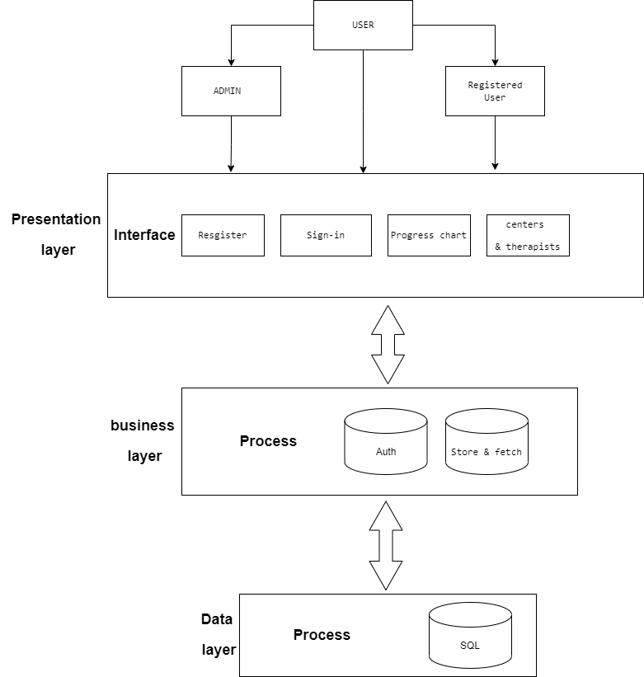

**Figure 4.1 Architectural Design**

**4.3 Detailed Design:**

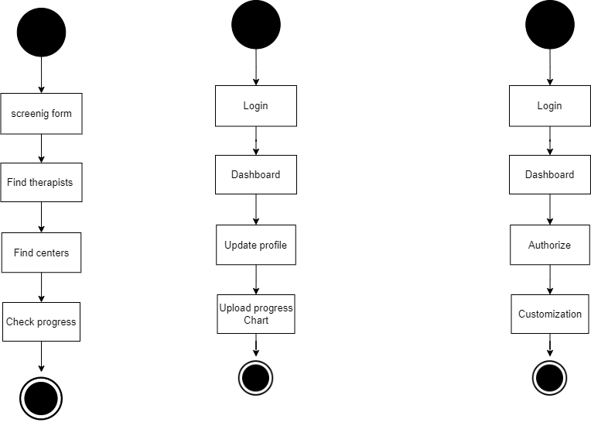

**Figure 4.2 Unregistered User Design**



**Figure 4.3 Registered User Design**



**Figure 4.4 Admin Design**

**4.4 Data Flow Diagram:**

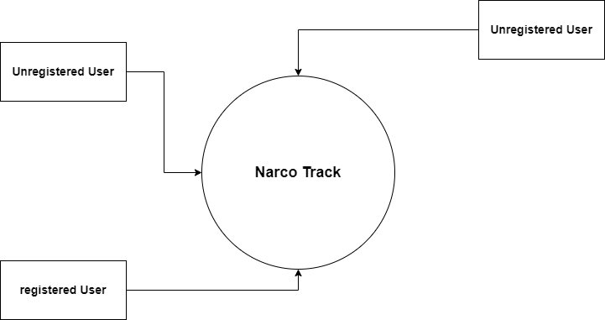

**Admin**

**Figure 4.5 Level 0 DFD**

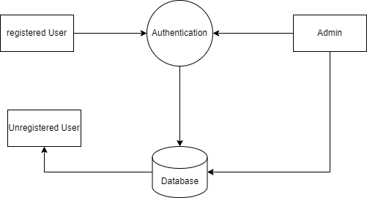

**Figure 4.6 Level 1 DFD**

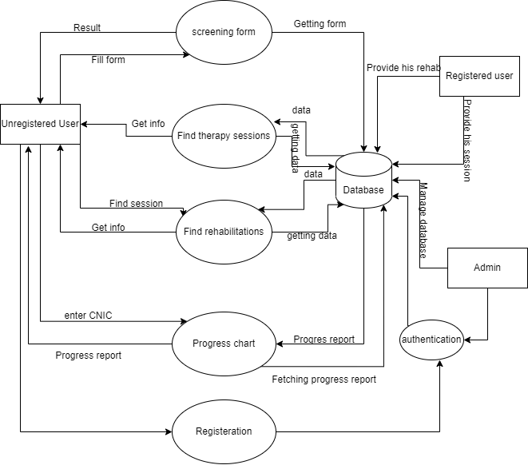

**Figure 4.7 Level 2 DFD**

**4.5 Use Case Diagram:**

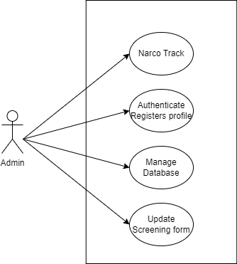

**Figure 4.8 Use Case for Admin**

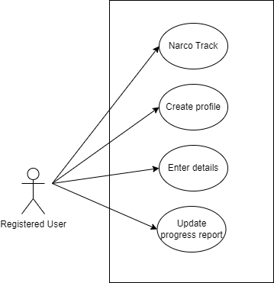

**Figure 4.9 Use Case for Registered User**

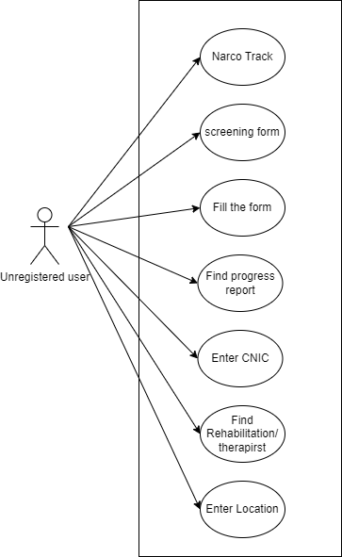

**Figure 4.10 Use Case Diagram for Un-Registered User**

**4.6 Activity Diagram:**

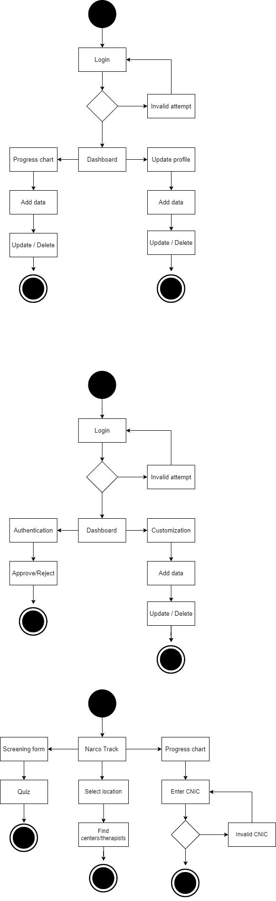

**Figure 2.11 Activity Diagram for Unregistered User**



**Figure 4.12 Activity Diagram for Registered User**



**Figure 4.13 Activity Diagram for Admin**

**4.7 State Diagram:**

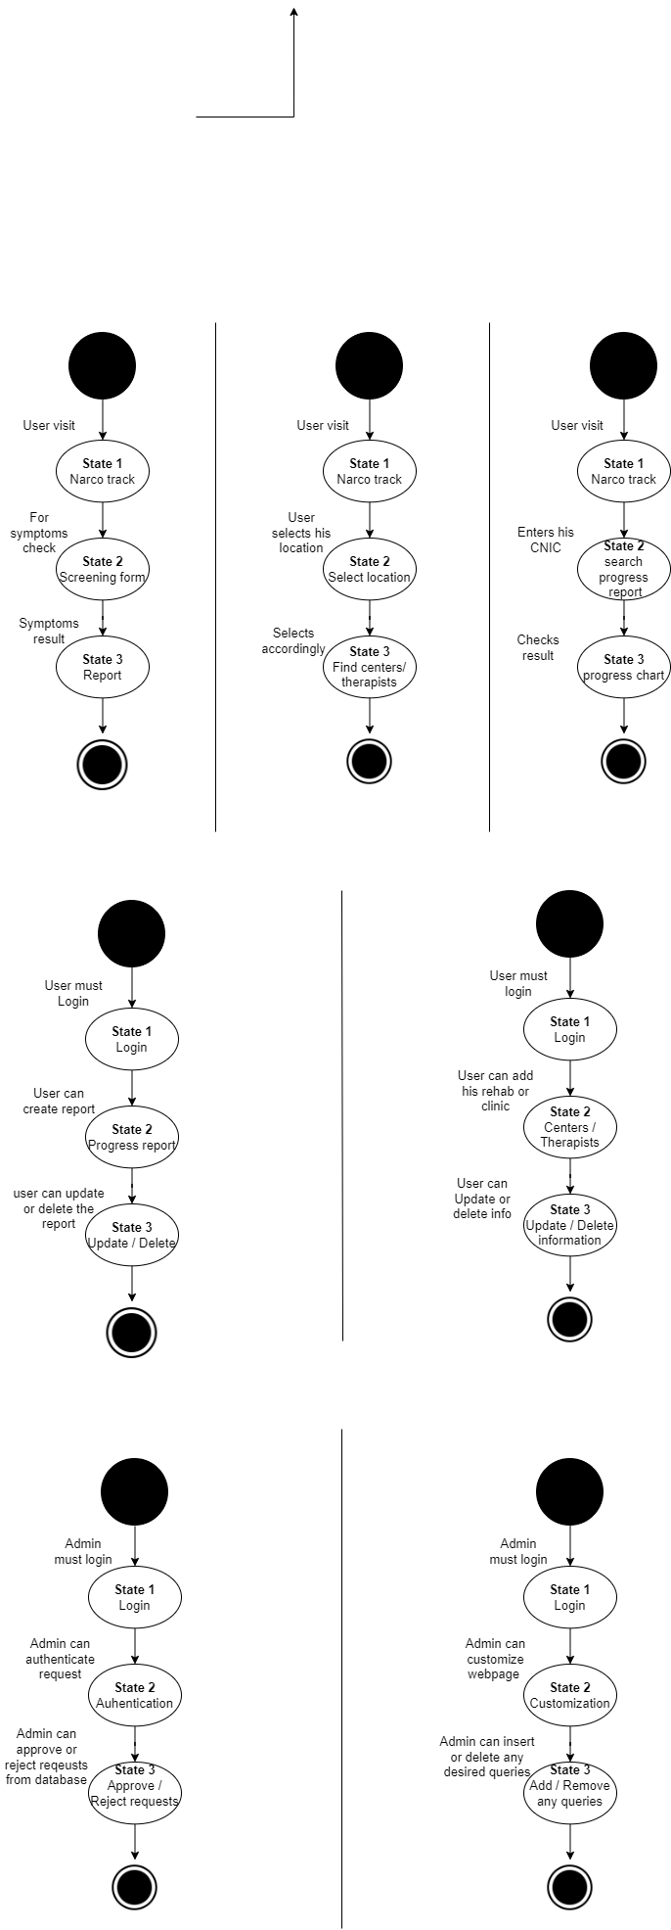

**Figure 4.14 State Diagram for Unregistered User**



**Figure 4.15 State Diagram for Registered User**



**Figure 4.16 State Diagram for Admin**

**4.8 Sequence Diagram:**

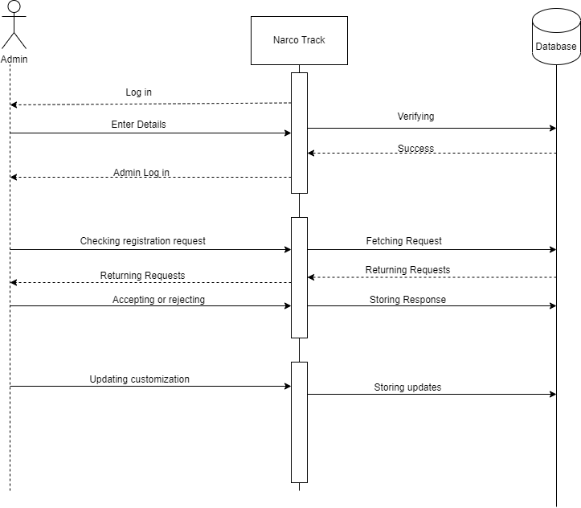

**Figure 4.17 Sequence Diagram for Admin**

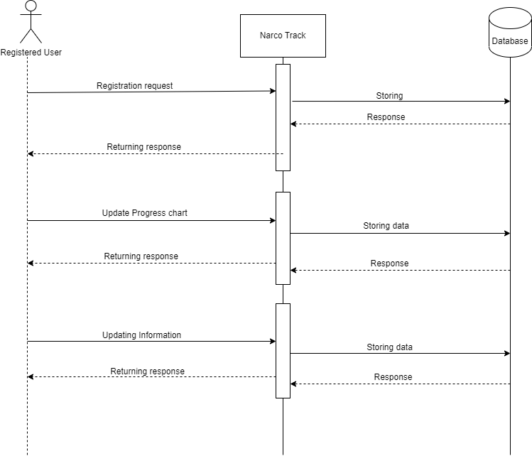

**Figure 4.18 Sequence Diagram for Registered User**

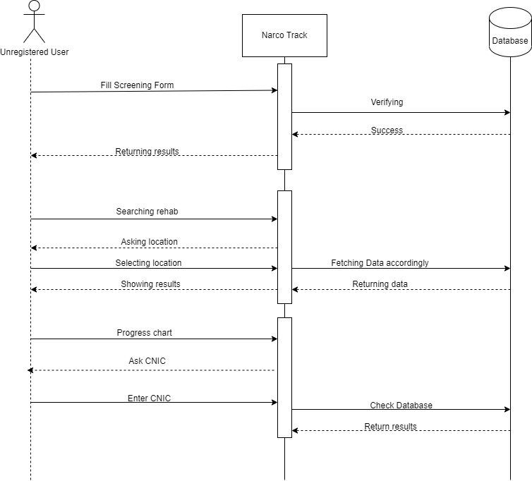

**Figure 4.19 Sequence Diagram for Un- Registered User**

**4.9 Class Diagram:**

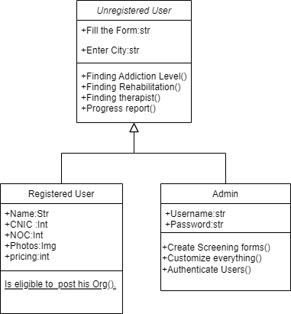

**Figure 4.20 Class Diagram**

**4.10 Entity Relationship Diagram:**

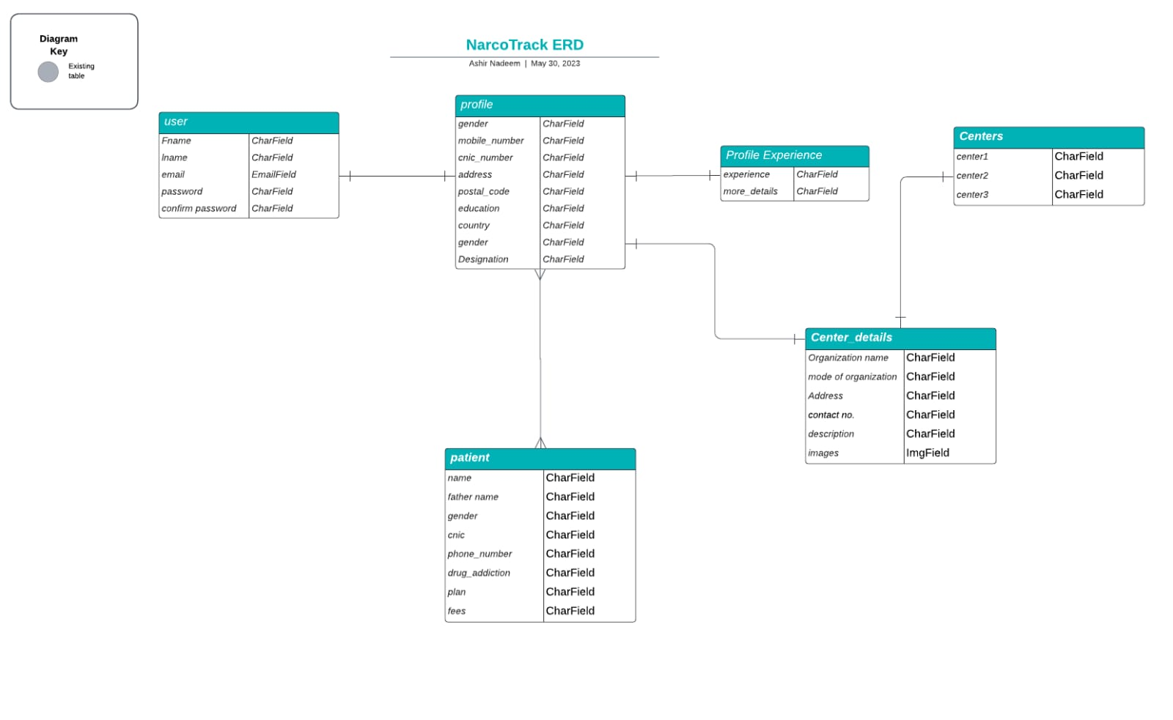

**Figure 4.21 Entity Relationship Diagram**

**4.12 Deployment Diagram**:

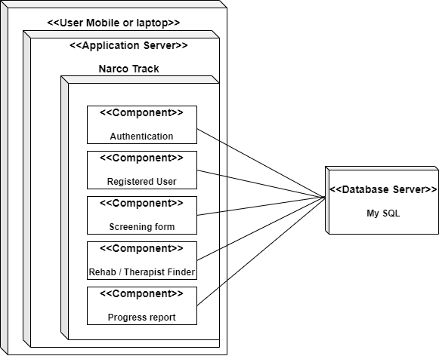

**Figure 4.22 Deployment Diagram**

**Chapter 5:**

**Implementation**

**Chapter 5: Implementation**

**5.1 Flow Control / Pseudo Code:**



**Figure 5.1 Flow Control**

**5.2 Components, Libraries and Web services:**

Django are the technology we are making use of in our utility. Django is a Python-based, version-template-views primarily based net framework this is loose and open-source. The Django software program basis, a non-income employer with headquarters in the United States, maintains it.

**5.2.1 Python**

Designed to be smooth to examine and use, Python is a high-degree programming language. Due to the fact it is open supply, anyone can use it for not anything, even for earnings. Alongside Java and Internet virtual machines, Python is accessible on Mac, windows, and UNIX working systems.

**5.2.2 Django:**

The essential motive of Django is to simplify the technique of creating hard, database-driven web sites. Much less code, minimal coupling, short improvement, and the "do no longer repeat yourself" precept are all encouraged by the framework. It additionally encourages thing reusability and "plug capacity." Python is used to create settings, documents, and information models. Fifty three the executive create, study, replace, and delete interface in Django is also dynamically generated and individually tailor-made the use of admin fashions. A few well-known websites that employ Django consist of Instagram, Mozilla, Disqus, Bit bucket, subsequent-door, and Clubhouse

**5.2.3 Libraries:**

* **Django-Ckeditor:** Ckeditor is a Django (a famous python internet framework) allows users to feature content material at once to internet pages or on-line programs.
* **Pillow:** A popular Python library which affords picture processing abilities.
* **Distlib:** Distlib is a Python library that provides capability for running with packaging, distribution, and set up of Python software.
* **Django-rest-framework:** Relax is a popular framework for constructing internet APIs the use of Django a Python internet framework.
* **manage.py:** manage.py is a command-line utility script in Django, a popular Python web framework. The purpose of manage.py is to provide a convenient interface to manage various aspects of your Django project.
* **Prompt-toolkit:** It is a library for building effective interactive command-line programs in Python, offering diverse components and utilities for developing custom command-line interfaces with features like auto completion, syntax highlighting, and key bindings.
* **Psycopg2:** Psycopg is the most famous PostgreSQL database adapter for the Python programming language. Its primary capabilities are the entire implementation of the Python.
* **Regex:** Regex are often used for pattern matching and validation purposes. Django provides a module known as re that allows you to paintings with normal expressions in diverse elements of your Django application, which includes URL routing, shape validation, and records processing.

**5.3 Code Layer:**

**5.3.1 Presentation Layer:**

Dashboard:

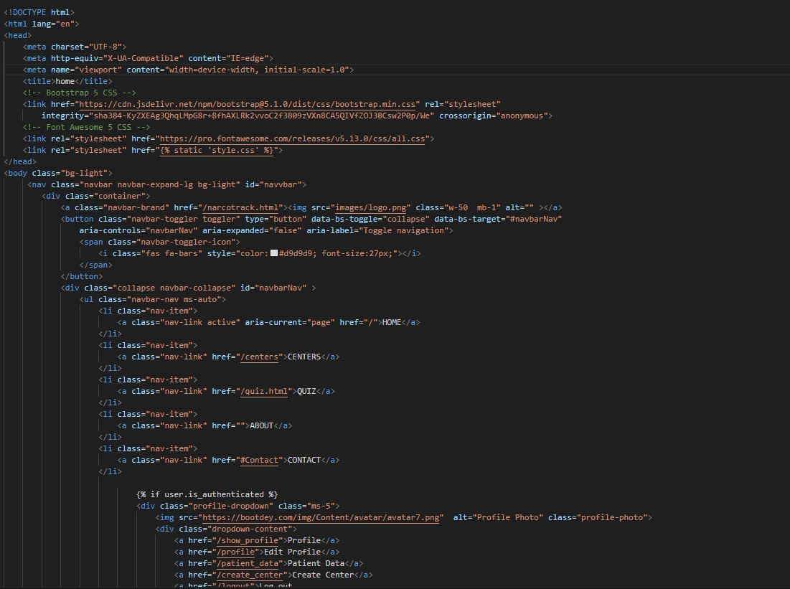

Output:

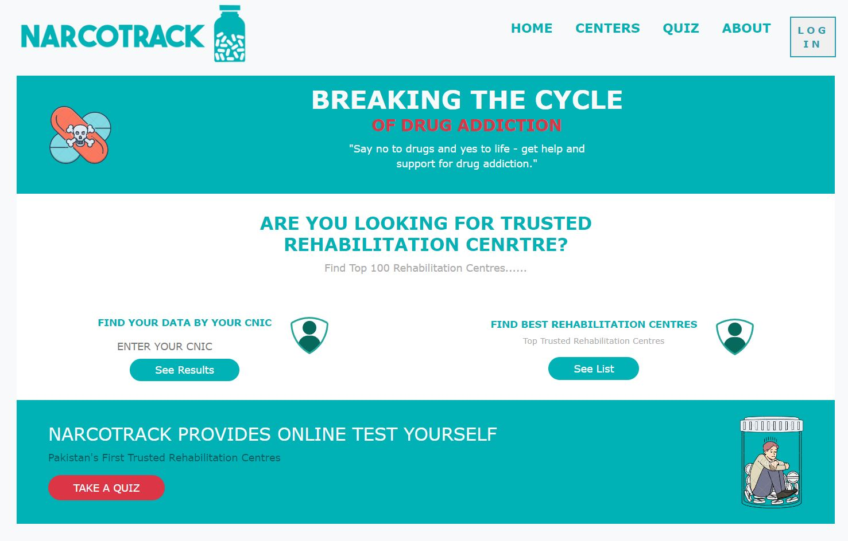

Create center:

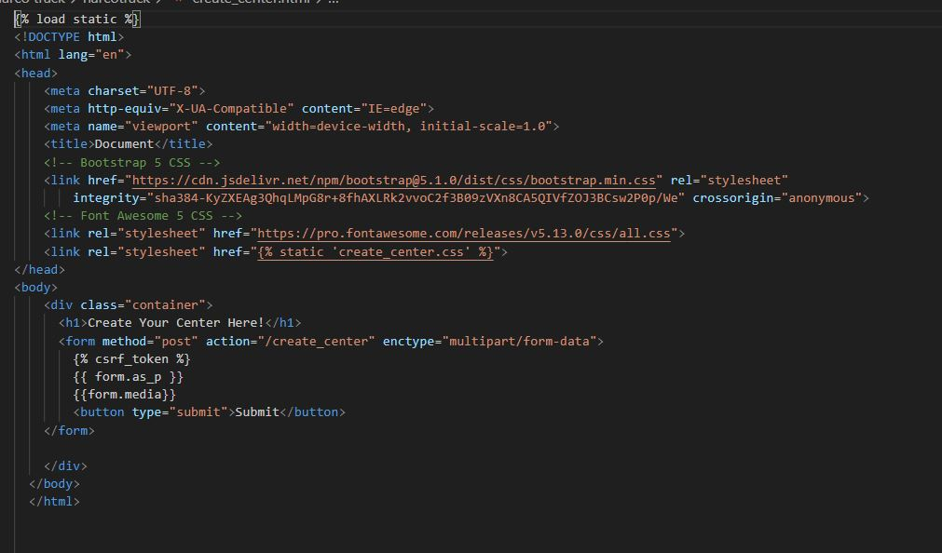

Output:

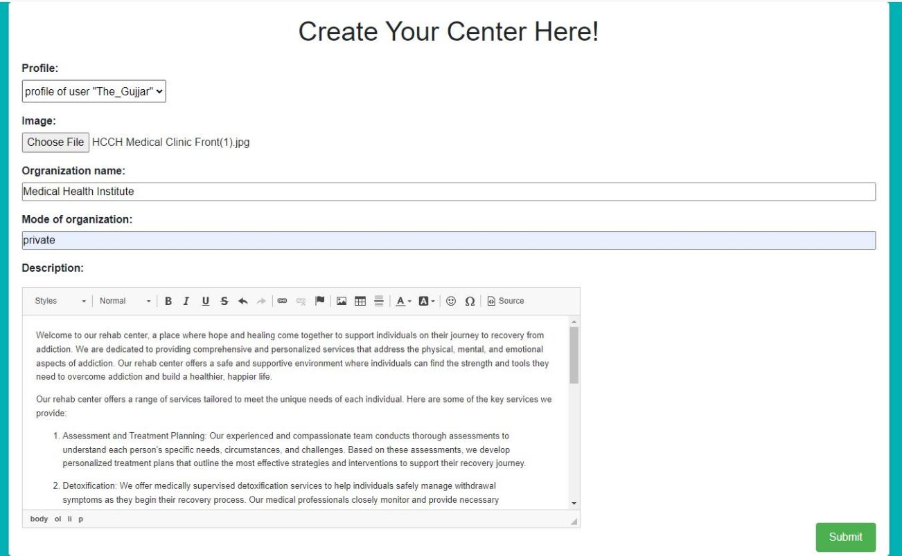

Profile setting:

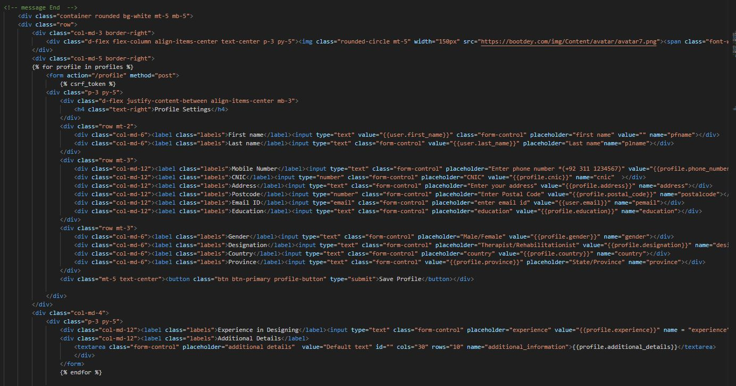

Output:

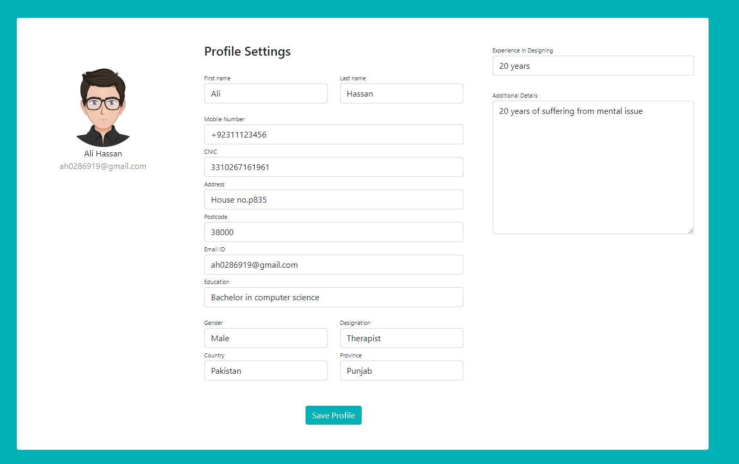

Views:

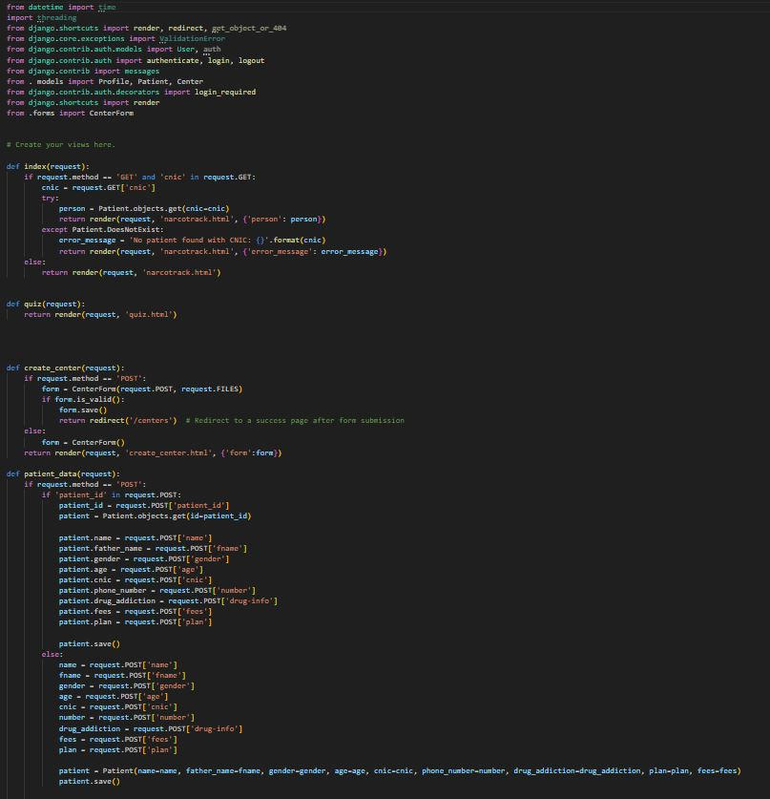

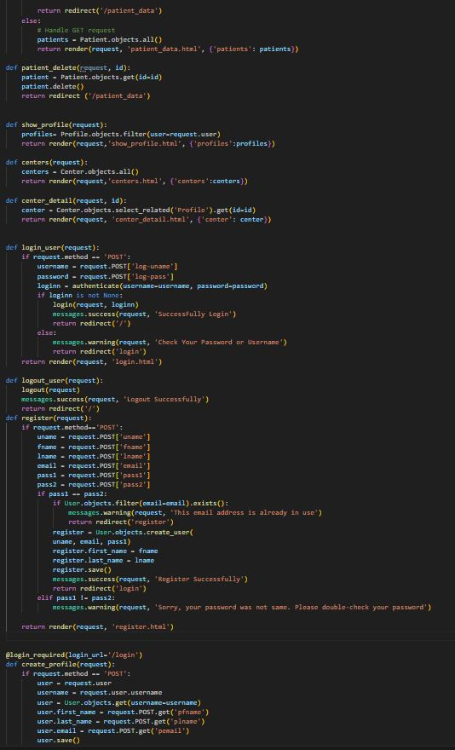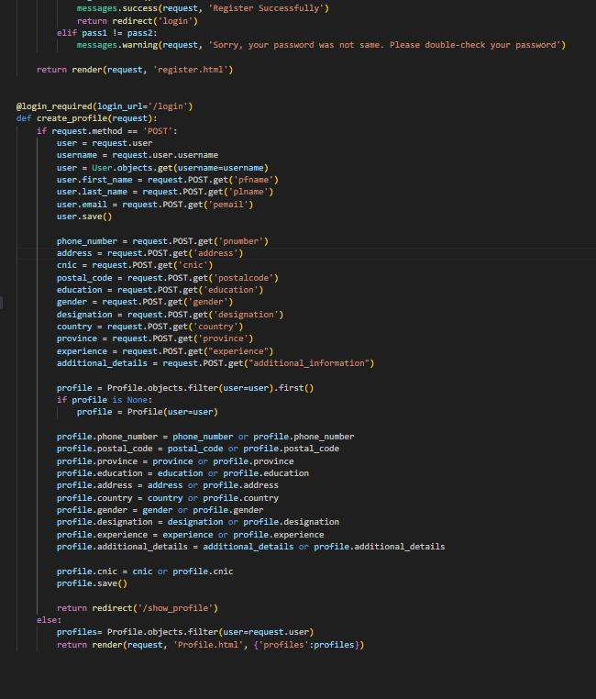

**5.3.2 Business Logic Layer:**

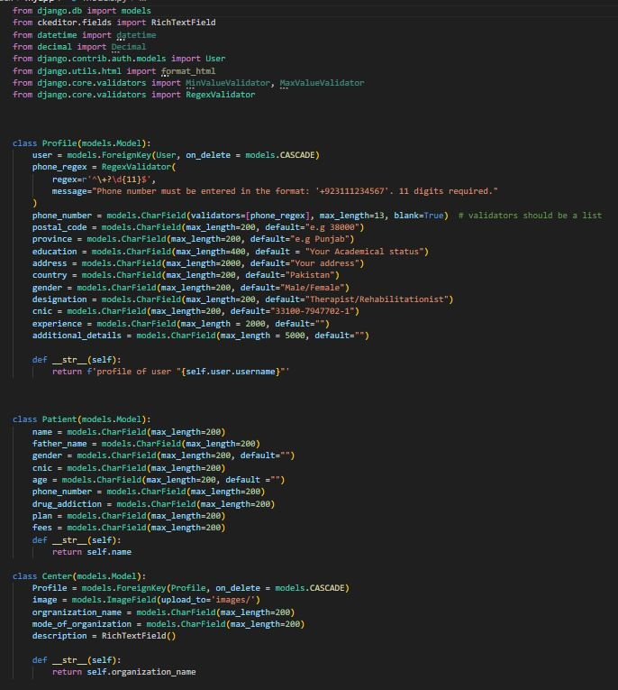

**5.3.3 Data Management / Access Layer:**

**Database Models:**

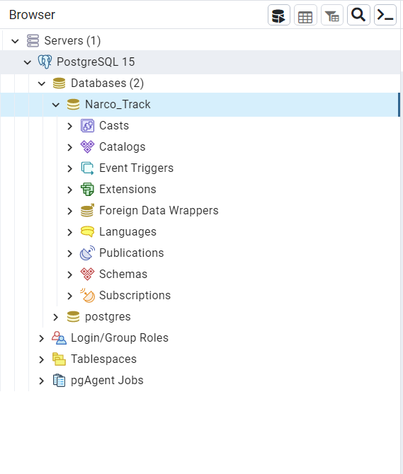

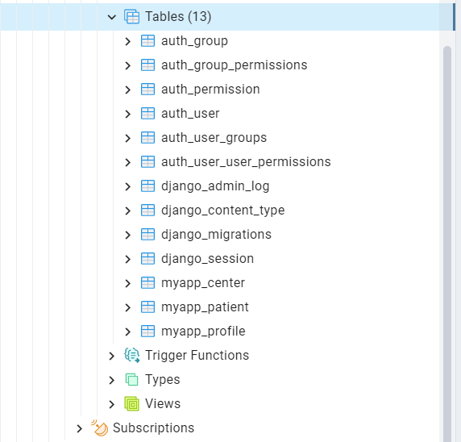

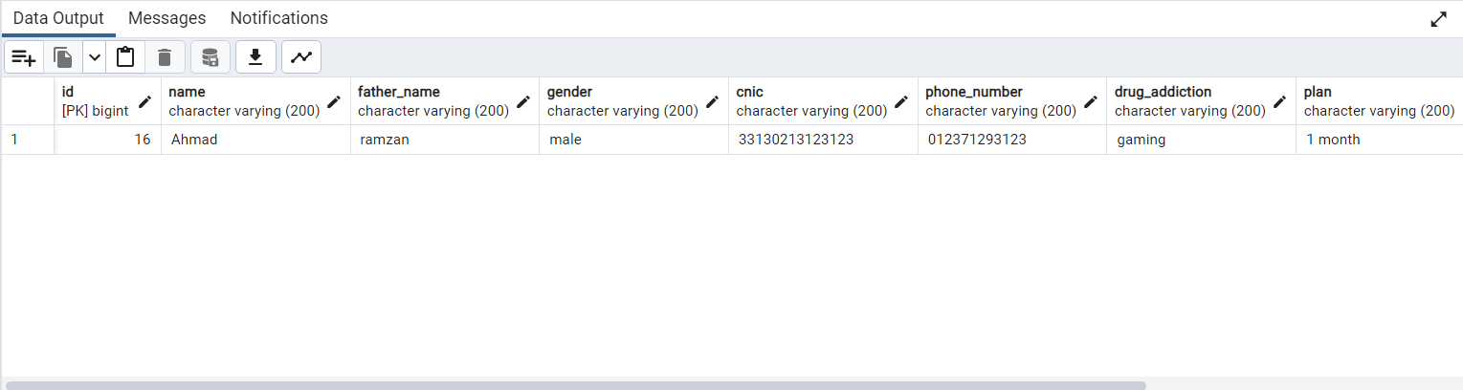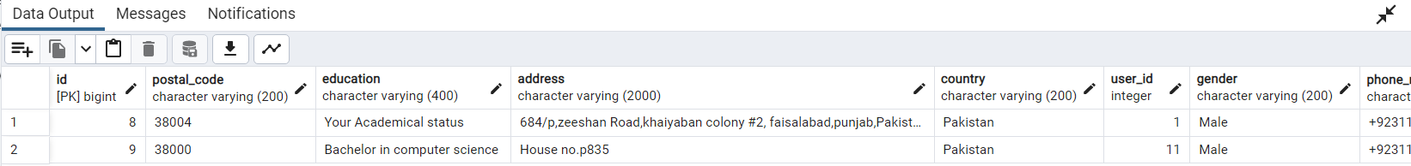

**Chapter 6:**

**Testing and Evaluation**

**Chapter 6: Testing and Evaluation**

**6.1 Introduction:**

Software application trying out is the technique of walking an application or software with the intention of figuring out software insects and figuring out whether or not the actual effects correspond to the anticipated effects, thereby making sure a software system freed from flaws. Black boxing is the method used to test the "fashion ahead" system. Black box trying out, also called specs-primarily based testing, is a way for software program testing that looks at an utility's capability in light of the specs. In this sort of checking out, internal gadget design is not taken under consideration. Assessments are primarily based on capability and necessities.

**6.2 List of Test Scenarios:**

* Test Case 1: Login
* Test Case 2: Sign Up
* Test Case 3: Creating a Rehab Profile
* Test Case 4: Drug Addiction Quiz
* Test Case 5: Registered User Add / Modify Patients Data
* Test Case 6: Unregistered User See Patients Report

**6.3 Performance and Evaluation:**

**6.3.1 Test Case 1: Login**

|  |
| --- |
| **Test Case:** 01 |
| **Test Case Name:** Login |
| **Description:** Take a look at that person login efficaciously and taken to Dashboard effectively in keeping with his consumer type. |
| **System:** NARCO TRACK |

**Table 6.1 Test Case Login**

|  |  |  |  |  |
| --- | --- | --- | --- | --- |
| **Steps** | **Test Steps** | **Expected Result** | **Actual Result** | **Result** |
| 1.1 | Scenario-1 (User Starts the system) | The system displayed a login form | Login form is displayed | Pass |
| 1.2 | Scenario -2  (User will type username  & password) | The system should accept it | The system accepts it | Pass |
| 1.3 | Scenario- 3 (User will enter invalid  username or password) | The system should not accept it | The system displays a message  “Invalid Username and Password” | Pass |
| 1.4 | Scenario -4 (Admin User Type Check) | If User Type is Admin take the user to Admin Dashboard | Admin Dashboard is opened | Pass |
| 1.5 | Scenario- 5 (Registered User Type Check) | If User Type is Registered take the user to Faculty Dashboard | Registered Dashboard is opened | Pass |

**6.3.2 Test Case: Sign Up**

|  |
| --- |
| **Test Case:** 02 |
| **Test Case Name:** Sign Up |
| **Description:** Test that user Sign Up successfully and taken to Dashboard successfully. |
| **System:** NARCO TRACK |

**Table 6.2 Test Case Sign Up**

|  |  |  |  |  |
| --- | --- | --- | --- | --- |
| **Steps** | **Test Steps** | **Expected Result** | **Actual Result** | **Result** |
| 1.1 | Scenario-1 (User click on sign up button) | The system will display a sign up, registration form. | Sign Up form is displayed | Pass |
| 1.2 | Scenario -2  (User enter the user name) | The system should accept it | The system accepts it | Pass |
| 1.3 | Scenario- 3 (User Name must be unique) | The system should not accept it if user name is not unique | The system displays a message  “Invalid Username or Username already taken” | Pass |
| 1.4 | Scenario- 4 (User Enter the first name) | The system should accept it | The system accepts it | Pass |
| 1.5 | Scenario- 5 (User Enter the last name) | The system should accept it | The system accepts it | Pass |
| 1.6 | Scenario-6 (User Enter the email) | The system accept it. | The system should accept it | Pass |
| 1.7 | Scenario-7  (User Enter the invalid email) | The system should not accept it. | The system displays a message “Invalid email” | Pass |
| 1.8 | Scenario- 8 (  User enters the Password twice) | The system should accept if password is entered same twice | The system should accept it | Pass |
| 1.9 | (User enters the Incorrect Password second time) | The system should not accept it. | The system displays a message “Invalid  Password” | Pass |

**6.3.3 Test Case 3: Creating a Rehab Profile**

|  |
| --- |
| **Test Case:** 03 |
| **Test Case Name:** Creating a Rehab profile |
| **Description:** Creating a Rehab profile or Registered Rehab Center successfully on system |
| **System:** NARCO TRACK |

**Table 6.3 Test Case Creating a Rehab Profile**

|  |  |  |  |  |
| --- | --- | --- | --- | --- |
| **Steps** | **Test Steps** | **Expected Result** | **Actual Result** | **Result** |
| 1.1 | Scenario-1 (User click on creating center) | The system displayed creating center form | Creating center form is displayed | Pass |
| 1.2 | Scenario -2  (User type Rehabilitation center Name  ) | The system should accept it | The system accepts it | Pass |
| 1.3 | Scenario- 3 (User input the location  ) | The system should accept it | The system accepts it | Pass |
| 1.4 | Scenario -4 (User input the mode (private/public)) | The system should accept it | The system accepts it | Pass |
| 1.5 | Scenario- 5 (User input the description which includes everything about Rehab) | The system should accept it | The system accepts it | Pass |

**6.3.4 Test Case 4: Drug Addiction Quiz**

|  |
| --- |
| **Test Case:** 04 |
| **Test Case Name:** Drug Addiction Quiz |
| **Description:** Test that user click on the Screening form taken to Screening form successfully. |
| **System:** NARCO TRACK |

**Table 6.4 Test Case Drug Addiction Quiz**

|  |  |  |  |  |
| --- | --- | --- | --- | --- |
| **Steps** | **Test Steps** | **Expected Result** | **Actual Result** | **Result** |
| 1.1 | Scenario-1 (User click on the Screening form) | The system displayed a Screening form | Screening form is displayed | Pass |
| 1.2 | Scenario -2  (User will solve all the quiz) | The system should accept it | The system accepts it | Pass |
| 1.3 | Scenario- 3 (User submit the quiz) | The system should accept it | The system accepts it | Pass |
| 1.4 | Scenario- 4 (User did not fill the quiz) | The system should not accept it | The system displays a message “Solve the quiz properly” | Pass |

**6.3.5 Test Case 5: Add / Modify Patients Data**

|  |
| --- |
| **Test Case:** 05 |
| **Test Case Name:** Add / Modify Patients Data |
| **Description:** Test that Registered user successfully Add / Modify the data of Patients Data |
| **System:** NARCO TRACK |

**Table 6.5 Test Case Add / Modify Patients Data**

|  |  |  |  |  |
| --- | --- | --- | --- | --- |
| **Steps** | **Test Steps** | **Expected Result** | **Actual Result** | **Result** |
| 1.1 | Scenario-1 (User Click on the Patients Data) | The system displayed a Patient Data | Patient Data is displayed | Pass |
| 1.2 | Scenario -2  (User must be Registered to Add / Modify Patients Data) | The system should accept it | The system accepts it | Pass |
| 1.3 | Scenario -3  (User is not Registered) | The system should not accept it | The system displays a message “Log In or Sign Up” | Pass |
| 1.4 | Scenario -4  (User add new user by filling the requirement fields and click add) | The system should add the new user | The new user is added | Pass |
| 1.5 | Scenario -4  (User modify the patients data and click modify) | The system should update the patients information | The system updates the information | Pass |

**6.3.6 Test Case 6: Unregistered user see Patients Report**

|  |
| --- |
| **Test Case:** 06 |
| **Test Case Name:** Unregistered User see Patients report |
| **Description:** Test that Unregistered user see the report of the Patient |
| **System:** NARCO TRACK |

**Table 6.6 Test Case Unregistered User see Patients report**

|  |  |  |  |  |
| --- | --- | --- | --- | --- |
| **Steps** | **Test Steps** | **Expected Result** | **Actual Result** | **Result** |
| 1.1 | Scenario-1 (User Click on the Patients Report) | The system displayed a CNIC field | CNIC field displayed | Pass |
| 1.2 | Scenario -2  (User must enter the CNIC of the patient) | The system should displayed the patient report | The system displayed the patient report | Pass |
| 1.3 | Scenario -3  (User did not enter the CNIC) | The system should not displayed the patient report | The system displays a message “enter the CNIC” | Pass |

**Chapter 7:**

**Conclusion and Outlook**

**Chapter 7: Conclusion and Outlook**

**7.1 Introduction:**

We will discuss our accomplishments, the lessons we've learned, and future improvements in this chapter. We faced a number of difficulties while creating our anti-drug web application, but we also learned a lot that helped us approach the problem. We successfully overcame challenges and reached significant milestones by conducting thorough research, collecting thorough requirements, and considering a variety of solutions.

**7.2 Achievements and Improvements:**

By the grace of Allah Almighty, our anti-drug web application has been a useful weapon in the war on drugs. It has given people a platform to access resources, support, and guidance in their journey towards a drug-free life through its user-friendly interface, extensive features, and real-time information. By enabling users to make informed decisions, find professional assistance, and locate the resources they need for prevention and recovery, we have worked to have a positive impact.

Throughout the course of creating our web application, we became acutely aware of the pressing need to address the complexity of drug abuse. Features that support education, early intervention, and harm reduction tactics have been incorporated. By utilizing technology, we have made it simpler for people to look for assistance, find treatment centers, access support groups, and keep up with the most recent advancements in the antinarcotics industry.

**7.3 Critical Review:**

By seamlessly integrating Python with the backend and successfully managing data, the Django and Python-based Antinarcotic web application achieved its goals. Our committed team put in a lot of work to ensure the project's successful completion with the invaluable guidance of our project supervisor and constructive feedback from the faculty. As a result, all functional requirements were put into place, tested in-depth, and made sure the application was fully functional and prepared for use in real-world scenarios. Python and Django's integration was flawlessly carried out, enabling a consistent user experience across platforms. The data is efficiently managed by the backend system, which also ensures its accuracy, security, and accessibility. An effective and dependable Anti narcotic web application that can be used for future development and use is the result of everyone's dedication, hard work, and adherence to rules.

**7.4 Future Recommendation / Outlook:**

We made each attempt to expand this device inside the given time. We will preserve running to make upgrades to our system in the destiny. For future, we will add new features to improve our drug web application:

• Online Session

• AI Consultant

**7.5 Summary:**

Our NARCO Track Web application is devoted to combating drug abuse via supplying comprehensive support and sources to individuals and households. We prioritize attention through supplying statistics on the dangers of medication and their effect on physical and mental health, empowering users to make knowledgeable selections. Our platform additionally presents various guide services, inclusive of intervention strategies, screening forms, and get admission to local rehabilitation facilities. We emphasize a holistic method that addresses each individuals and their support networks. Additionally, our NARCO Track Web application enables anonymous reporting of drug-related activities and offers sufferers report. By integrating information and facts, we attempt to focus on the superiority of drug abuse and recommend for evidence-primarily based solutions and effective policies. Ultimately, our purpose is to create a stronger, healthier, and drug-resistant society via serving as a hub of know-how, help, and empowerment for those affected by drug abuse. We can also add some features in the future which includes Online Session and AI Consultant.

**References:**

**1.** Conyers, B. Addict in the Family: Stories of Loss, Hope and Recovery; Hazelden Press: Centre City, MN, USA, 2014

**2.** Maloney E, Degenhardt L, Darke S, et al. Suicidal behaviour and associated risk factors among opioid-dependent individuals: a case-control study. Addiction. 2017

**3.** Chalk, Peter & Angel Rabasa , 2011. The Colombian Labyrinth: The Synergy of Drugs and Insurgency and Its Implications for Regional Stability. Santa Monica, CA: RAND

**4.** Michael S. Gordon, Thomas R. Blue, Kathryn Couvillion, Robert P. Schwartz, Kevin E. O’Grady, Terrence T. Fitzgerald, Frank J. Vocci, Initiating buprenorphine treatment prior to versus after release from prison: Arrest outcomes, Drug and Alcohol Dependence, 10.1016/j.drugalcdep.2018.04.010, 188, (232-238), (2018).

**5.** Bangkok Post Half measures against drugs (16 December 2014)

**6.** C. Atkinson, C. Bunse, H.-G. Gross;, and T. Kühne. Towards a general component model for web-based applications. Ann. Softw. Eng., 13(1-4):35-69, 2012

**7.** Ageed, Z.S., et al., A state of art survey for intelligent energy monitoring systems. Asian Journal of Research in Computer Science, 2021

**8.** Alfiraida, S. 2018. Identifikasi materi biologi SMA sulit menurut pandangan siswa dan guru SMA se-Kota Salatiga. Journal of Biology Education

**9.** Keserü, G. M. & Makara, G. M. The influence of lead discovery strategies on the properties of drug candidates. Nature Rev. Drug Discov. 8, 203–212 (2019)

**10.** Swift, W., Copeland, J. and Hall, W. 1998. “Choosing a diagnostic cut-off for cannabis dependence.” Addiction 93: 1681-1692. Martin, G., Copeland, J., Gates, P., and Gilmore, S. 2006. “The Severity of Dependence Scale (SDS) in an adolescent population of cannabis users: Reliability, validity and diagnostic cut-off.” Drug and Alcohol Dependence 83.

**11.** UNODC, Solvent abuse among street children in Pakistan, The United Nations System in Pakistan, Islamabad, 2015

**12.** For statistical consistency, the United Nations defines youth as those aged between 15 and 24 years.

**13.** Ramos-Cerqueira ATA, Lima MCP. A formação da identidade do médico: implicações para o ensino de graduação em Medicina. Interface. 2002;6(11).

**14.** Haglund M, aan het Rot M, Cooper NS, Nestadt PS, Muller D, Southwick SM, et al. Resilience in the third year of medical school: a prospective study of the associations between stressful events occurring during clinical rotations and student well-being. Acad Med. 2009;84(2).

**15.** UNODC 2017 Country Progress Reports 2017: Narrative Report.

**16.** Damiri, Basma, et al. "Drug use and possession, emerging of new psychoactive substances in the West Bank, Palestine." Egyptian Journal of Forensic Sciences 8.1 (2018).

**17.** International Journal of Scientific & Engineering Research Volume 10, Issue 10, October-2019 ISSN 2229-5518

**18.** Carroll, K. M., Ph, D., Onken, L. S., & Ph, D. (2005). Reviews and Overviews Behavioral Therapies for Drug Abuse. (August), 1452–1460.

**19.** Sleep, Darrell. "Albumin and its application in drug delivery." Expert opinion on drug delivery 12.5 (2015): 793-812.

**20.** Tintore M, Vidal-Jordana A, Sastre-Garriga J. Treatment of multiple sclerosis — success from bench to bedside. Nat Rev Neurol. (2019) 15:53–8. doi: 10.1038/s41582-018-0082-z

**21.** Waddington, Kirsty E., et al. "Using serum metabolomics to predict development of anti-drug antibodies in multiple sclerosis patients treated with IFNβ." Frontiers in immunology 11 (2020): 1527.

**22.** Bryant, Ayesha S., and Robert J. Cerfolio. "The influence of preoperative risk stratification on fast-tracking patients after pulmonary resection." Thoracic surgery clinics 18.1 (2015).

**23.** Raza, Syed Ali, Syed Tehseen Jawaid, and Ayesha Hassan. "Internet banking and customer satisfaction in Pakistan." Qualitative Research in Financial Markets (2015).

**24.** Purdon, Lucy, Arsalan Ashraf, and Ben Wagner. "Security v Access: The Impact of Mobile Network Shutdowns, Case Study Telenor Pakistan." (2015).

**25.** Farid, Shahid, et al. "Identification and prioritization of critical issues for the promotion of e-learning in Pakistan." Computers in Human Behavior 51 (2015).