Md. Ashir Rahman
ID: 20301079
Section: 18

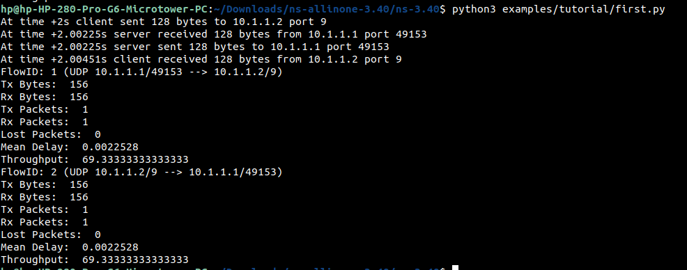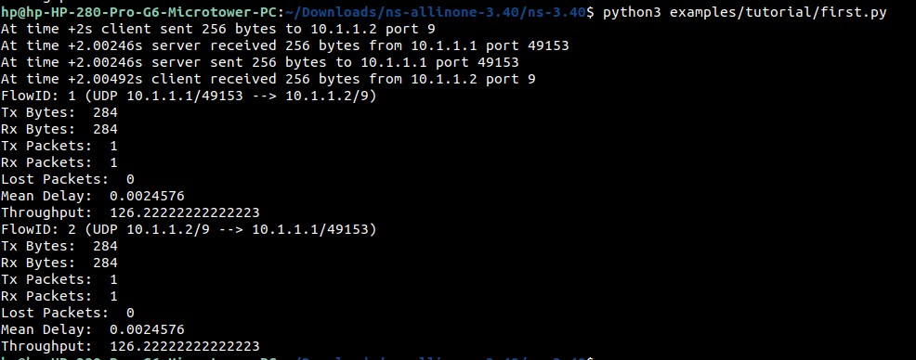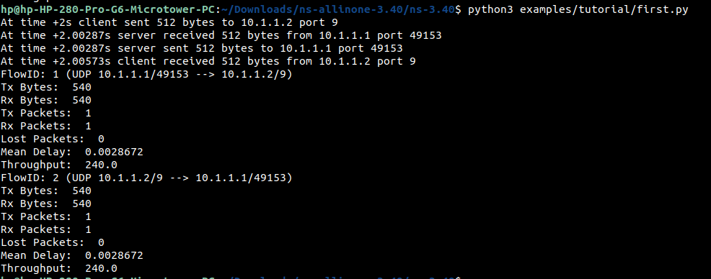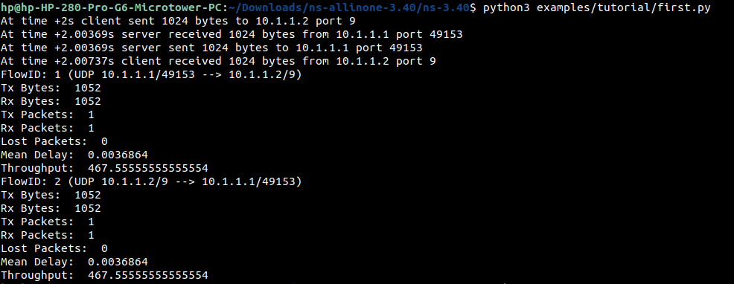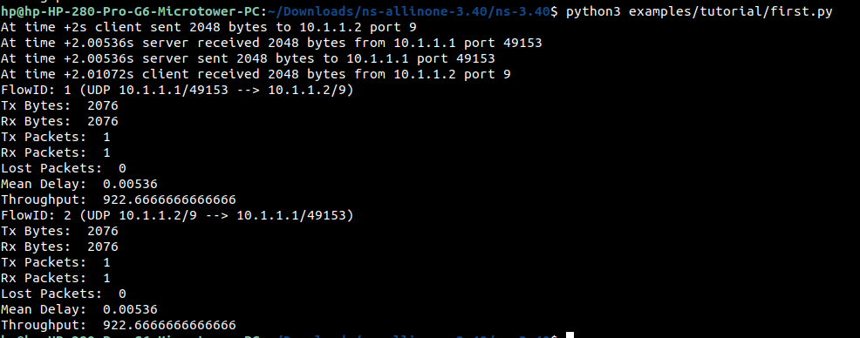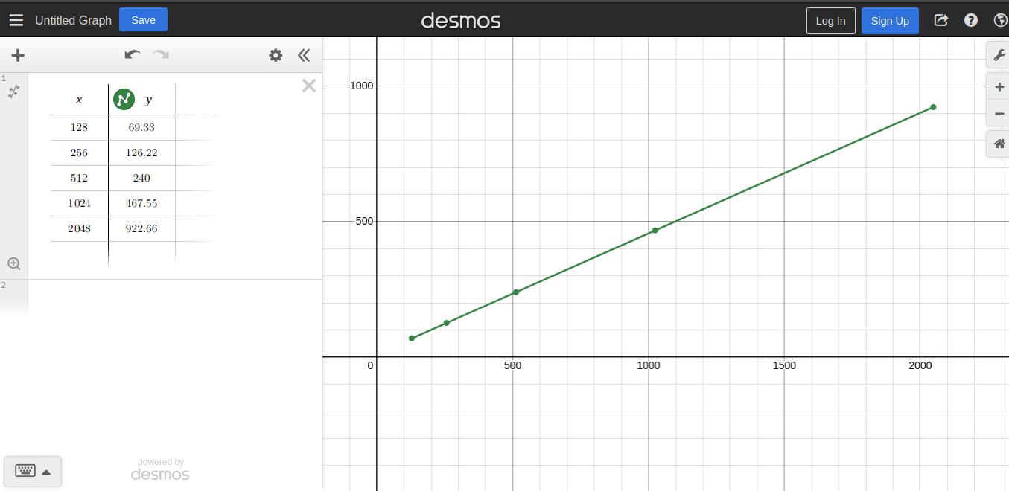

Graph Description:

The information provided indicates a correlation between data size and throughput in a network communication context. The data size ranges from 128 bytes to 2048 bytes, with throughput measured in bytes per second. Analysis shows that as the data size increases, the throughput also rises. This suggests that larger volumes of data can be transmitted at higher rates, resulting in increased throughput. The graphical representation of this relationship would exhibit an upward trend, with data size represented on the x-axis and throughput on the y-axis. The plotted points on the graph would illustrate a rise in throughput values as the data size grows.

