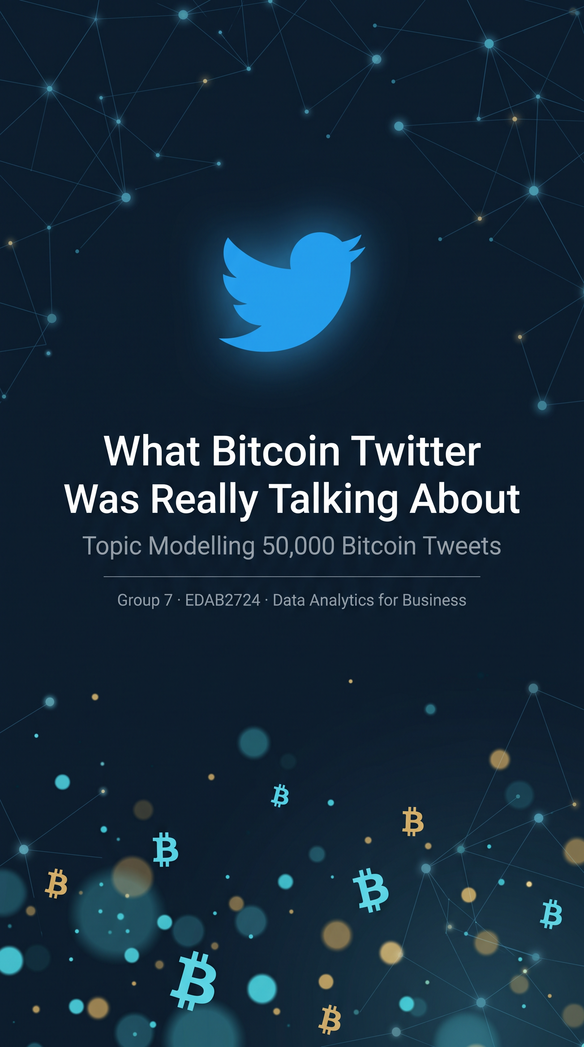
Group 1 EDAB

Executive Summary
We analysed 50,000 Bitcoin-related tweets posted during a single evening, 17:33 on 16 September 2022 to 00:04 on 17 September 2022 (UTC), to answer two questions a decision-maker would ask: what were people actually talking about, and how did that conversation move through the evening?

The headline finding is uncomfortable but useful: most of what looks like a "Bitcoin conversation" on Twitter is not people talking. After cleaning the data, only 11.9% of the original tweets (5,968 of 50,000) survived as distinct, English-language, original posts. Two-thirds of the raw feed was people reposting other people's posts, and a further third was written in other languages. Of the tweets that remained, roughly 27% came from automated accounts or outright promotion. Bots reciting market indicators, airdrop giveaways, affiliate deals and a mobile treasure-hunt game. The two main themes of the six we uncovered — price and trading talk (33.3%) and general crypto news (39.5%) — are mostly human discussion, though the price theme also contains automated alerts.

The second question produced the more commercially interesting answer. The conversation was not static. Through the evening, price-and-trading chatter grew from 31.0% of posts at 17:00 to a peak of 37.0% at 20:00, while giveaway and airdrop promotion shrank from 18.8% to a low of 12.3%. As the evening progressed, the crowd shifted from "look at this new project" to "what is happening to the price." For anyone using social media to time announcements, measure sentiment or understand market mood, when you look matters as much as what you look at.
Everything below explains how we reached these numbers, what each theme means in business terms, and just as important what this analysis cannot tell you, given that it covers one evening rather than a full market cycle.
________________________________

1. The Question We Set Out to Answer
Bitcoin generates tens of thousands of tweets a day, and those tweets move markets, shape reputations and sell products. But a raw feed of 50,000 tweets is not insight; it is noise with occasional signal buried in it. Our brief was to find the dominant themes in that feed and to explain how those themes changed over time.

We treated this as a business intelligence exercise rather than a purely technical one. A portfolio manager, a crypto exchange, a regulator or a marketing team looking at this data all want the same underlying thing: to know what the crowd is doing without reading 50,000 posts. The purpose of this report is to hand them that summary, with the receipts.

Two questions structure everything that follows:

- Which themes dominated the Bitcoin discussion during the observed period?
- How did the prominence of those themes change over the course of the evening?

________________________________

2. What We Had to Work With
The dataset is a public collection of Bitcoin-related tweets from Kaggle (kumari2000, "Bitcoin Tweets 2022", tweets.csv). Before any analysis, we audited it the way an auditor would: what is here, what is missing, what can be trusted.

Property | Finding
Raw size | 50,000 tweets
Time span | 17:33, 16 Sep 2022 → 00:04, 17 Sep 2022 (≈ 6.5 hours)
Missing tweet text | 0 tweets
Duplicate tweet IDs | 0
Tweet composition | 66.4% retweets · 23.5% original tweets · 10.0% replies
Language mix | 67.8% English · 16.8% Turkish · 5.2% Arabic · 2.6% Spanish
Two properties of this dataset shaped every decision we made afterwards.

First, the feed is mostly echo. Two of every three tweets are retweets, meaning the same message counted many times over. Had we analysed the raw data as-is, any "dominant theme" we found would have described whatever the loudest accounts chose to repeat, not what people were saying. This is the single most important fact about social listening data, and it is the reason we removed retweets before any analysis.

Second, the dataset covers one evening, not a market cycle. Six and a half hours is enough to see a conversation move, but not enough to claim anything about how Bitcoin discussion behaves in general. We return to this limitation in Section 10, because it governs how far any of these findings should be pushed.
________________________________

3. Finding the Real Conversation: Cleaning the Data
Raw social media data cannot be analysed directly, it is full of links, tags, spam, emoji, other languages and automated content. We cleaned the corpus in stages, and at every stage we tested our decision against the data rather than following a recipe. The result is a dramatic but defensible reduction:

Stage | What we did | Tweets remaining
Raw dataset | — | 50,000
English only | Kept English-language tweets | 33,515
Retweets removed | Kept only original posts | 12,985
Exact duplicates removed | Kept one copy of identical text | 12,048
Offensive content removed (−181) | Word-list filter | 11,867
Fewer than 3 useful words (−437) | Kept posts with 3+ meaningful words | 11,430
Near-duplicates removed (−5,462) | Kept one copy of near-identical text | 5,968 (11.9%)

Keeping one tweet in eight sounds like a failure. It is the opposite: it is the point of the exercise. What we removed was, almost entirely, material that would have misled us repeated bot templates (airdrop announcements, price-alert spam), conversations happening in Turkish and Arabic that an English-language theme analysis would mangle, and copy-paste promotion. The analysis below describes the actual discussion, not the amplification machinery around it.
Four cleaning decisions are worth explaining in business terms, because each one changed the result:
Emojis: removed, after testing the alternative. A quarter of tweets (24.7%) contained emoji, and some carry real meaning in crypto culture — the whale emoji (used 1,097 times, signalling large holders) and the rocket emoji (739 times, signalling expected price rises). We tested converting each emoji into its text description, as some textbooks recommend. The test showed this would flood the vocabulary with meaningless phrases like "backhand index pointing down" and would even preserve hundreds of near-identical bot posts that the emoji removal step helps catch. Emoji went.
Spell-correction: tested and rejected. Standard spelling tools would "correct" NFT to not and Ethereum to ethereal. For a general corpus that might be harmless; for ours it would destroy the exact vocabulary the business cares about. Rejected.

Offensive content: removed as the brief requires. We combined a standard profanity word list (844 terms) with adult-content spam terms common in crypto promotion, then hand-checked a sample of what was flagged before deleting it. This removed 181 tweets small in number, but the right call for a dataset portraying a public conversation.

The word bitcoin itself: handled with care, not deleted. The word appeared in 91.6% of tweets. The assignment guidelines told us not to remove common domain words just for being frequent, so we kept it in the cleaned text, the word clouds and the exported dataset. But for the theme-finding model itself, a word present in almost every post cannot distinguish one theme from another it is like a shopping-centre survey where every respondent mentions the mall. We capped it in the model only, measured the effect (theme distinctness improved from 0.65 to 0.80, while the other quality scores barely moved), and documented the change. Every other protected term btc, price, mining, trading, volatility, bullish, bearish stayed in throughout, and we verified that with an explicit check in the code.
________________________________

4. What the Conversation Looked Like

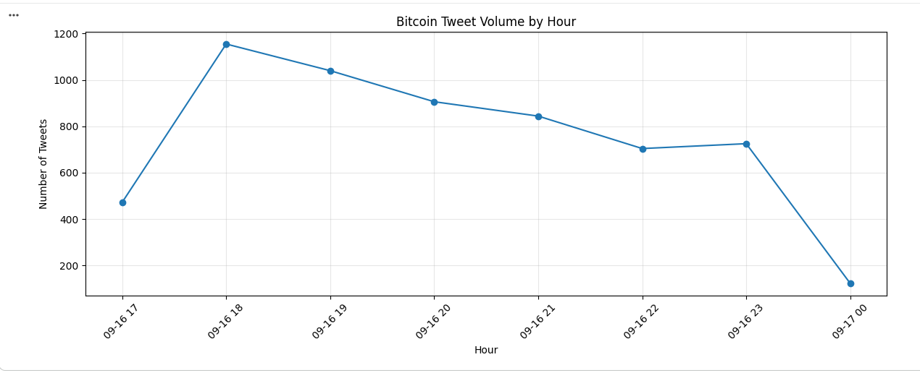
Figure 1: Hourly tweet volume

Activity peaked early. The busiest hour was 18:00–19:00, with 1,155 cleaned tweets, after which volume eased steadily through the evening (1,040 at 19:00, 906 at 20:00, 844 at 21:00, 704 at 22:00 and 725 at 23:00). The first and last hours are partial (the data starts at 17:33 and ends at 00:04), so their counts are not comparable with full hours. The conversation did not build to a climax; it front-loaded, then wound down.

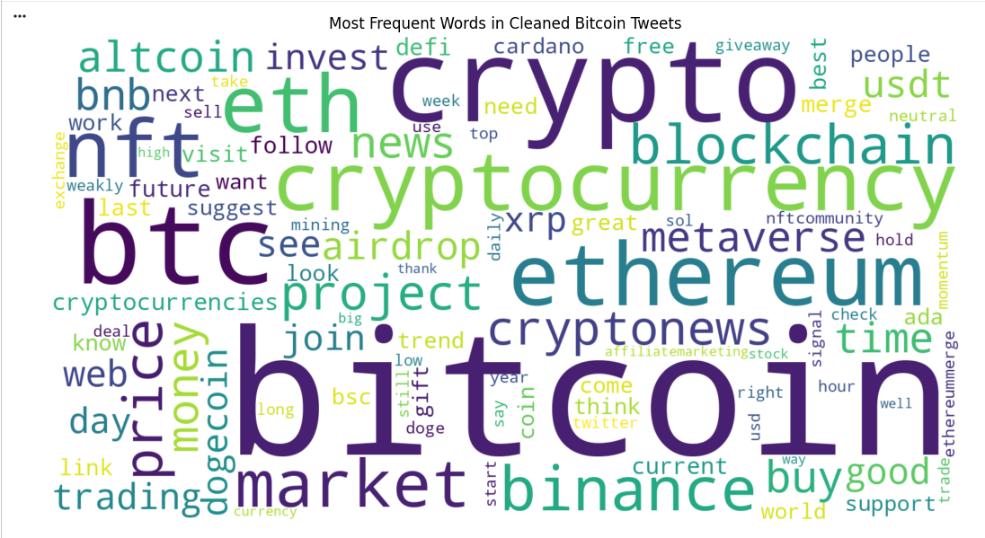

Figure 2: word cloud of cleaned tweets
The most frequent words after cleaning were: bitcoin (6,213 mentions), crypto (2,058), btc (1,995), Ethereum (1,095), cryptocurrency (1,031), eth (978), market (629), nft (600), binance (542), blockchain (506). Read at face value, this says the discussion is anchored on Bitcoin but reaches across the wider crypto world, Ethereum, NFTs and Binance all rank in the top ten. It also says frequency alone is a blunt instrument: bitcoin being everywhere tells us where the conversation happens, not what it is about. That is precisely why we needed theme modelling rather than word counts.
Hashtags reinforce the same picture (93.2% of surviving tweets carried at least one), and the most repeated three-word phrases in the corpus turned out to be fragments of a bot template, current momentum suggest market neutral appearing 127 times rather than human phrasing. Reading that correctly matters: an analyst who treated the top phrase as a crowd opinion would be quoting a machine. Two other repeated phrases are worth reading: “twitter facebook instagram” (62 times) points to social-media promotion, and “btc ethereum blockchain” (58 times) shows the discussion extending beyond Bitcoin to the wider ecosystem.

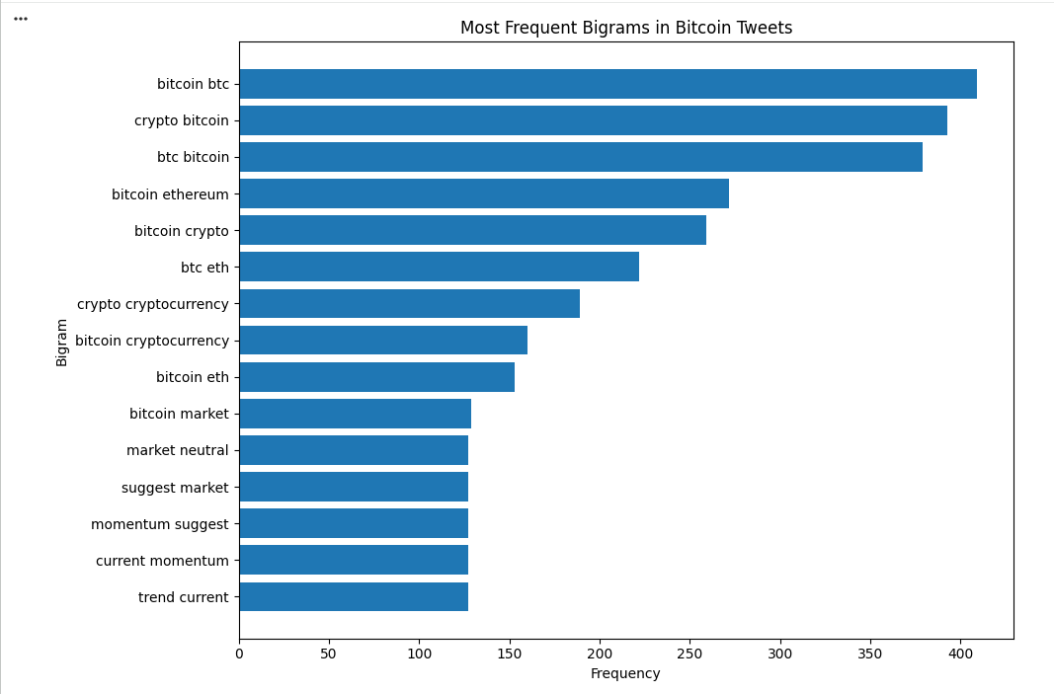
Figure 3: Most frequent bigrams
________________________________

5. How We Found the Themes (In Plain Language)
To move from frequent words to themes, we used topic modelling a family of techniques that read every tweet and group words that consistently appear together into themes, without being told in advance what those themes are. We built and compared two of the standard methods:

- LDA (Latent Dirichlet Allocation) — works from raw word counts per tweet.
- NMF (Non-Negative Matrix Factorisation) — works from word importance scores that down-weight words appearing everywhere and up-weight words that distinguish posts.

Both read the same 5,968 cleaned tweets. We ran each method at five sizes: 4, 5, 6, 7 and 8 themes (k = 4 to 8, with random state = 42 for reproducibility) and judged every run the way a manager would judge an analyst's summary, using three tests:

- Do the theme's words actually belong together? (coherence, we measured how often a theme's top words appear in the same real tweets, on a scale where higher is better)
- Are the themes genuinely different from each other? (diversity, the share of unique words across all themes' top-10 keywords)
- Can a human read the theme and understand it? (our six group members independently rated every configuration's theme 1–5 for interpretability)

We also stress-tested the winner: re-running it with a different random starting point (random state = 7) to confirm the themes were not a fluke of the random number generator.
________________________________

6. Choosing the Method We Could Trust
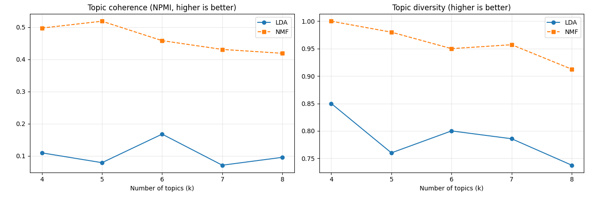
Figure 4: Coherence and diversity comparison across number of topics

The comparison was not close.
All ten model runs (LDA and NMF, k = 4–8): coherence, diversity and largest-topic share.
Method | Themes (k) | Coherence (NPMI) | Diversity | Largest topic share
LDA | 4 | 0.109 | 0.850 | 33.4%
LDA | 5 | 0.079 | 0.760 | 31.3%
LDA | 6 | 0.168 | 0.800 | 28.1%
LDA | 7 | 0.071 | 0.786 | 26.9%
LDA | 8 | 0.096 | 0.738 | 24.8%
NMF | 4 | 0.497 | 1.000 | 67.5%
NMF | 5 | 0.519 | 0.980 | 66.4%
NMF | 6 | 0.458 | 0.950 | 39.5%
NMF | 7 | 0.431 | 0.957 | 28.8%
NMF | 8 | 0.419 | 0.912 | 25.9%

NMF produced themes whose words genuinely co-occur, that barely overlap, and critically that reproduce exactly when the analysis is re-run from scratch. LDA's themes, by contrast, changed substantially between runs: its tweet-level agreement score was only 0.12 out of 1, against 0.90 for NMF. A method whose answer depends on the seed is a method whose answer you cannot take to a board meeting. NMF at four and five themes was also ruled out, because a single topic held 67.5% and 66.4% of tweets respectively. We selected NMF with six themes.
One further judgement call shaped the final model. In early runs, the word bitcoin appeared in the top keywords of all six themes, dragging theme distinctness down to 0.65 every theme looked like every other theme because they all shared one word. Applying the vocabulary cap described in Section 3 (model-only; the exported data keeps every term) removed that distortion while costing almost nothing in coherence (0.128 → 0.110). The final model, on 5,910 modelled tweets, is the version described below.
________________________________

7. Question 1: The Six Themes of Bitcoin Twitter
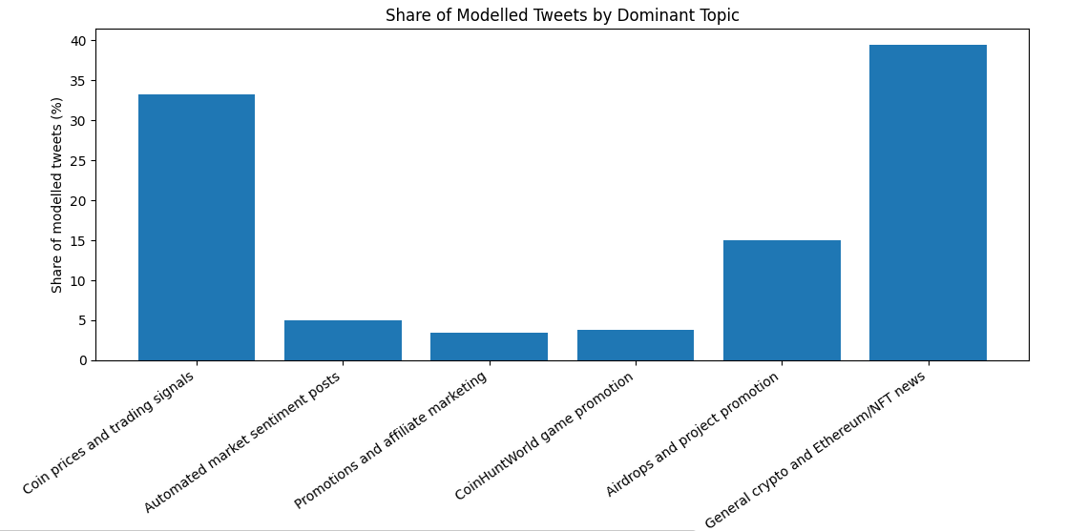
Figure 5: Share of tweets by topic
The model surfaced six themes. We label them, size them and translate each into what it means for a business reader:
# | Theme (our label) | Top-10 keywords (from the model) | Example tweets (two excerpts)
5 | General crypto & Ethereum/NFT news | crypto, ethereum, cryptocurrency, eth, blockchain, cryptonews, nft, merge, binance, news | You spend #Bitcoin to mine #STX through PoX al…  Ad Astra ✨ #Bitcoin #Ethereum #Binance #S…
0 | Coin prices & trading signals | btc, price, eth, last, bnb, usd, ada, signal, binance, time | Are you ready? 🔥🧨 💥 #Bitcoin #BTC  #Bitcoin $BTC Daily Summary September 16, 2022…
4 | Airdrops & project promotion | project, good, airdrop, future, great, best, bsc, usdt, hopefully, team | Good project and congratulations to the whole …  This is the great project and the best project…
1 | Automated market-sentiment posts | market, momentum, neutral, suggest, current, visit, trend, weakly, stock, forextrading | [1h] #Bitcoin market is strongly trending down…  [1D] #Bitcoin market is weakly trending down c…
3 | CoinHuntWorld game promotion | join, coinhuntworld, awesome, vault, location, play, find, cryptocurrency, user, blue | Bitzerk found #bitcoin Resources Only) in a Us…  Berzerker found #bitcoin in a User vault at th…
2 | Promotions & affiliate marketing | gift, deal, shop, affiliatemarketing, socialmedia, facebook, amazon, instagram, dogecoin, twitter | #linkedin #twitter #facebook #instagram #tikto…  #linkedin #twitter #facebook #instagram #surpr…

The structural insight sits in the arithmetic. Add the promotional and automated themes (15.0% + 4.9% + 3.8% + 3.5%) and 27.2% of the surviving conversation is marketing or machinery. Add the retweets stripped out at the cleaning stage and the true proportion of original human-to-human discussion in the raw feed is small. Anyone buying Bitcoin Twitter reach, running sentiment dashboards, or reading the feed as a gauge of public mood should assume a large fraction of what they are reading was placed there deliberately or generated automatically.

At the same time, the two largest themes are substantial and distinct: a news-and-ecosystem conversation (39.5%) and a price-and-trading conversation (33.3%). They behave differently which is the subject of the next section.
________________________________

8. Question 2: How the Conversation Moved Through the Evening
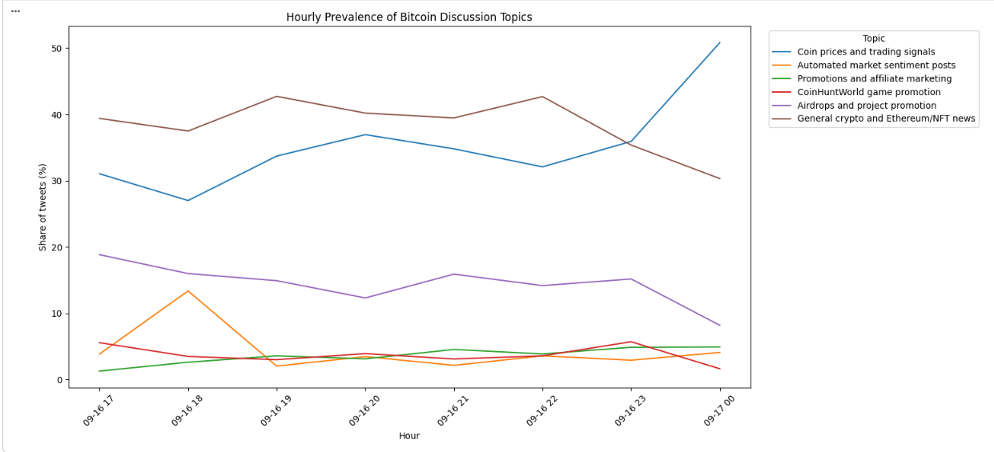
Figure 6: Hourly topic prevalence

We tracked each theme's share of tweets, hour by hour, through the evening (17:00 is a partial hour, as the data begins at 17:33). The themes did not move together and the movements tell a story about the evening:

Price talk grew as the evening went on. The price-and-trading theme started at 31.0% of posts at 17:00, dipped to 27.0% at 18:00, then climbed to its peak of 37.0% at 20:00 before easing to 34.8% at 21:00. As the night progressed, the crowd's centre of gravity moved toward the price chart.
Giveaway promotion faded. Airdrop and project promotion began the evening at 18.8% of posts, fell steadily to a low of 12.3% at 20:00, and finished the window at 15.9%. The promotional push was an early-evening activity.
General news stayed dominant throughout. The ecosystem-news theme ranged only between 37.5% and 42.7%, peaking at 19:00. It was the backdrop of the whole evening rather than a participant in the shift.
Automated posting arrived in bursts, not steadily. The automated market-sentiment theme jumped from 3.9% of posts at 17:00 to 13.4% at 18:00 — the busiest hour of the evening — before settling back to between 2% and 3.5%.

An evening on crypto Twitter has a shape. Early evening belongs to project promotion and giveaways; prime evening belongs to price talk; and the background hum of ecosystem news never stops. A marketing team launching a token giveaway would find its audience earlier in the evening. A desk monitoring crowd sentiment would do well to weight the 19:00–21:00 hours, when price discussion is at its most concentrated and to discount the bursts of automated posting that can distort a single hour.
________________________________

9. Four Insights for Decision-Makers
Each insight separates what the model shows from what we believe it may mean — the first is measured, the second is judgement.

Insight 1 — More than a quarter of the "conversation" is manufactured. What the model shows: promotional, automated and campaign themes account for 27.2% of cleaned tweets, on top of the 66.4% retweet share removed at cleaning. What it may mean: headline social-media volume overstates genuine community interest by a wide margin. Sentiment tools, influencer metrics and "buzz" measurements should be filtered for automated and promotional content before they inform spending or strategy. What remains after filtering not the raw feed is the real market mood.

Insight 2 — The crowd's attention rotates on a schedule. What the model shows: price talk rose from 31.0% to a 37.0% peak at 20:00 while airdrop promotion fell from 18.8% to 12.3% over the same window. What it may mean: there is a daily rhythm to what the audience wants. Timing is a lever: announcements land differently at 17:00 (promotion-friendly) than at 20:00 (price-focused). This is a one-evening pattern, so we would want it confirmed across more days before building a playbook on it. The mechanism (promoters work early, traders work late) is plausible enough to test.

Insight 3 — The discussion is about the ecosystem, not just Bitcoin. What the model shows: the largest single theme (39.5%) is general crypto/Ethereum/NFT news; ethereum and eth rank 4th and 6th among all frequent terms. What it may mean: Bitcoin remains the door to the conversation, but the room is bigger than Bitcoin. Brands, exchanges and media operating only in Bitcoin terms are absent from roughly two-fifths of the discussion happening around them.

Insight 4 — Automated posting arrives in bursts, not steadily. What the model shows: the automated market-sentiment topic jumped from 3.9% of posts at 17:00 to 13.4% at 18:00, then fell back to 2–3.5%. What it may mean: a single hour of templated posts can distort a sentiment reading, so tools should filter or down-weight automated content. The model cannot tell us why the burst occurred.
________________________________

10. What We Trust, and What We Do Not
What we trust. The cleaning funnel is documented and reversible every removed category is counted, and the decisions (emoji, spell-correction, the bitcoin cap) were each tested against the data before being applied. The winning model's themes reproduce perfectly under a different random seed (all six keyword sets matched; tweet-level agreement 0.904), which means the result is a property of the data, not of our random number generator. The theme labels are supported by keyword evidence and representative tweets, all preserved in the accompanying notebook and topic_assignments.csv.

What we do not claim. First and most importantly, this analysis covers one evening (≈6.5 hours) in September 2022. It shows how this conversation moved during this window; it cannot establish that these shares or shifts hold on other days, in other market conditions, or in 2026. Second, topics are model-derived themes, not ground-truth categories — the labels are our informed reading of keyword and example evidence, and other reasonable readings exist. Third, the corpus is English-only by design; the 32.2% of non-English posts (notably Turkish and Arabic) were excluded and their themes are invisible here. Fourth, engagement metrics (likes, retweets received) were explored but not modelled; this report measures what is said, not what is heard.

We flag one honest caveat about method: the final model choice combined statistical scores with a human interpretability panel from our group. The panel's scores are recorded in the notebook; where a future reader disagrees with them, the quantitative case for NMF at six themes stands on its own (coherence 0.458, diversity 0.95, seed-stability 1.000).
One further caveat comes from the modelling itself: topics 1 to 4 appear to be driven by repeated, templated or promotional tweets, so NMF's high coherence and stability may partly reflect repeated wording rather than genuinely distinct discussion. The model shows what is posted, not what people think.
________________________________

11. Conclusion
We set out to find what 50,000 Bitcoin tweets were talking about and how that changed. After stripping away the retweets, the other languages, the duplicates and the spam, we found a six-theme picture of one evening: a dominant ecosystem-news backdrop (39.5%), a large human price-and-trading conversation (33.3%), and a promotional layer (27.2%) that most observers would mistake for community enthusiasm.

The conversation moved. Price talk grew into the evening, peaking at 20:00; giveaways faded; automated posts arrived in bursts. For a decision-maker, the practical takeaways are to filter before you measure, to weight the hours when humans actually dominate, and to remember that Bitcoin sits inside a wider conversation it no longer owns.
The method proved out: the same themes emerge on re-run, every cleaning decision is documented and justified, and the full tweet-to-theme assignment is delivered alongside this report (topic_assignments.csv, tweet ID, datetime, cleaned text, assigned topic and topic score) so that any figure or claim here can be checked against the underlying posts.

The next question this raises is the one this dataset cannot answer: does the evening rhythm hold across a week, a month, a market cycle? The pipeline we built is built to run again the same cleaning, the same tests, more data. That is where we would go next.
________________________________

References
- Dataset: kumari2000, Bitcoin Tweets 2022 (tweets.csv), Kaggle. https://www.kaggle.com/datasets/kumari2000/bitcoin-tweets-2022
- Text-preprocessing pipeline adapted from: GeeksforGeeks, Text Preprocessing in NLP. https://www.geeksforgeeks.org/nlp/text-preprocessing-for-nlp-tasks/
- Course brief: University of the Free State, EDAB2724, Assignment 3 (2026).
- Anthropic. (2026). Claude Sonnet 5.5 [Large language model]. https://claude.ai — used for code support and language editing; see the Declaration of AI Use.

