Use Case 1: Register Account
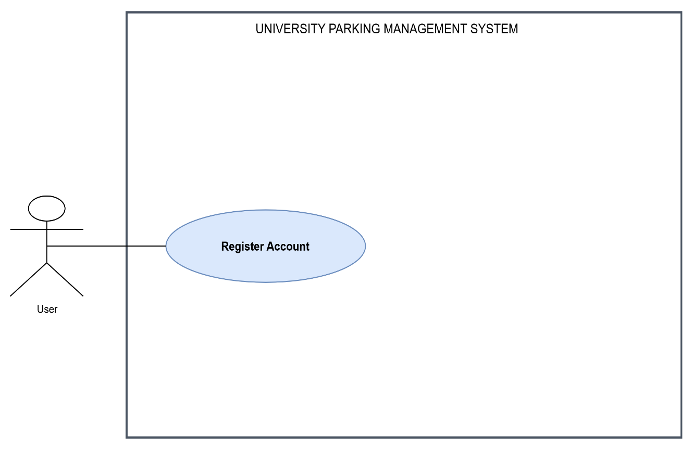

A. Brief Description
This use case allows a new user to create an account on the University Parking Management System by submitting their personal information and setting up secure login credentials.
B. Step-by-Step Description
- The user opens the USPMS website and selects Register Account on the main page.
- The system displays the registration page containing fields for the user's student or staff number, full name, institutional email address, phone number, password and password confirmation.
- The user enters their student or staff number in the identification field.
- The user enters their full name, institutional email address and phone number in the corresponding fields.
- The user creates a password and enters it again in the password confirmation field.
- The user selects Create Account.
- The system checks that all required fields have been completed and that the email address and other information follow the required formats.
- The system checks whether an account already exists for the supplied identification number or email address.
- The system verifies the user's university identification against the available university records, where university verification is supported.
- If the information is valid and the account does not already exist, the system securely stores the user's account information and password hash.
- The system displays a successful registration message and directs the user to the login page.
C. Worst-Case Scenario
If the user enters an invalid student or staff number, an incorrectly formatted email address, or leaves a required field empty, the system highlights the relevant field and displays a message explaining the error. The user corrects the information and submits the form again.
If the identification number or email address is already associated with an account, the system rejects the duplicate registration and instructs the user to log in or use the account recovery process.
If the passwords do not match or the password fails the security requirements, the system displays an appropriate error and requires the user to correct the password fields.
If university verification or the database is temporarily unavailable, the system informs the user that registration cannot be completed at that time. It does not create a partially registered account, and the user can retry when the service is available.

Use Case 2: Login
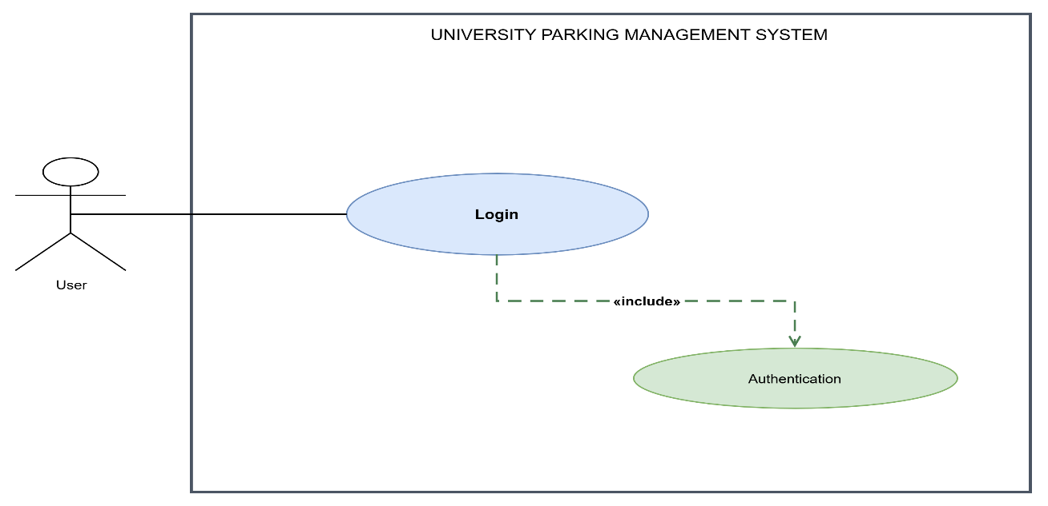

A. Brief Description
This use case allows a registered user to securely access the USPMS using their university identification number and password and proceed to their personal dashboard.
B. Step-by-Step Description
- The user opens the USPMS website and selects Login on the main page.
- The system displays the login page containing a university identification number field, a password field and a Login button.
- The user enters their registered student or staff number in the identification field.
- The user enters their account password in the password field.
- The user selects Login.
- The system checks that both fields have been completed.
- The system verifies the submitted credentials against the stored account information.
- The system checks whether the account is active and whether access is permitted.
- If the credentials are valid and the account is active, the system creates an authenticated session for the user.
- The system directs the user to their personal dashboard, where their account and parking information can be accessed.
C. Worst-Case Scenario
If the user enters an incorrect identification number or password, the system rejects the login and displays: "The identification number or password is incorrect. Please check your details and try again." The user remains on the login page and can re-enter their credentials. The system does not reveal which credential was incorrect.
If the user has not registered an account, the system denies access and provides a Register Account link.
If the account is inactive or suspended, the system denies access and explains that the account cannot currently be accessed. The user is directed to the appropriate university support channel.
If the user repeatedly enters incorrect credentials, the system applies its configured security controls, such as a temporary login restriction. If the authentication service is unavailable, the system displays an error message and allows the user to retry later. No authenticated session is created when authentication fails.

Use Case 3: Manage Account
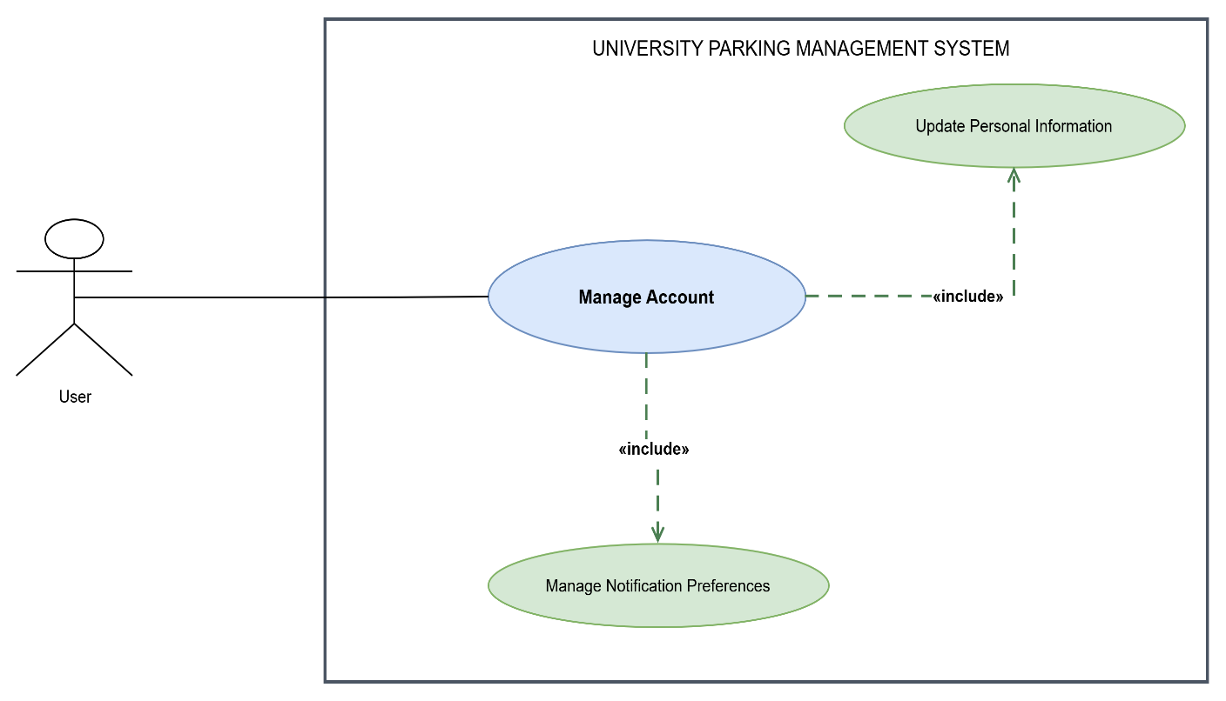

A. Brief Description
This use case allows an authenticated user to view and update their personal account information and configure their notification preferences.
B. Step-by-Step Description
- The user logs into the USPMS using their registered credentials.
- The system displays the user's personal dashboard.
- The user selects Manage Account from the dashboard menu.
- The system displays the account management page, containing the user's current personal information and notification preferences.
- To update personal information, the user selects Edit Personal Information.
- The system displays the editable fields, such as the user's full name and phone number. Any fields that must remain unchanged, such as a verified university identification number, are displayed as read-only.
- The user updates the required information and selects Save Changes.
- The system validates the updated information and checks that the values meet the relevant requirements.
- If the information is valid, the system saves the changes and displays a confirmation message.
- To manage notifications, the user returns to the account management page and selects Notification Preferences.
- The system displays the available notification categories and delivery options supported by the system.
- The user selects or clears the relevant notification options and selects Save Preferences.
- The system validates and saves the preferences, then displays a confirmation message.
- The user returns to the personal dashboard or leaves the account management page.
C. Worst-Case Scenario
If the user enters an invalid phone number, leaves a required field empty or submits information that does not meet the system's requirements, the system highlights the affected field and explains what must be corrected. The changes are not saved until the information is valid.
If the database becomes unavailable while the user is saving changes, the system displays a message explaining that the update could not be completed. The system retains the previously saved information and informs the user that they should retry. It must not display an update as successful when it has not been saved.
If the user attempts to modify a restricted field, such as a verified university identification number, the system prevents the modification and explains that the field cannot be changed through the account management page.
If the user attempts to manage their account after their session has expired, the system redirects them to the login page. After successful authentication, they can return to account management and continue.

Use Case 4: View Dashboard
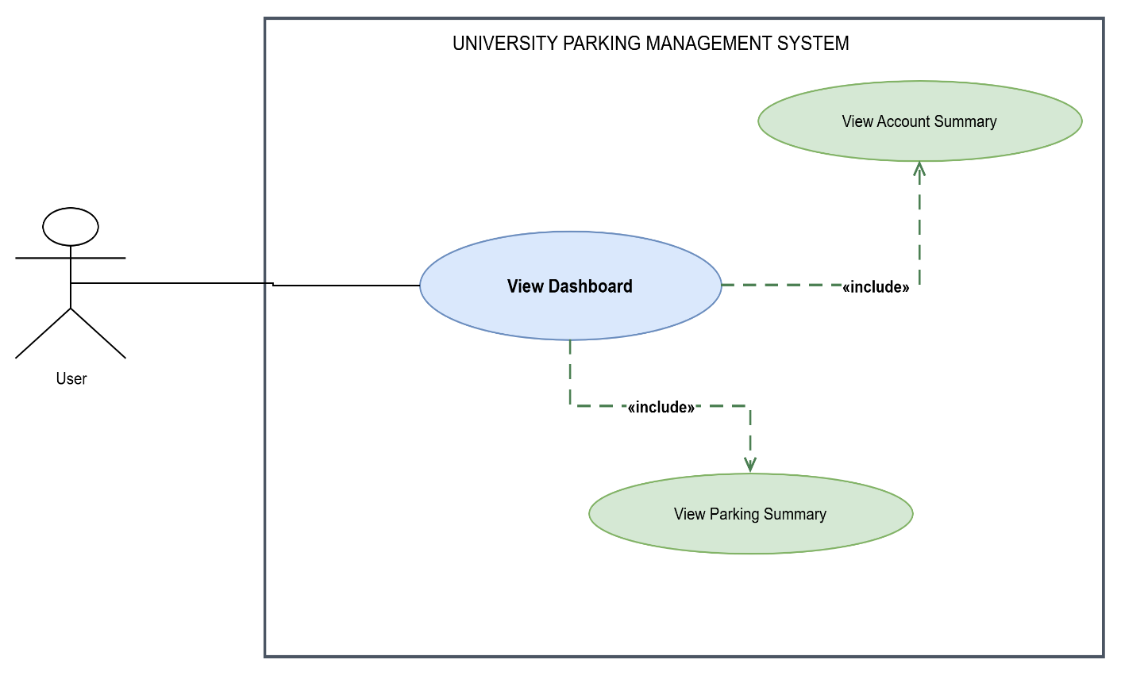

A. Brief Description
This use case allows an authenticated user to view a summary of their account, parking permits, reservations and other relevant parking activities from a central dashboard.
B. Step-by-Step Description
- The user opens the USPMS website and selects Login.
- The user enters their registered identification number and password, then selects Login.
- The system authenticates the user and displays their personal dashboard.
- The system retrieves the user's account information and relevant parking records.
- The system displays the Account Summary, including the user's name, identification details and account status.
- The system displays the Parking Summary, including relevant permit statuses, application statuses, reservation information and upcoming permit expiry dates where applicable.
- The user selects a displayed item, such as a permit application or parking reservation, to view its details.
- The system opens the relevant information page and displays the available details for that item.
- The user returns to the dashboard using the dashboard navigation option.
- The user logs out or navigates to another system function when finished.
C. Worst-Case Scenario
If the user has no permits, applications or reservations, the system displays an appropriate message, such as "No parking permits or reservations are currently available for your account." The system may provide links to the relevant functions, such as Apply for Parking Permit.
If some parking information cannot be retrieved because of a temporary database or service failure, the system displays the account information that remains available and clearly identifies the unavailable section. It does not display missing information as though it were confirmed or current.
If the user's session has expired, the system redirects them to the login page before allowing access to personal information.
If the system detects an unauthorised request to view another user's dashboard, it denies access and does not disclose the other user's account or parking information.

Use Case 5: Manage Registered Vehicles
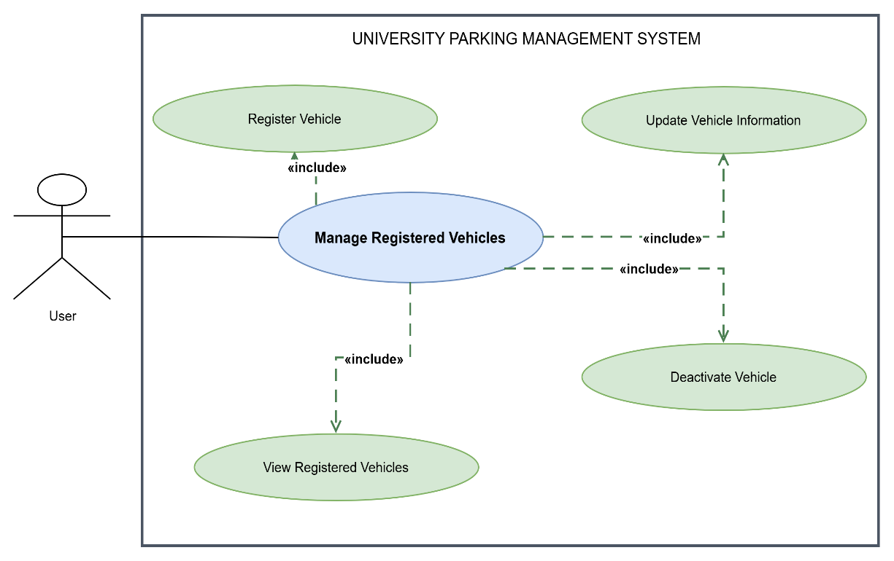

A. Brief Description
This use case allows an authenticated user to register vehicles, view their registered vehicles, update vehicle information and deactivate vehicles that they no longer use.
B. Step-by-Step Description
- The user logs into the USPMS and opens their personal dashboard.
- The user selects Manage Registered Vehicles from the dashboard menu.
- The system displays the registered vehicles associated with the user's account, including each vehicle's registration number, make, model and current status where available.
- To register a new vehicle, the user selects Register Vehicle.
- The system displays a vehicle registration form containing fields for the vehicle registration number, make, model, colour and any other required vehicle information.
- The user enters the vehicle information in the corresponding fields and selects Submit Vehicle Registration.
- The system validates the submitted information and checks whether the vehicle is already registered in the system.
- If the information is valid and the registration does not create a duplicate vehicle record, the system saves the vehicle against the user's account and displays a confirmation message.
- To update a vehicle, the user selects the relevant vehicle from the registered vehicles list and selects Update Vehicle Information.
- The system displays the vehicle's current information in an editable form.
- The user updates the permitted fields and selects Save Changes.
- The system validates the updated information, saves the changes and displays a confirmation message.
- To deactivate a vehicle, the user selects the vehicle and chooses Deactivate Vehicle.
- The system displays the vehicle details and asks the user to confirm the deactivation.
- The user selects Confirm Deactivation.
- The system checks whether any active permits or reservations depend on the vehicle.
- If deactivation is permitted, the system marks the vehicle as inactive and updates the registered vehicles list.
- The system displays a confirmation message indicating that the vehicle has been deactivated.
C. Worst-Case Scenario
If the user submits incomplete or incorrectly formatted vehicle information, the system highlights the relevant fields and explains what must be corrected. The vehicle is not registered until the required information passes validation.
If the vehicle registration number is already associated with an existing vehicle record, the system prevents the creation of a duplicate record and informs the user that the vehicle is already registered. Where appropriate, the system directs the user to check their existing vehicles or contact support if the vehicle belongs to them but is associated with another account.
If the user attempts to update a vehicle that does not belong to their account, the system denies the operation and does not disclose or modify another user's vehicle information.
If the user attempts to deactivate a vehicle that has an active permit or reservation, the system checks the applicable parking rules. If deactivation would invalidate an active permit or reservation, the system explains the conflict and prevents the action until the relevant conditions have been resolved. The system does not silently cancel an active reservation or revoke a permit.
If the database becomes unavailable while registering, updating or deactivating a vehicle, the system informs the user that the operation could not be completed. It preserves the last successfully saved vehicle information and allows the user to retry when the service is available.
Use Case 6: Apply for Parking Permit
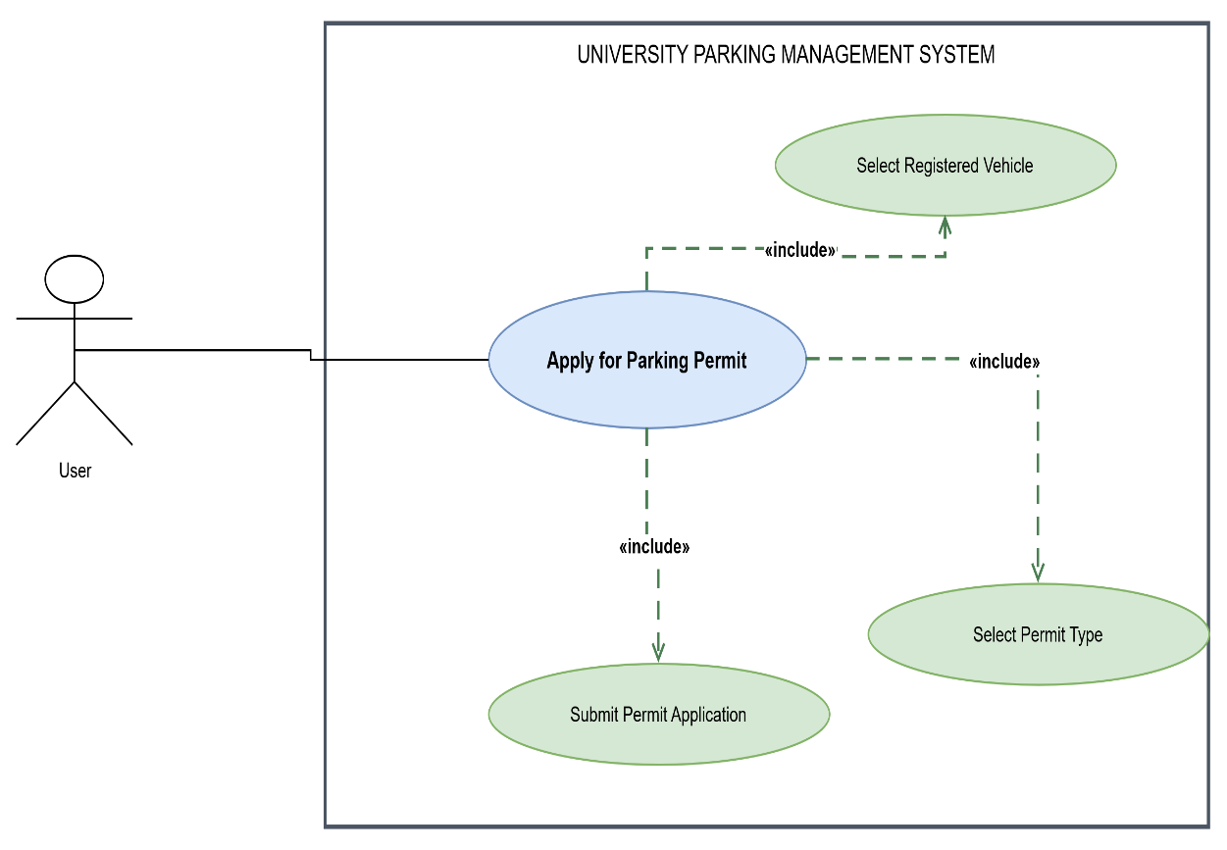

A. Brief Description
This use case allows an authenticated user to apply for a parking permit by selecting a registered vehicle, choosing an appropriate permit type and submitting the application for review by the Parking Administrator.
B. Step-by-Step Procedure
- The user opens the USPMS website and selects Login.
- The user enters their university identification number and password, then selects Login.
- The system verifies the credentials and displays the user’s dashboard.
- The user selects Apply for Parking Permit from the dashboard or parking menu.
- The system displays the permit application page and lists the vehicles registered to the user.
- The user selects the vehicle for which the permit is required.
- The system displays the available permit types, their requirements, validity periods and applicable parking restrictions.
- The user selects the required permit type.
- The system displays the application details, including the selected vehicle, permit type and any additional information required for that permit.
- The user checks the details, completes any outstanding required fields and selects Submit Permit Application.
- The system validates the submitted information and checks whether the selected vehicle and permit type meet the application requirements.
- If the information is valid, the system records the application with a unique reference number and a Pending Review status.
- The system displays a confirmation message and the application reference number.
- The system makes the application available to the Parking Administrator for review and notifies the user that the application has been submitted.
C. Worst-Case Scenario
If the user has no registered vehicles, the system displays a message explaining that a vehicle must be registered before applying and provides a link to Manage Registered Vehicles. If required information is missing or invalid, the system highlights the affected fields and prevents submission until the errors are corrected. If the selected vehicle already has a conflicting active permit or the user has submitted a duplicate application, the system explains the restriction and prevents an invalid application. If the system cannot save the application because of a database or network failure, it displays an error message, does not falsely confirm submission and allows the user to retry. The system should check whether an application was already recorded before accepting a retry to avoid duplicate submissions.

Use Case 7: Manage Permit Application
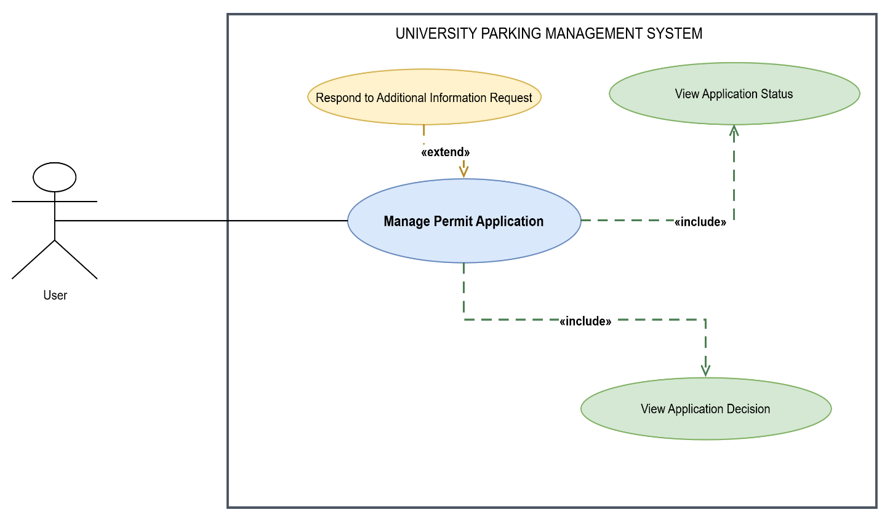

A. Brief Description
This use case allows a user to view the status and decision of a submitted parking permit application and respond when the Parking Administrator requests additional information.
B. Step-by-Step Procedure
- The user opens the USPMS website, selects Login, enters their university identification number and password, and selects Login.
- The system authenticates the user and displays the dashboard.
- The user selects My Permit Applications from the dashboard or parking menu.
- The system retrieves and displays the applications belonging to the authenticated user, including each application reference number, permit type, vehicle registration number, submission date and current status.
- The user selects an application by clicking its reference number or View Details.
- The system displays the application details, current status, submission date and any available administrator comments.
- If the application is still being reviewed, the system displays Pending Review or the applicable processing status.
- If a decision has been made, the system displays Approved or Rejected, together with the decision date and any recorded explanation.
- If additional information has been requested, the system displays the administrator’s request, the information required and the submission deadline, where applicable.
- The user selects Respond to Information Request.
- The system displays a response form containing the administrator’s request and fields for the requested information or supporting documents.
- The user enters the requested information, attaches any required documents where supported and selects Submit Response.
- The system validates the response and confirms that all required information has been supplied.
- If valid, the system records the response, updates the application record and makes the response available to the Parking Administrator for further review.
- The system displays a confirmation message and the updated application status, where applicable.
C. Worst-Case Scenario
If the user has no permit applications, the system displays a message stating that no applications have been submitted and provides a link to Apply for Parking Permit. If the user attempts to open an application belonging to another person, the system denies access and does not disclose the application details. If a response is incomplete, contains an unsupported file or is submitted after a deadline, the system explains the problem and follows the applicable submission rules. If the information request has already been closed or the administrator has made a final decision, the system prevents an invalid response and explains that the application can no longer be edited through that request. If a system failure occurs during submission, the system does not report success unless the response has been saved and allows the user to retry safely.

Use Case 8: Renew Parking Permit
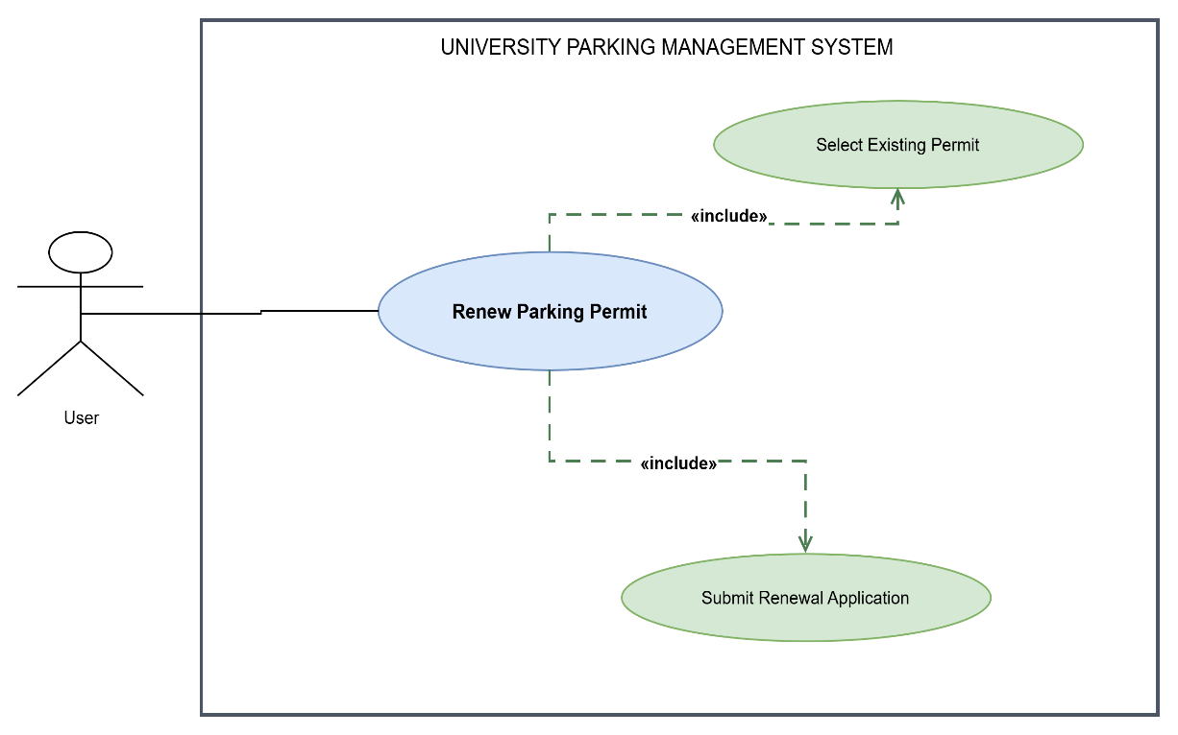

A. Brief Description
This use case allows a user to submit a renewal application for an existing parking permit that is eligible for renewal, providing continued parking authorisation subject to administrator approval.
B. Step-by-Step Procedure
- The user opens the USPMS website and logs in using their university identification number and password.
- The system authenticates the user and displays the dashboard.
- The user selects My Parking Permits or opens View Digital Parking Permit.
- The system displays the user’s permits, including permit numbers, associated vehicles, permit types, validity dates and current statuses.
- The user selects the permit that they want to renew.
- The system retrieves the selected permit’s details and checks whether it is eligible for renewal under the applicable rules.
- If eligible, the system displays the current permit information, the renewal period and any requirements that must be satisfied.
- The user selects Renew Permit.
- The system displays the renewal application form, pre-populating relevant information from the existing permit where appropriate.
- The user checks the vehicle and permit details, updates any permitted information and completes any additional required fields.
- The user selects Submit Renewal Application.
- The system validates the information and checks the permit’s current status and renewal eligibility again.
- If valid, the system creates a renewal application linked to the existing permit and assigns it a unique reference number.
- The system records the renewal application as Pending Review.
- The system displays a confirmation message and reference number and notifies the user that the renewal request has been submitted for review.
C. Worst-Case Scenario
If the selected permit has expired beyond the permitted renewal window, has been revoked, or is otherwise ineligible for renewal, the system explains why renewal is unavailable and directs the user to the applicable alternative, such as submitting a new application if allowed. If the permit is already undergoing renewal, the system prevents a duplicate renewal request and displays the existing application’s status. If the vehicle or permit details are invalid or incomplete, the system identifies the information that must be corrected. If the system cannot save the renewal application, it displays an error and does not confirm the renewal request until the record has been saved successfully. The existing permit’s status and validity must not be changed merely because a renewal application was submitted.

Use Case 9: View Digital Parking Permit
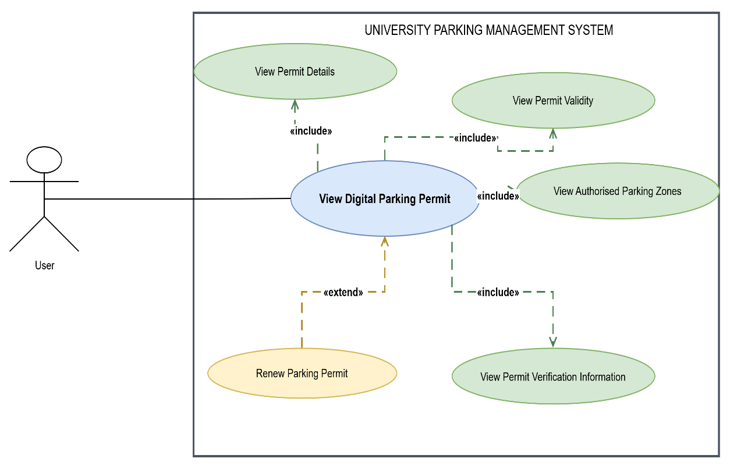

A. Brief Description
This use case allows an authenticated user to view the details and validity of an issued digital parking permit, including its authorised parking zones and information used to verify the permit.
B. Step-by-Step Procedure
- The user opens the USPMS website and selects Login.
- The user enters their university identification number and password, then selects Login.
- The system verifies the credentials and displays the dashboard.
- The user selects My Parking Permits or View Digital Parking Permit.
- The system retrieves the permits associated with the user’s account.
- The system displays the available permits with their permit numbers, vehicle registration numbers, permit types and current statuses.
- The user selects the required permit by choosing its permit number or View Permit.
- The system opens the digital permit and displays the permit number, permit type, associated vehicle, issue date, expiry date and current status.
- The user selects View Validity or reviews the validity section to confirm the period during which the permit is valid.
- The user selects Authorised Parking Zones to view the parking zones in which the permit allows parking.
- The system displays the authorised zones and any applicable restrictions recorded against the permit.
- The user selects Verification Information to view the available permit verification details, such as a verification code or QR code, where supported.
- The system displays the verification information associated with the issued permit.
- The user may return to My Parking Permits, select another permit or navigate back to the dashboard.
C. Worst-Case Scenario
If the user has no issued permits, the system displays a message explaining that no digital permits are available and provides a link to apply for a permit. If an application is pending or rejected, the system clearly distinguishes the application from an issued permit and does not display it as valid parking authorisation. If the selected permit has expired, been suspended or been revoked, the system displays the correct status and does not represent it as active. If no parking zones are authorised, the system explicitly states that no zones are assigned rather than implying unrestricted access. If permit information cannot be retrieved, the system displays an error and does not show stale or unverified details as current. Attempts to access another user’s permit are denied.

Use Case 10: Review Permit Applications
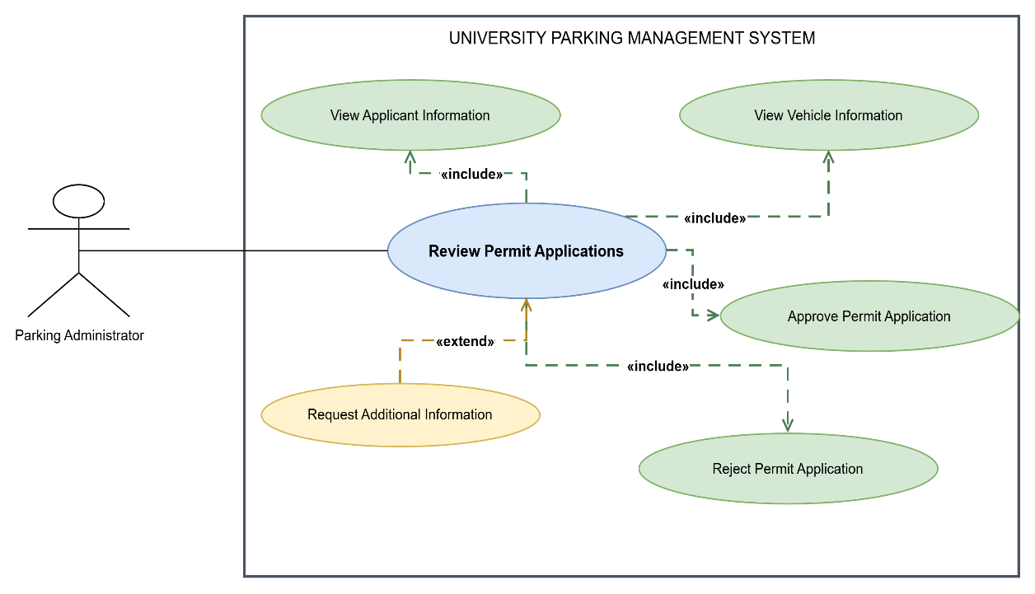

A. Brief Description
This use case allows the Parking Administrator to examine submitted parking permit applications, review the applicant’s and vehicle’s information, and approve, reject or request additional information before making a decision.
B. Step-by-Step Procedure
- The Parking Administrator opens the USPMS website and selects Login.
- The administrator enters their authorised university identification number and password, then selects Login.
- The system authenticates the administrator, verifies their administrative permissions and displays the administrator dashboard.
- The administrator selects Review Permit Applications.
- The system displays the applications awaiting review, including their reference numbers, applicant identification numbers, permit types, submission dates and current statuses.
- The administrator selects an application by clicking its reference number or Review Application.
- The system displays the applicant’s information, including the applicant’s name, university identification number and relevant account details.
- The administrator selects View Vehicle Information or reviews the vehicle section to inspect the registration number, make, model and other recorded vehicle details.
- The system displays the requested permit type, application information, supporting documents where available, and any relevant existing permit or application records.
- The administrator compares the submitted information with the permit requirements and checks whether the applicant and vehicle meet the applicable eligibility rules.
- If information is missing or clarification is needed, the administrator selects Request Additional Information.
- The system displays a request form. The administrator enters the information required, adds a response deadline where applicable and selects Send Request.
- The system records the request, updates the application status to indicate that additional information is required and notifies the applicant. The administrator may return to the application when the response is received.
- If the application meets all requirements, the administrator selects Approve Permit Application and reviews the confirmation screen.
- The administrator confirms the approval.
- The system records the decision, administrator identity and decision date, updates the application status to Approved and initiates the permit-issuance process.
- If the application does not meet the requirements, the administrator selects Reject Permit Application, enters a reason for rejection and confirms the decision.
- The system records the rejection and its reason, updates the application status to Rejected and notifies the applicant.
- The system returns the administrator to the application details or application list, where the updated status is displayed.
C. Worst-Case Scenario
If the administrator is not authorised to review applications, the system denies access to the administrative function and does not expose applicant information. If an application is incomplete, supporting information is missing or eligibility cannot be established, the administrator can request additional information rather than making an unsupported decision. If another administrator has already made a final decision, the system refreshes the application status and prevents an incompatible second decision. If the administrator attempts to reject an application without providing a required reason, the system highlights the reason field and prevents submission. If the system fails while recording an approval or rejection, it displays an error and does not claim that the decision was saved. The administrator must be able to verify the recorded status before retrying, preventing duplicate or conflicting decisions. If approval is saved but permit issuance fails, the system preserves the recorded decision, identifies the issuance problem and allows authorised staff to resolve it without requiring the applicant to submit a duplicate application.
Use Case 11: Manage Parking Permits
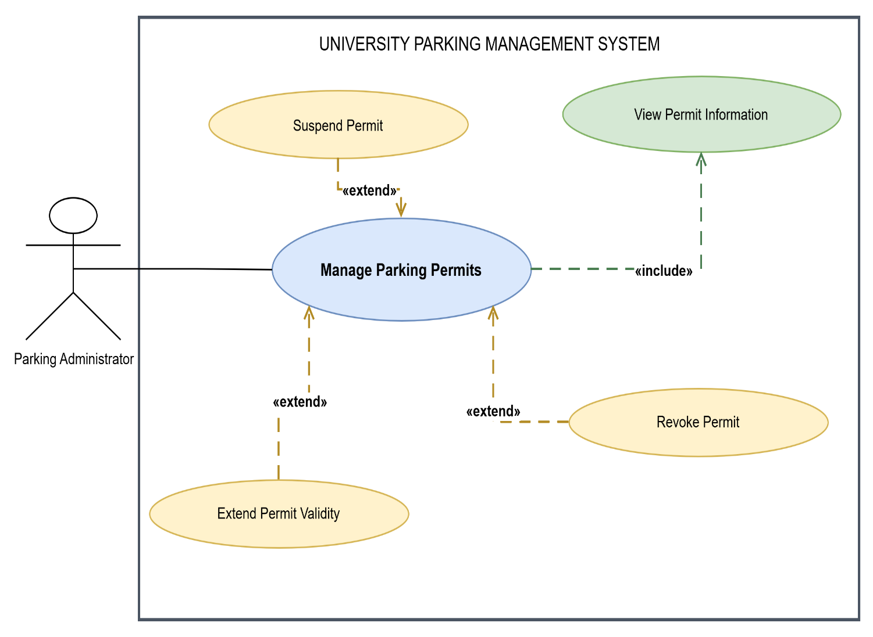

A. Brief Description
This use case allows the Parking Administrator to view issued parking permits and manage their status by suspending, revoking or extending their validity when authorised to do so.
B. Step-by-Step Procedure
- The Parking Administrator opens the USPMS website and selects Login.
- The administrator enters their university identification number and password, then selects Login.
- The system authenticates the administrator, verifies their administrative permissions and displays the administrator dashboard.
- The administrator selects Manage Parking Permits from the administration menu.
- The system displays a list of issued permits, including permit numbers, permit holders, vehicle registration numbers, permit types, validity dates and current statuses.
- The administrator searches for a specific permit using its permit number, holder identification number or vehicle registration number.
- The administrator selects the required permit from the search results.
- The system displays the permit details, including its issue date, expiry date, authorised parking zones and current status.
- To view additional information, the administrator selects View Permit Information. The system displays the recorded permit and authorisation details.
- To suspend a permit, the administrator selects Suspend Permit, enters the reason for suspension and reviews the confirmation screen.
- The administrator selects Confirm Suspension.
- The system validates the request, records the reason and administrator details, changes the permit status to Suspended and notifies the permit holder.
- To revoke a permit, the administrator selects Revoke Permit, enters the reason and selects Confirm Revocation after reviewing the permit details.
- The system validates the request, records the revocation and changes the permit status to Revoked. The permit holder is notified.
- To extend a permit’s validity, the administrator selects Extend Permit Validity.
- The system displays the existing expiry date and a field for the new expiry date.
- The administrator enters the proposed expiry date and provides a reason for the extension where required.
- The administrator selects Submit Extension and confirms the change.
- The system validates the new date against the applicable permit rules, saves the extension and updates the permit’s validity information.
- The system displays a confirmation message and the updated permit details.
C. Worst-Case Scenario
If the administrator searches for a permit that does not exist, the system displays a message stating that no matching permit was found and allows the search to be corrected. If the administrator lacks permission to manage permits, the system denies the action. If a permit is already suspended or revoked, the system prevents an incompatible repeat action and displays the current status. If an extension date is invalid, earlier than the existing expiry date or outside the permitted rules, the system explains the problem and prevents the change from being saved. If a permit is linked to a pending application or another conflicting administrative action, the system checks the applicable rules before allowing the change. If a database or network failure occurs, the system reports that the action could not be confirmed and preserves the last successfully saved permit record. It must not display a successful suspension, revocation or extension unless the change has been recorded.

Use Case 12: Manage Parking-Zone Authorisation
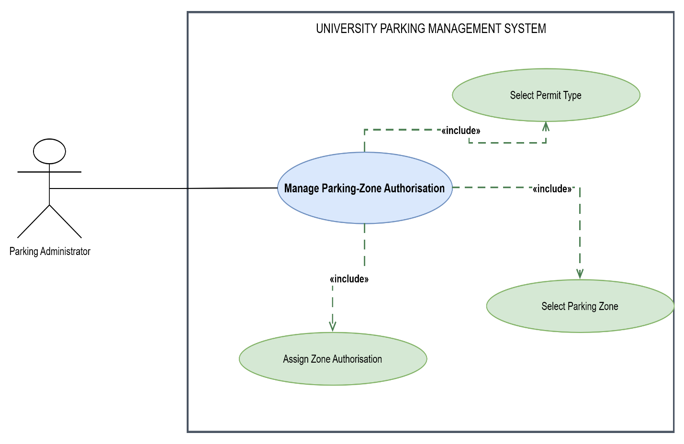

A. Brief Description
This use case allows the Parking Administrator to assign parking-zone permissions to permit types so that each issued permit authorises parking only in the zones allowed by university parking rules.
B. Step-by-Step Procedure
- The Parking Administrator opens the USPMS website and logs in using authorised administrative credentials.
- The system authenticates the administrator and displays the administration dashboard.
- The administrator selects Manage Parking-Zone Authorisation.
- The system displays the existing permit types and the parking zones configured in the system.
- The administrator selects the permit type whose zone permissions must be created or changed.
- The system displays the selected permit type and its currently authorised parking zones.
- The administrator selects Edit Zone Authorisation or Assign Parking Zone.
- The system displays a list of available parking zones, including their names, locations and applicable restrictions.
- The administrator selects the parking zone to be assigned to the permit type.
- The system displays the selected permit type and parking zone for confirmation.
- The administrator selects Assign Zone Authorisation.
- The system validates the selection against the university’s parking policies and checks whether the authorisation already exists.
- If the assignment is valid, the system records the relationship between the permit type and parking zone.
- The system refreshes the authorisation list to show the updated assignment.
- The administrator repeats the process to assign additional zones or selects an existing assignment to change it, where permitted.
- The system displays a confirmation message when the changes have been saved.
C. Worst-Case Scenario
If the administrator selects a permit type or parking zone that does not exist or is no longer active, the system prevents the assignment and asks the administrator to select a valid option. If the selected authorisation already exists, the system informs the administrator and avoids creating a duplicate. If the proposed assignment violates parking policy or exceeds the permitted access for that permit type, the system rejects the change and explains the restriction. If the administrator is unauthorised, the system blocks the operation. If saving fails, the system displays an error and retains the previous authorisation configuration. The system must not indicate that a zone has been assigned unless the change has been saved successfully.

Use Case 13: View Parking Availability
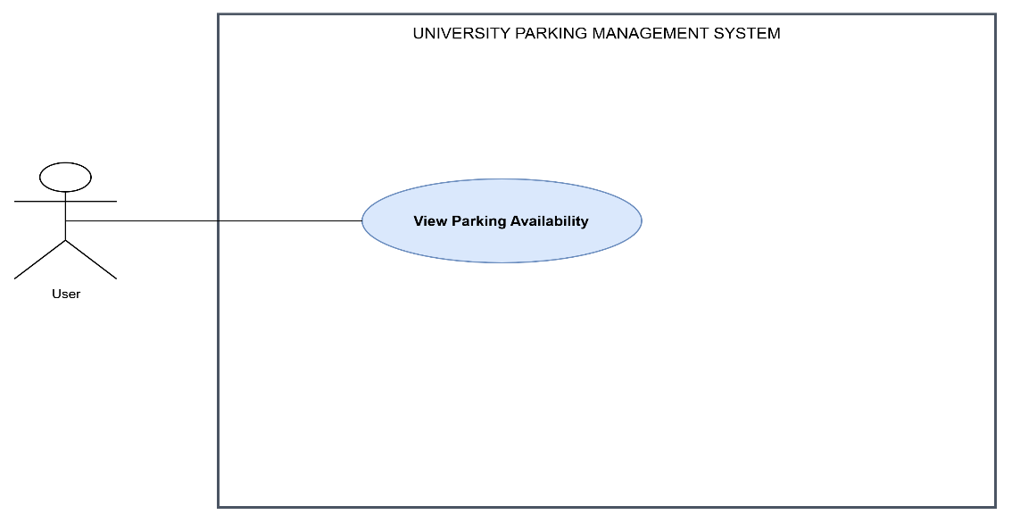

A. Brief Description
This use case allows a user to view parking availability and identify parking areas with available spaces, helping the user select a suitable area before travelling or parking.
B. Step-by-Step Procedure
- The user opens the USPMS website and logs in using their university identification number and password.
- The system authenticates the user and displays the dashboard.
- The user selects View Parking Availability from the parking menu.
- The system displays the available parking areas and any filters supported by the system, such as campus area, parking zone or permit eligibility.
- The user selects a campus area or applies a filter to narrow the results.
- The system retrieves the latest recorded parking availability for the selected area.
- The system displays each matching parking area with its name, location, total capacity, occupied spaces and available spaces, where those figures are supported by the system.
- The user selects a parking area to view more detailed availability information.
- The system displays the selected area’s details, including any parking restrictions or permit requirements.
- The user reviews the results and selects another area if the first area is unsuitable.
- The user returns to the availability list or navigates back to the dashboard.
C. Worst-Case Scenario
If no parking spaces are available in the selected area, the system displays a clear Full or No Spaces Available status and, where possible, shows other parking areas with availability. If no matching areas are found after filtering, the system informs the user and allows the filters to be changed. If live occupancy data is unavailable, the system identifies the data as unavailable or potentially outdated rather than presenting old figures as current. If the selected area has been closed or is restricted, the system displays the relevant restriction. If the availability service fails, the system displays an error and offers the user an opportunity to retry. The system must not guarantee a parking space merely because availability was displayed; a space is reserved only if the reservation process confirms it.

Use Case 14: Get Parking Guidance
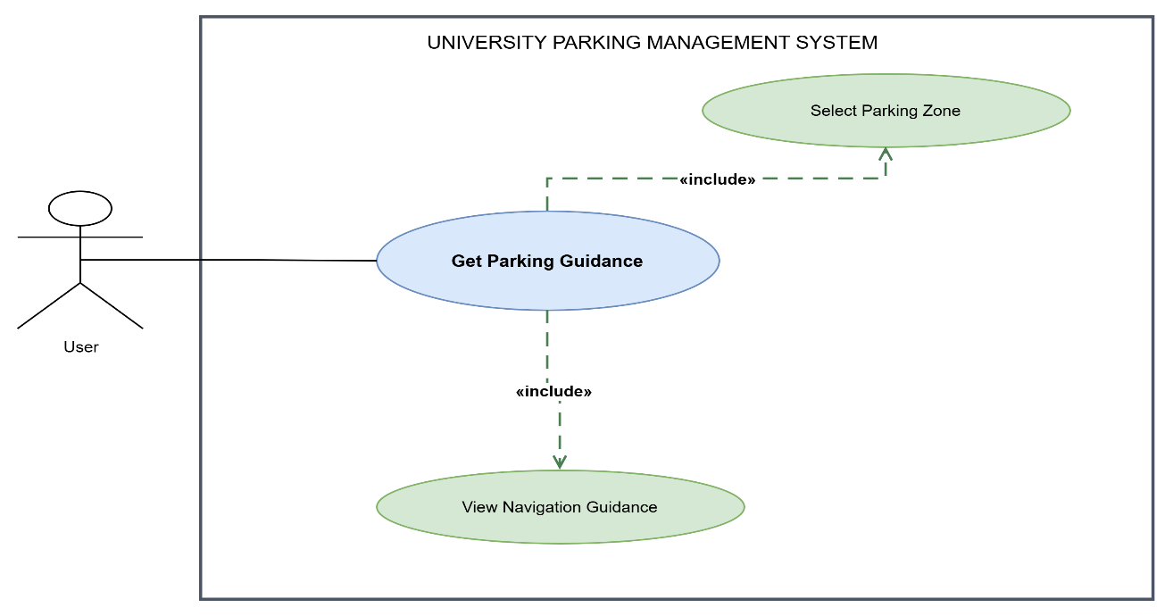

A. Brief Description
This use case allows a user to select a parking zone and receive guidance to help locate the relevant parking area on campus.
B. Step-by-Step Procedure
- The user opens the USPMS website and logs in using their university identification number and password.
- The system authenticates the user and displays the dashboard.
- The user selects Get Parking Guidance from the parking menu.
- The system displays the configured campus parking zones and their locations.
- The user selects the parking zone they want to reach.
- The system retrieves the selected zone’s location, access information and any applicable parking restrictions.
- If the system supports availability-based guidance, it retrieves the latest availability information for the selected zone.
- The system identifies the relevant parking area and generates navigation guidance using the campus location data and routing capabilities available to the system.
- The system displays the destination, route instructions and any relevant access restrictions.
- The user reviews the guidance and follows the displayed instructions to reach the parking area.
- If the user wants to navigate to another zone, they select Change Parking Zone and repeat the selection process.
- The user exits the guidance page or returns to the dashboard when finished.
C. Worst-Case Scenario
If the user selects a parking zone that does not exist, is closed or is inaccessible to their permit type, the system displays the applicable restriction and prompts the user to select another zone. If the system cannot generate a route because location or routing data is missing, it displays the available location information and explains that navigation guidance cannot currently be generated. If the selected zone is full and availability data is supported, the system warns the user and offers alternative zones where possible. If the navigation service fails, the system reports the problem and allows the user to retry. The system must not display an invented route or imply that the destination is accessible when the required information is unavailable.

Use Case 16: Arrange Visitor Parking
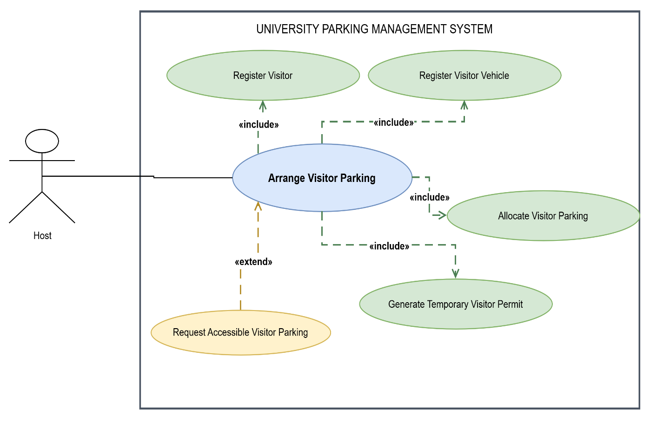

A. Brief Description
This use case allows an authorised university host to register a visitor and their vehicle, allocate suitable visitor parking and arrange a temporary parking permit for the visit.
B. Step-by-Step Procedure
- The host opens the USPMS website and selects Login.
- The host enters their university identification number and password, then selects Login.
- The system authenticates the host and verifies that the account is authorised to arrange visitor parking.
- The host selects Arrange Visitor Parking from the dashboard or visitor parking menu.
- The system displays the visitor parking form.
- The host enters the visitor’s required details, such as full name, contact information and visit purpose.
- The host enters the visit date and the expected arrival and departure times.
- The host selects Register Visitor Vehicle and enters the vehicle registration number, make, model and colour, as required by the form.
- The host reviews the visitor and vehicle details, then selects Continue.
- The system validates the required fields and checks for an existing visitor or conflicting visitor booking, where applicable.
- The system displays the visitor parking areas available for the specified date and time.
- The host selects an appropriate parking area or bay from the available options.
- If accessible visitor parking is required, the host selects Request Accessible Visitor Parking and supplies the necessary details.
- The system checks whether the selected parking area or bay meets the applicable availability and accessibility requirements.
- The host reviews the visitor details, vehicle information, visit period and parking allocation.
- The host selects Confirm Visitor Parking.
- The system validates the booking and records the visitor, vehicle, host and parking allocation.
- The system generates a temporary visitor parking permit linked to the visit and displays its permit details.
- The system confirms the arrangement to the host and, where supported, sends the visitor their temporary permit and parking instructions.
C. Worst-Case Scenario
If the host is not authorised to arrange visitor parking, the system denies access to the function and explains that an authorised account is required. If required visitor or vehicle details are missing or invalid, the system highlights the affected fields and prevents submission. If the selected parking area or bay is unavailable for the visit period, the system asks the host to choose another option. If accessible parking is requested but no suitable space is available, the system explains the limitation and allows the host to select another option or contact the relevant university service. If the visitor already has a conflicting booking, the system displays the conflict and requires the host to correct it. If the system fails while saving the arrangement or generating the temporary permit, it does not falsely confirm a completed booking. The host can check the booking status and retry without creating duplicate visitor records or permits.

Use Case 17: View Visitor Parking Permit
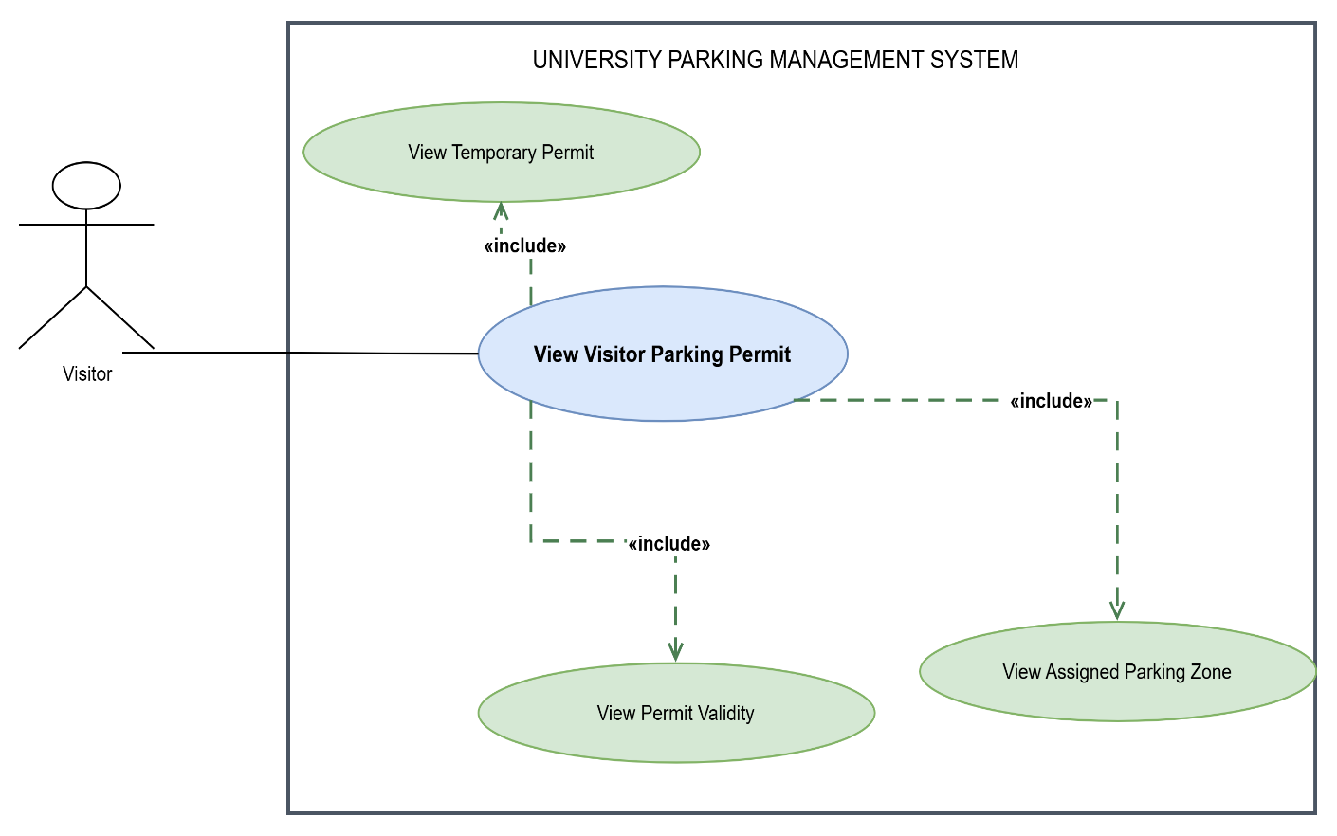

A. Brief Description
This use case allows a visitor to access and view their temporary parking permit, including the assigned vehicle, parking zone and validity period.
B. Step-by-Step Procedure
- The visitor receives a temporary permit link, reference number or other access instructions from the host or USPMS notification.
- The visitor opens the provided link or navigates to the visitor permit page on the USPMS website.
- The system displays the visitor permit access page and requests the required verification details, such as the permit reference number and any additional verification information configured by the university.
- The visitor enters the requested details and selects View Permit.
- The system validates the submitted information and verifies that the visitor is authorised to access the permit.
- The system retrieves the associated temporary visitor permit.
- The system displays the permit number, visitor name, assigned vehicle registration number, parking zone, visit date and validity period.
- The visitor reviews the permit details and checks that the vehicle and visit information are correct.
- The visitor selects View Assigned Vehicle to review the recorded vehicle details, if this is provided as a separate option.
- The visitor selects View Assigned Parking Zone to review the allocated parking location and any relevant parking instructions.
- The visitor checks the permit’s validity information to confirm when it becomes active and when it expires.
- The visitor may use the displayed permit or verification code at the parking facility if the university’s procedures require it.
- The visitor closes the page or returns to the permit access page when finished.
C. Worst-Case Scenario
If the visitor enters an incorrect permit reference or verification detail, the system rejects the request and asks them to check the information. If the permit does not exist, has expired, has been cancelled or is not yet valid, the system displays the appropriate status and does not represent the permit as active. If the visitor attempts to access another visitor’s permit without the required authorisation, the system denies access and does not disclose the permit details. If the host has entered incorrect vehicle or visit information, the system directs the visitor to contact the host or the relevant university service to request a correction. If the permit service is unavailable, the system displays an error and allows the visitor to retry or contact the host for assistance. The system must not display outdated permit details as current when it cannot verify their validity.

Use Case 19: Manage Parking Violations and Fines
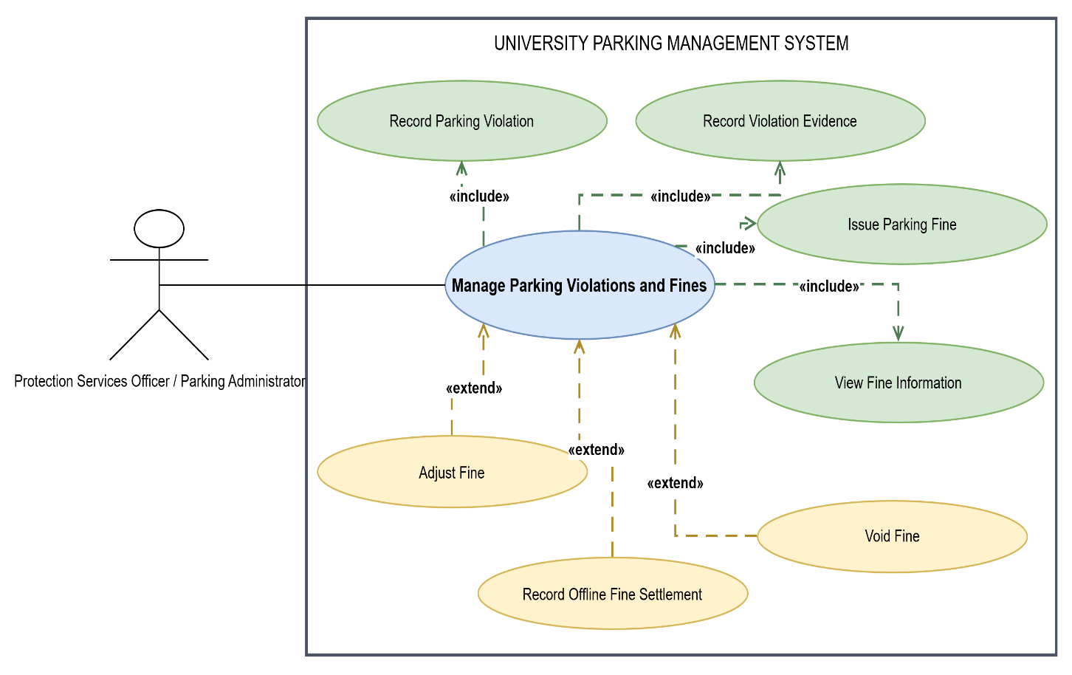

A. Brief Description
This use case allows Protection Services Officers to record parking violations, attach supporting evidence and issue fines, while authorised Parking Administrators manage fine records through permitted adjustments, voiding or recording offline settlements.
B. Step-by-Step Procedure
Recording a violation and issuing a fine
- The Protection Services Officer opens the USPMS enforcement interface and selects Login.
- The officer enters their authorised university credentials and selects Login.
- The system authenticates the officer and displays the enforcement dashboard.
- The officer selects Manage Parking Violations and Fines or opens a violation record created during a compliance check.
- The system displays the violation management page and any relevant existing records.
- The officer selects Record Parking Violation.
- The system displays a form for the vehicle registration number, violation category, observed parking location, date and time, and a description of the incident.
- The officer enters the required details and identifies the vehicle or permit associated with the violation, where a matching record exists.
- The officer selects Record Violation Evidence.
- The system displays the evidence upload section, where supported.
- The officer attaches available evidence, such as photographs or other permitted supporting documents, and enters any required evidence description.
- The officer selects Save Violation Record.
- The system validates the information and records the violation and supporting evidence.
- The officer selects Issue Parking Fine.
- The system displays the fine details, including the recorded violation, applicable fine category, amount and any relevant payment deadline.
- The officer reviews the fine details and selects Confirm Fine.
- The system checks the applicable fine rules and whether the violation already has a fine associated with it.
- If the fine is valid, the system records the fine, links it to the violation and vehicle or responsible party where identifiable, and assigns a fine reference number.
- The system displays a confirmation message and updates the fine status to the applicable initial state, such as Outstanding.
- The system notifies the relevant person through the configured notification method, where their details are available.
Managing an existing fine as a Parking Administrator
- The Parking Administrator logs in with authorised credentials and opens Manage Parking Violations and Fines.
- The system displays the fine records the administrator is authorised to manage.
- The administrator searches for the fine using its reference number, vehicle registration number or other supported search criteria.
- The administrator selects the relevant fine and reviews its details, evidence, amount, status and recorded history.
- To adjust a fine, the administrator selects Adjust Fine, enters the revised amount and reason, and submits the change for validation.
- To void a fine, the administrator selects Void Fine, enters the reason and confirms the action after reviewing the record.
- To record an offline settlement, the administrator selects Record Offline Fine Settlement, enters the required payment details and reference information, and submits the record.
- The system validates the action against the administrator’s permissions and the fine’s current status.
- The system records the approved change, retains the relevant audit history and updates the fine status or amount as appropriate.
- The system displays a confirmation message and the updated fine information.
C. Worst-Case Scenario
If the officer enters incomplete violation details or selects an invalid violation category, the system highlights the required fields and prevents the record from being submitted until the errors are corrected. If evidence cannot be uploaded because the file type or size is not supported, the system explains the restriction and allows the officer to provide acceptable evidence. If a fine has already been issued for the same violation, the system warns the officer and prevents an unintended duplicate fine, subject to the university’s rules. If the applicable fine amount cannot be determined, the system does not allow the officer to issue a fine with an unverified amount.
If a Parking Administrator attempts to adjust or void a fine without the required permission, the system denies the action. If the fine has already been paid or its status prevents the requested change, the system explains the restriction and applies the relevant administrative procedure rather than silently altering the record. If offline settlement details are incomplete or cannot be verified, the system refuses to mark the fine as settled until the required information is supplied. If the system fails while saving a violation, issuing a fine or updating a fine record, it displays an error and does not falsely confirm the action. The system preserves the last successfully saved record and maintains an audit trail of authorised changes.
Use Case 20: View Notifications
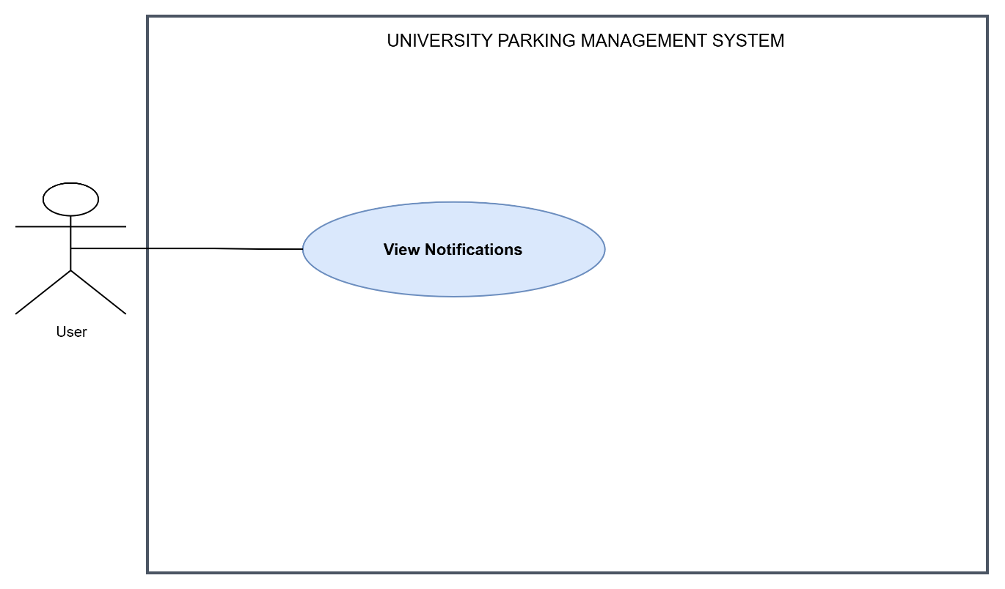

A. Brief Description
This use case allows an authenticated user to view notifications about parking applications, permit decisions, renewals, reservations, visitor parking arrangements, fines and other relevant system activities.
B. Step-by-Step Procedure
- The user opens the USPMS website and selects Login.
- The user enters their university identification number and password, then selects Login.
- The system authenticates the user and displays the dashboard.
- The user selects Notifications from the dashboard or navigation menu.
- The system retrieves notifications associated with the authenticated user’s account.
- The system displays the notifications in a list, showing available information such as the notification title, message summary, date and read/unread status.
- The user selects a notification by clicking its title or View Details.
- The system opens the full notification and displays its message, date and any related reference number.
- If the notification relates to an application, permit, reservation or fine, the system provides a link to the relevant record where supported and where the user has permission to access it.
- The user selects the provided link to open the related record, or returns to the notification list if no further action is required.
- If the system supports read-status tracking, it marks the notification as read when the user opens it or selects Mark as Read.
- The system updates the notification list to reflect the new read status.
- The user may select another notification, return to the dashboard or log out.
C. Worst-Case Scenario
If the user has no notifications, the system displays a message stating that there are currently no notifications to show. If a notification refers to a record that has been removed or is no longer accessible, the system displays the notification where appropriate but denies access to the restricted record and explains that it is unavailable. If the user attempts to open another person’s notification, the system denies access and does not disclose the notification’s contents. If the notification service fails, the system displays an error and allows the user to retry rather than showing incomplete results as a complete list. If the user opens a notification but the read status cannot be saved, the system reports the problem and retains the last successfully saved status. The system must not mark a notification as read unless that change has been successfully recorded.

