# Robustness: Test Cases

The resume of test cases for robustness are the following with their respective results:

|  |  |  |  |  |  |
| --- | --- | --- | --- | --- | --- |
| **Control number** | **Action** | **Objective or Explanation** | **Expected results** | **Pass** | **Fail** |
| 1 | Form input validation | The user must not be able to insert invalid characters or data. Hence, preventing the injection of malicious codes. Having said that, a range of valid characters are implemented within the system. | User cannot input invalid characters and will not be allowed to enter the game. | X |  |
| 2 | Reject incorrect moves | The program will prevent user from committing invalid moves of the chess pieces | Program will highlight valid moves for each chess pieces. Moreover, the incorrect move will not be executed and the piece will return to its previous valid location. | X |  |
| 3 | Multiple moves in one turn | According to the rules of chess, each player is only allowed one move at a time. Hence, we will test if numerous move is possible before switching turns with the opposite player. | Each player will only be allowed one move for each turn. | X |  |
| 4 | Player cannot manipulate opponent’s chess pieces | Allowing control over the opponent’s pieces is prohibited within the chess game rules and regulations. Therefore, manipulation of the opponent’s move should not be allowed. | If White was assigned to a player, then he/she can only move the white chess pieces can be moved. And if Black was assigned to a player, then he/she can only move the black chess pieces. | X |  |
| 5 | Chess pieces cannot be moved outside the chessboard | Chess pieces should only be allowed to move towards destination tiles that is within the boundary of an 8x8 matrix board. | The system will not allow user to allocate pieces outside the boundaries of a legitimate chess board. | X |  |

## Form input validation

**Objective:** The user must not be able to insert invalid characters or data.

Test steps:

1. Enter the login webpage: <http://chess372.azurewebsites.net/Chess_LoginPage.php>
2. Fill email with invalid characters but with a valid and registered password:
   1. Email: $curl -v --referer <referer-field> --user-agent "Mozilla/5.0 ()
   2. Password: 12345

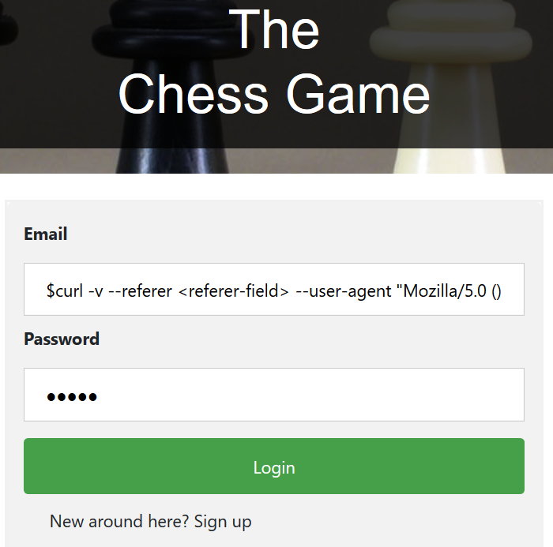

1. Click button submit

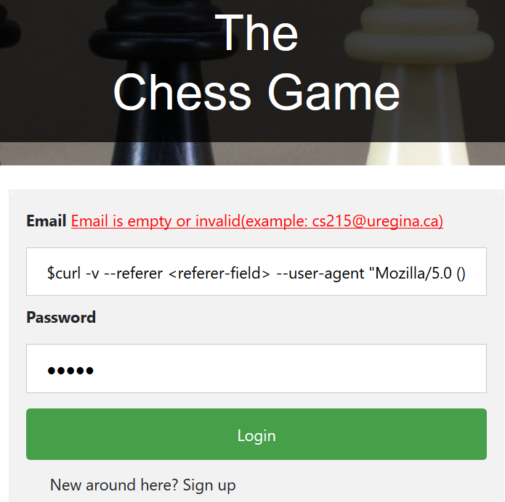

1. Fill password with invalid characters but with a valid and registered email:
   1. Email: joselagrosa@uregina.ca
   2. Password: <_type=password>” with “<_type=text>

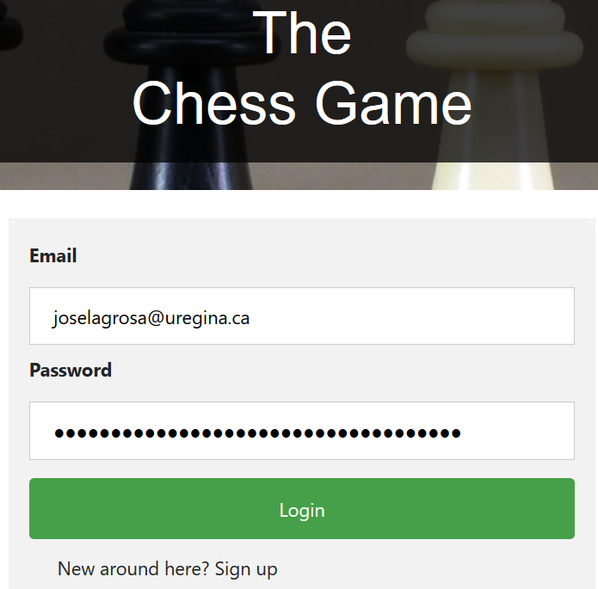

1. Click button submit

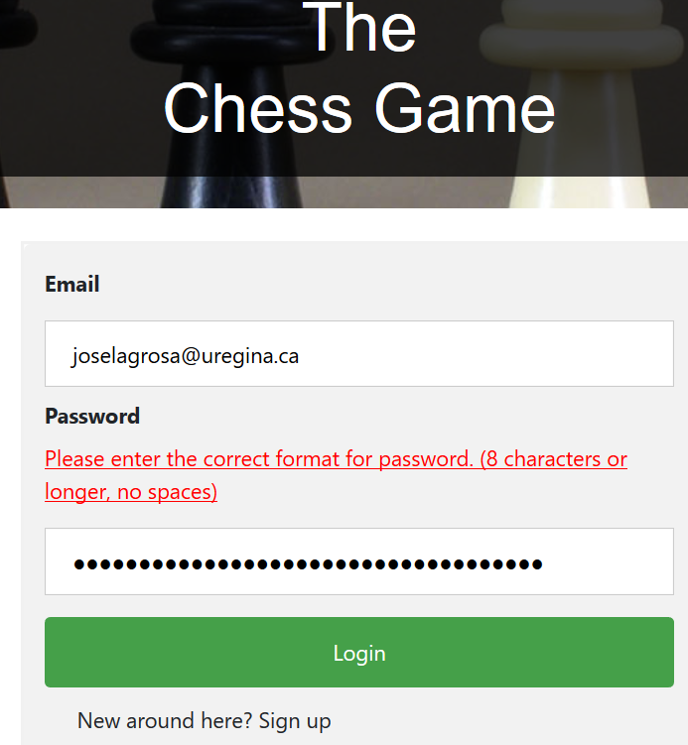

**Expected results**: User failed to insert invalid characters and was prevented from entering the game.

## Reject incorrect moves

**Objective:** The user must only be allowed to move chess pieces with legal moves.

Test steps:

1. Successfully login user



1. Start a match
   1. Play AI Match
   2. Attempt to move a piece with an illegal move by putting it into the highlighted tile.

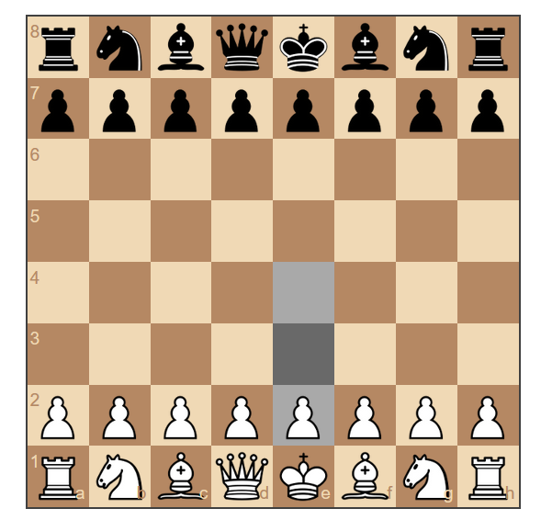

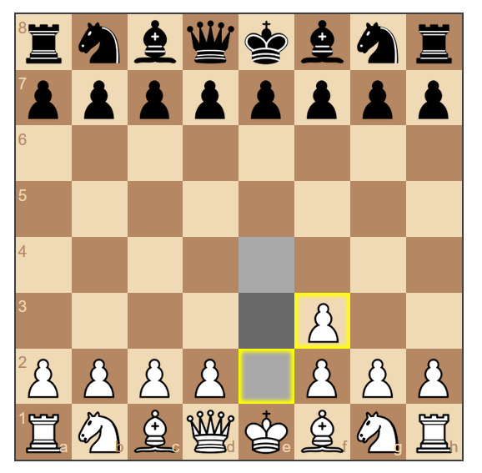

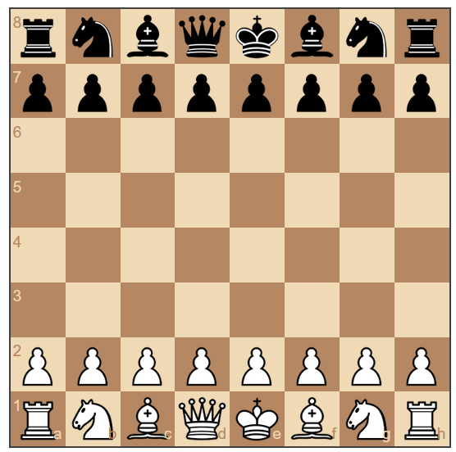

**Expected results**: User unable to execute illegal move.

## Multiple moves in one turn

**Objective:** Each player can only move one piece per turn.

Test steps:

1. Enter PVP lobby

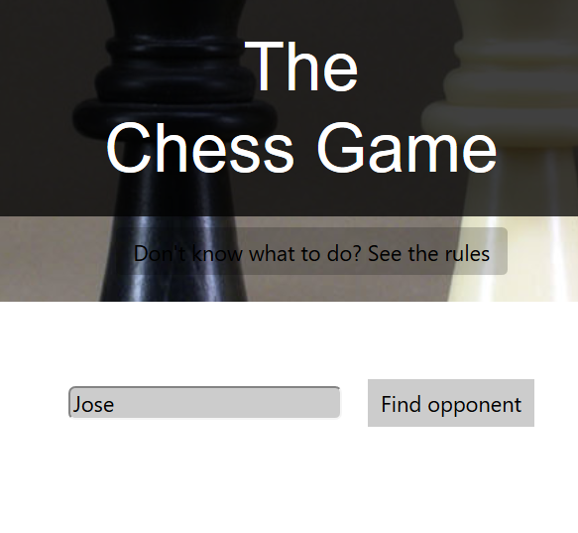

1. Find opponent and Start a PVP game

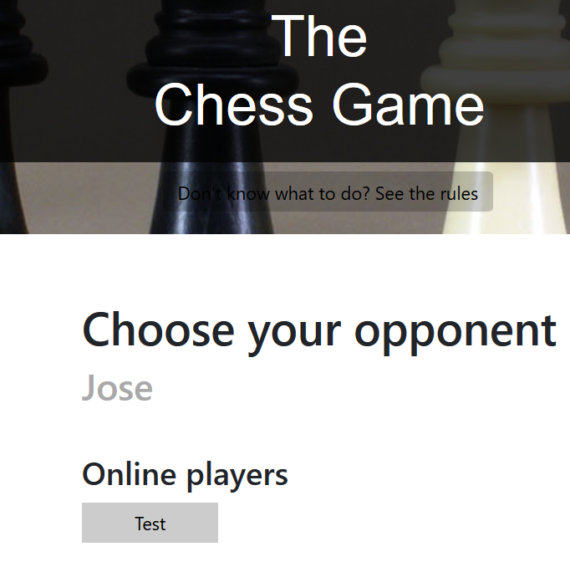

1. Attempt to move more than one piece in a single turn

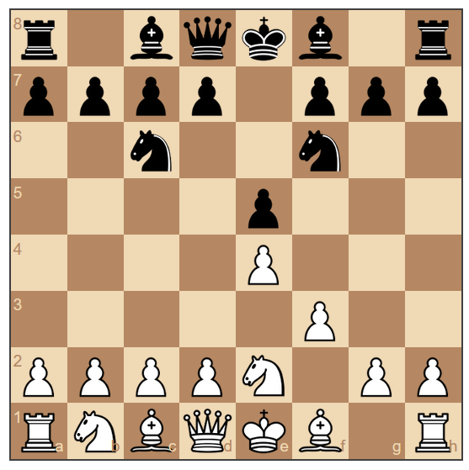

|  |  |  |
| --- | --- | --- |
|  | Player’s move | Opponent’s move |
| 1st turn | Pe4 | Pe5 |
| 2nd turn | Pf3 | Nf6 |
| 3rd turn | Ne2 | Nc6 |

* Looking at the figure and table above, we can surmise that each player is only given one move per turn and is not permitted to execute multiple moves in one turn.

**Expected results**: Each player will only be allowed one move for each turn.

## Player cannot manipulate opponent’s chess pieces

**Objective:** The user must control the piece with the color designated to him/her.

Test steps:

1. Start a game with control over the white pieces



1. Attempt to move a black pawn

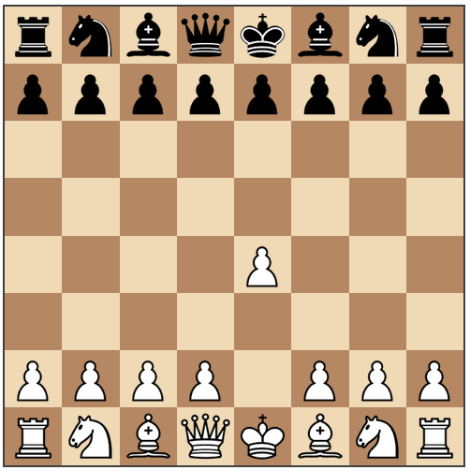

1. Attempt to move black horse



* As we can see, the system will not even let the user to click the black pieces, even more forcing it to move.

**Expected results**: If White was assigned to a player, then he/she can only move the white chess pieces can be moved. And if Black was assigned to a player, then he/she can only move the black chess pieces.

## Player cannot manipulate opponent’s chess pieces

**Objective:** The user must control the piece with the color designated to him/her.

Test steps:

1. Start a game



1. Try to move pieces outside the board

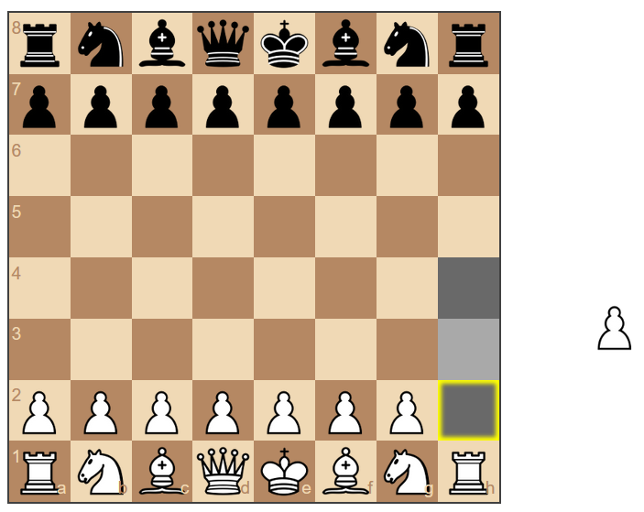



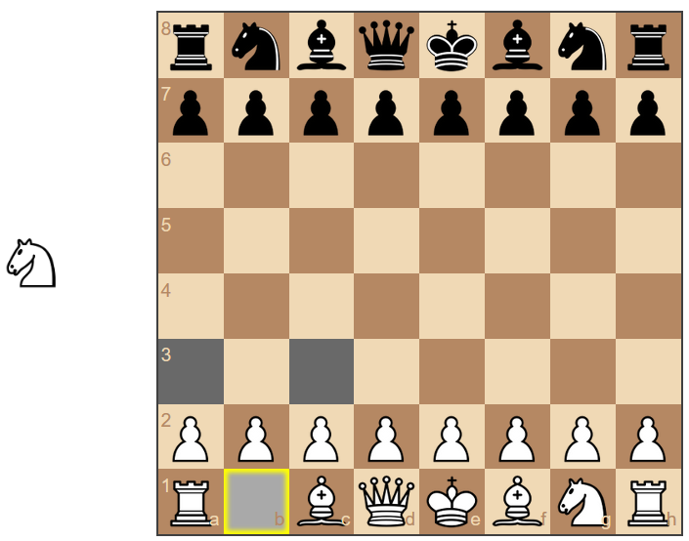



**Expected results**: The system will not allow user to allocate pieces outside the boundaries of a legitimate chess board.