**GGCSF’s**

**Govt. Graduate College Samanabad, FSD.**



**Academic Year 2023 -27**

**Department: Computer Science**

***Name of Assignment:***

**Programming Exercises**

***Submitted by*:** Muhammad Ashir

***Roll No*:** 23548

***Subject*:** Programming Fundamentals

***Submitted to*:** Miss Ifra

**Chapter # 6**

**PROGRAM NO 1:**

Write a program to display the following format using while loop:

----------

a b

----------

1 5

2 4

3 3

4 2

5 1

----------

**Code:**

#include <iostream>

using namespace std;

int main()

{

int i = 1, j = 5;

cout<<"----------\n";

cout<<("a \tb \n");

cout<<("----------\n");

while (i <= 5)

{

cout<<i<<"\t"<<j<<endl;

i++; j--;

}

cout<<("----------")<<endl;

cout<< “Name: Muhammad Ashir” << endl;

cout<< “Roll No: 23548” << endl;

return 0;

**}**

**OUTPUT:**

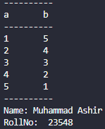

**PROGRAM NO 2:**

Write a program to display the following format using while loop:

--------------------

num sum

--------------------

1 1

2 3

3 6

4 10

5 15

--------------------

**Code:**

#include <iostream>

using namespace std;

int main()

{

int num = 1, sum = 0;

cout<<("--------------------\n");

cout<<("num\t\tsum\n");

cout<<("--------------------\n");

while (num <= 5)

{

sum = sum + num;

cout<<num<<"\t\t"<<sum<<"\n";

num++;

cout<<("--------------------")<<endl;

}

cout<< “Name: Muhammad Ashir” << endl;

cout<< “Roll No: 23548” << endl;

return 0;

}

**OUTPUT:**

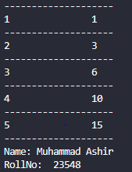

**PROGRAM NO 3:**

Write a program that displays the sum of the following series using do-while loop.

1 + 1/4 + 1/8 +...+1/100

**Code:**

#include <iostream>

using namespace std;

int main()

{

float c, r;

c = 4;

r = 1;

do

{

r = r + 1 / c;

c = c + 4;

}

while (c <= 100);

cout<<"Result is "<<r<<endl;

cout<< “Name: Muhammad Ashir” << endl;

cout<< “Roll No: 23548” << endl;

return 0;

}

**OUTPUT:**



**PROGRAM NO 4:**

Write a program to display alphabets from A to Z. using for loop.

**Code:**

#include <iostream>

using namespace std;

int main()

{

char ch;

for(ch='A'; ch<='Z'; ch++)

{

cout<<ch<<" ";

}

cout<<endl;

cout<< “Name: Muhammad Ashir” << endl;

cout<< “Roll No: 23548” << endl;

return 0;

}

**OUTPUT:**



**PROGRAM NO 5:**

Write a program to find the largest, smallest, and average of n whole numbers. You can assume that "n" has already been set by the user.

**Code:**

#include <iostream>

using namespace std;

int main()

{

int largest, smallest, value;

int n = 5;

float total;

cout <<"Please enter a whole number: ";

cin >>value;

largest = smallest = total = value;

for (int j = 0; j < n; ++j)

{

cout <<"Please enter another whole number: ";

cin >> value;

total += value;

if (value > largest)

largest = value;

if (value < smallest)

smallest = value;

}

cout <<"The largest value is: " <<largest <<endl;

cout <<"The smallest value is: " <<smallest <<endl;

cout <<"The average is: " <<total/n <<endl;

cout<< “Name: Muhammad Ashir” << endl;

cout<< “Roll No: 23548” << endl;

return 0;

}

**OUTPUT:**

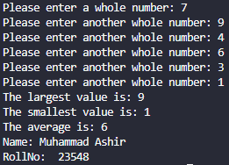

**PROGRAM NO 6:**

Write a program that will ask the user a question with four possible answers. The question should be asked 20 times. After all the input is gathered, the program should output the number of times each answer was selected.

**Code:**

#include <iostream>

using namespace std;

int main()

{

int Answer1=0, Answer2=0, Answer3=0, Answer4=0;

int Answer, Counter, Value;

for(Counter = 0; Counter < 20; Counter++)

{

cout<<"Enter either 1,2,3, or 4"<<endl;

cin>>Value;

switch(Value)

{

case 1:

Answer1++;

break;

case 2:

Answer2++;

break;

case 3:

Answer3++;

break;

case 4:

Answer4++;

break;

default:

cout<<"Incorect choice"<<endl;

Counter--;

}

}

cout<<"Number of Answer 1's = "<<Answer1<<endl;

cout<<"Number of Answer 2's = "<<Answer2<<endl;

cout<<"Number of Answer 3's = "<<Answer3<<endl;

cout<<"Number of Answer 4's = "<<Answer4<<endl;

return 0;

}

**OUTPUT:**

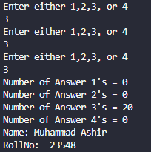

**PROGRAM NO 7:**

Write a program that inputs a series of 20 numbers and displays the minimum value.

**Code:**

#include <iostream>

using namespace std;

int main()

{

int Min, Counter, Value;

cout<<"Enter a Number"<<endl;

cin>>Min;

for (Counter = 0; Counter < 5; Counter++)

{

cout<<"Enter a Number"<<endl;

cin>>Value;

if (Value < Min)

Min = Value;

}

cout<<"The minimum value is: " <<Min<<endl;

cout<< “Name: Muhammad Ashir” << endl;

cout<< “Roll No: 23548” << endl;

return 0;

}

**OUTPUT:**

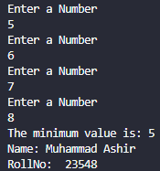

**PROGRAM NO 8:**

Write a program that inputs a number from the user and displays Fibonacci series up to the number entered.

**Code:**

#include <iostream>

using namespace std;

int main()

{

int a, b, next, limit;

cout<<"Enter the limit upto which fibonnaci terms requried: ";

cin>>limit;

a = 0;

b = 1;

cout<<"Fibonacci terms upto limit are: "<<endl;

cout<<a<<"\t"<<b;

next = a + b;

while(next <= limit)

{

next = a + b;

cout<<"\t"<<next;

a=b;

b=next;

next=a+b;

cout<< “Name: Muhammad Ashir” << endl;

cout<< “Roll No: 23548” << endl;

}

return 0;

}

**OUTPUT:**

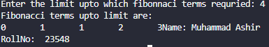

**PROGRAM NO 9:**

Write a program that inputs a number from the user and displays all Armstrong numbers up to the number entered.

**Code:**

#include <iostream>

using namespace std;

int main()

{

int num, n, r, sum, limit;

cout<<"Enter the limit up to which Armstrong numbers are required:";

cin>>limit;

for(num=1;num<=limit;num++)

{

n=num;

sum=0;

while (n!=0)

{

r = n% 10;

sum=sum+(r*r*r);

n /=10;

}

if(sum==num)

cout<<num<<"\t";

}

cout<<endl;

cout<< “Name: Muhammad Ashir” << endl;

cout<< “Roll No: 23548” << endl;

return 0;

}

**OUTPUT:**

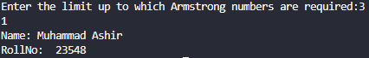

**PROGRAM NO 10:**

Write a program that inputs a number from the user and displays all perfect numbers up to the number entered.

**Code:**

#include <iostream>

using namespace std;

int main()

{

int i, num, mid, sum, limit;

cout<<"Enter the limit upto perfect numbers are required:";

cin>>limit;

if (limit<6)

cout<<"No perfect number up to"<<limit;

else

{

cout<<"Perfect numbers upto to "<<limit<<" are:\n";

for(num=6; num<=limit; num++)

{

sum=0;

mid=num/2;

for(i=1;i<=mid;i++)

{

if((num%i)==0)

sum=sum+i;

}

if (sum==num)

cout<<num<<"\t";

}

}

cout<<endl;

cout<< “Name: Muhammad Ashir” << endl;

cout<< “Roll No: 23548” << endl;

return 0;

}

**OUTPUT:**

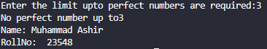

**PROGRAM NO 11:**

Write a program that inputs the number of students in the class. It then inputs the marks of these students and displays the highest and second highest marks.

**Code:**

#include <iostream>

using namespace std;

int main()

{

int marks, numberOfStudents;

double marks1 = -1;

double marks2 = -2;

cout << "Enter the number of students: ";

cin >> numberOfStudents;

for (int i = 0; i < numberOfStudents; i++)

{

cout << "Enter a student marks: ";

cin >> marks;

if (marks > marks1)

{

marks2=marks1;

marks1=marks;

}

else if (marks > marks2)

marks2=marks;

}

cout << "Highest marks is " << marks1 << endl;

cout << "Second highest marks is " << marks2 << endl;

cout<< “Name: Muhammad Ashir” << endl;

cout<< “Roll No: 23548” << endl;

return 0;}

**OUTPUT:** 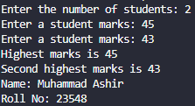

**PROGRAM NO 12:**

Write a program that calculates and prints the average of several integers. Assume that the last value read is sentinel 9999. A typical input sequence might be 10 8 6 7 2 9999 indicating that average of all values preceding 9999 is required.

**Code:**

#include <iostream>

using namespace std;

int main()

{

int c, num;

double sum = 0.0, avg = 0.0;

num = 1;

c = 0;

while (num != 9999 )

{

cout<<"Enter a number: ";

cin>>num;

if ( num ==9999)

break;

sum += num;

c++;

}

avg = sum / c;

cout<<"Average = "<<avg;

cout<<endl;

cout<< “Name: Muhammad Ashir” << endl;

cout<< “Roll No: 23548” << endl;

return 0;

}

**OUTPUT:**

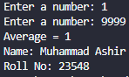

**PROGRAM NO 13:**

Write a program that inputs a number from the user and displays all prime numbers which are less than the input number using any loop.

**Code:**

#include <iostream>

using namespace std;

int main()

{

int n, c, num, p;

cout<<"Enter an integer: ";

cin>>num;

cout<<"List of prime numbers is as follows: "<<endl;

for( n = 1; n<=num; n++)

{

p = 1;

for ( c = 2; c <= n / 2; c++)

if(n%c==0)

{

p = 0;

break;

}

if (p==1)

cout<<n<<"\t";

}

cout<<endl;

cout<< “Name: Muhammad Ashir” << endl;

cout<< “Roll No: 23548” << endl;

return 0;

}

**OUTPUT:**

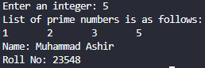

**PROGRAM NO 14:**

Write a program that inputs a number from the user and displays its factorial. It asks the user whether he wants to calculate another factorial or not. If the user inputs 1, it again inputs number and calculates factorial. If user inputs 0, program terminates.

**Code:**

#include <iostream>

using namespace std;

int main()

{

int i, f, n;

int op = 1;

while(op==1)

{

cout<<"Enter a number: ";

cin>>n;

f = 1;

for(i=n; i>=1; i--)

f = f*i;

cout<<"Factorial of "<<n<<" is "<<f;

cout<<"\nDo you want to enter again? (Enter 0 for No 1 for Yes)";

cin>>op;

}

cout<< “Name: Muhammad Ashir” << endl;

cout<< “Roll No: 23548” << endl;

return 0;

}**OUTPUT:** 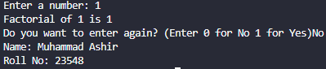

**PROGRAM NO 15:**

Write a program that inputs an integer and displays whether it is a prime number or not.

**Code:**

#include <iostream>

using namespace std;

int main()

{

int n, p, j;

cout<<"Enter a number: ";

cin>>n;

p = 1;

for(j=2; j<n; j++)

if(n%j==0)

{

p = 0;

break;

}

if(p==1)

cout<<" The number is prime.";

else

cout<<"The number is not prime.";

cout<<endl;

cout<< “Name: Muhammad Ashir” << endl;

cout<< “Roll No: 23548” << endl;

return 0;

}

**OUTPUT:**

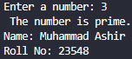

**PROGRAM NO 16:**

Write a program that continuously inputs positive integer values from the user. The user enters a zero to show that he has no more values to enter. The program should finally display the second largest number entered.

**Code:**

#include <iostream>

using namespace std;

int main()

{

int num , first, second;

first = second = num = 0;

do

{

if(num > first)

{

second = first;

first = num;

}

else if(num > second)

second = num;

cout<<"Enter a number (0 to exit): ";

cin>>num;

}

while(num != 0);

cout<<"Second largest number: "<<second;

cout<<endl;

cout<< “Name: Muhammad Ashir” << endl;

cout<< “Roll No: 23548” << endl;

return 0;

}

**OUTPUT:**

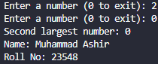

**PROGRAM NO 17:**

Write a program that takes n numbers as input. It displays total positive and negative numbers.

**Code:**

#include <iostream>

using namespace std;

int main()

{

int num, pos, neg;

pos = neg = 0;

do

{

cout<<"Entor a number: ";

cin>>num;

if(num > 0)

pos++;

else if(num < 0)

neg++;

}

while(num != 0);

cout<<"Total positive numbers: "<<pos<<endl;

cout<<"Total negative numbers: "<<neg<<endl;

cout<< “Name: Muhammad Ashir” << endl;

cout<< “Roll No: 23548” << endl;

return 0;

}

**OUTPUT:**

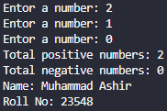

**PROGRAM NO 18:**

Write a program to calculate and display sum of the following series using for loop:

x + $x^{2}$ + $x^{3}$…. $x^{n}$

**Code:**

#include <iostream>

#include <cmath>

using namespace std;

int main()

{

int x, n, i;

long sum;

sum = 0;

cout<<"Enter value of x: ";

cin>>x;

cout<<"Enter value of n: ";

cin>>n;

for(i=1; i<=n; i++)

sum = sum + pow(x, i);

cout<<"Sum = "<< sum << endl;

cout<< “Name: Muhammad Ashir” << endl;

cout<< “Roll No: 23548” << endl;

return 0;

}

**OUTPUT:**

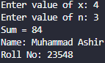

**PROGRAM NO 19:**

Write a program to calculate and display sum of the following series using for loop:

1! + 2! + 3! + 4! + 5!

Where the symbol "!" represents the factorial of the number.

**Code:**

#include <iostream>

using namespace std;

int main()

{

int i, j;

long f, sum;

sum = 0;

for(i=1; i<=5; i++)

{

f = 1;

for(j=i; j>=1; j--)

f = f*j;

sum = sum + f;

}

cout<<"The series is : 1! + 2! + 3! + 4! + 5! " << endl;

cout<<"Sum of the series is = "<< sum << endl;

cout<< “Name: Muhammad Ashir” << endl;

cout<< “Roll No: 23548” << endl;

return 0;

}

**OUTPUT:**

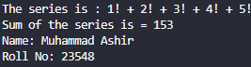

**PROGRAM NO 20:**

Write a program to calculate and display sum of the following series using for loop:

1 + 2x + 3 $x^{2}$ + 4 $x^{3}$ + $5x^{4}$

**Code:**

#include <iostream>

#include <cmath>

using namespace std;

int main()

{

int x, n, i, res;

long sum;

sum = 1;

cout<<"Enter value of x: ";

cin>>x;

for(i=1; i<=4; i++)

{

res = (i+1)* pow(x, i);

sum = sum + res;

}

cout<<"Sum = "<< sum <<endl;

cout<< “Name: Muhammad Ashir” << endl;

cout<< “Roll No: 23548” << endl;

return 0;

}

**OUTPUT:**

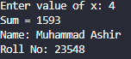

**PROGRAM NO 21:**

Write a program to calculate and display sum of the following series using for loop:

1/2 + 2/3 + 3/4 + ..... +99/100

**Code:**

#include <iostream>

using namespace std;

int main()

{

int i;

double sum = 0;

for (i=1; i <= 99; i++)

sum = sum + (i* 1.0/ (i + 1));

cout<< "The series is: 1/2 + 2/3 + 3/4 + ..... +99/100"<<endl;

cout<<"Sum is "<<sum <<endl;

cout<< “Name: Muhammad Ashir” << endl;

cout<< “Roll No: 23548” << endl;

return 0;

}

**OUTPUT:**

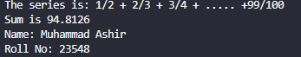

**PROGRAM NO 22:**

Write a program to print the following sequence:

64 32 16 8 4 2

**Code:**

#include <iostream>

using namespace std;

int main()

{

int c;

for ( c = 64 ; c >= 2; c/=2)

cout<<c<<"\t";

cout<<endl;

cout<< “Name: Muhammad Ashir” << endl;

cout<< “Roll No: 23548” << endl;

return 0;

}

**OUTPUT:**



**PROGRAM NO 23:**

Write a program to print the following sequence:

1 3 9 27 81 ... 200

**Code:**

#include <iostream>

using namespace std;

int main()

{

int c;

for ( c = 1; c <= 200; c*=3)

cout<<c<<"\t";

cout<<endl;

cout<< “Name: Muhammad Ashir” << endl;

cout<< “Roll No: 23548” << endl;

return 0;

}

**OUTPUT:**



**PROGRAM NO 24:**

Write a program to print the following sequence:

8 12 17 24 28 33 ... 100

**Code:**

#include <iostream>

using namespace std;

int main()

{

int num, inc;

num = 8;

inc = 4;

while(num<=100)

{

cout<<num<<"\t";

num = num + inc;

if( inc ==4 )

inc = 5;

else if(inc==5)

inc = 7;

else

inc = 4;

}

cout<<endl;

cout<< “Name: Muhammad Ashir” << endl;

cout<< “Roll No: 23548” << endl;

return 0;

}

**OUTPUT:**



**PROGRAM NO 25:**

Write a program to add the first seven terms of the following series using for loop:

1/1! + 2/2! + 3/3! ...

**Code:**

#include <iostream>

using namespace std;

int main()

{

double sum, num, f, n;

for(num=1; num<=7; num++)

{

f = 1;

for(n=1; n<=num; n++)

f = f*n;

sum = sum + num/f;

}

cout<<"The series is: 1/1! + 2/2! + 3/3! ..."<<endl;

cout<<"Sum of series: "<<sum<<endl;

cout<< “Name: Muhammad Ashir” << endl;

cout<< “Roll No: 23548” << endl;

return 0;

}

**OUTPUT:**

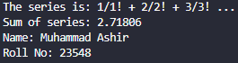

**PROGRAM NO 26:**

Write a program that sums the sequence of integers assuming that first integer read specifies the number of values remaining to be entered. The program should read one value per input statement. A typical input sequence might be 5 100 200 150 300 500. The first integer 5 indicates that subsequent five values are to be summed.

**Code:**

#include <iostream>

using namespace std;

int main()

{

int c, n, num, sum = 0;

cout<<"Enter a number (how many digits you want to be suumed): ";

cin>>n;

for (c=1; c<=n; c++)

{

cout<<"Enter a number: ";

cin>>num;

sum += num;

}

cout<<"Sum = "<<sum<<endl;

cout<< “Name: Muhammad Ashir” << endl;

cout<< “Roll No: 23548” << endl;

return 0;

}

**OUTPUT:**

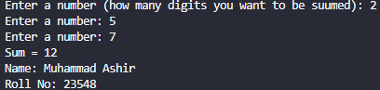

**PROGRAM NO 27:**

A person invests $1000.00 in a saving account yielding 5% interest. Assuming all interest is left deposit in the account, calculate and print the amount of money in the accounts at the end of each year for ten years. Formula: (a = p(1+ ${r)}^{n}$) where p is the original amount invested, r is the annual interest rate, n is the number of years and a is the amount on deposit at the end of nth years.

**Code:**

#include <iostream>

#include <iomanip>

#include <cmath>

using namespace std;

int main()

{

float p, r, a;

int y;

p = 1000;

r = 0.05;

cout.setf(ios::fixed, ios::floatfield);

cout<<setprecision(2);

for ( y = 1; y <= 10; y++)

{

a = p * pow(1 + r, y);

cout<<"Amount at the end of Year "<<y<<": "<<a<<endl;

}

cout<<endl;

cout<< “Name: Muhammad Ashir” << endl;

cout<< “Roll No: 23548” << endl;

return 0;

}

**OUTPUT:**

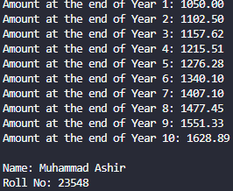

**PROGRAM NO 28:**

Write a program to calculate the sum of the first n odd integers.

**Code:**

#include <iostream>

using namespace std;

int main()

{

int n, num, sum, c;

sum = 0;

num = 1;

cout<<"How many odd integers to add? ";

cin>>n;

for(c=1; c<=n; c++)

{

sum = sum + num;

num = num + 2;

}

cout<<"Sum of first "<<n<<" odd integers: "<<sum<<endl;

cout<< “Name: Muhammad Ashir” << endl;

cout<< “Roll No: 23548” << endl;

return 0;

}

**OUTPUT:**

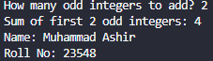

**PROGRAM NO 29:**

Write a program that could find whether the number entered through keyboard is odd or even and should also tell that whether it is prime or not. The program should keep on taking the value till the user ends and before termination should find the total number of odds, evens and primes entered.

**Code:**

#include <iostream>

using namespace std;

int main()

{

int num, odd, even, prime, c, p;

char op = 'y';

odd = even = prime = 0;

while(op!='n' && op!='N')

{

cout<<"Enter a number: ";

cin>>num;

if(num%2==0)

{

cout<<"Number is even. ";

even++;

}

else

{

cout<<"Number is odd. ";

odd++;

}

p = 1;

for(c=2; c<=num/2; c++)

if(num%c==0)

{

p = 0;

break;

}

if(p==1)

{

cout<<"It is a prime number."<<endl;

prime++;

}

else

cout<<"It is a composite number."<<endl;

cout<<"Enter 'N' to terminate?";

cin>>op;

}

cout<<"Total prime numbers: "<<prime<<endl;

cout<<"Total even numbers: "<<even<<endl;

cout<<"Total odd numbers: "<<odd<<endl;

cout<< “Name: Muhammad Ashir” << endl;

cout<< “Roll No: 23548” << endl;

return 0;

}

**OUTPUT:**

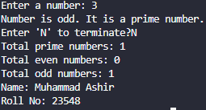

**PROGRAM NO 30:**

Write a loop that will calculate the sum of every third integer, beginning with i = 2 (i.e., calculate the sum 2 + 5 + 8 + 11 +...) for all values of i that are less than 100. Write the loop in each of the following ways:

(1) Using a for loop

(2) Using a while loop

(3) Using a do while loop

**Code:**

**(1) Using a for loop**

#include <iostream>

using namespace std;

int main()

{

int n, sum;

sum = 0;

for ( n = 2 ; n < 100; n = n + 3 )

sum += n;

cout <<" Sum = "<<sum<<endl;

cout<< “Name: Muhammad Ashir” << endl;

cout<< “Roll No: 23548” << endl;

return 0;

}

**OUTPUT:** 

**(2) Using a while loop**

#include <iostream>

using namespace std;

int main()

{

int n, sum;

sum = 0;

n = 2;

while(n<100)

{

sum += n;

n= n + 3;

}

cout<<"Sum = "<<sum<<endl;

cout<< “Name: Muhammad Ashir” << endl;

cout<< “Roll No: 23548” << endl;

return 0;

}

**OUTPUT:**



**(3) Using a do while loop**

#include <iostream>

using namespace std;

int main()

{

int n, sum;

sum = 0;

n = 2;

do

{

sum += n;

n = n + 3;

}

while (n < 100) ;

cout<<"Sum = "<<sum<<endl;

cout<< “Name: Muhammad Ashir” << endl;

cout<< “Roll No: 23548” << endl;

return 0;

}

**OUTPUT:**



**PROGRAM NO 31:**

Write a program to add first nine terms of following series using for and while loop:1/3! + 5/4! + 9/5! +...Where ! indicates factorial.

**Code:**

**(1)Using a for loop**

#include <iostream>

using namespace std;

int main()

{

double sum, num, f, n, d;

d = 1;

for ( num = 3; num<=11; num++) {

f = 1;

for ( n = 1; n<=num; n++)

f=f*n;

sum = sum + d/f;

d = d + 4;

}

cout<<"The series is:1/3! + 5/4! + 9/5! +... "<<endl;

cout<<"Sum of series: "<<sum<<endl;

cout<< “Name: Muhammad Ashir” << endl;

cout<< “Roll No: 23548” << endl;

return 0;

}

**OUTPUT:**

**(2) Using a while loop**

#include <iostream>

using namespace std;

int main()

{

double sum, num, f, n, d;

d = 1;

n = 3;

while(num <= 11)

{

f = 1;

n = 1;

while(n<=num)

{

f =f * n;

n++;

}

sum = sum + d/f;

d = d + 4;

num++;

}

cout<<"The series is:1/3! + 5/4! + 9/5! +... "<<endl;

cout<<"Sum of series: "<<sum<<endl;

cout<< “Name: Muhammad Ashir” << endl;

cout<< “Roll No: 23548” << endl;

return 0;

}

**OUTPUT:**

**PROGRAM NO 32:**

Write a program to calculate sum of the following series using for and do while loop:

1/3 + 3/5 + 5/7 + ... +97/99.

**Code:**

**(1)Using a for loop**

#include <iostream>

using namespace std;

int main()

{

double sum, n, r;

sum = 0;

for(n=1; n<=97; n=n+2)

sum = sum + n/(n+2);

cout<<"The series is:1/3 + 3/5 + 5/7 + ... +97/99 "<<endl;

cout<<"Sum of series: "<<sum<<endl;

cout<< “Name: Muhammad Ashir” << endl;

cout<< “Roll No: 23548” << endl;

return 0;

}

**OUTPUT:**

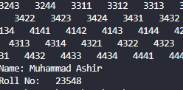

**(2) Using a do while loop**

#include <iostream>

using namespace std;

int main()

{

double sum, n, r;

sum = 0;

n = 1;

do

{

sum = sum + n/(n+2);

n = n + 2;

}

while (n <= 97);

cout<<"The series is:1/3 + 3/5 + 5/7 + ... +97/99 "<<endl;

cout<<"Sum of series: "<<sum<<endl;

cout<< “Name: Muhammad Ashir” << endl;

cout<< “Roll No: 23548” << endl;

return 0;

}

**OUTPUT:**

**PROGRAM NO 33:**

Write a program to generate all possible combinations of 1, 2, 3 and 4.

**Code:**

#include <iostream>

using namespace std;

int main()

{

int i, j, k, l;

for ( i = 1; i <= 4; i++)

{

for (j=1; j <= 4; j++)

{

for ( k = 1; k <= 4; k++)

{

for ( l = 1; l <= 4; l++)

cout<<i<<j<<k<<l<<" ";

}

}

}

cout<<endl;

cout<< “Name: Muhammad Ashir” << endl;

cout<< “Roll No: 23548” << endl;

return 0;

}

**OUTPUT:**



**PROGRAM NO 34:**

Write a program that inputs the starting and ending numbers and displays all prime number ending with digit 7 between the given range in descending order.

**Code:**

#include <iostream>

using namespace std;

int main()

{

int start, end, flag = 0,i,j, r;

cout<<" \n Enter the number to start with :";

cin>> start;

cout<<"\n Enter the number to end with :";

cin>>end;

if(start>end)

{

cout<<"\n Invalid Input.";

exit(1);

}

cout<<"\n The Series :\n";

for(i = end; i>=start; i--)

{

flag = 0;

for(j = 2; j<= -1;j++)

{

r = i%j;

if(r == 0)

flag = 1;

}

if(flag == 0)

{

if(i% 10 == 7)

cout<< i << " ";

}

}

cout<<endl;

cout<< “Name: Muhammad Ashir” << endl;

cout<< “Roll No: 23548” << endl;

return 0;

}

**OUTPUT:**

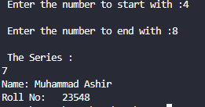

**PROGRAM NO 35:**

Write a program that displays all prime numbers between 100 and 500 that are also palindrome.

**Code:**

#include <iostream>

using namespace std;

int main()

{

int flag, rev, n, j, k;

cout<<"\nPalindrome prime numbers between 100 to 500 are :\n";

for(n = 100; n<=500; n++)

{

flag = 0;

for(j= 2; j<= n-1;j++)

{

if(n%j == 0)

{

flag = 1;

break;

}

}

rev = 0;

if(flag == 0)

{

for(k = n; k >=1; k = k/10)

rev = rev * 10 + k%10;

if(rev == n)

cout<< n << "\t";

}

}

cout<<endl;

cout<< “Name: Muhammad Ashir” << endl;

cout<< “Roll No: 23548” << endl;

return 0;

}

**OUTPUT:**

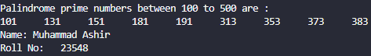

**PROGRAM NO 36:**

Write a program to display following output using nested for loop:

* * * * *

* *

* *

* *

* * * * *

**Code:**

#include <iostream>

using namespace std;

int main()

{

int n, m;

for ( n = 1; n <= 5; n++)

{

for ( m = 1; m <= 5; m++)

if (n==1 || m ==1 || n ==5||m==5)

cout<<"*";

else

cout<<" ";

cout<<endl;

}

cout<< “Name: Muhammad Ashir” << endl;

cout<< “Roll No: 23548” << endl;

return 0;

}

**OUTPUT:**

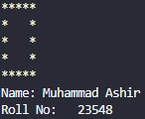

**PROGRAM NO 37:**

Write a program to print the following output using loop:

1

1. 2

1 2 3

1 2 3 4

1 2 3 4 5

**Code:**

#include <iostream>

using namespace std;

int main()

{

int i, j, s;

for(i=1; i<=5; i++)

{

for(s=1; s<=5-i; s++)

cout<<"\t";

for(j=1; j<=i; j++)

cout<<"\t"<<j;

cout<<"\n";

}

cout<< “Name: Muhammad Ashir” << endl;

cout<< “Roll No: 23548” << endl;

return 0;

}

**OUTPUT:** 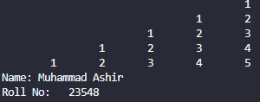

**PROGRAM NO 38:**

Write a program to print the following output using loop:

1 2 3 4 5

1 2 3 4

1 2 3

1 2

1

**Code:**

#include <iostream>

using namespace std;

int main()

{

int i, j, s;

for(i=5; i>=1; i--)

{

for(j=1; j<=i; j++)

cout<<"\t"<<j;

cout<<"\n";

}

cout<< “Name: Muhammad Ashir” << endl;

cout<< “Roll No: 23548” << endl;

return 0;

}

**OUTPUT:** 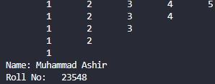

**PROGRAM NO 39:**

Write a program to print the following output using loop:

1

1 2

1 2 3

1 2 3 4

1 2 3 4 5

**Code:**

#include <iostream>

using namespace std;

int main()

{

int i, j;

for(i=1; i<=5; i++)

{

for(j=1; j<=i; j++)

cout<<setw(5)<<j;

cout<<endl;

}

cout<< “Name: Muhammad Ashir” << endl;

cout<< “Roll No: 23548” << endl;

return 0;

}

**OUTPUT:**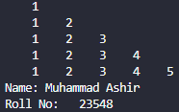

**PROGRAM NO 40:**

Write a program that uses nested for loops to display multiplication table as follows:

1 2 3 4 5

2 4 6 8 10

3 6 9 12 15

4 8 12 16 20

5 10 15 20 25

**Code:**

#include <iostream>

using namespace std;

int main()

{

int m, n;

m = 1;

while (m <= 5)

{

n = 1;

while (n <= 5)

{

cout<<"\t"<<m*n;

n++;

}

cout<<"\n";

m++;

}

cout<< “Name: Muhammad Ashir” << endl;

cout<< “Roll No: 23548” << endl;

return 0;

}

**OUTPUT:**

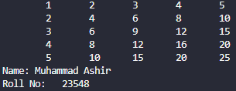

**PROGRAM NO 41:**

Write a program that uses nested for loops to display the following lines:

1 2 4 6

2 2 4 6

3 2 4 6

4 2 4 6

**Code:**

#include <iostream>

using namespace std;

int main()

{

for (int i = 1; i <= 4; ++i)

{

cout << i;

for (int j = 2; j <= 6; j += 2)

cout << " " << j;

cout << endl;

}

cout<< “Name: Muhammad Ashir” << endl;

cout<< “Roll No: 23548” << endl;

return 0;

}

**OUTPUT:**

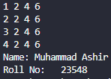

**PROGRAM NO 42:**

Write a program to print the following output using loop:

# # # # # * # # # # #

# # # # * # * # # # #

# # # * # # # * # # #

# # * # # # # # * # #

# * # # # # # # # * #

* # # # # # # # # # *

**Code:**

#include <iostream>

using namespace std;

int main()

{

int row, pound, star;

int nrows = 6;

for(row=1; row<=nrows; row++)

{

for(pound=1; pound<=nrows-row; pound++)

cout << "#";

for(star=1; star<=2*row-1; star++)

if(star == 1 || star == 2*row-1)

cout << "*";

else

cout << "#";

for(pound=1; pound<=nrows-row; pound++)

cout << "#";

cout << endl;

}

cout<< “Name: Muhammad Ashir” << endl;

cout<< “Roll No: 23548” << endl;

return 0;

}

**OUTPUT:**

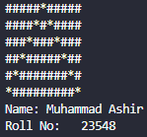

**PROGRAM NO 43:**

Write a program to print the following output using loop:

BBBBBBBBB

. BBBBBBB

. . BBBBB

. . . BBB

. . . . B

**Code:**

#include <iostream>

using namespace std;

int main()

{

int i,j,k;

for ( k = 5; k > 0; k = k - 1 )

{

for (i = 1 ; i <= 5 - k; i = i + 1 )

cout<<".";

for (j=1;j<=2 * k-1; j = j + 1 )

cout<<"B";

cout<<"\n";

}

cout<< “Name: Muhammad Ashir” << endl;

cout<< “Roll No: 23548” << endl;

return 0;

}

**OUTPUT:**

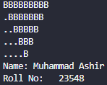

**PROGRAM NO 44:**

Write a program that inputs the height of a triangle and displays it using loop. For example, if the user enters height as 5, the program should print the following:

& & & & & & & & &

& & & & & & &

& & & & &

& & &

&

**Code:**

#include <iostream>

using namespace std;

int main()

{

int i,j,k;

for ( k = 5; k > 0; k = k - 1 )

{

for (i = 1 ; i <= 5 - k; i = i + 1 )

cout<<".";

for (j=1;j<=2 * k-1; j = j + 1 )

cout<<"&";

cout<<"\n";

}

cout<< “Name: Muhammad Ashir” << endl;

cout<< “Roll No: 23548” << endl;

return 0;

}

**OUTPUT:** 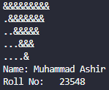

**PROGRAM NO 45:**

Write a program that displays a diamond of asterisks using loop.

*

* * *

* * * * *

* * * * * * *

* * * * * * * * *

* * * * * * *

* * * * *

* * *

*

**Code:**

#include <iostream>

using namespace std;

int main()

{

int row, space, asterisk;

for (row = 1; row <= 5; row++)

{

for (space = 1; space <= 5 - row; space++)

cout << " ";

for (asterisk = 1; asterisk <= 2*row - 1 ; asterisk++)

cout <<"*";

cout << "\n";

}

for ( row = 4; row >= 1 ; row--)

{

for (space = 1; space <= 5 - row; space++)

cout << " ";

for (asterisk = 1; asterisk <= 2 * row - 1; asterisk++)

cout <<"*";

cout << "\n";

}

cout<< “Name: Muhammad Ashir” << endl;

cout<< “Roll No: 23548” << endl;

return 0;

}

**OUTPUT:**

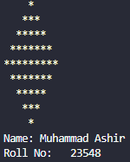

**PROGRAM NO 46:**

Write a program to generate the following pyramid of digits using nested loop:

1

232

34543

4567654

567898765

67890109876

7890123210987

890123454321098

90123456765432109

0123456789876543210

**Code:**

#include <iostream>

using namespace std;

int main()

{

int mid, i, j;

for(i=1;i<=10;i++)

{

cout<<" ";

mid=(2*i)-1;

for(j=1;j<=(10-i);j++)

cout<<" ";

for(j=i;j<=mid;j++)

cout<<(j%10);

for(j=(mid-1);j>=i;j--)

cout<<(j%10);

cout<<endl;

}

cout<< “Name: Muhammad Ashir” << endl;

cout<< “Roll No: 23548” << endl;

return 0;

}

**OUTPUT:**

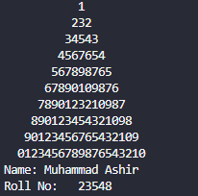

**PROGRAM NO 47:**

Write a program that inputs the height of triangle and displays a triangle of alphabets. For example, if the user enters 5, it displays the following:

A

A B

A B C

A B C D

A B C D E

**Code:**

#include <iostream>

using namespace std;

int main()

{

char ch='A';

int n,i,j;

cout<< "\n Enter the height of the triangle: ";

cin>> n;

for(i=1; i<= n; i++)

{

ch = 'A';

for(j=1;j<=i;j++)

{

cout<< ch<<" ";

ch++;

}

cout<< "\n";

}

cout<< “Name: Muhammad Ashir” << endl;

cout<< “Roll No: 23548” << endl;

return 0;

}

**OUTPUT:**

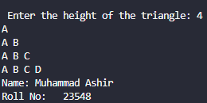

**PROGRAM NO 48:**

Write a program to display the following output using while loop:

1

3 5

7 9 11

13 15 17 19

21 23 25 27 29

31 33 35 37 39 41

43 45 47 49 51 53 55

**Code:**

#include <iostream>

using namespace std;

int main()

{

int n, m, val;

n = 1;

val = 1;

while(n<=7)

{

m = 1;

while(m<=n)

{

cout<<val<<" ";

m++;

val = val + 2;

}

cout<<endl;

n++;

}

cout<< “Name: Muhammad Ashir” << endl;

cout<< “Roll No: 23548” << endl;

return 0;

}

**OUTPUT:** 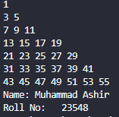

**PROGRAM NO 49:**

Write a program to display the following output using loop:

1 2 3 4 5 6 7 6 5 4 3 2 1

1 2 3 4 5 6 6 5 4 3 2 1

1 2 3 4 5 5 4 3 2 1

1 2 3 4 4 3 2 1

1 2 2 1

1 1

**Code:**

#include <iostream>

using namespace std;

int main()

{

int n, m, x, y, s;

s = 0;

for ( n = 7; n >= 1; n--)

{

for ( m = 1; m <= n; m++)

cout<< m;

for ( y = 0; y < s; y++)

cout<<" ";

for(x=m-1; x >= 1; x--)

if(x!=7)

cout<<x;

if (n==7)

s++;

else

s = s + 2;

cout<<endl;

}

cout<< “Name: Muhammad Ashir” << endl;

cout<< “Roll No: 23548” << endl;

return 0;

}

**OUTPUT:**

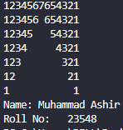

**PROGRAM NO 50:**

Write a program to display the following output using loop:

&

&&&&&&&& &

&&&&&&& &

&&&&&& &

&&&&& &

&&&& &

&&& &

&& &

& &

&&&&&&&&&&&&&&&&&

**Code:**

#include <iostream>

using namespace std;

int main()

{

int n;

cout<<"\n Enter height :";

cin>>n;

for(int r = 1 , sp = n - 1 ; r <= n ; r ++, sp--)

{

for (int k = 0; k <= sp ; k++)

cout<<" ";

for(int c = 1; c <2 * r ; c++)

{

if (c==1||c==2 * r-1||r==n)

cout << "&";

else

cout<<" ";

}

cout<< endl;

}

cout<< “Name: Muhammad Ashir” << endl;

cout<< “Roll No: 23548” << endl;

return 0;

}

**OUTPUT:**

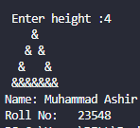

**PROGRAM NO 51:**

Write a program to display the following output using loop:

0

0 1

0 1 2

0 1 2 3

0 1 2 3 4

0 1 2 3 4 5

**Code:**

#include <iostream>

using namespace std;

int main()

{

int i, j;

for ( i = 0; i <= 5; i++)

{

for(j=0; j <= i; j ++)

cout<<j <<"";

cout<<endl;

}

cout<< “Name: Muhammad Ashir” << endl;

cout<< “Roll No: 23548” << endl;

return 0;

}

**OUTPUT:**

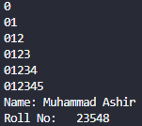

**PROGRAM NO 52:**

Write a program that generates the following checker board by using loop.

- - - - - - - -

- - - - - - - -

- - - - - - - -

- - - - - - - -

- - - - - - - -

- - - - - - - -

- - - - - - - -

- - - - - - - -

**Code:**

#include <iostream>

using namespace std;

int main()

{

int row = 8;

int side;

while (row--> 0)

{

side = 8;

if (row%2!=0)

cout <<" ";

while (side--> 0)

cout << "-";

cout << endl;

}

cout<< “Name: Muhammad Ashir” << endl;

cout<< “Roll No: 23548” << endl;

return 0;

}

**OUTPUT:**

