1.Dates
8-April
- 1.Difference between let and var?
- 2.primitive and non primitive data type?
- Difference between null and undefined?
- Different ways of creating arrays in js?
- Difference between join and separator?
9-April
- array.join(separator)
- array1.sort()
- Finding any values in array
- Array.find();
- What array methods makes mutable and unmutable?
10-April
- Decision making

2.Function
- Functions are reusable block of code
- It designed to perform some operation.
- As long as u are not calling the function it is not executing. Even the compiler ignore it kinda.
- 2 major parts of function
  - Function Declaration
  - Function Calling
- Types of function
  - Parameterized
    - Parameterized values are limited inside the function
  - Non parameterized
    - A function does not require any value to operate on
- Console.log(arguments)
  - Arguments object special array type of object find in functions, responsible to store all the values in array objects.
  - All the args by default get stored here.
  - Parameters are placeholders for this object , but internally it use arguments.
- Function Expression
  - Strong a function inside a variable
  - Just a way of declaring the function
  - Benefit – {could not call this function before declaration }
  - Why function expression came into picture?
- Hoisting [flag hoisting] -> Calling a function b4 declaration.
- Taking the declaration part to the top of java script

- Significance of arrow funciton
  - Minimalistic version of creating a function in modern way of function
  - Don’t have to use function keyword as well as function name to create an arrow function
  - If there’s only one statement or one result to return no need of block of code or no need of return statement
  - If there is only one value as param and one return then no need of return type or curly braces too.
  - Argument object -> is not present in arrow function , it’s present in general function only
- Ways of creating a function
  - Function keyword
  - Function expression
  - Arrow function
- Call Back function
  - The function which has been passed as argument is callback function
  - A function calling another function is high order function
  - Passing function as argument to another function means storing a function inside a variable.
- Default return type of function is undefined.
- Tdb -> temporal dead zone

3.Operators
- Operators are symbols that is used to perform tasks
- In an operation both operand and operators take part

- Unary - Take only one operand/value
- Binary – take two
- Ternary – more then 2 values , and it is an alternative of decision statement.(if/else)
- Binary Operators
  - Arithmetic Operators [ + , - ]
    - + do addition , concatenation
    - “abc”-“def” [ NAN ]
    - arr1 * arr2 [NAN]
    - true + true [2]
  - Logical operators [&&, || , !]
    - ! is unary operator

  - Comparison Operator [=,===.!=,!==,>=,<=]
    - 10 == ‘10’ [true] as type cohesion happens
    - 10 === ‘10’ [false] it check value w data type.
- Unary Operator
  - Increment
  - Decrement
  - Assignment Operator =
    - += ,-=,*=(binary Operator)
  - Logical Not
- Ternary operator

4.Decision making
- Simple if
- If else
- Nested if else
- Switch

5.TDZ
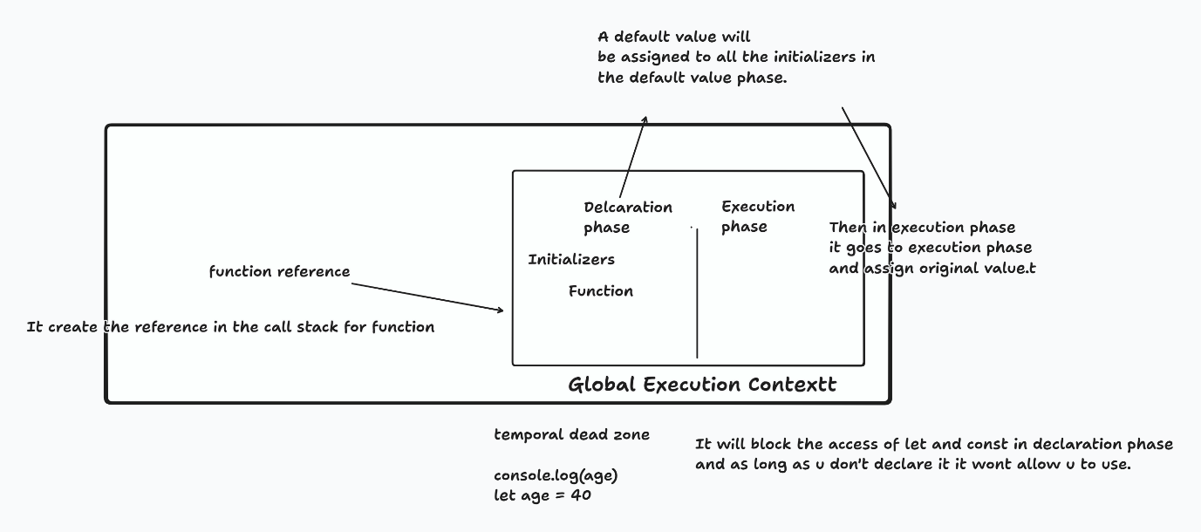
Control statement

6.Scope in js
- Global Scope [var]
- Function Scope [var, const , let]
- Block Scope [let]
Var – global + function

7.Async Js
- Set Interval
- Set Timeout
- Clear Interval
- Promise
  - Then moment we interact w backend we have to deal with promise
  - A call back with two parameters
  - Resolve , pending , rejected
  - If promise gets full filled then we have to collect data
    - Method name is .then(callback)
  - .then()
  - .catch(errorMessage)
  - .finally()

8.How js send request to backend
- Fetch
  - Receives an api and if nothing mentioned it’s a get request.
  - Platzi fake store api
  - An async operation
  - Not worry about creating a promise its more about handling here.
- Async / await

- Axios
  - For handling apis (modern way)
  - Combine both modern way for handling async operation
  - (async await + modern way of handling api)
  - Axios cdn
    - Add in the html-header and link your javaScript file

9.Rest Parameter
- Accept the rest of the values.
- Function name(para1, …para2)

10.Spread Operator
- Used with both arrays and functions.
- Similar as …rest parameter but its for arrays.

11.Destructuring in javascript - Array and object
- let [name1,name2,name3,name4] = array01;
- array destructuring with rest
- object destructuring
  - In case of object destructuring key name should be same

