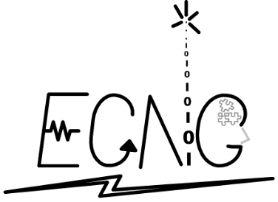THE UNIVERSITY OF THE WEST INDIES

ST. AUGUSTINE, TRINIDAD & TOBAGO, WEST INDIES

FACULTY OF ENGINEERING

**Department of Electrical & Computer Engineering**

BSc. in Electrical & Computer Engineering

**ECNG 3008**

**Digital Electronics**

Lab 1

Driving a DC-DC Buck Converter

Name: Jonnathan Ramdass

ID: 816020166

Course Lecturer: Dr Arvin Singh

Date Submitted: 24th November 2022

**Statement of academic Honesty**

THE UNIVERSITY OF THE WEST INDIES

ST. AUGUSTINE, TRINIDAD & TOBAGO, WEST INDIES

FACULTY OF ENGINEERING

**Department of Electrical & Computer Engineering**

B. Sc. in Electrical & Computer Engineering

**CHEATING, PLAGIARISM AND COLLUSION DECLARATION FORM**

According to Rules 3.31 and 3.32 of The UWI Faculty of Engineering Undergraduate Regulations and Syllabuses 2018/2019:

3.31 “**Cheating, Plagiarism and Collusion are serious offences under University Regulations**.

(a) Cheating is any attempt to benefit one’s self or another by deceit or fraud.

(b) Plagiarism is the unauthorised and/or unacknowledged use of another person’s intellectual efforts and creations howsoever recorded, including whether formally published or in manuscript or in typescript or other printed or electronically presented form and includes taking passages, ideas or structures from another work or author without proper and unequivocal attribution of such source(s), using the conventions for attributions or citing used in this University. Plagiarism is a form of cheating.

(c) For the purposes of these Regulations, ‘collusion’ shall mean the unauthorised or unlawful collaboration or agreement between two or more students in the preparation, writing or production of a course assignment for examination and assessment, to the extent that they have produced the same or substantially the same paper, project report, as the case may be, as if it were their separate and individual efforts, in circumstances where they knew or had reason to know that the assignment or a part thereof was not intended to be a group project, but was rather to be the product of each student’s individual efforts.

3.32 Cheating, plagiarism and collusion shall be reported to the Campus Committee on Examinations and the penalties would be in accordance with the University Examination Regulations.”

I, **JONNATHAN RAMDASS**, have read and understood Rules 3.31 and 3.32 of The UWI Faculty of Engineering Undergraduate Regulations and Syllabuses 2018/2019 on Cheating, Plagiarism and Collusion.

I understand that my submission is subject to the electronic plagiarism checker, Turnitin.

I declare that this assignment is my own work and does not involve cheating, plagiarism or collusion.

Signature: ……………………………………………. Date: 24/11/2022

*3.4.1 Low-side Driver Circuit*

2. g.

Simulated PWM signals at Gate and function generator for low-side driver

20%

50%

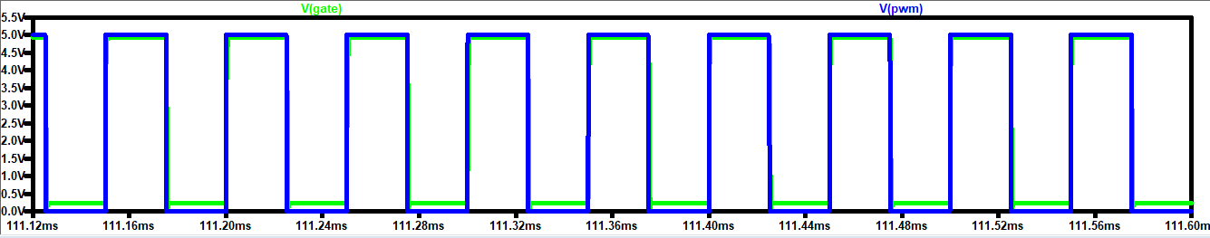

80%

*3.4.2 High-side Driver*

2. g. Simulated differential voltage, 𝑉𝑔𝑠 for high side driver

20%

50%

80%

*3.4.3 Buck Converter*

1. Briefly explain the operation of the buck converter. Include circuit diagram and waveforms to support your answer.

A buck converter steps down the applied DC input voltage level.

The operation of a buck converter:

The switch turns on and lets current flow to the output capacitor, charging it up. Since the voltage across the capacitor cannot rise instantly, and since the inductor limits the charging current, the voltage across the cap during the switching cycle is not the full voltage of the power source.

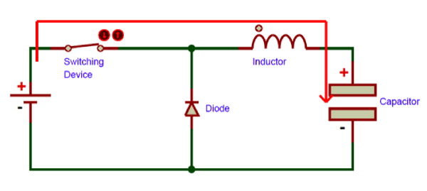

The switch now turns off. Since the current in an inductor cannot change suddenly, the inductor creates a voltage across it. This voltage is allowed to charge the capacitor and power the load through the diode when the switch is turned off, maintaining current output current throughout the switching cycle.

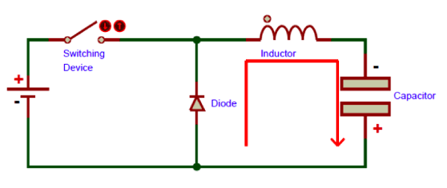

These two steps repeat very frequently, resulting in continuous output.

Source: https://components101.com/articles/buck-converter-basics-working-design-and-operation

The figure given below shows the waveform representation of a Buck Converter:

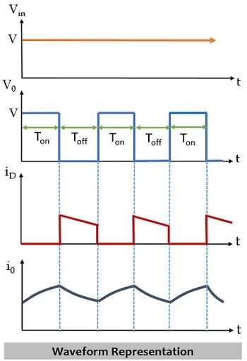

Source: https://electronicscoach.com/buck-converter.html