PDPM Indian Institute of Information Technology
Design and Manufacturing, Jabalpur



“IOT ENABLED SMART LIGHT SOLUTION FOR ELECTRIC VEHICLE”

Name of Inventor:
Dr. Avinash Ravi Raja Email: avinash.raviraja@iiitdmj.ac.in
Gyanendra Kumar Email: sagargyanendra35@gmail.com
Amit Kumar Email: amitmawar113@gmail.com
Ashish Suryavanshi Email: ashish019suryavanshi@gmail.com
Vijay Kumar Email: vj.saini.2105@gmail.com
Virat Singh Email: virpri666@gmail.com

Working process
One major novelty of the system is the automatic day–night recognition using an LDR sensor. During daytime, when the ambient light level is sufficiently high, the microcontroller commands the headlight to remain completely OFF, preventing unnecessary energy consumption and extending lamp life. As the surroundings become darker, the system automatically switches ON the headlamp and begins regulating its brightness based on real-time light detection. This enables automatic illumination management without driver input, similar to features found in modern vehicles.

A second innovative feature is the servo-based beam angle adjustment. Instead of relying on a fixed or manually set headlight angle, the microcontroller directly controls a servo motor to dynamically tilt the headlight between 0° to 15°. This helps prevent glare for oncoming drivers and improves the user's visibility on curved or uneven roads. Importantly, the servo movements are not independent; they are continuously influenced by the same sensor data that drives the brightness control, creating a coordinated adaptive lighting response.

The brightness regulation itself is another key novelty. Using a TIP120 Darlington transistor, the system drives a 12-volt automotive lamp with smooth dimming. A reverse-proportional control algorithm ensures that strong incoming headlight glare causes gradual dimming of the lamp, while darker conditions automatically increase its brightness. This avoids abrupt switching and eliminates flickering, offering a more comfortable and safer lighting experience for both the driver and surrounding vehicles.

A critical aspect of novelty is that both major processes—brightness control and servo angle adjustment—operate simultaneously, powered by continuous sensor feedback. The microcontroller processes real-time LDR input and simultaneously executes:
brightness adjustment through the TIP120 transistor
Servo rotation commands for beam angle correction
Workflow Method
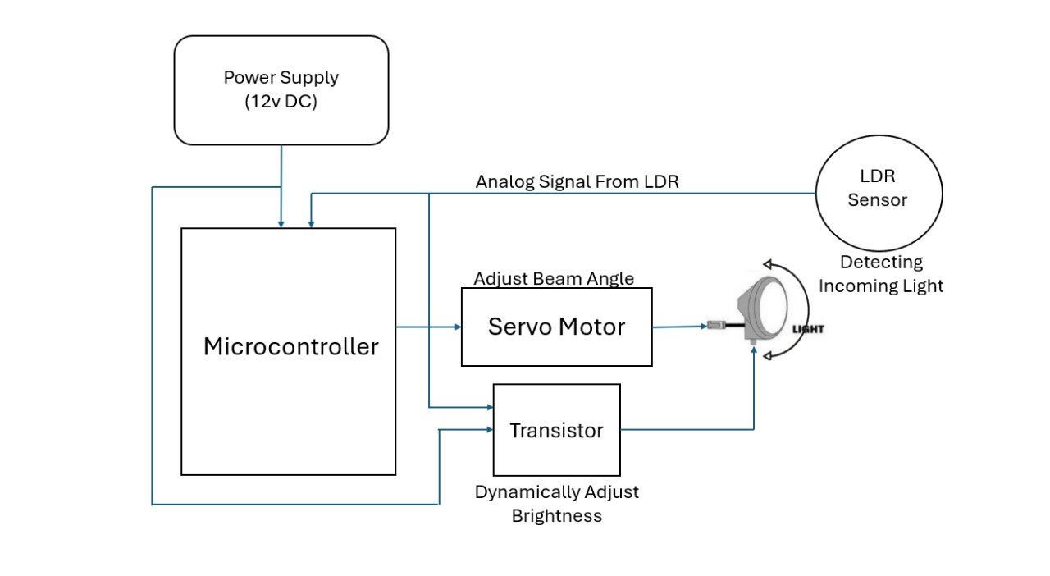
Circuit Diagram-
