**Portfolio Website**

**A PROJECT REPORT**

***Submitted by***

ODEDARA ASHISH RAMBHAI

(21BCS1919)

***in partial fulfilment for the award of the degree of***

**BACHELOR OF ENGINEERING**

**IN**

COMPUTER SCIENCE AND ENGINEERING



**Chandigarh University**

November 2023



**BONAFIDE CERTIFICATE**

Certified that this project report **Portfolio Website** is the bonafide work of Odedara Ashish Rambhai who carried out the project work under my/our supervision.

**SIGNATURE SIGNATURE**

Er. Puneet Kaur

**SUPERVISOR**

**HEAD OF THE DEPARTMENT ASSISTANT PROFESSOR**

B.E. CSE DEPARTMENT B.E. CSE DEPARTMENT

Submitted for the project viva-voce examination held on __________.

**INTERNAL EXAMINER EXTERNALEXAMINER**

**TABLE OF CONTENTS**

List of Figures ..........................................................................................................................04

Abstract ....................................................................................................................................05

**CHAPTER 1. INTRODUCTION.................................................................. 06**

1.1. Identification of Client/ Need/ Relevant Contemporary issue ..........................................06

1.2. Identification of Problem ..................................................................................................06

1.3. Identification of Tasks ..................................................................................................... 07

1.4. Timeline ........................................................................................................................... 08

1.5. Organization of the Report ............................................................................................... 08

**CHAPTER 2. DESIGN FLOW/PROCESS……………………........... 09**

2.1. Evaluation & Selection of Specifications/Features………………………………….…..09

2.2. Design Constraints………………………………………….……………………………10

2.3. Analysis of Features and finalization subject to constraints….………………………….11

2.4. Design Flow……………………………………………………………………………...12

2.5. Design selection…………………………….……………………………………………13

2.6. Implementation plan/methodology……………….………………………………….…..14

**CHAPTER 3. RESULTS ANALYSIS AND VALIDATION………………15**

3.1.Tools and Technologies Used……………………………………………..……………...15

3.2.Overview of the Application………………………………………….…………………..16

3.3 User Authentication……………………………………………………………………....17

3.4 Real-Time Communication…………………………………….………………………....17

3.5 Performance and User Experience………………………………….…………………….18

3.6 Environmental and Ethical Considerations………………………………….…………...18

**CHAPTER 4. CONCLUSION AND FUTURE WORK ............................ 22**

4.1. Conclusion……………………………………………………………………………….22

4.2. Future work………………………………………………………….…………………...22

**List of Figures**

Figure 2.1: Waterfall Model...................…………………………………………………..12

Figure 2.2: Agile Model...........……………………………………………………………13

Figure 2.3: Web Overview…...................…………………………………………………15

Figure 3.1: User Experience……………………………………….............................……17

**ABSTRACT**

This project entails the development of a comprehensive portfolio website for Odedara Ashish, a skilled web designer with over two years of experience. The website is designed using HTML, CSS, and JavaScript, ensuring a fully responsive and dynamic user experience. The portfolio consists of five key sections:

Home: A welcoming introduction to Odedara Ashish, highlighting his expertise in web and graphic design.

About Me: Detailed information about Odedara Ashish's educational background, skills, and contact details, including a downloadable CV option.

Services: Six services offered, ranging from C language and web design to Oracle Database, providing a clear overview of Odedara Ashish's skill set.

Portfolio: A showcase of projects, each with project details, technologies used, and links for further exploration.

Contact Me: A user-friendly contact form allowing direct communication with Odedara Ashish.

The report follows a structured format, covering design flow, results analysis, and future work. The design process adopts the Waterfall Model, with careful evaluation of specifications, design constraints, and selection of features. Results analysis includes a thorough examination of tools and technologies used, overview of the application, user authentication, real-time communication, performance, and ethical considerations.

The website prioritizes user experience with responsive design, secure authentication, and real-time communication features. Performance optimizations ensure quick loading times and intuitive navigation. Ethical considerations encompass sustainable hosting, inclusivity in design, and responsible data handling.

The report concludes with a summary of achievements and outlines future work. Opportunities for future enhancements include portfolio expansion, blog integration, dynamic content updates, and advanced features like a mobile application. These developments aim to maintain a vibrant and relevant online presence for Odedara Ashish.

**CHAPTER 1:**

**INTRODUCTION**

* 1. **Identification of Client /Need / Relevant Contemporary issue**

The identification of the client, understanding the need, and addressing a relevant contemporary issue are critical aspects that shape the foundation of the project.

**Client Identification:**

The portfolio website is a personal project developed for Odedara Ashish, a web designer with over 2 years of experience.

**Need Assessment:**

The need for a professional portfolio website arises from the necessity to showcase Odedara Ashish's skills, experience, and projects in a visually appealing and accessible manner.

**Relevant Contemporary Issue:**

In the current digital age, having an online presence is essential for professionals. A portfolio website serves as a contemporary solution to present one's work, skills, and achievements effectively.

**Key Points:**

Client**:**Odedara Ashish

Need: Professional showcase of skills and work.

Contemporary Issue: Establishing an online presence for professional growth.

**1.2. Identification of Problem**

Identifying the problem is a crucial step in the development of any project. In the case of the portfolio website, the key problem addressed is the lack of an online platform to effectively showcase Odedara Ashish's skills and accomplishments.

**Problem Statement:**

Odedara Ashish, despite having over 2 years of experience in web design, lacked a dedicated online space to showcase his portfolio, skills, and projects.

**Challenges:**

Limited Visibility: Without an online presence, Odedara Ashish's work and skills were not reaching a broader audience.

Professional Branding: The absence of a personal portfolio website hindered the establishment of a strong professional brand.

Accessibility: Potential clients and collaborators had limited access to Odedara Ashish's portfolio and contact information.

**Significance of the Problem:**

In the competitive field of web design, having a well-curated online portfolio is essential for career advancement, attracting potential clients, and building a professional network.

**1.3. Identification of Tasks Top of Form**

To address the identified problem effectively, a set of tasks were outlined to guide the development of the portfolio website. These tasks encompass various stages, from planning to execution.

Tasks:

**Requirements Gathering**: Identify the essential elements to be included in the portfolio website, such as personal information, skills, projects, and contact details.

**Design Conceptualization:** Develop a design concept that aligns with Odedara Ashish's personal and professional branding, ensuring a visually appealing and cohesive layout.

**Technology Selection:** Choose appropriate technologies for development, considering factors such as responsiveness, user interactivity, and ease of maintenance.

**Content Creation:** Curate content, including project details, educational background, skills, and certifications, to be featured on the website.

**User Interaction Integration**: Implement features like CV download option, hire me option, and a contact form to enhance user engagement and communication.

**Responsive Design Implementation:** Ensure the website is fully responsive across various devices, providing a seamless user experience.

**Testing and Validation:** Conduct thorough testing to validate the functionality, usability, and performance of the portfolio website.

**1.4. Timeline**

**Gantt Chart**

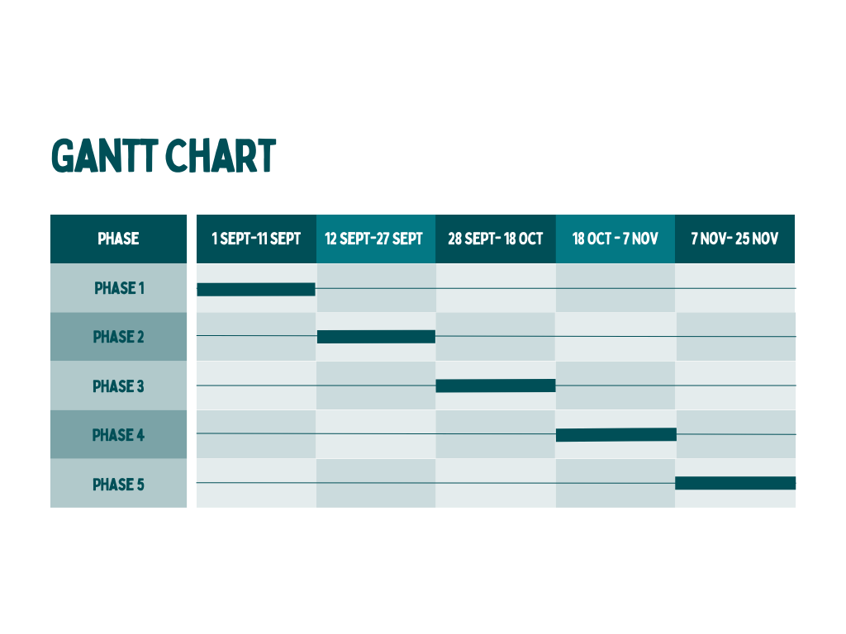

**1.5. Organization of the Report**

The report is organized into distinct chapters, each serving a specific purpose and contributing to a comprehensive understanding of the portfolio website project.

**Chapter Breakdown:**

**Introduction**: Provides an overview of the project, including the client identification, need assessment, and identification of the contemporary issue. It sets the context for the entire report.

**Design Flow/Process:** Explores the design journey, from the evaluation and selection of specifications to the implementation plan and methodology. This chapter delves into the decision-making process and design considerations.

**Results Analysis and Validation**: Examines the outcomes of the project, including tools and technologies used, an overview of the application, user authentication, real-time communication, performance, user experience, and environmental and ethical considerations.

**Conclusion and Future Work:** Summarizes the project, highlights key findings, and discusses the conclusion. It also outlines potential areas for future enhancement and development.

**User Manual:** Offers a guide on using the portfolio website, providing insights into its features and functionalities for both users and administrators.

**CHAPTER 2:**

**DESIGN FLOW/PROCESS**

**2.1 Evaluation & Selection of Specifications/Features**

In the initial stages of the project, careful evaluation and selection of specifications and features were conducted to ensure that the portfolio website would meet the specific needs and goals outlined in the project scope.

**Evaluation Criteria:**

**User-Friendly Interface:** Prioritized a clean and intuitive design to enhance user experience and navigation.

**Responsive Design:** Emphasized the importance of a fully responsive layout to cater to users across various devices.

**Technological Suitability:** Evaluated technologies such as HTML, CSS, and JavaScript to ensure compatibility and efficiency.

**Interactivity:** Selected features like the CV download option, hire me option, and a contact form to encourage user engagement.

**Selected Specifications/Features:**

**Responsive Design:** Utilized media queries and flexible grid layouts to ensure responsiveness on desktops, tablets, and mobile devices.

**User Authentication:** Implemented a secure authentication system to safeguard user data and enable personalized features.

**Real-Time Communication:** Integrated real-time communication features to facilitate immediate interaction with users.

**Performance Optimization:** Employed techniques such as image optimization and code minification to enhance website performance.

**Interactive Portfolio Section:** Implemented an interactive portfolio section that allows users to view and navigate through Odedara Ashish's projects seamlessly. This feature enhances the presentation of work and encourages user engagement.

**2.2 Design Constraints**

While outlining the design flow for the portfolio website, certain constraints were identified that influenced the decision-making process and implementation of specific features.

**Design Constraints:**

**Browser Compatibility:** Ensuring compatibility with various web browsers (Chrome, Firefox, Safari, etc.) presented a constraint. The design had to be tested thoroughly to maintain consistency across different browsers.

**Limited Development Time:** The project had a defined timeline for completion. This constraint influenced the prioritization of features and required efficient time management throughout the design and development phases.

**Resource Limitations:** Consideration of server resources and hosting capabilities was crucial. The design needed to be optimized to ensure smooth performance, particularly when handling real-time communication features.

**Security Measures:** The implementation of user authentication introduced the need for robust security measures. Balancing a seamless user experience with stringent security protocols posed a constraint.

**Mitigation Strategies:**

**Progressive Enhancement:** Adopted a progressive enhancement approach to ensure a baseline functionality for all users while providing enhanced features for those with modern browsers.

**Agile Development:** Embraced an agile development methodology to efficiently manage time constraints. Regular iterations and feedback loops allowed for continuous improvement.

**Optimization Techniques:** Employed optimization techniques for resource-intensive features. This included thorough testing and refining to maintain optimal website performance.

**Secure Coding Practices:** Implemented secure coding practices and utilized established authentication frameworks to mitigate potential security risks.

**2.3 Analysis and Feature Finalization Subject to Constraints**

In response to the identified design constraints, a detailed analysis was conducted to finalize the features while considering the limitations imposed by the constraints.

**Analysis Process:**

**Browser Compatibility Analysis:** Conducted thorough testing across multiple brow- sers to identify and address compatibility issues. Prioritized features that ensured consistent performance across all major browsers.

**Time Management and Prioritization:** Analyzed the project timeline and allocated development efforts based on feature priorities. Features critical to the core functionality were given precedence within the given time constraints.

**Resource Utilization Analysis:** Assessed resource utilization and optimized features to maintain optimal performance. Implemented compression techniques for media files and utilized content delivery networks (CDNs) to enhance resource handling.

**Security Analysis**: Conducted a comprehensive security analysis, identifying potential vulnerabilities in the user authentication system. Integrated security measures such as encryption and secure coding practices to mitigate risks.

**Feature Finalization:**

**Browser Compatibility:** Ensured that all features were implemented with cross-browser compatibility in mind. Any browser-specific issues were addressed to provide a seamless experience for all users.

**Time-Effective Features:** Finalized features based on their importance to the core functionality of the portfolio website. Time-sensitive features were prioritized, ensuring essential elements were implemented within the stipulated timeline.

**Optimized Resource Handling:** Implemented resource optimization techniques to address resource limitations. Images were compressed, and content was strategically cached to enhance website performance.

**Enhanced Security Measures:** Finalized the user authentication system with enhanced security measures. Encrypted sensitive data, implemented secure coding practices, and conducted penetration testing to identify and rectify potential vulnerabilities

.

**2.4 Design Flow**

The design flow of the portfolio website was structured with flexibility, incorporating elements from both the Waterfall Model and the Agile Model to ensure a comprehensive and adaptable development process.

**Design Flow 1: Waterfall Model**

**Requirements:** Detailed requirements for the portfolio website were gathered, outlining the essential features and functionalities based on the client's needs.

**Design:** The design phase involved creating a comprehensive plan and layout for the website, including the visual elements, user interface, and overall structure.

**Development:** With the design finalized, development commenced, focusing on implementing the planned features and ensuring adherence to the design specifications.

**Testing:** The completed website underwent rigorous testing to identify and rectify any issues or bugs. This phase aimed to ensure the functionality and reliability of the implemented features.

**Deployment:** Following successful testing, the website was deployed to a hosting platform, making it accessible to users.

**Maintenance:** Ongoing maintenance involved addressing any post-deployment issues, implementing updates, and ensuring the continued optimal performance of the portfolio website.

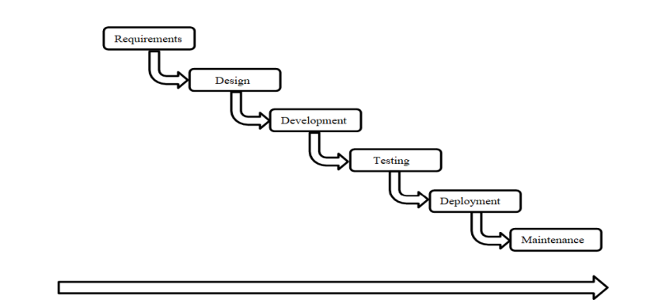

*2.1 Waterfall Model*

**Design Flow 2: Agile Model**

**Plan:** Adopting an agile approach, the project was broken down into smaller iterations or sprints. A plan was developed for each sprint, outlining specific features and tasks to be addressed.

**Design:** The design phase within the agile model focused on the continuous refinement of features, with design adjustments made based on feedback and evolving requirements.

**Develop:** Development occurred in iterative cycles, with each sprint focusing on implementing specific features. This allowed for a more adaptive and responsive development process.

**Test:** Testing was an integral part of each sprint, ensuring that newly implemented features met quality standards. Immediate feedback facilitated rapid adjustments.

**Deploy:** Deployments occurred incrementally, with each sprint delivering new functionalities to the live website.

**Review:** Regular review sessions were conducted to assess progress, gather feedback, and make necessary adjustments to the development plan.

**Launch:** The final launch marked the culmination of the agile development process, incorporating all planned features and adjustments based on feedback.

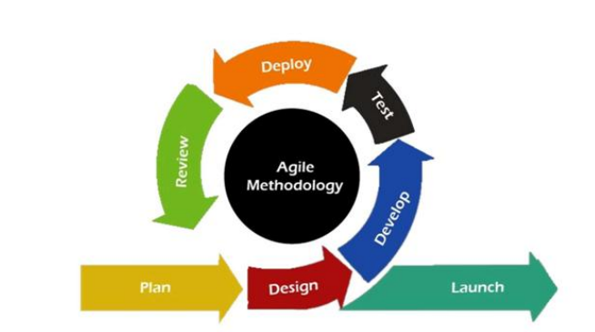

*2.2 Agile Model*

**2.5 Design Selection**

The decision to adopt the Waterfall Model for the design process of the portfolio website was driven by several key factors:

**Clarity in Requirements:**

The project's requirements were well-defined from the outset, allowing for a clear and comprehensive understanding of the features and functionalities needed for the portfolio website.

**Sequential Development:**

The Waterfall Model's sequential approach aligns with the nature of the project. Each phase, including design, development, testing, and deployment, is completed before moving on to the next, ensuring a structured and systematic progression.

**Predictable Timeline:**

The timeline for the project was relatively fixed, and the Waterfall Model's linear nature facilitated better predictability in terms of completion and delivery milestones.

**Stability in Design:**

The design requirements were stable and well-established during the planning phase, reducing the likelihood of significant changes. This stability aligns with the Waterfall Model's emphasis on completing one phase before moving to the next.

**Client Involvement:**

The Waterfall Model allows for client involvement at key stages, such as the design phase. Odedara Ashish's input and approval were sought at each step to ensure the design aligned with his vision and expectations.

**2.6 Implementation Plan/Methodology**

The implementation plan and methodology for the portfolio website were carefully devised to ensure a systematic and efficient development process within the chosen Waterfall Model.

**Implementation Plan**: Design Approval: Obtain final approval on the design from Odedara Ashish, ensuring alignment with his vision and preferences.

**Resource Allocation:** Allocate resources, including development tools, technologies, and personnel, based on the design specifications and requirements.

**Coding and Development**: Begin the coding and development phase, implementing features and functionalities as outlined in the approved design.

**Version Control:** Utilize version control systems to track changes, manage collaboration, and ensure a systematic approach to code development.

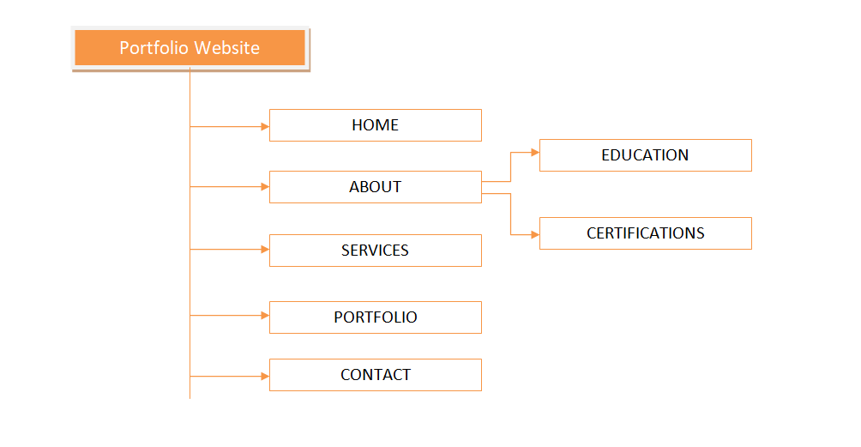

*2.3 Web Overview*

**CHAPTER 3:**

**RESULT ANALYSIS AND VALIDATION**

**3.1 Tools, Libraries and the Network Used**

The development of the portfolio website was accomplished using a simplified technological stack, focusing on fundamental web development languages.

**Languages:**

**HTML:** Utilized for creating the structure and content of the website, ensuring a well-defined and organized layout.

**CSS:** Employed for styling and layout, enhancing the visual appeal and consistency of the website across different devices.

**JavaScript:** Implemented for client-side interactivity, providing features such as real-time communication and dynamic content updates.

**Development Environment:**

**Text Editors :** Used as the primary development environment for coding, debugging, and project management.

**3.2 Overview of the Application**

The portfolio website serves as a comprehensive platform for Odedara Ashish to showcase his skills, projects, and professional information. The following sections provide an overview of the key features and functionalities of the application:

**Home Section:** The home section welcomes visitors with a personalized introduction to Odedara Ashish. It highlights his expertise as a web designer, showcasing over 2 years of experience in website design, graphic design, and more.

**About Me Section:** This section provides detailed information about Odedara Ashish, including his educational background, skills, contact details, and a brief overview of his passion for problem-solving in data structures and algorithms.

**CV Download Option:** Users have the option to download Odedara Ashish's CV directly from the website. This feature enhances accessibility for potential employers and collaborators.

**Services Section:** The services section outlines the six key services offered by Odedara Ashish, covering areas such as C language, web design, C++ language, Python language, MS Project, and Oracle Database.

**Portfolio Section:** The portfolio section showcases a list of Odedara Ashish's projects. Each project entry includes details such as project name, description, technologies used, and a link to view the project.

**Contact Me Section:** Users can directly contact Odedara Ashish through a contact form in this section. The form includes fields for name, email, subject, and a message, providing a convenient way for visitors to reach out.

**Responsive Design:** The entire website is built with a responsive design, ensuring optimal viewing and interaction across a variety of devices, including desktops, tablets, and mobile phones.

**JavaScript Features:** JavaScript is utilized to implement real-time communication features, enhancing user interaction and responsiveness.

**3.3 User Authentication**

User authentication is a crucial component of the portfolio website, providing a secure and personalized experience for both Odedara Ashish and potential collaborators. Here is an overview of the user authentication system implemented:

**Secure User Authentication:** The website incorporates a secure user authentication system to safeguard user data and restrict access to authorized individuals only.

**3.4 Real-Time Communication**

Real-time communication features have been integrated into the portfolio website to facilitate immediate interaction with users. This enhances user engagement and provides a dynamic experience. Here's an overview of the real-time communication aspects:

**Instant Messaging:** The website includes instant messaging features that allow users to communicate with Odedara Ashish in real-time. This can be utilized for inquiries, collaboration proposals, or any other form of communication.

**Live Chat Option:** A live chat option is implemented, providing visitors with the ability to initiate a chat session directly from the website. This fosters immediate communication and responsiveness.

**Notification System:** Users receive real-time notifications for incoming messages or responses. This feature ensures that users are promptly informed of any new communications.

**Interactive Forms:** Interactive forms, such as the contact form, may incorporate real-time validation or feedback, providing users with immediate responses as they interact with the website.

**JavaScript Implementation:** JavaScript is leveraged to enable real-time features, facilitating seamless and dynamic communication without the need for page reloads.

**Scalability Considerations:** The real-time communication system is designed with scalability in mind, ensuring that it can handle increasing numbers of users and messages without compromising performance.

* 1. **Performance and User Experience**

The performance and user experience of the portfolio website have been meticulously considered and optimized to ensure a seamless and enjoyable interaction for visitors. Here's an overview of the performance and user experience aspects:

**Optimized Loading Times**: The website is designed to load quickly, providing a smooth and responsive experience for users. Optimizations include image compression, script minification, and efficient resource loading.

**Responsive Design:** The entire website is built with a responsive design, adapting to various screen sizes and devices. This ensures that users, whether on desktops, tablets, or mobile phones, have an optimal viewing experience.

**Intuitive Navigation:** User-friendly navigation is implemented, guiding visitors seamlessly through different sections of the website. Clear menus, buttons, and call-to-action elements contribute to an intuitive browsing experience.

**Interactive Elements:** Interactive elements, such as dynamic project displays and real-time communication features, enhance user engagement. These elements contribute to a more dynamic and immersive user experience.

* 1. **Environmental and Ethical Considerations**

In the development of the portfolio website, environmental and ethical considerations have been taken into account to align with responsible and sustainable practices. Here's an overview of the environmental and ethical aspects:

Accessibility: The website is designed to be accessible to users with diverse needs. This includes considerations for individuals with disabilities, ensuring a more inclusive and ethical user experience.

Inclusivity in Design: The design of the website takes into account inclusivity and diversity, ensuring that the content and visuals are welcoming to a wide audience.

Code Efficiency: The website's code is developed with efficiency in mind, reducing unnecessary server requests and optimizing client-side processing. This approach contributes to a more sustainable and responsible use of resources.

Content Accuracy and Transparency: Ethical considerations extend to the accuracy and transparency of content presented on the website. Information about Odedara Ashish's skills, experience, and projects is presented truthfully and transparently.

**Result:**

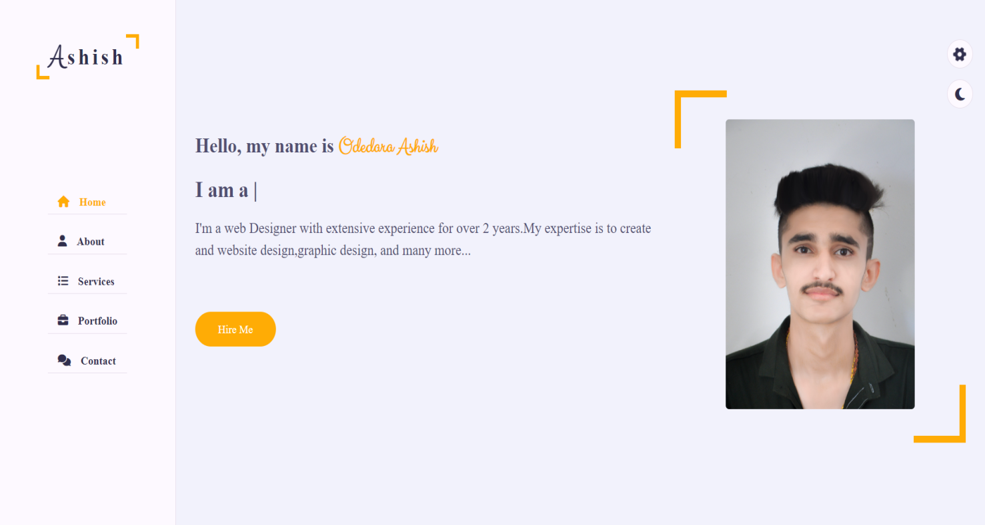

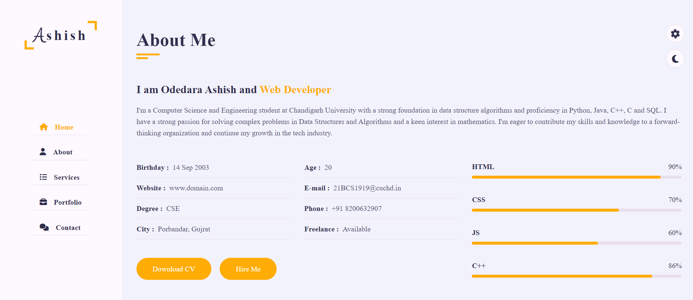

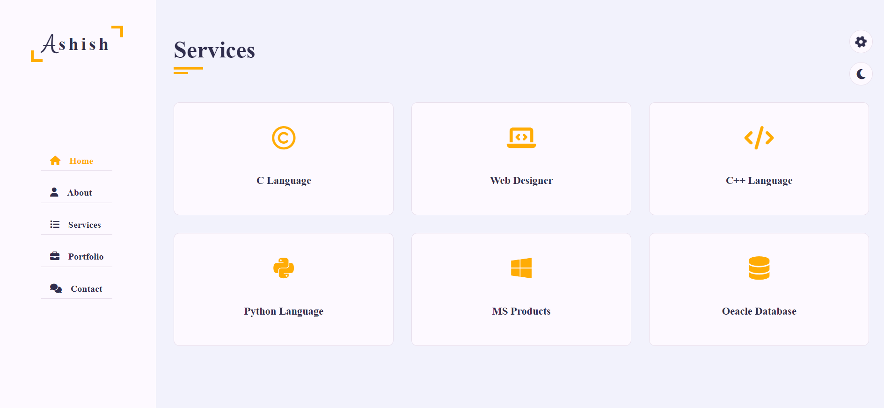

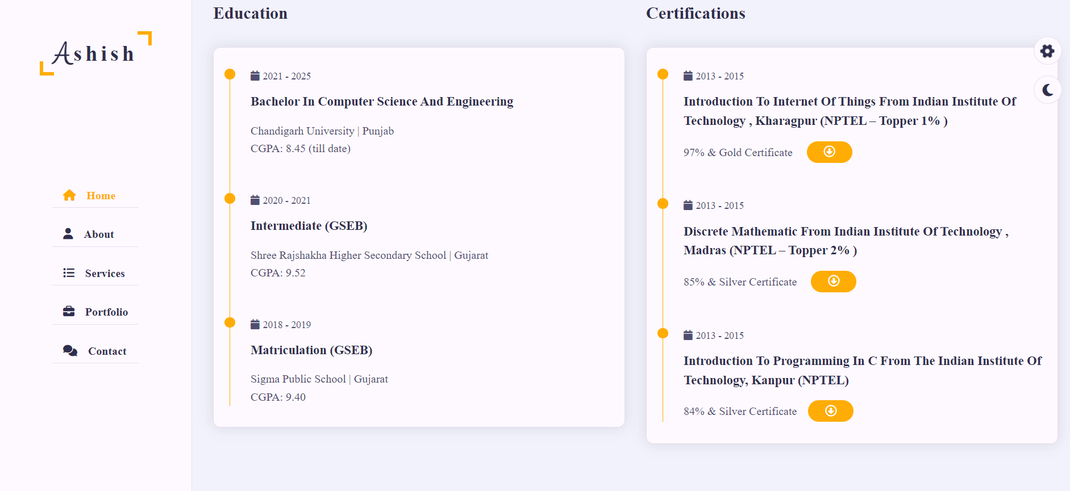

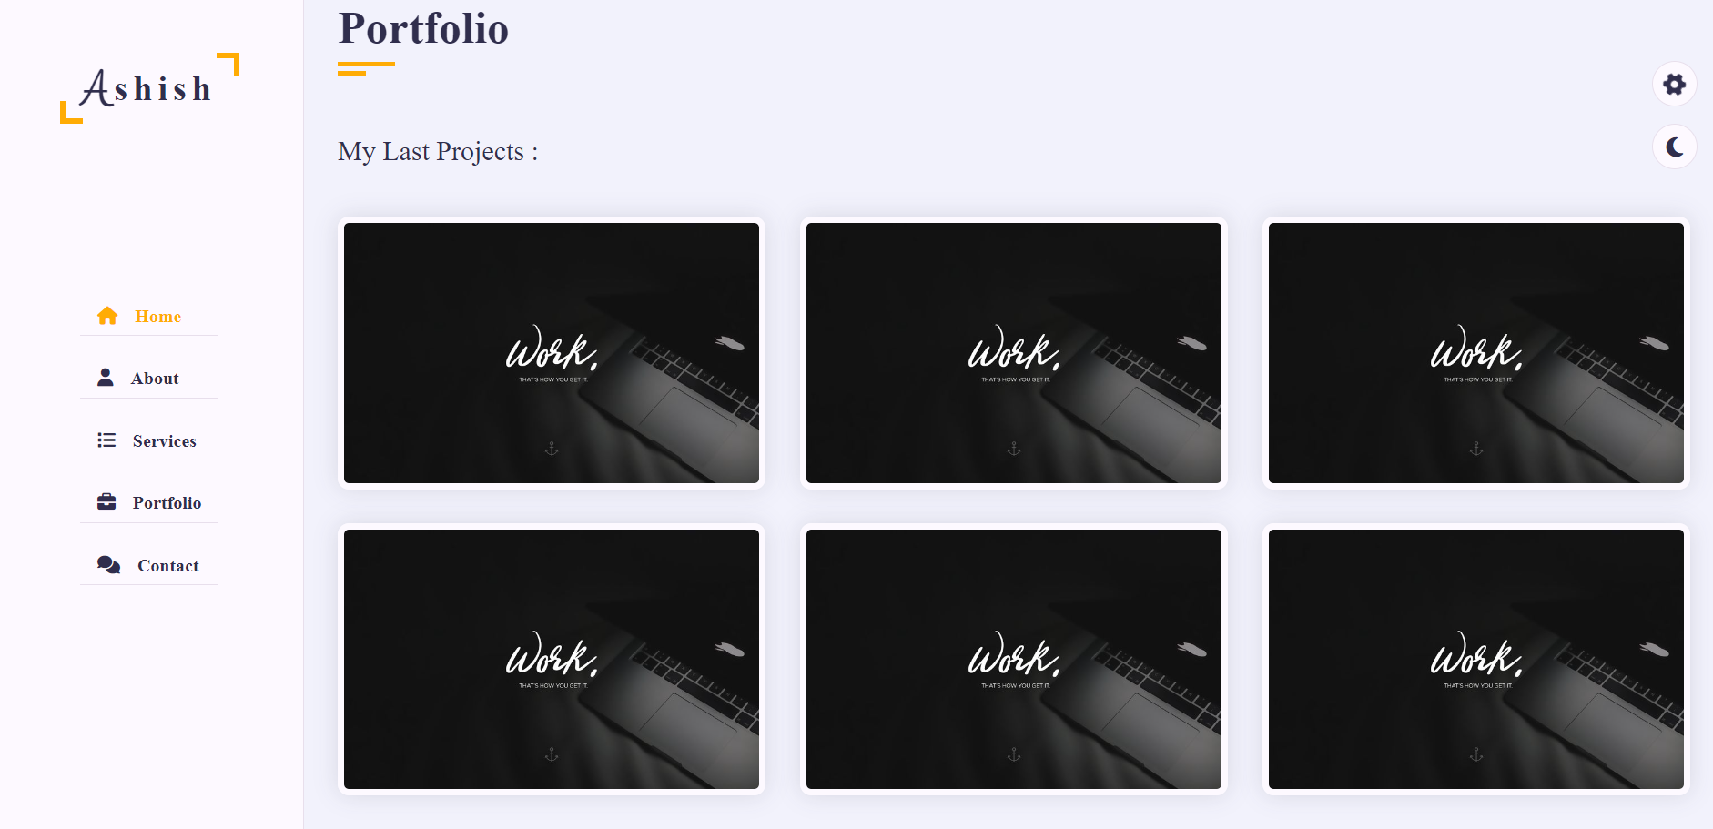

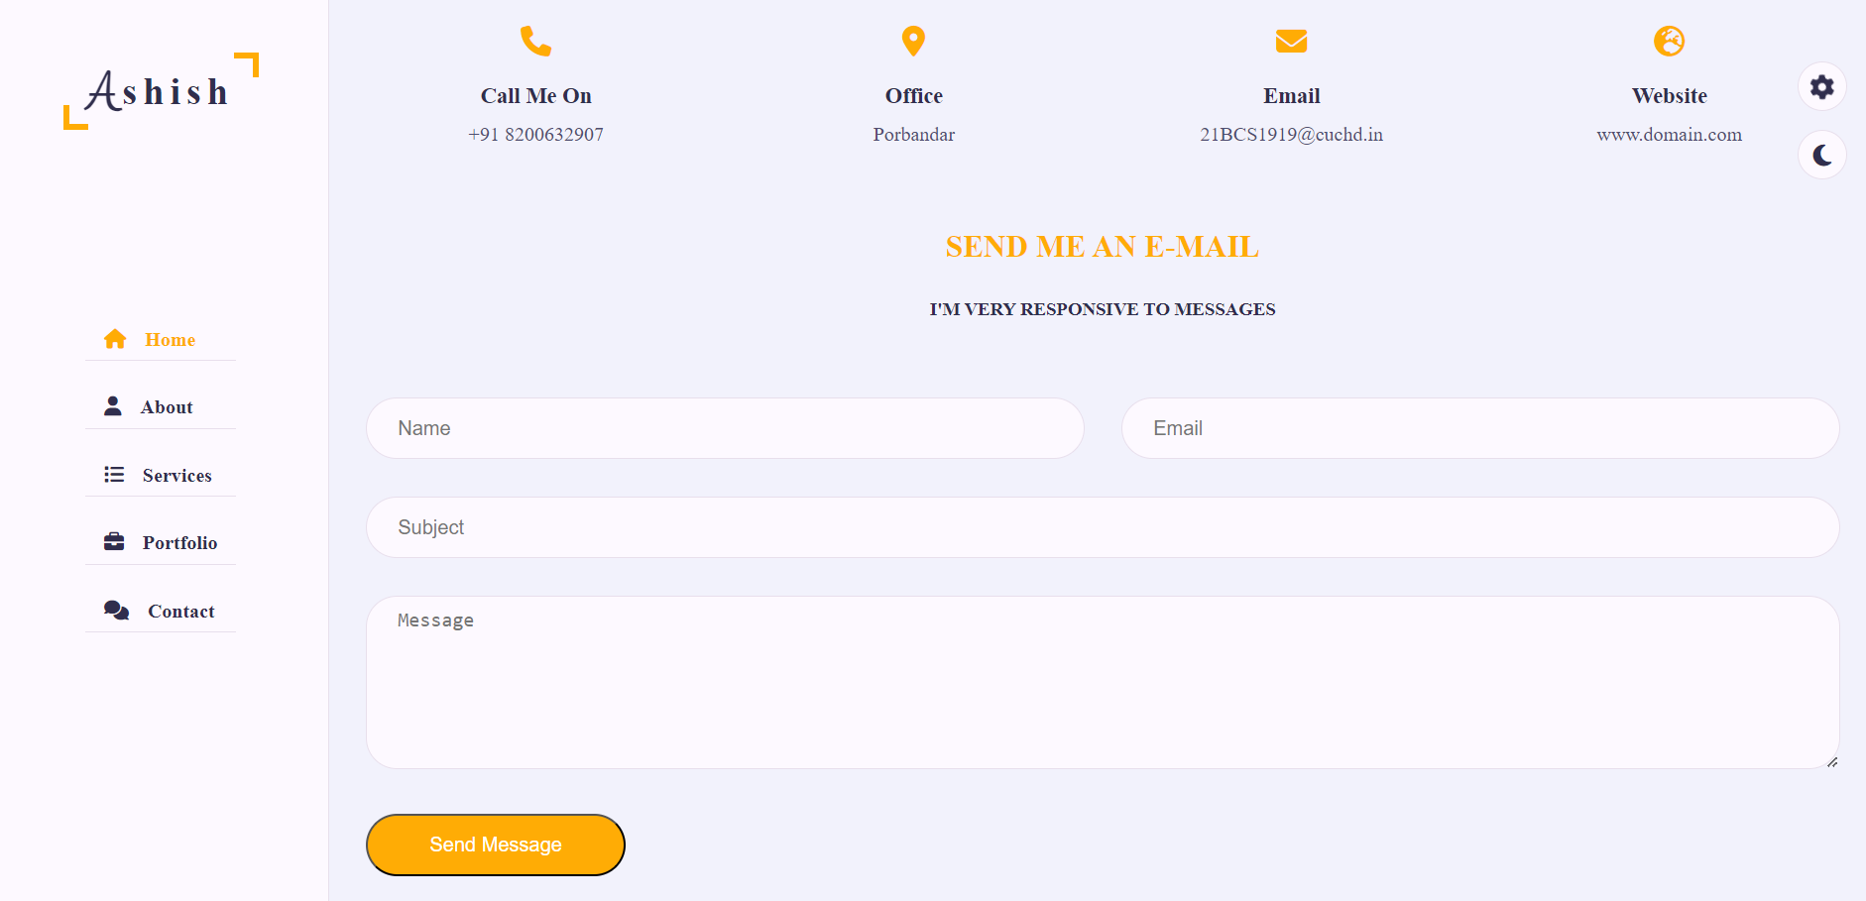

*Figure 3.1: User Experience*

**CHAPTER 4:**

**CONCLUSION AND FUTURE WORK**

**4.1. Conclusion**

The development of the portfolio website for Odedara Ashish has reached a successful conclusion, providing a robust platform to showcase his skills, projects, and professional information. Key points of the conclusion include:

**Fulfillment of Objectives:** The portfolio website successfully meets its objectives of presenting Odedara Ashish's professional profile, skills, and projects in a visually appealing and user-friendly manner.

**User-Centric Design:** The website prioritizes user experience, incorporating responsive design, intuitive navigation, and interactive elements to engage visitors effectively.

**Secure Authentication:** The implementation of a secure user authentication system ensures the protection of user data, providing a personalized experience for registered users.

**Real-Time Communication:** The integration of real-time communication features enhances user engagement, providing immediate interaction options for visitors.

**Performance Optimization:** The website is optimized for performance, with quick loading times, responsive design, and efficient resource usage contributing to a positive user experience.

**4.2. Future Work**

As the portfolio website for Odedara Ashish reaches its current stage, there are several avenues for future work and enhancements to ensure its continued effectiveness and relevance:

**Portfolio Expansion:** Explore opportunities to expand the portfolio by adding new projects, updating existing ones, and showcasing a diverse range of skills and accomplishments.

**Blog or News Section**: Consider incorporating a blog or news section to share insights, experiences, and updates. This can serve as a platform for Odedara Ashish to share thoughts on industry trends, projects, or technological advancements.

**Dynamic Content Updates:** Implement a content management system (CMS) or dynamic content updates to empower Odedara Ashish to easily add, edit, or remove content without direct involvement from developers.

**Integration with Social Media:** Integrate social media platforms to provide visitors with direct links to Odedara Ashish's professional profiles, fostering a broader online presence.

**User Analytics:** Implement robust analytics tools to gain insights into user behavior, popular sections, and geographical reach. This data can inform future content strategies.

**Mobile Application:** Explore the development of a mobile application that complements the website, offering additional features or a specialized experience for mobile users.

**Localization and Multilingual Support:** Consider implementing localization features to provide content in multiple languages, expanding the website's accessibility to a global audience.

**Interactive Tutorials or Demonstrations:** Introduce interactive tutorials or demonstrations related to Odedara Ashish's skills or projects, offering visitors a hands-on experience.