Context Level DFD

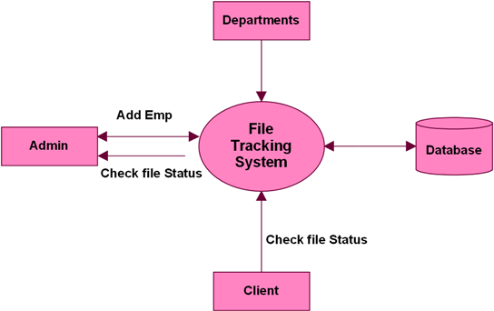

Level 0 DFD

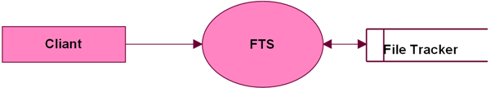

Level 0 Client Module:

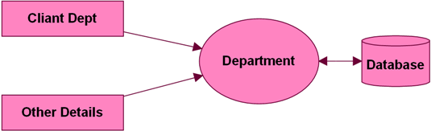

Level 0 Admin Module:

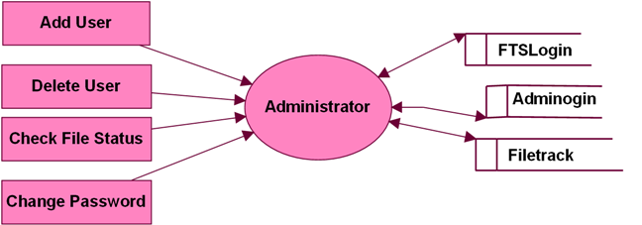

Level 1 Clerk Department:

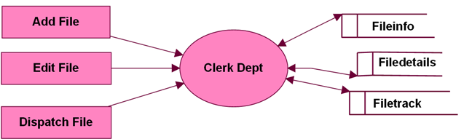

Level 1 Other Department:

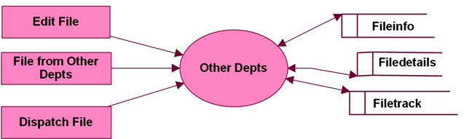

Level 0 for Edit File:

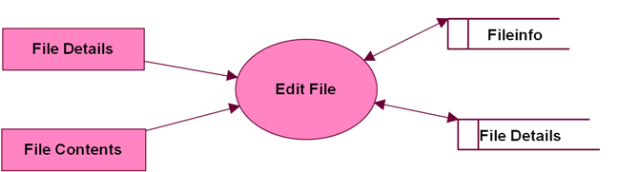

Level 0 DFD for User:

