AN INTERNSHIP -1/2/3 - PROJECT REPORT
on
FITNESS ACTIVITY TRACKER AND PROGRESS ANALYZER
As a part of
Internship Credit (CE0318/CE0523/CE0726)
Submitted by
SHAKORIYA ASHISH VIJAYBHAI
IU2441230435
In fulfillment for the award of the degree of
BACHELOR OF TECHNOLOGY
in
COMPUTER SCIENCE ENGINEERING

INSTITUTE OF TECHNOLOGY AND ENGINEERING
INDUS UNIVERSITY CAMPUS, RANCHARDA, VIA-THALTEJ
AHMEDABAD-382115, GUJARAT, INDIA
WEB: www.indusuni.ac.in
SEPTEMBER 2026

ABSTRACT
The Fitness Activity Tracker and Progress Analyzer is a desktop application developed in Python for maintaining daily fitness activity records and understanding consistency, duration, distance and changes in activity levels. The application focuses on common activities such as walking, running and cycling. It provides a structured graphical interface for entering activity information, persistent CSV-based storage, search and filtering, summary calculations, activity and period comparisons, and graphical reports. Pandas and NumPy are used for structured data processing and numerical calculations, while Matplotlib produces the analytical visualizations. Tkinter provides the graphical user interface. Input validation and exception handling are included to improve reliability. The project therefore combines Python programming, data structures, file handling, GUI development and data visualization in a single practical fitness-oriented application.
1. PROJECT TITLE
Fitness Activity Tracker and Progress Analyzer
2. PROBLEM STATEMENT
A person records daily fitness activities such as walking, running or cycling but wants to understand consistency, duration and changes in activity levels. The project addresses this need by providing a simple application that stores activity records and converts them into useful summaries and visual trends.
3. OBJECTIVE
The objective is to develop an application that maintains fitness activity records and provides progress analysis. The application is designed to make routine entry, retrieval and interpretation of activity data simple enough for regular use while demonstrating the required Python programming and data-analysis techniques.
4. DOMAIN
Sports & Fitness
5. FUNCTIONAL REQUIREMENTS
- Record activity details including date, activity type, duration, distance and optional notes.
- Search and filter the stored activity records by text, activity type and date range.
- Calculate useful measures including total activity count, total distance, total duration and average speed.
- Compare different activity types using aggregated distance, duration and session counts.
- Compare the latest seven-day period with the preceding seven-day period and calculate percentage change.
- Identify activity patterns and trends from the stored daily records.
- Generate at least two meaningful visual reports using Matplotlib.
6. TECHNICAL REQUIREMENTS
- Python functions, classes and built-in data structures are used to implement application logic.
- File handling is implemented through persistent CSV storage.
- The solution contains four user-defined modules: main.py, activity_manager.py, analytics.py and validation.py.
- Pandas is used for tabular data storage/processing and NumPy is used for numerical aggregation.
- Tkinter is used to implement the desktop GUI.
- Matplotlib is used for two analytical visualizations: a daily distance trend and distance by activity type.
- Input validation checks date, activity type and numerical limits before saving records.
- Exception handling is included around storage, filtering, record modification and report generation.
- Unit testing and a README document provide testing and documentation support.
7. SYSTEM DESIGN AND ARCHITECTURE
The system uses a modular architecture. The Tkinter interface in main.py collects user actions and displays results. activity_manager.py handles CRUD operations and CSV persistence. validation.py isolates input-validation rules. analytics.py performs calculations and creates Matplotlib reports. The CSV file in the data folder acts as the persistent data store. The reports folder stores generated visual output.

Layer | Module | Responsibility | Output
GUI | main.py | Tkinter dashboard, forms, filters and actions | Interactive application
Validation | validation.py | Checks dates, activity types and numerical input | Validated data
Storage | activity_manager.py | CSV persistence and CRUD/search operations | activity records
Analytics | analytics.py | Pandas/NumPy aggregation and Matplotlib reports | metrics + PNG reports
8. MODULE DESCRIPTION
Module | Purpose
main.py | Creates the Tkinter application, dashboard cards, activity form, records table, filters, analytics panel and user actions.
activity_manager.py | Provides persistent CSV storage with load, save, add, update, delete and search operations.
validation.py | Validates date format, allowed activity types, duration and distance limits.
analytics.py | Calculates summaries, activity comparisons and seven-day period comparison, then generates the two Matplotlib charts.
9. IMPLEMENTATION DETAILS
9.1 Data Model
Each activity record contains an integer ID, date, activity type, duration in minutes, distance in kilometres and optional notes. This compact schema is sufficient for the stated problem while remaining easy to store in CSV and process with Pandas.
9.2 Persistent Storage
The ActivityManager class creates the data directory and CSV file when required. Records are loaded into a Pandas DataFrame, modified in memory and saved back to CSV. This allows the application's data to remain available after the program is closed and reopened.
9.3 Validation and Exception Handling
The validation module enforces the YYYY-MM-DD date format, restricts the activity type to Walking, Running or Cycling, and requires positive numeric duration and distance values within practical limits. The GUI catches validation, storage, missing-record and unexpected errors and displays appropriate message boxes instead of terminating silently.
9.4 Analytics
Summary analytics calculate activity count, total distance, total duration, average speed and the most frequent activity. Group-by aggregation is used to compare activity types. A seven-day period comparison uses the latest recorded date as the end of the current window and compares its distance with the preceding seven-day window.
10. USER INTERFACE AND OUTPUT
The completed interface contains four main tabs: Dashboard, Add / Edit Activity, Activity Records, and Analytics & Reports. The screenshots below demonstrate the implemented user interface and analytical output.
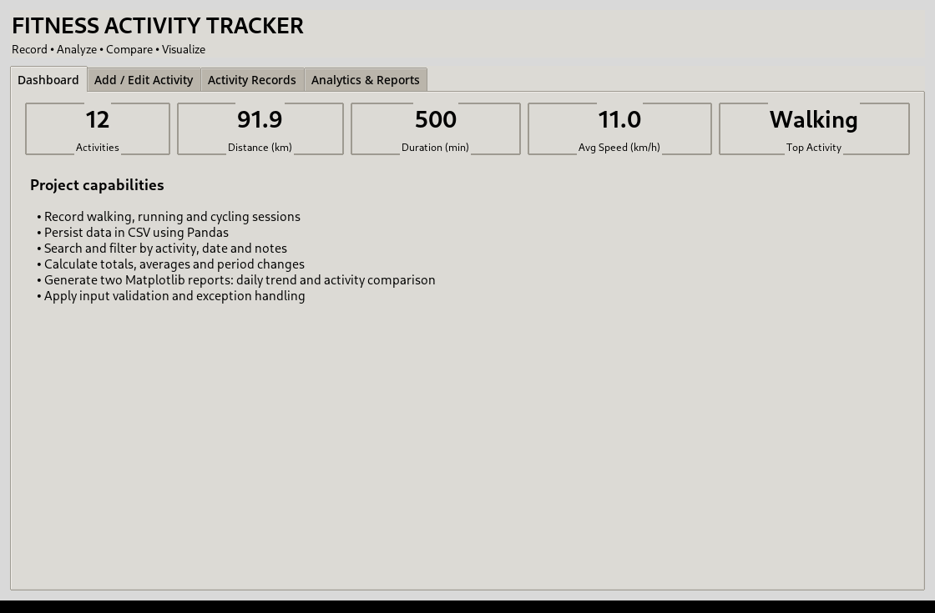
Figure 1: Dashboard showing summary metrics and project capabilities.
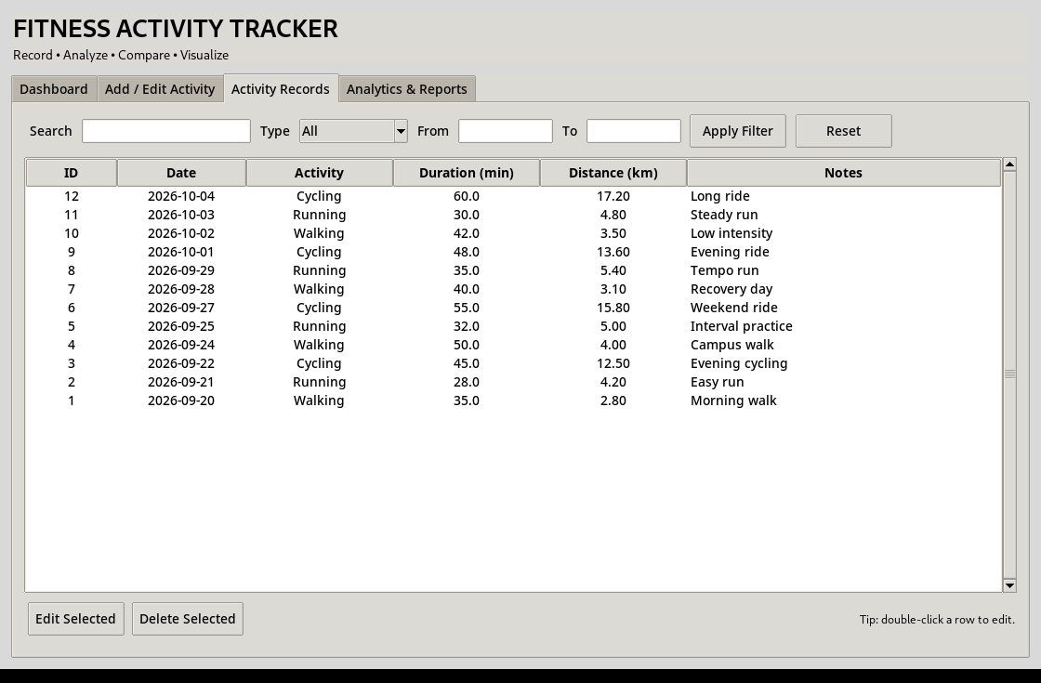
Figure 2: Activity Records tab with search/filter controls and persistent activity data.

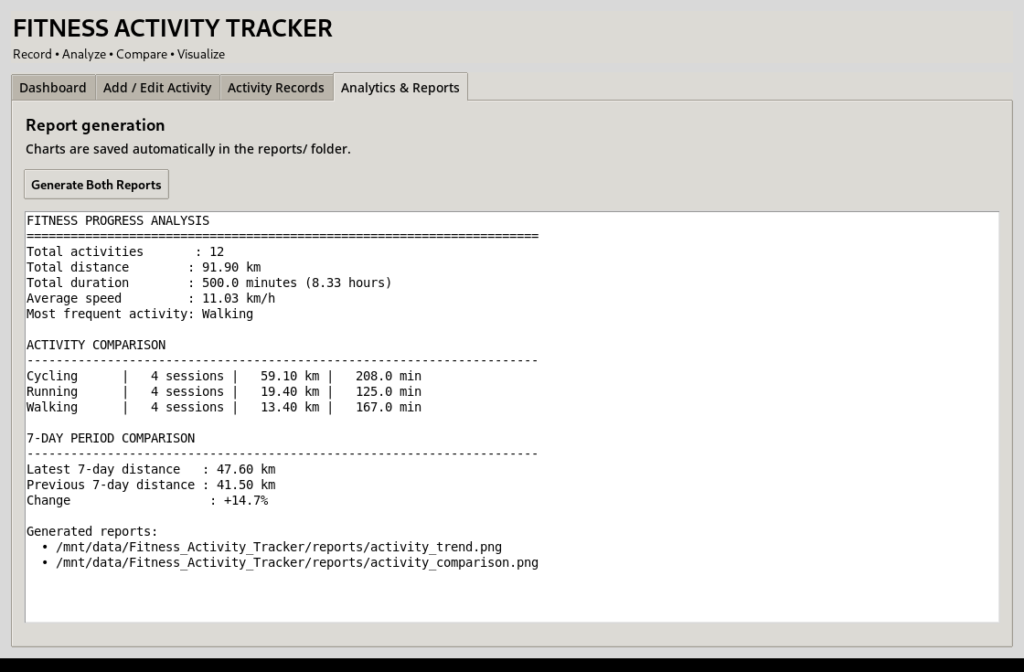
Figure 3: Analytics & Reports tab showing summary analysis, activity comparison and seven-day period change.
11. MATPLOTLIB VISUAL REPORTS
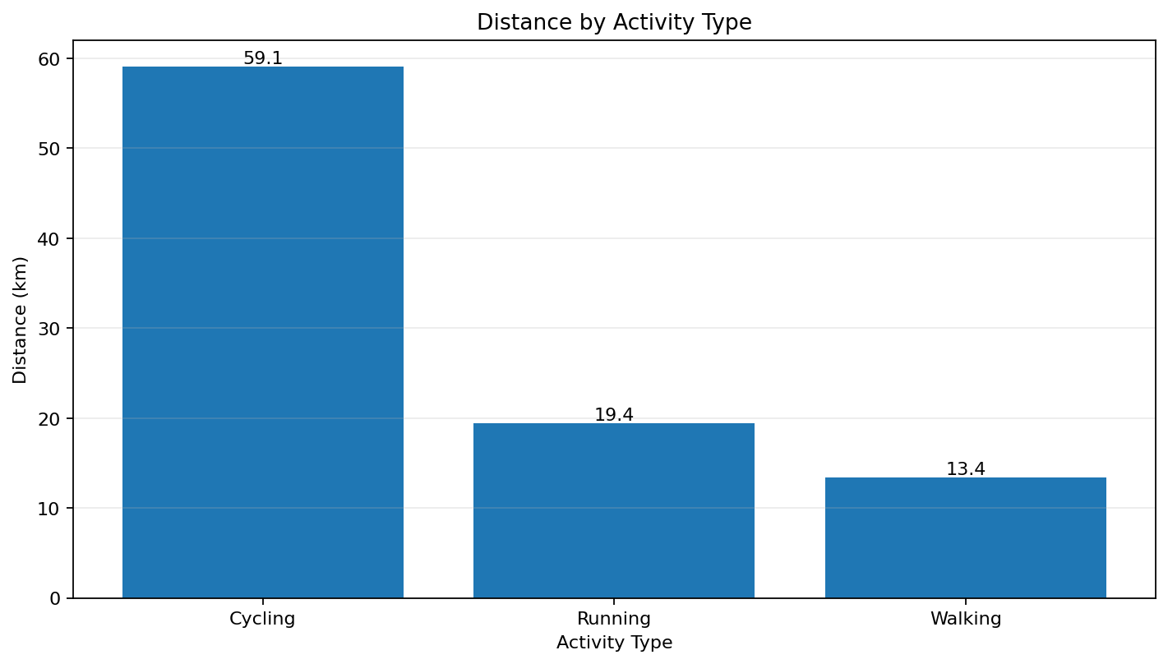
Figure 4: Distance comparison across walking, running and cycling activities.
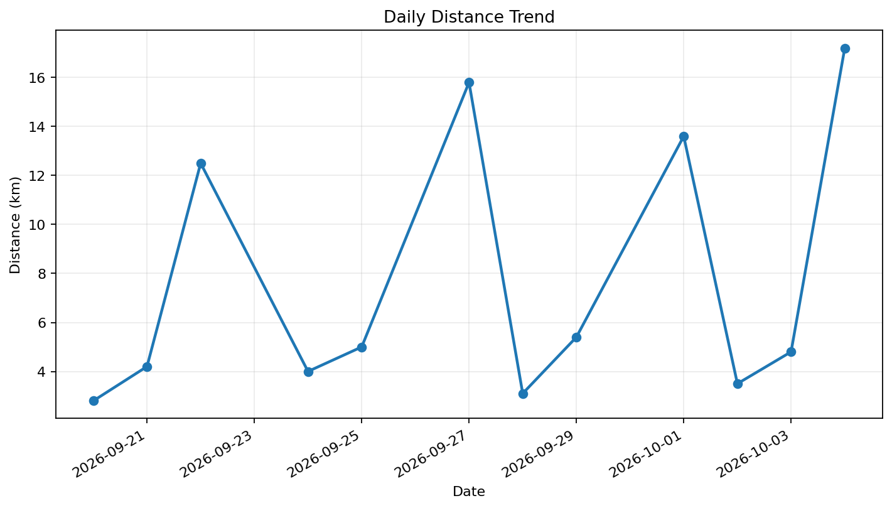
Figure 5: Daily distance trend generated from persistent activity records.
12. SAMPLE ANALYSIS RESULT
The included demonstration dataset contains 12 sample sessions. The application reports 91.90 km of total distance across 500 minutes of activity, with an overall average speed of approximately 11.03 km/h. Cycling contributes the highest aggregated distance (59.10 km), while the latest seven-day window contains 47.60 km compared with 41.50 km in the preceding seven-day window, representing a 14.7% increase in distance. These values demonstrate that the system is performing actual calculations from stored records rather than presenting static output.

13. TESTING
Unit tests were created for input validation, activity CRUD operations, search functionality and analytical calculations. The test suite was executed successfully with four test cases passing.
Test Case | Purpose | Result
Validation success | Accept valid date, activity type, duration and distance | PASS
Validation failure | Reject invalid date format | PASS
CRUD and search | Add, search, update and delete an activity | PASS
Analytics | Verify totals and activity comparison aggregation | PASS
14. PROJECT STRUCTURE
The final project is organized into separate modules and folders to keep interface, validation, storage, analytics, data and testing concerns clear.
Fitness_Activity_Tracker/
├── main.py
├── activity_manager.py
├── analytics.py
├── validation.py
├── data/activities.csv
├── reports/activity_trend.png
├── reports/activity_comparison.png
├── reports/ui_dashboard.png
├── reports/ui_records.png
├── reports/ui_analytics.png
├── tests/test_activity_tracker.py
├── requirements.txt
└── README.md
15. CONCLUSION
The Fitness Activity Tracker and Progress Analyzer satisfies the assigned Sports & Fitness problem statement by providing activity recording, persistent storage, search/filtering, calculations, comparisons and meaningful visual reporting. The implementation demonstrates the required use of Python functions and data structures, file handling, multiple user-defined modules, Pandas/NumPy, Tkinter and Matplotlib, together with validation, exception handling and testing. The resulting application is suitable for demonstration during the project viva because its workflow and outputs can be shown directly from the graphical interface.
16. FUTURE SCOPE
- Add user profiles and separate datasets for multiple users.
- Add calorie estimation, heart-rate and pace metrics when additional input data is available.
- Add weekly/monthly calendar views and more advanced trend statistics.
- Export customized PDF/Excel reports and support backup/restore of activity data.
- Integrate wearable-device or smartphone data through an API in a future version.
17. VIVA DEMONSTRATION FLOW
For the viva demonstration, start the application and show the Dashboard, add a new activity through the form, open Activity Records to search/filter and edit the record, then open Analytics & Reports and generate both charts. Conclude by showing the GitHub repository URL containing the project source code and README documentation.
18. STUDENT DESIGN & IMPLEMENTATION SUMMARY
The project was designed as a modular desktop application. The Tkinter layer manages the user interface, activity_manager.py handles record creation, retrieval, updating, deletion and CSV persistence, validation.py validates user input, and analytics.py performs calculations and generates Matplotlib reports. Pandas supports tabular processing and NumPy supports numerical aggregation. The implementation was tested with normal and invalid inputs and verified through the included unit-test suite.
19. STUDENT REFLECTION
This project provided practical experience in converting a problem statement into a working Python application. I learned how to separate functionality into modules, maintain persistent data using file handling, validate user inputs, perform analysis with Pandas and NumPy, and present results through Tkinter and Matplotlib. I also learned the importance of testing, documentation and being able to explain each implementation decision during a viva.

