1. Basic Frame Layout

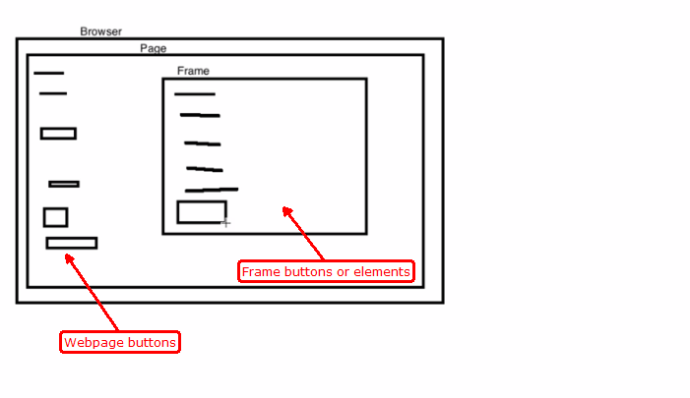

1. How to check Particular Page Cointain Frame or not. Or click on view page source.

