**Mini Project Report**

**On**

**“Online shoping”**



**Department of Information & Technology Microtek Institute of Information Technology Maldahiya, Varanasi (U.P)**

**October, 2021**



**[Mahatma Gandhi Kashi Vidyapith](https://www.mgkvp.ac.in/)**

**Varanasi**

**Under Esteemed Guidance Of**

**Submitted To: Submitted By:**

**Sanjay kumar singh Shivam Keshari**

**Atul pandey**

**TABLE OF CONTENTS**

* **INTRODUCTION**
* **OBJECTIVES**
* **PROJECT OVER VIEW**
* **ANALYSIS**
  + **ER diagram**
  + **DFD diagram**
* **MODULES OF THE PROJECT**
* **TOOLS/PLATFORM, H/W AND S/W REQUIREMENT**
  + **SPECIFICATIONS**
* **FUTURE SCOPE OF THE PROJECT**

**INTRODUCTION**

This project is a web based shopping system for an existing shop. The project objective is to deliver the online shopping application into android platform.

Online shopping is the process where by consumers directly buy goods or services from a seller in real-time, without an intermediary service, over the Internet. It is a form of electronic commerce. This project is an attempt to provide the advantages of online shopping to customers of a real shop. It helps buying the products in the shop anywhere through internet by using an android device. Thus the customer will get the service of online shopping and home delivery from his favorite shop

The concept of online shopping was first introduced by Michael Aldrich in 1980. In March he started Redifon’s Office Revolution, which permitted consumers, agents, distributors and suppliers to be connected online. By using videotex technology, he designed, installed, manufactured, sold and supported many online shopping systems. The first-ever shopping store name was Tesco store.

**OBJECTIVE**

The objective of the project is to make an application in android platform to purchase items in an existing shop. In order to build such an application complete web support need to be provided. A complete and efficient web application which can provide the online shopping experience is the basic objective of the project. The web application can be implemented in the form of an android application with web view.

The main objective of the online Shopping system is to manage the details of Shopping,Internet,Payment,Bill,Customer.

It manages all the information about Shopping ,Product,Customer, Shopping.the project is totally built at administrative end and thus only the administrator is guaranteed the access.The purpose of the project is to built an application program to reduce the manual work for managing the shopping,Internet,products Payment.It tracks all the details about the Payment,Bill,Cus

**PROJECT OVER VIEW**

The central concept of the application is to allow the customer to shop virtually using the Internet and allow customers to buy the items and articles of their desire from the store. The information pertaining to the products are stores on an RDBMS at the server side (store).

The Server process the customers and the items are shipped to the address submitted by them. The application was designed into two modules first is for the customers who wish to buy the articles. Second is for the storekeepers who maintains and updates the information pertaining to the articles and those of the customers. The end user of this product is a departmental store where the application is hosted on the web and the administrator maintains the database. The application which is deployed at the customer database, the details of the items are brought forward from the database for the customer view based on the selection through the menu and the database of all the products are updated at the end of each transaction. Data entry into the application can be done through various screens designed for various levels of users. Once the authorized personnel feed the relevant data into the system, several reports could be generated as per the security.

**PROJECT CATEGORY**

WEB BASED PROJECT

* **ANALYSIS**
* **ER Diagrams**
* **DFD Diagram**

**ER Diagram:-**

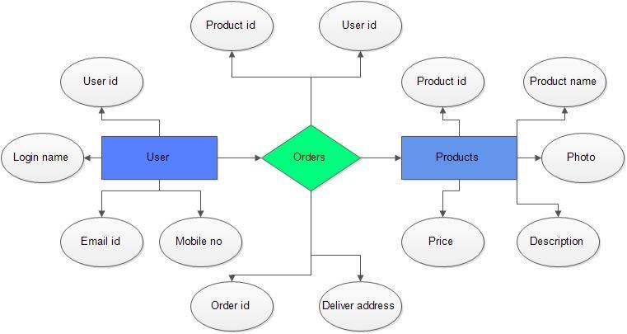

**DFD Diagram:-**

* 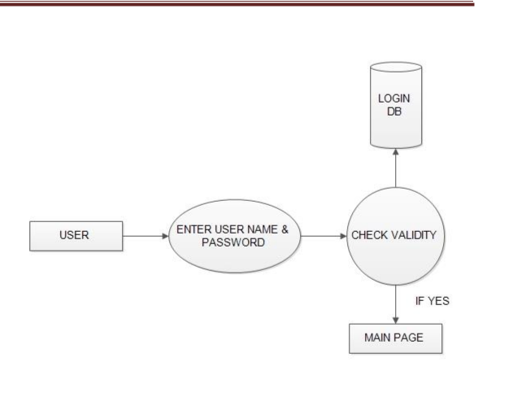LOGIN DFD

REGISTRATION DFD

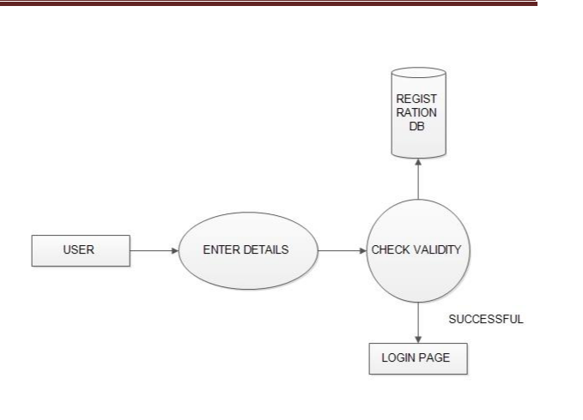

ADMIN DFD

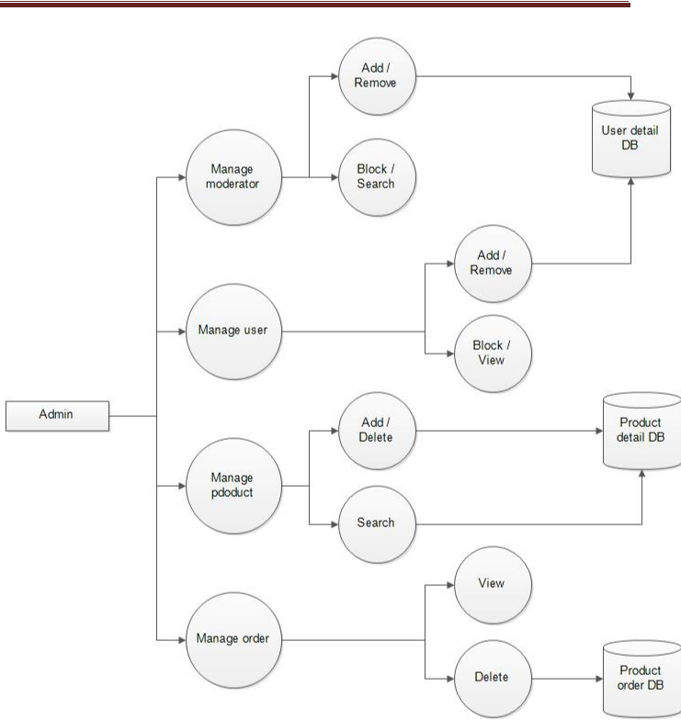

**MODULES**

The system after careful analysis has been identified to be presented with

the following modules and roles.

The modules involved are:

* Administrator
* Moderators
* Users

The administrator is the super user of this application. Only admin have access into this admin page. Admin may be the owner of the shop. The administrator has all the information about all the users and about all products.

This module is divided into different sub-modules.

1. Manage Moderators
2. Manage Products
3. Manage Users
4. Manage Orders

**REQUIRMENT OF H/W & S/W**

**Hardware Requirements:-**

1. Processor : Pentium Processor ISA

32 Family

1. Secondary : 6GB HDD
2. Rom : 52 x CD ROM Drive
3. Memory : 1 GB RAM or Above
4. Network Adapter : Ethernet Adapter
5. Mouse : Optical Mouse
6. Others : 15’inch Color Monitor,Dot

Matrix/HP Laser/HP Inkjet

Printer,Keyboary.

**Software Requirements:-**

1. Operating System : Windows XP/ 7 / Vista Operating

System

1. Platform : Windows , XAMPP , Notepad
2. Framework : Bootstrap Framework
3. Front-End Tool : Java-script, HTML, CSS,

jQuery , Bootstrap, Ajax

1. Editing Tool : Microsoft Front Page 2000,

Microsoft Word

**Project Scope :**

This system can be implemented to any shop in the locality or to multinational branded shops having retail outlet chains. The system recommends a facility to accept the orders 24*7 and a home delivery system which can make customers happy.

If shops are providing an online portal where their customers can enjoy easy shopping from anywhere, the shops won’t be losing any more customers to the trending online shops such as flipkart or ebay. Since the application is available in the Smartphone it is easily accessible and always available.

**BIBLIOGRAPHY:-**

Website

* 1. [www.w3schools.com](http://www.w3schools.com/)
  2. [www.geeksforgeeks.org](http://www.geeksforgeeks.org)
  3. www.websitesetup.org