PROJECT PROGRESS REPORT  Phase II Evaluation (2 of 3)  Project-Based Learning | Academic Session 2026–27 | 

PROJECT AND TEAM INFORMATION
Project Title
BloodBond — Real-Time Blood Donor & Recipient Matching System
Student / Team Information
Team Name: Apollo  Team # AJP-III-2026-TO52 | Apollo
Team member 1 (Team Lead)  Kothari, Ashish –  25201300186  ashish.kothari2004@gmail.com | Kothari, Ashish - 25201300186  ashish.kothari2004@gmail.com  
Team member 2  Jadli, Divyansh –  2520230344  divyanshjadli08@gmail.com | Jadli, Divyansh - 2520230344  divyanshjadli08@gmail.com  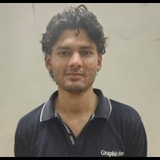
Team member 3  Saklani, Neeraj –  2520230402  neerajsaklani655@gmail.com | Saklani, Neeraj - 2520230402  neerajsaklani655@gmail.com  
MENTOR & REPORT DETAILS
Course / Section | MCA / Section __G1 AND G2__________
Mentor / Supervisor | __Payal Karki____________________________
Mentor interactions completed | __2______
Reporting period | ____________ to ____________
GitHub repository | ://github.com/Ashish-Kothari-2004/PBL-project-.git____________
Deployed / demo link (if any) | ______ not deployed as of now ________________________
1. PROJECT OVERVIEW (FROM PHASE I PROPOSAL)
Problem | Finding a compatible blood donor in an emergency still relies on WhatsApp groups and phone calls — slow and unsearchable.
Solution | One real-time platform of verified donors, searchable by blood group, approximate location and live availability, ranked by distance, with private chat and an admin moderation dashboard.
Approach | Spring Boot 3.x (Java 21+) REST + WebSocket/STOMP backend, MySQL 8+, React frontend, JWT/BCrypt role-based security (Donor, Recipient, Admin), Haversine proximity matching, pluggable AI request assistant (OpenAI / mock).
Deliverables | Working MVP: registration and profiles, live availability, blood-request flow with ranked matching, real-time chat and notifications, AI urgency assistant, admin dashboard, tests and documentation on GitHub.
2. PROGRESS SUMMARY
Since the Phase I proposal, the team has worked on the BloodBond foundation (Spring Boot backend, MySQL database, GitHub workflow) and the core modules: authentication, donor/recipient profiles, and the blood-group- and proximity-based matching engine.
Edit to match actual progress — overall completion: __40____ %. ________________________________________

Milestone | Scope (from proposal) | Status | % done
M1 – Core Setup (Phase II) | Scaffolding, MySQL schema, JWT auth, registration & profiles | __completed | ______100_
M2 – Matching Core (Phase II) | ABO/Rh rules, availability, eligibility, Haversine, ranked matching | _partially completed | __30_____
M3 – Real-Time (Phase II/III) | Blood requests, STOMP chat, notifications | __pending_____ | ______20_
M4 – AI & Admin (Phase III) | AI request assistant, admin dashboard | ___completed____ | _____100__
M5 – Testing & Deployment (Phase III) | Tests, security hardening, MVP deployment | ______partially completed_ | ____25___
Status: Completed / In Progress / Not Started.
3. WORK COMPLETED SINCE PHASE I
Module | Work done | Status
Setup & database (M1) | Spring Boot 3.x (Java 21+) project with Maven, on GitHub (_____ commits). MySQL schema via Spring Data JPA: users, donor_profile, recipient_profile, blood_request, chat_message, notification. | ____partially completed_____
Authentication & roles (M1) | Spring Security with stateless JWT and BCrypt hashing; role-gated access for Donor, Recipient and Admin (JWT expiry: _____). | ___completed______
Profiles (M1) | Registration with validation; profile create / view / update; approximate location via browser Geolocation API. React pages done: ______________. | __partially completed_______
Matching core (M2) | ABO/Rh compatibility rules (e.g. O− donors suit all recipients), availability toggle, eligibility from last donation (min gap ____ days), Haversine distance, radius filter (default ____ km) and nearest-first ranking. | _______pending__
Real-time (M3, if started) | Blood request module, STOMP/SockJS private chat, real-time notifications. Write “Planned for Phase III” for anything not done: ______________ | ____pending_____
Haversine: d = 2R · arcsin( √( sin²(Δφ/2) + cos φ₁ · cos φ₂ · sin²(Δλ/2) ) ), R = 6371 km
4. SYSTEM DESIGN
4.1 System Architecture
React talks to the Spring Boot backend over REST (secured by JWT) and WebSocket/STOMP for live chat and alerts. Nine services share one MySQL database; an external AI API handles request triage and Firebase handles push notifications (planned).
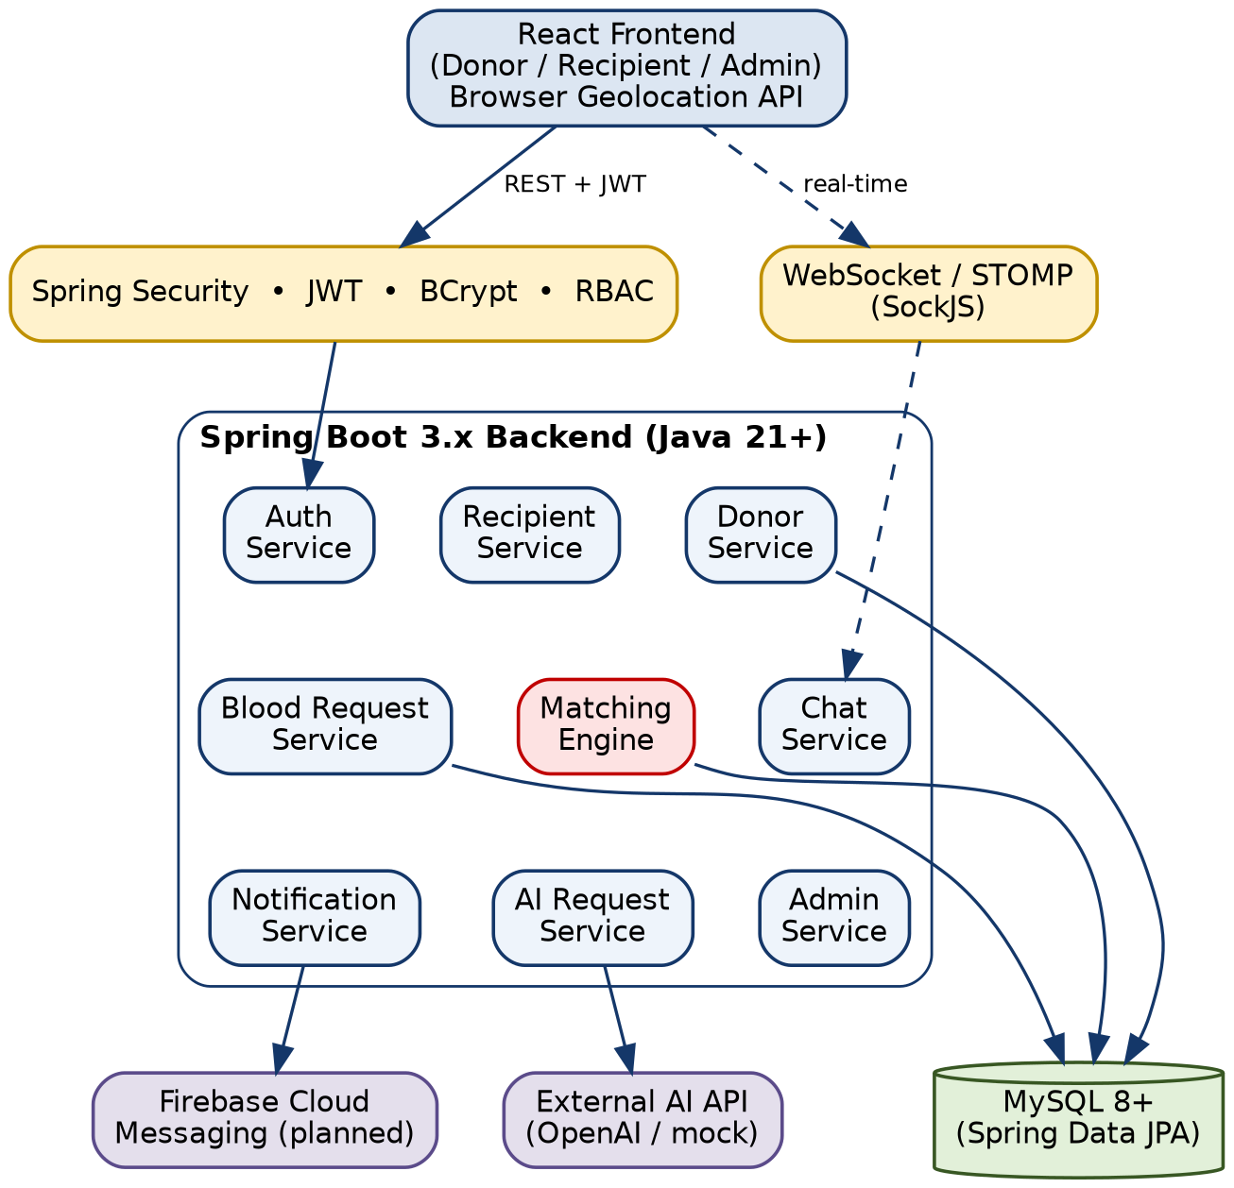
Figure A: High-level system architecture of BloodBond
4.2 Matching Pipeline
Every blood request passes through the same eight steps; the Haversine distance is d = 2R · arcsin( √( sin²(Δφ/2) + cos φ₁ · cos φ₂ · sin²(Δλ/2) ) ), R = 6371 km.
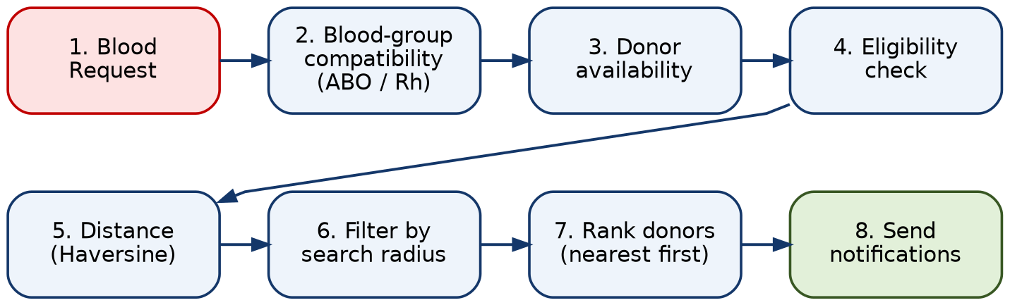
Figure B: Donor matching pipeline
4.3 Database Design (ER Diagram)
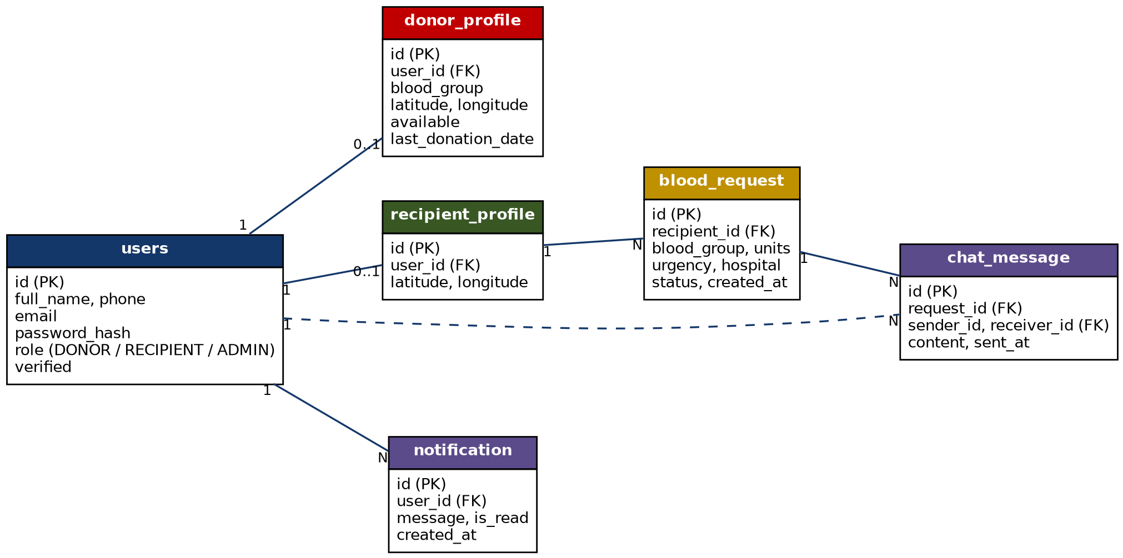
Figure C: Entity-relationship diagram (proposed schema; update if your tables differ)
5. IMPLEMENTATION SCREENSHOTS
[ Insert scre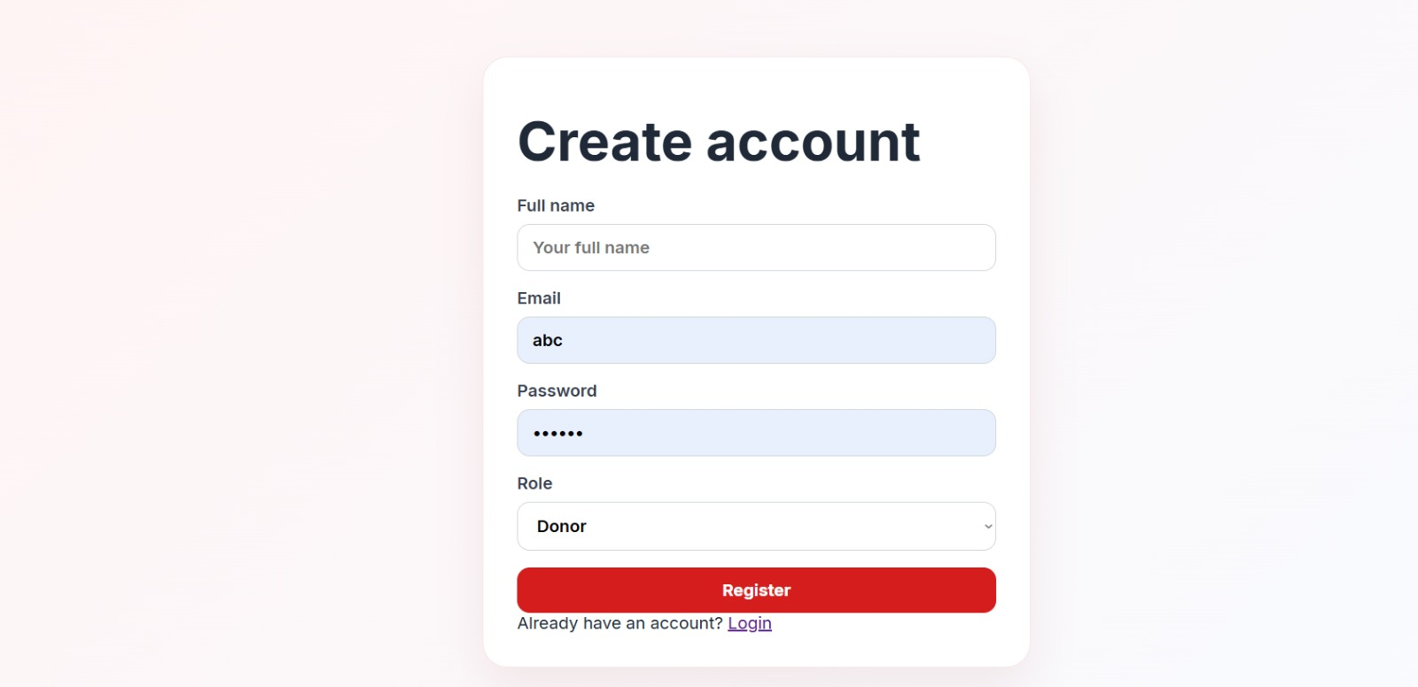enshot ] | [ Ins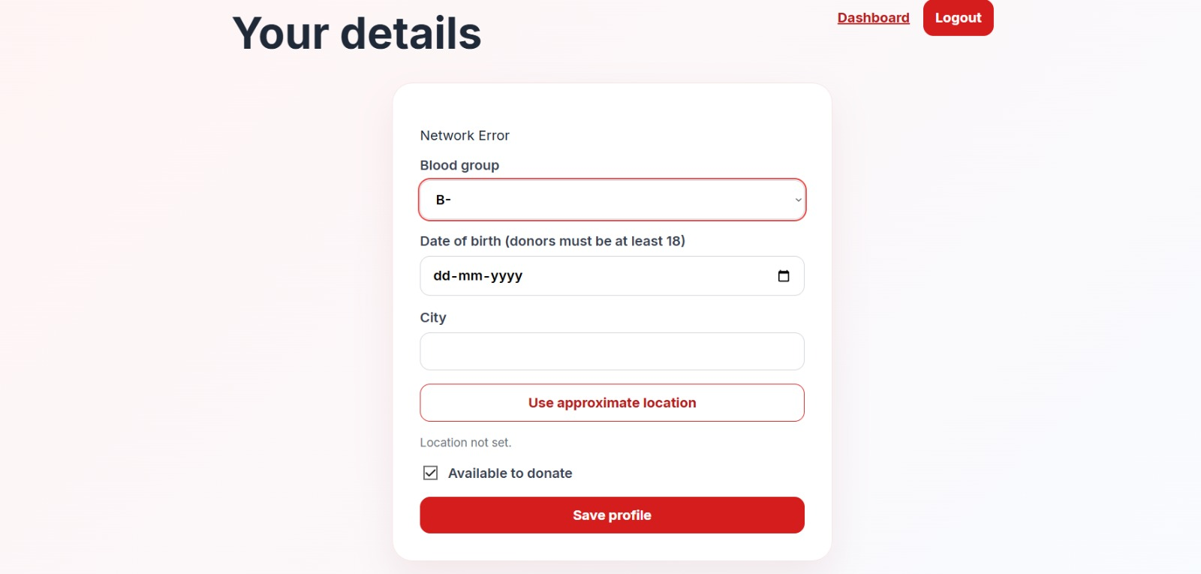ert screenshot ]
Figure 1: Login page and JWT token response | Figure 2: Donor profile with availability toggle
6. TESTING AND VALIDATION
ID | Test case |  | Pass/Fail
T1 | Register with valid details stores a BCrypt hash; wrong-password login is rejected |  | __pass____
T2 | Donor token cannot access admin endpoints (403) |  | ___pass___
T3 | O− donor is returned for an AB+ request; unavailable or ineligible donors are excluded |  | ___in progress___
T4 | Donors outside the radius are filtered; results sorted nearest first |  | __in progress____
T5 | Haversine output matches a known city-pair distance |  | ____in progress__

7. CHALLENGES, TEAM CONTRIBUTION AND MENTOR FEEDBACK
Challenges & solutions
1
2

Member | Tasks completed in this phase
Kothari, Ashish (Team Lead) | H2 database, design, and testing
Jadli, Divyansh | Springboot setup, APIs, and APIs testing
Saklani, Neeraj | Frontend, react , TSX

Mentor meeting date | Points discussed | Feedback / action items
8. PLAN FOR PHASE III
Remaining work | Details | Target date
Finish M3 (if pending) | Blood requests, STOMP chat, notifications | __26/10/26________
M4 – AI & Admin | AiRequestService (OpenAI + mock), admin dashboard | ___26/10/26_______________
M5 – Testing & Deployment | Unit/integration/frontend tests, hardening, MVP deployment | ____26/10/26______________
Tech stack: Java 21+, Spring Boot 3.x, MySQL 8+, React, WebSocket/STOMP, JWT, Maven, GitHub. Changes from proposal: ________________
Assumption: blood group and eligibility are self-reported (a reminder, not medical clearance); the app works without the AI API.
References: Spring Boot, Spring Security, MySQL 8.0, React, Firebase Cloud Messaging and Haversine formula documentation (links as in the Phase I proposal).
Team Lead signature: ______________ Mentor signature: ______________ Date: ____10/10/26______

