**SCREENSHOTS OF THE WORKFLOW**

1. **On clicking ‘Browse the image’ button, the following window appears to select the desired image from the working directory.**

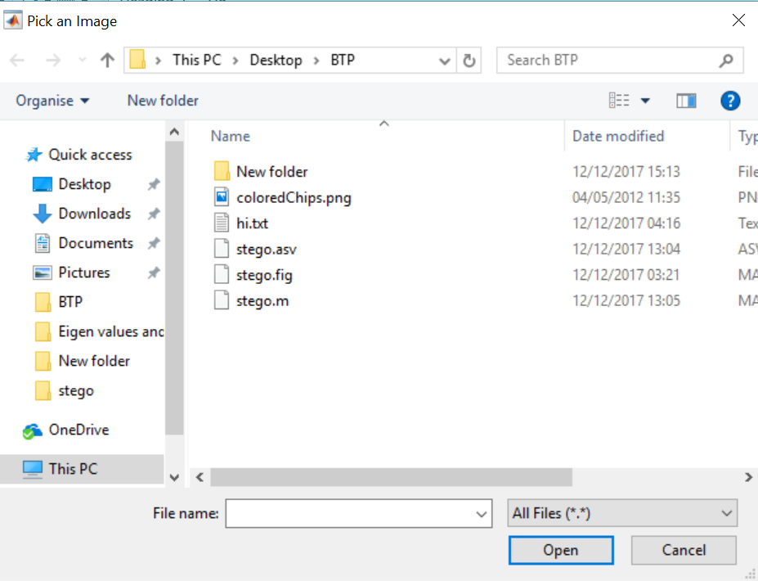

**On selection of the image it is shown in the axes1 as-**

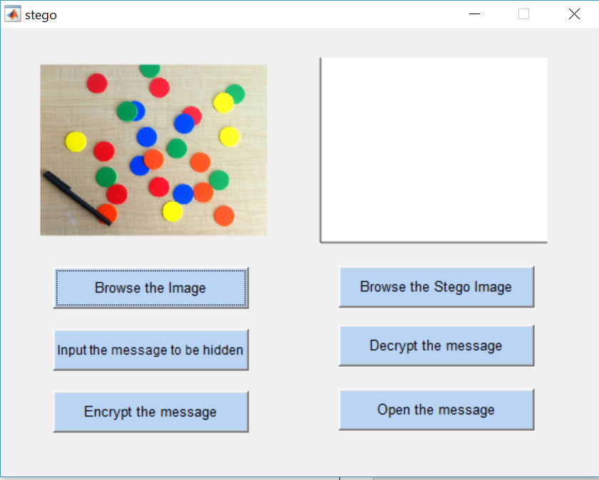

1. **Input the message button opens the following text file, for the user to enter the message into it.**

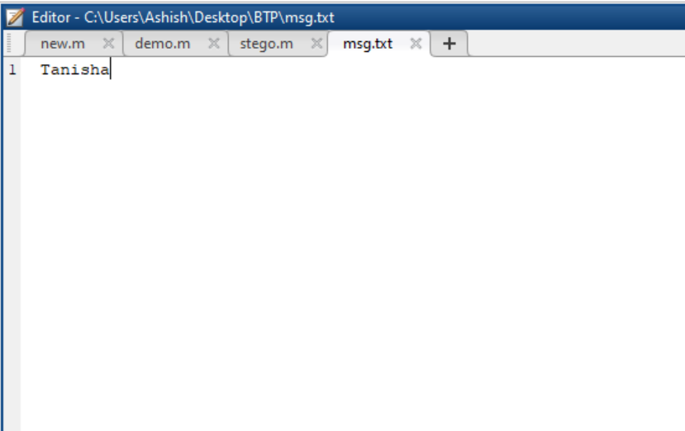

1. **The Encrypt the message button runs the algorithm and shows a pop-up window as-**

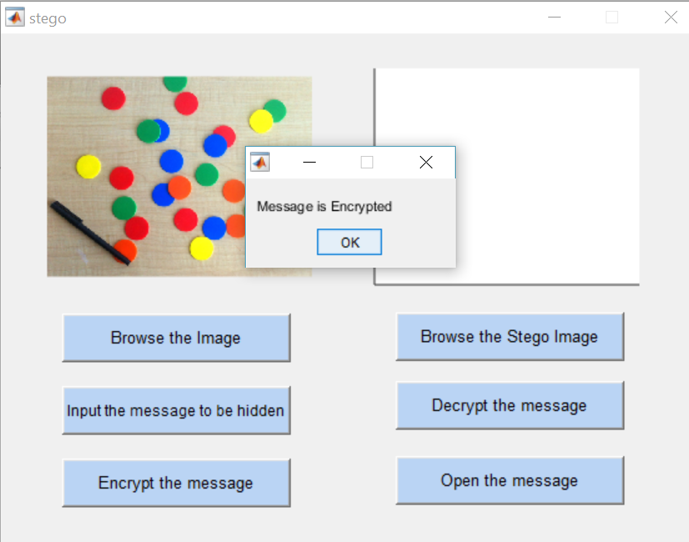

1. **On the decryption part, when the stego image which has the hidden message, appears in the axes2. And it can be seen that these two images look the exactly the same.**

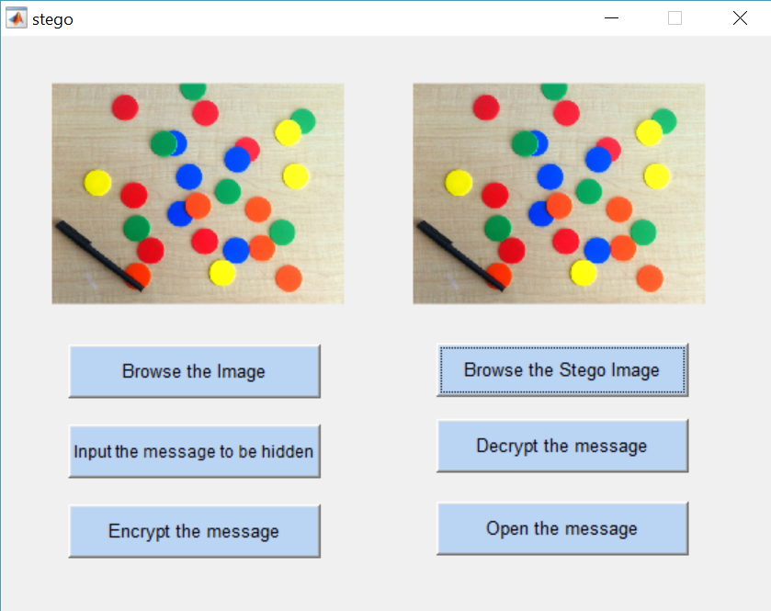

1. **Decrypt the message button runs the decryption algorithm and shows a pop-up as-**

