PRODUCT REQUIREMENTS DOCUMENT
AI Demo Agent — Allyvate
Conversation-First · GraphRAG Brain · Voice + Avatar · Steered Discovery · Closed-Loop CRM
Version | 3.3 │ 10 May 2026
Status | For Review
Classification | Confidential
Scope | AI Demo Agent — Full product, conversation-first runtime with sales-discipline backbone
Change log | v3.3 refines §2 North Star with the SDR benchmark: the agent earns the buyer's trust and builds the company's pipeline just like a human SDR. §2.2 heading updated; §2.3 architectural implication makes the SDR comparator explicit. v3.2 reframed the North Star in active, positive language. v3.1 tightened barge-in handling. v3.0 rearchitected the agent around a conversation-first runtime with the North Star as foundational design contract.
Allyvate is revenue infrastructure for the agentic era. We create AI-led growth loops that expand revenue velocity from first touch to upsell — without adding headcount. www.allyvate.ai

1. Executive Summary
The AI Demo Agent runs a conversational, voice-first product demo on behalf of companies that do not yet have sales headcount to run them at scale. The agent answers what the buyer wants to know, fills the gaps they did not think to ask about, captures structured qualification data, and proposes a concrete next step. By the end of the session, the buyer has learned what they came to learn, and the company has a CRM record that earns its place in the pipeline.
The agent is conversation-first. There is no pre-written script that drives the agenda — the buyer drives, the agent steers. A brief Opening Choreography (intro line + low-friction discovery question + 2–3 prompt bubbles) solves the blank-screen problem, and from there the buyer can ask anything about the product. Every substantive question routes through Hybrid GraphRAG retrieval and returns voice + asset within ~1.3 seconds.
Three sales-discipline capabilities are built into every conversation: Steering Moves (the agent occasionally bridges the buyer's question to a related capability they should know about), MEDDIC Capture (five conditional nudges woven naturally across the session), and Agent-Led Close (the agent proactively proposes a concrete next step before the session ends). These exist because a pure Q&A bot meets only half of the North Star. The other half — the company's pipeline — requires structure.
The intelligence layer — the Organisation Brain — is a Hybrid GraphRAG architecture: a typed-edge knowledge graph (Postgres at launch, graduating to Neo4j) enriched by hybrid search over vector + BM25 embeddings, built at upload with zero manual tagging. The graph encodes which asset closed deals for which persona, which talk track countered which objection, which slide moved CFOs past pricing. Retrieval is judgment, not search.
Customers upload documents directly — pitch decks, call transcripts, demo recordings, case studies, product docs. The agent builds its knowledge graph from whatever the customer throws at it. Minimal KB quick-start: upload one pitch deck and one case study. Agent is live in under 15 minutes (including CRM connect).
Launch configuration: 3 standard voices (Voxtral TTS), 3 standard avatars (HeyGen/Tavus), HubSpot + Salesforce CRM via MCP — bidirectional (pre-call context read at session start, structured writeback at session end). No voice cloning at launch. No scripted DemoPlan.

2. North Star
The agent earns the buyer's trust — and builds the company's pipeline just like a human SDR.
This is the design contract. Every section below reports to it. The two halves are not optional alternatives — both are earned in every session, or the agent has not done its job. The SDR comparator is deliberate: the agent is benchmarked against the human role it most directly stands in for — capturing intent, qualifying fit, surfacing the right material, and moving deals forward. Anyone in the ICP knows what an SDR is worth. The agent has to earn that comparison.

2.1 How the agent earns the buyer's trust
- It answers substantively and accurately — what they asked, with evidence, not deflections
- It references what they said earlier — they feel heard, not handled
- It surfaces things they hadn't thought to ask — they feel guided, not sold to
- Sub-second responses, real assets, no fluff — their time is respected
- They leave with a concrete next step they chose — they have momentum, not a vague 'we'll be in touch'

2.2 How the agent builds the company's pipeline
- Every demo produces a structured CRM record (Activity + MEDDIC fields + Tasks), not a free-text transcript
- The right things get covered for the persona — coverage is the agent's job, not the buyer's
- The agent stays accurate, on-message, and on-brand — no hallucinations, no off-policy claims
- Reps inherit qualified leads, not raw conversations they have to re-qualify
- Pipeline conversion meets or beats the human-SDR baseline

2.3 Architectural implication
A pure Q&A bot earns the buyer's trust and leaves the company with nothing — it is a brochure with audio, not an SDR. The architecture below treats answering, steering, qualifying, and closing as four first-class capabilities — because building pipeline like an SDR requires all four. Naturalness is the means. Trust and pipeline are the outcomes.

3. Problem Statement

3.1 The Demo Quality Problem
Sales demos are the highest-leverage touchpoint in a deal. A strong demo accelerates the deal; a weak one stalls or kills it. Yet demo quality is almost entirely rep-dependent — determined by how deeply a rep has internalised product knowledge, competitive context, and buyer-specific pain points. Sub-$5M ARR SaaS companies often have no dedicated rep at all; the founder runs demos until they can't, and the funnel suffocates at that ceiling.

3.2 The Knowledge Fragmentation Problem
Sales knowledge lives everywhere and nowhere: product decks on drives, case studies in email threads, competitive intel in Slack, demo recordings on Loom. The winning slide exists. The right answer exists. They are inaccessible at the moment they are needed — mid-conversation with a buyer.

3.3 The Coverage Gap
Buyers do not always know what to ask. A free-flow Q&A leaves them with the questions they walked in with, not the questions they should have asked. A buyer who never asks about the differentiator never learns there is one. Coverage of high-value topics for the buyer's persona is the agent's job, not the buyer's job — but it has to happen without making the agent feel like it is following a script.

3.4 The Closing Gap
Most product demos end with 'thanks, I'll think about it,' which is sales-speak for never. A human rep proposes a next action with a date. A Q&A agent that does not propose a next step turns demos into one-way information transfers, not pipeline. Without an explicit close, the agent is a brochure with audio.

3.5 The Post-Call Intelligence Problem
After every demo, reps are expected to update the CRM. In practice this is done hastily, incompletely, or not at all. MEDDIC criteria are partially captured at best. Deal intelligence is lost. Forecasting is guesswork.

3.6 Summary
Problem | Cost | Agent Solution
Demo quality varies by rep | Inconsistent win rates; founder bottleneck | Consistent, knowledge-grounded demo every time
Right asset not surfaced in time | Objections not handled with evidence | Graph-traversal retrieval < 1.5s
Buyers don't know what to ask | Coverage gaps; differentiator never learned | Steering Moves bridge to high-value topics for the persona
Demos end without a close | Pipeline leaks; 'I'll think about it' = never | Agent-Led Close proposes a concrete next step before session ends
Knowledge locked in files | Slow ramp; knowledge walks out the door | LLM-compiled knowledge graph at upload
Post-call notes incomplete | Poor forecasting; lost deal intelligence | MEDDIC scorecard + question log auto-written to CRM (HubSpot/Salesforce via MCP)

4. Voice Stack
API-first, no self-hosting. At projected volumes (<500 demos/month), the full voice stack costs <$25/month. Self-hosting an A100 costs $1,200+/month. The crossover is ~2,000 demos/month. Use APIs now, abstract the provider, revisit self-hosting post-PMF.

4.1 Real-Time STT: Deepgram Nova-3
Purpose-built for voice agents. WebSocket streaming with ~300ms P50 latency. Native end-of-turn detection. The orchestrator subscribes to two distinct event types: VAD signals (~50–100ms after speech onset) for barge-in detection, and utterance_end events for final transcripts. $200 free credits on signup. Pricing: $0.0077/min streaming.

4.2 Real-Time TTS: Voxtral TTS (Mistral API)
68% win rate vs ElevenLabs Flash v2.5 in human evaluations. ~90ms time-to-first-audio. Hindi support. 3-second zero-shot voice cloning built into the same model for future upgrade. 73% cheaper than ElevenLabs at $0.016/1K characters. 3 pre-built voices at launch.
ElevenLabs Flash v2.5 serves as automatic fallback if Voxtral returns error or timeout >2 seconds. Both providers must support clean stream cancellation for barge-in (verified at provider-abstraction layer).

4.3 Batch Transcription: Whisper API
OpenAI Whisper / GPT-4o Mini Transcribe at $0.003–$0.006/min. Used in the ingestion pipeline ONLY — transcribing uploaded call recordings, demo videos, and meeting recordings before graph construction. NOT used for real-time conversation.

4.4 Voice Provider Abstraction
All voice services accessed through provider interfaces (STTProvider, TTSProvider, BatchTranscriber). The TTSProvider interface mandates a cancel() method that aborts the active stream within 50ms; this is required for barge-in handling. Swapping API to self-hosted, or pipeline to STS at a future date, is a deployment-config change, not a code change. Built from day one.

4.5 STS Posture
Speech-to-Speech models (OpenAI Realtime, Gemini Live) are tracked but not adopted at v3.0. Reasoning: structured work (retrieval, MEDDIC, CRM, policy) remains text-domain; cost is 6–10× higher than the pipeline; provider lock-in eliminates the strategic optionality of Claude-as-brain plus best-of-breed voice. Revisit in 6 months as STS function-calling reaches text-LLM parity and pricing normalises. Interface abstraction (above) keeps the door open.

4.6 Monthly Cost at 50 Demos/Month
Service | Calculation | Cost
Deepgram Nova-3 (real-time STT) | 1,500 min × $0.0077 | $11.55
Voxtral TTS (agent speaks) | 700K chars × $0.016/1K | $11.20
Whisper batch (uploaded recordings) | ~200 min × $0.003 | $0.60
Total voice stack |  | $23.35/mo

5. The Organisation Brain — Hybrid GraphRAG
The Organisation Brain is the most important architectural decision in the system. Everything else — voice, avatar, MEDDIC, asset display, steering, close — is the interface. The Brain is what makes the agent intelligent rather than scripted.

5.1 Why Not a Wiki or Flat Vector RAG
Vector RAG gives you vibes. It finds content semantically similar to a query. Graph RAG gives you facts. It traverses explicit relationships — Asset → COUNTERED → Objection → FOR_PERSONA → CFO → LED_TO → Deal Won. Hybrid GraphRAG gives you both. And because vectors blur exact phrases — product names, specific figures — retrieval is hybrid in a second sense: vector similarity plus keyword (BM25) matching, fused via reciprocal rank fusion and reranked, so the agent never misses an artifact the buyer named explicitly.

5.2 The Four Layers
Layer 1 — The Raw Vault: Everything uploaded, stored as-is in S3. Pitch decks, call transcripts, demo recordings, case studies, product docs. Nothing is discarded. The immutable source of truth.
Layer 2 — The Knowledge Graph: a typed-edge graph. Every piece of content becomes a node; relationships between pieces of content are edges. This is a logical layer — at launch the graph lives in Postgres (typed-edge tables + recursive-CTE traversal), which a real production deployment at 146K+ pages demonstrates scales well past a single tenant's full footprint. It graduates to Neo4j when real-time multi-hop traversal latency demands it (see Section 16).
Layer 3 — The Vector Index: every graph node has a vector embedding. Hybrid retrieval (vector + keyword/BM25 + reciprocal rank fusion + reranker) finds the entry points into the graph; graph traversal finds the answer. At launch the vector index is pgvector in the same Postgres instance; it graduates to Qdrant at roughly 1M vectors or when metadata filtering and quantization are needed (Section 16).
Layer 4 — The Outcome Learning Layer: Every conversation adds edges and updates weights in the graph. Asset shown + buyer reacted positively = edge weight increases. Talk track used + deal advanced = reinforced.

5.3 Node and Edge Types
Node Types: Asset (Slide, Case Study, Battlecard, Pricing Sheet, Architecture Diagram, One-Pager), Concept (Product Feature, Use Case, Pain Point, Industry, Persona, Competitor, Objection Type, MEDDIC Criterion), Outcome (Deal Won, Deal Lost, Objection Handled, Buyer Signal), Conversation (Talk Track, Qualifying Question, Buyer Utterance Pattern).
Key Edge Types: Asset → ADDRESSES → Objection Type, Asset → RELEVANT_FOR → Persona, Asset → LED_TO → Outcome (weighted), Objection → COUNTERED_BY → [Asset, Talk Track], Pain Point → SOLVED_BY → Product Feature. Every edge stores a provenance backpointer; inferred edges store model-confidence; deprecated source content does not propagate positive ranking weight.

5.4 Graph Construction at Upload — Zero Manual Tagging
Sources span the full footprint — website crawl, Confluence (via MCP), CRM (via MCP), and Google Drive (via MCP). For each unit: extract text, render slide thumbnails, transcribe video/audio via Whisper. Edge creation is two-pass: a deterministic regex inference cascade types the obvious relationships (USES, INTEGRATES_WITH, FOR_PERSONA) with zero LLM calls, and Claude is reserved for ambiguous semantic edges, typed Knowledge Object classification, and cross-source entity resolution — the same concept appearing across website, Confluence, a deck, and a CRM note resolves to one canonical node. Vector embeddings are written to the index; ApprovalStatus defaults to draft → approved on customer review. Call transcripts and demo recordings carry higher signal than static docs — by call 10–20, outcome-weighted edges begin to dominate.

5.5 Knowledge Object Model
The Brain operates on typed business objects, not generic text chunks. The Claude classifier that runs during ingestion (Section 6) assigns every extracted chunk to one of the following node types, which become the typed entities in the knowledge graph. The ranker (Section 7) uses these types as a primary input to objection-match and persona-match scoring.
ObjectionHandler — a response to a buyer concern (price, competitor, security, timeline, change management)
PricingClaim — a price point, pricing tier, discount structure, or commercial term
ROIStory — a quantified outcome story tied to a specific customer or use case (e.g. "40% reduction in onboarding time at Acme")
CaseStudy — a structured narrative of a customer journey: problem, solution, outcome
ImplementationPath — a description of how the product gets deployed, integrated, rolled out
SecurityResponse — a stance on a specific compliance or security concern (SOC 2, GDPR, data residency, audit logging)
CompetitorCounter — a positioning move against a named competitor, with explicit comparison framing
FeatureExplanation — a description of a specific product feature, with the persona and use case context where it matters
Rationale: When a buyer raises a security concern, the ranker preferentially surfaces SecurityResponse and ImplementationPath nodes — not FeatureExplanation. When the buyer challenges price, the ranker reaches for ROIStory and PricingClaim. The type system makes this routing precise and tunable; without it, the ranker is reduced to semantic similarity on chunks, which loses to a competent AE every time.

5.6 Conversation Memory Architecture
The Knowledge Graph stores static knowledge about the business. Conversation memory stores what happened during conversations. These are distinct systems with different storage characteristics and retention policies.
Four scopes, each with its own store and lifecycle:
Session memory — Redis
Scope: the current call
Contents: turn history, intent classifications, MEDDIC accumulator state, coverage tracker, prompt-bubble interactions, live state machine status
Lifecycle: cleared (or archived to Episodic) when the call ends
Episodic memory — the graph store (Postgres at launch; Neo4j / Graphiti when triggered) with temporal validity
Scope: past calls with the same Contact
Contents: which assets were surfaced, which earned positive reactions, which got interrupted, the agent's running model of this individual buyer
Account memory — the graph store (Postgres at launch)
Scope: across the buying committee at a single Account
Contents: roles per Contact (when committee modeling is enabled in Phase 3), shared context across calls, deal-level state, MEDDIC roll-up across stakeholders
Long-term memory — Layer 4 of the Brain (Outcome Learning)
Scope: cross-tenant patterns, the implicit knowledge that emerges from many demos
Contents: edge-weight updates, persona-specific asset effectiveness scores, objection-resolution patterns
Privacy: anonymized at this layer; no tenant-specific data leaks across boundaries
How each scope feeds the Retrieval Intelligence Engine:
Session memory drives within-call coverage tracking (don't re-surface an asset already shown this call)
Episodic memory drives the "what they liked last time" scoring input
Account memory drives buying-committee-aware messaging
Long-term memory drives the ranker weights themselves

5.7 Knowledge Compilation & the Brand Book
The Brain follows a compile-don't-re-derive discipline borrowed from the markdown-first agent-knowledge pattern: raw sources are distilled once, at ingestion, into clean typed Knowledge Objects (Section 5.5) rather than re-interpreted from raw chunks on every query. Two principles govern this:
Markdown is the system of record; the index is derived. Compiled Knowledge Objects and the per-tenant Brand Book live as human-editable, git-versioned markdown. The Postgres index (vectors + typed edges + metadata) is rebuilt from it. Humans can edit the markdown directly; a sync job re-indexes. This keeps the brain auditable and prevents lock-in.
The Brand Book is the constitution layer. A small, bounded, human-editable markdown document per tenant captures brand voice, banned/preferred words, compliance rules, and positioning. It is small enough to load into context on every generation and governs both the sales agent's tone and Creative Studio's output. This is the one place a literal wiki belongs; the full corpus does not fit in context and stays in the retrieval layer.
A scheduled overnight consolidation job (off the hot path) runs entity-resolution passes, applies Outcome Reinforcement weight updates, fixes citations/provenance, and checks for staleness — so the brain gets sharper between sessions rather than only during them.

5.8 Storage Strategy — Logical Layers, Physical Stores
The Four Layers (5.2) are a logical architecture. Their physical deployment is staged: start lean on Postgres, graduate specific layers to purpose-built stores only when measured triggers fire. This is not under-building — a production agent brain at 146K+ pages runs the graph and vector layers on Postgres+pgvector with typed edges, larger than a single Allyvate tenant's full footprint, which establishes that capacity is not the constraint.
At launch, one Postgres instance does five jobs: pgvector (vectors), full-text search (BM25 keyword arm), the relationship graph (typed-edge tables + recursive CTEs), outcome-weight tables, and Knowledge Object metadata + episodic/account memory.
The graph layer is critical — but its store is a latency decision, not a capacity one. Evidence shows turning the graph layer off costs a large precision drop, so the relationships must be modeled; whether they live in Postgres or Neo4j is decided by whether real-time multi-hop traversal stays inside the 590ms budget under concurrent load.
The Retrieval Intelligence Engine interface is unchanged across stores. Graduating a layer (Postgres→Neo4j, pgvector→Qdrant) swaps the store adapter behind the RIE, not the engine or either consuming product. Triggers are tabulated in Section 16.

6. Real-Time Pipeline — Response in < 1.3 Seconds
The pipeline is streamed and parallelised — steps do not wait for previous steps to complete. This is the core engineering pattern that makes a conversational agent feel real.
Example: Buyer asks 'How does your pricing compare to Gong?'
Step | What Happens | Technology | Latency
1. STT | Buyer utterance transcribed via WebSocket streaming | Deepgram Nova-3 | ~300ms
2. Claude turn | Single streaming call: classify (objection: competitor pricing), update MEDDIC silently, decide retrieval, evaluate steering candidate, evaluate MEDDIC nudge candidate, generate response | Claude Sonnet (streaming) | ~200ms to first token
3a. Hybrid search | Broad semantic search over node embeddings | pgvector + BM25 | ~100ms
3b. TTS | PARALLEL: first sentence piped to TTS immediately. Buyer hears audio at ~590ms. | Voxtral TTS | ~90ms TTFA
4. Graph | Traverse: Objection → COUNTERED_BY → Battlecard, ranked by outcome weight + approval state | Postgres graph (→ Neo4j) | ~200ms
5. Rank | Top asset selected. Thumbnail pre-cached at ingest. | Scoring + CDN | ~50ms
6. Display | Battlecard appears in panel. Agent mid-sentence narrating it. | UI + Voxtral | ~400ms
Total | Buyer hears first audio at ~590ms. Full response + asset displayed. |  | < 1.3s

6.1 Three architectural decisions
1. Claude streams its response. The first sentence goes to Voxtral immediately, while Claude is still generating sentence 2.
2. Graph retrieval runs in parallel with TTS. Retrieval and TTS pipelines start from Claude's output simultaneously. The asset appears while the agent is mid-sentence.
3. Thumbnails are pre-cached at ingest. When the ranker selects the pricing battlecard, the thumbnail is already on CloudFront. Display is an image-URL swap.

6.2 Latency Budget with Fallbacks
Step | Provider | Budget | If Exceeded
STT streaming | Deepgram Nova-3 | < 350ms | Text input fallback offered to buyer
Claude turn (first token) | Claude Sonnet | < 200ms | Cached response templates for common intents
Vector search | pgvector (Postgres) | < 100ms | Increase ANN index size / reduce ef parameter
Graph traversal | Postgres graph (→ Neo4j) | < 200ms | Cypher timeout, fall back to vector-only retrieval
TTS first audio | Voxtral | < 100ms | Failover to ElevenLabs Flash (~75ms TTFA)
TTS interrupt cancel | Voxtral / ElevenLabs | < 50ms | Client-side audio buffer drain (≤150ms perceived)
Asset display | CloudFront CDN | < 50ms | S3 direct if CDN miss

7. Retrieval Intelligence Engine
Allyvate is, at its core, a system that learns which sales artifact to surface next, wrapped in a conversational interface. The Retrieval Intelligence Engine (RIE) is the component that makes that selection. The voice stack, the avatar, the MEDDIC capture, the CRM writeback — all of these are supporting infrastructure around the RIE's per-turn decision.
The PRD up to v3.4 described retrieval as plumbing (GraphRAG over Qdrant + Neo4j produces an asset). v3.5 promotes retrieval to a first-class component with an explicit interface, named scoring inputs, and a feedback loop. This is the architectural decision that makes the compounding-moat story credible: every demo tunes the ranker; the ranker is the moat.

7.1 Three-stage pipeline
Each buyer turn that requires an artifact runs through three stages: candidate generation, scoring, and selection. See Section 14.8 for the visual.

7.2 Stage 1 — Candidate generation
Retrievers run in parallel and union their results into a candidate pool of approximately 20 artifacts:
Hybrid search over the corpus — vector similarity (pgvector) + keyword (BM25), fused via reciprocal rank fusion and a reranker. The keyword arm catches exact product names and figures that pure vector blurs.
Graph traversal — from concepts mentioned in the question and from current Conversation Memory state; multi-hop relations across the Knowledge Object Model.
Conversation Memory direct lookup — episodic + session; assets that earned positive reactions on prior calls with this contact, or were referenced earlier in the current call.
The pool size (~20) is large enough to give the ranker meaningful choice and small enough to keep scoring under 50ms.

7.3 Stage 2 — Scoring
Each candidate gets a weighted score. The v1 heuristic weights are:
0.30 — Relevance (hybrid score: vector + BM25, fused and reranked)
0.20 — Persona match (does the candidate's typed node match the buyer's persona profile?)
0.15 — Objection match (if the buyer raised an objection, prefer ObjectionHandler / SecurityResponse / CompetitorCounter as appropriate)
0.15 — Historical success (outcome-weighted edge from prior demos with similar buyers)
0.10 — Opportunity stage match (early-stage opportunities reach for CaseStudy and ROIStory; late-stage reach for ImplementationPath and PricingClaim)
0.05 — Freshness (newer assets weighted slightly higher; stale assets decay)
0.05 — Approval weight (assets that have been explicitly admin-approved score higher than draft-state assets)
These weights are starting heuristics. They are not fixed. The Outcome Reinforcement Engine (Section 7.5) tunes them per tenant based on observed demo outcomes. By Phase 4 (general availability), the v1 heuristics should be largely overwritten by learned weights for each tenant.

7.4 Stage 3 — Selection and output contract
The RIE returns a structured output, not just an artifact ID:
top_artifact_id — the selected artifact
confidence — score in [0,1] from the ranker, used by the Runtime to decide whether to display directly, prompt verbally then display, or hold back if below a per-tenant threshold
reasoning_trace — which inputs contributed how much, captured for the admin audit trail and for the Outcome Reinforcement Engine's training signal
alternatives — ranks 2 through 5, used as the fallback chain if the buyer rejects or interrupts the top artifact
The reasoning_trace is both a debugging tool and a customer-facing feature. Surfacing "the agent chose Asset X because of persona match (0.4) + objection match (0.3) + historical success (0.2)" lets admins verify the agent's behavior and gives customers a defensible audit trail.

7.5 Outcome Reinforcement Engine
The Outcome Reinforcement Engine is the feedback loop that tunes the ranker over time. It transforms Allyvate from a system that retrieves into one that learns to sell.
Reward signals (positive) — observed within or after the demo:
Opportunity progressed to the next CRM stage within N days of the demo
Buyer asked a follow-up question on the same topic (sustained engagement)
MEDDIC field captured during or after the artifact display
Buyer made an explicit positive statement ("that makes sense", "useful", "can you send that?")
Next step booked at the close of the demo
Penalty signals (negative) — also observed within or after the demo:
Buyer hard-interrupted the artifact display (Section 8.9 barge-in pattern)
Buyer changed topic immediately after the artifact appeared
Demo ended without any next step set
Opportunity stagnated for > 30 days or moved to Closed-Lost
Update mechanics (v1):
Edge weight update — exponentially-weighted moving average over outcome signal, applied to the (persona, objection_type, asset_node) edge
Decay — edge weights age by approximately 5% per quarter, so stale wins don't dominate indefinitely
Exploration — ε-greedy at approximately 10%; a non-top-ranked candidate is surfaced 10% of the time to avoid local maxima in the ranker
Negative reinforcement — assets that consistently miss are explicitly down-weighted, not merely absent from positive updates; this prevents under-explored assets from being treated equivalently to actively-failing ones
All update signals are tenant-scoped. Cross-tenant patterns surface only as anonymized Long-term memory aggregates (Section 5.6), never as leakage of one tenant's outcomes into another's ranker.

8. Conversation Runtime
This section is the heart of v3.0. It defines how the agent runs a conversation that meets both halves of the North Star — natural enough for the buyer to feel respected, structured enough for the company to get pipeline.

8.1 Deployment Modes
Mode | Who Uses It | Interface | Key Difference
Buyer-Facing Widget | Buyer directly | Split-screen embed | Primary mode. No rep in loop. Agent runs full conversation autonomously.
Internal Co-pilot | Sales rep, live call | Browser sidebar | Rep runs conversation. Agent suggests responses, steering moves, MEDDIC nudges, and closes — rep approves/dismisses.
Presentation Mode from v2.2 is removed. The conversation-first construct has no script for the agent to drive on screen-share.

8.2 Opening Choreography
The only choreographed content in the entire session. Three beats, ~45–60 seconds total, designed to lower friction without faking energy.

Beat 1 — Brief intro narration (~15–20s)
Avatar appears. Brief warm intro: 'Hi, I'm [agent name] from [company]. I'll show you around — feel free to interrupt or ask anything.' If pre-call CRM context resolved an Opportunity (§7.10), this beat is personalised: 'Welcome back — picking up from your call with [rep] last week' or 'I saw you booked from our pricing page.'

Beat 2 — Micro-discovery (~15s)
Single low-friction prompt: 'Before we dive in — what's your work email, and what brought you in today?' This captures Champion identity + Pain seed in one exchange. Buyer can type or speak. Skippable in co-pilot mode (rep already has the context).

Beat 3 — Prompt bubbles (~3 options, persona-conditional)
Three tappable conversation starters appear, conditioned on detected persona:
Persona Signal | Default Bubbles
No persona detected (default) | How does it work? | How does pricing compare? | Is it SOC 2 compliant?
CFO / Finance lead | Show me the ROI math | What does pricing look like? | What's the implementation timeline?
CTO / Engineering lead | Walk me through architecture | How does it integrate with our stack? | What about security?
RevOps / Sales lead | Show me the analytics view | How does it work with our CRM? | What's the onboarding lift?
Bubbles disappear once the buyer asks a first question (typed or spoken). The choreography exists to solve the cold-start problem, not to drive the agenda.

8.3 State Machine
Five primary states. Three utility states (DUCKED, INTERRUPTED, ENDED). Simplified from the 12-state machine in v2.2 because there is no script to execute or resume. DUCKED is new in v3.1 — it enables soft-cancel-then-classify for backchannel handling (§7.8.2).
State | Description | Exit Triggers
IDLE | Session created, awaiting buyer arrival | Buyer joins → OPENING
OPENING | Running the 3-beat opening choreography | Choreography complete → LISTENING; VAD signal → DUCKED (buyer barges into intro narration)
LISTENING | Buyer can speak or type; agent waiting; VAD active | STT utterance_end → PROCESSING
PROCESSING | STT done; Claude classifying + retrieving + generating response (single streaming call) | Claude streams first token → ANSWERING
ANSWERING | Agent speaking (Voxtral); asset displayed; coverage tracker updated | Response complete → LISTENING; VAD signal → DUCKED
DUCKED | VAD detected; agent audio reduced to ~50% volume; classifying intent (backchannel vs. substantive) | Backchannel confirmed → resume ANSWERING (un-duck within 100ms); substantive confirmed → INTERRUPTED
INTERRUPTED | Hard cancellation: Voxtral cancelled; agent transitions to listening pose; stale-asset guard fires | STT utterance_end → PROCESSING
ENDED | Session over (buyer left, close completed, or timeout); writeback queued | —

8.4 The Turn Loop
For every buyer turn after the opener, the agent runs this loop. Critical: classification, retrieval planning, MEDDIC update, steering decision, and nudge decision all happen inside Claude's single streaming call. There is no separate intent service, steering microservice, or nudge orchestrator. The prompt is structured; Claude's structured output drives the runtime.

8.5 Decision Hierarchy
The single-Claude-call architecture (one streaming call per turn) is a deliberate choice — it gives consistent state, lower latency, and easier evaluation than a multi-agent orchestration. To prevent the system prompt from sprawling into chaos as the product evolves, the prompt enforces an explicit priority order. Each turn's reasoning proceeds through these layers in order; earlier priorities suppress later ones.
1. Safety — content policy violations (per the runtime policy layer, Section 13.2); refuse and redirect, do not continue
2. Policy — tenant-specific rules (e.g. don't quote pricing without the configured quote tool; don't commit to availability windows)
3. Objection — if the buyer raised an objection, resolve it before continuing; objection-handling takes precedence over retrieval routing and steering
4. Retrieval — invoke the Retrieval Intelligence Engine (Section 7) to surface the artifact for this turn
5. MEDDIC — capture any field the buyer just revealed; this is passive accumulation, not an active question
6. Steering — bridge to an under-covered persona-priority topic if conversational state permits (Section 8.6 Steering Moves)
7. Close — propose a next step if the close trigger criteria are met (Section 8.8 Agent-Led Close)
If a safety issue surfaces, the turn ends after layer 1; no retrieval, no MEDDIC capture, no close. If an objection is raised, the turn resolves it and only then runs retrieval. This hierarchy is encoded in the system prompt as named gates, so future additions (new policy layers, new sales-discipline capabilities) have a defined slot.

Step 1 — STT
Deepgram utterance_end fires; final transcript ready.

Step 2 — Claude streaming call (the brain)
A single structured-prompt call that produces:
- Utterance classification (question / objection / acknowledgment / close-signal / off-topic)
- MEDDIC accumulator update (any signal extracted, with verbatim quote)
- Retrieval strategy (hybrid graph+vector vs. cached known-answer for FAQ)
- Coverage tracker update (which topics have now been substantively covered)
- Response generation, streamed token-by-token, with three optional appendices: an acknowledgment prefix ('Yeah — and on that…'), a steering bridge (if criteria in §7.5 are met), a MEDDIC nudge (if criteria in §7.6 are met)

Step 3 — Parallel retrieval + TTS
Voxtral streams first sentence as Claude generates. Hybrid search (vector + BM25) and graph traversal retrieve the top asset; ranking applies approval-status + freshness filters; thumbnail displays.

Step 4 — Listen
Agent returns to LISTENING. VAD active for the next turn.

8.6 Steering Moves
Definition: A one-sentence offer the agent appends to a substantive response, proposing to cover a related topic the buyer has not asked about but should care about.

7.5.1 Trigger Conditions
Claude evaluates per turn whether to append a steering move. All conditions must be satisfied:
- Persona is detected (from email domain, CRM Contact role, or intro signal)
- Persona has known high-value topics defined in the customer's persona-priority map (§8.1)
- One or more of those topics has not been substantively covered (coverage tracker)
- The current turn's content opens a natural bridge to that topic
- The buyer has not signaled they want to wrap up
- No steering move has been offered in the last 3 turns
- The current turn is not turn 1 or 2 (let the buyer establish their agenda first)
- The previous turn was not an unresolved objection

7.5.2 Pattern and Examples
Respond to what was asked. Then bridge.
After answering architecture: 'While we're on the technical side — most CTOs at your stage also want to know how this handles SSO and SCIM. Want to cover that next?'
After answering pricing: 'Speaking of value — the ROI math we run for fintech customers is worth seeing. Should I pull that up?'
After answering features: 'Out of curiosity, on the integration side — what's currently in your stack? I can show how it plugs in.'

7.5.3 Decline Handling
Steering moves are always declinable. Buyer's 'no thanks' or topic-change cancels the offer cleanly — the agent does not push, does not re-offer the same topic in the same session. Decline is logged to the coverage tracker as 'offered, declined' (signal for the rep, not a failure).

8.7 MEDDIC Capture — Conversational, not Phase-Driven
MEDDIC is a passive accumulator with five planned nudges. The nudges fire conditionally on conversation flow, not on a fixed schedule.

7.6.1 The Accumulator
Every buyer turn is analysed for MEDDIC signal in Claude's classification step. Quotes are captured verbatim and tagged to the relevant criterion. Confidence scored per criterion (0–1). The accumulator state is visible to the orchestrator on every turn — and to the nudge decision logic.

7.6.2 The Five Planned Nudges
Criterion | Nudge | Natural Moment
Champion + Pain (seed) | 'What's your work email, and what brought you in today?' | Opening Choreography, beat 2 — always fires
Economic Buyer | 'Out of curiosity — who else on your side would weigh in on a decision like this?' | After first objection or tough question
Decision Process | 'Is there a timeline you're working against?' | After a feature deep-dive
Metrics | 'What metric would actually move if this worked?' | After a pricing question or ROI claim
Decision Criteria | 'What would have to be true for this to be an easy yes?' | After substantial coverage, before close

7.6.3 Nudge Decision Rules
- Each nudge fires at most once per session
- Skip a nudge if the criterion was already filled passively (buyer volunteered it unprompted)
- Fire only at the natural moment defined; otherwise carry forward and re-evaluate
- Maximum 5 nudges per 15-minute session — typically 3–4 actually fire
- If buyer refuses to answer ('I'd rather not say'), record as 'declined' and never re-ask in the session

7.6.4 Output
At session end, the MEDDIC accumulator writes to CRM custom fields (mapping per §7.11). Each criterion carries: score (0–6), confidence, verbatim quote, source turn ID. Reps see populated MEDDIC fields with audit trail — not a free-text dump.

8.8 Agent-Led Close
The close is the bridge from demo to pipeline. Without it, the agent is a brochure with audio. With it, every demo produces a proposed next step the buyer engaged with — accepted, deferred, or declined.

7.7.1 Trigger Detection
Close triggers when any of these signals fire:
- Buyer says a completion phrase ('I think I've got what I need', 'this is helpful', 'thanks for walking me through')
- N substantive turns elapsed (default 5) AND last turn was a substantive answer, not an unresolved objection
- Silence threshold exceeded after a substantive answer (default 8 seconds)
- Buyer asks a close-adjacent question ('how do I get started', 'what's the next step', 'how do I try this')

7.7.2 Close Execution
Single agent turn, ~30–45 seconds, three beats:
Beat 1 — Brief recap (1 sentence): 'So we covered [topic A], [topic B], and [topic C].' Pulled from the coverage tracker.
Beat 2 — Two-option proposal, CRM-stage-aware:
CRM Stage at Session | Option A | Option B
No Opportunity / early-stage | 30-min discovery call with our team | Send a one-pager + case studies to your inbox
Mid-stage Opportunity | Technical deep-dive with our engineer | Pricing + procurement conversation
Late-stage Opportunity | Contract review session | Loop in the rest of your evaluation team
Beat 3 — Capture response: buyer picks one, asks one more question (back to LISTENING), or declines. Outcome logged to CRM as a proposed Task with suggested date (next business day default).

7.7.3 Constraints
- Close attempted once per session by default; can be re-attempted once if buyer rejects the first close and continues asking questions
- Never close mid-objection — handle the objection first
- Co-pilot mode: close suggestion goes to rep, rep delivers
- Buyer's pick or decline is logged to CRM; silence past 30s after close = recorded as 'no response'

8.9 Barge-In Handling
The agent must handle three distinct interruption patterns. Naive 'cancel on VAD signal' breaks two of them. Each pattern is specified explicitly so engineering does not have to discover the failure modes in pilot.

7.8.1 Hard Barge-In — Substantive Interrupt
The default case. Buyer interrupts the agent's answer with a substantive question or comment. Full cancellation path:
- T+50–100ms: VAD signal fires (Deepgram)
- T+150ms: AudioInterruptController issues hard cancel to Voxtral
- T+200ms: Client-side audio buffer drained; perceived stop
- Avatar transitions to listening pose; UI signals 'Agent is listening'
- Talk-over guard: agent will not start new audio while buyer speech energy exceeds threshold
- On utterance_end, standard turn loop processes the new utterance — no cursor to preserve, no bridge phrase to generate

7.8.2 Soft Barge-In — Backchannel Handling
Buyers naturally backchannel during agent responses: 'uh-huh', 'got it', 'okay', 'right', 'mm-hmm'. A naive cancel-on-VAD makes the agent stop mid-sentence every time the buyer acknowledges — which feels broken. The agent must distinguish backchannel from substantive interrupt before fully cancelling.
The duck-and-classify pattern:
- T+50–100ms: VAD signal fires
- T+100ms: AudioInterruptController DUCKS audio (drops volume to ~50%); agent enters DUCKED state
- T+100–400ms: Two-track decision runs in parallel:
- Track A — Duration: if buyer audio continues past 400ms, treat as substantive → transition to INTERRUPTED (hard cancel)
- Track B — Content: when Deepgram returns first partial transcript (~200–300ms), run lightweight classification (keyword match against backchannel list, fallback to Claude micro-call)
- If backchannel confirmed AND buyer audio has stopped: un-duck within 100ms, resume at full volume, agent continues original response. Buyer perceives a slight volume dip, not an interruption.
- If substantive confirmed (either track): transition to INTERRUPTED, standard hard-cancel flow
Backchannel keyword list (English baseline; localised per voice): 'uh-huh', 'mm-hmm', 'yeah', 'yes', 'right', 'got it', 'okay', 'sure', 'makes sense', 'cool', 'nice', 'interesting', 'I see', 'mm'. Tunable per customer if their buyer base uses different verbal habits.

7.8.3 Topic-Shift Interrupt
Buyer interrupts mid-answer not to clarify but to shift topic entirely: agent is 4 seconds into explaining architecture, buyer says 'actually, what about your security model?' This is a hard barge-in PLUS specific context cleanups that must happen atomically:
- Voxtral stream cancelled (server-side, < 50ms)
- Claude response generation aborted server-side — any tokens still in flight are discarded, not delivered to TTS
- Stale-asset guard fires: any in-flight asset render is invalidated; the partial UI state does not persist
- Coverage tracker: original topic is NOT marked as covered (the response was abandoned mid-stream; the buyer did not actually receive the answer)
- Claude's next turn treats the new topic as a fresh question — no context bleed from the abandoned response in the prompt
- MEDDIC accumulator: any signals captured from the buyer's interrupt utterance are kept; signals attributed to the agent's abandoned response are discarded
This is critical for the coverage tracker's integrity. If abandoned topics get marked as covered, the steering engine will skip topics the buyer never actually heard — a silent failure that degrades pipeline quality without surfacing in any visible bug.

7.8.4 Interruption During Opening Choreography
Beat 1 (intro narration, 15–20s) is a Voxtral stream like any other agent utterance. If the buyer barges into the intro with a substantive question or request ('Wait, I just need to know about pricing'), the choreography must abort cleanly:
- Standard barge-in flow applies (Hard or Soft per §7.8.1 and §7.8.2)
- Remaining beats (micro-discovery, prompt bubbles) are skipped
- Agent transitions directly to LISTENING → PROCESSING on the buyer's utterance
- The skipped Champion + Pain seed nudge (§7.6.2 beat 2) is re-queued opportunistically to fire later in the session if a natural moment arises
Engineering must not hard-code the choreography as un-interruptible. It is the first content the buyer hears; if they already know what they want, they should be allowed to skip it.

8.10 Asset Surfacing
Each substantive turn either surfaces an asset or does not, based on retrieval confidence + policy approval. No 'slide deck' abstraction — just a sequence of contextually-surfaced assets in the right-hand panel.
- Most recent asset visible in the main panel
- Scrollback rail shows prior assets in this session, clickable to re-view
- Provenance popover on every asset (source file, page/slide locator, approval status)
- Asset trigger types: explicit (buyer asks to see), implicit (objection/pain detected), proactive (steering move offered it)
- Stale-asset guard: if response plan changes before UI swap, the stale asset event is invalidated

8.11 Pre-Call CRM Context
MCP is bidirectional. At session start, the agent pulls relevant CRM records — the demo opens with that context, not with a generic introduction.

7.10.1 Session-to-Opportunity Resolution
Three resolution paths, in order of confidence:
- Calendar booking link: booking creates Opportunity association at booking time
- Buyer email match: at session start, email is looked up against CRM Contacts; most recent Open Opportunity selected
- Manual selection: in co-pilot mode, rep selects the Opportunity before the call

7.10.2 What the Agent Reads Pre-Call
CRM Source | Used For
Opportunity stage + amount | Tone of demo + which Close options to surface (§7.7.2)
Existing MEDDIC fields | Skip ground already covered; focus nudges on missing criteria
Contact role / title | Persona detection → drives prompt-bubble selection (§7.2 beat 3) and steering priorities (§7.5)
Account industry + size | Surface industry-specific case studies in the opener
Last 3 Activities (calls/emails) | Reference recent context naturally ('Last week you mentioned…')
Open Objections field | Anticipate objections; pre-load relevant battlecards

7.10.3 Privacy
Reads only the records for the active session — never bulk-pulls the CRM. Scope limited to the resolved Opportunity + directly linked Contact and Account. No customer-wide caching. MCP-level read scopes minimised at OAuth time.

8.12 Post-Call CRM Sync
Within 60 seconds of session end, the agent writes structured intelligence to the customer's CRM (HubSpot or Salesforce) via MCP. Every agent output maps to a structured CRM object, not a free-text note dump.

7.11.1 Object Mapping
Agent Output | CRM Destination | Notes
Call session itself | Activity record (Call/Meeting type) on the Opportunity | Start/end time, participants, outcome, transcript link
MEDDIC scorecard (0–6 per criterion) | Custom fields on Opportunity (Metrics, EconomicBuyer, DecisionCriteria, DecisionProcess, IdentifyPain, Champion) | With verbatim buyer quote per criterion
Pain points (buyer language) | Custom field 'Buyer Pain' on Opportunity + tagged on Contact | Append, do not overwrite — pain narrative compounds
Objections raised + handling | Activity description + 'Open Objections' field | Open objections persist across calls until resolved
Assets shown + buyer reaction | Activity 'Materials Shown' custom field | Each asset linked with reaction tag (positive/neutral/negative)
Steering moves offered + outcome | Activity 'Coverage Map' field | Offered topic, accepted/declined
Full Q&A transcript | Activity description (Q&A log) | Every turn captured with timestamp
Close outcome (proposed next step) | Task on Opportunity, assigned to rep, with due date | Buyer's pick / decline / no-response logged
Buyer signal strength | Engagement score on Contact + Opportunity | Composite: interrupt frequency, asset reactions, MEDDIC fill, close engagement

7.11.2 Provider Abstraction
CRM access through a CRMProvider interface. HubSpotProvider and SalesforceProvider implement it; both connect via MCP servers (HubSpot's official MCP, Salesforce-first-party MCP where available, Composio/Zapier MCP fallback). Custom field mapping per tenant — customers map Allyvate's MEDDIC field IDs to their CRM field IDs once during onboarding.

7.11.3 Failure Handling
Redis session flush happens only after CRM writeback succeeds. If CRM is unreachable, writeback persists to S3 + PostgreSQL as durable fallback and retries on backoff (1m, 5m, 30m, 2h, 12h). Customer sees a 'CRM sync pending' banner in admin. Expired OAuth refresh: agent queues writeback, prompts customer to reconnect via MCP — the live demo is unaffected.

9. Onboarding Flow
Every step is designed to eliminate friction and deliver visible progress. The customer never sees a blank screen or waits without feedback. Quick-start target: agent live in <15 minutes including CRM connect.

9.1 Minimal KB Quick-Start
Step | Customer Does | System Does | Time
1 | Email + Google OAuth | Account created; tenant provisioned | ~2 min
2 | Drag-and-drop upload (deck + case study) | Files stored in S3; ingestion queue started | ~2 min
3 | Watch live progress | Extract slides, render thumbnails, run LLM classification, build graph, generate embeddings, capture provenance | ~5–8 min
4 | Review auto-generated tags + approve content | Surface top 10 inferred tags; assets move draft → approved | ~2 min
5 | Connect CRM (HubSpot or Salesforce) | OAuth via MCP gateway; default MEDDIC field mapping detected; customer can override | ~2 min
6 | Review persona-priority topic map | Auto-generated from uploaded content: per persona (CFO/CTO/etc.), the 3–5 topics the agent should steer toward if not asked | ~2 min
7 | Configure opening choreography | Intro line + 3 prompt bubbles (auto-drafted from deck; customer edits) | ~2 min
8 | Pick voice (3 options) | Voice ID stored; Voxtral configured | ~1 min
9 | Pick avatar (3 options) | Avatar ID stored; render pipeline configured | ~1 min
10 | Name agent + persona | System prompt personalised | ~1 min
11 | Run 3 test questions + dry-run a close | Agent responds with voice + avatar + asset panel; close beat fires on completion signal; test writeback to CRM sandbox | ~3 min
12 | Copy embed code | Agent live; calendar booking links auto-map to CRM Opportunity records | ~1 min
CRM connection is required before live buyer demos but optional during product evaluation. Customers without a CRM at signup can run the agent in demo-only mode; writebacks queue and replay on connection.

9.2 The Persona-Priority Topic Map
New in v3.0. Drives the Steering Moves engine (§7.5). For each persona the customer sells to, a ranked list of 3–5 topics the agent should ensure are covered — even if the buyer doesn't ask. Auto-generated from uploaded content and customer-editable.
Example map for an HR-tech company: CFO → [ROI math, pricing model, implementation timeline]; HR Director → [user experience, employee adoption, change management]; CTO → [integration with HRIS, SSO/SCIM, data residency].

9.3 Full KB Path
Same flow with 10–50 documents including call transcripts and demo recordings. Ingestion ~15–20 min with batch Whisper transcription. Graph quality measurably improves; outcome-weighted edges begin to dominate after 10–20 real calls.

9.4 Supported File Types
Documents: PDF, PPTX, DOCX, TXT/MD. Audio/Video: MP4, WebM, MP3, WAV. Max file size: 500 MB (video), 100 MB (documents). Knowledge base limit: 500 documents / 5 GB per customer.

10. Technology Stack
Component | Technology | Notes
LLM — Reasoning | Claude Sonnet (Anthropic API) | Single streaming call per turn handles classification, MEDDIC update, retrieval planning, steering decision, nudge decision, and response generation
Real-time STT | Deepgram Nova-3 (WebSocket) | Streaming, ~300ms P50, $0.0077/min. VAD + utterance_end events both consumed.
Real-time TTS | Voxtral TTS (Mistral API) | Primary. ~90ms TTFA, $0.016/1K chars. 3 voices. Stream cancellation < 50ms required.
TTS Fallback | ElevenLabs Flash v2.5 (API) | Auto-failover if Voxtral error/timeout >2s
Audio Interrupt Controller | In-house (provider-agnostic) | Duck-and-classify pattern: soft cancel (volume duck) on VAD, hard cancel on substantive confirmation. Coordinates with Backchannel Classifier. < 50ms hard-cancel latency; ≤ 100ms un-duck on backchannel resume.
Backchannel Classifier | Keyword match + Claude micro-call fallback | Runs on Deepgram partial transcripts (~200–300ms). Classifies utterance as backchannel | substantive. Tunable keyword list per customer.
Coverage Tracker | In-house (Redis session state) | Tracks substantively-covered topics per session; consumed by Steering decision logic
MEDDIC Accumulator | In-house (Redis session state) | Per-criterion score + confidence + verbatim quote + source turn ID
Persona Resolver | In-house | From email domain, CRM Contact role, and intro signal — drives prompt-bubble selection + steering priorities
Close Detector | In-house (rules-based + Claude classifier) | Detects completion phrases, silence threshold, turn-count threshold, close-adjacent questions
Batch Transcription | Whisper / GPT-4o Mini (OpenAI) | Ingestion only. $0.003–$0.006/min
Graph Database | Postgres typed-edge tables (launch) → Neo4j AuraDB [trigger] | Relationship graph. Launch: typed-edge tables + recursive-CTE traversal in Postgres. Graduates to Neo4j when real-time multi-hop p95 breaches 590ms under concurrent load (see §16). Provenance backpointers required.
Vector Index | pgvector in Postgres (launch) → Qdrant [trigger] | Hybrid search: vector + BM25 + reciprocal rank fusion + reranker. Launch: pgvector. Graduates to Qdrant at ~1M vectors or when metadata filtering / quantization is needed (see §16).
Orchestration | In-house turn orchestrator | Single Claude streaming call per turn (see 10.1 and Decision Hierarchy §8.5). In-house session-state machine + provider abstractions; no multi-agent framework.
Document Extraction | LlamaParse / Unstructured.io | PPT, PDF, DOCX, image extraction
Avatar | HeyGen or Tavus | 3 pre-built avatars, real-time lip-sync, listening-pose support
Embedding Model | OpenAI text-embedding-3-large | Sales content embeddings
Session State | Redis (managed) | MEDDIC + coverage + persona + transcript + close-state. Flushed post-call after writeback success.
File Storage | AWS S3 | Raw vault + thumbnails. Immutable.
Upload Queue | BullMQ + Redis | Async ingestion. Decouple upload from graph build.
CRM Sync | HubSpot MCP, Salesforce MCP (via Anthropic MCP gateway) | Bidirectional. Pre-call read + post-call structured write.
MCP Gateway | Anthropic MCP gateway | Per-tenant OAuth credential storage, refresh, scope minimisation
Durable Writeback Fallback | AWS S3 + PostgreSQL | Used when CRM is unreachable; queued writebacks replay on reconnection
API Framework | Fastify (Node.js) | REST + WebSocket
Auth | Clerk or Auth.js | Google OAuth, session tokens, team mgmt
App Database | PostgreSQL (Neon or RDS) | Accounts, agent configs, persona-priority maps, opening choreography, custom field mappings, usage tracking. At launch this same Postgres instance also hosts the vector index (pgvector), BM25 search, the typed-edge relationship graph, and outcome-weight tables — the single store described in §10.3.
ORM | Drizzle | Type-safe SQL, migrations
Frontend | Next.js 16 + Tailwind CSS 4 | SSR onboarding/admin, CSR real-time widget
State Management | Zustand | Client-side session, conversation, assets, prompt bubbles, close state
Serving | ECS Fargate (managed) | Serverless containers, auto-scaling
CI/CD | GitHub Actions + Turborepo | Per-package caching, build orchestration
IaC | SST v3 or Terraform | All AWS resources as code
Logging | Pino | Structured JSON, latency per retrieval step + per state transition + per steering/nudge decision
Validation | Zod | Runtime type validation for all API inputs + Claude structured-output schemas
Eval Harness | In-house (Phase 1) | Offline scenario set + online quality signals (see §12.3)

10.1 Note on the brain
Several capabilities in v3.0 (Steering decision, MEDDIC nudge decision, close detection, coverage tracking) live inside Claude's single streaming call — not as separate microservices. The orchestrator provides structured context (persona, coverage, MEDDIC state, recent turns); Claude's structured output drives the runtime. This is a deliberate design choice: fewer moving parts, lower latency, easier to evolve, easier to evaluate.

10.2 Ingestion Layer
Sources (full footprint). Customers connect, rather than hand-curate:
Website — crawler (Playwright or managed crawl): pages, blog, case studies, docs
Confluence — via MCP; preserves internal page-link structure
CRM (HubSpot / Salesforce) — via MCP, bidirectional (read for ingestion, write post-call)
Google Drive — via MCP; the 50–75 presentations + docs
Processing pipeline.
File-type router → LlamaParse (document + PPT extraction) → Whisper (audio/video transcription)
Regex inference cascade — typed graph edges from structure/wikilinks with zero LLM calls (USES, INTEGRATES_WITH, FOR_PERSONA)
Claude Sonnet classifier — reserved for typed Knowledge Object classification, cross-source entity resolution, and ambiguous semantic edges
Embeddings — OpenAI text + CLIP-style image; index construction writes vectors + typed edges to Postgres; thumbnail rendering

10.3 Storage — the Brain
Launch posture: one Postgres instance does five jobs (vectors via pgvector, BM25 keyword search, typed-edge relationship graph, outcome-weight tables, Knowledge Object metadata + episodic/account memory). Graph and vector layers graduate to purpose-built stores at the triggers in Section 16.
Postgres (Neon) — [launch] — the five jobs above
Redis (ElastiCache) — [launch] — live session memory + BullMQ queue
S3 + CloudFront — [launch] — raw vault, compiled Brand Books (markdown system-of-record), thumbnails, images
Neo4j AuraDB — [trigger] — relationship graph graduates here when real-time multi-hop p95 breaches 590ms under concurrent load
Qdrant — [trigger] — vector arm graduates here at ~1M vectors or when metadata filtering / quantization is needed
Graphiti — [trigger] — temporal validity on the graph; justified once continuous website/Confluence sync makes staleness measurable

10.4 Intelligence Layer
Retrieval Intelligence Engine — candidate generation via hybrid search (vector + BM25 + RRF + reranker) + graph traversal + conversation memory → weighted scoring → selection with confidence, reasoning trace, alternatives
Outcome Reinforcement Engine — reward/penalty signals, EWMA updates, decay, ε-greedy exploration; tunes the ranker per tenant
Creative Intelligence Engine — same three-stage pattern, creative-specific weights (channel, audience, objective, brand-voice match) for the Creative Studio interface
Brand Book — compiled per-tenant markdown constitution (voice, banned words, compliance, positioning), loaded into context
Overnight consolidation cron — entity-resolution, Outcome Reinforcement updates, citation/staleness checks off the hot path

10.5 Models & AI APIs
Claude Sonnet — ingestion classifier, runtime turn brain, creative generator
Deepgram Nova-3 — real-time STT (WSS, VAD); Mistral Voxtral — TTS primary; ElevenLabs Flash v2.5 — TTS fallback
OpenAI — Whisper (batch transcription) + text embeddings; CLIP-style — image embeddings
Reranker — Cohere Rerank / ZeroEntropy / self-hosted cross-encoder (hybrid-search precision)
HeyGen / Tavus — video avatar + lip-sync

10.6 Connectors (MCP)
HubSpot MCP, Salesforce MCP — [launch] CRM read + writeback
Confluence MCP, Google Drive MCP — [launch] ingestion sources
Slack / Gmail MCP — [later] tribal-knowledge capture
Meta / LinkedIn MCP — [later, Creative Studio] campaign performance feedback into the ranker

10.7 Compute & Application
ECS Fargate — four task families: Runtime API, Ingestion API, Onboarding API, Async Workers
Fastify (Node.js) API framework; BullMQ async queue on Redis (ingestion + overnight consolidation)
Next.js 16 frontend (both products); Creative Studio: TypeScript, Fabric.js, Zustand, MJML, HTML/CSS export

10.8 Network & AWS
VPC us-east-1, multi-AZ — public / private / database subnets
ALB — TLS termination, WebSocket upgrade (idle_timeout ≥ 4000s for long demos)
NAT gateway — Elastic IPs documented for HubSpot/Salesforce/Confluence vendor whitelisting
CloudFront + Route 53 + WAF — edge, DNS, protection

10.9 Platform & Cross-Cutting
Clerk + Google OAuth — auth, sessions, multi-tenant isolation (the per-tenant data boundary the brain is built around)
AWS Secrets Manager + KMS — secrets, per-tenant keys, AES-256 at rest, TLS 1.3 in transit
Pino → CloudWatch + DataDog + OpenTelemetry — logs, metrics, distributed tracing, per-tenant dashboards
GitHub Actions + SST/Terraform + Turborepo — CI/CD, IaC, monorepo
Policy layer, provenance/approval lifecycle, eval framework — including retrieval metrics and a graph-on/graph-off precision check that keeps validating the graph layer's contribution

10.10 Ruled Out (as engines)
GBrain — single-operator design; multi-tenant SaaS isolation is a structural mismatch, plus early-version maturity. Studied as reference; patterns borrowed (regex edges, hybrid search, markdown-as-record, overnight cron).
Byterover — coding-agent focused; source-available restrictions.
OpenViking — AGPLv3 commercial blocker + origin/procurement risk.
Pure vector RAG — fails SDR-quality multi-hop and misses exact phrases (hence hybrid).
Pure long-context / wiki as core — corpus (1–3M tokens/tenant) does not fit context; the wiki principle survives only as the Brand Book layer.

11. Non-Functional Requirements
Category | Requirement | Target
Performance | STT transcription latency (Deepgram Nova-3) | < 350ms
Performance | TTS time-to-first-audio (Voxtral) | < 100ms
Performance | TTS cancellation on barge-in (server-side) | < 50ms from VAD signal
Performance | Perceived audio stop on hard barge-in (incl. buffer drain) | < 200ms
Performance | Un-duck latency on backchannel resume | < 100ms
Quality | Backchannel false-positive rate (hard-cancelled when shouldn't have) | < 2%
Quality | Backchannel false-negative rate (continued speaking through substantive interrupt) | < 5%
Quality | Topic-shift coverage-tracker correctness (abandoned topics not marked covered) | 100%
Performance | Asset retrieval + display | < 1.5s
Performance | Agent first audio (turn loop) | ~590ms
Performance | P95 turn latency | < 1.8s
Performance | Pre-call CRM context read | < 1.5s at session start
Performance | Post-call CRM write-back | < 60s after session end
Performance | Batch transcription (Whisper) | < 5 min / 30-min recording
Performance | Ingestion: 100 documents | < 20 minutes
Reliability | Agent uptime (business hours) | 99.5%
Reliability | Graceful degradation — graph down | Fall back to vector-only
Reliability | Graceful degradation — STT failure | Text input fallback
Reliability | Graceful degradation — Voxtral TTS down | Failover to ElevenLabs Flash
Reliability | Graceful degradation — CRM down or OAuth expired | Durable writeback to S3/Postgres + retry; live demo unaffected
North Star — Buyer | Buyer post-session rating (when surveyed) | ≥ 4/5
North Star — Buyer | Buyer felt heard (verified via Q4 follow-up) | ≥ 70%
North Star — Company | MEDDIC criteria populated per session | ≥ 4 of 6
North Star — Company | Steering move uptake rate (offered → accepted) | ≥ 40%
North Star — Company | Agent-Led Close trigger accuracy | ≥ 90% fire at correct moment
North Star — Company | Close engagement rate (buyer picked an option) | ≥ 50%
North Star — Company | Demo → next-step conversion (vs. human-SDR baseline) | ≥ parity by Phase 4
Quality | Asset misfire rate (wrong asset surfaced) | < 5%
Quality | Provenance present on returned assets | > 95%
Quality | Stale-asset cancellation correctness | 100%
Quality | No blocked/deprecated asset surfaces in live demos | 100%
Security | Data encryption | AES-256 at rest, TLS 1.3 in transit
Security | Buyer session data | Flushed from Redis after writeback success
Privacy | Call recording / transcript | Opt-in only, stored encrypted
Privacy | PII redaction | Applied at ingestion (transcripts) + writeback boundary
Scale | Concurrent buyer sessions | Up to 50
Limits | Supported upload types | PDF, PPTX, DOCX, TXT/MD, MP4, WebM, MP3, WAV
Limits | Max file size | 500 MB (video), 100 MB (docs)
Limits | Knowledge base per customer | 500 documents / 5 GB
Limits | Conversations per month | 500 buyer conversations

12. Phased Delivery Roadmap
Phase | Weeks | Deliverables | Exit Criteria
1 Foundation | 1–4 | Upload pipeline, S3 storage, batch Whisper transcription, LLM graph constructor with provenance + approval state, Neo4j + Qdrant setup, slide-level thumbnail render, basic Q&A agent (text only) | >80% accurate asset retrieval; provenance on >95% returned assets; no blocked assets surface
2 Voice + Runtime | 5–8 | Deepgram Nova-3 STT streaming (VAD + utterance_end), Voxtral TTS, ElevenLabs fallback, AudioInterruptController, HeyGen/Tavus avatar, real-time conversation loop with 5-state machine, opening choreography, text fallback, 3 voices, 3 avatars | First-audio + barge-in latency hit budgets; voice + avatar passes internal quality bar; opening choreography functional
3 Conversation Intelligence | 9–13 | Coverage Tracker, Persona Resolver, MEDDIC Accumulator + 5 nudge logic, Steering Moves engine (decision + bridge generation), Agent-Led Close detection + execution, runtime policy layer for high-risk topics, persona-priority topic map editor in admin | Agent completes a 15-min demo with ≥3 steering moves offered, ≥3 MEDDIC nudges fired, and a close beat triggered correctly in ≥90% of dry-run scenarios
4 CRM Sync + Onboarding + Eval | 14–17 | Post-call CRM write-back via HubSpot MCP + Salesforce MCP (Activity + MEDDIC + Tasks + Coverage Map), pre-call CRM context read, custom field mapping UI, upload wizard, minimal KB quick-start, opening choreography editor, embed code generation, graph enrichment from call outcomes, offline scenario eval harness, online quality dashboards including North Star metrics | Pilot customers onboard in <15 min including CRM connect; agent live; CRM Activity records created on every call with ≥4 MEDDIC criteria populated and Close outcome logged; eval harness operational with pass-gate metrics from §10
Future phases (not in scope): voice cloning, custom avatars, private cloud deployment, additional CRM connectors beyond HubSpot/Salesforce, RL decisioning layer (Part 2 PRD), STS substrate evaluation (revisit at 6 months).

13. Provenance, Policy & Evaluation
Three controls that turn the agent from a demo prototype into a production system. Required for pilot launch.

13.1 Provenance — First-Class Contract
Every surfaced asset and every high-confidence claim carries source metadata pointing to the original upload, the chunk/page/slide location, the extraction version, and the approval status.
Field | Type | Purpose
source_file_id | string | Original upload identifier
source_filename | string | Human-readable file name
source_type | enum (pdf | pptx | docx | txt | md | audio | video) | Origin format
source_locator | string | Page, slide, or timecode reference
extraction_version | string | Pipeline version that produced this derived object
derived_object_id | string | Identifier of the derived chunk/asset/edge
derived_object_type | enum | chunk | asset | edge | summary | transcript_segment
approval_status | enum (draft | approved | deprecated | blocked) | Lifecycle state
freshness_score | number | Decay score based on extraction timestamp + source last-modified
Provenance surfaces in the UI via a popover on every shown asset and on every CRM Activity record's 'Materials Shown' entry. Blocked or deprecated assets must never surface in live demos.

13.2 Runtime Policy Layer
The model alone does not decide whether to answer high-risk commercial questions. A deterministic, testable policy layer gates these topic classes: pricing claims, competitor comparisons, quantified ROI statements, customer outcome claims, security/compliance claims, roadmap statements, integration availability.
Action | When | Buyer Experience
answer | Approved evidence exists, freshness OK, confidence high | Normal response with provenance popover
answer_with_warning | Evidence exists but freshness low or confidence borderline | Response delivered + soft caveat ('this figure is from Q3 — let me confirm the latest')
ask_clarifying_question | Question is ambiguous or under-specified | Agent asks one clarifying question before answering
abstain | No approved evidence; high-risk topic | Agent says: 'I want to make sure I get this right — let me bring our team in on this one'
escalate_to_human | Co-pilot mode + abstain trigger | Suggestion shown to rep; rep decides

13.3 Quality Evaluation Subsystem

13.4 Retrieval-Specific Quality Metrics
Retrieval is the product, so retrieval quality is the headline measure of the system. The general eval framework in Section 13.3 covers latency, MEDDIC capture rate, close trigger accuracy, and barge-in handling — these are hygiene. Retrieval quality is the moat measure.
Four primary metrics — each with a target at general availability (Phase 4):
Asset Precision@1 — target ≥ 70%
Of all turns where the RIE selected an artifact, what fraction were judged correct by a human evaluator?
Asset Precision@3 — target ≥ 90%
Was the correct artifact in the top three ranked by the RIE?
Catches near-misses; surfaces whether the ranker is directionally correct even when the top pick is sub-optimal
Human AE Benchmark — target ≥ 75%
Blind comparison: given the same buyer question and same available artifacts, how often does the RIE pick the same asset as a top human AE?
The most important number for both the investor pitch and the customer pitch
Asset Coverage Score — target ≥ 80%
Of the artifacts a top AE would have surfaced at some point in a demo, what fraction did the RIE actually surface during the conversation?
Benchmark context. Production conversational AI retrieval typically sits at 50–60% Precision@1 on open-domain question answering. Hitting Allyvate's targets depends on the Outcome Reinforcement Engine maturing through approximately 50 customer demos per tenant — the compounding cycle is what makes these numbers reachable.
Continuous evaluation harness — three feedback loops keep the metrics live:
Offline scenario suite — labeled (buyer question, expected artifact) pairs curated per tenant; run on every release
Shadow-mode AE comparisons — production demos periodically replayed against a human-AE panel for ground-truth labeling
In-product feedback — admins flag (turn, artifact) pairs from the demo replay UI; flags become training signal for the Outcome Reinforcement Engine

Offline scenario evals
Test sets covering: competitor objection, pricing objection, pain discovery, unclear buyer intent, missing evidence, stale content conflict, incorrect asset temptation, unsupported ROI claim, MEDDIC signal extraction, steering move appropriateness, close-trigger accuracy, multi-document conflict retrieval.

Online quality signals
Tracked per session: asset relevance rating, buyer interruption frequency, P95/P99 turn latency, agent abstention correctness, steering uptake rate, MEDDIC fill rate, close engagement rate, human override frequency in co-pilot mode.

North Star metrics
Tracked weekly: buyer post-session rating (when surveyed), MEDDIC criteria populated per session, steering uptake, close engagement, demo → next-step conversion vs. human-SDR baseline. These are the metrics that report directly to §2.

Acceptance gates
No phase exits without passing explicit acceptance metrics for retrieval precision, grounded response quality, latency budgets, policy compliance, UI asset timing, fallback correctness, and (Phase 3+) steering/MEDDIC/close behavior correctness.

14 · Architecture Diagrams
Eight focused architectural views. Together they cover deployment topology, application services, the data layer, the ingestion workflow, third-party integrations, the cross-cutting platform, and the live runtime state machine.

14.1 Network & deployment topology

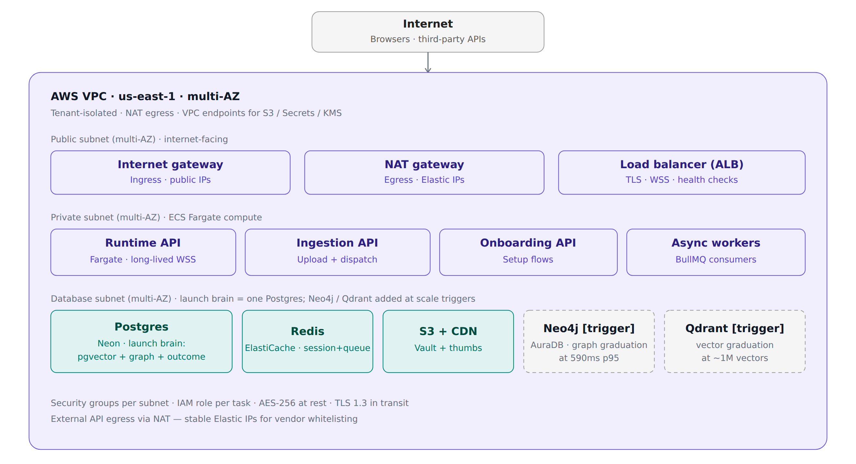
Figure 14.1 — VPC topology, subnets, and managed data services

14.2 Application services & internal modules
Four ECS Fargate task families. Runtime API runs the live demo turn loop (Deepgram STT, Claude turn brain, Voxtral + ElevenLabs TTS, audio interrupt controller, session orchestrator). Ingestion API handles uploads and job dispatch. Onboarding API runs the setup, embed code, and test runner flows. Async workers consume BullMQ jobs for Whisper batch transcription, document extraction, Claude classification, embedding, graph build, and post-call writeback.
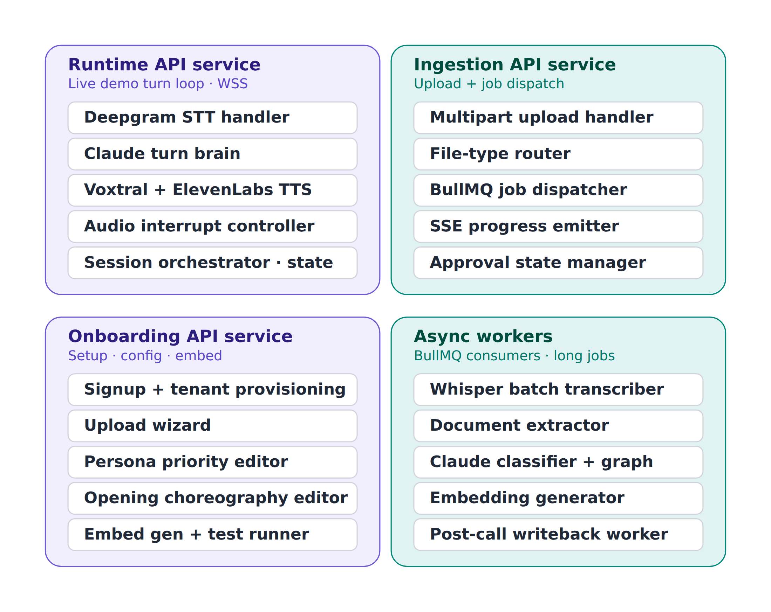
Figure 14.2 — Four service families with their primary internal modules

14.3 The Organisation Brain · data architecture

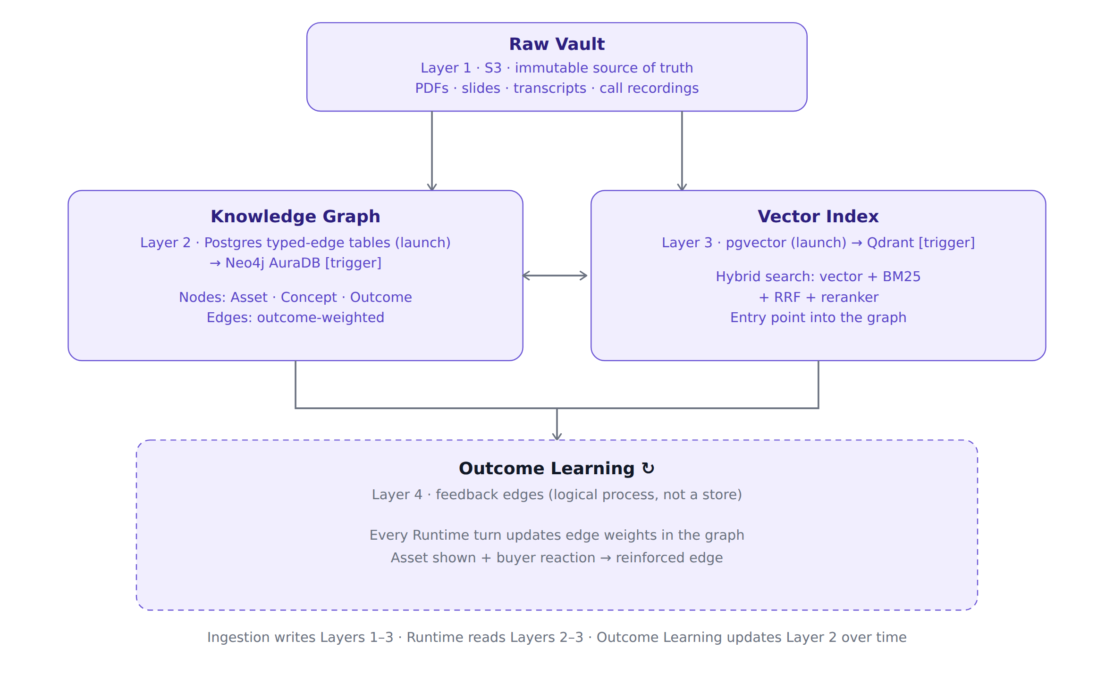
Figure 14.3 — Four-layer Brain: Raw Vault, Knowledge Graph, Vector Index, Outcome Learning

14.4 Ingestion pipeline

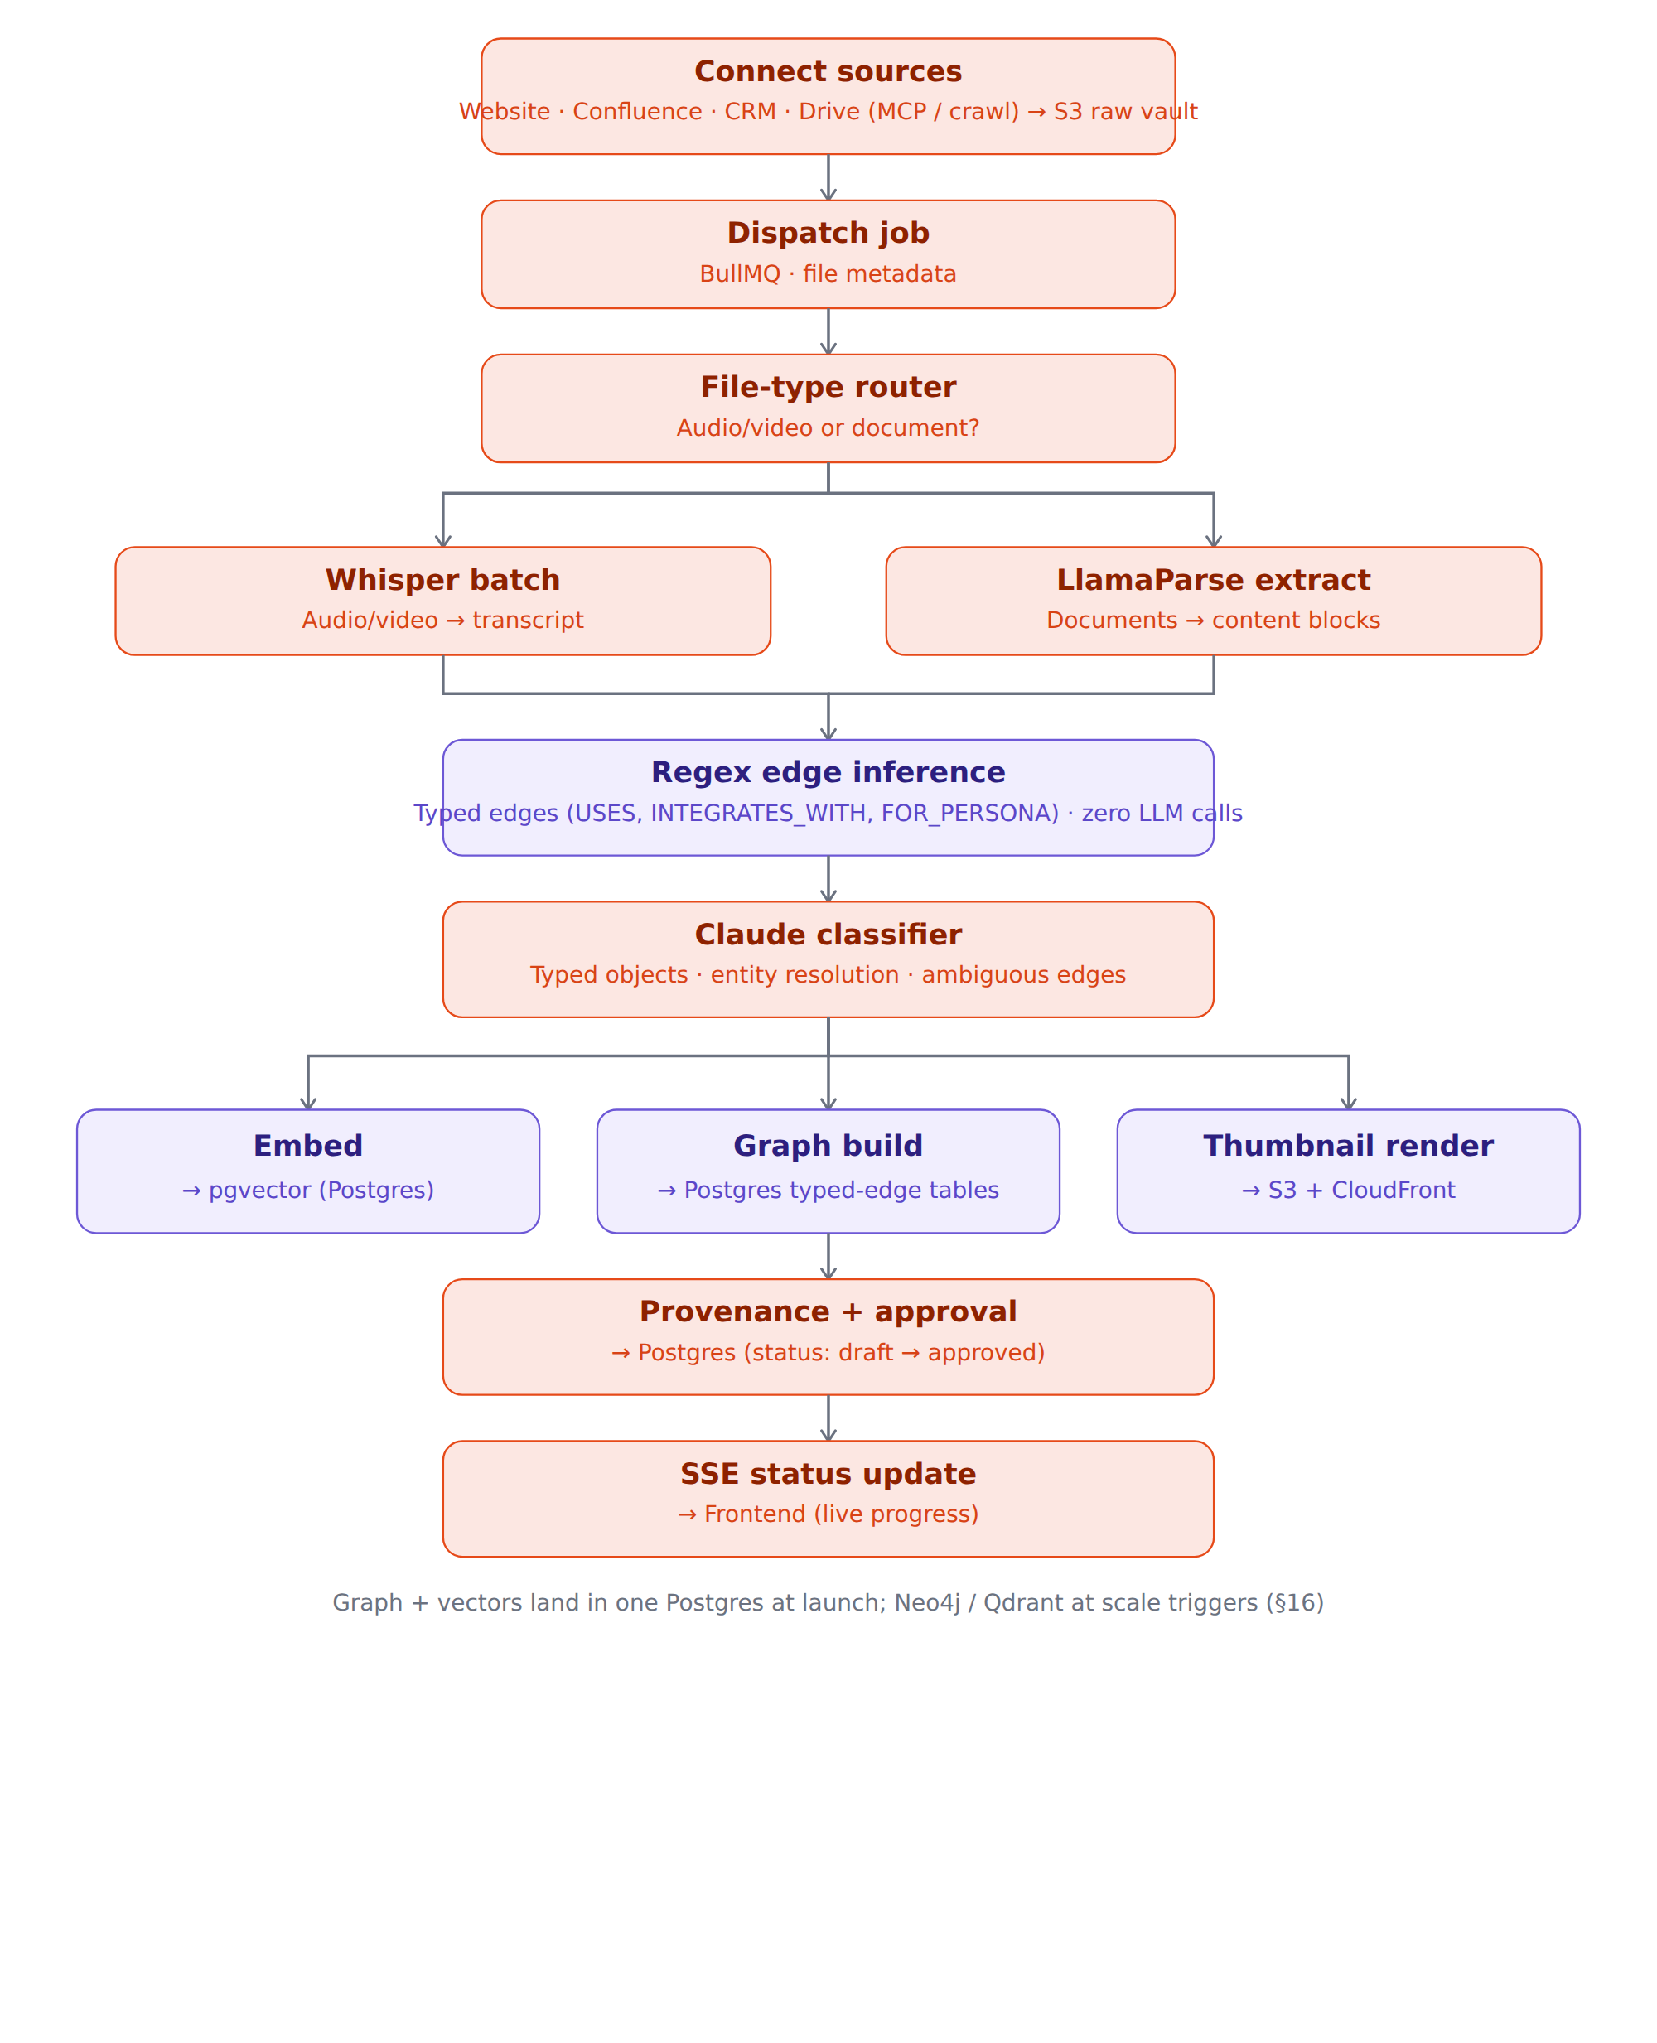
Figure 14.4 — Ingestion pipeline: upload to Brain with branched extraction and parallel write fan-out

14.5 External integrations map

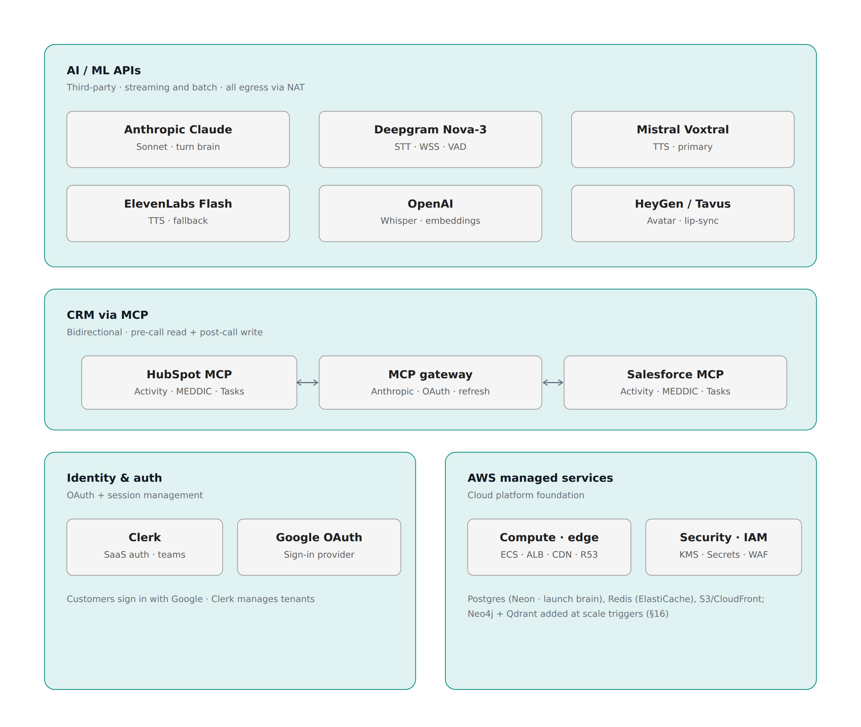
Figure 14.5 — Third-party integration surface area, grouped by category

14.6 Cross-cutting platform
Six operational concerns that apply across every subsystem above: auth and identity (Clerk, OAuth, RBAC, tenant isolation); secrets and encryption (AWS Secrets Manager, KMS, AES-256 at rest, TLS 1.3 in transit); observability (Pino logs, CloudWatch, DataDog, OpenTelemetry traces); policy and provenance (high-risk topic gates, escalation rules, asset state lifecycle, per-asset audit trail); eval framework (offline scenario harness, persona coverage, soft barge-in metrics, close trigger accuracy, MEDDIC capture quality); and CI/CD with infrastructure-as-code (GitHub Actions, SST or Terraform, Turborepo, canary deploys, drift detection).
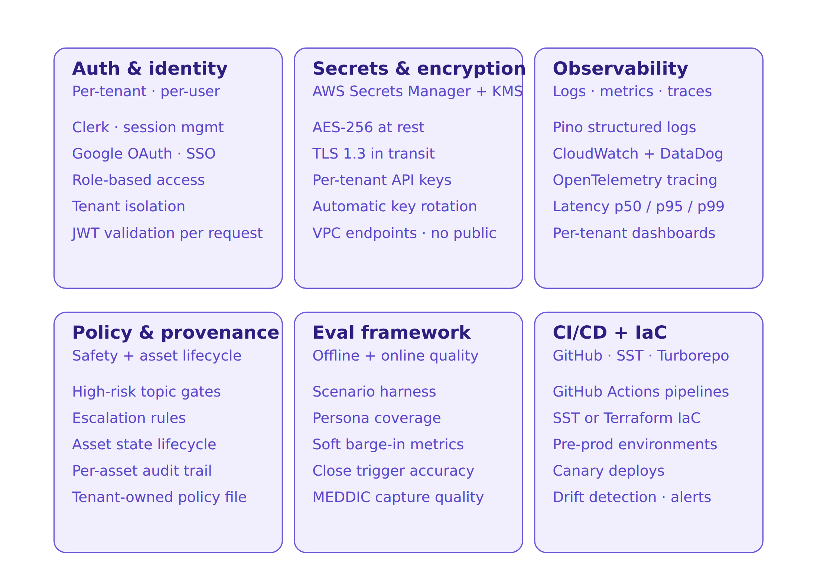
Figure 14.6 — Cross-cutting platform concerns

14.7 Runtime state machine & barge-in patterns
Five primary states form the conversation loop: IDLE, OPENING (choreography intro), LISTENING (STT capturing), PROCESSING (Claude generating), ANSWERING (TTS + playback). Three utility states handle exceptional transitions: DUCKED for soft backchannel barge-in (resumes ANSWERING after classifier confirms backchannel); INTERRUPTED for hard barge-in (cancels TTS, returns to LISTENING for a new utterance); ENDED for the close trigger from any state.
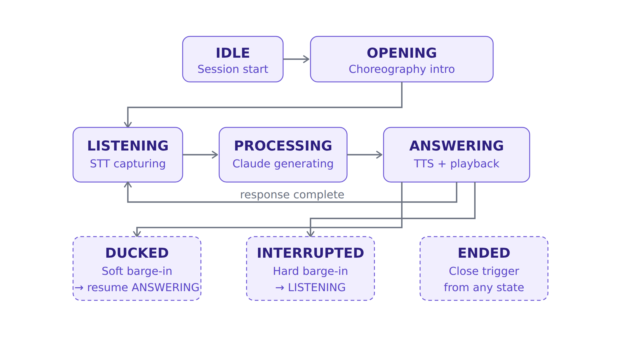
Figure 14.7 — Runtime state machine: five primary states plus three utility states for barge-in and close handling

14.8 Retrieval Intelligence Engine
The three-stage retrieval pipeline introduced in Section 7. Candidate generation pulls from hybrid search (vector + BM25), graph traversal, and Conversation Memory (session + episodic) in parallel, producing a pool of approximately 20 candidates. The ranker scores each candidate across seven weighted inputs; weights are v1 heuristics tuned per tenant by the Outcome Reinforcement Engine. Selection emits the top artifact along with a confidence score, the reasoning trace, and a fallback chain of alternatives.
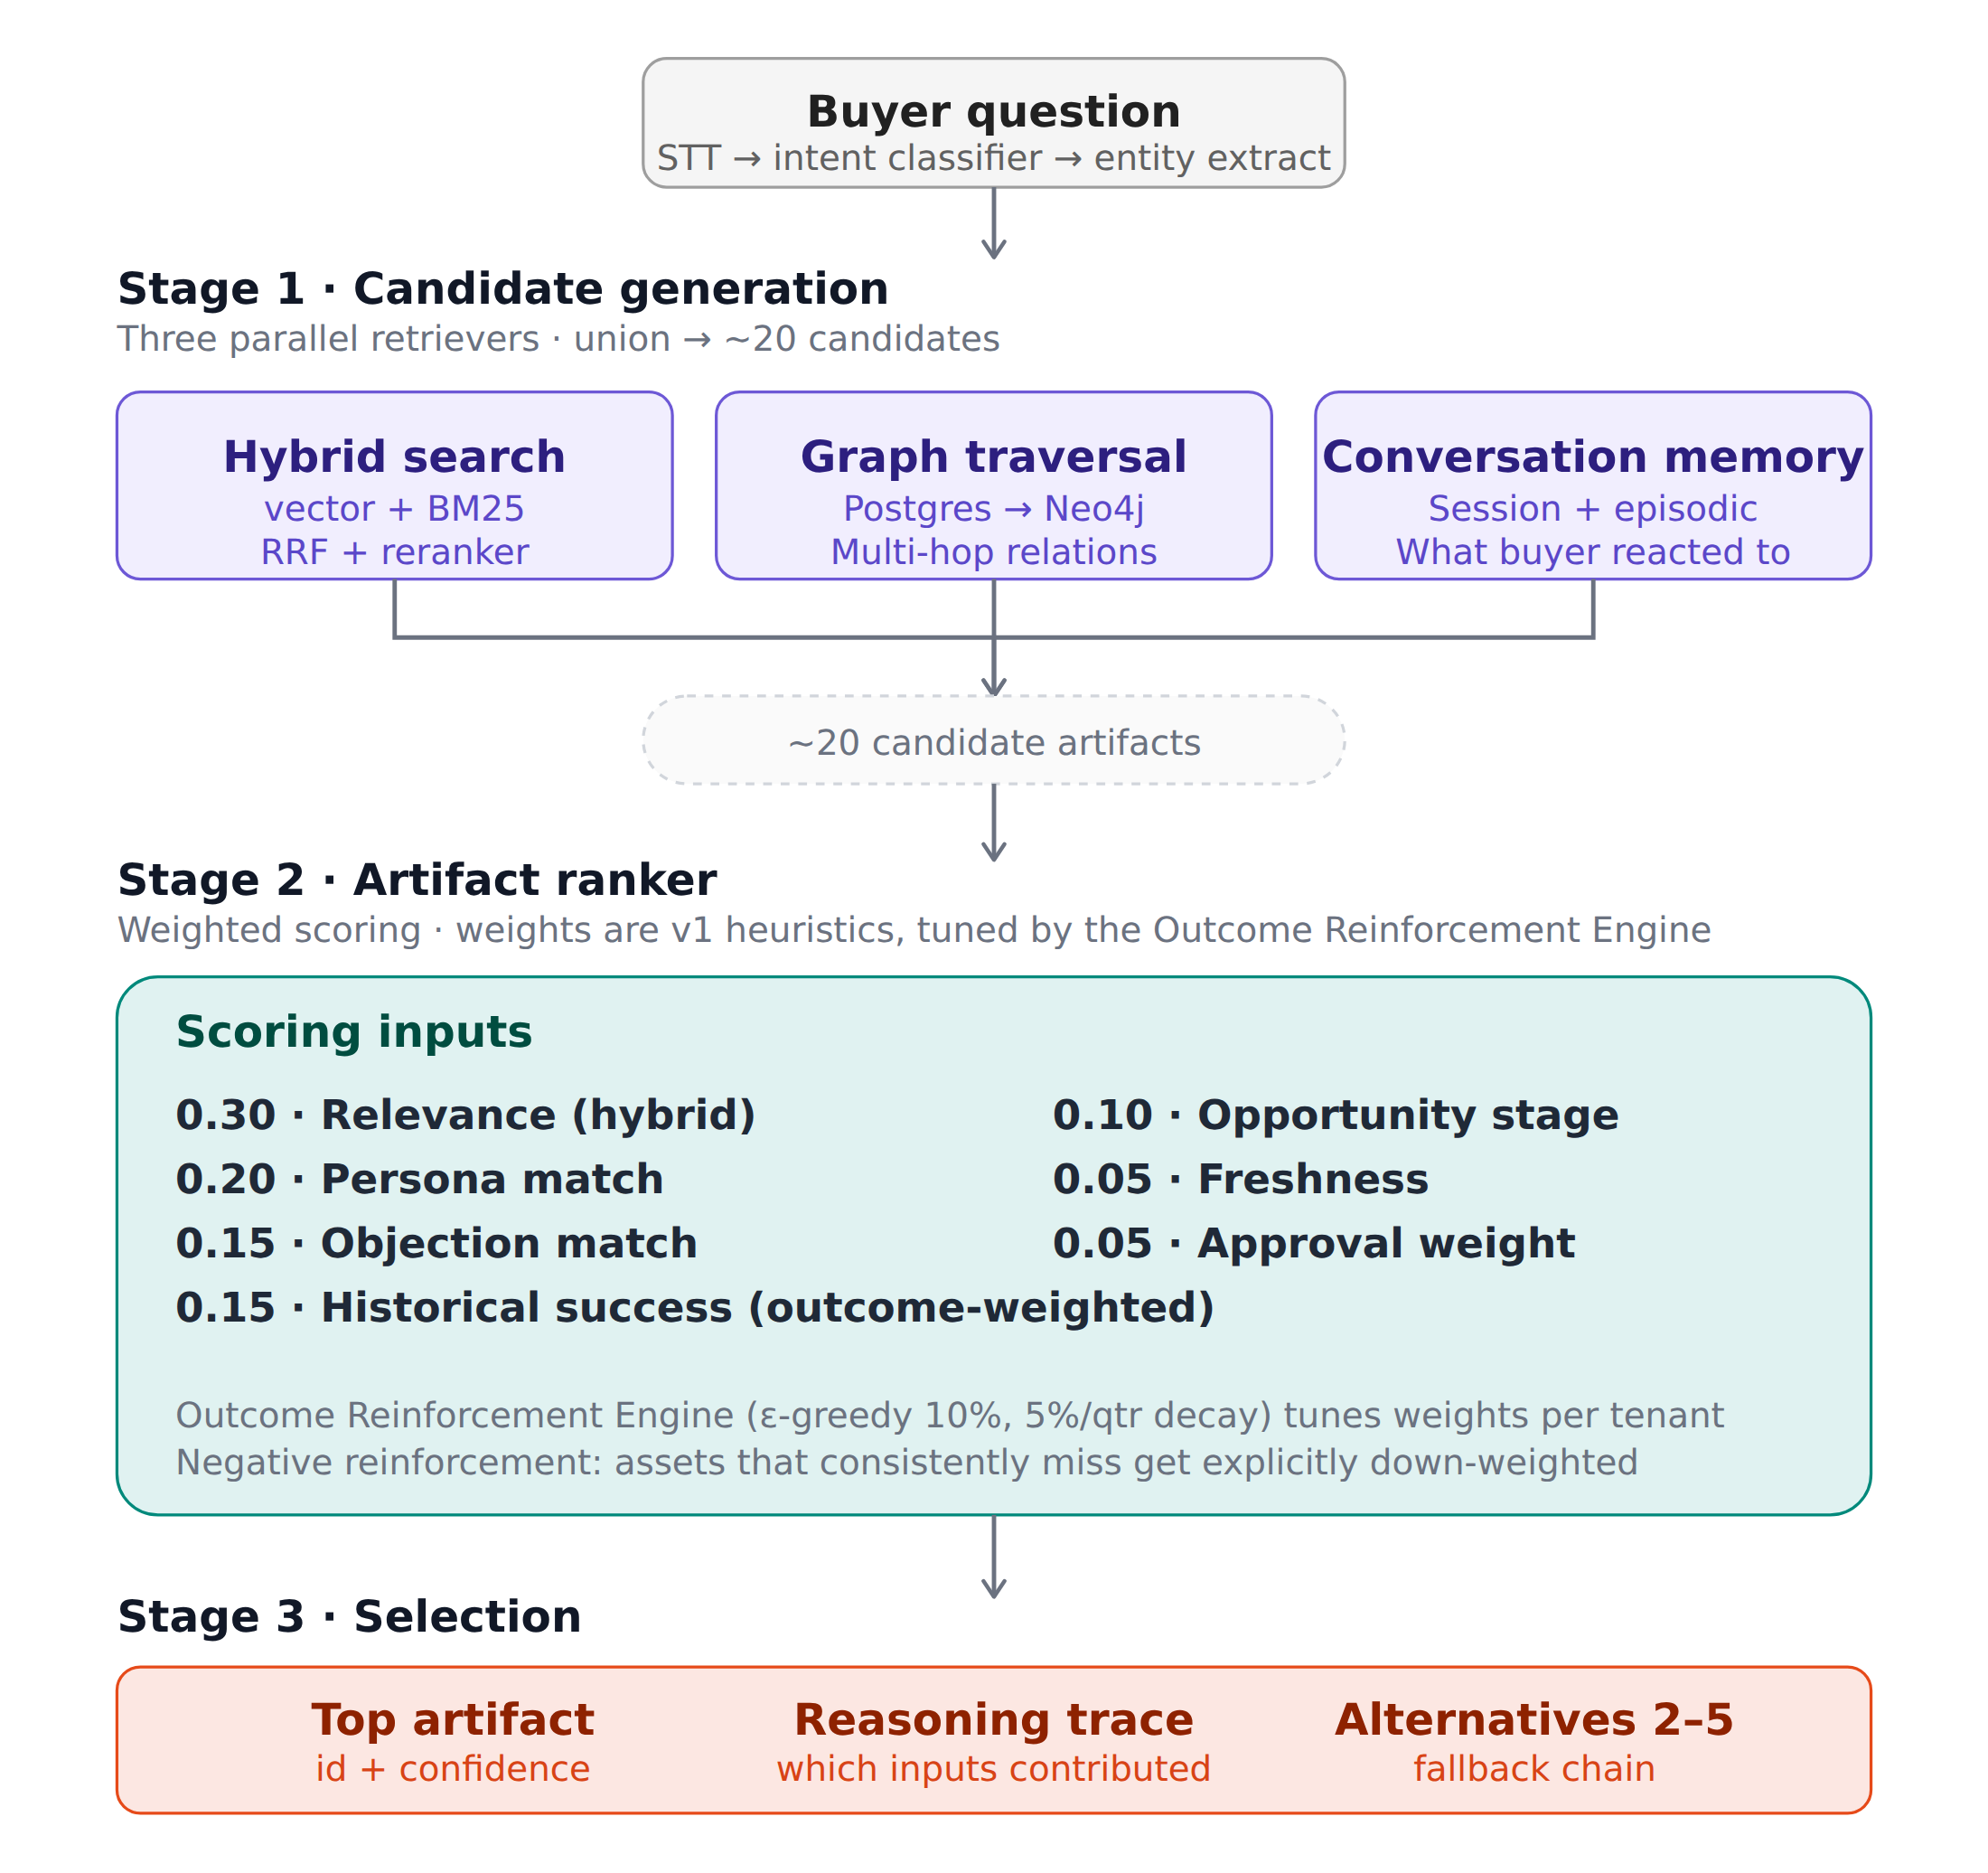
Figure 14.8 — Retrieval Intelligence Engine: candidate generation, weighted scoring, selection

15. Future Evolution
Two architectural moves are designed-for but not built in v1. They are documented here so that the v1 architecture decisions are conscious rather than accidental, and so the path to absorbing them later is clear.

15.1 Buyer & Committee Identity Graph
The v1 persona model (CFO, CTO, RevOps, VP of Engineering, etc.) is sufficient for the current ICP — sub-$5M ARR SaaS where opportunities close with one or two buyers and there is no formal buying committee. Moving upmarket (mid-market and above) requires a richer ontology of roles per opportunity.
The role ontology:
Economic Buyer — signature authority on the contract
Champion — the internal advocate driving the deal forward
Technical Evaluator — assesses product fit and integration feasibility
Security Reviewer — gatekeeper on SOC 2, GDPR, data residency
Legal Reviewer — contract terms, liability, IP
Procurement — pricing, vendor onboarding, payment terms
Executive Sponsor — senior stakeholder providing top-down endorsement
Data model. Roles are per opportunity, not per contact — a VP of Engineering can play Champion at one customer and Technical Evaluator at another. The schema:
Contact participates in Opportunity through one or more Roles
Opportunity has a Buying Committee composed of Roles played by Contacts
Account is the company that contains both
What it unlocks:
Buying-committee-aware messaging — what the Security Reviewer needs to hear differs from what the Economic Buyer needs to hear
Per-role MEDDIC field assignment — the Champion drives Identify Pain; the Economic Buyer drives Decision Criteria
Committee-coverage tracking — have all required stakeholders been briefed before the close?
Roadmap position. Phase 3, contingent on moving the ICP upmarket past sub-$5M ARR. Until then, the simpler persona model is sufficient and the additional schema complexity is not justified.

15.2 Multi-Agent Decomposition Path
The current architecture uses a single Claude streaming call per turn, with the Decision Hierarchy (Section 8.5) defining the priority order of concerns within that call.
Why single-call is correct for v1:
Single source of truth for state — no inter-agent coordination overhead
Lower latency — one network call per turn, not several
Easier evaluation — one prompt, one output, one set of behaviors to grade
Faster iteration — prompt changes are atomic, no orchestration logic to update
Future decomposition path, if scale or complexity warrants. Today's single call does conversation flow, retrieval planning, MEDDIC capture, steering, and close detection. The future decomposition would split these into focused agents:
Conversation Agent — turn-taking, tone, empathy, barge-in handling
Retrieval Agent — drives the Retrieval Intelligence Engine, selects artifacts, manages the candidate set
Sales Coach Agent — MEDDIC capture, steering moves, close detection, persona-priority tracking
CRM Agent — pre-call read, post-call writeback, field mapping, deal-stage logic
Policy Agent — safety gating, tenant-specific policy enforcement, escalation rules
Each future agent has its own prompt, tool set, and eval suite; an orchestrator routes the turn through them in the order defined by the Decision Hierarchy. This adds end-to-end latency (multiple LLM calls per turn) but enables independent evolution and evaluation of each concern.
Architectural reservation. Not in the v1 or v2 plan. Documented here so that the architectural commitment to single-call simplicity is intentional, and the path forward is reserved rather than discovered later.

16. Sizing & Scaling Triggers
This appendix anchors the storage strategy (Section 5.8) to real numbers and defines the measured triggers that graduate a layer from Postgres to a purpose-built store. Benchmarked against a Hightouch-class B2B SaaS tenant.

16.1 Footprint Benchmark — a Hightouch-class tenant
A real mid-market SaaS has far more than a handful of documents. Hightouch's public footprint: 250+ destination integration guides plus source/concept/platform docs (~350–500 doc pages); ~30–60 published case studies; ~50–100 product/solution/comparison pages; an active blog (~300–600 posts); plus the customer's own ~50–75 presentations. Two ingestion postures result:
Curated corpus — the sales-relevant subset (~230 docs, ~500K tokens, ~1,000 chunks, ~5–10K edges). Postgres is comfortable on every layer.
Full footprint — connect website + Confluence + CRM + Drive and ingest everything (~1,000–3,000 docs, ~2M+ tokens, ~10–30K chunks/tenant, ~30–100K edges). Pure long-context is impossible at this size; retrieval is essential, and the relationship graph is load-bearing.
Across 50 tenants the full-footprint vector total lands near ~0.5–1.5M vectors — the boundary where the Qdrant trigger becomes relevant. The graph stays on Postgres until real-time traversal latency, not capacity, forces the move.

16.2 Storage Strategy
Logical layers are fixed (Section 5.2). Physical stores are staged: launch on a single Postgres instance, graduate individual layers only when a trigger fires. The Retrieval Intelligence Engine interface is identical across stores, so each graduation is a store-adapter swap — not a re-architecture and not a change to either consuming product.

16.3 Scaling Trigger Table
Layer | Launch store | Graduates to | Trigger
Relationship graph | Postgres typed-edge tables + recursive CTEs | Neo4j AuraDB | Real-time multi-hop p95 breaches 590ms under concurrent load
Vector index | pgvector (same Postgres) | Qdrant | ~1M vectors total, or need for metadata filtering / quantization
Temporal validity | Last-write-wins + admin approval gate | Graphiti (on the graph store) | Stale-fact errors measurable in eval
Edge inference | Regex cascade + Claude for ambiguous | (scale workers, not architecture) | Ingestion volume — horizontal worker scaling, no store change
Each [trigger] component in Section 10 maps to a row here. Until a trigger fires, the launch store carries the load; when it fires, the swap happens behind the RIE interface.

Revenue is becoming code.
This document defines version 3.6 of the AI Demo Agent product requirements. v3.6 reconciles the Brain and Technology Stack to the full-footprint ingestion model (website + Confluence + CRM + Google Drive via MCP), adopts hybrid retrieval (vector + BM25 + reciprocal rank fusion + reranker) in the Retrieval Intelligence Engine, moves edge construction to a regex-first cascade with Claude reserved for ambiguous edges and entity resolution, and restages storage as Postgres-graph-first with Neo4j, Qdrant, and Graphiti behind measured latency/scale triggers (Sections 5.7, 5.8, 10, 16). It retains the first-class Retrieval Intelligence Engine and Outcome Reinforcement Engine (Section 7), the Knowledge Object Model (5.5), Conversation Memory (5.6), the runtime Decision Hierarchy (8.5), retrieval-specific quality metrics (13.4), and the reserved future-evolution paths (Section 15). The product ships with multi-source ingestion, hybrid GraphRAG retrieval, a Deepgram + Voxtral voice stack with VAD-driven barge-in, a streamed parallel pipeline under 1.3-second response, three sales-discipline capabilities (Steering, MEDDIC Capture, Agent-Led Close), and CRM-native intelligence via HubSpot and Salesforce MCP.
The buyer drives. The agent steers. The pipeline gets built.

