🎯 RECOMMENDED LEFT NAV (AI AD CREATIVE DESIGNER)
1. 📁 Projects / Assets [ Show like the start page of AIChat Gemini]
Icon: Folder / Grid
Purpose:
- Campaigns
- Saved creatives
- Templates
👉 Entry point into work
2. 🧱 Layout / Template [ Floating on Right Side]
Icon: Grid / Layers
Purpose:
- Choose ad format (story, banner, square)
- Switch templates
3. 🖼️ Media (Images / Video)
Icon: Image / Play button
Purpose:
- Upload images/videos [ Opens the Approved images page, see ref]
- AI generate visuals
- Replace background
👉 Core visual layer
4. ✍️ Copy (Text / Headline) [ Floating on Right Side]
Icon: Text (T)
Purpose:
- Headline
- Subtext
- Description
5. 🎯 CTA / Action [ Floating on Right Side]
Icon: Button / Cursor click
Purpose:
- CTA text
- Destination
- Behavior (future: actions like your email system)
👉 Important: keep separate from text
6. 🎨 Style / Brand [ Floating on Right Side]
Icon: Palette / Sparkles
Purpose:
- Colors
- Fonts
- Brand kit
- AI styling
7. ⚡ AI Assist [ Floating Editing Toolbar Under/ Above the creative Ad]
Icon: Magic wand / Sparkles
Purpose:
- Generate creatives
- Improve copy
- Suggest layouts
8. 🧪 Variants [ Floating Editing Toolbar Under/ Above the creative Ad]

Icon: Split / Shuffle
Purpose:
- Create variations
- Compare creatives
- Optimize
👉 Very important for ads
9. 📱 Preview
Icon: Device / Eye
Purpose:
- See how ad looks (platform formats)
- Feed vs story vs reel
10. 📤 Export / Publish [ Floating on Right Side]
Icon: Upload / Share
Purpose:
- Download assets
- Push to ad platforms

Floating Editing ToolBar1: On Click on an Image in the Canvas:
- PromptBox (for remixing headline/text)
- Image icon: Take to image asset page
- Ration: select one or convert to all

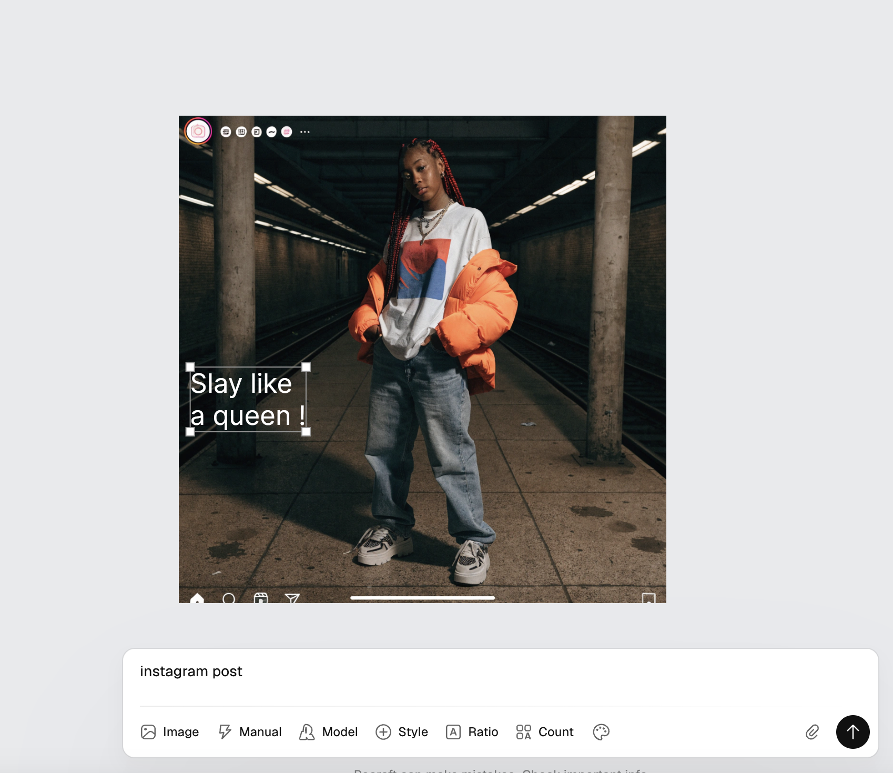

Floating Editing ToolBar2: Example

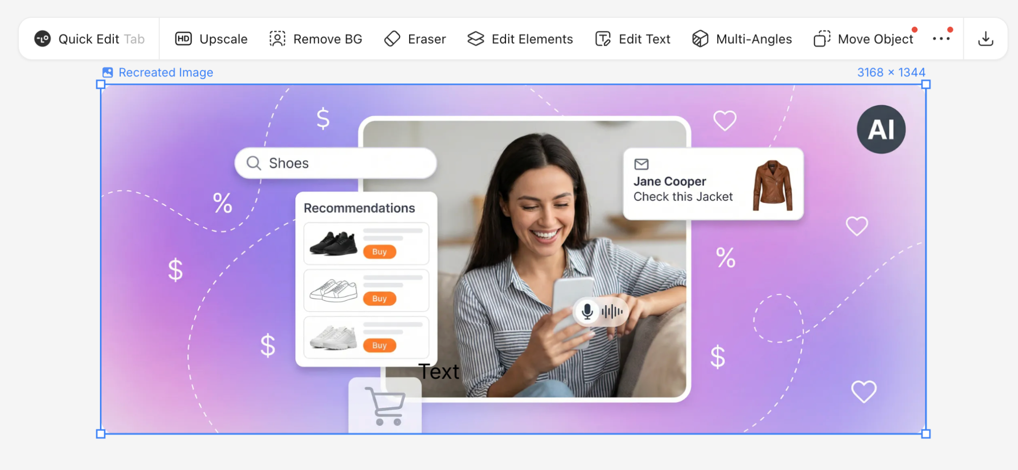

UI for Approved Images Page
