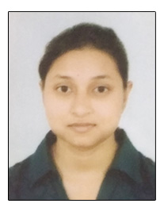 **Sushma Bharti**

Mail ID : sushmabharti0709@gmail.com  
 Contact No: 7979986158

**Education and Qualification**

|  |  |  |  |
| --- | --- | --- | --- |
| EXAMINATION PASSED | BOARD /  UNIVERSITY | YEAR OF  PASSING | MARKS/CGPA OBTAINED |
| BPT | VINOBA BHAVE UNIVERSITY,HAZARIBAGH | 2020 | 73% |
| CLASS XIITH | GURU GOBIND SINGH PUBLIC SCHOOL | 2012 | 71.4% |
| CLASS XTH | GURU GOBIND SINGH PUBLIC SCHOOL | 2010 | 9.2 CGPA |

**Achievements and Certifications**

* Manual Therapy in Spinal Dysfunction at Hazaribagh, by IAP.
* One Day workshop on HandsOn Training on Kinesio Taping, at VBU, Hazaribagh.
* As Delegate in National Physiotherapy Conference, BHU, Varanasi.
* 1st Prize in Poster Competition in National Physiotherapy Conference, BHU, Varanasi.
* Poster Competition at 55th Annual Conference of IAP, RIIMS, Ranchi, Jharkhand.
* As Delegate in 55th Annual Conference of IAP, RIIMS, Ranchi, Jharkhand.

**Hobbies**

* Art and craft, Painting, Poster Making, Sketching
* Photography
* Sports - Badminton

**Personal Details**

* Date of Birth : 07/09/1994
* Gender : Female
* Nationality : Indian
* Languages Known : English and Hindi
* Address : Plot No : 936, Bari Cooperative Colony, B.S. City, Jharkhand, India, Pincode : 827012.