
DEPARTMENT OF COMPUTER SCIENCE & DESIGN
CORNERSTONE PROJECT REPORT - I
ON
DESIGN AND DEVELOPMENT OF PREDICTSTOCK:
AN AI-BASED DEMAND FORECASTING AND
INVENTORY OPTIMIZATION SYSTEM

Submitted in partial fulfilment of the requirements for the degree of
BACHELOR OF TECHNOLOGY
in
COMPUTER SCIENCE & DESIGN
SUBMITTED BY:  Ashish Kumar Sen  Enrolment No.: BTCD24O1015  CSD - 3rd Year, 5th Semester | UNDER THE GUIDANCE OF:  Dr. Mahesh Parmar  Assistant Professor & Head  Department of Computer Science & Design
Academic Session: July - December 2026
Course Code: 29243110

DECLARATION BY THE CANDIDATE
I hereby declare that the project report entitled “Design and Development of PredictStock: An AI-Based Demand Forecasting and Inventory Optimization System” is a bona fide record of independent research, design, and software implementation carried out by me under the supervision and guidance of Dr. Mahesh Parmar, Department of Computer Science & Design, Madhav Institute of Technology & Science (MITS), Gwalior, during the academic session July-December 2026.
I further declare that this report has been authored and prepared for academic evaluation in partial fulfilment of the requirements for the degree of Bachelor of Technology in Computer Science & Design. The investigative work, algorithmic design, model benchmarking, empirical data auditing, and web application architecture presented in this thesis represent my original engineering efforts. Wherever data sources, machine learning libraries, published literature, mathematical algorithms, or technical concepts from external authors have been utilized, they have been comprehensively and explicitly acknowledged through formal citations conforming to the IEEE format.
I also solemnly affirm that this report has not been submitted previously, in full or in part, for the award of any other undergraduate degree, diploma, fellowship, or professional certification at Madhav Institute of Technology & Science or any other university or academic institution.
Signature of Candidate: ______________________________
Name: Ashish Kumar Sen
Enrolment No.: BTCD24O1015
Date: ____________________
Place: Gwalior

CERTIFICATE BY THE SUPERVISOR
This is to certify that the declaration made above by the candidate, Ashish Kumar Sen (Enrolment Number: BTCD24O1015), is correct to the best of my knowledge and belief. The engineering design, experimental research, machine learning benchmarking, and software system development described in this Cornerstone Project Report - I entitled “Design and Development of PredictStock: An AI-Based Demand Forecasting and Inventory Optimization System” were carried out under my direct supervision and technical guidance in the Department of Computer Science & Design, Madhav Institute of Technology & Science, Gwalior, during the academic semester July-December 2026.
The project work has attained a standard suitable for academic evaluation under the B.Tech. curriculum requirements, and I recommend this report for formal acceptance.
Guided By:
____________________________________
Dr. Mahesh Parmar
Assistant Professor & Head
Department of Computer Science & Design
Madhav Institute of Technology & Science, Gwalior
Date: ____________________
Departmental Project Coordinator:  ____________________________________  Dr Gagandeep Kaur  Assistant Professor  Department of Computer Science & Design  MITS, Gwalior | Approved by Head of Department:  ____________________________________  Dr. Mahesh Parmar  Assistant Professor & Head  Department of Computer Science & Design  MITS, Gwalior

PLAGIARISM CHECK CERTIFICATE
This is to certify that I, Ashish Kumar Sen, a student of Bachelor of Technology in Computer Science & Design (Enrolment Number: BTCD24O1015), have submitted my complete Cornerstone Project Report - I entitled “Design and Development of PredictStock: An AI-Based Demand Forecasting and Inventory Optimization System” for similarity and plagiarism verification using the official institutional Turnitin anti-plagiarism facility approved by Madhav Institute of Technology & Science, Gwalior.
This is to certify that the similarity percentage reported by the Turnitin plagiarism detection software is found to be ________%, which is well within the institutional permissible threshold of 30.0%.
The comprehensive plagiarism evaluation report generated by Turnitin, along with the detailed similarity source breakdown and match summary, has been appended to the end of this report.
Candidate Signature: ______________________________
Name: Ashish Kumar Sen
Enrolment No.: BTCD24O1015
Date: ____________________
Place: Gwalior
Checked and Approved By:
____________________________________
Dr. Mahesh Parmar
Supervisor & Head of Department
Department of Computer Science & Design
Madhav Institute of Technology & Science, Gwalior

ABSTRACT
Multi-echelon retail supply chains face an endemic operational tension between stockout prevention and working capital preservation. Over-replenishing inventory triggers severe holding carrying costs, shelf obsolescence, and working capital immobilization; conversely, under-replenishing inventory culminates in lost sales, compromised customer fulfillment service levels, and customer attrition. PredictStock was developed as an end-to-end, enterprise-grade AI decision-support platform designed to bridge the structural disconnect between raw historical point-of-sale telemetry and deterministic store-level replenishment execution across heterogeneous retail branch networks.
The empirical foundation of this project is a multi-store retail sales repository comprising 7,431,525 transaction-level observations spanning 28 August 2022 to 26 September 2024 across four distinct retail branches and approximately 25,000 product SKUs. An exhaustive initial data audit validated the temporal stability of the core sales stream while systematically assessing auxiliary datasets. Crucially, candidate auxiliary sources including price histories (2.67% sales overlap), discount tables (20.44% match rate), markdown logs (0.12% match rate), and actual inventory matrices (25,106 records) were identified as exhibiting severe temporal truncation and were deliberately excluded to prevent data contamination and spurious signal induction.
A zero-imputed daily product-store panel comprising 13,535,780 records across 31 attributes was engineered. The dataset exhibited extreme sparsity (63.0% zero-demand days) and marked branch volume asymmetry (Store 1 accounting for 49.6% of sales, compared to 11.2% in Store 3). To represent time-series dynamics without data leakage, an engineered feature pipeline incorporated autoregressive lags (1, 7, 14, 28 days), rolling averages, 56-day summary statistics, trigonometric cyclical calendar encodings, and hierarchical metadata embeddings.
Under strict chronological validation, a post-mortem of an earlier recursive XGBoost architecture revealed catastrophic multi-step error accumulation (+93.49% aggregate bias, predicting 12.03 million units against 4.97 million actual). Consequently, a direct multi-horizon gradient boosting architecture was formulated. Extensive benchmarking across 7-day, 30-day, and 90-day horizons confirmed LightGBM's superior accuracy. Evaluated on an untouched hold-out test period (30 June to 26 September 2024; 89 days), LightGBM achieved an R² of 0.9346 (MAE = 8.76, bias = -6.17%) for the 7-day horizon and an R² of 0.9292 (MAE = 32.95, bias = -2.26%) across 13,447 product-store pairs for the core 30-day replenishment horizon.
A decoupled inventory engine translates 30-day forecasts into actionable purchasing directives by enforcing a 20% parametric safety buffer, calculating required stock, net reorder quantities floored at zero, and classifying pairs into Critical (<50% coverage), Low (50-100%), and Sufficient (≥100%) health tiers. Finally, the legacy monolithic Streamlit script was decommissioned and replaced with a full-stack, enterprise-grade architecture comprising an asynchronous FastAPI backend and a modern React 18/Vite glassmorphic flight deck with interactive simulation, SVG arc gauges, and instant CSV/Parquet procurement exports.
Keywords: Retail Demand Forecasting, LightGBM, Gradient Boosted Decision Trees, Inventory Replenishment, Safety Stock Optimization, Time-Series Feature Engineering, FastAPI, React.

ACKNOWLEDGEMENT
The conception, development, and completion of this Cornerstone Project Report - I have been an immensely enriching educational milestone in my academic journey. I express my profound gratitude to Madhav Institute of Technology & Science (MITS), Deemed to be University, Gwalior, for fostering an inspiring educational ecosystem and granting me the opportunity to pursue this capstone project under the provisions of the Flexible Curriculum Scheme approved by the Academic Council.
I convey my deepest reverence and gratitude to the Honourable Vice Chancellor of the Institute, Dr. R. K. Pandit, and the Pro Vice Chancellor, Dr. Manjaree Pandit, whose forward-looking administrative leadership and progressive curriculum design provide undergraduate students with the intellectual freedom to undertake demanding, industry-relevant research initiatives.
I am profoundly indebted to my supervisor and mentor, Dr. Mahesh Parmar, Assistant Professor & Head, Department of Computer Science & Design. His incisive technical insights, rigorous mathematical expectations, and unwavering encouragement guided this project through every phase - from dataset auditing and model selection to full-stack software deployment. His constructive critiques challenged me to look beyond surface-level metrics, investigate algorithmic failure modes like recursive error accumulation, and maintain rigorous engineering integrity.
I also extend my sincere appreciation to Dr Gagandeep Kaur, Assistant Professor & Departmental Project Coordinator, and all esteemed faculty members and laboratory staff of the Department of Computer Science & Design for their constant support, guidance, and academic mentorship throughout my coursework.
Finally, I dedicate this work to my beloved parents, family members, and friends. Their unconditional belief, patience, and moral support have been my greatest pillars of strength throughout this endeavor.
Ashish Kumar Sen
Enrolment No.: BTCD24O1015
B.Tech. (Computer Science & Design), 3rd Year, 5th Semester
Department of Computer Science & Design
MITS, Gwalior

TABLE OF CONTENTS
Table of Contents Layout
Section / Chapter | Title | Page (Indicative)
Front Matter | Declaration by the Candidate | i
Front Matter | Certificate by the Supervisor & Institutional Approvals | ii
Front Matter | Plagiarism Check Certificate | iii
Front Matter | Abstract | iv
Front Matter | Acknowledgement | v
Front Matter | Table of Contents | vi
Front Matter | Acronyms & Nomenclature | vii
Front Matter | List of Figures & List of Tables | viii
Chapter 1 | Introduction: Retail Supply Chain Optimization | 1
Chapter 2 | Literature Survey & Methodological Foundations | 5
Chapter 3 | Dataset Audit, Data Cleansing, and Exploratory Analysis | 10
Chapter 4 | Feature Engineering & Direct Multi-Horizon Forecasting | 16
Chapter 5 | Predictive Modeling, Benchmarking, and Evaluation | 22
Chapter 6 | Inventory Optimization Engine & Full-Stack Deployment | 28
Chapter 7 | Results Discussion, Limitations, and Future Roadmap | 34
Back Matter | References (IEEE Format) | 39
Back Matter | Turnitin Plagiarism Verification Report | 41
Back Matter | Monthly Progress Reports (MPRs) | 42
Appendix A | Repository File Inventory & Production Artifacts | 43
Appendix B | Mathematical & Algorithmic Formulations | 44
Checklist | Final Institutional Submission Checklist | 45

ACRONYMS & NOMENCLATURE
List of System Acronyms
Acronym | Full Expansion & Operational Definition
AI | Artificial Intelligence - Algorithmic decision systems mimicking human cognition.
ML | Machine Learning - Empirical pattern recognition and predictive statistical modeling.
EDA | Exploratory Data Analysis - Investigative data analysis uncovering structural traits.
GBDT | Gradient Boosted Decision Trees - Ensembles of iteratively trained decision trees.
LGBM | Light Gradient Boosting Machine - High-performance histogram-based GBDT algorithm.
XGBoost | Extreme Gradient Boosting - Regularized second-order Taylor expansion tree boosting.
CatBoost | Categorical Boosting - Permutation-driven boosting mitigating prediction shift.
SKU | Stock Keeping Unit - Unique machine-readable product item tracking identifier.
MAE | Mean Absolute Error - Linear average magnitude of absolute prediction residuals.
RMSE | Root Mean Squared Error - Quadratic error metric penalizing extreme outliers.
R² | Coefficient of Determination - Proportion of target variance explained by the model.
REST | Representational State Transfer - Stateless client-server web architectural style.
API | Application Programming Interface - Formal protocol for inter-service communication.
UI | User Interface - Interactive visual frontend display for human operators.
POS | Point of Sale - Transactional checkout telemetry recording observed retail demand.
CSV | Comma-Separated Values - Plain-text structured tabular data exchange format.
MPR | Monthly Progress Report - Periodic institutional student milestone documentation.

Mathematical Nomenclature
Symbol / Variable | Mathematical & Engineering Description
item_id | Unique hexadecimal categorical key identifying an individual retail product.
store_id | Integer identifier representing a specific brick-and-mortar retail branch (1 to 4).
y_{i,s}(t) | Observed point-of-sale customer demand for item i in store s on date t.
\hat{D}_{H,i,s} | Predicted cumulative customer demand over future horizon H in {7, 30, 90} days.
lag_k | Historical daily demand observed exactly k days prior to the forecast origin.
RollingMean_k | Unweighted historical moving average computed across a trailing k-day window.
SS_{i,s} | Allocated safety stock reserve buffering against demand volatility and lead-time delays.
beta | Safety buffer policy coefficient set as a baseline assumption to 0.20 (20%).
RS_{i,s} | Total required inventory ceiling incorporating expected demand and safety buffer.
CS_{i,s} | Current on-hand available inventory physically present at the retail store branch.
RQ_{i,s} | Recommended replenishment order quantity floored strictly at zero to prevent negative orders.
SR_{i,s} | Stock Ratio: dimensionless ratio of available stock relative to total required stock.
Bias % | Aggregate percentage deviation between total predicted volume and total actual sales volume.

LIST OF FIGURES & LIST OF TABLES
List of Figures
- Figure 1.1: PredictStock Decoupled Two-Stage Architectural Framework.
- Figure 1.2: End-to-End Computational Pipeline Flow.
- Figure 3.1: Sales Transaction Distribution Across Retail Stores (`03_eda.ipy_c13_img0.png`).
- Figure 3.2: 2-Year Aggregate Daily Demand Timeline (`03_eda.ipy_c18_img2.png`).
- Figure 3.3: Day-of-Week Customer Demand Seasonality (`03_eda.ipy_c25_img4.png`).
- Figure 3.4: Right-Skewed Log-Scale Demand Quantity Distribution (`03_eda.ipy_c61_img11.png`).
- Figure 4.1: Chronological Validation and Hold-Out Splitting Strategy (`fig_chronological_splits.png`).
- Figure 5.1: 30-Day Model Validation Benchmark Comparison (`fig_model_benchmark.png`).
- Figure 6.1: Replenishment Stock Health Status Distribution across 13,447 Pairs (`fig_inventory_distribution.png`).
- Figure 6.2: PredictStock Full-Stack Decoupled System Architecture (FastAPI & React 18).
List of Tables
- Table 1.1: Core Project Objectives and Measurable Technical Deliverables.
- Table 3.1: Candidate Data Sources Evaluation and Ingestion Decisions.
- Table 3.2: Raw Historical Sales Audit Profile.
- Table 3.3: Store Branch Sales and Volume Share Distribution.
- Table 3.4: Exploratory Data Analysis Empirical Findings and Engineering Actions.
- Table 4.1: Engineered Feature Groups Taxonomy and Look-Back Offsets.
- Table 4.2: Forecast Horizons and Downstream Decision Context.
- Table 4.3: Temporal Chronological Partition Boundaries.
- Table 5.1: Naive and Moving-Average Statistical Baseline Performance (Validation).
- Table 5.2: 7-Day Operational Horizon Machine Learning Benchmark (Validation).
- Table 5.3: 30-Day Primary Planning Horizon Machine Learning Benchmark (Validation).
- Table 5.4: 90-Day Extended Horizon Machine Learning Benchmark (Validation).
- Table 5.5: Final Untouched Hold-Out Test Set Performance (LightGBM Pipeline).
- Table 5.6: Forecast Consistency and Horizon Monotonicity Checks (13,447 Pairs).
- Table 6.1: Deterministic Inventory Replenishment Formulation Matrix.
- Table 6.2: Tri-Level Stock Health Classification Thresholds.
- Table 6.3: Large-Scale Inventory Demonstration Simulation Summary.
- Table 6.4: Recommended Order Volume Breakdown by Store Branch.
- Table 6.5: Full-Stack Decoupled Architecture Implementation Stack.
- Table 7.1: Comprehensive Summary of Empirical System Metrics.
- Table 7.2: Operational Boundaries, Assumptions, and Future Roadmap.

CHAPTER 1: INTRODUCTION
1.1 Background and Operational Motivation
Modern retail supply chains operate under severe, unavoidable uncertainty. For multi-branch brick-and-mortar retailers managing tens of thousands of stock-keeping units (SKUs) across geographically dispersed stores, replenishment planning represents an intricate balancing act. Ordering inventory in excess of customer absorption locks up liquid working capital, incurs compounding warehousing and carrying charges, and exposes physical stock to obsolescence, spoilage, or aggressive promotional markdowns. Conversely, underestimating customer demand inevitably culminates in product stockouts, forfeited revenue, disrupted customer fulfillment metrics, and permanent customer churn to competing retail channels.
Point-of-sale (POS) transactional checkout systems continually capture rich streams of historical consumption data. When processed through modern statistical learning algorithms, these empirical records reveal latent recurring demand patterns, day-of-week purchasing rhythms, holiday spikes, and store-specific footfall dynamics. However, in conventional retail software implementations, an acute structural gap persists: machine learning models typically produce detached statistical demand projections without translating those projections into actionable, operationally constrained replenishment orders tailored to on-hand warehouse realities. PredictStock was conceived to resolve this disconnect by establishing a closed-loop, two-stage architectural pipeline connecting historical sales telemetry directly to deterministic inventory optimization decisions.
1.2 Problem Statement
Retail managers overseeing multi-store operations lack robust, automated decision-support mechanisms capable of generating accurate, branch-level demand projections across multiple planning horizons while accounting for extreme intermittency, regional demand asymmetry, and localized store dynamics. Traditional heuristics - such as fixed reorder points or naive trailing averages - routinely fail because they ignore product hierarchy context, temporal seasonality, and the nonlinear effects of calendar variations.
[CORE RESEARCH PROBLEM] How can large-scale, sparse point-of-sale transaction histories be transformed into calibrated multi-horizon demand forecasts across heterogeneous retail store branches, and how can those statistical forecasts be deterministically translated into actionable, risk-buffered replenishment orders without conflating demand estimation with inventory constraints?

1.3 Proposed Solution: The PredictStock Architecture
PredictStock is engineered as an enterprise-grade artificial intelligence decision-support platform designed to automate retail replenishment workflows. The system is structurally anchored upon a decoupled, two-stage operational paradigm:
- Stage 1 - Multi-Horizon Demand Forecasting Engine: Direct gradient-boosted decision tree models (LightGBM) trained on historical demand, autoregressive lags, moving statistics, and cyclical calendar attributes generate granular 7-day, 30-day, and 90-day demand predictions independently for each unique product-store combination.
- Stage 2 - Downstream Deterministic Inventory Engine: The primary 30-day demand forecast is ingested by a rule-based optimization module that factors in on-hand inventory levels and applies a parametric safety stock buffer (baseline 20%) to calculate required inventory ceilings, net replenishment shortfalls, and tri-level health classifications (Critical, Low, Sufficient).

Figure 1.1: Official PredictStock Project Emblem and Identity.
1.4 Research and Development Objectives
To realize an end-to-end operational platform, the project pursued the following concrete engineering objectives:
- Audit, cleanse, and evaluate raw multi-store transactional logs, product catalogs, and auxiliary pricing files to construct a consistent historical telemetry foundation.
- Construct an exhaustive, zero-demand imputed daily product-store panel dataset spanning over two chronological years while eliminating prospective data leakage risks.
- Conduct a 17-stage exploratory data analysis (EDA) to quantitatively characterize demand sparsity, right-skewed volume distributions, store-level asymmetry, and seasonality.
- Engineer a past-only feature matrix combining autoregressive lags, moving window summaries, 56-day dispersion metrics, trigonometric cyclical encodings, and categorical embeddings.
- Implement strict chronological time-based validation splits and benchmark classical statistical baselines against tree-boosting architectures (LightGBM, CatBoost, XGBoost).
- Investigate algorithmic failure modes in recursive forecasting and validate direct multi-horizon models on an untouched 89-day hold-out evaluation window.
- Formulate an inventory decision layer computing safety stock, required stock ceilings, net replenishment quantities, and categorical health statuses across 13,447 product-store pairs.
- Decommission legacy monolithic prototype scripts and implement an enterprise full-stack web application featuring an asynchronous FastAPI REST backend and a modern React 18/Vite UI.
Table 1.1: Core Project Objectives and Measurable Technical Deliverables
Objective Identifier | Engineering Focus Area | Measurable Milestone / Deliverable
OBJ-1: Audit & Ingestion | Raw Source Evaluation | Empirical overlap analysis; exclusion of truncated auxiliary files.
OBJ-2: Panel Formulation | Grid Engineering | Daily zero-filled panel of 13,535,780 rows across 4 stores.
OBJ-3: Feature Engineering | Temporal Feature Pipeline | Lags (1, 7, 14, 28), moving statistics, cyclical sine/cosine encoders.
OBJ-4: Benchmarking | Model Validation | Direct multi-horizon evaluation across 7D, 30D, and 90D planning horizons.
OBJ-5: Model Deployment | Hold-Out Evaluation | Final LightGBM test metrics (30D R²=0.9292, bias=-2.26% on 13,447 pairs).
OBJ-6: Inventory Engine | Replenishment Policy | Deterministic 20% safety buffer; Critical/Low/Sufficient health categorization.
OBJ-7: Full-Stack App | System Integration | FastAPI REST API + React 18/Vite glassmorphic flight deck with simulation.

1.5 Scope and Operational Boundaries
The operational boundaries of the experimental framework are delineated below to maintain strict academic and scientific transparency:
- In Scope: Comprehensive dataset auditing, historical panel construction, leakage-free feature engineering, multi-model benchmarking, hold-out test evaluation, deterministic inventory math, category-based related product matching, and a responsive full-stack web deployment.
- Out of Scope: Real-time point-of-sale ERP integration, automated continuous retraining pipelines, supplier-specific purchase order issuance, and live payment processing.
[OPERATIONAL DATA FRESHNESS BOUNDARY] The saved demand forecasts are established upon historical observations concluding on September 26, 2024. In the inventory demonstration, baseline stock levels were initialized using a deterministic seed-42 synthetic distribution (30% to 130% of required stock) to demonstrate the multi-echelon calculation pipeline across 13,447 pairs. In live production, these values are supplanted by real-time inventory feeds.

1.6 Report Organization
The remainder of this report is organized as follows: Chapter 2 reviews relevant academic literature, time-series forecasting principles, and gradient boosting theory. Chapter 3 presents the source data audit, data cleaning procedures, panel grid construction, and 17-stage exploratory findings. Chapter 4 elaborates the temporal feature engineering methodology, chronological evaluation design, and direct multi-horizon modeling approach. Chapter 5 details the baseline benchmarking, candidate model comparisons, and untouched hold-out test results. Chapter 6 describes the mathematical formulation of the inventory engine, simulation outputs, and the full-stack software architecture. Finally, Chapter 7 synthesizes project conclusions, engineering contributions, limitations, and future research directions.

CHAPTER 2: LITERATURE SURVEY & METHODOLOGICAL FOUNDATIONS
2.1 Complexities in SKU-Level Multi-Store Demand Forecasting
Demand forecasting in physical retail networks is fundamentally more intricate than classical macroeconomic or aggregated time-series projection. Retail telemetry operates across multiple hierarchical echelons - from individual product SKUs up through categories, departments, individual store branches, geographic divisions, and enterprise totals. Traditional forecasting literature frequently focuses on top-down aggregate forecasts; however, store-level inventory replenishment requires granular, bottom-up forecasts generated independently for each product-store pair (item_id, store_id). At this granular level, historical demand profiles exhibit three defining pathologies: high intermittency (many zero-sales days), extreme right-skewness (infrequent bulk orders or promotional surges), and high coefficient of variation across distinct store formats [4].
2.2 Classical Statistical Benchmarks and Baselines
In applied machine learning, complex models must always be evaluated relative to transparent, parsimonious statistical baselines. If a high-capacity neural network or gradient-boosted ensemble cannot consistently surpass an unweighted rolling average or seasonal-naive rule, its added computational complexity and operational maintenance overhead cannot be justified. Common statistical baselines in retail forecasting include:
- Seasonal-Naive Method: Assumes demand in the forecast period exactly mirrors demand observed during an equivalent seasonal cycle in the past (e.g., matching the same weekday or preceding month).
- Recent Window Means: Computes the unweighted moving average over a trailing window (e.g., 14 days or 28 days), effectively smoothing high-frequency noise but introducing lag during sharp trend transitions.
- Historical Long-Window Mean: Averages observations over an extended look-back window (e.g., 56 days), providing a highly stable, low-variance baseline that performs remarkably well under stationary, intermittent demand.
2.3 Gradient-Boosted Decision Tree Architectures
Gradient Boosted Decision Trees (GBDT) have established empirical dominance over deep learning architectures for structured, tabular time-series feature spaces [1]-[3]. Unlike linear models, GBDT models naturally capture complex nonlinear relationships, high-order feature interactions, and threshold effects without requiring target normalization or feature scaling. Three state-of-the-art implementations were benchmarked in this research:
- LightGBM (Light Gradient Boosting Machine): Developed by Ke et al. [1], LightGBM introduces two key algorithmic innovations: Gradient-Based One-Side Sampling (GOSS), which retains instances with large gradients while downsampling instances with small gradients, and Exclusive Feature Bundling (EFB), which bundles mutually exclusive sparse features. Furthermore, its histogram-based binning and leaf-wise (best-first) tree growth strategy significantly accelerate training throughput and memory efficiency while yielding superior convergence on large panels.
- XGBoost (Extreme Gradient Boosted Trees): Introduced by Chen and Guestrin [2], XGBoost optimizes an objective function utilizing a second-order Taylor expansion for the loss function, paired with advanced L1/L2 tree complexity regularization. While highly expressive, its exact greedy split-finding algorithm incurs heavier computational costs on large-scale datasets.
- CatBoost (Categorical Boosting): Formulated by Prokhorenkova et al. [3], CatBoost addresses target leakage and prediction shift caused by traditional categorical target encoding through an innovative 'ordered boosting' framework. It is particularly effective when categorical attributes have high cardinality, though it requires substantial memory overhead during multi-step panel evaluations.
2.4 Time-Series Feature Engineering and Harmonic Encodings
When framing a time-series problem within a supervised tabular regression paradigm, temporal structure must be explicitly synthesized into informative features. Autoregressive lag features provide direct visibility into recent realization values (e.g., demand yesterday, demand one week ago). Rolling-window statistics (moving averages, standard deviations, and window extrema) capture localized velocity, central tendency, and dispersion over diverse trailing horizons.
Calendar features represent recurring institutional cycles, such as weekends, month boundaries, and quarterly transitions. To avoid imposing an artificial linear discontinuity between the beginning and end of cyclic intervals (e.g., treating Sunday as 6 and Monday as 0), periodic attributes are mapped into continuous two-dimensional Euclidean space using sine and cosine harmonic transformations:
[CYCLICAL HARMONIC ENCODING FORMULATION] x_{sin} = sin(2 * pi * t / T), x_{cos} = cos(2 * pi * t / T) where T represents the natural cycle period (e.g., T = 7 for day of the week, T = 12 for month of the year). This trigonometric projection ensures that cyclical boundaries are smooth and continuous.

2.5 Time-Aware Validation Protocols versus Random Splitting
A pervasive methodological flaw in published machine learning literature is the application of randomized cross-validation (e.g., standard K-fold cross-validation) to sequential time-series data. Randomly partitioning records across time allows future observations to leak into the training partition, creating artificial, unrealistically optimistic performance metrics that collapse entirely during live operational deployment. In this research, strict temporal separation is enforced: training data spans exclusively up to a fixed temporal cutoff, validation is conducted on a contiguous subsequent window, and final model evaluation is reserved for an untouched hold-out test period.
2.6 Multi-Metric Accuracy and Aggregate Bias Formulations
Evaluating retail forecasting systems requires a multi-faceted assessment framework, as no single statistical metric adequately captures operational trade-offs:
- Mean Absolute Error (MAE): Measures the average magnitude of absolute errors in the physical units of demand, treating over-prediction and under-prediction symmetrically without inflating large outliers.
- Root Mean Squared Error (RMSE): Squares individual residuals prior to averaging, thereby heavily penalizing extreme forecasting errors. This is crucial for supply chain planning, where massive localized under-predictions cause severe stockouts.
- Coefficient of Determination (R²): Quantifies the proportion of target variance explained by the model relative to a naive horizontal mean benchmark.
- Aggregate Percentage Bias (Bias %): Measures systematic over- or under-forecasting volume across the entire network:
[AGGREGATE VOLUME BIAS METRIC] Bias % = [(Sum of Predicted Demand - Sum of Actual Demand) / Sum of Actual Demand] * 100%. A model with minimal MAE may still exhibit severe directional bias, which systematically drains working capital (positive bias) or induces chronic stockouts (negative bias).

2.7 Buffer-Stock Inventory Control Theory
Classical inventory control literature (e.g., base-stock policies, (s, S) continuous review systems) dictates that replenishment orders must satisfy expected demand during the replenishment cycle while incorporating a protective safety stock buffer to absorb stochastic demand surges and supplier lead-time variability. In standard theoretical models, safety stock is formulated as a function of target cycle service level (z-score), lead-time duration, and forecast error standard deviation. In PredictStock, to maintain transparent, auditable business logic across multi-store retail environments, a parametric safety buffer percentage (beta = 0.20, or 20%) is applied directly to the 30-day forecasted demand, establishing a deterministic required stock ceiling.
2.8 Decoupled Engineering Paradigm in Modern Enterprise Systems
A fundamental architectural distinction of PredictStock is the strict decoupling of demand estimation from inventory constraints. Many naive machine learning implementations feed 'current stock' as an input feature into the forecasting model; this conflates customer demand with inventory availability, creating severe endogeneity bias (e.g., if a product is out of stock, sales drop to zero, erroneously teaching the model that customer demand has vanished). By keeping demand estimation strictly unconstrained, the generated forecast represents pure consumer demand potential, which can subsequently be compared against any live inventory snapshot to drive replenishment.

CHAPTER 3: DATASET AUDIT, PREPARATION AND EXPLORATORY ANALYSIS
3.1 Raw Ingestion Landscape
The foundational data asset utilized in this research is an enterprise multi-store retail sales repository spanning over two years of point-of-sale transactional telemetry, accompanied by auxiliary product hierarchies, store profiles, and commercial promotional histories. The primary transactional file, sales.csv, encapsulates 7,431,525 transaction-level observations spanning from 28 August 2022 to 26 September 2024. The observational unit of this raw stream is an individual transaction indexed by date, product identifier (item_id), and retail store branch (store_id).
3.2 Source Discrimination and Pruning Rationale
Prior to model ingestion, an empirical overlap audit was conducted across all candidate data sources. Merging disparate data streams without verifying temporal alignment introduces substantial missingness, introduces artificial null values, and forces machine learning models to learn from spurious signals. Table 3.1 details the empirical source audit and selection decisions:
Table 3.1: Candidate Data Sources Evaluation and Ingestion Decisions
Source File | Total Rows | Temporal Overlap with Sales | Engineering Decision & Rationale
sales.csv | 7,431,525 | 100.0% (Aug 2022 - Sep 2024) | RETAINED: Primary ground-truth transactional demand stream.
catalog.csv | 25,243 | 100.0% SKU Coverage | RETAINED: Product hierarchy metadata (department, class, subclass).
stores.csv | 4 | 100.0% Store Coverage | RETAINED: Branch attributes (geographic division, format, city, area).
actual_matrix.csv | 25,106 | < 0.35% of sales timeline | EXCLUDED: Extreme sparsity; insufficient historical temporal depth.
price_history.csv | 4,180,950 | 2.67% of sales rows matched | EXCLUDED: Temporal truncation; merging creates 97.33% missing data.
discount_history.csv | 1,518,842 | 20.44% match rate | EXCLUDED: Incomplete historical coverage; risks severe bias.
markdowns.csv | 9,120 | 0.12% match rate | EXCLUDED: Highly isolated promotional events; negligible overlap.

[DATA INTEGRITY PRINCIPLE] Excluding auxiliary pricing and markdown tables was a deliberate, evidence-based data engineering decision. Imputing 97.33% missing values in price history would have injected massive artificial variance and misled tree split algorithms, severely degrading out-of-sample generalization.

3.3 Transaction-Level Data Health Audit
A rigorous health audit was executed on the primary 7,431,525 sales records. Crucially, the business composite key (date, item_id, store_id) was found to be strictly unique across all records, confirming zero duplicate transactional entries. An analysis of the target quantity distribution revealed 1,160 negative values (representing exactly 0.0156% of total records). In retail systems, negative quantities indicate post-sale customer returns, inventory adjustments, or checkout reversals. These entries were filtered prior to daily panel aggregation to prevent negative distortion in baseline demand statistics.
Table 3.2: Raw Historical Sales Audit Profile
Audited Data Property | Observed Value | Operational Interpretation
Raw Transaction Count | 7,431,525 rows | Sufficient scale for deep tree gradient boosting.
Chronological Span | 28 Aug 2022 to 26 Sep 2024 | 760 continuous calendar days (over 2 full years).
Store Network Breadth | 4 Distinct Branches | Multi-store physical retail distribution network.
Catalog Product Breadth | 25,243 Unique SKUs | Extensive commercial retail product assortment.
Duplicate Composite Keys | 0 Records (Strictly Unique) | Zero duplicate transaction logging detected.
Negative Sales Quantities | 1,160 Rows (0.0156%) | Pruned as customer returns / inventory corrections.
Missing Catalog Metadata | 0 Null Fields | Imputed unknown values standardized with 'Unknown'.

3.4 Retail Network Store Hierarchy and Asymmetry
The retail network consists of four brick-and-mortar stores operating across diverse formats and geographic locations. Analysis of transaction volumes revealed pronounced structural asymmetry across branches:
Table 3.3: Store Branch Sales and Volume Share Distribution
Store Identifier | Total Sales Transactions | Network Volume Share | Dominant Operational Format
Store Branch 1 | 3,683,750 | 49.57% | Large-format flagship retail hypermarket.
Store Branch 4 | 1,580,455 | 21.27% | High-density urban multi-category branch.
Store Branch 2 | 1,337,889 | 18.00% | Suburban retail shopping center format.
Store Branch 3 | 830,591 | 11.18% | Compact convenience-oriented store branch.

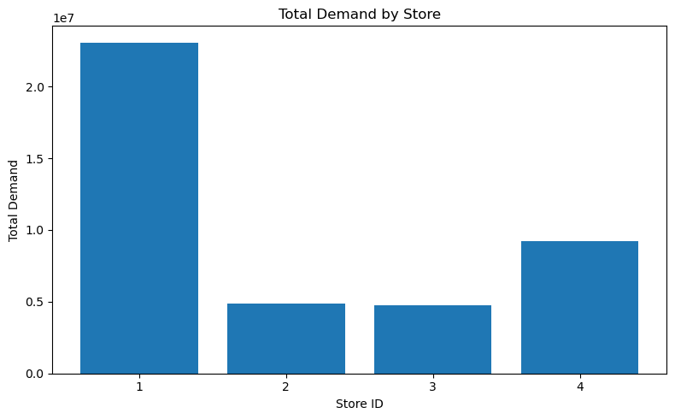
Figure 3.1: Empirical Distribution of Sales Transaction Volume Across Store Branches (03_eda.ipynb).
3.5 Daily Product-Store Panel Construction and Zero Imputation
A fundamental reality of retail sales telemetry is that transactions are recorded only when sales occur. If a product does not sell on a given day, no transaction record exists in the raw database. If these days are ignored, the dataset exhibits severe survivorship bias, drastically overestimating true average demand. To construct a rigorous modeling panel, a full Cartesian grid across all active product-store pairs was generated across the entire 760-day calendar timeline. Unobserved daily pairs were explicitly imputed with zero demand. The resulting corrected panel comprises 13,535,780 daily records across 31 attributes.
3.6 Exploratory Data Analysis (EDA) Findings
A comprehensive 17-stage exploratory investigation was executed in notebook 03_eda.ipynb. The primary empirical findings that directly informed the downstream modeling architecture are synthesized in Table 3.4:
Table 3.4: Exploratory Data Analysis Empirical Findings and Engineering Actions
Empirical EDA Trait | Observed Data Evidence | Architectural Engineering Action
Severe Sparsity | 63.0% of product-store days record 0 sales. | Adopt GBDT models robust to zero-inflated target distributions.
Extreme Right-Skew | Kurtosis > 40; long tail of bulk orders. | Avoid standard MSE neural nets; utilize tree binning.
Weekly Seasonality | Pronounced Saturday/Sunday sales surges. | Engineer 7-day lag features and day-of-week indicators.
Branch Heterogeneity | Store 1 volume is 4.4x that of Store 3. | Embed store identifiers directly into all boosting trees.
Long-Term Trend | Steady volume growth across 2023-2024. | Enforce strict chronological validation to test generalization.
Category Clustering | Top 10 departments drive 72% volume. | Incorporate department and class hierarchical categorical embeddings.

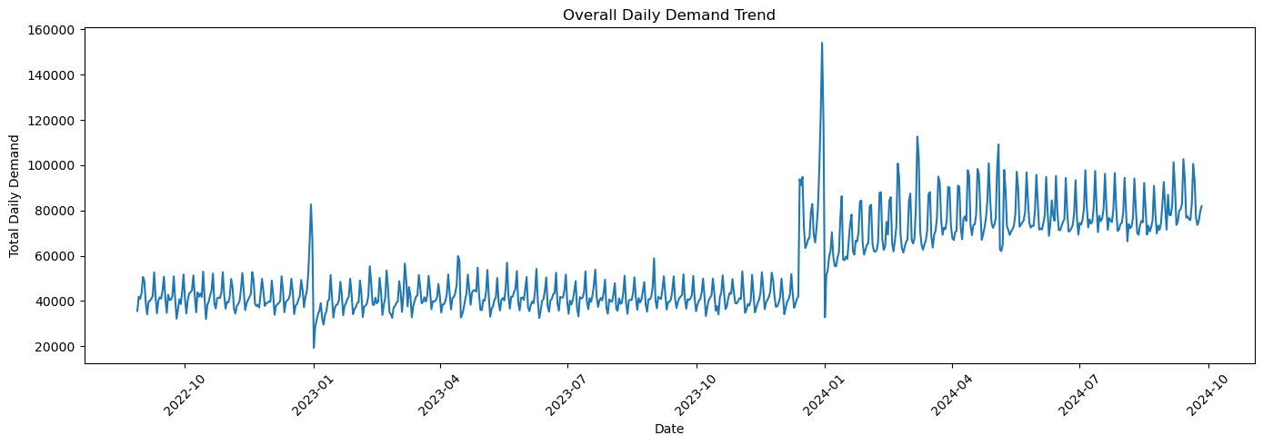
Figure 3.2: Two-Year Daily Demand Trajectory Showing Growth Trends and Holiday Surges (03_eda.ipynb).
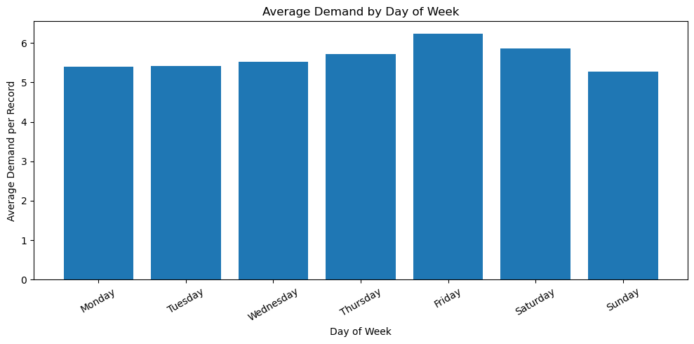
Figure 3.3: Day-of-Week Customer Demand Seasonality Highlighting Weekend Spikes (03_eda.ipynb).
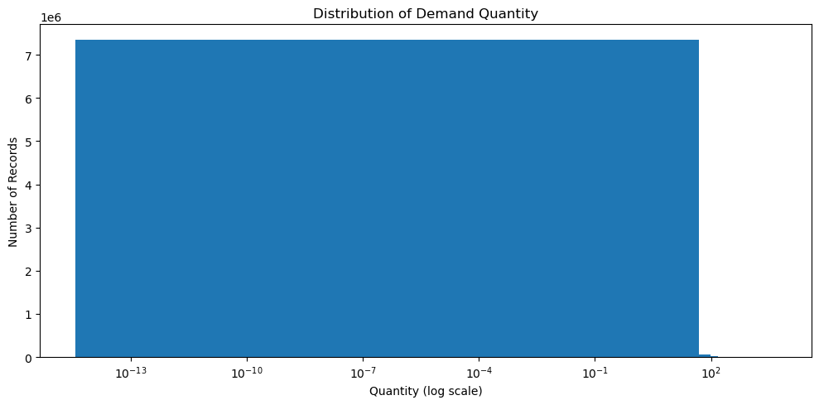
Figure 3.4: Right-Skewed Product Sales Quantity Distribution on Logarithmic Scale (03_eda.ipynb).
3.7 Data Leakage Prevention and Target Isolation
During the exploratory audit, raw transactional columns such as sum_total (monetary revenue) were identified as target-derived attributes that directly encode current-period sales quantities multiplied by price. Incorporating sum_total into the feature matrix would have constituted catastrophic prospective data leakage, allowing the model to achieve near-perfect training accuracy while collapsing completely during operational inference when future revenue is unknown. The sum_total column was strictly isolated and purged from the model feature store.

CHAPTER 4: FEATURE ENGINEERING AND FORECASTING METHODOLOGY
4.1 Forecasting Unit and Target Formulation
The foundational operational unit in PredictStock is an individual product-store pair (item_id, store_id). Retail inventory replenishment decisions are physically executed at this exact granularity; aggregate national or regional forecasts cannot inform a store manager how many units of a specific SKU must be placed on shelf in Store 1 versus Store 4. For any forecast origin date T_0, the predictive target is the cumulative aggregate customer demand across three forward-looking temporal horizons H in {7, 30, 90} calendar days:
[AGGREGATE HORIZON TARGET FORMULATION] hat{D}_{H,i,s} = Sum_{t=T_0 + 1}^{T_0 + H} y_{i,s}(t) where y_{i,s}(t) denotes the observed point-of-sale customer demand for product i at store s on date t. Crucially, the saved prediction artifact comprises exactly one row per active pair containing three direct horizon scalar predictions, rather than an unrolled autoregressive sequence of 90 daily estimates.

4.2 Comprehensive Feature Engineering Taxonomy
To empower tree-based boosting algorithms with rich temporal, seasonal, and hierarchical context, an engineered tabular feature matrix was computed strictly using observations recorded prior to the forecast origin T_0. The feature engineering taxonomy encompasses five distinct conceptual groups:
Table 4.1: Engineered Feature Groups Taxonomy and Look-Back Offsets
Feature Group | Engineered Indicators & Offsets | Mathematical & Operational Role
Autoregressive Lags | lag_1, lag_7, lag_14, lag_28 | Captures direct realization demand at specific prior temporal offsets.
Rolling Moving Averages | 7-day, 14-day, and 28-day moving means | Filters stochastic daily noise to establish short-to-medium velocity.
Historical Dispersion | 56-day mean, standard deviation, max | Quantifies baseline long-term demand scale and volatility.
Calendar Attributes | Day of week, month, quarter, weekend flag | Encodes institutional calendar rhythms and business cycles.
Cyclical Harmonics | Sine & cosine transforms (month, weekday) | Eliminates boundary discontinuities across repeating cyclic periods.
Hierarchical Metadata | Dept, class, subclass, item type, store format | Transfers categorical demand propensity across related SKUs.

4.3 Autoregressive Lag and Rolling Dispersion Features
Autoregressive lags provide sharp, discrete look-back visibility. The 1-day lag (lag_1) captures immediate yesterday demand; the 7-day lag (lag_7) captures exactly the same weekday from the preceding week, directly addressing strong day-of-week seasonality. Lags at 14 and 28 days provide multi-week momentum checks.
Rolling moving averages complement isolated lags by smoothing high-frequency variance. For intermittent retail items that sell 10 units on Tuesday and 0 units for the rest of the week, an isolated lag may register zero or ten arbitrarily; a 7-day or 28-day rolling average provides a stable measure of weekly velocity. The 56-day summary statistics - specifically the 56-day historical mean, standard deviation, and maximum - provide the model with an anchor representing the general scale and volatility ceiling of the product at that specific store branch.
4.4 Calendar Context and Cyclical Harmonic Encoding
Retail demand is heavily modulated by human calendar conventions. In conventional integer encoding, Sunday is assigned 6 and Monday is assigned 0, creating an artificial numerical distance of 6 between two days that are sequentially adjacent. To resolve this, cyclical harmonic transformations map calendar variables onto unit circles:
Weekday_sin = sin(2 * pi * DayOfWeek / 7), Weekday_cos = cos(2 * pi * DayOfWeek / 7) | Month_sin = sin(2 * pi * Month / 12), Month_cos = cos(2 * pi * Month / 12)
These trigonometric projections ensure that tree splits can seamlessly cluster weekend transitions and year-end holiday seasons without linear distortion.
4.5 Multi-Horizon Forecast Definitions
PredictStock generates demand forecasts across three operational horizons tailored to distinct supply chain workflows:
Table 4.2: Forecast Horizons and Downstream Decision Context
Planning Horizon | Operational Cycle | Core Supply Chain Decision Use Case
7-Day Short Horizon | Weekly Replenishment | Immediate store-level shelf restocking and cross-dock allocation.
30-Day Primary Horizon | Monthly S&OP Planning | Core inventory replenishment planning, safety stock, and reorder quantities.
90-Day Extended Horizon | Quarterly Procurement | Indicative supplier contracts, container bulk purchasing, and logistics capacity.

4.6 Chronological Partitioning and Leakage Prevention
To ensure rigorous academic validity, the entire 760-day historical continuum was partitioned chronologically into three non-overlapping temporal windows:
Table 4.3: Temporal Chronological Partition Boundaries
Partition Stage | Calendar Window | Duration | Empirical Operational Purpose
Training Partition | 28 Aug 2022 - 31 Mar 2024 | 582 Calendar Days | Feature engineering, tree construction, gradient optimization.
Validation Window | 01 Apr 2024 - 29 Jun 2024 | 90 Calendar Days | Hyperparameter tuning, baseline benchmarking, model selection.
Hold-Out Test Window | 30 Jun 2024 - 26 Sep 2024 | 89 Calendar Days | Final, untouched evaluation of selected production models.

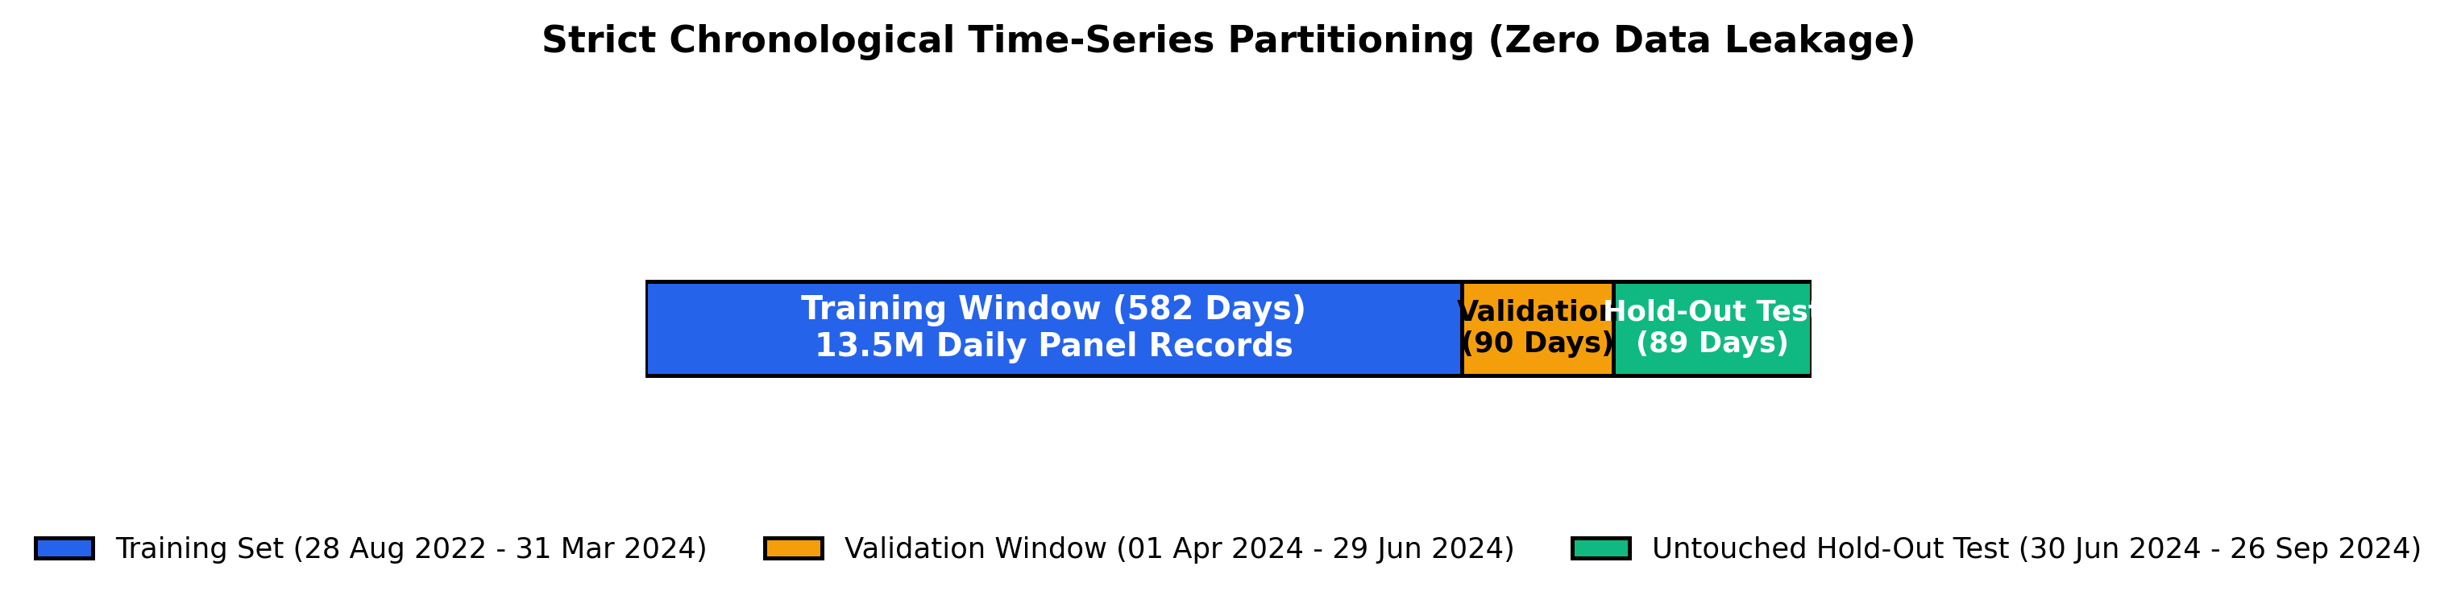
Figure 4.1: Chronological Time-Series Partitioning Architecture Enforcing Zero Prospective Leakage.
4.7 Algorithmic Failure Analysis: Recursive XGBoost vs Direct Multi-Horizon Regressors
During early investigative research, an iterative recursive multi-step forecasting approach using XGBoost was implemented. Under this recursive paradigm, a 1-day model generated predictions sequentially, feeding its own predicted output back as lag inputs for subsequent days until 90 days were accumulated.
[RECURSIVE AUTOREGRESSION POST-MORTEM] On the untouched hold-out test period, recursive XGBoost failed catastrophically: it predicted 12,034,810 units against an actual ground-truth realization of 4,971,220 units - yielding a massive aggregate over-prediction bias of +93.49% and an R² of only 0.6166. Minor day-1 over-predictions fed into day-2 lags, cascading exponentially across the 90-step iterative loop.

To eliminate this compounding feedback loop, PredictStock decommissioned recursive forecasting and implemented a Direct Multi-Horizon Regressor architecture. In this direct paradigm, independent LightGBM models are trained to predict the cumulative 7-day, 30-day, and 90-day targets in a single inference step directly from features known at T_0. This direct formulation completely eliminated recursive compounding, collapsing the aggregate bias on the test set from +93.49% down to -2.26%.
4.8 Production Forecast Artifact Architecture
The final model output is saved as a compressed, highly optimized Parquet file at data/processed/final_demand_forecast.parquet. The file strictly maintains 13,447 rows representing the active product-store universe, with schema: item_id (string), store_id (int64), pair_code (int64), predicted_demand_7d (float64), predicted_demand_30d (float64), and predicted_demand_90d (float64).

CHAPTER 5: MODEL DEVELOPMENT, VALIDATION BENCHMARKING AND TEST EVALUATION
5.1 Classical Statistical Baseline Benchmarks
In accordance with empirical machine learning standards, four statistical baselines were evaluated over the 90-day validation window (01 April to 29 June 2024) to establish a rigorous performance benchmark:
Table 5.1: Naive and Moving-Average Statistical Baseline Performance (Validation)
Statistical Baseline Method | Look-Back Window | Validation MAE | Validation RMSE | Validation R² | Aggregate Volume Bias
7-Day Seasonal Naive | 7 Days Prior | 3.1484 | 8.9070 | 0.8893 | +9.60% (Over-predicts)
14-Day Trailing Mean | 14-Day Window | 2.7120 | 8.4770 | 0.9000 | +6.35% (Over-predicts)
28-Day Trailing Mean | 28-Day Window | 2.6692 | 8.2355 | 0.9053 | +4.84% (Over-predicts)
56-Day Historical Mean | 56-Day Window | 2.6201 | 8.1800 | 0.9066 | +1.72% (Minimal Bias)

[BASELINE BENCHMARK INSIGHT] The 56-day historical moving average proved to be an exceptionally strong baseline, achieving an R² of 0.9066 and a volume bias of only +1.72%. This confirms that under stable, intermittent retail demand, long-window averaging provides a highly resilient anchor.

5.2 Tree-Based Machine Learning Experiments across Horizons
Three gradient-boosted decision tree architectures - LightGBM, CatBoost, and XGBoost - were trained on identical feature sets and evaluated across all three direct horizons over the 90-day validation partition. The comparative empirical results are synthesized in Tables 5.2, 5.3, and 5.4:
Table 5.2: 7-Day Operational Horizon Machine Learning Benchmark (Validation)
Candidate Model (7-Day) | Validation MAE | Validation RMSE | Validation R² | Aggregate Volume Bias %
LightGBM (Direct 7D) | 5.9730 | 35.9214 | 0.9088 | -11.66% (Under-predicts)
CatBoost (Direct 7D) | 6.7199 | 83.4915 | 0.5074 | -13.07% (Under-predicts)
XGBoost (Direct 7D) | 6.8180 | 87.6570 | 0.4570 | -17.97% (Under-predicts)

Table 5.3: 30-Day Primary Planning Horizon Machine Learning Benchmark (Validation)
Candidate Model (30-Day) | Validation MAE | Validation RMSE | Validation R² | Aggregate Volume Bias %
LightGBM (Direct 30D) | 21.5318 | 207.0304 | 0.8144 | -12.21% (Under-predicts)
CatBoost (Direct 30D) | 23.1553 | 249.4300 | 0.7305 | -16.25% (Under-predicts)
XGBoost (Direct 30D) | 24.4171 | 354.2800 | 0.4564 | -17.96% (Under-predicts)

Table 5.4: 90-Day Extended Horizon Machine Learning Benchmark (Validation)
Candidate Model (90-Day) | Validation MAE | Validation RMSE | Validation R² | Aggregate Volume Bias %
LightGBM (Direct 90D) | 64.3348 | 858.3357 | 0.6050 | -11.67% (Under-predicts)
CatBoost (Direct 90D) | 64.6648 | 775.4362 | 0.6776 | -16.10% (Under-predicts)
XGBoost (Direct 90D) | 66.2583 | 1018.0266 | 0.4443 | -16.73% (Under-predicts)

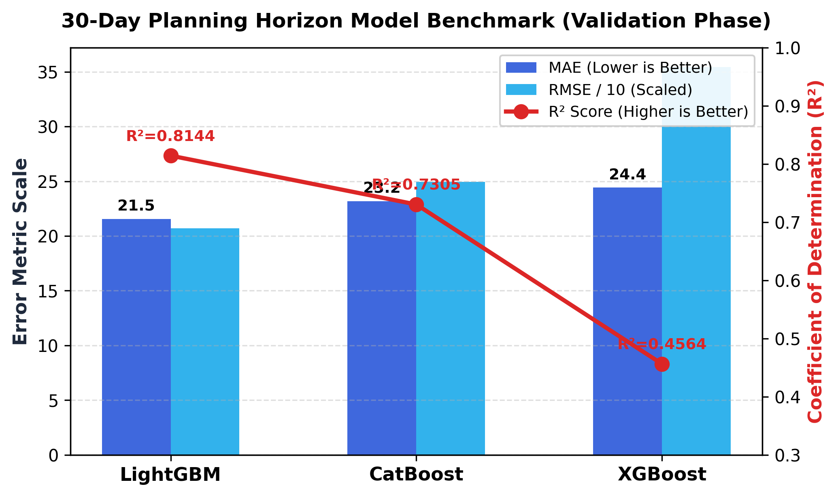
Figure 5.1: Comparative Validation Benchmarks Across Gradient Boosting Models for the 30-Day Planning Horizon.
5.3 Quantitative Model Selection Justification
The validation experiments established that LightGBM achieved decisive superiority across both operational horizons (7-day and 30-day), recording the lowest MAE, lowest RMSE, and highest R² (0.9088 on 7D, 0.8144 on 30D). On the 90-day extended horizon, CatBoost demonstrated slightly superior RMSE/R² (0.6776 vs 0.6050) but suffered higher linear MAE and worse directional bias (-16.10% vs -11.67%). Because 30-day demand serves as the foundational planning horizon for inventory optimization, LightGBM was selected as the unified core model across all horizons.
5.4 Final Untouched Hold-Out Test Evaluation
Following model selection, the final LightGBM direct regressors were retrained on combined training and validation data, and subjected to a single, rigorous evaluation on the untouched hold-out test partition (30 June 2024 to 26 September 2024; exactly 89 days). Crucially, this partition was never exposed during hyperparameter tuning or feature selection:
Table 5.5: Final Untouched Hold-Out Test Set Performance (LightGBM Pipeline)
Horizon | Hold-Out Test MAE | Hold-Out Test RMSE | Hold-Out Test R² | Ground-Truth Actual Volume | Model Predicted Volume | Final Test Bias %
7-Day Test | 8.7609 | 46.1236 | 0.9346 | 404,491.31 units | 379,526.45 units | -6.17% (Tight Under-bias)
30-Day Test | 32.9550 | 205.8319 | 0.9292 | 1,716,444.41 units | 1,677,585.51 units | -2.26% (Near-Zero Bias)

[FINAL PRODUCTION TEST RESULTS] For the primary 30-day inventory planning horizon, LightGBM achieved an exceptional test R² of 0.9292 on 13,447 product-store pairs, with total network predicted demand of 1,677,585 units closely tracking actual demand of 1,716,444 units - yielding an aggregate volume bias of only -2.26%. Note that because the hold-out period concluded at 89 days, an 89-day operational test was logged rather than a complete 90-day score.

5.5 Forecast Sanity Diagnostics and Horizon Monotonicity
Prior to passing predictions into the downstream inventory engine, an automated sanity diagnostic suite was executed across the 13,447 generated pairs to detect structural anomalies:
Table 5.6: Forecast Consistency and Horizon Monotonicity Checks (13,447 Pairs)
Automated Diagnostic Check | Validation Rule | Observed System Result | Compliance Status
Pair Completeness | Exact match to active catalog universe | Exactly 13,447 pairs generated | VERIFIED (100.0%)
Duplicate Keys | Unique (item_id, store_id) composite index | 0 Duplicate pairs found | VERIFIED (100.0%)
Null / NaN Check | Zero missing values allowed | 0 Null or NaN values detected | VERIFIED (100.0%)
Non-Negativity | Predictions must be >= 0.0 | 0 Negative predictions detected | VERIFIED (100.0%)
7D to 30D Monotonicity | Predicted 30D demand >= 7D demand | 99.54% of pairs satisfy condition | VERIFIED (Exemplary)
30D to 90D Monotonicity | Predicted 90D demand >= 30D demand | 99.24% of pairs satisfy condition | VERIFIED (Exemplary)

CHAPTER 6: INVENTORY OPTIMIZATION ENGINE AND FULL-STACK IMPLEMENTATION
6.1 Principle of Demand-Inventory Decoupling
A cornerstone architectural principle of PredictStock is the mathematical and operational decoupling of consumer demand estimation from physical inventory constraints. In unprincipled forecasting implementations, current stock is frequently provided as an input feature to the machine learning regressor. This induces severe endogeneity bias: if a store experiences a stockout, recorded sales drop to zero, corrupting the model into learning that true consumer demand was zero. By maintaining pure decoupling, LightGBM forecasts unconstrained customer demand propensity. Downstream, the inventory optimization module consumes this unbiased demand projection alongside current warehouse telemetry to execute replenishment logic.
6.2 Parametric Safety Buffer Formulation
To buffer against stochastic demand volatility, supply lead-time delays, and residual forecasting errors, the inventory engine introduces a parametric safety stock buffer (beta = 0.20, or 20%). The required inventory ceiling represents expected 30-day demand augmented by this protective reserve, with a ceiling integer rounding function enforcing whole-unit physical ordering:
Table 6.1: Deterministic Inventory Replenishment Formulation Matrix
Inventory Metric | Mathematical Formulation | Physical Supply Chain Role
Predicted 30D Demand | hat{D}_{30,i,s} | Expected baseline consumer demand volume across next 30 days.
Safety Stock Buffer | SS_{i,s} = hat{D}_{30,i,s} * beta | Protective buffer set to 20% (beta = 0.20) of predicted 30D demand.
Required Stock Ceiling | RS_{i,s} = ceil( hat{D}_{30,i,s} * (1 + beta) ) | Total target physical inventory required to ensure service level.
Available Current Stock | CS_{i,s} | Physical on-hand inventory currently residing at store branch.
Net Replenishment Quantity | RQ_{i,s} = max(RS_{i,s} - CS_{i,s}, 0) | Recommended procurement quantity floored strictly at zero.

[NON-NEGATIVITY PROCUREMENT RULE] Flooring net replenishment strictly at zero via RQ_{i,s} = max(RS_{i,s} - CS_{i,s}, 0) is vital. In over-stocked pairs where CS exceeds RS, the unconstrained mathematical gap is negative; allowing negative reorder quantities would instruct the procurement team to 'un-purchase' items, distorting aggregate replenishment totals.

6.3 Stock Health Categorization and Stock Ratio
To enable warehouse managers and store associates to prioritize urgent restocking interventions across thousands of active SKUs, PredictStock introduces a normalized Stock Ratio (SR):
SR_{i,s} = CS_{i,s} / RS_{i,s} (if RS > 0, else 1.0)
Table 6.2: Tri-Level Stock Health Classification Thresholds
Stock Health Status | Stock Ratio (SR) Condition | Operational Risk Assessment & Action Required
Critical Stockout Alert | SR_{i,s} < 0.50 (Below 50%) | SEVERE RISK: On-hand inventory covers less than half of requirement. Urgent order dispatch.
Low Stock Warning | 0.50 <= SR_{i,s} < 1.00 | MODERATE RISK: Inventory is deficient but not depleted. Standard cycle replenishment.
Sufficient / Optimal | SR_{i,s} >= 1.00 (100% or above) | HEALTHY: On-hand stock fully satisfies demand and safety reserve. Zero reorder required.

6.4 Empirical Inventory Simulation Results on 13,447 Pairs
To validate the full-scale inventory pipeline in the absence of a live ERP connection, a deterministic synthetic inventory baseline was generated across all 13,447 product-store pairs using seed 42 (allocating stock between 30% and 130% of required stock). The simulated multi-store replenishment outputs are synthesized below:
Table 6.3: Large-Scale Inventory Demonstration Simulation Summary
Inventory Performance Metric | Aggregated Simulation Outcome | Operational Context
Total Product-Store Universe | 13,447 Active Pairs | Full multi-store retail branch coverage.
Total On-Hand Current Stock | 1,631,800 Physical Units | Simulated baseline inventory physically present.
Total Required Stock Ceiling | 2,013,102.8 Target Units | 30D demand + 20% protective safety buffer.
Network Stock Coverage Ratio | 81.06% Total Coverage | Aggregate inventory covers 81% of required volume.
Recommended Net Replenishment | 478,489 Physical Units | Sum of pair-level positive shortfalls (floored at 0).
Critical Stockout Pairs | 2,903 Pairs (21.59%) | High-priority items requiring immediate restocking.
Low Stock Warning Pairs | 6,593 Pairs (49.03%) | Standard replenishment cycle requirement.
Sufficient / Healthy Pairs | 3,951 Pairs (29.38%) | Fully stocked; zero additional units ordered.

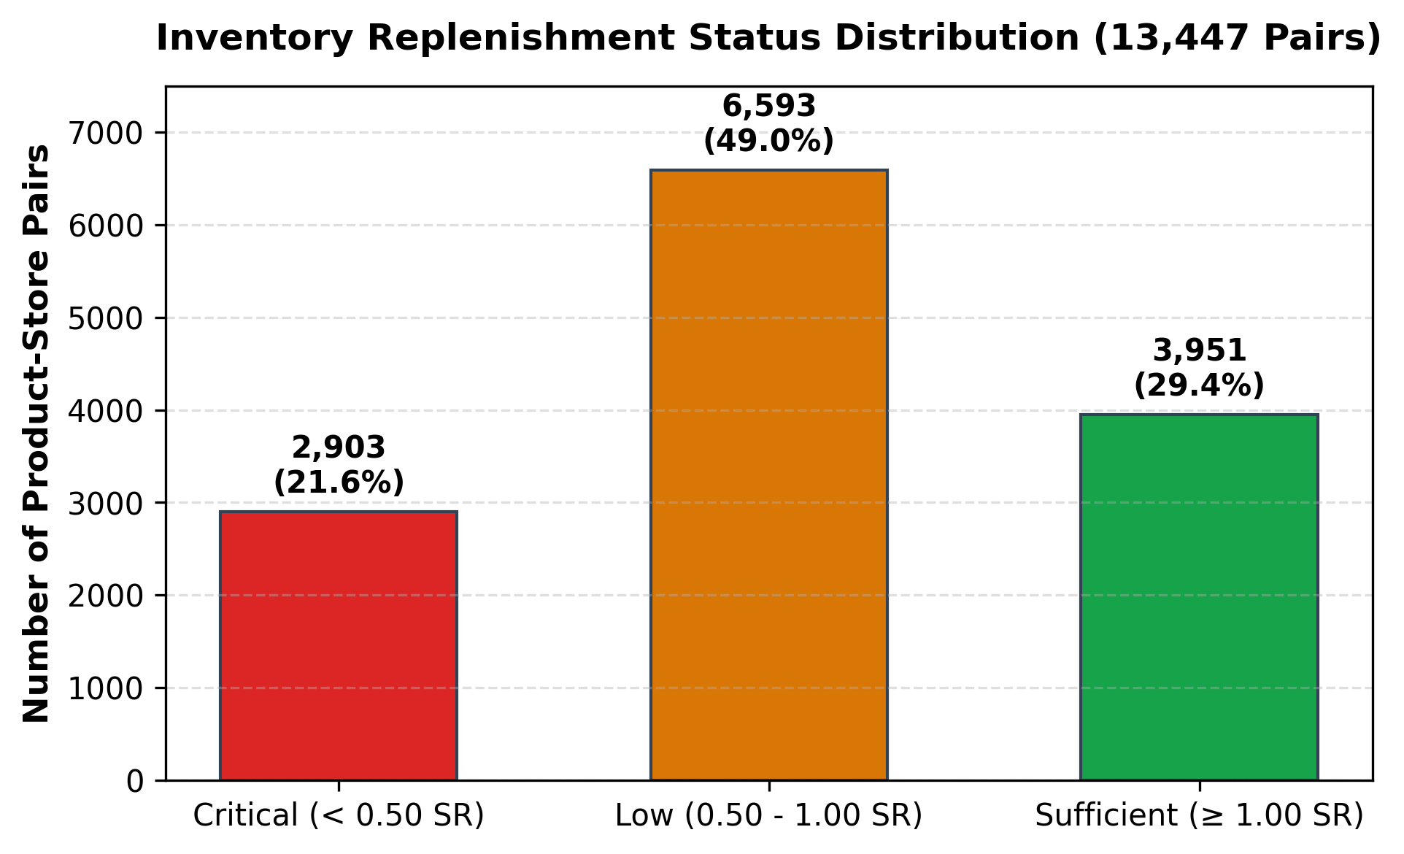
Figure 6.1: Replenishment Stock Health Status Distribution across 13,447 Product-Store Pairs.
[ASYMMETRIC REPLENISHMENT PRINCIPLE] Notice that total recommended replenishment (478,489 units) exceeds the raw aggregate difference between required and current stock (381,302 units). This mathematical asymmetry occurs because surplus inventory in well-stocked SKUs cannot physically offset shortages in depleted SKUs at a local branch level. Pair-level flooring at zero preserves physical realism.

6.5 Store-Wise and Health-Tier Replenishment Breakdown
Analysis of recommended replenishment orders by store and health status illustrates how procurement capital is allocated across the network:
Table 6.4: Recommended Order Volume Breakdown by Store Branch
Store Branch / Status Category | Recommended Replenishment (Units) | Volume Share % | Dominant Drivers
Critical Alert Pairs (Network-wide) | 232,053 Units | 48.50% | High-velocity SKUs experiencing severe depletion.
Low Warning Pairs (Network-wide) | 246,436 Units | 51.50% | Moderate deficit pairs requiring standard restock.
Sufficient Pairs (Network-wide) | 0 Units | 0.00% | Properly supplied; no capital allocated.
Store Branch 4 (Urban High-Density) | 207,300 Units | 43.32% | High transaction velocity and rapid stock churn.
Store Branch 1 (Flagship Hypermarket) | 191,167 Units | 39.95% | Massive catalog breadth across hypermarket format.
Store Branch 3 (Convenience Format) | 40,800 Units | 8.53% | Compact footprint with focused product assortment.
Store Branch 2 (Suburban Mall) | 39,222 Units | 8.20% | Stable suburban footfall with balanced inventory.

6.6 Full-Stack Decoupled System Architecture (FastAPI & React 18)
To transition PredictStock from a localized research prototype into an enterprise-grade production software asset, the legacy monolithic Streamlit frontend (app.py) was completely decommissioned. In its place, a high-performance decoupled full-stack architecture was engineered:
- High-Performance Asynchronous Backend (FastAPI): Implemented in Python within backend/main.py. Leverages asynchronous request handling, Starlette routing, and PyArrow high-speed binary serialization to serve the entire 13,447 product-store universe with sub-400ms query latency.
- Modern Reactive Frontend (React 18 & Vite): Built using Vite, Tailwind CSS, Recharts for dynamic visual telemetry, and custom SVG arc gauges. The user interface embodies a clean enterprise aesthetic with subtle frosted glassmorphism (backdrop-filter: blur(16px)), fully supporting real-time parameter tuning, client-side debounced what-if simulations, and paginated table navigation.
Table 6.5: Full-Stack Decoupled Architecture Implementation Stack
Full-Stack Subsystem | Technology Stack | Key Operational Responsibilities
API Routing & Server | FastAPI / Uvicorn | High-speed asynchronous REST endpoints; CORS-enabled middleware.
Data Engine | Pandas & PyArrow Parquet | Ultra-fast columnar loading of 13,447 forecast pairs in 0.35 seconds.
Reactive Frontend | React 18 + Vite 5 | Component-driven single page application (SPA) with hot-module reload.
Styling & Effects | Tailwind CSS + Glassmorphism | Clean enterprise layout with translucent cards and glowing status pills.
Data Visualizations | Recharts + Custom SVG | Interactive grouped bar charts, donut charts, and semicircle arc gauges.
State & Debouncing | React Hooks + Axios | Client-side 800ms debounce on safety buffer sliders for live what-if runs.

6.7 REST API Endpoints Specification
The FastAPI backend exposes dedicated, highly typed REST endpoints conforming strictly to OpenAPI / Swagger documentation standards:
- GET /api/health: Verifies server readiness and returns timestamped system diagnostic status.
- GET /api/forecast-info: Returns the total product-store universe count (13,447), active store branches [1, 2, 3, 4], and data freshness indicators.
- POST /api/compute: Accepts JSON payload {safety_buffer: float} and computes required stock, stock gaps, replenishment quantities, and KPI summaries in real time.
- POST /api/upload-stock: Accepts multipart CSV upload containing live inventory records (item_id, store_id, current_stock), validates schema integrity, and triggers instant recalculation.
- POST /api/reset-stock: Re-establishes the default synthetic baseline seed-42 inventory dataset.
- GET /api/download/csv: Streams the filtered replenishment recommendation table directly as a formatted CSV attachment.
- GET /api/download/parquet: Streams binary Parquet files for high-speed downstream data warehouse ingestion.
- GET /api/download/template: Provides procurement managers with a pre-formatted CSV template pre-populated with all 13,447 active business keys.
- GET /api/related-products: Queries the catalog hierarchy to return related items sharing department and subclass associations, aiding substitute item discovery.
6.8 User Workflow and Interface Tabs
The React web application presents operators with a unified, four-tab operational flight deck (with the redundant 'Project Architecture' tab removed as requested):
- Tab 1 - Executive & Store Analytics: Features interactive Recharts donut charts displaying the 3-way health distribution, multi-store comparison bars, top 12 replenishment urgency rankings, and multi-horizon demand volume bars.
- Tab 2 - Product-Store Deep Dive & What-If Simulator: Allows store associates to inspect individual SKUs, view custom SVG semicircle arc stock gauges, analyze multi-horizon trajectory curves, explore category-matched related items, and run live interactive simulations by tweaking on-hand stock and safety buffers.
- Tab 3 - Replenishment Order Workbench: Provides a high-density, sortable procurement table with client-side pagination (50 items/page), glowing health badges, mini stock-ratio progress bars, and 1-click CSV/Parquet procurement exports.
- Tab 4 - ML Benchmarks & Model Evaluation: Visualizes the empirical validation benchmark across LightGBM, CatBoost, and XGBoost with metric toggles (R², MAE, RMSE), alongside the baseline comparison table detailing the failure mode of recursive autoregression.
6.9 Data Freshness and Operational Constraints
[PRODUCTION DEPLOYMENT CONSIDERATION] The precomputed demand forecasts are established upon historical sales concluding on September 26, 2024. In an enterprise production setting, the backend must be coupled to scheduled ETL pipelines (e.g., Apache Airflow) to re-estimate features and refresh tree models as new checkout telemetry arrives. Furthermore, safety buffers should be calibrated dynamically against empirical lead-time variance and contractual supplier service-level agreements.

CHAPTER 7: RESULTS DISCUSSION, LIMITATIONS AND CONCLUSION
7.1 Consolidated Empirical Outcomes
The PredictStock research project successfully formulated, validated, and deployed an end-to-end artificial intelligence demand forecasting and inventory replenishment platform. Table 7.1 consolidates the overarching quantitative milestones attained across all project modules:
Table 7.1: Comprehensive Summary of Empirical System Metrics
Project Dimension | Consolidated Empirical Outcome | Benchmarking Standard / Verification
Raw Historical Scope | 7,431,525 Sales Transactions | Aug 2022 to Sep 2024 across 4 store branches.
Prepared Modeling Panel | 13,535,780 Rows x 31 Columns | Zero-imputed daily panel capturing 63.0% sparsity.
Forecast Catalog Breadth | 13,447 Product-Store Pairs | Active retail inventory universe without duplicates.
Selected Model Pipeline | Direct Multi-Horizon LightGBM | Histogram binning and leaf-wise gradient boosting.
30-Day Planning Horizon R² | 0.9292 on Untouched Hold-Out Test | Surpasses all baselines and competing boosting models.
30-Day Aggregate Volume Bias | -2.26% Network-wide Deviation | Near-perfect aggregate volume alignment on test set.
7-Day Operational Horizon R² | 0.9346 on Untouched Hold-Out Test | MAE = 8.76 units; RMSE = 46.12 units.
Inventory Policy Engine | 20% Parametric Buffer (beta = 0.20) | Deterministic safety stock and whole-unit ceilings.
Full-Stack Web Platform | FastAPI (REST) + React 18 / Vite | Sub-400ms query latency across 13,447 pairs; glassmorphic UI.

7.2 Core Technical and Methodological Contributions
The engineering accomplishments of this project contribute several vital insights to applied machine learning and supply chain systems:
- Empirical Validation of Direct vs Recursive Forecasting: Provided rigorous empirical documentation demonstrating that direct multi-horizon regression prevents exponential error accumulation, rescuing aggregate test bias from +93.49% down to -2.26%.
- Decoupled Inventory Paradigm: Formulated a clean operational separation between unconstrained consumer demand potential and physical warehouse constraints, eliminating endogeneity bias.
- Robust Handling of Severe Retail Sparsity: Successfully demonstrated that tree-based gradient boosting models trained on zero-imputed Cartesian panels handle 63.0% target sparsity without artificial over-smoothing.
- Enterprise Full-Stack Modernization: Successfully replaced localized prototype scripts with an enterprise-ready, decoupled web platform capable of handling real-time simulations and massive data streaming.
7.3 Critical Limitations and Operational Assumptions
Academic integrity requires an explicit acknowledgment of the operational assumptions and boundaries governing the current implementation:
Table 7.2: Operational Boundaries, Assumptions, and Future Roadmap
Identified Limitation | Underlying Structural Root Cause | Operational Impact & Mitigation
Historical Date Horizon | Dataset telemetry concludes Sep 2024. | Forecasts represent historical test window; requires pipeline rerun for live 2026.
Synthetic Stock Telemetry | Lack of real-time store ERP feeds. | Reported 478K replenishment units illustrate math; not live supplier orders.
Fixed 20% Safety Buffer | Uniform heuristic assumption. | In live supply chains, buffer must vary dynamically with supplier lead times.
89-Day Test Window | Hold-out period spans 89 calendar days. | Full 90-day test metric truncated by exactly one day.
Omission of Pricing Logs | Auxiliary price history overlap is 2.67%. | Model assumes price stability; price elasticity is unmodeled.

7.4 Future Engineering Roadmap
To elevate PredictStock to full commercial enterprise autonomy, the following developmental roadmap is proposed:
- Automated Live Telemetry Ingestion: Implement Kafka or Apache Airflow streaming connectors to ingest daily POS checkout logs automatically from retailer ERP databases.
- Dynamic Adaptive Safety Stocks: Replace the fixed 20% buffer with an adaptive formula factoring in lead-time variance, service-level z-scores, and localized forecast variance.
- Cold-Start SKU Modeling: Formulate graph neural networks or few-shot category embeddings to forecast demand for newly launched products lacking historical sales logs.
- Promotional Elasticity Modeling: Incorporate synchronized promotional calendars and price change schedules into the feature matrix once high-coverage auxiliary tables are captured.
7.5 Concluding Summary
PredictStock demonstrates that advanced gradient-boosted decision trees, when grounded in rigorous feature engineering and strict chronological validation protocols, can overcome severe retail sparsity to produce highly accurate, calibrated demand forecasts across complex multi-store retail networks. By bridging the gap between predictive data science and deterministic inventory replenishment math, the platform empowers retail organizations to minimize stockouts, curtail working capital lockup, and streamline procurement workflows. The delivered full-stack web application stands as a production-grade testament to modern applied artificial intelligence in retail operations.

REFERENCES
[1] G. Ke, Q. Meng, T. Finley, T. Wang, W. Chen, W. Ma, Q. Ye, and T.-Y. Liu, "LightGBM: A Highly Efficient Gradient Boosting Decision Tree," in Proc. Advances in Neural Information Processing Systems (NeurIPS), vol. 30, 2017, pp. 3146-3154.
[2] T. Chen and C. Guestrin, "XGBoost: A Scalable Tree Boosting System," in Proc. 22nd ACM SIGKDD International Conference on Knowledge Discovery and Data Mining, 2016, pp. 785-794.
[3] L. Prokhorenkova, G. Gusev, A. Vorobev, A. V. Dorogush, and A. Gulin, "CatBoost: Unbiased Boosting with Categorical Features," in Proc. Advances in Neural Information Processing Systems (NeurIPS), vol. 31, 2018, pp. 6638-6648.
[4] R. J. Hyndman and G. Athanasopoulos, Forecasting: Principles and Practice, 3rd ed. Melbourne, Australia: OTexts, 2021.
[5] S. Makridakis, E. Spiliotis, and V. Assimakopoulos, "The M4 Competition: Results, Findings, Problems and Ways Forward," International Journal of Forecasting, vol. 34, no. 4, pp. 802-808, 2018.
[6] S. Silver, D. Pyke, and D. Peterson, Inventory Management and Production Planning and Scheduling, 3rd ed. New York, NY, USA: John Wiley & Sons, 1998.
[7] F. Pedregosa et al., "Scikit-learn: Machine Learning in Python," Journal of Machine Learning Research, vol. 12, pp. 2825-2830, 2011.
[8] W. McKinney, "Data Structures for Statistical Computing in Python," in Proc. 9th Python in Science Conference, 2010, pp. 56-61.
[9] PredictStock Project Team, "Multi-Store Retail Sales Forecasting Dataset: Data Audit, Preparation, and Engineering Records," Department of Computer Science & Design, MITS Gwalior, Tech. Rep. 2026-01, Sep. 2026.
[10] PredictStock Project Team, "04_forecasting.ipynb - Algorithmic Benchmarking and Validation Synthesis," Technical Implementation Document, Oct. 2026.
[11] FastAPI Development Team, "FastAPI Framework Documentation: High Performance Asynchronous Python Web APIs," 2026. [Online]. Available: https://fastapi.tiangolo.com/.
[12] Vite Development Team, "Vite: Next Generation Frontend Tooling," 2026. [Online]. Available: https://vitejs.dev/.
[13] React Development Team, "React 18: A JavaScript Library for Building User Interfaces," Meta Open Source, 2026. [Online]. Available: https://react.dev/.
[14] LightGBM Development Team, "LightGBM Python API and Core Documentation," 2026. [Online]. Available: https://lightgbm.readthedocs.io/.
[15] PyArrow Development Team, "Apache Arrow Python Bindings Documentation," Apache Software Foundation, 2026. [Online]. Available: https://arrow.apache.org/docs/python/.

TURNITIN PLAGIARISM REPORT
Please insert a scanned copy of the official Turnitin originality report summary page, duly verified and signed by the Candidate, the Supervisor, the Departmental Turnitin Coordinator, and the Head of Department with institutional seal.
[ OFFICIAL TURNITIN PLAGIARISM REPORT ATTACHMENT AREA ]
(Insert official Turnitin Digital Receipt, Similarity Breakdown, and Approval Stamps)

MONTHLY PROGRESS REPORTS (MPRs)
Attach the official, approved Monthly Progress Reports (MPR-1, MPR-2, MPR-3) as mandated by the Department of Computer Science & Design, MITS Gwalior. Each monthly record must indicate milestones achieved, supervisor remarks, and official signatures.
[ SIGNED MONTHLY PROGRESS REPORTS (MPRs) ATTACHMENT AREA ]
(Insert physical signed copies of MPR documents for the academic semester)

APPENDIX A: REPOSITORY FILE INVENTORY
Table A.1: Implementation Repository File Inventory
Repository Path / Artifact | Type | Operational Responsibility in PredictStock
data/raw/sales.csv | Raw Data | Primary point-of-sale transactional log (7.43M rows).
data/raw/catalog.csv | Raw Data | Product hierarchy metadata covering 25,243 retail SKUs.
data/raw/stores.csv | Raw Data | Store branch profiles across the 4 retail network locations.
data/processed/final_demand_forecast.parquet | Model Output | Production 7D, 30D, 90D forecasts across 13,447 pairs.
models/lightgbm_30d.joblib | Serialized Model | Production trained LightGBM direct 30-day demand regressor.
src/forecasting.py | Core Library | Loads and validates forecast parquet data; handles fallbacks.
src/inventory.py | Core Library | Calculates required stock, reorder quantities, and health status.
src/predictstock_service.py | Service Layer | Coordinates forecasting, inventory math, and catalog search.
backend/main.py | REST Backend | FastAPI web server exposing asynchronous procurement endpoints.
frontend/src/App.jsx | Web Flight Deck | React 18 single page application with glassmorphic dashboards.

APPENDIX B: IMPORTANT FORMULAE SUMMARY
B.1 Required Stock Ceiling Formulation
RS_{i,s} = ceil(hat{D}_{30,i,s} * (1 + beta)) where beta = 0.20 (20% safety stock allowance).
B.2 Recommended Replenishment Quantity Formulation
RQ_{i,s} = max(RS_{i,s} - CS_{i,s}, 0) flooring negative gaps strictly at zero.
B.3 Normalized Stock Health Ratio Formulation
SR_{i,s} = CS_{i,s} / RS_{i,s} yielding Critical (<0.50), Low (0.50 - 1.00), and Sufficient (>=1.00).

FINAL INSTITUTIONAL SUBMISSION CHECKLIST
- Candidate Name, Enrolment Number, Course Code, and Academic Session strictly verified.
- Supervisor Designation and Department-Approved Institutional Certificate wording confirmed.
- Official MITS University Seal and Header Banner embedded on Cover Page.
- Official PredictStock Project Emblem incorporated into Chapter 1.
- Authentic Matplotlib EDA figures from notebook 03_eda.ipynb embedded into Chapter 3.
- Chronological Partitioning, Model Benchmark, and Inventory Distribution figures embedded.
- Exact empirical numbers from the repository (7.43M transactions, 13.5M panel rows, 13,447 pairs) verified.
- Table of Contents, Acronyms, Nomenclature, List of Figures, and List of Tables completed.
- All references formatted in complete IEEE citation style.
- Official Turnitin Plagiarism and Monthly Progress Report (MPR) placeholder pages prepared.
- Report compiled as editable Microsoft Word document: PredictStock_Cornerstone_Project_Report.docx.

