Install Jenkins on a Windows machine.

Pre requisite:

Make sure you have Java 11 or 17

Go to official website of Jenkins to install Jenkins for windows OS:

<https://www.jenkins.io/download/>

Here scroll down to windows tab, we will install the LTS version. Click on Windows

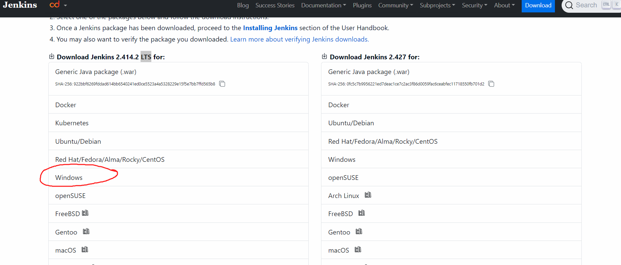

As you will click on Windows, it will automatically install Jenkins in your downloads folder



Double click on Jenkins Windows installer to start the instillation.

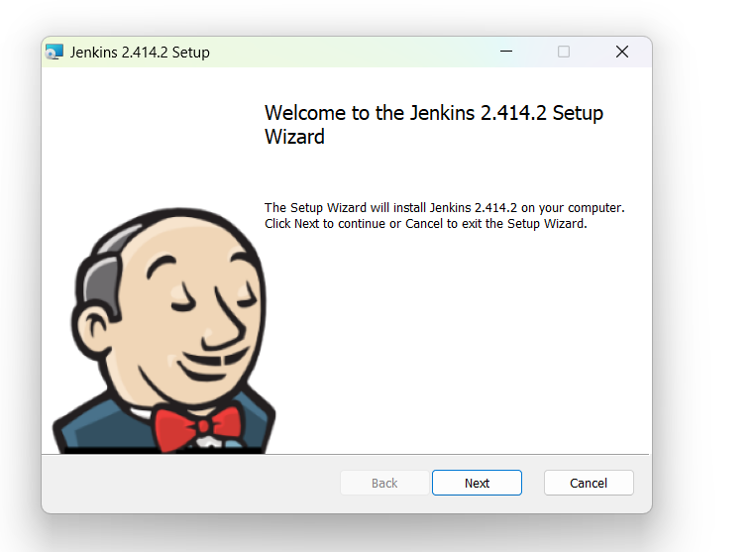

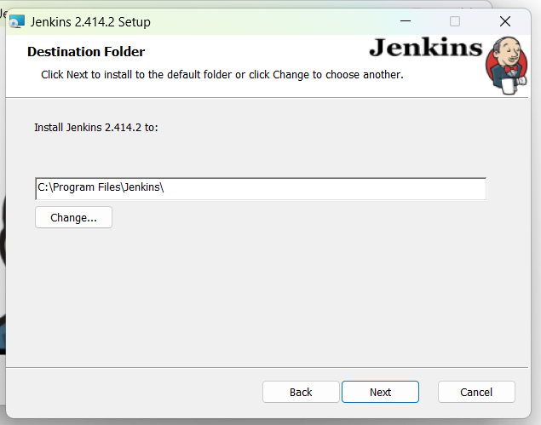

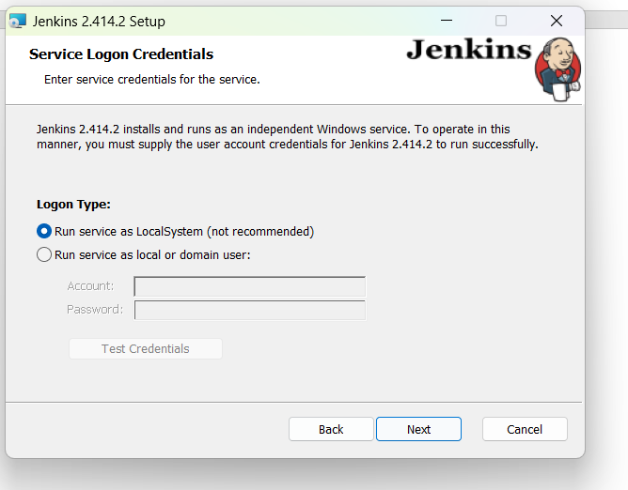

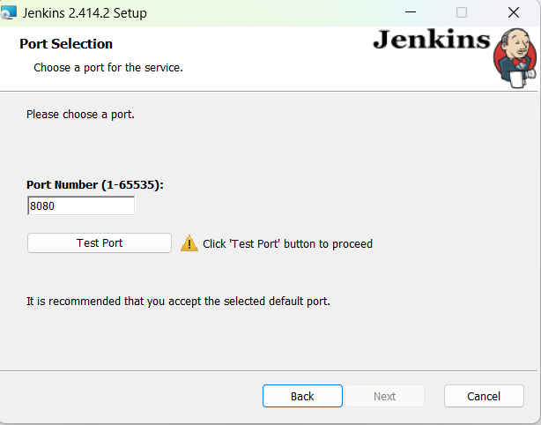

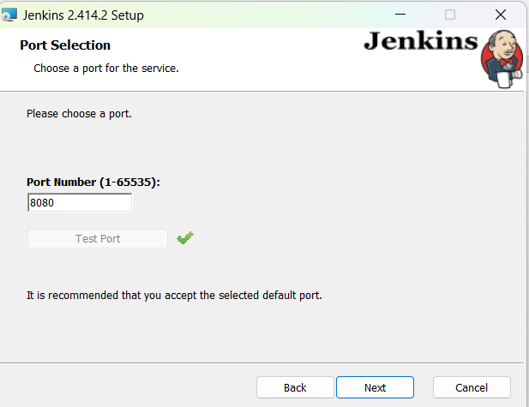

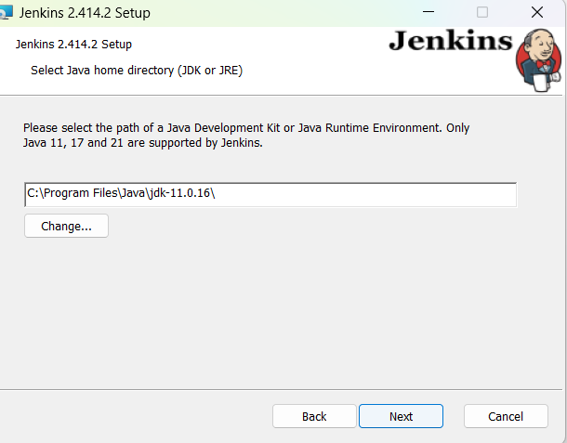

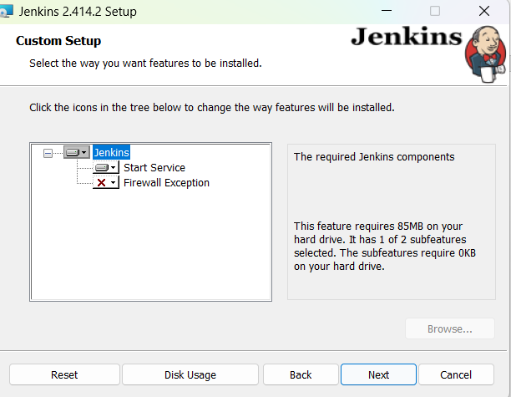

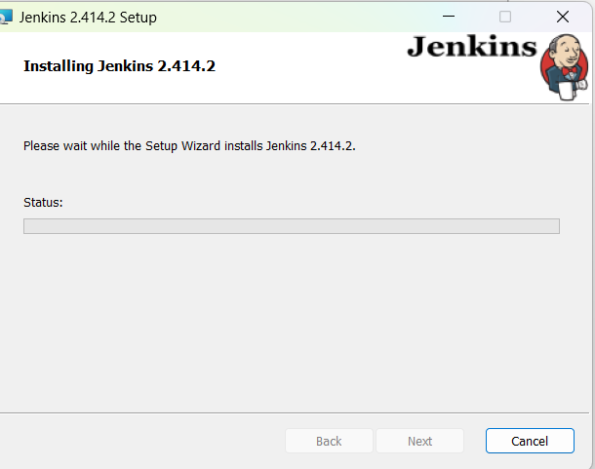

Installation will complete in sometime

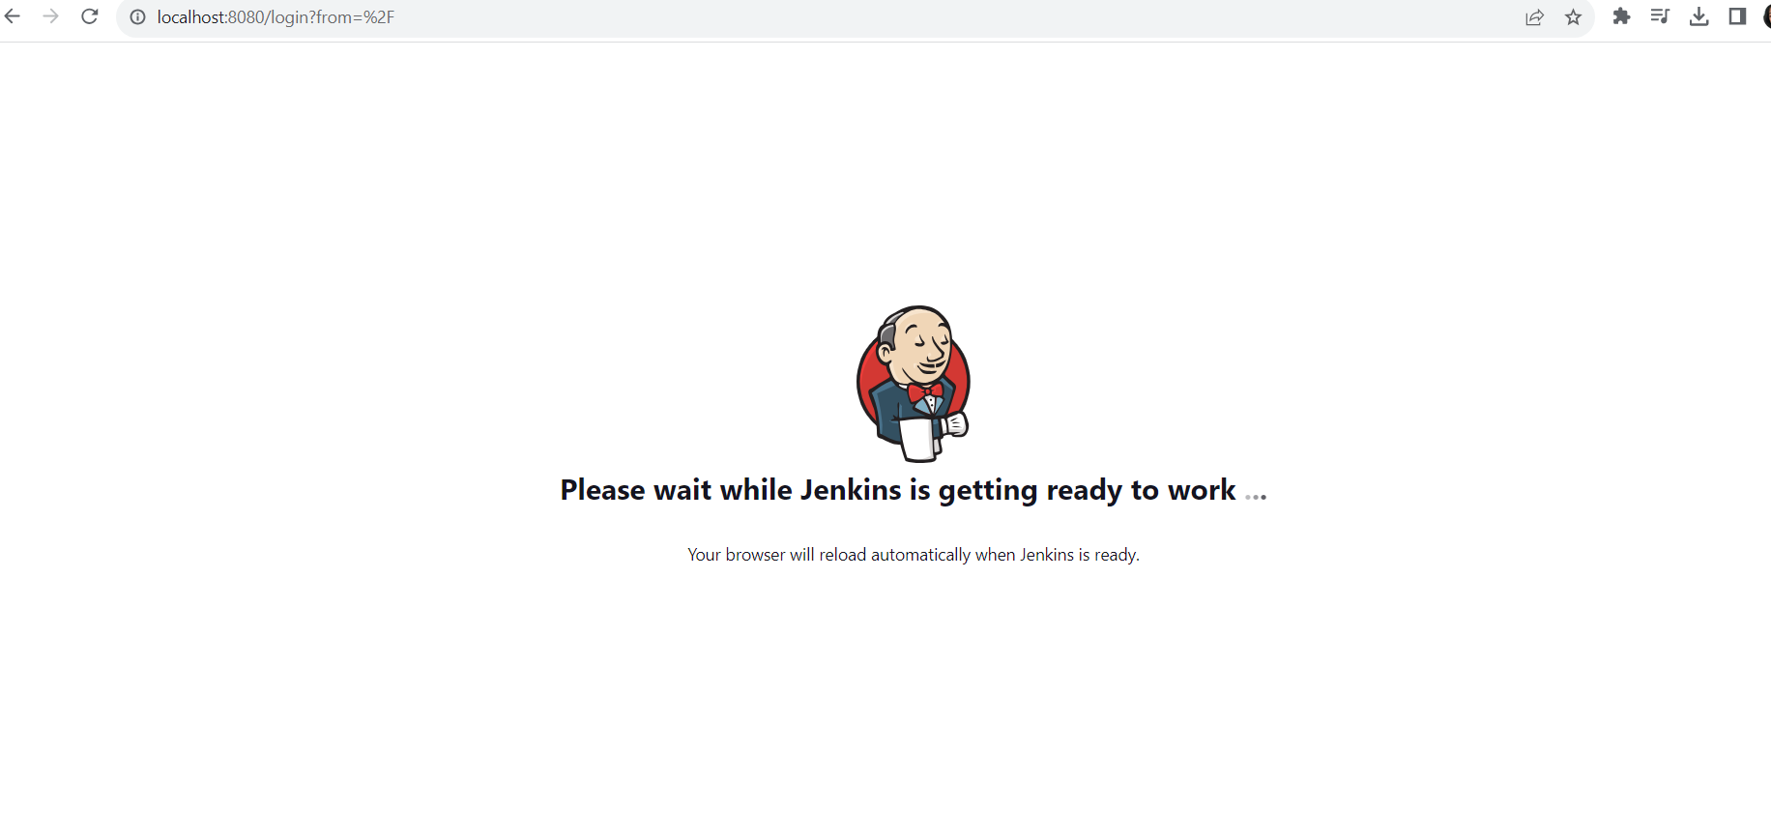

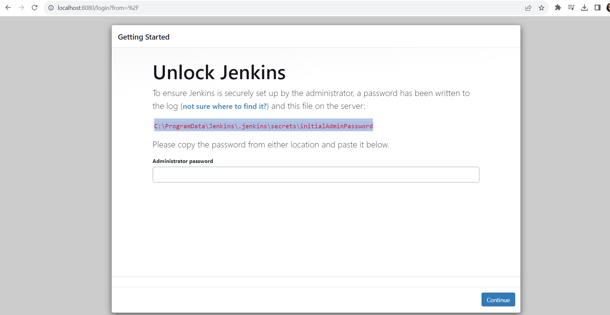

Go to this path: C:\ProgramData\Jenkins\.jenkins\secrets

You will get a file: initialAdminPassword

Open it with notepad => you will get a password🡺 copy it and paste on browser

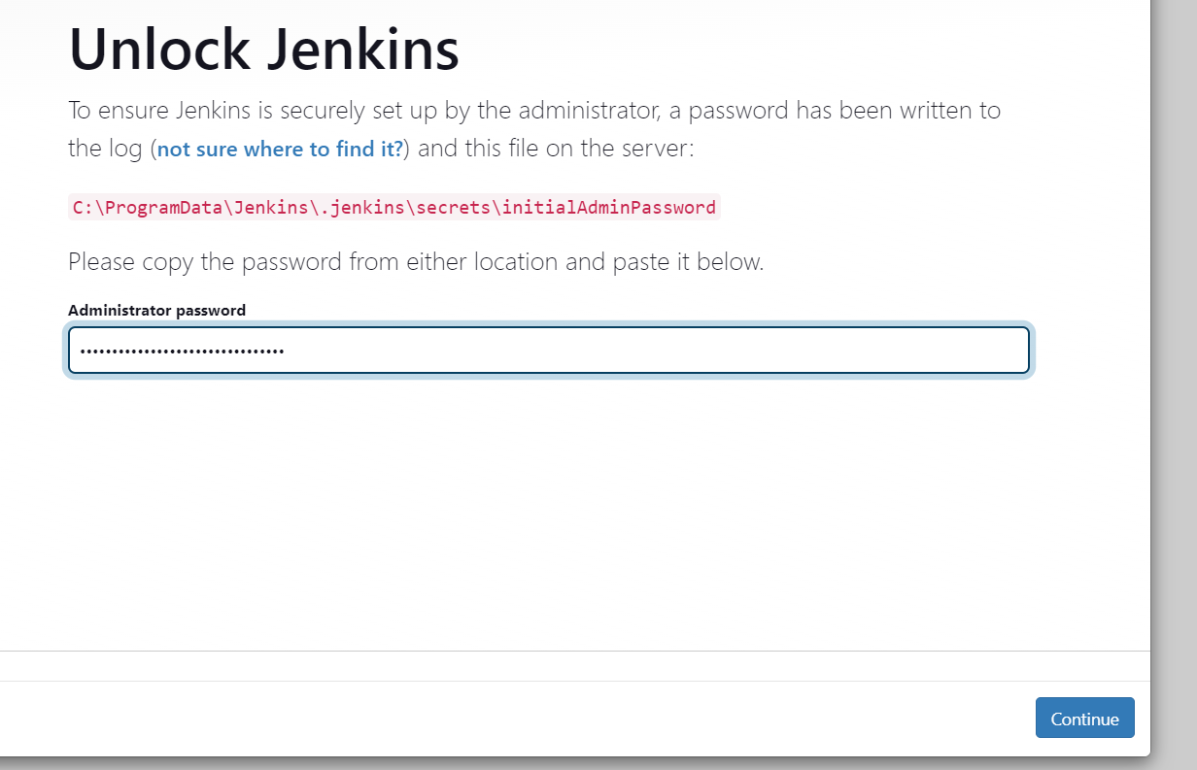

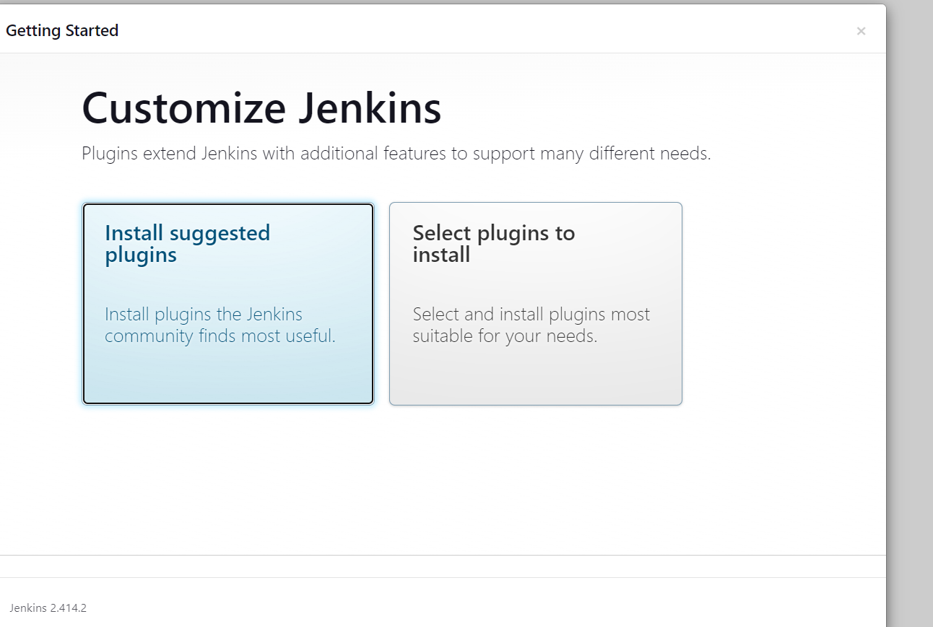

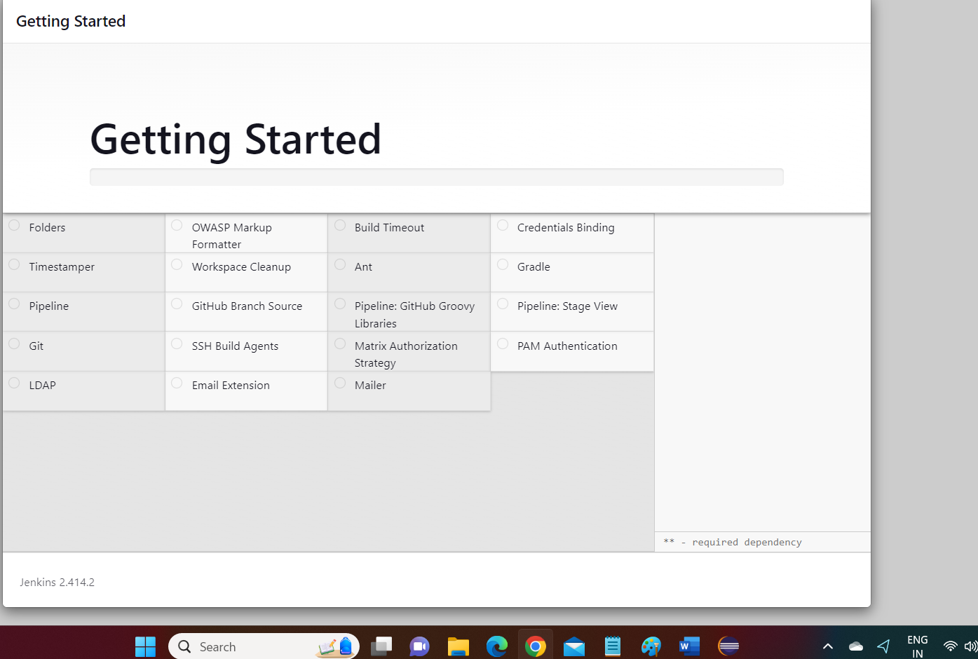

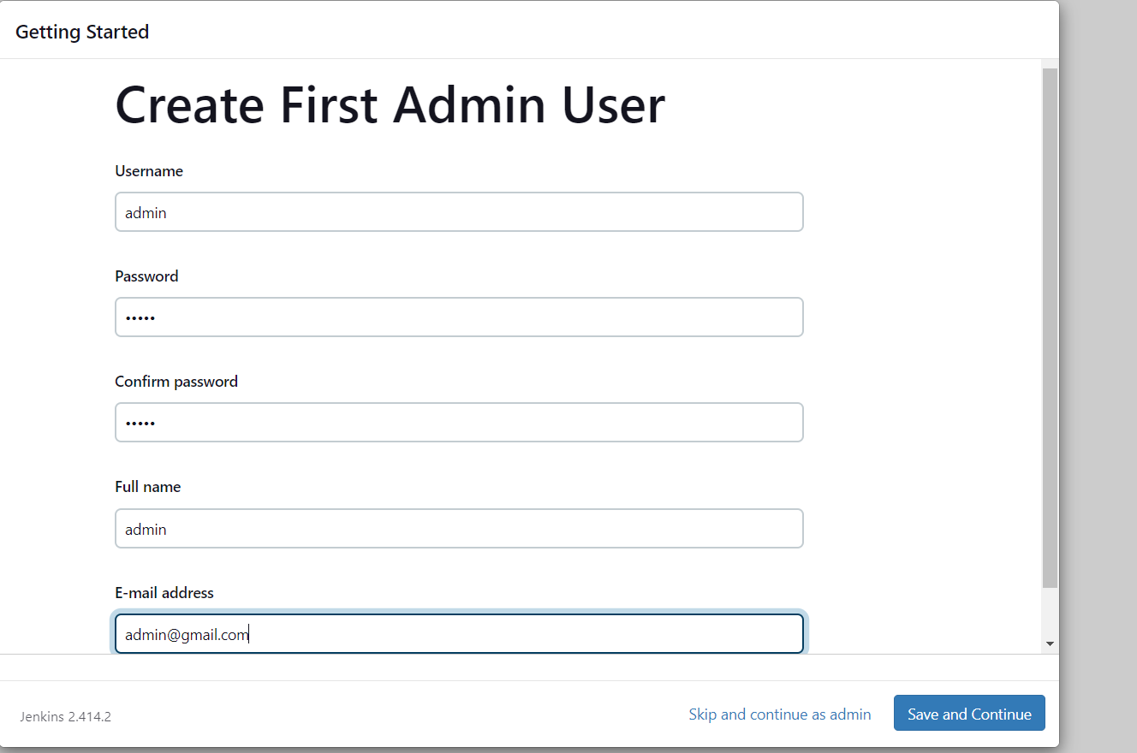

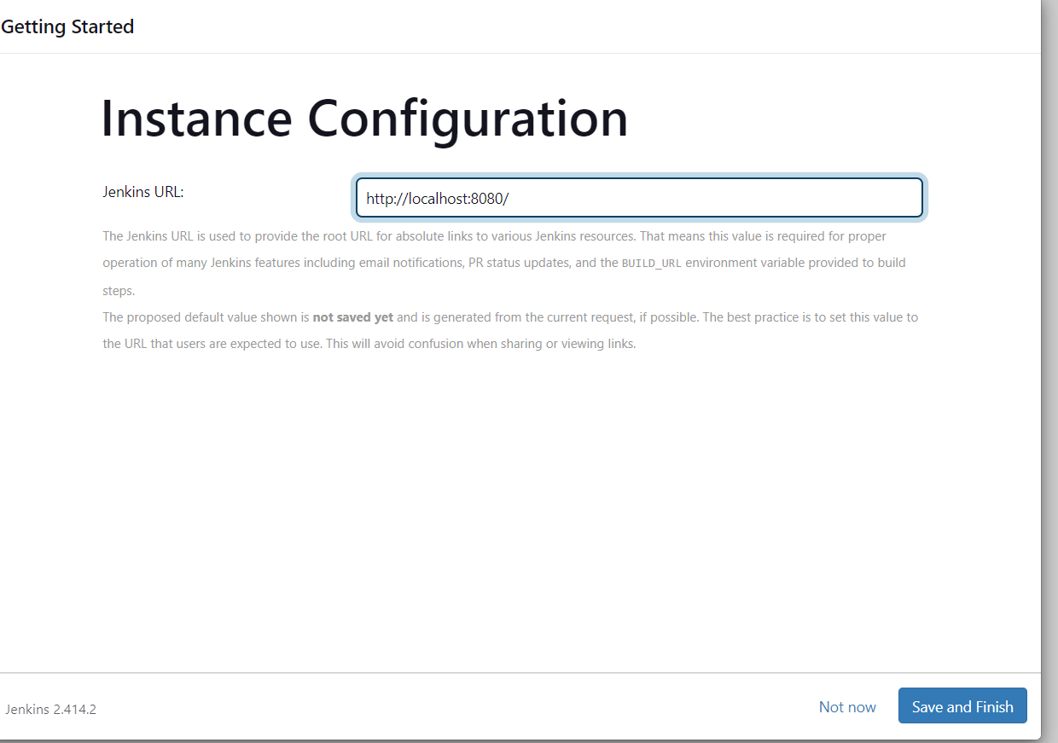

Click on save and finish.

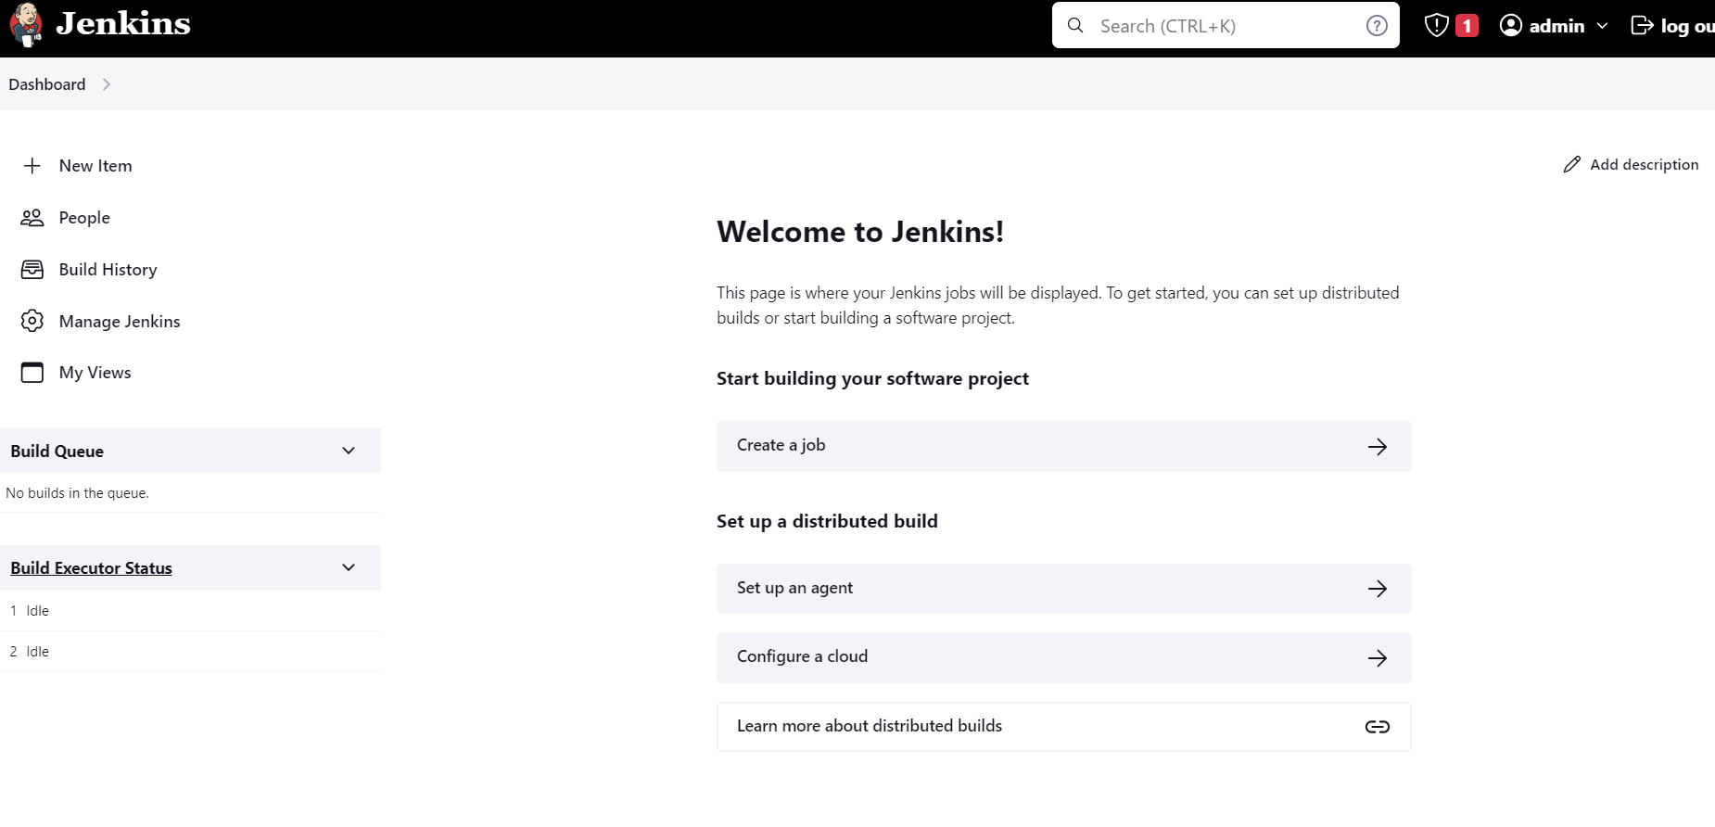

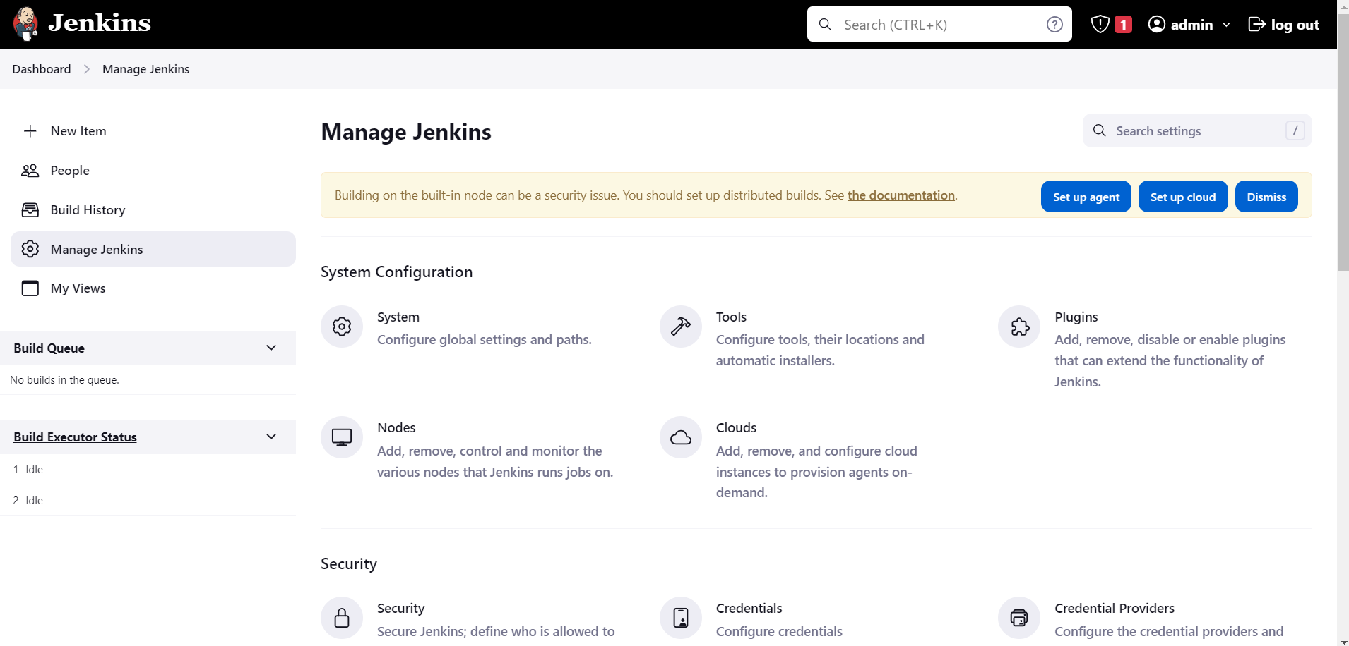

Go to tools and scroll down to Maven

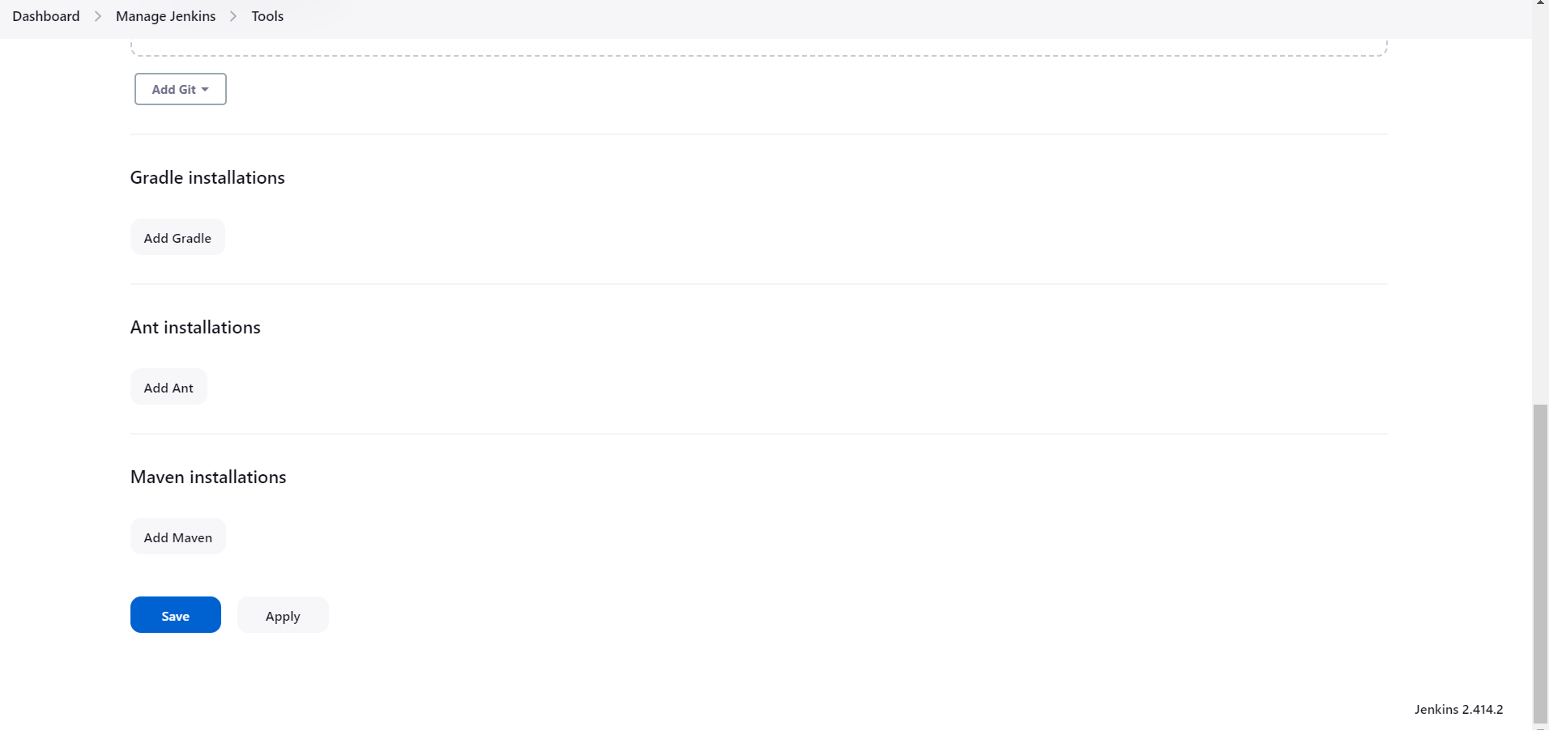

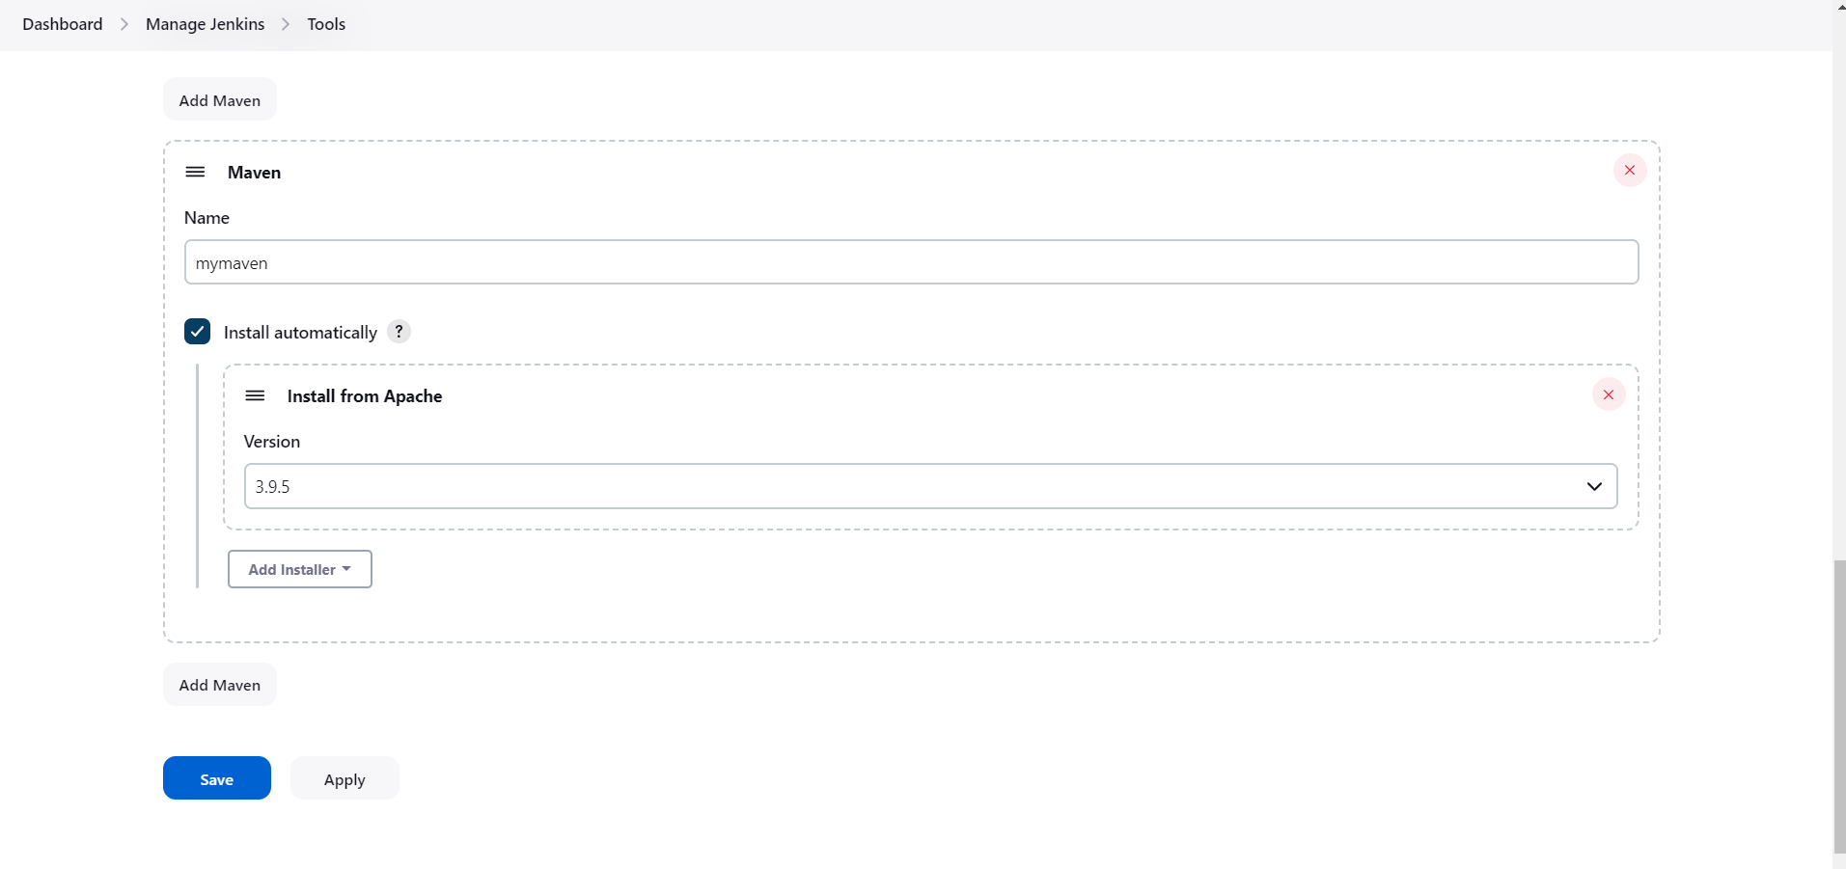

Maven Project in Eclipse:

It is not a Simple project 🡪 select the workspace

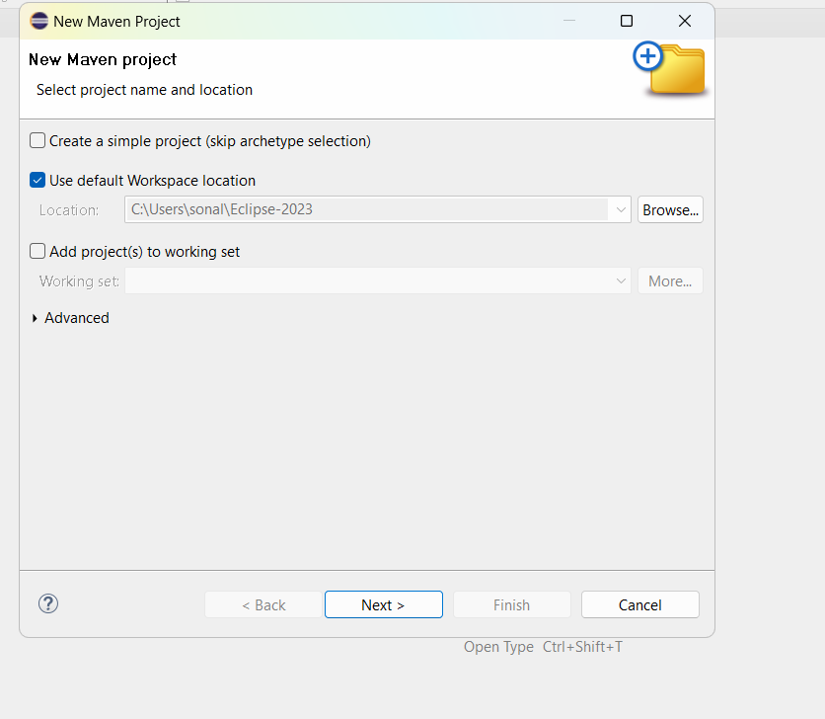

Press next > In the filter type maven-archetype-quickstart > select the option as shown below

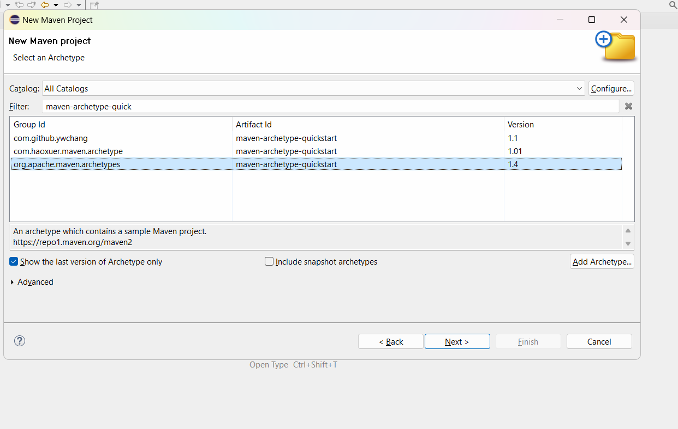

Press next and give groupid and artifact id

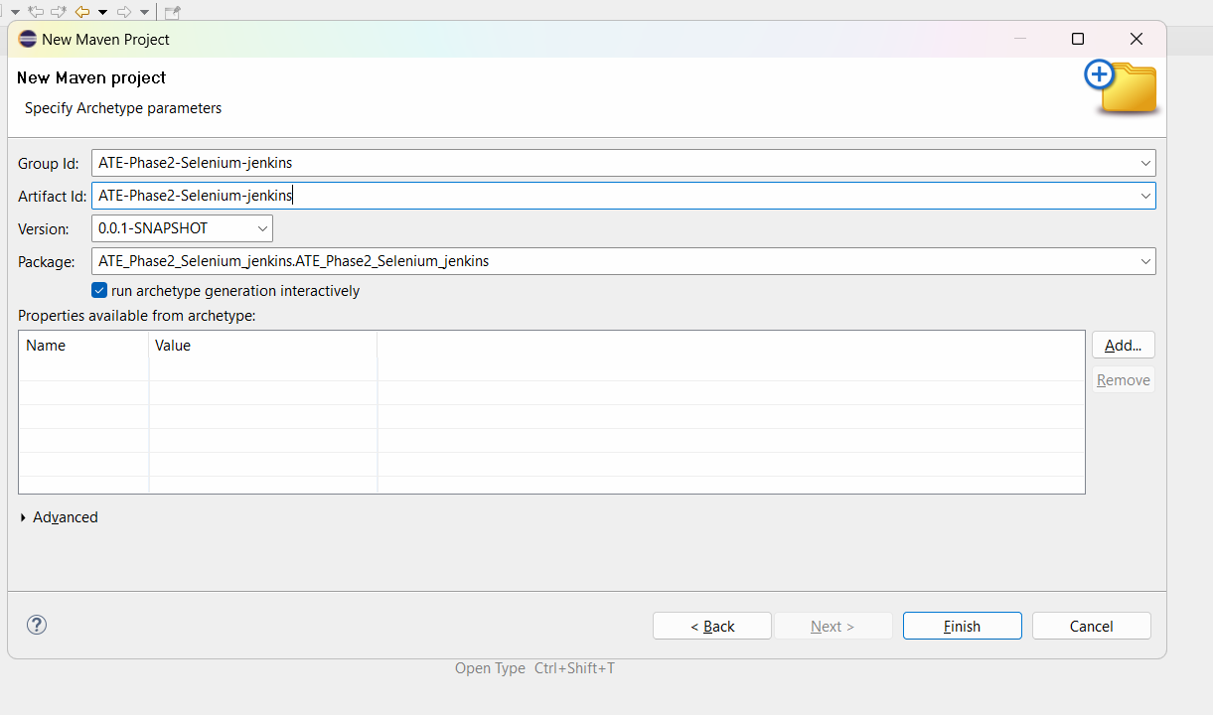

Click on Finsih buton and wait for it to complete building the project

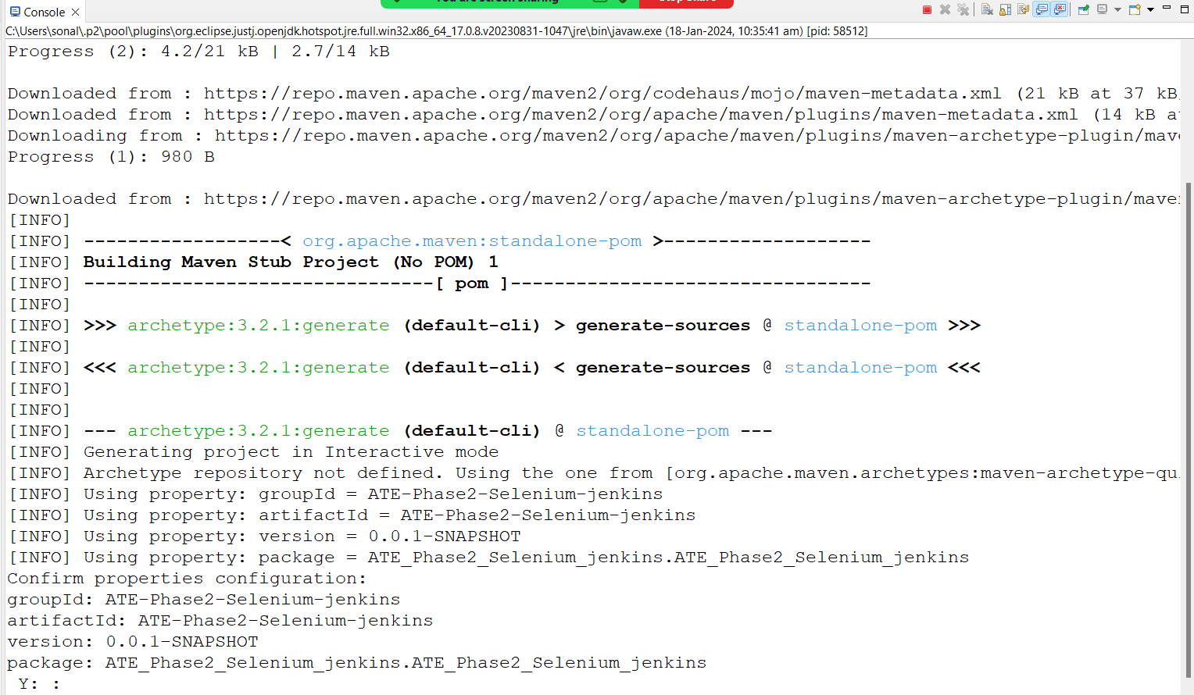

After this pls give Y in the console to continue the process

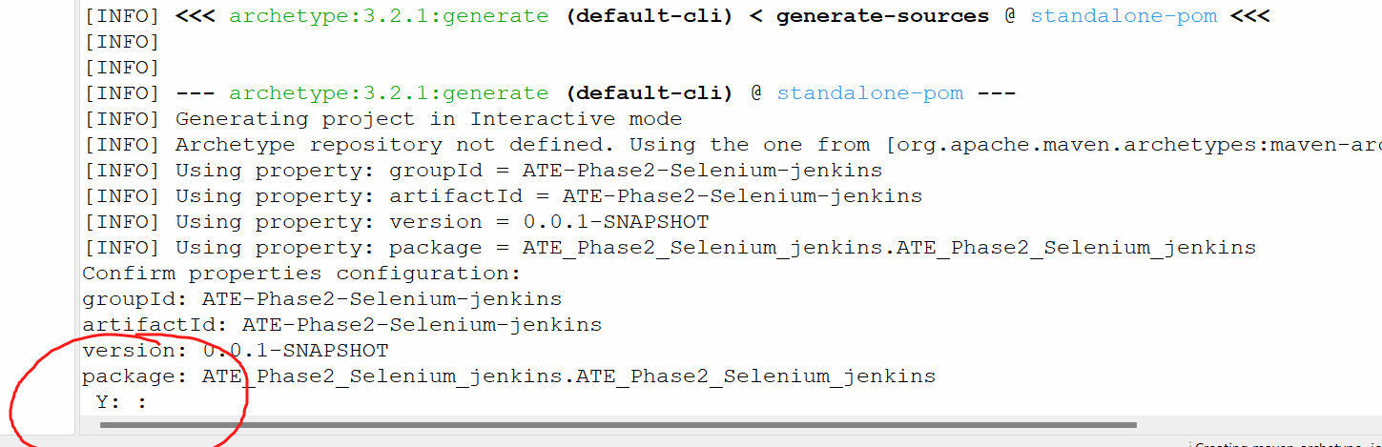

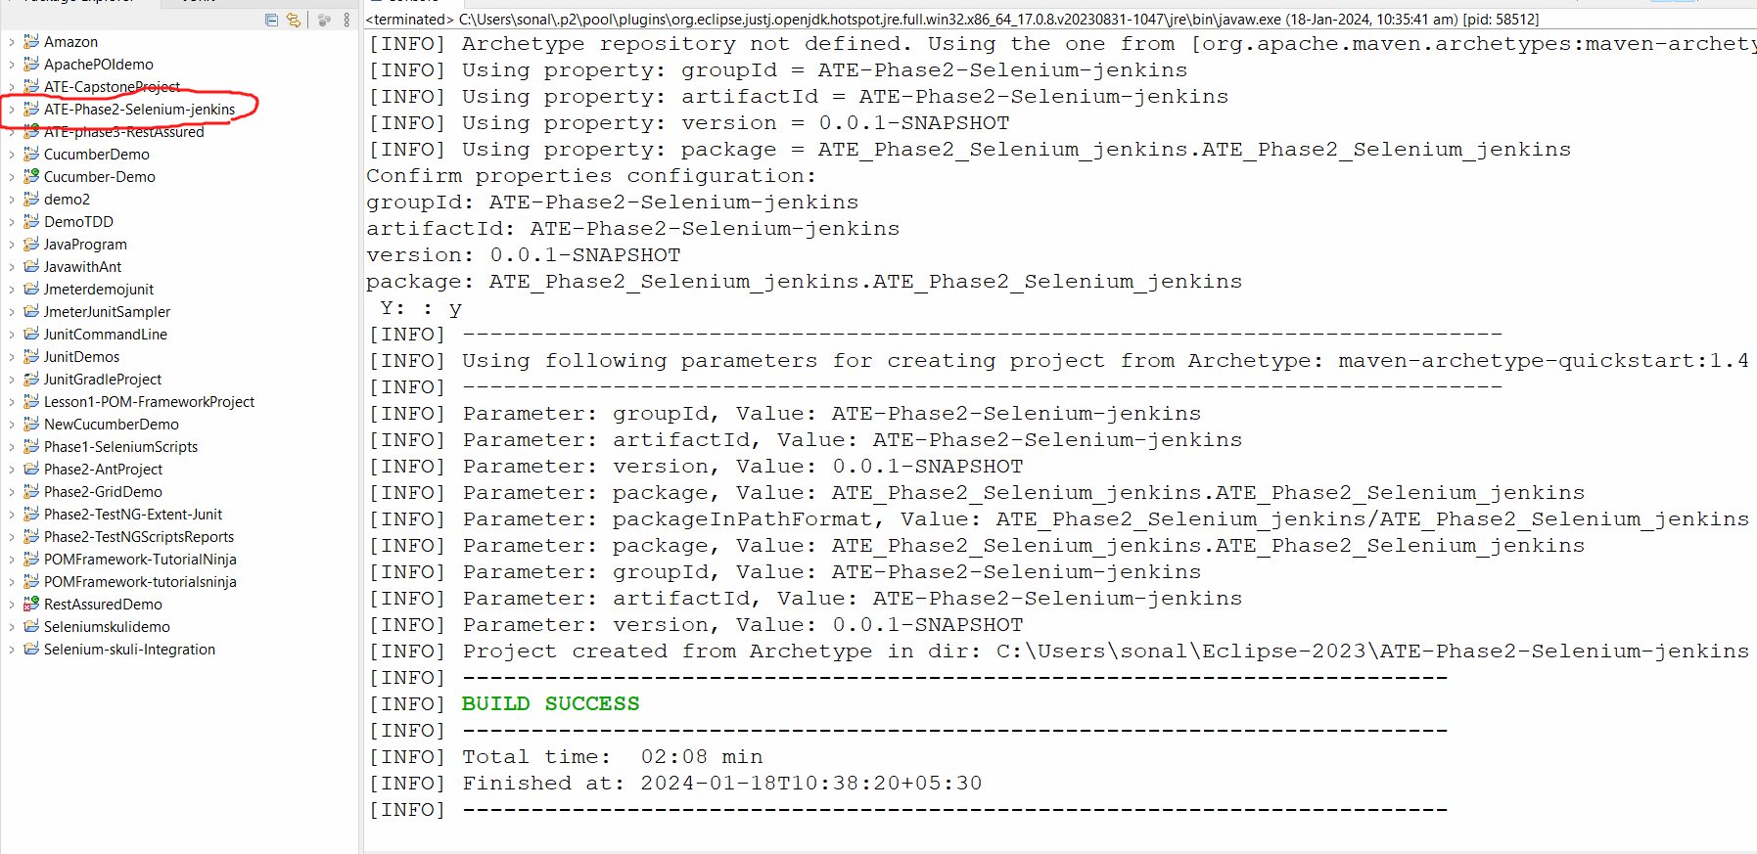

Open the POM file and we will add the dependencies and plugins for maven

Under dependencies -> remove the junit dependency

Add the below dependencies:

<dependency>

<groupId>org.seleniumhq.selenium</groupId>

<artifactId>selenium-java</artifactId>

<version>4.11.0</version>

</dependency>

<!-- https://mvnrepository.com/artifact/io.github.bonigarcia/webdrivermanager -->

<dependency>

<groupId>io.github.bonigarcia</groupId>

<artifactId>webdrivermanager</artifactId>

<version>5.4.1</version>

</dependency>

<!-- https://mvnrepository.com/artifact/org.testng/testng -->

<dependency>

<groupId>org.testng</groupId>

<artifactId>testng</artifactId>

<version>7.7.1</version>

<scope>test</scope>

</dependency>

Now go to src/test/java folder 🡺 there will be a default package => right click and delete it.

==================================================================

There may be an error on the project because some of the files may be missing

For this -> rightclick on your project🡪 go to maven 🡪 go update project 🡪 click on force upadate project/snapshots -> click OK

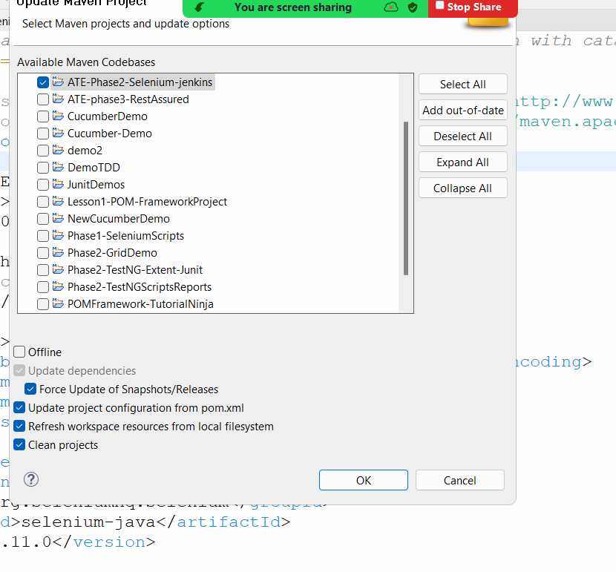

Error will be gone.