FIRST PROGRAM OUTPUT:

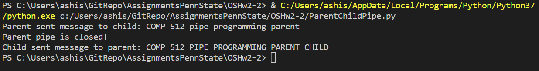

SECOND PROGRAM OUTPUT:

