Report
Of
UI/UX Design Internship

Submitted
To

School of Computer Science and Engineering
IILM University, Greater Noida, U.P.

In partial fulfilment of the requirement of degree of
B.Tech CSE Core



By
Roll Number of Student: 25SCS1003000879
Name of Student: ASHISH KUMAR
Batch:
2025-2029

CANDIDATE'S DECLARATION

I, Ashish Kumar, do hereby declare that the internship report titled “UI/UX Design Internship” has been completed by me to fulfil the requirement for the award of the degree of Bachelor of Technology in CSE Core. All the references have been quoted and I have not taken as such any material from any other source. I affirm that this report is my own work and has not been submitted to any other institute for any degree/diploma requirement, and I shall be solely responsible for any kind of copyright violation in this regard.

Signature
Student Name: Ashish Kumar
Roll No.: 25SCS1003000879

ACKNOWLEDGEMENT

I am using this opportunity to express my gratitude to everyone who supported me throughout the internship program at Thiranex. I am thankful for their aspiring guidance, invaluably constructive criticism, and friendly advice during this work. I am sincerely grateful to them for sharing their truthful and illuminating views on a number of issues related to this work.
I also express my gratitude to my parents for their blessings and continuous support.

Signature
Student Name: Ashish Kumar
Roll No.: 25SCS1003000879

INTERNSHIP COMPLETION CERTIFICATE

(Attach the official Internship Completion Certificate issued by Thiranex here)

TABLE OF CONTENTS

Chapter No. | Chapter Name | Page Nos.
 | Cover Page | ---
1. | Candidate's Declaration | i
2. | Acknowledgment | ii
3. | Internship Completion Certificate | iii
4. | Project Description  4.1 Introduction  4.2 Organization Profile  4.3 Problem Statement  4.4 Project Objectives  4.5 Scope of the Project  4.6 Technologies and Tools Used  4.7 System Architecture  4.8 Methodology  4.9 Expected Outcomes  4.10 Certificates of Completion | 1
5. | Bibliography/References | 10

CHAPTER 4: PROJECT DESCRIPTION
4.1 Introduction
This report presents the work undertaken during a one-month internship in the User Interface (UI) and User Experience (UX) Design domain, completed under the Thiranex virtual internship program. The internship was designed to provide hands-on, project-based exposure to the design process followed in the software industry, moving progressively from research and wireframing to high-fidelity design, interactive prototyping, and usability evaluation. Over the course of the program, four structured design tasks were undertaken, each targeting a distinct stage of the UI/UX design lifecycle.
4.2 Organization Profile
Thiranex is an MSME-registered EdTech initiative, operated through Thiranex IT Solutions, that offers free, verified virtual internship programs to students across more than fifteen technical and design domains. The platform focuses on bridging the gap between academic learning and industry practice by offering self-paced, project-based internships that can be completed remotely, along with mentorship, task guides, instant offer letters, and verifiable completion certificates. Interns are assigned a structured set of milestone-based tasks, and their progress is tracked and reviewed through an online dashboard.
4.3 Problem Statement
Undergraduate students often possess theoretical knowledge of design principles but lack practical, industry-aligned exposure to the end-to-end UI/UX design workflow — from understanding user needs to delivering a tested, interactive prototype. There was a need for a structured, project-based internship that would allow a learner to apply design tools and methods to realistic problems, covering wireframing, interface redesign, prototyping, and usability testing within a short and well-defined timeframe.
4.4 Project Objectives
- To understand and apply the early-stage design process, including user research, personas, and user flows.
- To design low-fidelity wireframes for a mobile application using industry-standard tools.
- To redesign an existing website interface by identifying usability issues and improving visual hierarchy and responsiveness.
- To convert static wireframes into an interactive, clickable prototype that simulates real application behaviour.
- To plan and conduct usability testing on a digital product and analyse the results to suggest design improvements.
4.5 Scope of the Project
The scope of the internship was limited to four milestone tasks assigned over the one-month duration: (1) wireframing a mobile application, (2) redesigning an existing website's user interface, (3) building an interactive prototype from the wireframes, and (4) conducting usability testing and analysis on a digital product. Each task built upon the deliverables of the previous one, taking the project from a conceptual design stage through to a testable, interactive artifact.
4.6 Technologies and Tools Used
- Figma – for wireframing, high-fidelity UI design, and interactive prototyping.
- Adobe XD – as an alternative tool for wireframing and mock-up design.
- InVision – for converting design screens into clickable, navigable prototypes.
- Basic HTML/CSS concepts – for understanding responsive layout behaviour across devices.
- Thiranex online dashboard – for task submission, tracking, and review.
4.7 System Architecture / Design Workflow
Rather than a software system architecture, this internship followed a design-process workflow. The workflow began with user research and requirement understanding, followed by the creation of low-fidelity wireframes to establish structure and flow. This was followed by high-fidelity interface design and a heuristic evaluation of the existing website to identify usability gaps. Validated designs were then converted into an interactive prototype with navigation and transitions, which was finally subjected to usability testing so that feedback could be looped back into design refinement.
4.8 Methodology
Task 1: Mobile App Wireframing (Due: 29 Aug 2026 – Completed)
The objective of this task was to design low-fidelity wireframes for a mobile application, focusing on early-stage design planning.
Key activities carried out:
- Conducted basic user research to identify user needs.
- Created user personas and user flow diagrams.
- Designed low-fidelity wireframes using Figma.
- Documented the design thinking process followed.
Outcome: Gained an understanding of early-stage design planning and how user flows are translated into wireframe structures.
Task 2: Website UI Redesign (Due: 05 Sept 2026 – Completed)
This task involved redesigning the user interface of an existing website to improve its overall usability.
Key activities carried out:
- Performed a heuristic evaluation of the existing website to identify usability issues.
- Created mood boards and style guides to define the new visual direction.
- Designed high-fidelity mock-ups for the redesigned interface.
- Ensured responsive layouts for both desktop and mobile screens.
Outcome: Gained practical experience in visual hierarchy, layout design, and responsive design principles.
Task 3: Interactive Prototype Creation (Due: 12 Sept 2026 – Completed)
The goal of this task was to build a clickable prototype that simulates real application interactions.
Key activities carried out:
- Converted the earlier wireframes into interactive prototypes using Figma and InVision.
- Added animations, transitions, and navigation flows between screens.
- Conducted quick user testing on the prototype.
- Gathered feedback and refined the design accordingly.
Outcome: Learned how to present and test interactive designs effectively before handoff.
Task 4: Usability Testing & Analysis (Due: 19 Sept 2026 – Completed)
This task focused on conducting usability testing on a digital product and analysing the results.
Key activities carried out:
- Prepared usability test plans and test scenarios.
- Recruited sample users and conducted testing sessions.
- Recorded observations and collected user feedback.
- Prepared a report summarizing findings and design improvement suggestions.
Outcome: Developed an understanding of usability metrics, testing methods, and the iterative design improvement cycle.
4.9 Expected Outcomes
By the end of the internship, the following learning outcomes were achieved: an understanding of early-stage design planning and user-flow creation; practical experience in visual hierarchy, layout, and responsive design; the ability to translate static designs into interactive, testable prototypes; and a working knowledge of usability testing methods and how test findings feed back into iterative design improvement. Together, these outcomes reflect a complete, end-to-end exposure to the UI/UX design lifecycle within the one-month internship period.
4.10 Certificates of Completion and Other Communication Mail Proof
The official Thiranex offer letter confirming the internship (Intern ID: THX-AUG2226-122, UI/UX Designing, 22 Aug 2026 to 21 Sept 2026) is attached below as proof of enrolment. The final internship completion certificate may be attached alongside it once issued.
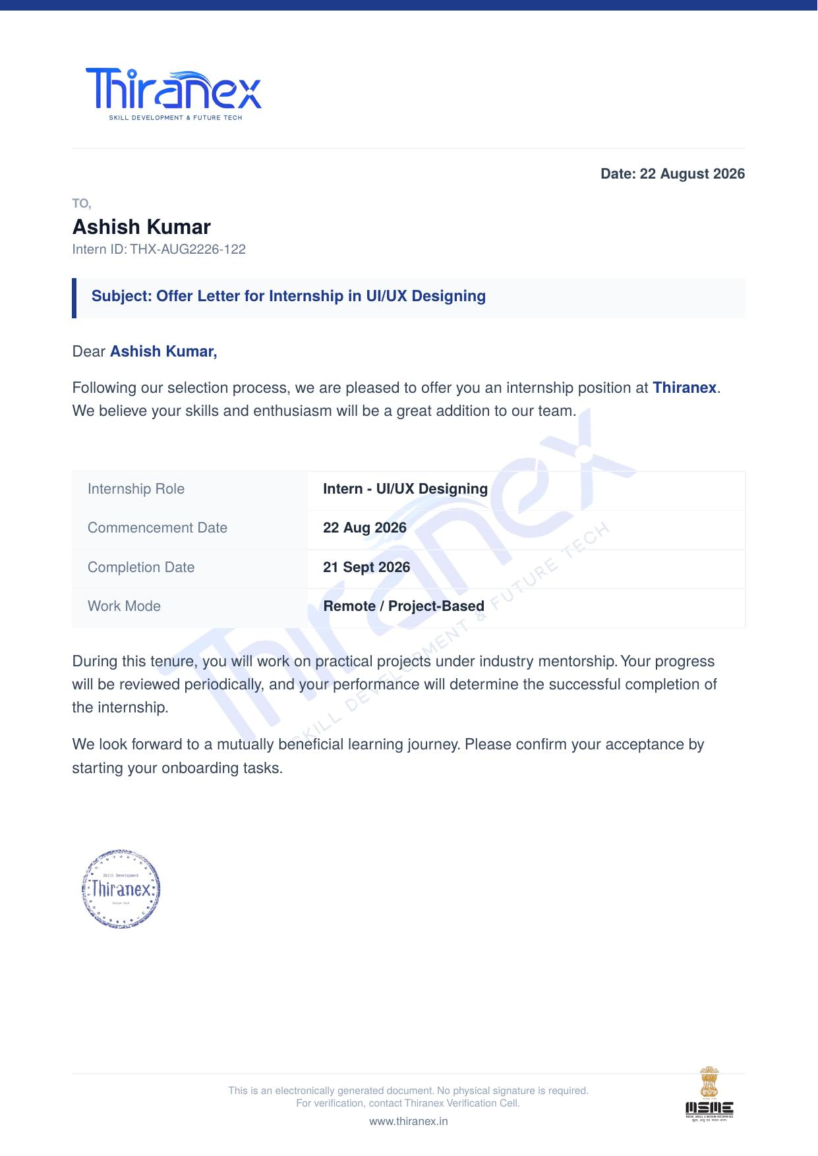
Fig 4.1: Thiranex Internship Offer Letter

CHAPTER 5: BIBLIOGRAPHY / REFERENCES
1. Thiranex – Free Verified Virtual Internship Platform. Available at: https://www.thiranex.in/
2. Figma – Collaborative Interface Design Tool. Available at: https://www.figma.com/
3. Adobe XD – User Experience Design Software. Available at: https://www.adobe.com/products/xd.html
4. InVision – Digital Product Design Platform. Available at: https://www.invisionapp.com/
5. Nielsen, J. Usability Engineering. Nielsen Norman Group – UX research and heuristic evaluation principles.

