

**Elements of AIML**

**Lab Assignment 1 on 7th November**

**Name:** Ashish Varma Dandu

Course: **B.Tech. C.S.E.**

**Batch**: 12

**Sap.id.:** 500121801

**Enrollment no.:** R2142230372

**TOPIC – CREATING A GITHUB**

**REPOSITORY**

**Step 1-**  We will create a account in GitHub.

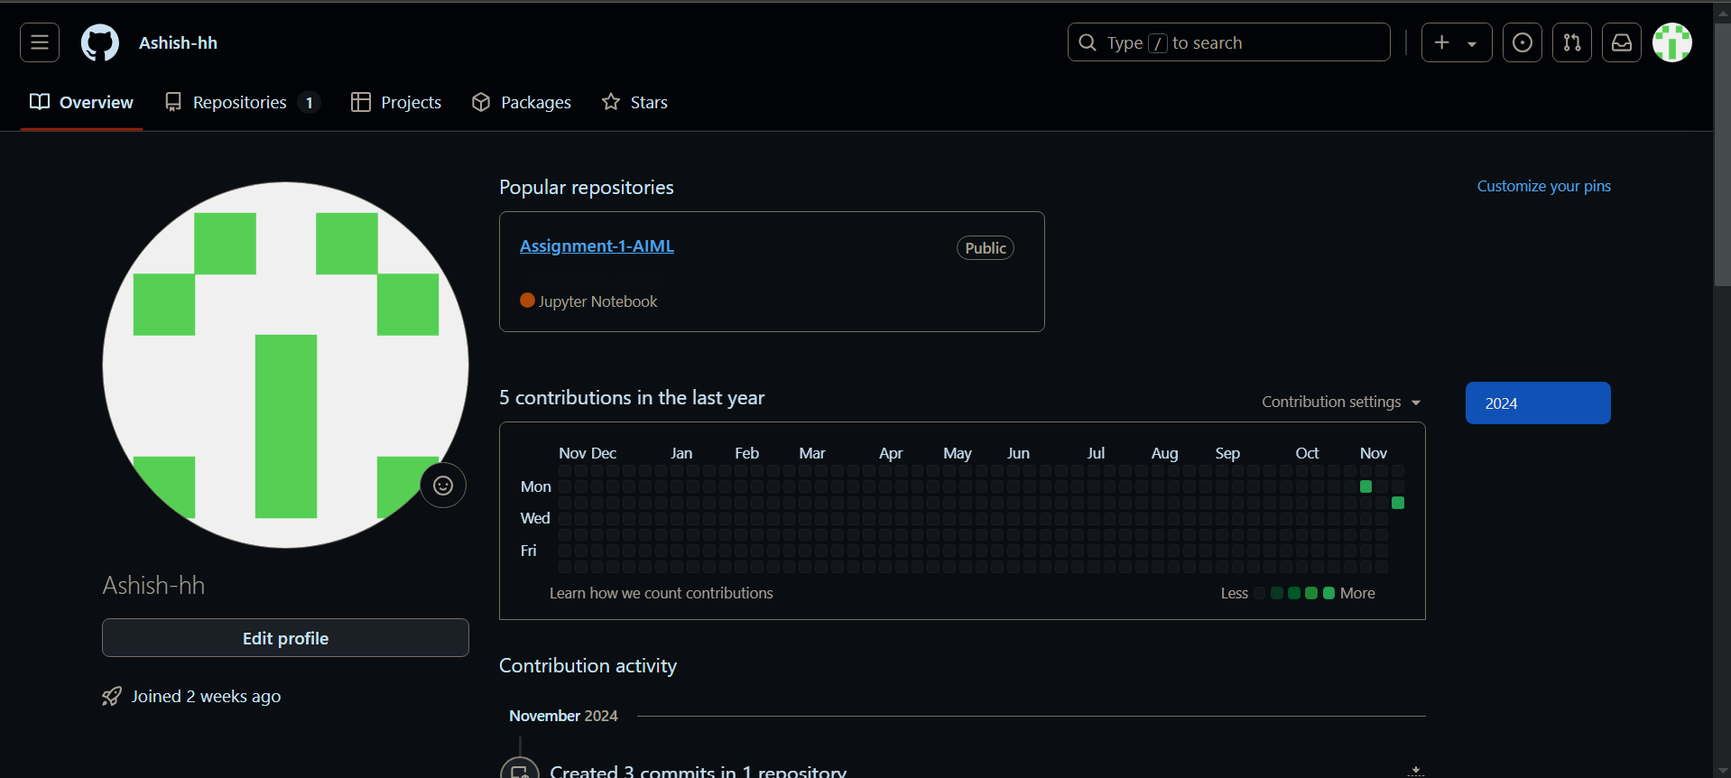

**Step 2-** We will create a Repository named “Assignment

1 AIML” and Branched”Main”

––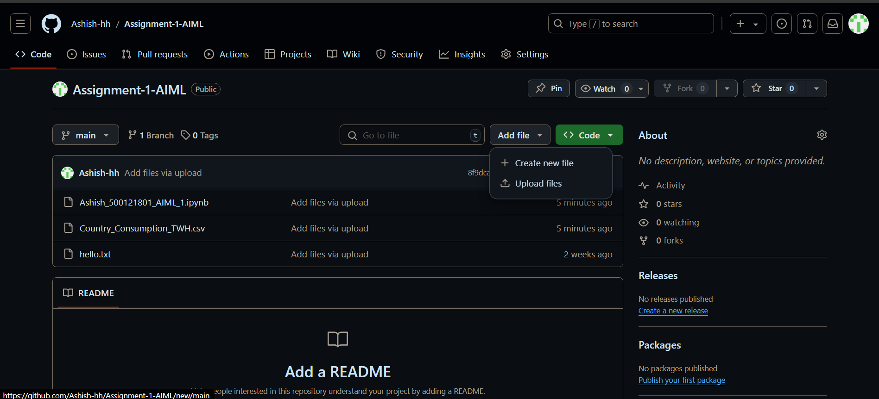

+

**Step 3**- we will create a text file named “Hello.txt” with our normal words and then attached in this branch.

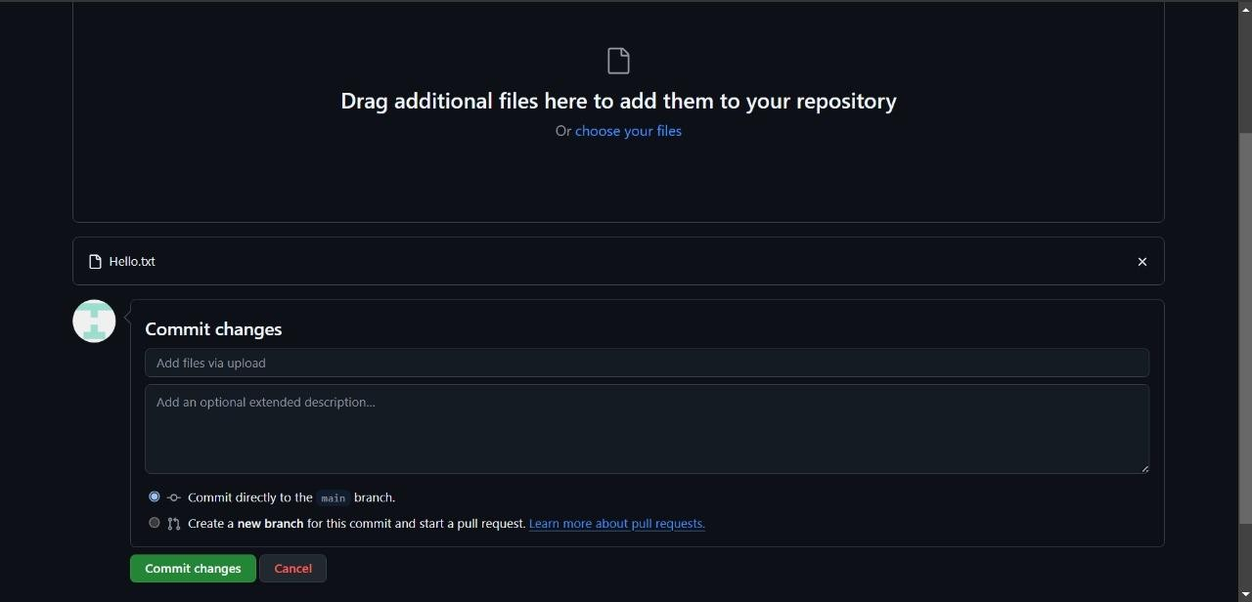

**Step 4**- After the text file upload we will run it on out GitHub.



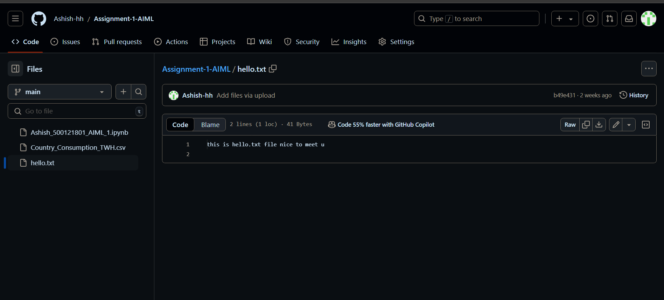

**CODE :-** 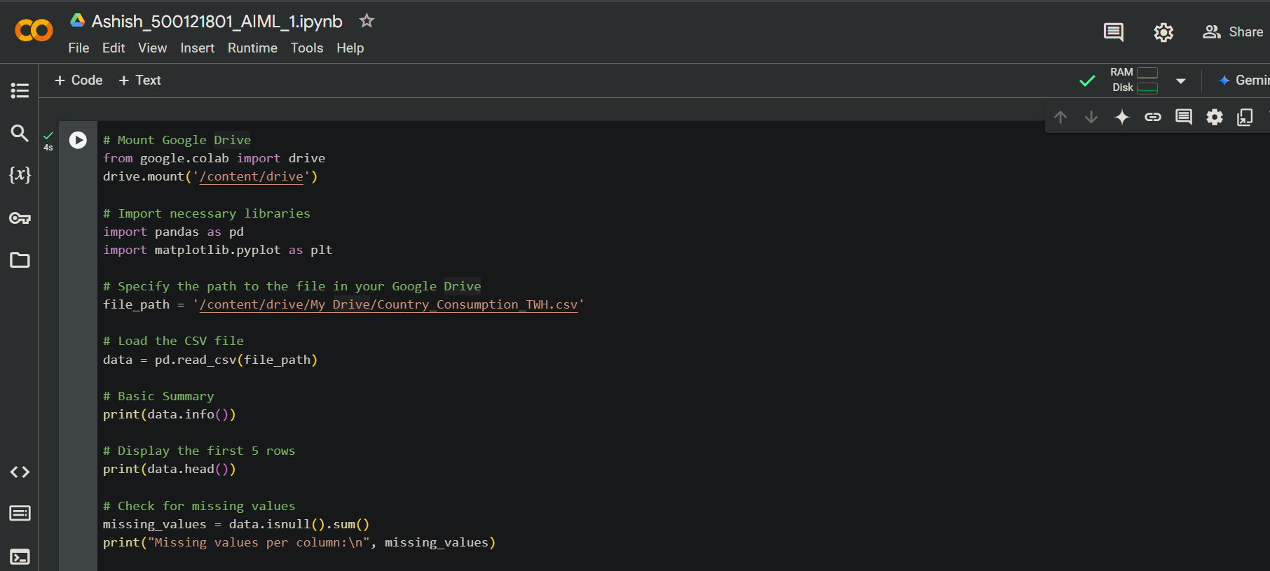 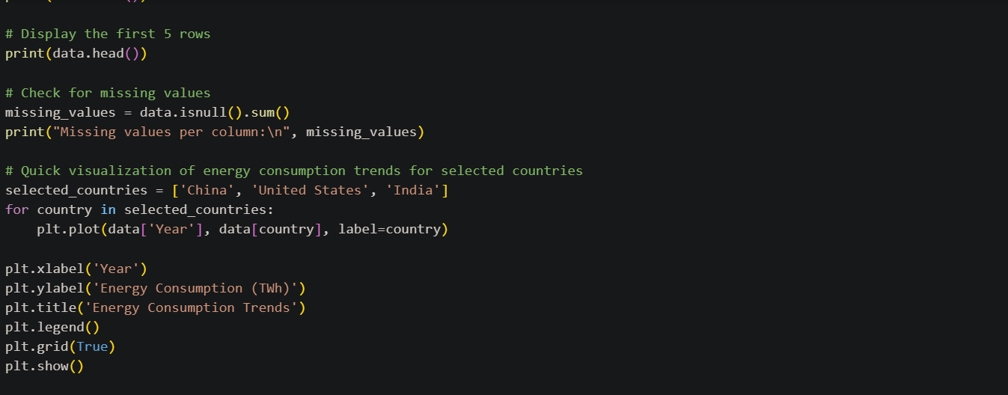

**OUTPUT:-**

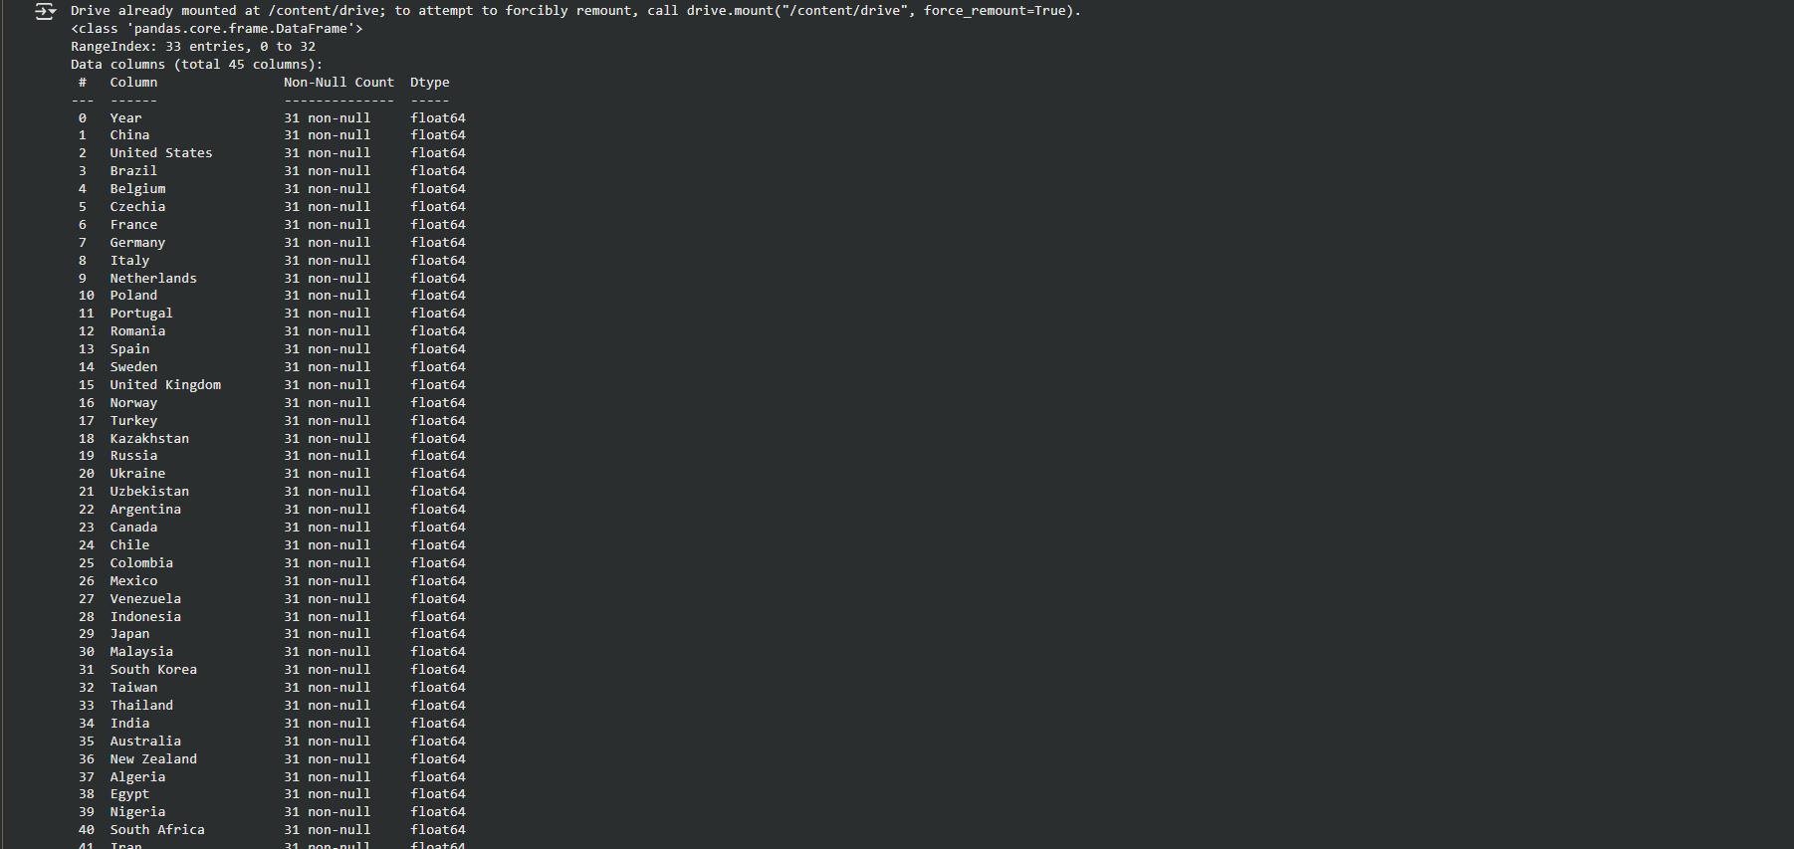

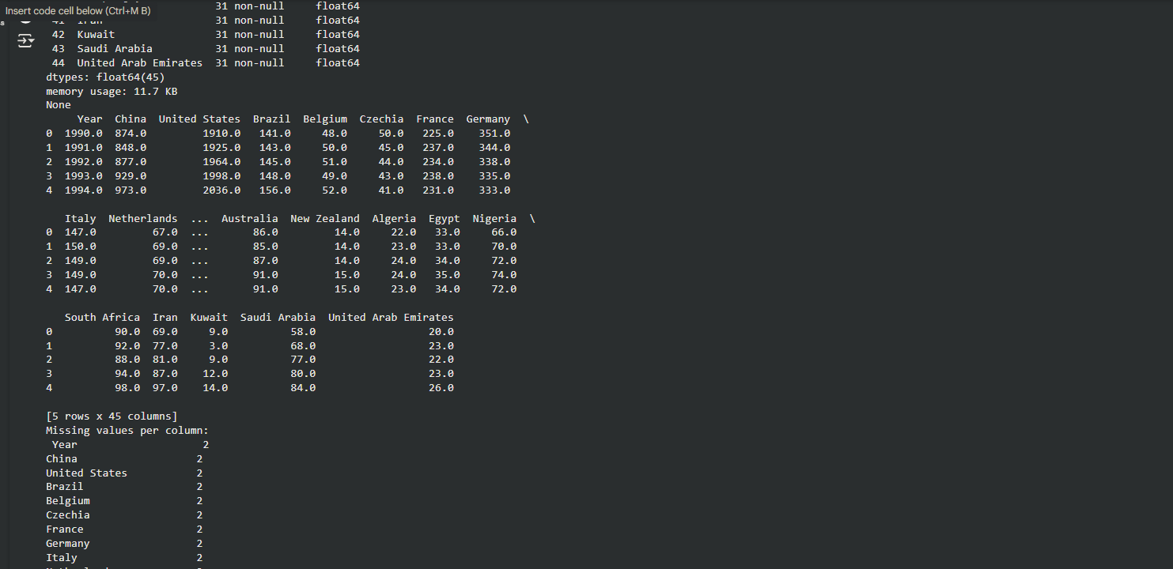

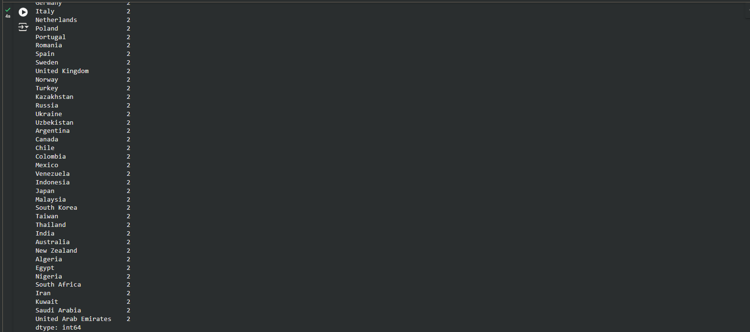

**GRAPH:-**

