Guidance for Submitting Final Scientific/Technical Reports
for ARPA-E Projects

The core mission of the U.S. Department of Energy’s (DOE) Office of Scientific and Technical Information (OSTI) is “to advance science and sustain technological creativity by making R&D findings available and useful to DOE researchers and the public.”¹ By submitting your Final Scientific/Technical Report to OSTI, you are fulfilling the obligation you agreed to when you accepted taxpayer dollars, and you are serving the best interests of the research community. OSTI centralizes, organizes, and leverages the R&D work supported throughout the Department. This allows DOE and the broader research community to make informed decisions based upon both successful and unsuccessful past federally-funded research projects.

Subject to an information hold of up to five years, only if appropriate, your report will be added to information from 18 U.S. Government science organizations within 13 federal agencies as part of the Science.Gov alliance. OSTI’s data is also combined with 95 other databases and portals from over 70 countries to form the WorldWideScience.org website. In addition, OSTI coordinates with Google Scholar to make technical data easily available. All of this is done because OSTI ensures that researchers such as yourselves will be able to learn from the technical insights ARPA-E has supported.

The terms of your Cooperative Agreement, as well as DOE Order 241.1B, require the submission of your Final Scientific/Technical Report to OSTI in order to complete and formally close out your project. Properly and appropriately marked reports may be kept confidential for up to five

- years, subject to DOE approval. Figure 1 includes a notional timeline to help you understand this process.

It is your responsibility to exclude Intellectual Property (IP) created outside your ARPA-E project (note, IP created as an in-kind cost share contribution to your ARPA-E project is considered part of your ARPA-E project). If your Final Scientific/Technical Report contains no protected data, OSTI will publish your Final Scientific/Technical Report upon receipt. If your Final Scientific/Technical Report appropriately includes protected data, such data will not be published for up to five years.

The remainder of this document contains specific guidance to help you navigate the OSTI reporting process while ensuring your protected data will not be publicly released for up to five years.

- See http://www.osti.gov/mission html

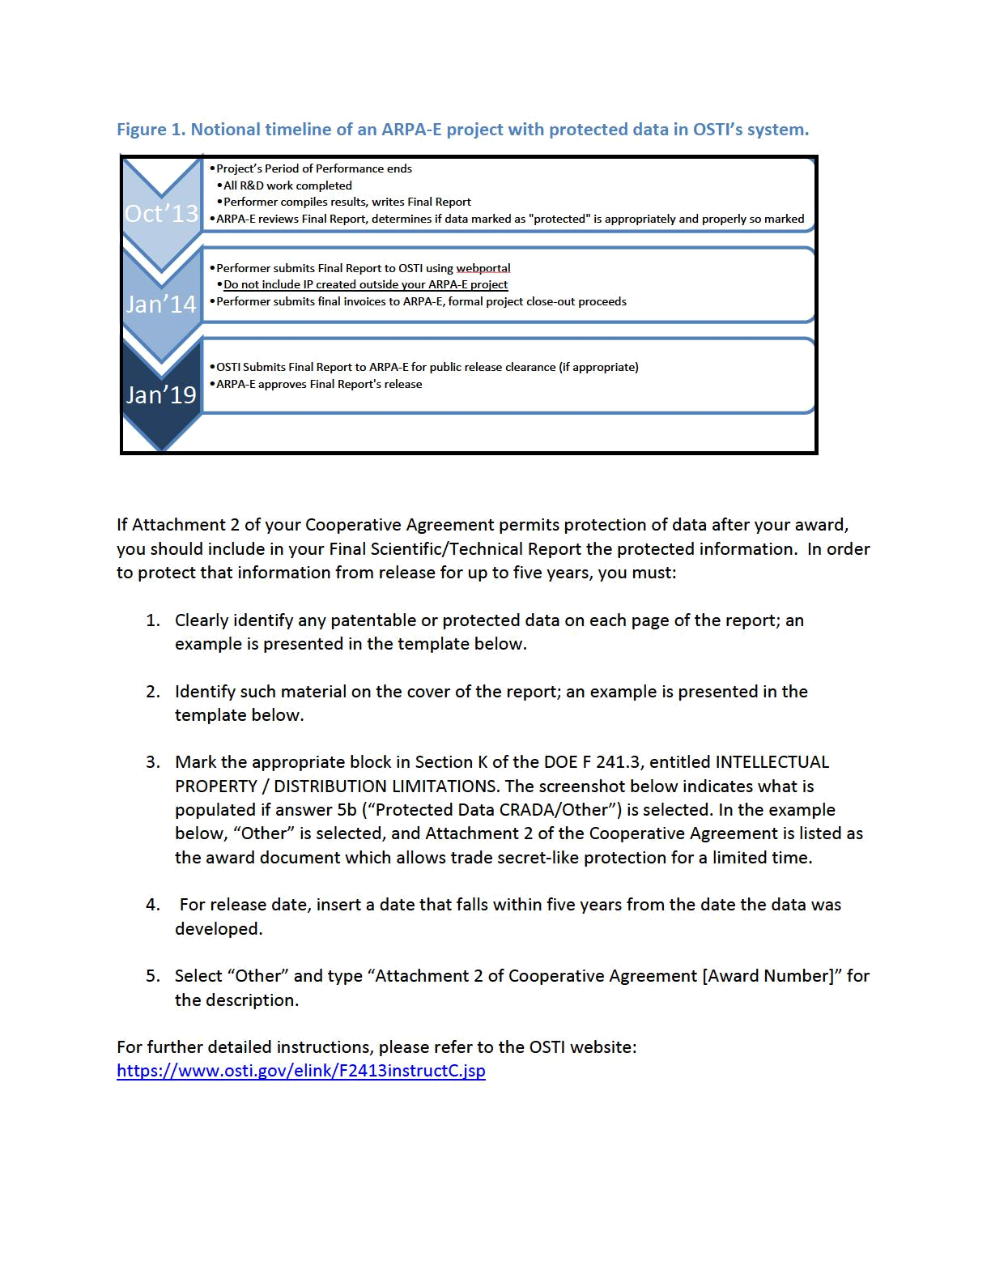
Electronic Submission: The Final Scientific/Technical Report must be submitted electronically
via the DOE Energy Link System (E-Link) accessed at https://www.osti.gov/elink/241-3.jsp.
Reports must be submitted in the Adobe Portable Document Format (PDF) and be one
integrated PDF file that contains all text, tables, diagrams, photographs, schematics, graphs,
and charts. Materials, such as prints, videos, and books, that are essential to the report but
cannot be submitted electronically, should be sent to the Contracting Officer at the address
listed in Block 16 of the Assistance Agreement Cover Page. Part II of the F 241.3 cannot be
completed until every required field (i.e., fields with red text) in Part I are completed. Specific

guidance on DOE F 241.3 is available at
https://www.osti.gov/elink/F2413instructC.jsp?printerfriendly=true#org.

Submittal Form: The report must be accompanied by a completed electronic version of DOE Form 241.3, “U.S. Department of Energy (DOE), Announcement of Scientific and Technical Information (STI).” You can complete, upload, and submit the DOE F.241.3 online via E-Link (https://www.osti.gov/elink/241-3.jsp). Reports must not contain any limited rights data, classified information, information subject to export control classification, or other information not subject to release.

Figure 2. Screen Shot of DOE Electronic Form 241.3.
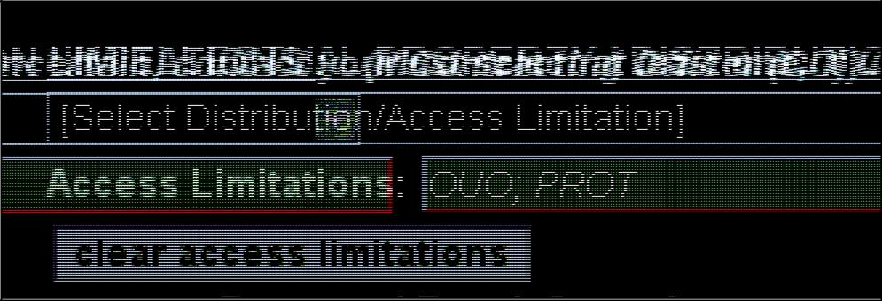

Final Scientific/Technical Report Template

[Optional John Doe Enterprises Logo]

[John Doe Enterprise]

Final Scientific/Technical Report

[Project Name]

[Contract Number]

[Optional Image]

Award: | [DE-AR0000XXX]
Lead Recipient: | [John Doe Enterprise]
Project Title: | [Transformational & Disruptive Technology]
Program Director: | [Dr. XXXX XXXXX]
Principal Investigator: | [Dr. XXXX XXXXX]
Contract Administrator: | [XXXXX XXXXX]
Date of Report: | [January 1, 2013]
Reporting Period: | [January 1, 2010 – November 1, 2012]

This document contains protected data that was produced under agreement no. [DE-AR0000XXX] with the U.S. Department of Energy and that may not be published, disseminated, or disclosed to others outside the Government until five years after development of such data, unless express written authorization is obtained from the recipient. All paragraphs/sections containing protected data are marked with the symbol ╬. Upon expiration of the period of protection set forth in this Notice, the Government shall have unlimited rights in this data,
including the right to publish the data. This Notice shall be marked on any reproduction of this data, in whole or in part, during the applicable period of protection.

- Paragraphs/sections marked with this symbol may contain protected data produced under agreement no. [DE-AR0000XXX] with the U.S. Department of Energy that may not be published, disseminated, or disclosed to others outside the Government until 5 years after development of such data under this agreement, unless written authorization is obtained from the recipient. Upon expiration of the period of protection set forth in this Notice, the Government shall have unlimited rights in this data, including the right to publish. This Notice shall be marked on any reproduction of this data, in whole or in part.

Public Executive Summary

Provide an executive summary, which should contain information with unlimited rights but NOT contain proprietary or protected information. ARPA-E may use this section to respond to requests for information about your project after its conclusion or may otherwise determine that it needs to make this information immediately available to the public.

This section should include a discussion of 1) how the research adds to the understanding of the area investigated; 2) the technical effectiveness and economic feasibility of the methods or techniques investigated or demonstrated; and 3) how the project is otherwise of benefit to the public. The discussion should be written in terms understandable by an educated layman.

Acknowledgements

Credit substantial contributors to the work who are not authors. Typically, this section includes a formal acknowledgement of ARPA-E for financially supporting the research, acknowledgement of any other groups that provided financial support (e.g. cost-share), as well as to other members of the project team.

- Paragraphs/sections marked with this symbol may contain protected data produced under agreement no. [DE-AR0000XXX] with the U.S. Department of Energy that may not be published, disseminated, or disclosed to others outside the Government until 5 years after development of such data under this agreement, unless written authorization is obtained from the recipient. Upon expiration of the period of protection set forth in this Notice, the Government shall have unlimited rights in this data, including the right to publish. This Notice shall be marked on any reproduction of this data, in whole or in part.

Table of Contents

Public Executive Summary 6

Acknowledgements 6

Table of Figures/Tables 7

Accomplishments and Objectives 8

Project Activities 9

Project Outputs 9

Follow-On Funding 10

Table of Figures/Tables

Table 1. Key Milestones and Deliverables. 8

- Paragraphs/sections marked with this symbol may contain protected data produced under agreement no. [DE-AR0000XXX] with the U.S. Department of Energy that may not be published, disseminated, or disclosed to others outside the Government until 5 years after development of such data under this agreement, unless written authorization is obtained from the recipient. Upon expiration of the period of protection set forth in this Notice, the Government shall have unlimited rights in this data, including the right to publish. This Notice shall be marked on any reproduction of this data, in whole or in part.

Accomplishments and Objectives

[Provide a comparison of the actual accomplishments with the technical milestones and deliverables of the project.]

This award allowed [John Doe Enterprise] to demonstrate a number of key objectives. The focus of the project was on building a [Transformational & Disruptive Technology].

A number of tasks and milestones were laid out in Attachment 3, the Technical Milestones and Deliverables, at the beginning of the project. The actual performance against the stated milestones is summarized here:

Table 1. Key Milestones and Deliverables.

Tasks | Milestones and Deliverables
Task 1: Task title | Q1: Milestone as stated in statement of project objectives.
1.1 Subtask | Actual Performance: (Completion date) Performer states progress
1.1 Subtask | against the milestone and completion date. Should be as quantitative
1.2 Subtask | as possible.
1.3 Subtask | Q2: Milestone as stated in statement of project objectives.
 | Actual Performance: (Completion date) Performer states progress
 | against the milestone and completion date. Should be as quantitative
 | as possible.
 | ...
Task 2: Task title | Q1: Milestone as stated in statement of project objectives.
2.1 Subtask | Actual Performance: (Completion date) Performer states progress
2.1 Subtask | against the milestone and completion date. Should be as quantitative
2.2 Subtask | as possible.
2.3 Subtask | Q2: Milestone as stated in statement of project objectives.
 | Actual Performance: (Completion date) Performer states progress
 | against the milestone and completion date. Should be as quantitative
 | as possible.
 | ...

For projects involving computer modeling, provide a brief description of the model, key assumptions, how the model was validated, and whether or not the model and results were presented in peer-reviewed publications.

- Paragraphs/sections marked with this symbol may contain protected data produced under agreement no. [DE-AR0000XXX] with the U.S. Department of Energy that may not be published, disseminated, or disclosed to others outside the Government until 5 years after development of such data under this agreement, unless written authorization is obtained from the recipient. Upon expiration of the period of protection set forth in this Notice, the Government shall have unlimited rights in this data, including the right to publish. This Notice shall be marked on any reproduction of this data, in whole or in part.

Project Activities

One paragraph that succinctly summarizes the project’s focus, major approaches and hypotheses utilized, and a high-level summary of the project’s results.

If there was a modification to the award as a result of changes in tasks or milestones, state when that occurred and provide a brief narrative describing the change.

Project Outputs

A. Journal Articles

XXXXXXXXX [list journal name, volume, issue]

  - Papers

XXXXXXXXX

  - Status Reports

XXXXXXXXX

  - Media Reports

XXXXXXXXX [If not provided previously, attach or send copies of any public releases to the DOE Program Manager identified in Block 15 of the Assistance Agreement Cover Page]

  - Invention Disclosures

XXXXXXXXX

- Patent Applications

XXXXXXXXX

- Licensed Technologies

XXXXXXXXX

- Networks/Collaborations Fostered

XXXXXXXXX

- Websites Featuring Project Work Results

XXXXXXXXX

- Other Products (e.g. Databases, Physical Collections, Audio/Video, Software, Models, Educational Aids or Curricula, Equipment or Instruments)

XXXXXXXXX

  - Awards, Prizes, and Recognition

XXXXXXXXX

- Paragraphs/sections marked with this symbol may contain protected data produced under agreement no. [DE-AR0000XXX] with the U.S. Department of Energy that may not be published, disseminated, or disclosed to others outside the Government until 5 years after development of such data under this agreement, unless written authorization is obtained from the recipient. Upon expiration of the period of protection set forth in this Notice, the Government shall have unlimited rights in this data, including the right to publish. This Notice shall be marked on any reproduction of this data, in whole or in part.

Follow-On Funding

Additional funding committed or received from other sources (e.g. private investors, government agencies, nonprofits) after effective date of ARPA-E Award.

Table 2. Follow-On Funding Received.

Source | Funds Committed or Received
XXXXX | XXXXX

- Paragraphs/sections marked with this symbol may contain protected data produced under agreement no. [DE-AR0000XXX] with the U.S. Department of Energy that may not be published, disseminated, or disclosed to others outside the Government until 5 years after development of such data under this agreement, unless written authorization is obtained from the recipient. Upon expiration of the period of protection set forth in this Notice, the Government shall have unlimited rights in this data, including the right to publish. This Notice shall be marked on any reproduction of this data, in whole or in part.

