**Project-Name : MenStyle**

 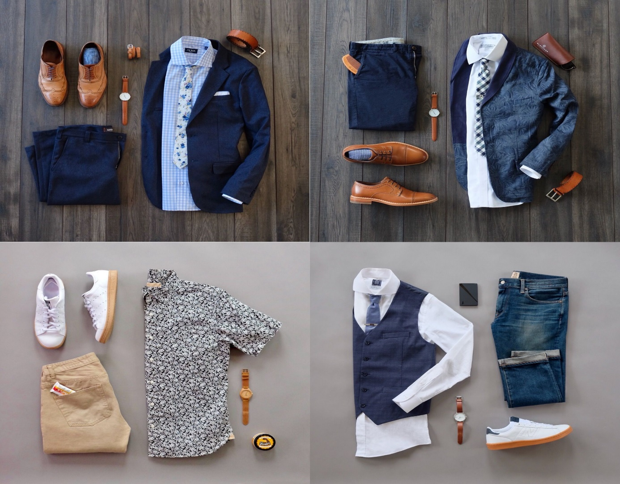

OVERVIEW

It’s an e-commerce website for men’s lifestyle requirements where everything is available under the same roof either it’s clothing, grooming , wellness or footwear.

PAGE STRUCTURE

* Login/Sign-up page
* Home page
* Main page
* Details page
* payment page

HOME PAGE:

> LOGO

> ICONS - (WISHLIST, ADD TO CART)

> SEARCH BAR

> SLIDERS WITH ARROWS - (IMAGES)

> DEALS - (IMAGES)

> FEATURED - (IMAGES)

> TRENDING - (IMAGES)

> FOOTER - ( CONTACT US , HELPLINES , BRIEF DESCRIPTION , SOCIAL

MEDIA HANDLE ICONS , LINK TO MOBILE APP)

MAIN PAGE:

> FILTERS - BRANDS , COLOR , DISCOUNT RANGE , PRICE

COUNTRY OF ORIGIN , MATERIAL , FEATURES ,

FIT , OCCASION , PATTERN , RATING , SIZE ,

TYPE , SORT BY:

> IMAGES OF THE CHOSEN PRODUCT WITH DETAILS LIKE -

BRAND , PRODUCT NAME , PRICE , DISCOUNT% ( IF ANY )

DETAILS PAGE:

> PRODUCT DESCRIPTION - BRAND , PRODUCT NAME ,

PRICE , DISCOUNT% (IF ANY) , SIZE CHART ,

DELIVERY OPTIONS , PRODUCT

DETAILS , SIZE & FIT , MATERIAL & CARE ,

SPECIFICATIONS , RATINGS , CUSTOMER REVIEWS

WITH IMAGES (IF ANY)

> LOWER HALF OF THE PAGE - RELATED PRODUCTS OF SAME

CATEGORY

PAYMENT PAGE:

> ADDRESS SELECTION

> PAYMENT METHOD - PHONEPE , GOOGLE PAY , BHIM UPI ,

COD , CREDIT/DEBIT CARD , NET - BANKING , EMI , PAYTM

LOGIN/SIGNUP PAGE:

> LOGIN – INPUT ID AND PASSWORD, LOGIN BUTTON

> FORM – PERSONAL DETAILS , MOBILE NO. , MAIL ID , ADDRESS ,

SIGNUP BUTTON