**Facts about Planet Mercury:**

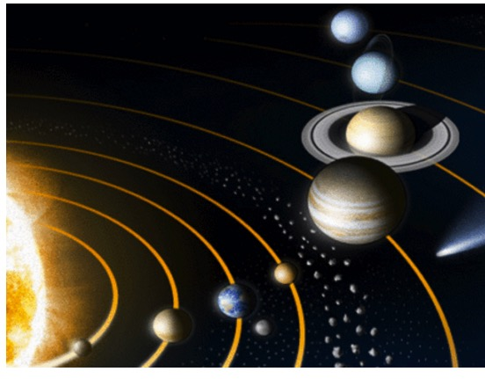

1. Maximum temperature on mercury can go upto 400 °C and minimum can go upto -200 °C
2. Mercury turns very slowly on its axis. And takes 59 days to complete 1 day and night.
3. Mercury has no atmosphere to protect it from the Sun. Life is not possible on mercury.
4. NASA sent a satellite named MESSENGER to mercury in 2004 to take pictures. It reached mercury after 6 and a half years.
5. Next mission is planned in 2018 by European and Japanese space agency.