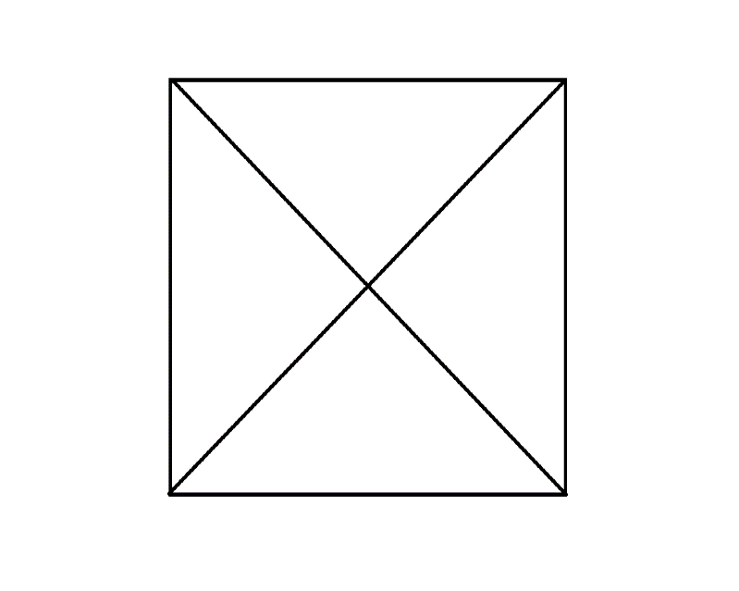
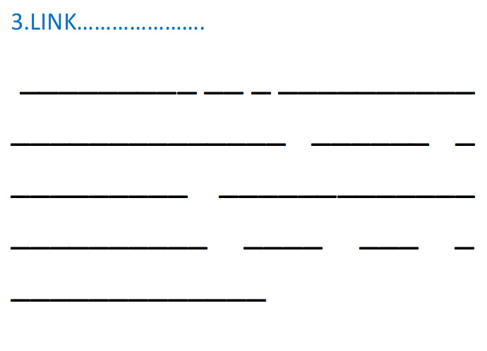
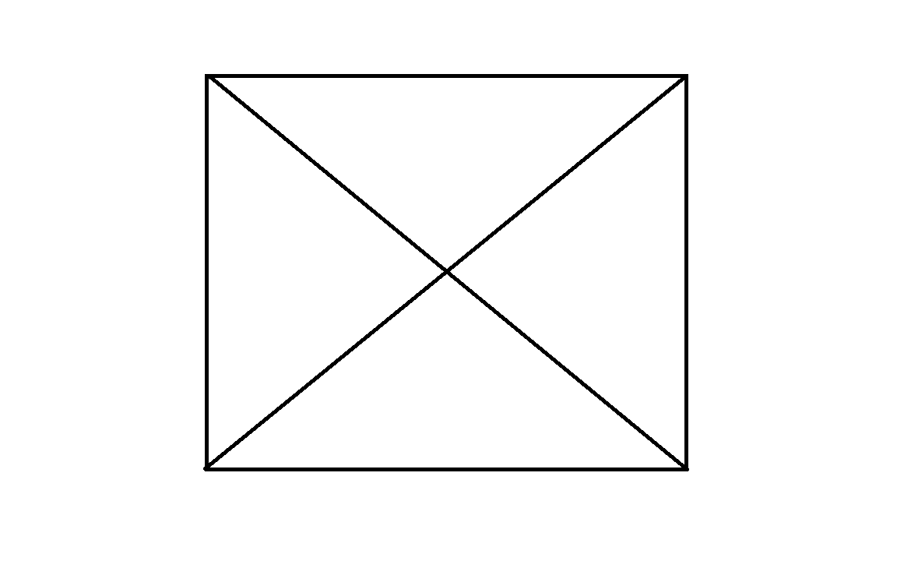
5.LINK………………….
_________ __ _ __________ ______________ ______ _ _________ _____________ __________ ____ ___ _ _____________ ____________ _______
4.LINK………………….
_________ __ _ __________ ______________ ______ _ _________ _____________ __________ ____ ___ _ _____________ ____________ _______


WELCOME TO BRAINSPARK
2.LINK………………….
_________ __ _ __________ ______________ ______ _ _________ _____________ __________ ____ ___ _ _____________ ____________ _______
1.LINK………………….
_________ __ _ __________ ______________ ______ _ _________ _____________ __________ ____ ___ _ _____________ ____________ _______

